3/11/2020

Assignment 4

NETW3500

Pod 7 – Courtney Hagen, Jessey Harlow, Zach Slaunwhite

Table of Contents

Introduction 2

Screenshots 2

Appendix A 2

Assignment 4

# Introduction

The purpose of this assignment was to demonstrate the deployment of software via SCCM.

# Screenshots

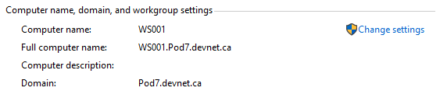

This screenshot shows the hostname and domain of the group workstation.

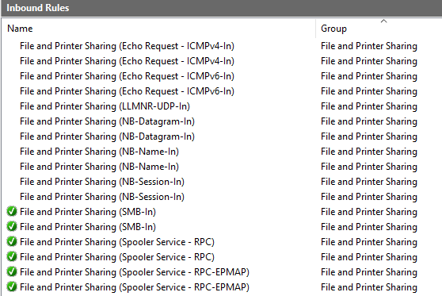

This shows the appropriate Inbound File and Printer Sharing rules are enabled.

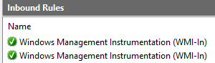

This shows the WMI-IN inbound firewall rules enabled.

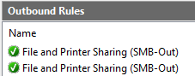

This shows the appropriate Outbound firewall rules set.

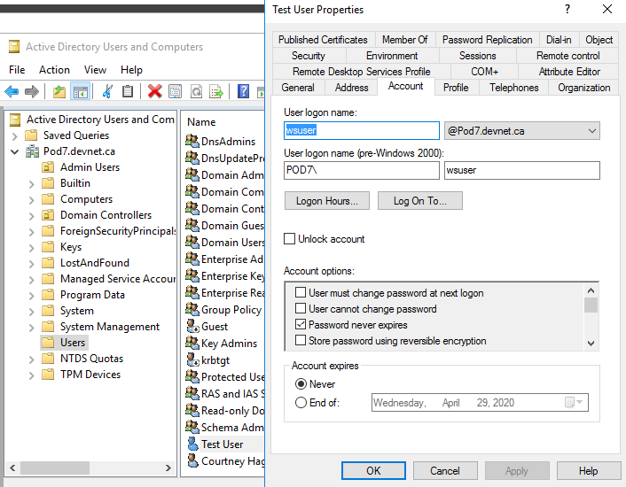

This demonstrates the wsuser account in the correct OU.

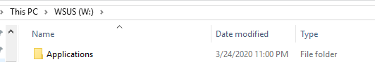

This demonstrates the Applications directory creation in the WSUS drive.

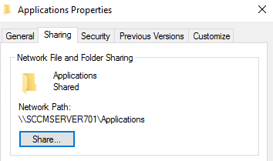

This shows that Applications directory is being shared.

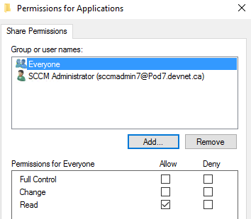

This shows the Applications permission for Everyone

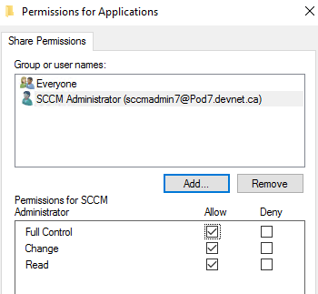

This shows the Applications permissions for SCCMAdmin7.

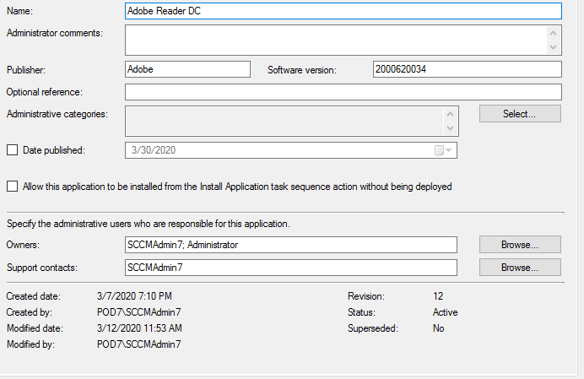

This demonstrates the Adobe Reader DC software settings.  


This shows the location for the Adobe Reader software.

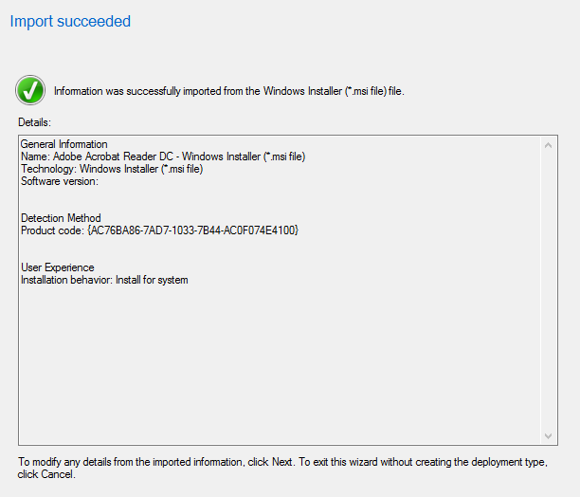

This screenshot demonstrates that the Adobe Acrobat Reader DC deployment type import succeeded.

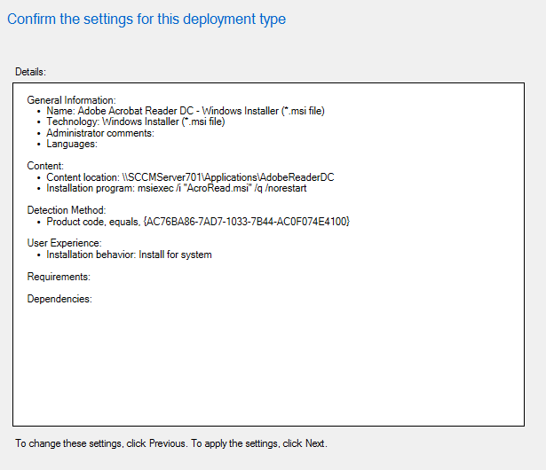

This screenshot demonstrates our deployment type settings and modifications.



This screenshot demonstrates the Client Version of WS001.

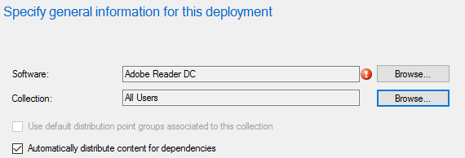

This demonstrates the deployment was set to All Users

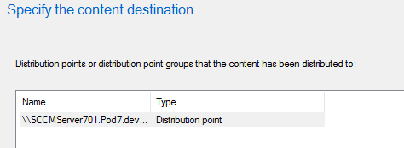

This demonstrates the FQDN of the server has the distribution point.

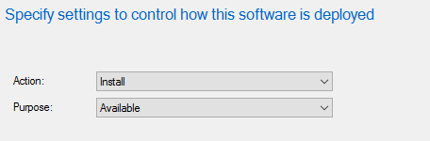

This shows that the deployment was set to Available.

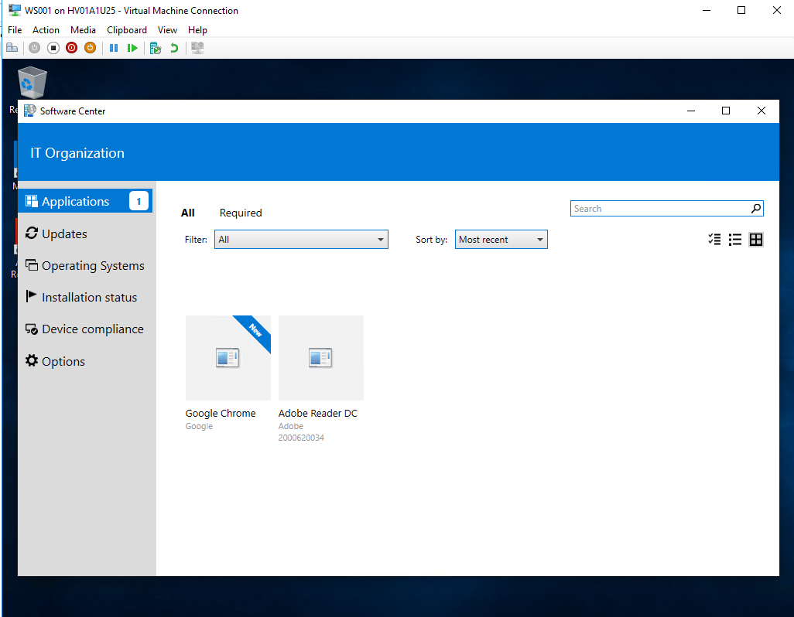

This screenshot demonstrates Google Chrome Enterprise being added to SCCM and successfully deployed.

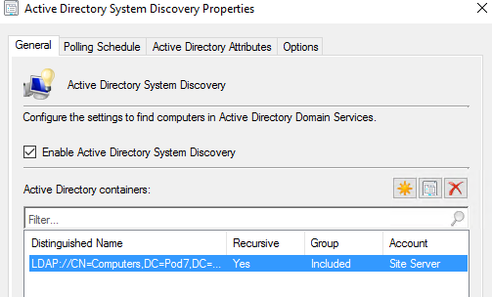

This demonstrates the Active Directory System Discovery settings.

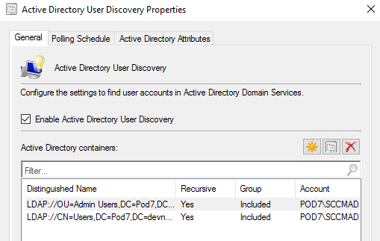

This demonstrates the Active Directory User Discovery settings.

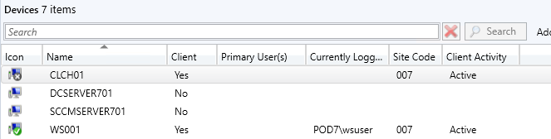

This demonstrates that the devices are being added to the right collection.

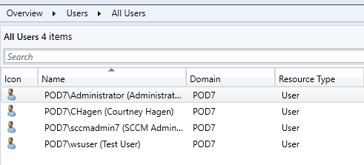

This demonstrates that the users are being added to the right collection.

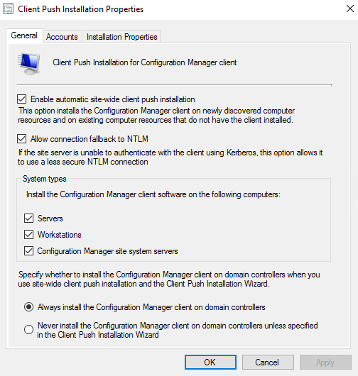

This shows the client push installation settings including that it is set to automatically install clients to the workstations.

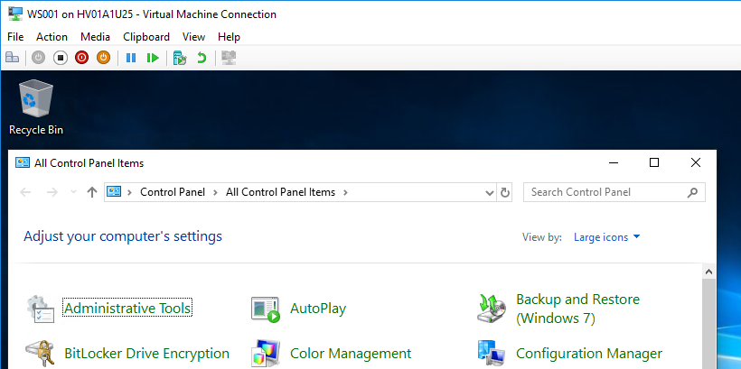

This shows that the Configuration Manager (SCCM Client) is installed on WS001.

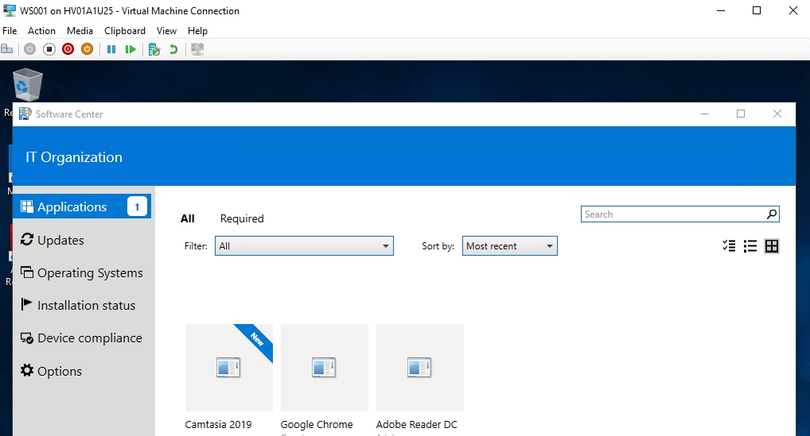

This demonstrates the Software Center on WS001.

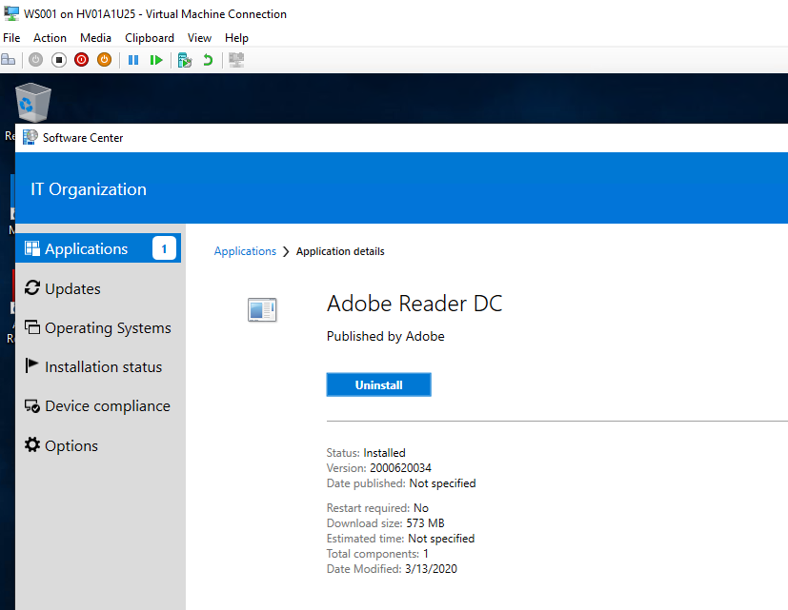

This shows Adobe Reader DC was installed on WS001 via Software Center.

# Appendix A

Individual Work Logs

Courtney Hagen

|  |  |
| --- | --- |
| **Total time spent:** | **10 Hours** |
| **Details of work completed:** | Completed tasks 1 and 2. Helped troubleshoot issue with SCCM client not deploying. Helped finish task 4. Took all screenshots for documentation. Installed Camtasia. |

Zach Slaunwhite

|  |  |
| --- | --- |
| **Total time spent:** | **7 Hours** |
| **Details of work completed:** | Troubleshooting SCCM content not being discovered (0x87d00607), assisted with setup of SCCM and contributed to troubleshooting the application install through software center. |

Jessey Harlow

|  |  |
| --- | --- |
| **Total time spent:** | **8 Hours** |
| **Details of work completed:** | Was a part of most actual work done on the sccm server in one way or another along the way to finishing this, did a lot of the in class troubleshootings. All of us had a hand in some way or another with whatever another was doing with this one. |

Marking Rubric

Courtney Hagen

|  |  |  |  |
| --- | --- | --- | --- |
| Criteria | Courtney | Zach | Jessey |
| Attendance | 1 | 1 | 1 |
| Submission Deadline | 1 | 1 | 1 |
| Quality of Work | 1 | 1 | 1 |
| Communication | 1 | 1 | 1 |
| Participation | 1 | 1 | 1 |

Zach Slaunwhite

|  |  |  |  |
| --- | --- | --- | --- |
| Criteria | Courtney | Zach | Jessey |
| Attendance | 1 | 1 | 1 |
| Submission Deadline | 1 | 1 | 1 |
| Quality of Work | 1 | 1 | 1 |
| Communication | 1 | 1 | 1 |
| Participation | 1 | 1 | 1 |

Jessey Harlow

|  |  |  |  |
| --- | --- | --- | --- |
| Criteria | Courtney | Zach | Jessey |
| Attendance | 1 | 1 | 1 |
| Submission Deadline | 1 | 1 | 1 |
| Quality of Work | 1 | 1 | 1 |
| Communication | 1 | 1 | 1 |
| Participation | 1 | 1 | 1 |