Final Project

NETW3500

Pod 7 – Courtney Hagen, Jessey Harlow, Zach Slaunwhite

Table of Contents

Introduction 2

Screenshots 2

NETWUser2020.csv 7

Scripts 8

Script to Create Array 8

Process Records Script 8

Appendix A 9

Final Project

# Introduction

The purpose of this assignment is to demonstrate more learning via System Center Orchestrator including using PowerShell scripts to create users and groups.

# Screenshots

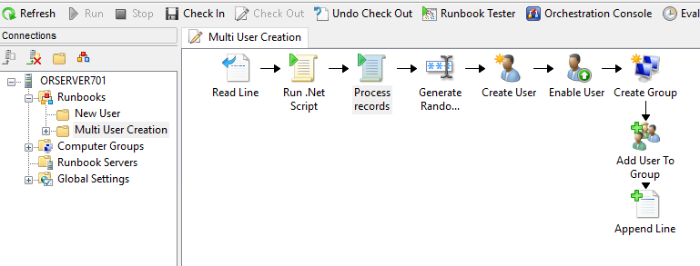

This demonstrates our runbook and workflow.



















The above series of screenshots demonstrates all of the tasks were successful in the Runbook Tester.

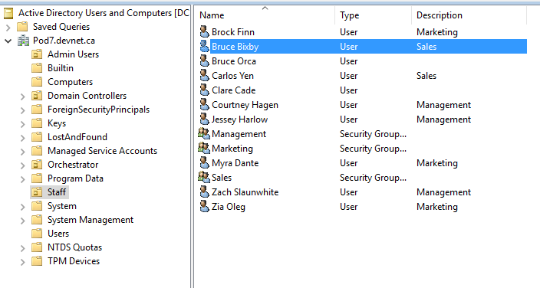

This demonstrates all the users were created correctly in the Staff OU.

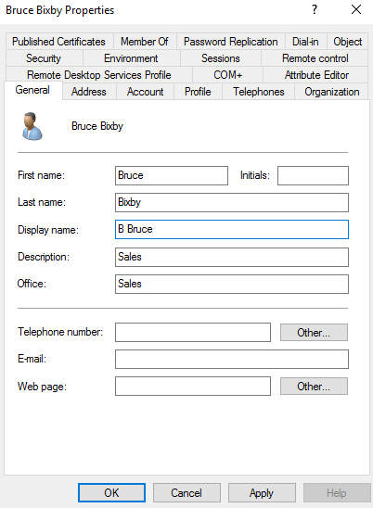

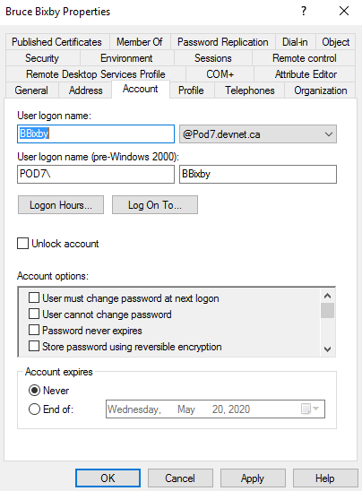

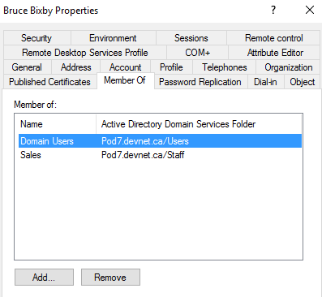

The above three screenshots demonstrate the correct settings for Bruce Bixby

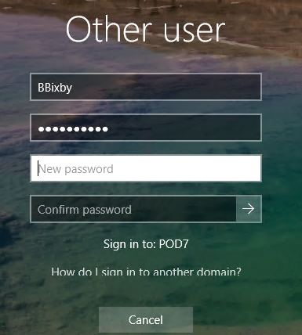

This demonstrates BBixby was prompted to change their password at login.



This demonstrates a successful login with bbixby.

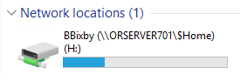

This shows that BBixby’s home drive on the $Home share is accessible and viewable.

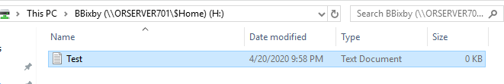

This demonstrates the ability to create a text file in the H: drive.

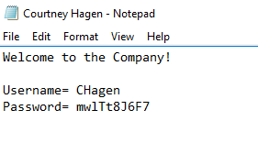

This demonstrate the text being created with the user’s username and password that was generated.

# NETWUser2020.csv

|  |  |  |  |  |  |  |  |  |  |
| --- | --- | --- | --- | --- | --- | --- | --- | --- | --- |
| FirstName | MiddleInitial | LastName | FirstInitial | Department | OU |  |  |  |  |
| Jessey | R | Harlow | J | Management | Staff | | | |  |
| Courtney | N | Hagen | C | Management | Staff | | | |  |
| Zach | Z | Slaunwhite | Z | Management | Staff | | | |  |
| Myra | Y | Dante | M | Marketing | Staff | | | |  |
| Brock | R | Finn | B | Marketing | Staff | | | |  |
| Zia | I | Oleg | Z | Marketing | Staff | | | |  |
| Bruce | Y | Bixby | B | Sales | Staff | | | |  |
| Carlos | A | Yen | C | Sales | Staff | | | |  |
|  |  |  |  |  |  |  |  |  |  |

# Scripts

## Script to Create Array

#Authored By: Zach Slaunwhite

#Comments By: Courtney Hagen

#The following initializes the array

$ArrayList = @()

# The following line splits the variables from each run

“{Line text from “Read Line”}”.split(“’n”|foreach{

$ArrayList += “$_”

}

## Process Records Script

#Authored By: Zach Slaunwhite

#Comments By: Courtney Hagen

#This gets the FirstName variable from the first position in the array

$FirstName = “[Field({Array List from “Run .Net Script”},’,’,1)]”

#This gets the MiddleInitial variable from the second position in the array

$MiddleInitial = “[Field({Array List from “Run .Net Script”},’,’,2)]”

#This gets the LastName variable from the third position in the array

$LastName = “[Field({Array List from “Run .Net Script”},’,’,3)]”

#This gets the FirstInitial variable from the 4th position in the array

$FirstInitial = “[Field({Array List from “Run .Net Script”},’,’,4)]”

#This gets the Department variable from the 5th position in the array

$Department = “[Field({Array List from “Run .Net Script”},’,’,5)]”

#This gets the OU variable from the 6th position in the array

$OU = “[Field({Array List from “Run .Net Script”},’,’,6)]”

# Appendix A

Individual Work Logs

Courtney Hagen

|  |  |
| --- | --- |
| **Total time spent:** | **5 hours** |
| **Details of work completed:** | Created document, joined group call to complete and help with all tasks. Took the lead on creating the new runbook, creating initial scripts that ended up not being used, adding comments to code, and taking the screenshots |

Zach Slaunwhite

|  |  |
| --- | --- |
| **Total time spent:** | **4 hours** |
| **Details of work completed:** | Participated in group call to assist with editing and creating the runbook and supporting scripts. Was not present for original creation of scripts (that weren’t used) but was present for everything used in the final submission |

Jessey Harlow

|  |  |
| --- | --- |
| **Total time spent:** | **4 Hours** |
| **Details of work completed:** | Joined a group call. Created the CSV, helped create the user integration script, assisted on everything else, but didn’t take the lead on anything in this one. Was present and helped for everything tackled in this assignment. |

Marking Rubric

Courtney Hagen

|  |  |  |  |
| --- | --- | --- | --- |
| Criteria | Courtney | Zach | Jessey |
| Attendance | 1 | 1 | 1 |
| Submission Deadline | 1 | 1 | 1 |
| Quality of Work | 1 | 1 | 1 |
| Communication | 1 | 1 | 1 |
| Participation | 1 | 1 | 1 |

Zach Slaunwhite

|  |  |  |  |
| --- | --- | --- | --- |
| Criteria | Courtney | Zach | Jessey |
| Attendance | 1 | 1 | 1 |
| Submission Deadline | 1 | 1 | 1 |
| Quality of Work | 1 | 1 | 1 |
| Communication | 1 | 1 | 1 |
| Participation | 1 | 1 | 1 |

Jessey Harlow

|  |  |  |  |
| --- | --- | --- | --- |
| Criteria | Courtney | Zach | Jessey |
| Attendance | 1 | 1 | 1 |
| Submission Deadline | 1 | 1 | 1 |
| Quality of Work | 1 | 1 | 1 |
| Communication | 1 | 1 | 1 |
| Participation | 1 | 1 | 1 |