**Name:**

*Be sure to use correct units and significant figures throughout all your answers.*

*Showing full work for answers will unlock possible partial credit. Save as .pdf upload to Canvas assignment.*

1. The average human hair grows 1.5cm longer per month. After a 2 hour 45 minute physics lab how much longer will your hair be in µm from the time lab started? Note: average human hair width is 17-180µm.
2. (a) How many regulation sized ping pong balls would fill the entire volume of a standard size faculty member’s office in the College of Arts & Sciences (125sqft with 9ft ceilings)? Assume you can obtain the optimal sphere packing fraction of 74% volume.

(b) Same question, but for regulation tennis balls.

1. How long is the Legacy walk (including an uncertainty) in meters from where it starts opposite the road from Henderson Building to where it ends at the landscaping below the Eagle/Plane sculpture? You must devise a physical means of measuring the distance, NOT using a map or app. State your measurement method including an estimate of your uncertainty. Error propagation will probably be necessary, if so show it.
2. The equation that describes the motion of an object is , where *x* is position, *a* is acceleration, *t* is time, and *v* is velocity. Using standard SI units, show that the dimensions in the equation are consistent.
3. Give the number of significant figures in each of the following numbers:
   1. 112.4±0.2
   2. 10.0
   3. 3.14159
   4. 1700
   5. 1250±50
   6. 5.0030
   7. 9.33x103
   8. 0.02240
4. Discuss the merits and drawback of using a person’s foot as a length standard in terms of accessibility, invariability, indestructibility, reproducibility, and uncertainty. Consider both *(a)* a particular person’s foot, and *(b)* any person’s foot.
5. You measure the radius of a wheel to be 4.16cm. If you multiply by 2 to get the diameter, should you record the result as 8cm or 8.32cm? Justify your answer.
6. What is the percent uncertainty for each of the following measurements?
   1. 3.75±0.25m
   2. 116.3±0.1g
7. Find the percent uncertainty in θ and in sinθ for the two following measurements. Note: for error propagation the uncertainty in θ must be in radians.
   1. θ=15.0°±0.5°
   2. θ=75.0°±0.5°
8. Given the image, what is:

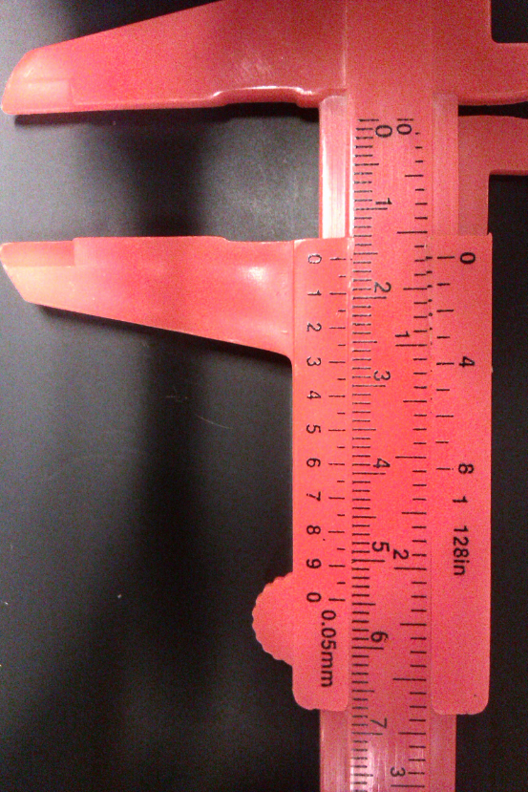

1. The resolution of the Vernier caliper [mm]?
2. The width reading on the Vernier caliper in [mm]?
3. The uncertainty of the above width reading in [mm]?
4. The ruler in the image is marked to the nearest mm. Note: Each edge measurement is technically a position measurement with its own uncertainty. What is: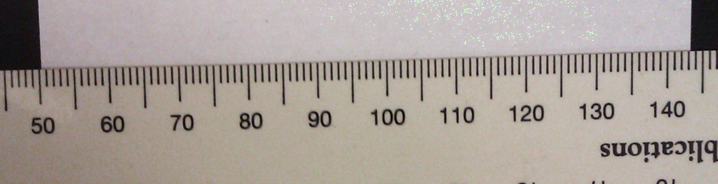
5. The resolution of the ruler in [mm]?
6. The position measurement uncertainty you feel possible with the ruler in [mm]?
7. The width of the piece of paper in [mm]?
8. The propagated uncertainty on the paper width in [mm]?