Unit Review Studio
Developer guide
Self-serve resource for curriculum developers building unit review activities.
Unit Review Studio is the authoring tool. Students see a unit review on a lesson road.
You do not need to write code. You fill in the studio, preview as a student, then publish a zip into the repo.

Contents
Jump to a section:
Links
What students get
Student start / road
A question
Match with Clear
Finished road
End screen with lesson to revisit
Before you build
Build a review in the studio
1. About this unit and questions
2. Name each lesson
3. Add questions
Question-type tips
4. Name and publish
Put it in the repo and ship it
Ship checklist
Common questions

Links
Studio: https://courtniestrongmind.github.io/Unit_Review_Studio/studio/
Sample student view: https://courtniestrongmind.github.io/Unit_Review_Studio/review/index.html?set=sample-unit-review
Open these in Chrome or Edge.
Progress only lasts while the browser tab is open. Close the tab or use Start over on the road screen to begin at Lesson 1 again.
Back to contents

What students get
Students travel a road of lessons for one unit.
- They see the course name, unit title, short directions, and numbered stops.
- They answer a few questions per lesson. Types can be multiple choice, select all, match, or sort.
- They get a few tries. After a miss, they see a tip. Correct answers show short feedback.
- When the dotted trail reaches the flag, a yellow star appears.
- The end screen congratulates them. If anything was missed, it lists Lessons to look at again with the lesson number and topic as plain text. There are no Course Builder hyperlinks in the interactive.

Student start / road
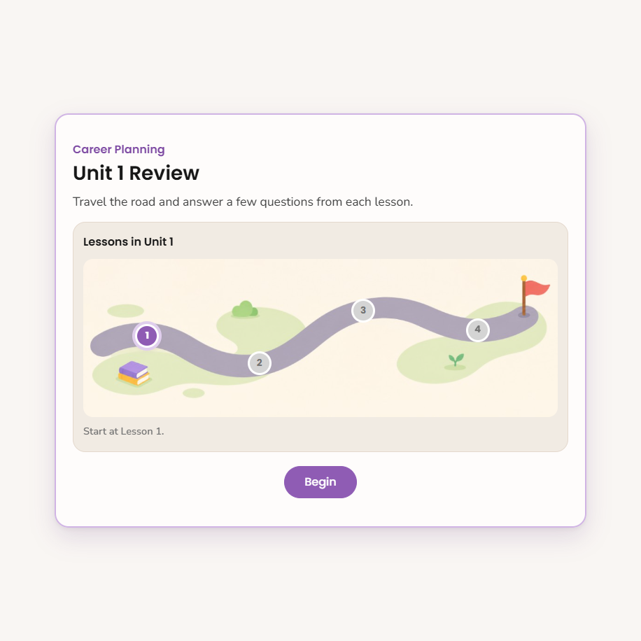
Student road with numbered lesson stops

A question
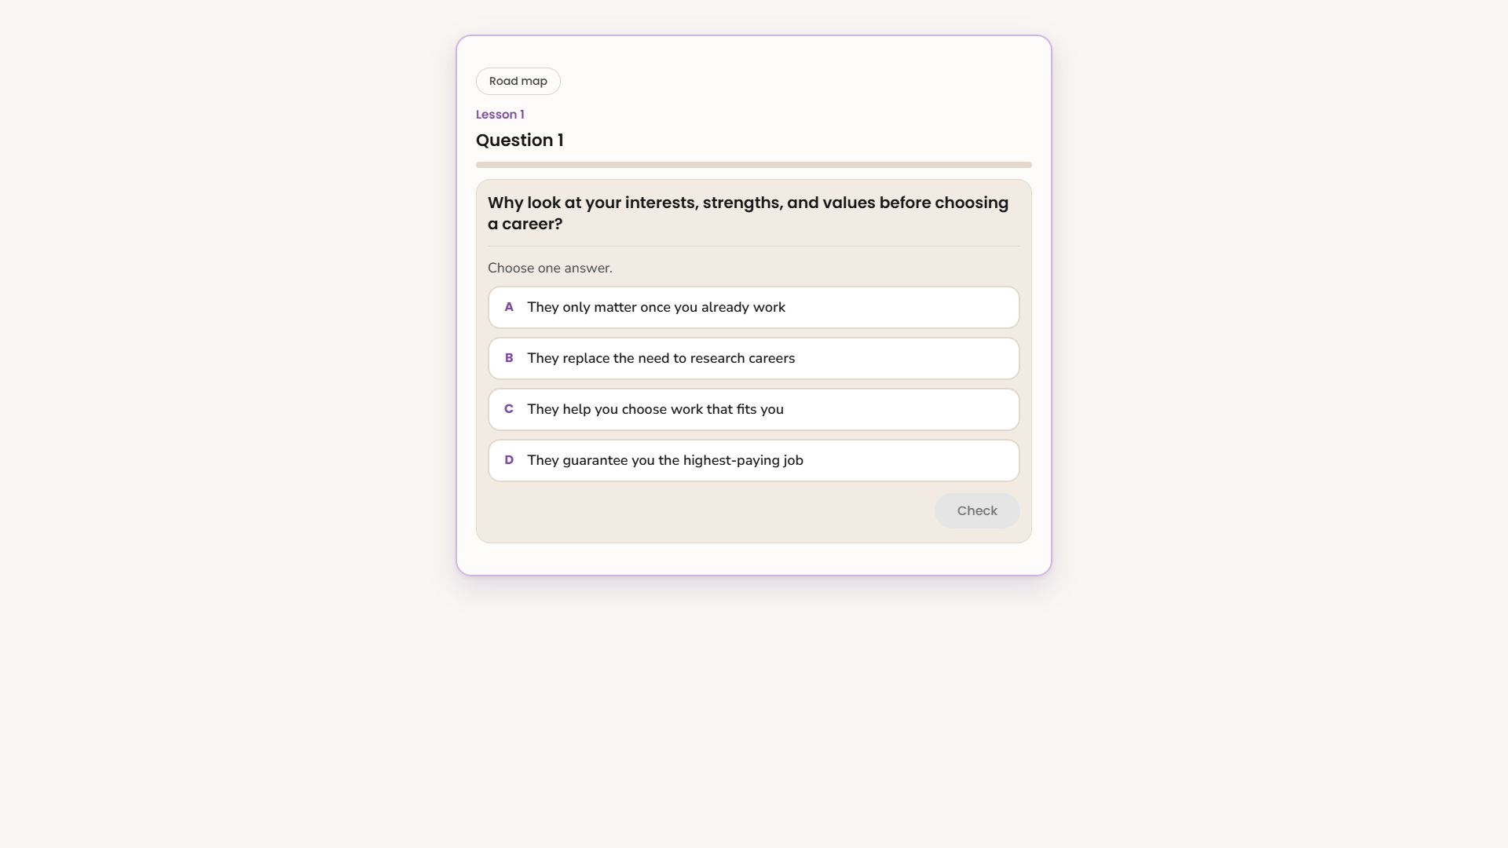
Multiple choice question with Check

Match with Clear
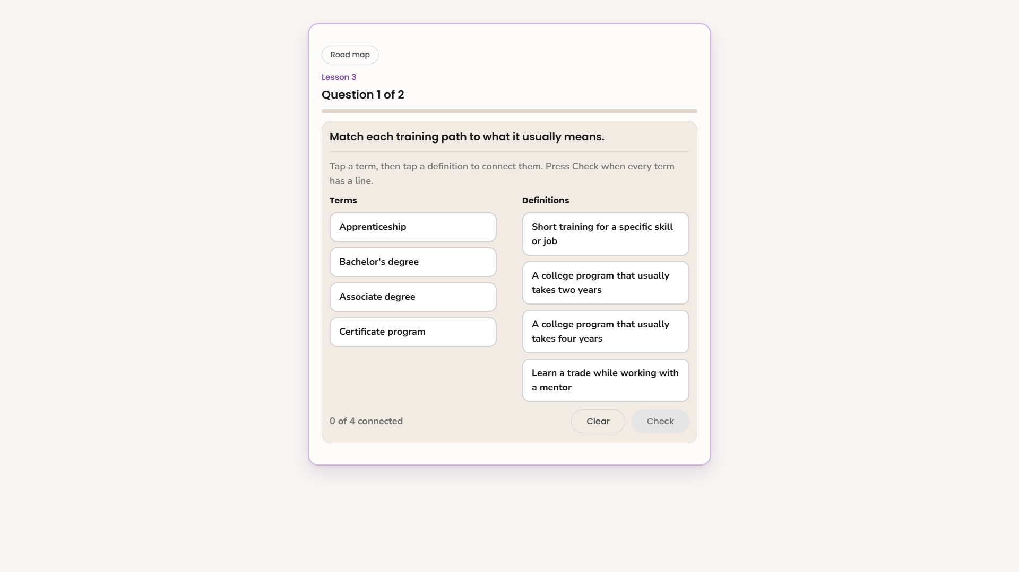
Match activity with Clear and Check

Finished road
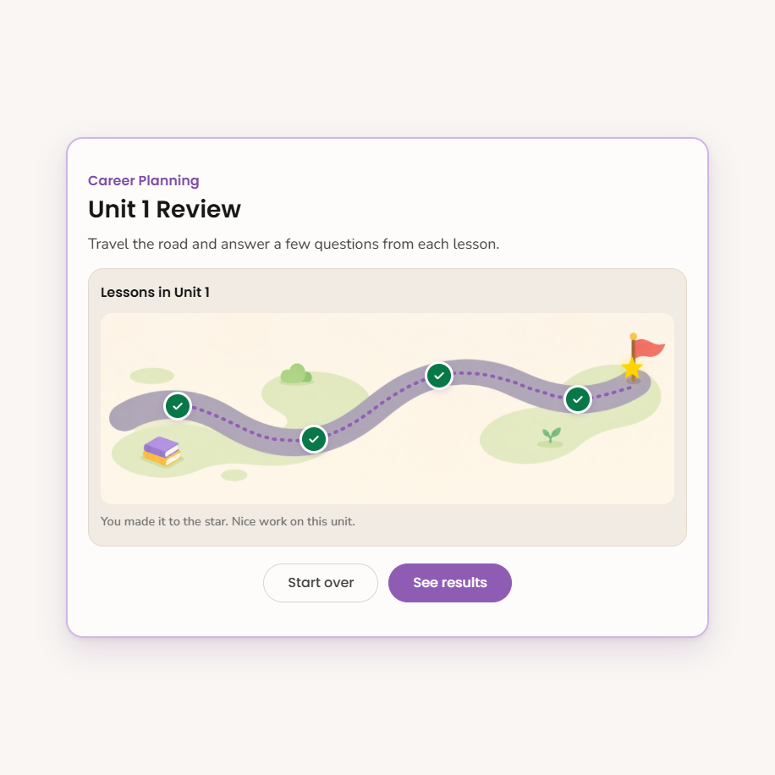
Completed road with yellow star at the flag

End screen with lesson to revisit
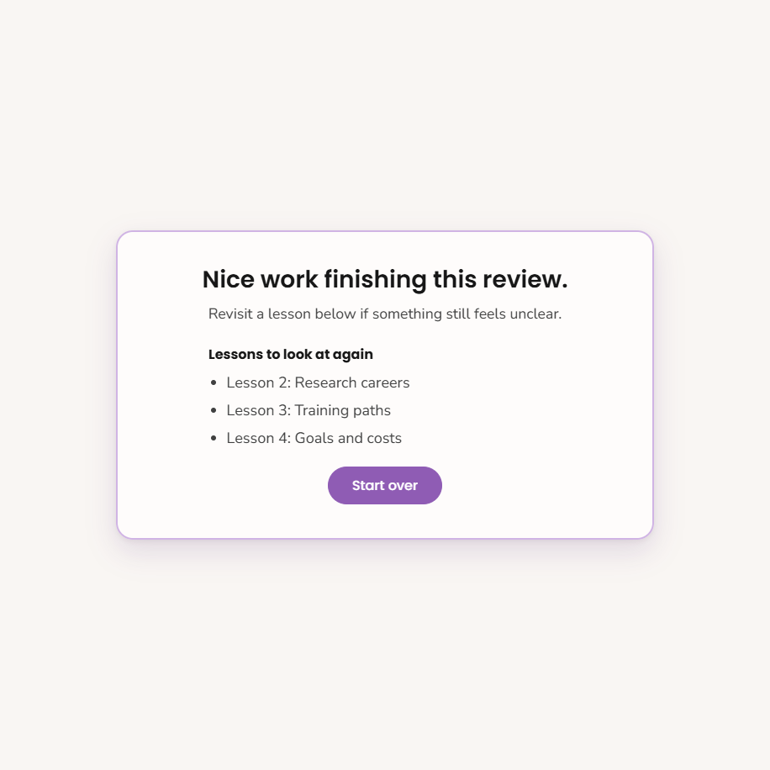
End screen listing lessons as plain text
Back to contents

Before you build
Have ready:
- The course, grade, and unit number
- Lesson titles for that unit
- Rough ideas for the questions you want in each lesson
- Topic names for each lesson on the road
Try the sample student link once so you know the experience you are building.
Back to contents

Build a review in the studio

1. About this unit and questions
Open the studio and click Start.
Under About this unit, set:
- Grade
- This unit
- Course
- Lessons in this unit (this builds the road stops)
Optional: open Tries per question if you want something other than 3 tries.
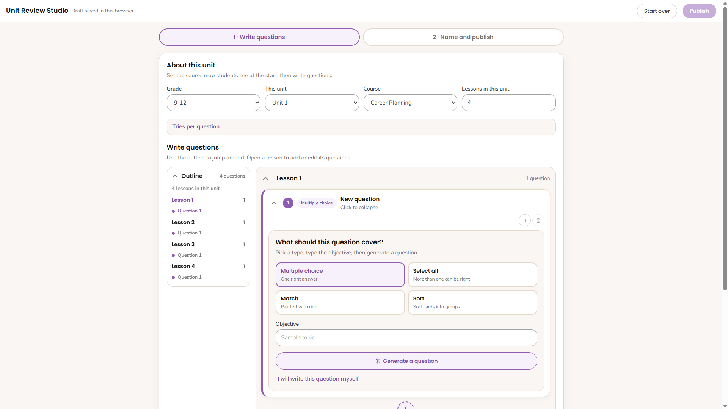
Studio About this unit, outline, and question editor

2. Name each lesson
Each lesson keeps a fixed Lesson 1, Lesson 2 label. Next to it, type the topic or lesson name in its own box.
That topic helps authors stay oriented. Students mainly see numbered stops on the road. On the end-screen revisit list, topics show as Lesson 3: Training paths.

3. Add questions
- Open a lesson and add a question.
- Pick a type: Multiple choice, Select all, Match, or Sort.
- Use Generate a question for a starting draft, or choose I will write this question myself.
- Fill in objective, prompt, answers, correct feedback, and incorrect feedback.
- Fill in objective, prompt, answers, correct feedback, and incorrect feedback.
Repeat for each lesson on the road.
Wrong-answer tips and the end screen do not link out to Course Builder. The end list is only a reminder of which lessons felt shaky.

Question-type tips
Multiple choice / Select all
- Keep choices short and parallel.
- Avoid making the longest choice the only correct one every time.
- For select all, mark every correct choice.
Match
- Keep left and right items short enough to read at a glance.
- Students connect pairs, then press Check.
- Clear removes unlocked connections.
Sort
- Name groups clearly.
- Assign each card to the correct group in the authoring view.
- Students sort cards into bins, then press Check.
- Clear sends unlocked cards back.

4. Name and publish
Click Name and publish.
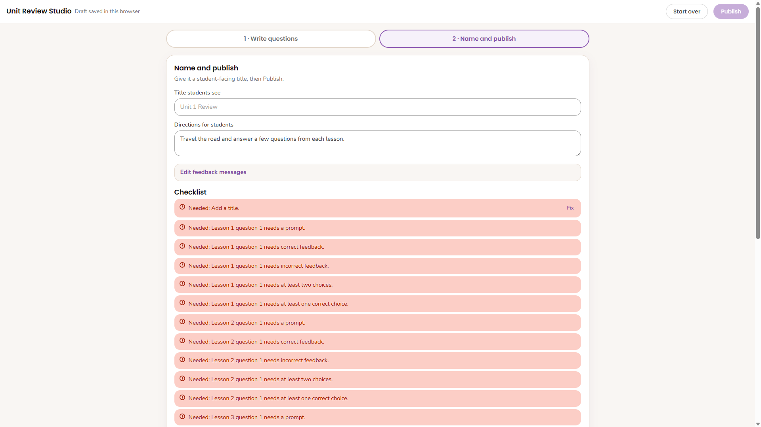
Name and publish step with checklist
- Set the Title students see and Directions for students.
- Optional: edit shared feedback lines and the end message.
- Read the Checklist and fix anything it flags.
- Click Publish and save the downloaded zip.
The studio also saves a draft in that browser automatically. Drafts do not sync to other computers. Publish is how you get the files that belong in the repo.
Back to contents

Put it in the repo and ship it
- Unzip the publish folder into review/sets/. You should get something like review/sets/my-activity-name/content.json.
- Activity folder names use lowercase letters, numbers, and dashes only.
- Branch, commit, open a PR, merge, then run Dev Deploy and Prod Deploy the usual way.
- Student link pattern after hosting is live: .../review/index.html?set=<activity-name>
- Embed that player URL in Helios in an iframe, same as other interactives.
Until the shared StrongMind interactives host is pointed at this repo, use the GitHub Pages links above for review.
Back to contents

Ship checklist
- Course, unit, grade, and lesson count match the real unit
- Every road lesson has at least one question
- Each question has clear correct and incorrect feedback
- Match and sort items are short and readable on a phone
- You played the whole road once in preview or the published sample
- Publish zip is in review/sets/ and named correctly
- Helios embed uses the player link with the right ?set=
Back to contents

Common questions
Why did my review open on Lesson 2?
You already finished Lesson 1 in that same browser tab. Close the tab, use Start over, or open a fresh link.
Where did my draft go?
Drafts live in local browser storage on that computer. Another browser or computer will not see them. Publish and save the zip if you need a lasting copy.
Why are end-screen lesson names not links?
By design. The list only reminds students which lessons to reopen in the course, so changing Course Builder URLs cannot break the interactive.
Do students see points or a percent score?
No. This review is light. The focus is finishing the road and knowing which lessons to reopen.
Can I change the player design later?
Yes, but that is a code change in review/index.html. After player edits, someone needs to run python tools/build_studio.py so the studio preview stays in sync.
Back to contents

