Installation instructions for PxWeb 2019 v1

Table of contents

Prerequisites 3

Hardware requirements 3

Clustered web servers 3

Installation on IIS 10 (Windows Server 2016), IIS 8 (Windows Server 2012) and IIS 8.5 (Windows Server 2012 R2) 4

Troubleshooting 7

Installation instructions for PxWeb

This instruction is for how to install PxWeb 2019 v1 on a computer.

**Tip:** When the installation is finished place your own database in the <installation-directory>\resources\px\databases and visit the administration pages to generate the database description file and to make it visible for the end users.

# Prerequisites

Make sure that the following components is installed and running properly

* Microsoft .Net Framework 4.6.1
* Internet Information Services 8.0 or greater (depends on the operation system version) and that ASP.NET is installed.

**Notice:** To be able to install PxWeb it requires administrative rights to the computer.

# Hardware requirements

This is depending on the load on your web site. A typical server could be a virtual machine with 2 CPU:s and 4G RAM.

# Clustered web servers

If you want more than one web server you need to use some kind of load balancing to ensure that a web session always returns to the same server. You need to do this because PxWeb has sticky sessions.

# Installation on IIS 10 (Windows Server 2016), IIS 8 (Windows Server 2012) and IIS 8.5 (Windows Server 2012 R2)

**Step 1 – Extracting files**

Extract the PxWeb_2019_v1.zip to

C:\Inetpub\wwwroot\PXWeb

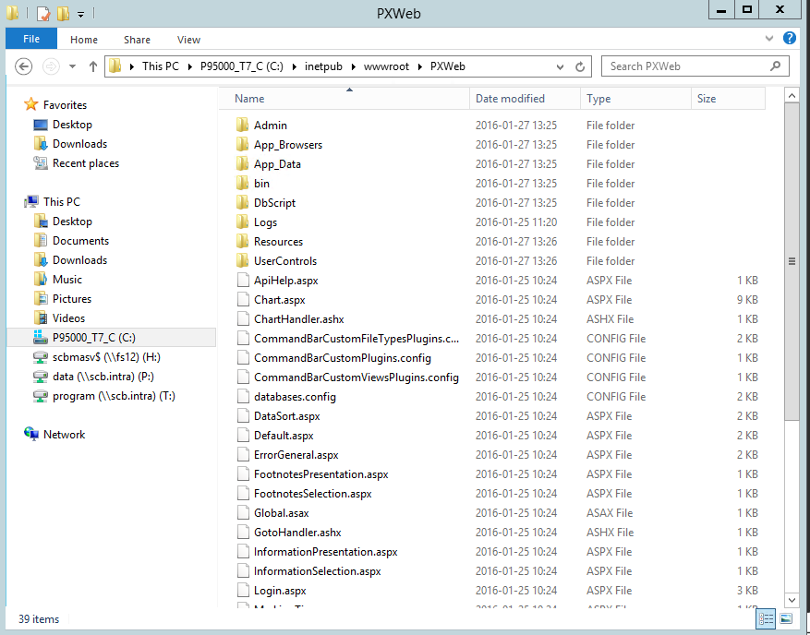

**Step 2 – Configure IIS**

In the Internet Information Services Manager expand the Default Web Site and right click on the PXWeb folder and select Convert to Application.

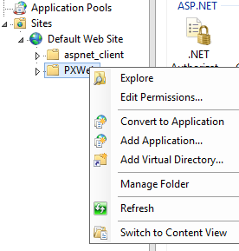

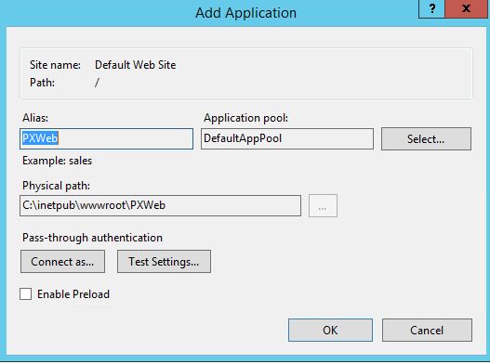

Click the OK button to convert the folder to an application.

Select the DefaultAppPool application pool and select to view the Basic Settings tab and confirm that the ASP.NET version is set to 4.0 (.Net CLR version).

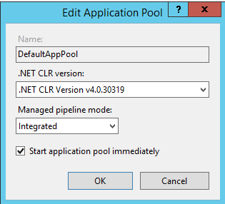

**Step 3 – Set rights**

By running the set-rights.bat file, permissions will be changed on some of the folders and files below the PXWeb folder. The permissions need to be changed for the user statistics feature to work properly also for being able to change and save settings in the administration tool.

Run as an administrator by right clicking on the file in Explorer.

C:\Inetpub\wwwroot\PXWeb\set-rights.bat

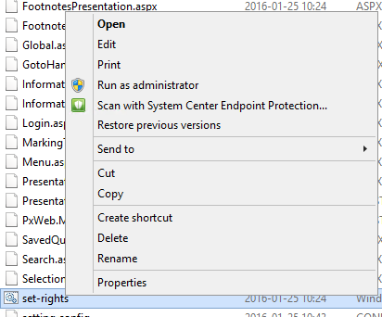

**Step 4 – Launch PxWeb**

In the Internet Information Services Manager click on the Browse button when the PxWeb site is selected. The Start page of PxWeb will appear.

# Troubleshooting

**Save as Html**

On some installations of PxWeb there can be problems saving as Html-file and Html5 table. When saving the resulting Html file will first contain the actual file content (the content you want) but after that the Html file will also contain the rest of the html-page that you visited in PxWeb when performing the save operation.

Solution:

To fix this you must configure IIS:

1. Start IIS (Internet Information Services) on the webserver where your PxWeb web site is installed
2. Select your PxWeb web site and double click the Compression icon:  
   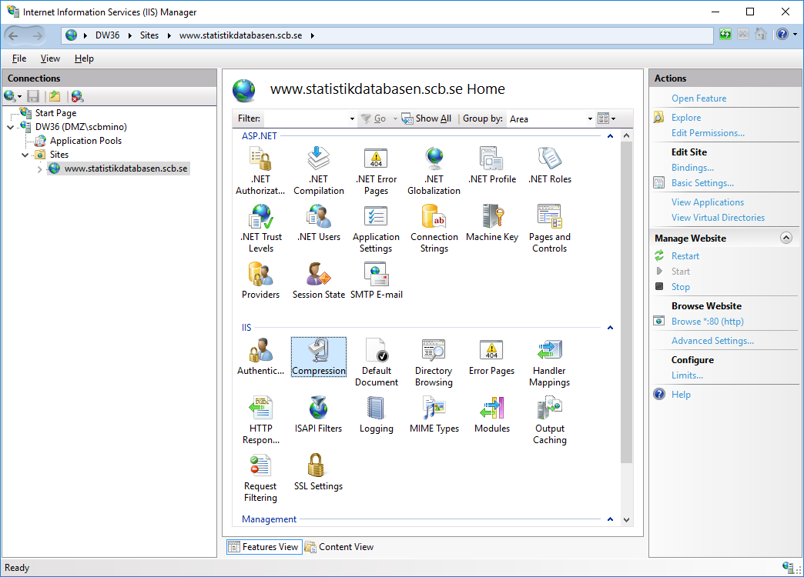
3. Uncheck the “Enable dynamic content compression” checkbox

After completing step 1-3 it shall be possible to save as Html file without problems.

**Save as PX-file**

**In some installations of PxWeb there can problems saving as PX-file. To solve this following the steps below.**

**To be able to download .px files from the web application and the API .px files has to be added in a list of allowed file types. The handler that processes the request for the .px file needs to be added in the *Handler Mappings* feature page.**

In the Internet Information Services Manager click on the PXWeb folder and open Handler Mappings.

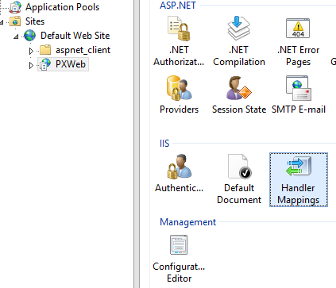

**Below Actions click on the link Add Managed Handler.**

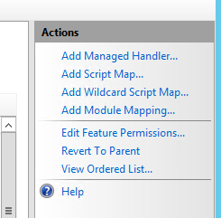

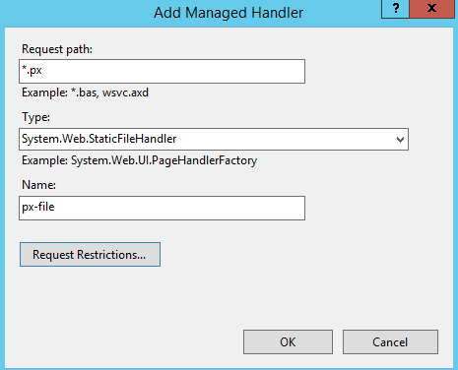

**Type in *.px in the text field Request path and type in System.Web.StaticFileHandler in the Type field and px-file in the last field and confirm with the OK button.**

**Now px-file appears in the list of request types.**

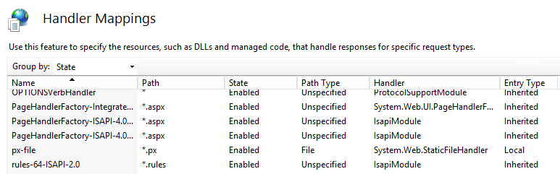

After completing these steps it shall be possible to save as PX-file.