

Woodstock TextField
Functional Specification

Dmitry Kushner
Revision 0.41

Table of Contents
1Summary 1
2Relevant Documents 2
3Requirements, goals, and assumptions 3
3.1Requirements 3
4High-level design 4
4.1Structure 4
4.2Deployment 5
5Properties/Attributes 6
5.1Properties 7
5.2JSF attributes 8
6Functions / Behavior 9
6.1Javascript functions 9
6.2Dynamic Behavior 9
6.2.1Auto-Validation 10
6.2.2Asynchronous Refresh 10
6.3Basic Interactions 11
6.3.1Creation of the TextField 11
6.3.2Client Side control 11
6.3.3Auto Validation 12
7Special Features 12
8Usage 12
8.1Declarative – JSF-based rendering 12
8.2Client side – javascript only, no JSF/JSP 13
8.3Programmatic - JSF Managed Bean-based rendering 14
9Interfaces 14
9.1Imported Interfaces 14
9.1.1Libraries 14
9.1.2Theme Dependencies ( resources, styles, images) 14
9.1.3Other Woodstock components 15
9.2Exported Interfaces 15
10Document Revision History 16

Summary
This document provides abbreviated requirements, design considerations, functional specification and usage examples and patterns for Woodstock client-side rendered TextField component. Woodstock TextField component is used to render input element of text type.
While based on completely different client side architecture, client-side rendered TextField continues to provide all of the features of server rendered TextField available in Braveheart release of components. In addition, TextField is enabled for dynamic client-side behavior, such as asynchronous update ( ajax based refresh), auto-validation ( ajax based validation of entered text)
Common platform note: TextField is built using common component architecture approach. It is important to understand such architecture, assumptions, requirements, underlying technologies and dependencies, as well as all the common features implemented there. All of common features and requirements are implicitly assumed and may not be mentioned specifically here. Such common features in particular include: performance and common functional requirements, browser and platform support, accessibility, localization requirements, assumption, goals, tools support ( Visual Web Pack for Netbeans), extensibility, debugging considerations and external dependencies
Thereby see referenced common documentation before proceeding with this specification.

Relevant Documents
- TextField Web ApplicationGuidelines
- Woodstock Common Architecture Documents
  - Woodstock components functional specification.
  - Ajax Architecture for Woodstock Java Server Faces
  - Ajax Architecture Examples for Woodstock JSF components
- Javascript (http://docs.sun.com/source/816-6408-10/contents.htm)
- JSON (http://www.json.org/)
- HTML 4.01 Specification (http://www.w3.org/TR/html401/)

Requirements, goals, and assumptions

Requirements
- Produce branded ( theme-based) <input type=”text” component with the following visual appearance :
Mode / Attribute | Appearance
No Label
With Label
Required
Disabled
Invalid

- Client-side TextField component is to continue to support all the features of previous TextField component ( the one rendered with html renderer)
- TextField must support the following facets:
- label - replaces the default label implementation. Using label facet, develop may supply any presentation of the label associated with the TextField.
- TextField must provide optional ajax-based autovalidation functionality, where content of the text field is submitted for validation via AJAX-based mechanism (upon onBlur event). Implementation of the validation may be provided by:
  - pluggable developer-provided validation function(s), or
  - (default ) through the JSF-based validator. Thus while JSF based implementation is to be provided, no explicit dependency on JSF is to be required.
The default behavior of the JSF-based text field upon validation is as following:
Validation request is sent to the server (using ajax-based mechanism) upon onBlur event. Standard JSF configured validator validates data, and returns the result to the browser:
- SUCCESS - no visible changes are presented
- FAILED VALIDATION
  - If label is present, it will be invalidated (changes color to red, added exclamation mark image)
- Label text is NOT changed
- FacesMessage provided by the validator is added to the set of FacesMessages. While this message becomes available on the client, currently it will remain a responsibility of the developer to properly display such message. The default mechanism does not seek and display alerts/messages
[ In future, a functionality may be added to display such message above the text field]
- TextField must provide for a set of client-side control functions that change its visual appearance. Such functinality is defined by all the supported component attributes ( below). All client side control functions should function independently of the server support ( and existence) and not depend on the server.

High-level design

Structure
At the high level, the end-result of rendered TextField component is the following closure ( where id represents a developer supplied id) :
<span id="id">
<span id = “id_label”>
... label ...
</span>
<input id="id_field" type="text" ...attributes...></input>
</span>
Note that TextField is rendered based on the template that can be replaced at developer's will. The above implementation is based on the default template provided with the component.
Thus, as the result, the following elements of interest are added to the document DOM model of document (while there are some other by-product elements, they do not represent a consumable public interfaces and not reviewed here) :
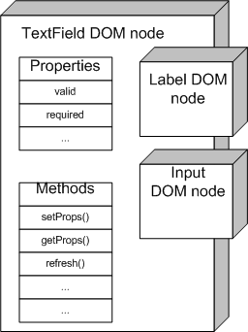
- TextField DOM node ( id=”id”)
This node does not have visual representation ( in the browser), although from programmatic stand point it represents a public interface to the component. Specifically, this node contains all the properties of the text field component ( see Properties/Attributes) and has an attached behavior in form of javascript functions ( see Functions/Behavior). TextField component as a complex component ( including all of its subcomponents, such as label and input field) is controlled through this this level node through the functions ( see Behavior) attached to it. For example, in order to change value of the input field, or required flag, a setProps(properties) function is used.
- Label span
This span encloses the label of the component. The default implementation renders Woodstock Label component here (TODO reference) which provides standard label with optional image, required image and valid/invalid behavior. Developer may substitute default implementation of the label into any other valid HTML code ( or JSF component if used in conjunction with JSF server infrastructure)
- Input field
Represents actual input field that will be submitted on form submit.

Note that while nested nodes ( i.e. label or input field) are regular DOM nodes, and are retrievable, accessible and manipulatable as such, they essentially represent private elements of the TextField component and should not be accessed directly. All access should be limited through the use of properties and functions of enclosing TextField DOM node.

Deployment
TextField is complex component that depends on external resources – other components ( i.e. label), branded images, template, javascript resources. All of the resources are provided through URL-accessible sources. While http:// is the basic transport tested and used in default implementation, others – such as ftp://, file://, etc. may be used.
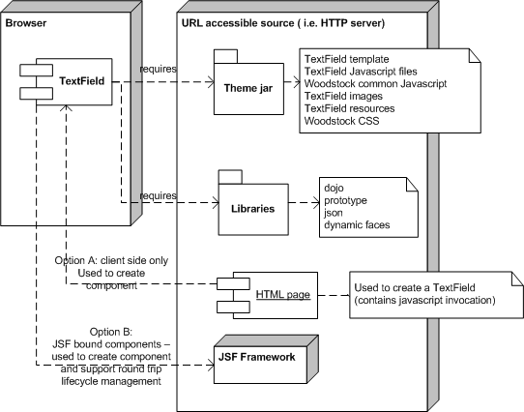

Properties/Attributes
TextField represents an object that has properties and methods. Properties are set/modified on TextField during its initialization, and during the lifetime as result of miscellaneous events through the javascript. Properties eventually define look and behavior of the TextField ( such as required, valid, etc).
Properties are saved on the TextField DOM node, and must be accessible through public methods getProps() and setProps(). While in Javascript there is no easy way to hide properties from the direct access, such access is discouraged.
Developer has complete control over TextField properties:
- initial set of properties is defined when component is rendered
  - if JSF is used to render TextField, <webuijsf:textField attributes are automatically translated into rendered TextField component properties
  - if JSF is not used, but TextField is generated by direct javascript call, parameters of the createWidget() method represent such properties

Properties
TextField component supports the following properties

Property | Description | Default | Valid values
TextField specific properties
label | text of the label | '' | Any text
required | Marks field as required | 'false' | 'true' / 'false'
size | Size of the input field in characters | 20 | Positive integer
valid | Marks field as invalid ( triggers exclamation mark and color change on the label) | 'true' | 'true' / 'false'
Common Woodstock Properties
id | Id of the component ( required) |  | Valid HTML id
className | Name of the class ( optional) |  | Class name
style | Style |  | Style name
disabled | Makes field disabled. | 'false' | 'true' / 'false'
visible | Makes TextField visible/invisible | 'true' | 'true' / 'false'
value | Initial value of the input field |  | Any text
htmlTemplate | Template to be used for component rendering | /theme/com/sun/webui/jsf/suntheme/templates/textField.html
Pass-through HTML attributes | same meaning/values as corresponding HTML attributes
onClick |  |  | Valid Javascript code
onDblClick |  |  | Valid Javascript code
onFocus |  |  | Valid Javascript code
onKeyDown |  |  | Valid Javascript code
onKeyPress |  |  | Valid Javascript code
onKeyUp |  |  | Valid Javascript code
onMouseDown |  |  | Valid Javascript code
onMouseMove |  |  | Valid Javascript code
onMouseOut |  |  | Valid Javascript code
onMouseOver |  |  | Valid Javascript code
onMouseUp |  |  | Valid Javascript code
OnSelect |  |  | Valid Javascript code
accesskey |  |  | Valid Javascript code
dir
lang
tabIndex |  |  | number

Updating Properties
As mentioned before, updating properties must be done through the use of setProps(props) function, where props is a json object containing any subset of properties:

// Update text field.
function updateField(props) {
//retrieve the DOM node
var domNode = document.getElementById("form1:textFieldA");
//set the properties
domNode.setProps(props);
}
and such function would be invoked with something like this:
<a onclick=
"updateField({ required:true });">
Make text field required
</a>
or
<a onclick=
"updateField({ required:true , valid:true , size:40 });">
Make text field required, valid and size of 40 characters
</a>

JSF attributes
Woodstock JSF harness provides a powerful and convenient server based application environment. In particular, Woodstock components can be rendered and bound to the JSF beans automatically. In this case JSF attributes define ( directly, or indirectly) all the above listed properties of the client side rendered component.
For complete information and description of all attributes, see TLD documentation for <webuijsf:textField tag (woodstock/webui/tlddocs/webuijsf/textField.html )

Functions / Behavior

Javascript functions
Client side TextField component exposes set of functions for developer's use. All of the functions are attached to the primary TextField DOM node, and appropriately named not to cause name-space conflicts in an environment where multiple instances or versions of the TextField or other Woodstock components are used.
All functions for the TextField component are nested within namespace webui.@THEME@.widget.textField that gets final resulution during the build process. For example, in the default suntheme theme, this name becomes webui.suntheme.widget.textField. Developer does not have to concern herself with this fully qualified name though, as all functions are to be called directly on the DOM object ( ex. domNode.setProps() )
For more information and documentation on functions, see Javascript functions documentation ( TODO link)
Function | Parameters | Returns | Description
Public
setProps() | props – json object containing 0 or more key-value properties, as specified above | True | Iterates through specified properties and sets them appropriately on the TextField and its subcomponents.
getProps() |  | Props | Collects properties from TextField and its subcomponents and returns in the form of json object. Such object can be modified and used as a parameter to setProps()
refresh() |  | True | Asynchronously reloads the content of the TextField component by publishing refresh event. Has no meaning when component is not server bound.
getInputElement() |  | Text input DOM node | Returns the node representing actual text input.
Private
webui.@THEME@.widget.textField .fillInTemplate |  | True | This functions is supplied as interface with dojo widget creation infrastructure. Not to be used publicly.

Dynamic Behavior
TextField is designed with dynamic behavior in mind. Dynamic features will be expanding in future.

Auto-Validation
When auto-validation is enabled, onBlur event from text input triggers validation event posted to dojo event system. Developer has two options on how to process auto-validation:
- By default, in JSF-bound environment, when validator is specified for TextField component, it will be used automatically by executing ajax call to the server. In order to enable auto-validation in JSF-bound environment, the following attributes need to be specified on <webuijsf:textField component :
  - autoValidate=true attribute
  - validatorExpression=EL expression

For Example (see Usage, Attributes for more examples):
<webuijsf:textField
id="textFieldA"
text="4111 1111 1111 1111"
label="Enter Credit Card Number"
columns="20"
required="true"
autoValidate="true"
validatorExpression="#{Payment.cardValidator}"
/>
Upon return of the validation ajax call, TextField is updated ( see Requirements on what and how is updated)
- In not-JSF bound environment, or in case standard JSF based validation processing is not satisfactory, developer can still interpret and process the validation by subscribing to the event and reacting to it in appropriate manner. This will require Javascript coding.
Developer can model event subscription from existing code that is used in order to accomplish autoValidation within JSF-bound environment ( found in themes/javascript/widget/jsfx/textField.js), but in short subscribing to a dojo event would have to look like:
// Listen for Dojo Widget events.
dojo.event.topic.subscribe(
webui.@THEME@.widget.textField.validation.beginEventTopic,
webui.@THEME@.widget.jsfx.textField, "processValidationEvent");

Asynchronous Refresh
TextField can asynchronously refresh its state from the server by executing refresh() function. This will trigger an ajax call to the server.

// Refresh field.
function refreshField() {
var domNode = document.getElementById("form1:field1"); // Get field
return domNode.refresh(); // Asynchronously refresh field
}

Basic Interactions
The following sequence diagrams provide a high level overview of interaction,and are not meant to be an exact and precise representation of the object model and collaboration. For the purpose of demonstration, TextField here collectively represents widget, DOM node, and associated with TextField Javascript code.

Creation of the TextField
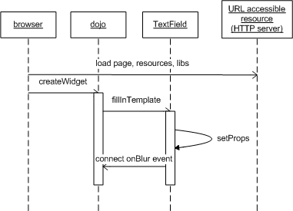

Client Side control
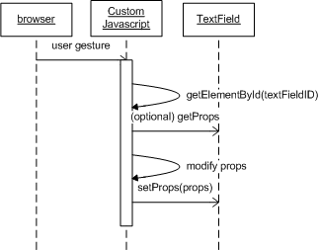

Auto Validation
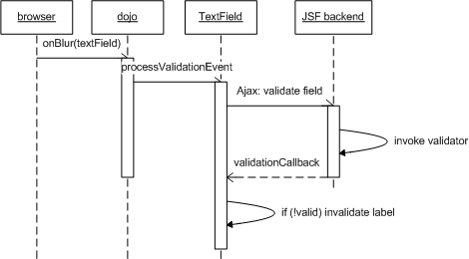

Special Features
This section outlines special features of the TextField that are not explicitly covered by Properties and Behavior sections.

Usage
Woodstock components can be used in a few different ways. The most typical way to use a component is with the JSP tag from within a JSF based application. Another approach is to use them in not-JSF-bound environment, which will require some Javascript coding.

Declarative – JSF-based rendering
Using JSP tag provides for convenient and bullet-proof way to generate TextField component presentation. Using the JSP tag, all the in-line JavaScript necessary to generate a Dojo widget is automatically output in the rendered HTML page. This includes the name of the desired widget, any localized and themed properties required to populate the HTML template, and any JavaScript files (e.g., widget JavaScript) necessary to support the Dojo Widget. JSP tag attributes are automatically translated into corresponding properties of the client side component.
Example: to include a TextField in the JSP page, the web app developer will include a tag like this.
<webuijsf:textField id="TextField1" text="TextField 1" />
or
<webuijsf:textField
id="testValidator"
text="4111 1111 1111 1111"
label="Enter Credit Card Number"
validatorExpression="#{Payment.cardValidator}"
/>
For complete information and description of all attributes, see TLD documentation for <webuijsf:textField tag (woodstock/webui/tlddocs/webuijsf/textField.html ) , but here is the quick syntax of JSP tag:

<webuijsf:textField
<!-- Individual attributes -->
[required="true|false "]
[text="text" ]
[size="size |20"]
[autoValidate="true |false"]
<!-- Standard attributes -->
[id="id "]
[ajaxify="true |false"]
[rendered="true |false"]
[binding="componentBinding "]
[validator="validatorMethod "]
[converter="converter "]
[valueChangeListener="listenerMethod "]
[immediate="true|false "]
<!-- HTML attributes -->
[accesskey="accessKey "] [alt="altText "] [dir="ltr|rtl"]
[disabled="true|false "] [lang="lang "]
[onblur="code "] [onchange="code "] [onclick="code "] [ondblclick="code "]
[onfocus ="code "] [onkeydown="code "] [onkeypress="code "] [onkeyup="code "]
[onmousedown="code "] [onmousemove="code "] [onmouseout="code "]
[onmouseover="code "] [onmouseup="code "] [onselect="code "]
[readonly="true|false "] [size="size"] [style="style "][styleClass="styleClass "]
[tabindex="tabIndex "] [title="title "]
/>

Client side – javascript only, no JSF/JSP
A Dojo Widget can also be represented by the following JavaScript. This JavaScript makes the Woodstock component available to web app developers who cannot, or do not want to, use the JSP and/or JSF frameworks.
Note that creation of TextField widget is performed with the use of Woodstock and dojo libraries, and requires the inclusion of dependencies such as styles and javascript files ( see Deployment, TODO link to sample HTML file)
Also note that any one of the key-value pairs of properties below can contain more key-value pairs, possibly used by subcomponents.
dojo.require("webui.<theme>.widget.TextField");
webui.<theme>.widget.common.createWidget({
_widgetType: "webui.<theme>:textField",
templatePath":"/<appname>/theme/com/sun/webui/jsf/<theme>/templates/TextField.html",
value: "TextField1"
id: "form1:TextField1"
});

Programmatic - JSF Managed Bean-based rendering
Web app developers may also continue to define components and properties via a managed bean as shown below. In this scenario, the component will behave similarly as if a JSP tag were used. That is, the in-line JavaScript, necessary to instantiate a Dojo Widget, is automatically output in the page by the widget renderer.
public class TextFieldBean {
private TextField TextField = null;
public TextField getTextField() {
if (TextField == null) {
TextField = new TextField();
TextField.setText("TextField 1");
}
return TextField;
}
public void setTextField(TextField TextField) {
this.TextField = TextField;
}
}
Note that the above example assumes the binding attribute of a JSP tag is used. For example:
<webuijsf:textField id="TextField1" binding="#{TextFieldBean.TextField}" />

Interfaces

Imported Interfaces

Libraries
- dojo.js
- prototype.js
- woodstock theme

Theme Dependencies ( resources, styles, images)
- Themed CSS selectors and other properties shall be added to the props.js file of the module. For example, widget/props.js includes the following TextField properties.
// TextField properties.
textField: {
enabledClassName: "TxtFld@THEME_CSS@",
disabledClassName: "TxtFldDis@THEME_CSS@"
}
- Also, the following theme dependencies exist:
  - htmlTemplate – “textField”

Other Woodstock components
TextField uses Label in order to render input label ( TODO link Label)

Exported Interfaces

Interface Name | Classification | Reference | Comments
com.sun.webui.jsf.component.TextField | Stable |  | The interface for JSF components
com.sun.webui.jsf.renderkit.html.TextFieldRenderer | Stable |  | The interface for design-time rendering
com.sun.webui.jsf.renderkit.widget.TextFieldRenderer | Stable |  | The interface for widget rendering
com.sun.webui.jsf.renderkit.ajax.TextFieldRenderer | Stable |  | The interface for ajax widget rendering
com.sun.webui.jsf.taglib.TextFieldTag | Stable |  | The interface for JSP tags
themes\javascript\widget\textField.js | Stable |  | Client side Javascript interfaces
themes\javascript\widget\jsfx\textField.js | Stable |  | Client side ajax Javascript interfaces
component-type and renderer-type faces-config.xml parameters
com.sun.webui.jsf.TextField | Stable |  | The name used to define the component-type
com.sun.webui.jsf.html.TextField | Stable |  | The name used to define the renderer-type for design-time rendering
com.sun.webui.jsf.widget.TextField | Stable |  | The name used to define the renderer-type for widget rendering
com.sun.webui.jsf.ajax.TextArea | Stable |  | The name used to define the renderer-type for widget rendering in response to Ajax calls

(TODO link to javadocs)

Document Revision History

Revision | Date | Synopsis | Author
0.1 | 02/18/2007 | Initial Draft | Dmitry Kushner
0.2 | 03/21/2007 | Updated for new format and design, examples | Dmitry Kushner
0.3 | 04/05/2007 | Added review comments | Dmitry Kushner
0.41 | 05/30/2007 | Removed editable cell option – now implemented as a standalone editableField component | Dmitry Kushner
0.42 | 06/19/2007 | Removed password mode feature | Dmitry Kushner

