

Draw It or Lose It

CS 230 Project Software Design Template
Version 1.0

Table of Contents

CS 230 Project Software Design Template 1
Table of Contents 2
Document Revision History 2
Executive Summary 3
Requirements 3
Design Constraints 3
System Architecture View 3
Domain Model 3
Evaluation 4
Recommendations 5

Document Revision History

Version | Date | Author | Comments
1.0 | 09/26/2024 | Christopher Biele | Added entries for the ‘Executive Summary’ and ‘Design Constraints’ sections.
2.0 | 10/09/2024 | Christopher Biele | Added entry for the ‘Evaluation’ section.
3.0 | 10/24/2024 | Christopher Biele | Added entry for the ‘Recommendations’ section.

Executive Summary

Our client, The Gaming Room, is seeking to develop a web-based version of their existing game, Draw It or Lose It, on Android OS. With a new web-based game, the goal is to create cross-platform capabilities through support of multiple platforms, allowing for gameplay that is focused on teams. Draw It or Lose It is a puzzle game, where players guess by looking at rendered images, drawing inspiration from the classic game show Win, Lose, or Draw. The solution is to move the game into a web-based application that can support multiple teams, create unique team and game instances, and manage multiple users cross-platform. When evaluating the design and goals, there are three important objectives to focus on in the project: manage singular instances of a game in the memory by utilizing unique identifiers, allow multiple teams with groups of players, and provide proper identification by giving unique names for the games, teams, and players.

Requirements

There are several business and technical requirements requested by The Gaming Room:

Business Requirements:
- Multiplayer teams
- Multiteam gameplay
- Game, Team, and Player names need unique IDs
- Management of a single game instance

Technical Requirements:
- Compatibility with other platforms
- Scalability
- Real-time syncing
- Data integrity
- Cybersecurity
- Performance
- Concurrency in all game states

Design Constraints

There are six design constraints that need to be addressed when building the architecture and developing the software for The Game Room.

The top constraint to discuss is distributed environments in relation to scalability, latency performance, syncing, and concurrency. Firstly, let us address scalability and its relation to the distributed environments constraint. With the launch of the new platform’s version of the game, the number of players is bound to increase. A common issue we see in modern game design is underestimating demand and its impact on architecture performance. We need to ensure the architecture can manage the rising number of players and game sessions. Latency, synchronization, and concurrency go together like a horse, reigns, and a carriage. Since Draw It or Lose It is a multiplayer game, there needs to be a focus on ensuring synchronization across platforms and devices. Issues with syncing can cause latency lag and rendering errors, diminishing the player experience. Concurrency is the final detail to address. As noted above, the player count for the game will increase, and the system must adapt to this. Concurrency is the relationship between multiple users and their connection to the game or application. They exist in tandem and verified methods can be implemented to handle concurrent connections.

Another constraint is in cross-platform compatibility. Since the game will be on multiple platforms, the front-end stack needs to share compatibility between different operating systems. React can be utilized as the framework, allowing seamless compatibility between devices. The backend will be tooled to support different API requests from said devices.

Data management and security are the next constraints to address. The game will require unique game, team, and player names that necessitate the use of checks on two levels – database and application – to ensure duplicate names are not permitted and that only one instance of the game exists. MySQL is fantastic for storing data and allows for implementation of constraints in its storage design. Redis provides in-memory data storage that will ensure real-time access to session data, full management of the game state, and reduce concurrence in instances.

Security is something we all understand, and digital security is a serious matter. The game instances, teams, and player identifiers are all at risk of security threats without proper security protocols. OAuth and JSON are fantastic options for user authentication protocols. The use of HTTPS is a necessity to protect data while it is ‘moving’ between systems.

The final constraint to address is performance and game integrity. Performance is critical to a game’s user friendliness. Choppy rendering and inconsistent performance are critical to the game’s functionality in rendering images. A real-time rendering software to consider is WebGL. This would ensure consistent gameplay experiences. Good coding practices are required to reduce bugs that would affect gameplay. Network performance testing will need to be done to ensure conditions under different networks is consistent and reliable.

System Architecture View

Please note: There is nothing required here for these projects, but this section serves as a reminder that describing the system and subsystem architecture present in the application, including physical components or tiers, may be required for other projects. A logical topology of the communication and storage aspects is also necessary to understand the overall architecture and should be provided.

Domain Model

The UML class diagram below has several classes: Entity, Game, Team, Player, GameService, and SingletonTester. Starting with the Entity class, this is a base class/superclass. It holds common attributes, like id and name, and shared behaviors to and from other classes. This class shows the principle of inheritance, because other classes are permitted to extend it. This principle is crucial in ensuring redundancy is kept low.

The next class is the Game class. This class extends the Entity class and adds team management features. The principle of composition is seen in the class, as it holds Team lists that represent teams in a game session. This leads us into the Team class, which also extends the Entity class. It manages the Player objects by creating lists. The Team class shows the same principle as the Game class – composition, since the Team class shows how teams and players are related.

The Player class also extends the Entity class, inheriting id and name from the Entity class. The GameService class is the brain of the game. It follows the singleton pattern (mentioned below) and ensures there is only one instance of the game running. GameService acts as the logic module, managing the Game objects and verifying new games are being assigned unique IDs. The SingletonTester is the final class and works in tandem with the GameService class. This class tests singleton behavior, ensuring there is only one instance of the program running. Without the SingletonTester, the constraints previously mentioned would be breached.

Outside of classes’ specific principles noted above, there is one principle that is seen throughout each class: encapsulation. Encapsulation verifies that any modifications made are only done when permitted by parameters. We see this in how each class manages input to attributes and uses methods like addTeam to control modification access.

Overall software requirements that are fulfilled:
- Unique IDs, generated by the GameService class, are made to prevent duplicate names and increase entity searchability.
- The Game, Team, and Player classes create a method that manages multiple teams, with several players on each, in a session.
- The GameService class verifies only one instance of the game exists at any point in time, because it contains our Singleton Pattern.

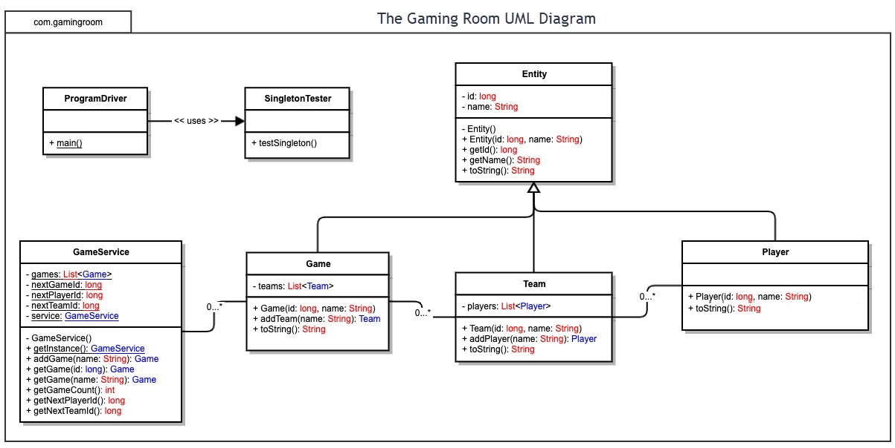

Evaluation

Using your experience to evaluate the characteristics, advantages, and weaknesses of each operating platform (Linux, Mac, and Windows) as well as mobile devices, consider the requirements outlined below and articulate your findings for each. As you complete the table, keep in mind your client’s requirements and look at the situation holistically, as it all has to work together.

In each cell, remove the bracketed prompt and write your own paragraph response covering the indicated information.

Development Requirements | Mac | Linux | Windows | Mobile Devices
Server Side | Server support is limited, OS is primarily used for development and testing, has a user-friendly development environment, is not optimal for high-traffic hosting, and has limited scalability. | Commonly used for web hosting, has great support for server applications, is open-source, cost-effective, fully customizable, but has a dramatic learning curve, config can be complex if not acclimated to the OS. | It has strong support for server applications, primarily for desktops, commonly used among developers, has integration with other Microsoft products and applications, but has expensive licensing fees, with less flexibility than Linux OS. | Native apps are developed separately, have a large potential user base, are widely available, but are limited by their hardware; which can vary greatly between users.
Client Side | It has modern browser support, good performance metrics, user-friendly UI, can be integrated with other Apple products and software, with a strong graphics ceiling, but is limited in gaming; many games do not have Mac versions. | Compatible with most web browsers, has open-source (allowing for flexibility), is cost-effective, has the most customization options, good performance metrics on lighter browsers, but some applications may lack compatibility. The learning curve of Linux is also steep. | Commonly used, has strong support for most modern web browsers, robust gaming support, but has security vulnerabilities that could increase the odds of being on the receiving end of a malware attack. | Runs most web apps in mobile browsers, supports native applications, large amount of users and accessibility, touch screen capabilites increase user engagement, but have small screens with hardware-limited performance.
Development Tools | Vast IDE and framework compatibility, strong web development support tools, native support for web development, strong tools in graphics and design, but can be expensive, with limited game development support and tools  Tools:  - IDEs & Editors  - Xcode  - Visual Studio  - Sublime  - JetBrains IntelliJ  - Programming  - Swift  - Objective-C  - JavaScript  - CSS  - HTML5  - Python  - Java  - C++  - Frameworks  - Cocoa  - Node.js  - React Native  - Electron  - Dev Tools  - Homebrew  - Git  - Docker | Variety of open-source tools, cost-effective, highly customizable development environments, but has a very steep learning curve and lack compatibility support.  Tools:  - IDEs & Editors:  - Visual Studio  - Sublime  - JetBrains IntelliJ  - Eclipse  - Vim  - Emacs  - Programming  - Python  - Jave  - C  - C++  - Go  - Ruby  - JavaScript  - CSS  - HTML5  - Bash  - Frameworks  - Node.js  - Django  - Spring Boot  - Flask  - Dev Tools  - Git  - Docker  - Jenkins  - Make  - Cmake | Vast IDE and development environment support, has the most commonly used OS and interface, with large amounts of user support through community resources, but has expensive licensing costs and there are known fragmentation concerns with software.  Tools:  - IDEs & Editors  - Visual Studio  - Visual Studio Code  - JetBrains IntelliJ  - Sublime  - Notepad++  - Programming  - C#  - .NET  - Python  - JavaScript  - HTML5  - CSS  - C++  - PowerShell  - Frameworks  - .NET Core  - Node.js  - Electron  - React Native  - Dev Tools  - Git  - Docker  - Windows Subsystem for Linux  - Jenkins | The development process has cross-platform tools, fast development, great deployment for multiple platforms, has a large user base, but there are concerns with complexity of testing (fragmentation concerns) and an over-reliance on using emulation in performance metric testing.  Tools:  - IDEs & Editors  - Xcod  - Android Studio  - Visual Studio Code  - JetBrains IntelliJ  - Programming  - Swift  - Kotlin  - Java  - JavaScript  - HTML5  - CSS  - Dart  - Frameworks:  - React Native  - Flutter  - Cordova  - Ionic  - Dev Tools  - Git  - Fastlane  - Jenkins  - Firebase

Recommendations

Analyze the characteristics of and techniques specific to various systems architectures and make a recommendation to The Gaming Room. Specifically, address the following:

- Operating Platform:
- My recommendation for the primary operating platform is Linux, on Ubuntu Server. When considering security, cost-effectiveness, flexibility, and coherence, Linux is the clear-cut winner. Linux offers support for development tools that improve the ability to adapt to environments. As the active player count increases, the server configurations and development tools will allow for consistent scaling. It is a well-known fact that Linux offers some of the most powerful security features. These benefits are bolstered by consistent security updates and communities supported by security professionals. The amount of available support in these communities cannot be overstated in relation to providing quick resolutions and enacting preventative measures. Coherence is a priority throughout this project, and for good reason. Having an operating platform like Linux allows coherence to shine. Many companies utilize Linux’s environment, because it has the most consistent performance and support.

- Operating Systems Architectures:
- Ubuntu Server platforms operate on the monolithic kernel architecture. The architecture lends itself to efficiency, with core components having direct lines of communication. These lines of communication allow for efficient retrieval of resources that can often be slower on other platforms. In this architecture, primary functions operate in the same space and would allow the game’s resource demands to be met. Linux is flexible in terms of modulation, as their kernel provides tools to configure web applications with optimization in mind. With the number of resources needed for this game, resource optimization is vital.

- Storage Management:
- My recommendation for storage management is a NAS (network-attached storage) system like OpenMediaVault. OMV has seamless integration with Ubuntu’s platform and provides a scalable storage option. OMV also supports large libraries, which will be imperative for storing the high-definition image files. There is full support for security without hindering accessibility on data retrieval. Combined with the impressive transfer rates on NAS systems, coherence in image rendering will be consistent in each instance. Given the requirement to consider cost in the project, OMV is also a cheap option. With the cost, integration, scalability and speeds provided by an NAS system like OMV, all requirements for the game are met.

- Memory Management:
- As mentioned in previous recommendations, coherence is a huge priority for this project. Ubuntu runs on a virtual memory system that creates seamless memory allocation and efficient multitasking. Ubuntu offers unique tools and features that can be implemented for effective memory management techniques, such as:
- Adjustable spaces with Swappiness. Swappiness allows for workload management.
- Linux utilizes algorithms for memory management for pages, between LRUs and LFUs. The tools vmstat, htop and free provide an overview for memory usage, allowing for detailed memory management analysis.
- Cache management in the Linux kernel can be managed through tuning cache behavior. Vm.vfs.cache.pressure can dramatically improve retrieval performance.

- Distributed Systems and Networks:
- A distributed system architecture makes the most sense here, given the priority of cross-platform communication. A client-server model should be used, because it provides management services for key features (game logic, user authentication, etc.). With the use of RESTful APIs and Websockets, cross-platform communication can be implemented with efficiency in mind. Deploying on a cloud platform allows for scalability and adding a CDN (content delivery network) will allow static assets to be loaded faster.
- When considering networks, there are some redundancies to consider. For example, if a network outage were to occur, graceful degradation can install a small range of functionality. Implementing load balances can improve traffic by setting distribution techniques, thus improving overall coherence and consistency.

- Security:
- Comprehensive security measures need to be employed to prioritize storage safety, whether it be in transit or at rest. To achieve this, data encryption, user authentication, and secure API development are vital. Addressing encryption, TLS (transport layer security) ensures encryption on all data exchanges and enacts solid security of sensitive data. For at-rest data, an algorithim like AES-256 can be implemented to ensure at-rest data is protected. Authentication methods can be implemented to increase security. For example, requiring strong passwords and multi-factor authentication for users would dramatically increase account protections. Ensuring RBAC is enacted will limit unwanted access and ensure only the proper roles are given specific permissions. Simple security standards like security audits and real-time monitoring can prevent attacks or compromises of the system.

