note: ho generato il report con Claudio che tanto è più bravo di me a spiegare cosa è stato fatto. Devo rivedere un po’ tutto quindi aggiungete volentieri note e commenti cosi che io possa sistemare appena riesco.

At the Same Level of Exposure, Does Security Awareness Reduce the Risk of a Digital Financial Incident?

Abstract
Part 3 of this study showed that more intensive users of digital financial services report substantially more incidents, and that this association is driven by exposure rather than by a deficit of digital skill. This part completes the RQ4 analysis by asking a complementary question: at a given level of usage intensity, does greater security awareness lower the probability of reporting an incident? A ten-item, direction-corrected security awareness index is constructed from questionnaire items on digital-contract knowledge, data-sharing awareness, password practices, and safe browsing attitudes. Three logistic regressions show that security awareness is strongly protective on its own and after controlling for usage intensity (odds ratio approximately 0.42–0.48, p < 0.001). Once an interaction between awareness and intensity is added, the protective effect is shown to strengthen as usage intensity increases (interaction odds ratio 0.62, p = 0.006): security awareness matters modestly for light users but substantially for medium and intense users. The connected sample is 4,427 respondents; the final regression sample is 3,686 respondents with 650 reported incidents.

1. Research Question
RQ4 asks: at the same level of digital financial activity, is greater security awareness associated with a lower probability of experiencing a financial incident? This is the protective-factor counterpart to RQ3, which established that usage intensity itself is the dominant driver of exposure. RQ4 asks whether, within that exposure, behavioural and attitudinal security awareness makes a measurable difference.
Hypothesis (H4): At the same level of digital financial activity, greater security awareness is associated with a lower probability of experiencing a financial incident.

2. Sample and Feature Construction
The analysis is restricted to the 4,427 respondents with Internet access (the connected sample defined in Part 1), because the questionnaire batteries used here (QP9, QP10, QS4) are only administered conditional on Internet access. Three indicators are constructed.

2.1 Digital finance intensity
Reused unchanged from Part 3: the row-wise mean of seven QP9 frequency items (scale 1 = Never to 4 = Very often), requiring at least four of the seven items to be valid. Valid for 4,240 respondents (mean = 2.07, SD = 0.67).

2.2 Security awareness
Ten items from four questionnaire batteries (QK7 true/false knowledge items; QS2, QS3, QS4 frequency and agreement scales) measure security-relevant knowledge and behaviour. The items do not share a common direction — some are protective statements where agreement is the aware response, others are risk statements where disagreement or “never” is the aware response. Each item was therefore recoded so that a higher value always indicates greater awareness, standardised to a common z-scale, and averaged, requiring at least six of the ten items to be valid. The index is valid for 3,889 respondents and is approximately centred at zero by construction (mean = 0.00, SD = 0.41).
Item | Awareness = | Recoding applied
QK7_4 (digital contract requires paper signature) | False | 1 − value
QK7_5 (public data used for targeted offers) | True | value
QK7_6 (crypto has legal-tender status) | False | 1 − value
QS2_6 (shares passwords with friends) | Never | no flip
QS2_7 (checks provider is regulated) | Always | 6 − value
QS2_8 (shares financial info publicly) | Never | no flip
QS3_13 (regularly changes passwords) | Completely | 6 − value
QS4_1 (safe to shop on public Wi-Fi) | Disagree | no flip
QS4_2 (website security matters before a transaction) | Agree | 6 − value
QS4_3 (T&Cs are not important to read) | Disagree | no flip
Table 1. Direction correction applied to the ten security-awareness items prior to standardisation.

2.3 Financial incident
A binary indicator equal to 1 if the respondent reports at least one of four adverse events (QP10_1–QP10_4: investment scam, phishing, unauthorised card use, unrecognised transaction), and 0 only when all four items are validly observed as “No”. The raw incident rate among the 4,189 classifiable connected respondents is 16.2% (678 respondents).

3. Descriptive Evidence
Incident rates rise sharply with usage intensity, replicating the Part 3 pattern, and fall consistently as security awareness increases.
Usage-intensity group | n (valid) | Weighted incident rate
Non-user | 946 | 8.9%
Low use | 2,094 | 12.5%
Medium use | 956 | 33.3%
Intense use | 85 | 23.4%
Table 2. Incident rate by usage-intensity group (population-weighted).
Security-awareness tertile | n (valid) | Weighted incident rate
Low awareness | 1,199 | 23.3%
Medium awareness | 1,261 | 16.4%
High awareness | 1,281 | 12.6%
Table 3. Incident rate by security-awareness tertile (population-weighted).
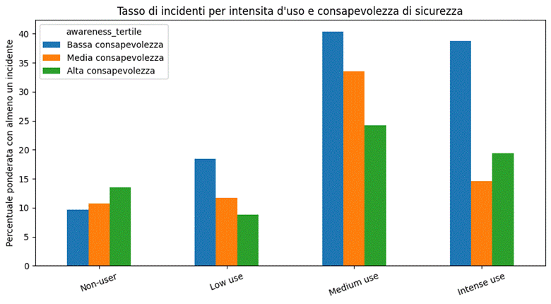
Figure 1. Incident rate by usage-intensity group and security-awareness tertile.
The cross-tabulation is the most informative single table: awareness makes almost no difference among non-users (9.7% vs. 13.5%, low vs. high awareness), a moderate difference among light users (18.5% vs. 8.8%), and the largest difference among medium-intensity users (40.3% vs. 24.2%). This pattern anticipates the interaction result reported in Section 4.

4. Regression Results
Three logistic regressions were estimated with financial_incident as the dependent variable, using population weights and heteroskedasticity-robust standard errors (HC1).
Model | n | Awareness OR | Intensity OR | Interaction OR | Pseudo R²
1. Awareness only | 3,686 | 0.42*** | — | — | 0.019
2. + usage intensity | 3,686 | 0.48*** | 2.30*** | — | 0.064
3. + interaction + controls | 3,686 | 1.41 (n.s.) | 2.45*** | 0.62** | 0.089
Table 4. Summary of the three logistic models. Odds ratios (OR); *** p < 0.001, ** p < 0.01, n.s. = not significant at 5%. Model 3 includes age, education, gender, work status, region, and urbanisation as controls.
In Models 1 and 2, security awareness is strongly and significantly protective on its own: each one-unit increase in the standardised awareness index is associated with roughly a 52–58% reduction in the odds of an incident, and this survives adjustment for usage intensity.
Model 3 note: the awareness coefficient in Model 3 is the effect at digital_finance_intensity = 0, a value outside the observed range of the index (1–4) and therefore not directly interpretable, this is why it appears non-significant even though the underlying relationship is strong. The interaction term is the substantively important result: it is negative and significant (p = 0.006), meaning the protective effect of awareness grows stronger as usage intensity increases. Table 5 reports the combined (marginal) effect of awareness at representative intensity levels, obtained by summing the main and interaction coefficients.
Usage intensity | Combined awareness effect (log-odds) | Approx. odds ratio
Low (1.0) | −0.13 | 0.88
Below average (2.0) | −0.60 | 0.55
Above average (3.0) | −1.07 | 0.34
Intense (4.0) | −1.54 | 0.21
Table 5. Approximate combined effect of a one-unit increase in security awareness on the log-odds and odds of an incident, evaluated at four representative levels of usage intensity. Point estimates only (standard errors of the combined effect are not reported here and should be computed with a delta-method / margins command before quoting a confidence interval in the final report).
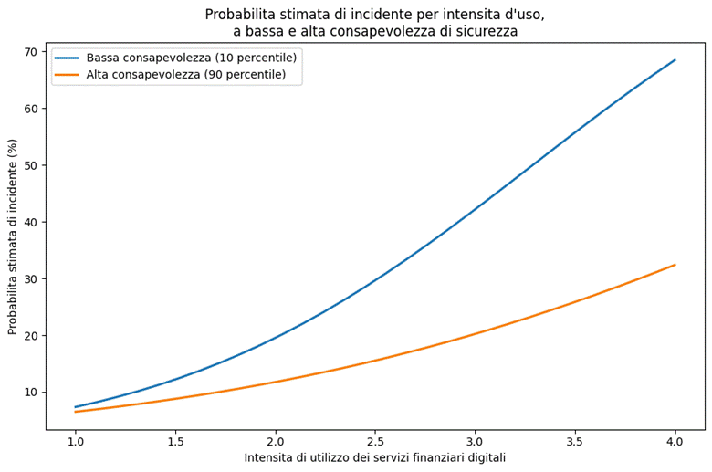
Figure 2. Predicted probability of a financial incident by usage intensity, at the 10th and 90th percentile of security awareness (Model 3).
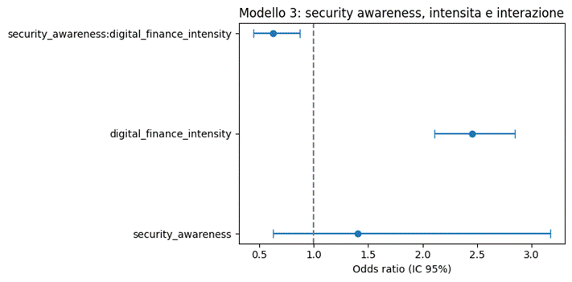
Figure 3. Odds ratios (95% CI) for security awareness, usage intensity, and their interaction (Model 3).

5. Discussion
The results support H4, with an important qualification. Security awareness is not uniformly protective across all users: its protective effect is small and imprecisely estimated among people who barely use digital financial services, and becomes progressively stronger among medium- and high-intensity users, exactly the group Part 3 identified as most exposed. In other words, security awareness and usage intensity do not act independently — awareness pays off precisely where exposure is highest.
Read together with Part 3, the two parts describe a coherent two-stage picture: usage intensity is the primary driver of exposure to incidents (Part 3), and security awareness is the primary protective factor conditional on that exposure (Part 4). This is a more actionable finding for stakeholders than either part alone: it suggests that security-awareness campaigns are likely to have the largest measurable payoff if targeted at medium- and high-intensity digital financial users, rather than distributed uniformly across the population.

6. Limitations
● Cross-sectional design: direction of causality between awareness and incidents cannot be established; experiencing an incident may itself raise subsequent awareness.
● Self-reported measures: both the awareness items and the incident items rely on recall and self-assessment, and may be affected by social-desirability bias.
● Composite index: security_awareness aggregates ten heterogeneous items into a single z-score average; the choice of items and the direction-correction rules should be reported transparently and, ideally, tested for internal consistency (e.g., Cronbach's alpha) before the index is used in the final deliverable.
● Small cells: the intense-use segment is small (n = 85–108 across tables) and its awareness-tertile cross-cells are flagged as unreliable (n < 30) in the underlying analysis; treat the intense-use row in Table 2 and Figure 1 as descriptive only.
● Approximate combined effects: the odds ratios in Table 5 are point estimates that ignore the covariance between the main and interaction coefficients; a proper delta-method or margins-based confidence interval should be computed before these numbers are used in a final, citable report.

7. Conclusion
Security awareness is associated with a substantially lower probability of reporting a digital financial incident, and this protective association is not constant across users: it strengthens with usage intensity, reaching its largest measurable size among the medium- and high-intensity users who Part 3 showed to be the most exposed group. Combined with the earlier parts of this project, the analysis supports a policy message centred on exposure and awareness together, rather than on either factor read in isolation.

