海狗测试

目录

广告 1

硬件环境 1

数据情况 1

硬盘使用情况 2

使用http_load做并发测试 2

并发3 压300秒 2

并发10 压300秒 2

并发30压300秒 3

并发50压300秒 3

并发100压300秒（出现超时） 3

100并发期间cpu负载 4

查询性能 4

## 广告

1. 当前higo只是秒级的查询，并非秒级的数据源，数据延迟一天
2. 实时数据源目前在开发中，敬请期待…….

## 硬件环境

1. 硬件配置：16 core 、48G内存、2T*10的磁盘
2. 机器数量：10台

## 数据情况

|  |  |  |  |  |
| --- | --- | --- | --- | --- |
| 数据表名 | 目前总数据量(亿) | 每天数据量 | 维度个数 | 目前已保存月数 |
| rpt_p4padhoc_product | 51.6 | 2000~3000万 | 42 | 8月 |
| r_rpt_cps_luna_item | 23 | 7500~9000万 | 81 | 2月 |
| rpt_hitfake_auctionall_d | 45.5 | 2300~2400万 | 75 | 8月 |
| r_rpt_cps_adhoc_seller | 13 | 4000~5000万 | 149 | 2月 |
| r_rpt_cps_adhoc_pid | 0.16913286 | 48~50万 | 28 | 2月 |
| rpt_p4padhoc_cust | 3.2 | 150~160万 | 220 | 8月 |
| rpt_b2bad_hoc_memb_sum_d | 0.19 | 150~160万 | 171 | 1月 |
| 合计 | **163亿** | **1.5~1.9亿** | **-** | **-** |

## 硬盘使用情况

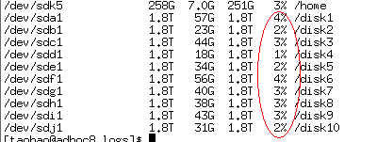

## 使用http_load做并发测试

测试的url为如下文件



本测试数值仅供参考，具体业务具体分析

### 并发3 压300秒

http_load -p 3 -s 300 ./a.txt

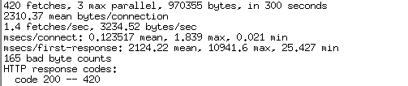

### 并发10 压300秒

http_load -p 10 -s 300 ./a.txt

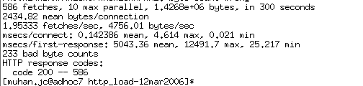

### 并发30压300秒

http_load -p 30 -s 300 ./a.txt

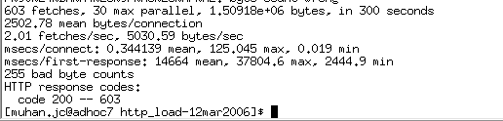

### 并发50压300秒

http_load -p 50 -s 300 ./a.txt

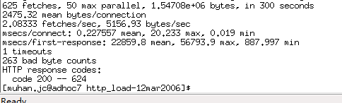

### 并发100压300秒（出现超时）

http_load -p 100 -s 300 ./a.txt

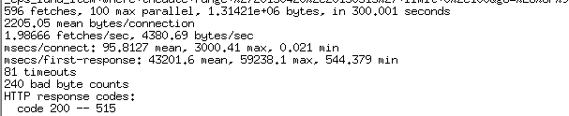

### 100并发期间cpu负载

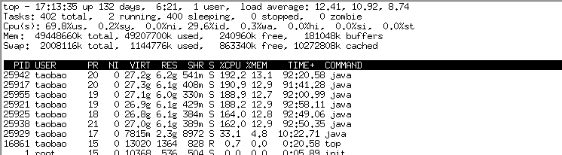

## 查询性能

|  |  |  |  |  |  |  |
| --- | --- | --- | --- | --- | --- | --- |
| 大类别 | 子类别 | 数据量 | 分区数 | 用例 | 首次响应时间 | 非首次响应 |
| Filter+count | 无 | 20亿 | 3 | 用例1 | 2.65 | 0.61 |
| 城市模糊匹配 | 20亿 | 3 | 用例2 | 1.138 | 0.201 |
| 用户id模糊匹配 | 20亿 | 3 | 用例3 | 25.23 | 0.182 |
| 按标题模糊匹配 | 20亿 | 3 | 用例4 | 22 | 0.117 |
| 根据商品ID查找 | 20亿 | 3 | 用例5 | 0.823 | 0.109 |
| count | 无分组 | 20亿 | 3 | 用例6 | 2.65 | 0.61 |
| 按时间分组 | 20亿 | 3 | 用例7 | 4.68 | 3.034 |
| 按一级类目分组 | 20亿 | 3 | 用例8 | 18.572 | 2.809 |
| 按省取topN | 20亿 | 3 | 用例9 | 28 | 3.468 |
| 按userid取topN | 20亿 | 3 | 用例10 | 50 | 14.042 |
| Sum | 拍下笔数 无分组 | 20亿 | 3 | 用例11 | 13.44 | 4.66 |
| 拍下金额 按时间分组 | 20亿 | 3 | 用例12 | 16.53 | 5.75 |
| 支付宝金额  按城市TopN | 20亿 | 3 | 用例13 | 29.62 | 7.225 |

#### sql用例

|  |  |  |
| --- | --- | --- |
| Filter+count | 用例1 | select count(higoempty_count_l) from r_rpt_cps_luna_item  where thedate range '20130420,20130515' limit 0,100 |
| 用例2 | select count(higoempty_count_l) from r_rpt_cps_luna_item where thedate range '20130420,20130515' and city like '%市%' limit 0,100 |
| 用例3 | select count(higoempty_count_l) from r_rpt_cps_luna_item where thedate range '20130420,20130515' and user_id like '%9%' limit 0,100 |
| 用例4 | select count(higoempty_count_l) from r_rpt_cps_luna_item where thedate range '20130420,20130515' and title like '%数码%' limit 0,100 |
| 用例5 | select count(higoempty_count_l) from r_rpt_cps_luna_item where thedate range '20130420,20130515' and auction_id eq '13974448655'limit 0,100 |
| count | 用例6 | select count(higoempty_count_l) from r_rpt_cps_luna_item  where thedate range '20130420,20130515' limit 0,100 |
| 用例7 | select thedate,count(higoempty_count_l) from r_rpt_cps_luna_item where thedate range '20130420,20130515' group by thedate limit 0,100 |
| 用例8 | select category_level1,count(higoempty_count_l) from r_rpt_cps_luna_item where thedate range '20130420,20130515' group by category_level1 limit 0,100 |
| 用例9 | select prov,count(higoempty_count_l) as cnt from r_rpt_cps_luna_item where thedate range '20130420,20130515' group by prov order by cnt desc limit 0,100 |
| 用例10 | select user_id,count(higoempty_count_l) as cnt from r_rpt_cps_luna_item where thedate range '20130420,20130515' group by user_id order by cnt desc limit 0,100 |
| Sum | 用例11 | select sum(cm_gmv_num) from r_rpt_cps_luna_item where thedate range '20130420,20130515' limit 0,100 |
| 用例12 | select thedate,sum(cm_gmv_amt) from r_rpt_cps_luna_item where thedate range '20130420,20130515' group by thedate limit 0,100 |
| 用例13 | select city,sum(cm_alipay_amt) as amt from r_rpt_cps_luna_item where thedate range '20130420,20130515' group by city order by amt desc limit 0,100 |

压测用例

|  |
| --- |
| select count(higoempty_count_l) from r_rpt_cps_luna_item  where thedate range '20130515,20130515' limit 0,100 |
| select count(higoempty_count_l) from r_rpt_cps_luna_item where thedate range '20130420,20130515' and auction_id eq '13974448655'limit 0,100 |
| select thedate,count(higoempty_count_l) from r_rpt_cps_luna_item where thedate range '20130510,20130515' group by thedate limit 0,100 |
| select category_level1,count(higoempty_count_l) from r_rpt_cps_luna_item where thedate range '20130501,20130510' group by category_level1 limit 0,100 |
| select prov,count(higoempty_count_l) as cnt from r_rpt_cps_luna_item where thedate range '20130420,20130515' group by prov order by cnt desc limit 0,100 |
| select user_id,count(higoempty_count_l) as cnt from r_rpt_cps_luna_item where thedate range '20130420,20130515' group by user_id order by cnt desc limit 0,100 |
| select sum(cm_gmv_num) from r_rpt_cps_luna_item where thedate range '20130420,20130515' limit 0,100 |
| select thedate,sum(cm_gmv_amt) from r_rpt_cps_luna_item where thedate range '20130420,20130515' group by thedate limit 0,100 |
| select city,sum(cm_alipay_amt) as amt from r_rpt_cps_luna_item where thedate range '20130420,20130515' group by city order by amt desc limit 0,100 |