Open Monkey Mind

# List of bugs

## We cannot modify participants on server

When a participant has been created, it can no longer be modified, an error message appears, and changes cannot be saved.

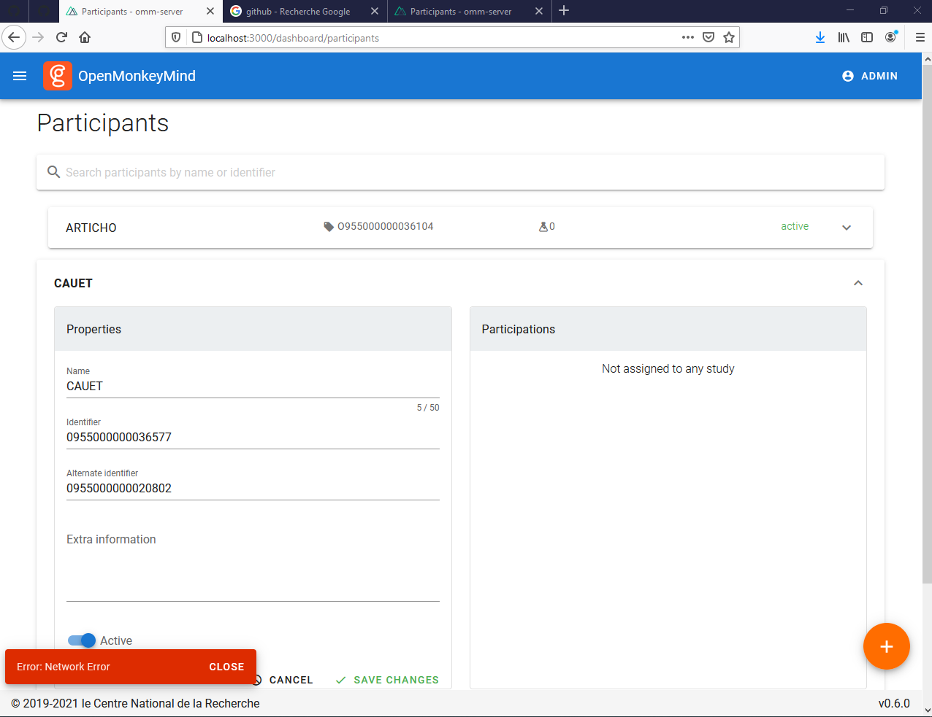

## Impossible to retrieve data

When trying to download data (in any format), an error message appears with “out of sort memory” mentioned.

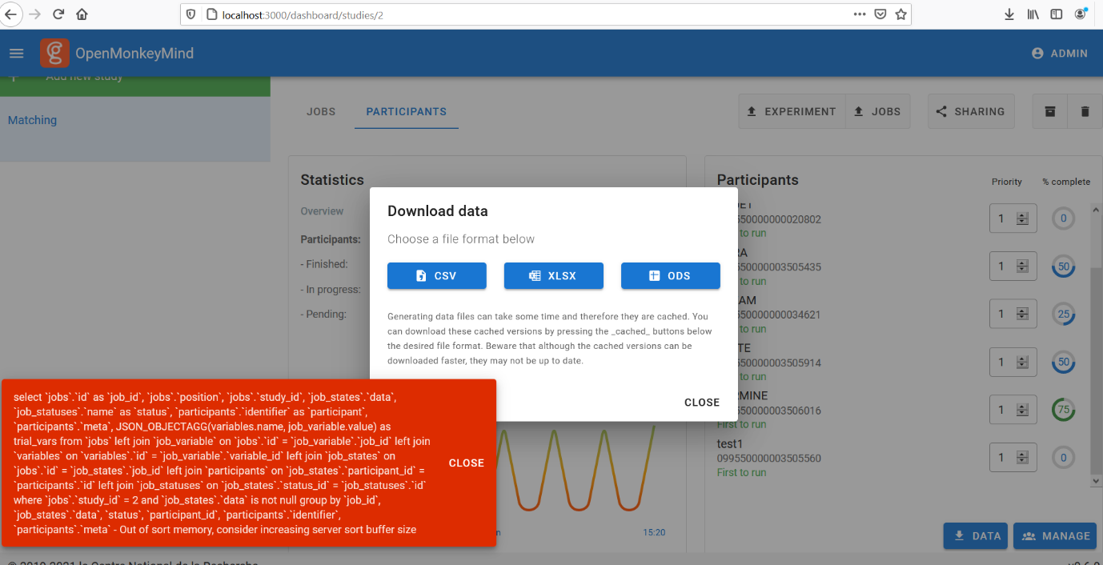

## Fall back experiment

For some reason the fallback experiment works fine locally (installed on both Joel and Nicolas’ laptops) but not on Rousset’s computers????

Fallback is installed:

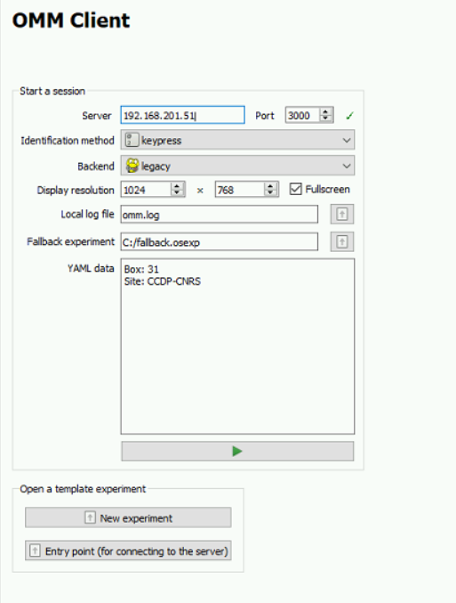

When an experiment is launched we get an error message saying no fallback experiment:

Finally, Fallback experiment does not appear in the entry point:

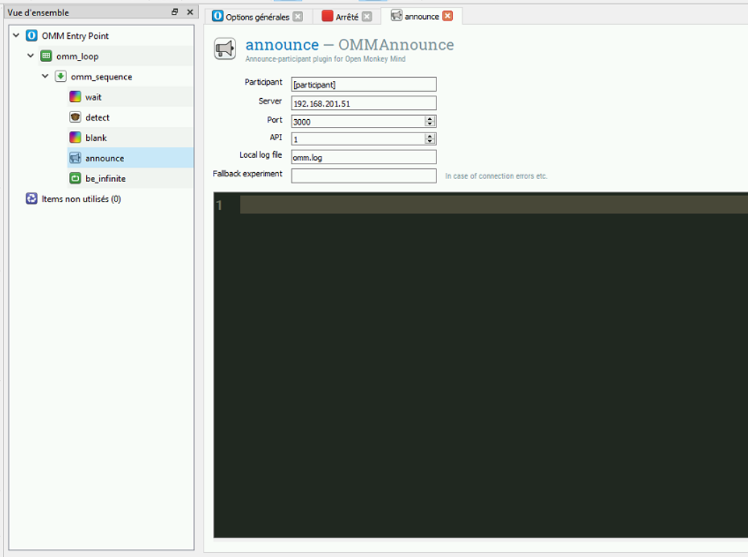

# List of possible improvements

## Dispenser

OMM_conditioner correctly triggers the food dispenser, but it makes five instead of one turn on each command. We suggest adding the number of pulses and duration of the pause as variables that can easily be controlled from the program, would that be possible?

## Identification of participants when client crashes

When the client crashes could it display the name of the participant that caused the problem? (in particular for the NoJobsForParticipant problem).

## When an experiment is running, ID is through RFID but can we use keyboard (ctrl+shift? Or other) to launch a trial?

I thought we would be able to define a “fake” monkey and use keyboard to refer to the monkey while the experiment is running, is that possible? How? This option is important when we control the client from a remote computer (no access to the RFID reader)

## Adding an OMM_block loop item

Because OMM works on a trial basis, the only way to control for the block loop is to add an inline with python commands. That makes the control of the experimental block very difficult to program for users that are both naïve with python and opensesame. Our suggestion is to add an OMM_looping item that optionally sets to pending the status of the jobs at the end of the very last trial of the list. Something equivalent to block_loop window in opensesame

## How to change the entry point?

Changing the entry point is difficult, we had to seek the file in the omm folder and follow the path. Could that be made easier? Or clearly explained in documentation?

## Problem adding description of new study above 100 characters.

Would it be possible to increase that limit? Say 1000? Or more even?

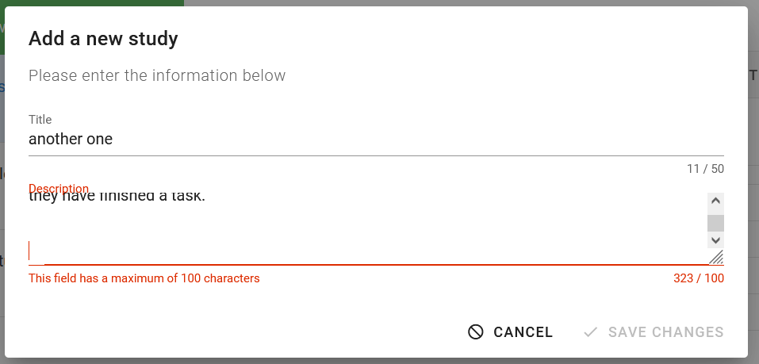

## Priority order for the participants (dashboard).

It currently has a limit of 99 which could be exceeded. Can we increase it to say 1000? And could we please reverse the order so that priority 1 is highest priority?

## Help with database

Daniel mentioned the possibility to interact easily with the DB using certain softwares, could we see that together?