2、There is one CPU and two external devices IO1 and IO2 in a computer system. Now there are three processes P1, P2 and P3 already in the main memory to be executed, the priority is P1>P2>P3. The order and time they use are as following:
P1: IO2(30ms),CPU(10ms),IO1(30ms),CPU(10ms)
P2: IO1(20ms),CPU(20ms),IO2(40ms)
P3: CPU(30ms),IO1(20ms)
Now the three processes run at the same time and the use of resources is preemptive, please answer the following questions:
(1)Calculate the time P1,P2,P3 cost from start to finish.
(2)What is the CPU utilization when three jobs are finishing?
Answer:
(1) P1:IO2(30ms)->CPU(10ms)->IO1(30ms)->CPU(10ms)
30+10+30+10=80ms

P2:IO1(20ms)->CPU(10ms)->wait(10ms)->CPU(10ms)->IO2(40ms)
20+10+10+10+40=90ms

P3:CPU(20ms)->wait(30ms)->CPU(10ms)->wait(10ms)->IO1(20ms)
20+30+10+10+20=90ms

- There exist two processes P₁ and P₂ in a multiprogramming batch system. P₂ enters into the system 10ms later than P₁, and their executing traces, i.e. alternating sequences of CPU bursts and I/O bursts, are as follows:
P₁: computing, 80ms → I/O operation, 100ms → computing, 40ms
P₂: computing, 130ms → I/O operation, 50ms → computing, 50ms
It is assumed that time costs of CPU scheduling and process switch are omitted, what is the maximal throughput for completing these two processes, and why?
Answers：
1. 最大吞吐量 = 2/(80+130+50+50) = 2/310= 1/155 个/ms

2. 当P₁、P₂的CPU计算和I/O操作最大程度并行执行时，2个进程总的执行时间最短，系统吞吐量达到最大，如下图所示；

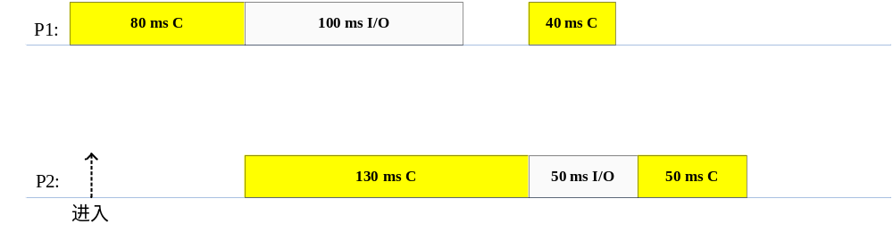

- In a computer system, the users submit to the system their computational tasks as jobs, and all these jobs are then stored as the standby jobs on the disk.

The job scheduler (also known as long-term scheduler) selects the standby jobs on the disk, creates new processes in memory for them, and then starts executing of these processes. Each job’s ID is the same as that of the process created for it, for example, J_{i} and P_{i}.

When the number of concurrent processes in memory is lower than three, the job scheduler takes the FCFS algorithm to select a standby job on the disk to create a new process. Otherwise, the jobs should wait on the disk.

For the processes in memory, the process scheduler (also known as short-term scheduler) takes the non-preemptive priority-based algorithm to select a process and allocates the CPU to it.

It is assumed the system costs resulting from job and process scheduling are omitted.

Consider the following set of Jobs J₁, J₂, J₃ , J₄ and J₅. For 1≤ i ≤5, the arrival time of each J_{i} , the length of the CPU burst time of each process P_{i}, and the priority number for each J_{i}/P_{i} are given as below, and a smaller priority number implies a higher priority.

Job Arrival Time Burst Time Priority Number

(minute)

J₁ 14:00 40 4

J₂ 14:20 30.01 2

J₃ 14:30 50.01 3

J₄ 14:50 20.01 5

J₅ 15:05 10.01 5

- Illustrate the execution of each job/process by charts.
- What is the turnaround time of each job?
- What is the waiting time of each job?

Note: The waiting time of a job includes the time it waits on the disk and that it (as a process) waits in memory.

Answer:

（1）
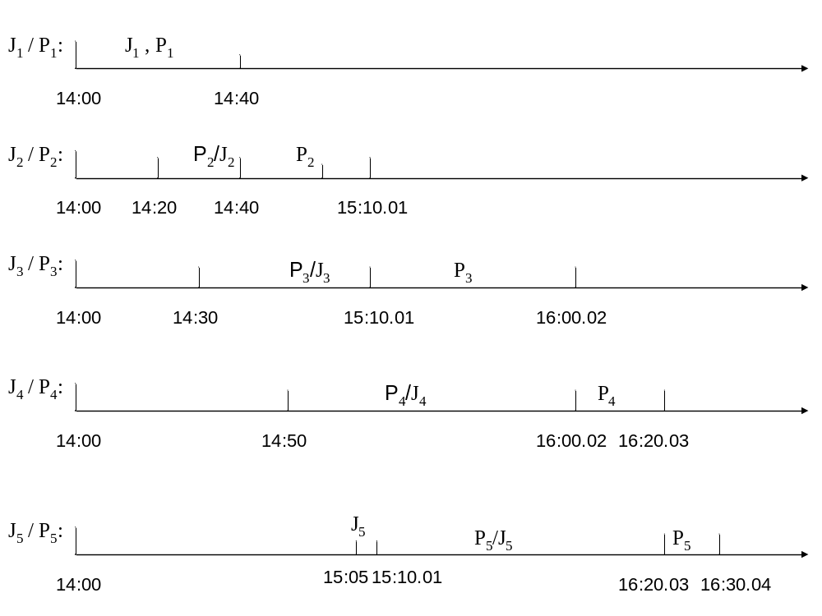
注：图中J_{i}部分表示作业被调入内存，P_{i}表示进程被调度执行。
J₁到达时，内存中并发进程数=0<3，作业被直接调入内存，创建进程P₁；P₁被调度程序选中，开始执行。
在P₁执行过程中，J₂到达，内存中并发进程数=1<3，作业被直接调入内存，创建进程P₂；此时P₁在执行，由于采用非抢占式进程调度，P₂处于就绪等待状态。
在P₁执行过程中，J₃到达，内存中并发进程数=2<3，作业被直接调入内存，创建进程P₃，等待P₂执行完毕。
P₁结束后，作业J₁随之结束，系统内有作业J₂、J₃对对应的进程P₂、P₃。进程调度选择高优先级的P₂开始执行。
P₂执行过程中，J₄到达时，内存中并发进程数=2<3，作业被直接调入内存，创建进程P₄，等待P₂执行完毕。
P₂执行过程中，J₅到达时，内存中并发进程数=3，必须等到P₂结束后，系统内并发进程数<3，方能创建进程P₅。
P₂执行完毕后，系统内有2个作业J₃、J₄对应的进程P₃、P₄，内存中并发进程数=2<3。此时，长期调度程序首先为作业J₅创建进程P₅。然后，进程调度程序从P₃、P₄、P₅中，选择高优先级的P3开始执行。
P₃执行完毕后，系统内有2个作业J₄、J₅对应的进程P₄、P₅，2者的优先级相同，按照FCFS原则，P₄先执行。
P₄执行完毕后，剩余的唯一进程P₅开始执行。

（2）J₁ ：T₁ = 40 （min）
J₂ ：T₂ = 20 + 30.01 = 50.01 （min）
J₃ ：T₃ = 40.01 + 50.01 = 90.02 （min）
J₄ ：T₄ = 70.02 + 20.01 = 90.03 （min）
J₅ ：T₅ = 5.01 + 70.02 + 10.01 = 85.04（min）

（3）J₁ ：W₁ = 0 （min）
J₂ ：W₂ = 20（min）
J₃ ：W₃ = 40.01（min）
J₄ ：W₄ = 70.02（min）
J₅ ：W₅ =75.03（min）

- Considering a real-time system, in which there are 4 real-time processes P₁, P₂, P₃ and P₄ that are aimed to react to 4 critical environmental events e₁, e₂, e₃ and e₄ in time respectively.

The arrival time of each event e_{i} , 1≤ i ≤4, (that is, the arrival time of the process P_{i}), the length of the burst time of each process P_{i}, and the deadline for each event e_{i} are given below. Here, the deadline for e_{i} is defined as the absolute time point before which the process P_{i} must be completed.

The priority for each event e_{i} (also for P_{i}) is also given, and a smaller priority number implies a higher priority.

Events Process Arrival Time Burst Time Priorities Deadline

e₁ P₁ 0.00 4.00 3 7.00

e₂ P₂ 3.00 2.00 1 5.50

e₃ P₃ 4.00 2.00 4 12.01

e₄ P₄ 6.00 4.00 2 11.00

- Suppose that priority-based preemptive scheduling is employed,
  - Draw a Gantt chart illustrating the execution of these processes
  - What are the average waiting time and the average turnaround time
  - Which event will be treated with in time ?
- Suppose that FCFS scheduling is employed,
  - Draw a Gantt chart illustrating the execution of these processes
  - What are the average waiting time and the average turnaround time
  - Which event will be treated with in time, that is, the process reacting to this event will be completed before its deadline?

Answers:

(1) 甘特图如下

P1
P4
P2
P1
P3
0
3
5
6
10
12

平均等待时间=[(5─3) + (3─3) + (10─4) + (6─6)] /4 = 2

平均周转时间=[(6─0) + (5─3) + (12─4) + (10─6)] /4 = 5

根据各进程的完成时间点和所对应的事件的deadline可知，全部４个事件均可得到及时响应．

(2) 甘特图如下

P１
P2
P３
P４
12
8
6
4
0

平均等待时间=[(0─0) + (4─3) + (6─4) + (8─6)] /4 = 1.25

平均周转时间=[(4─0) + (6─3) + (8─4) + (12─6)] /4 = 4.25

根据各进程的完成时间点和所对应的事件的deadline可知，事件e1和e3可得到及时响应．

- As illustrated in the figure, on the two sides of a one-plank bridge(独木桥), there are two groups of soldiers that are composed of m and n people respectively and need to cross the bridge, but the narrow bridge allows only one group of the soldiers in the same direction to cross at the same time. One group of the soldiers is permitted to cross as long as there are no people on the bridge. Once one group of the soldiers begins walking on the bridge, the other group should be waiting to start crossing until all members of the first group have passed the bridge.
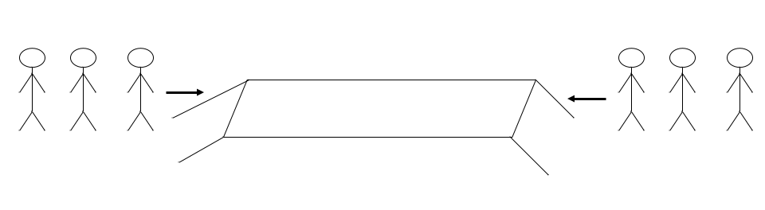
Please design two semaphore-based processes to describe the crossing actions of the soldiers in the two groups. It is required
(1) to define the semaphores and variables needed, explain their roles?, and give their initial values; and
(2) to illustrate the structures of processes for the soldiers in each group.

Answers:
该问题可归结为读写者问题，但2队士兵均为读者。

（1）定义2个整型变量count1、count2，分别用于计数每组士兵过桥人数。
定义2个二元信号量mutex1、mutex2，用于控制对count1、count2的互斥访问。
定义二元信号量bridge，用于2队士兵间的互斥。
初始化：
count1=0，count2=0；
mutex1=1、mutex2=1；
bridge=1；

（2）
P1()
{
wait(mutex1);
count1 ++;
if count1 = =1
wait(bridge); // 该组第1个士兵过桥时，阻塞另一组过桥
signal(mutex1);
….…
crossing the bridge;
……
wait(mutex1);
count1 --;
if count1 = =0
signal(bridge); // 该组最后1个士兵过桥后，允许另一组过桥
signal(mutex1);
}.

P2()
{
wait(mutex2);
count2 ++;
if count2 = =1
wait(bridge); // 该组第1个士兵过桥时，阻塞另一组过桥
signal(mutex2);
….…
crossing the bridge;
……
wait(mutex2);
count2 --;
if count2 = =0
signal(bridge); // 该组最后1个士兵过桥后，允许另一组过桥
signal(mutex2);
}.

- Consider the bounded-buffer (also known as producer-consumer problem). There are several producer processes and consumer processes, and these processes share a pool of buffer. The pool of buffer consists of n buffers, and each buffer can hold only one item. The producer process produces one item and puts it into an empty buffer in the pool. The consumer process takes one item from a full buffer in the pool and consumes this item.
At each moment, at most one producer process and at most one consumer process are permitted to simultaneously operate on the buffer pool, i.e.,
- one producer process is permitted to access the buffer lonely
- one consumer process is permitted to access the buffer lonely
- if two or more processes want to access the buffer simultaneously,
  - two or more producer processes are not permitted to simultaneously operate on the buffer, they should access the buffer mutual exclusively
  - two or more consumer processes are also not permitted to simultaneously operate on the buffer, they should access the buffer mutual exclusively
  - only one producer process and one consumer process are allowed to simultaneously operate on different items in the buffer
Write an algorithm to synchronize producer processes and consumer processes by using semaphores.

Answer1:
- Principles:
define the semaphores empty and full to count the number of empty buffers and full buffers in the pool, respectively;
define binary semaphore mutex1 to control all producers to access the empty buffers in the pool mutual exclusively;
define binary semaphore mutex2 to control all consumers to access the full buffers in the pool mutual exclusively;
- Algorithm
Semaphores empty, full
Binary semaphores mutex1, mutex2
Initially,
empty:= n; full:=0; mutex1:=1; mutex2:=2;

The structure of the producer process is as follows:
do { …

produce an item in nextp
…

wait(empty);
wait(mutex1);
search for an empty buffer
…
add nextp to the empty buffer
…

signal(mutex1);
signal(full);
} while (1);

The structure of the consumer process is as follows:
do { …

wait(full);
wait(mutex2);
search for an full buffer
…
remove item in buffer[j] to next ;
….
signal(mutex2);
signal(empty);
…
consume the item in nextc
…
} while (1);

Answer2:
Semaphores empty, full;
Binary semaphores mutex1, mutex2, mutex;
Array Flag[n]; /* Flag[i] =0 indicates that buffer[i] is empty,
Flag[i] =1 indicates that buffer[i] is full, 0≤ i ≤n-1; */
Initially,
empty:= n; full:=0; mutex1:=1; mutex2:=1; mutex=1;
Flag[i] =0, 0 ≤ i ≤n-1;

The structure of the producer process is as follows:
do { …

produce an item in nextp
…

wait(empty);
wait(mutex1);

wait(mutex);
search on array Flag for an empty buffer[i], where Flag[i] =0;
signal(mutex);
…
add nextp to the empty buffer[i];

wait(mutex);
Flag[i] : = 1;
signal(mutex);

signal(mutex1);
signal(full);
…
} while (1);

The structure of the consumer process is as follows:
do { …

wait(full);
wait(mutex2);

wait(mutex);
search on array Flag for an full buffer[j], where Flag[j] =1;
signal(mutex);
…
remove item in buffer[j] to next ;

wait(mutex);
Flag[j] : = 0;
signal(mutex);

signal(mutex2);
signal(empty);
…
consume the item in nextc
…
} while (1);

- Here are three workers W₁, W₂ and W₃. W₁ and W₂ are responsible for producing the part(零件) P₁ and part P₂ respectively, and W₃ takes charge of assembling (装配) the part P₃.

W₁ produces one P₁ and then puts it into the cargo tank(货箱) T₁; W₂ manufactures one P₂ and then puts it into the cargo tank T₂. W₃ takes P₁ from T₁ and P₂ from T₂, and then assembles P₁ and P₂ into P₃.

It is assumed that (1) T₁ can hold 8 parts of P₁, and T₂ can hold 10 parts of P₂, and they are all initially empty; (2) each time W₃ can takes only one part of P₁ from T₁ and one part of P₂ from T₂, and then assembles one part of P₃; (3) T₁ and T₂ are permitted only to be taken or put in the mutually exclusive mode, that is, at any time only one worker are allowed to operate on T₁ or T₂.
Please design three semaphore-based programs for W₁, W₂ and W₃, to describe their production activities. It is required
(1) to define the semaphores for synchronizing the three processes, explain the role of each semaphore, and give their initial values; and
(2) to illustrate the structures of processes for W₁, W₂ and W₃.

Answers:
(1)
信号量定义：
Binary semaphore mutex1, mutex2
Semaphore empty1, full1, empty2, full2
信号量含义：
mutex1用于控制W₁和W₂对T1的互斥访问，mutex2用于控制W₁和W3对T₂的互斥访问；
empty1和empty2分别表示T₁和T₂中的空闲容量，full1和full2分别表示T₁和T₂中已经被占用的容量。
信号量初值：
mutex1=1; mutex2=1;
empty1=8; empty2=10;
full1=0; full2=0;

（2）
W₁：
Produce one P₁ ;
Wait(empty1);
Wait(mutex1);
Puts it into T₁,
Signal(mutex1);
Signal(full1);

W₂：
Produce one P₂ ;
Wait(empty2);
Wait(mutex2);
Puts it into T₂,
Signal(mutex2);
Signal(full2);

W₃：
Wait(full1);
Wait(mutex1);
takes one P₁ from T₁;
Signal(mutex1);
Signal(empty1);

Wait(full2);
Wait(mutex2);
takes one P₂ from T₂;
Signal(mutex2);
Signal(empty2);

Assembles P₁ and P₂ into P₃.

- 某系统有n台互斥使用的同类设备，3个并发进程分别需要使用2、3、4台设备，设备数目N最大为多少，系统还可能发生死锁？
答案：
资源/设备总实例数N = 进程资源需求总数L — 进程总数m*1
N= (2+3+4) — 3*1
= 6

