- (5 points)There exist two processes P₁ and P₂ in a multiprogramming batch system. P₂ enters into the system 10ms later than P₁, and their executing traces, i.e. alternating sequences of CPU bursts and I/O bursts, are as follows:
P₁: computing, 80ms → I/O operation, 100ms → computing, 40ms
P₂: computing, 130ms → I/O operation, 50ms → computing, 50ms
It is assumed that time costs of CPU scheduling and process switch are omitted, what is the maximal throughput for completing these two processes, and why?
Answers：
1. 最大吞吐量 = 2/(80+130+50+50) = 2/310= 1/155 个/ms (3 points)

2. 当P₁、P₂的CPU计算和I/O操作最大程度并行执行时，2个进程总的执行时间最短，系统吞吐量达到最大，如下图所示；（2 points）

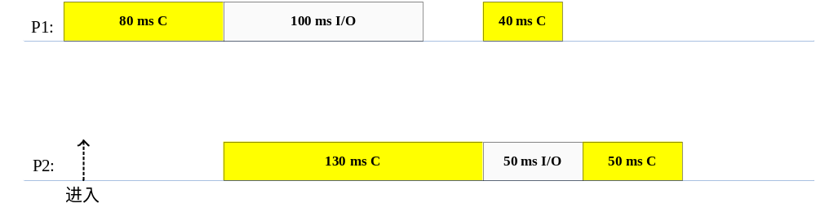

- In a computer system, the users submit to the system their computational tasks as jobs, and all these jobs are then stored as the standby jobs on the disk.

The job scheduler (also known as long-term scheduler) selects the standby jobs on the disk, creates new processes in memory for them, and then starts executing of these processes. Each job’s ID is the same as that of the process created for it, for example, J_{i} and P_{i}.

When the number of concurrent processes in memory is lower than three, the job scheduler takes the FCFS algorithm to select a standby job on the disk to create a new process. Otherwise, the jobs should wait on the disk.

For the processes in memory, the process scheduler (also known as short-term scheduler) takes the non-preemptive priority-based algorithm to select a process and allocates the CPU to it.

It is assumed the system costs resulting from job and process scheduling are omitted.

Consider the following set of Jobs J₁, J₂, J₃ , J₄ and J₅. For 1≤ i ≤5, the arrival time of each J_{i} , the length of the CPU burst time of each process P_{i}, and the priority number for each J_{i}/P_{i} are given as below, and a smaller priority number implies a higher priority.

Job Arrival Time Burst Time Priority Number

(minute)

J₁ 14:00 40 4

J₂ 14:20 30.01 2

J₃ 14:30 50.01 3

J₄ 14:50 20.01 5

J₅ 15:05 10.01 5

- Illustrate the execution of each job/process by charts.
- What is the turnaround time of each job?
- What is the waiting time of each job?

Note: The waiting time of a job includes the time it waits on the disk and that it (as a process) waits in memory.

Answer:

（1）
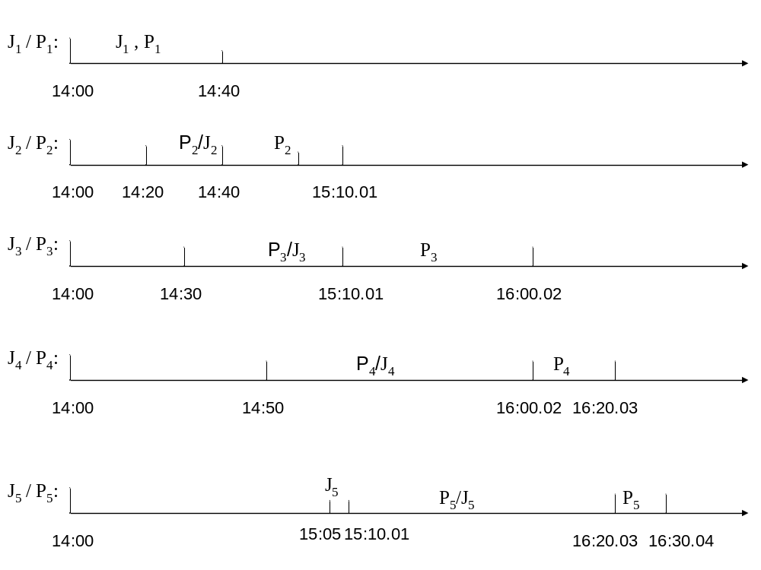
注：图中J_{i}部分表示作业被调入内存，P_{i}表示进程被调度执行。
J₁到达时，内存中并发进程数=0<3，作业被直接调入内存，创建进程P₁；P₁被调度程序选中，开始执行。
在P₁执行过程中，J₂到达，内存中并发进程数=1<3，作业被直接调入内存，创建进程P₂；此时P₁在执行，由于采用非抢占式进程调度，P₂处于就绪等待状态。
在P₁执行过程中，J₃到达，内存中并发进程数=2<3，作业被直接调入内存，创建进程P₃，等待P₂执行完毕。
P₁结束后，作业J₁随之结束，系统内有作业J₂、J₃对对应的进程P₂、P₃。进程调度选择高优先级的P₂开始执行。
P₂执行过程中，J₄到达时，内存中并发进程数=2<3，作业被直接调入内存，创建进程P₄，等待P₂执行完毕。
P₂执行过程中，J₅到达时，内存中并发进程数=3，必须等到P₂结束后，系统内并发进程数<3，方能创建进程P₅。
P₂执行完毕后，系统内有2个作业J₃、J₄对应的进程P₃、P₄，内存中并发进程数=2<3。此时，长期调度程序首先为作业J₅创建进程P₅。然后，进程调度程序从P₃、P₄、P₅中，选择高优先级的P3开始执行。
P₃执行完毕后，系统内有2个作业J₄、J₅对应的进程P₄、P₅，2者的优先级相同，按照FCFS原则，P₄先执行。
P₄执行完毕后，剩余的唯一进程P₅开始执行。

（2）J₁ ：T₁ = 40 （min）
J₂ ：T₂ = 20 + 30.01 = 50.01 （min）
J₃ ：T₃ = 40.01 + 50.01 = 90.02 （min）
J₄ ：T₄ = 70.02 + 20.01 = 90.03 （min）
J₅ ：T₅ = 5.01 + 70.02 + 10.01 = 85.04（min）

（3）J₁ ：W₁ = 0 （min）
J₂ ：W₂ = 20（min）
J₃ ：W₃ = 40.01（min）
J₄ ：W₄ = 70.02（min）
J₅ ：W₅ =75.03（min）

