To do for the publication: Figures

Late is good as is.

Make sure Sham is always to the left when comparing to OVX. Controls always go to the left.

FIGURE 1

One graph of ONLY age for the wild type.

Two figures, one for just the late showing age on the x and just for sham

One for just the reversal day 5 for just the sham.

FIGURE 2. The figure that was in Figure 6 of the poster is fine.,

FIGURE 3. Compare the Sham and OVX (don’t bother with the Escape Strategies).

Color scheme. Black for control and maroon for OVX.

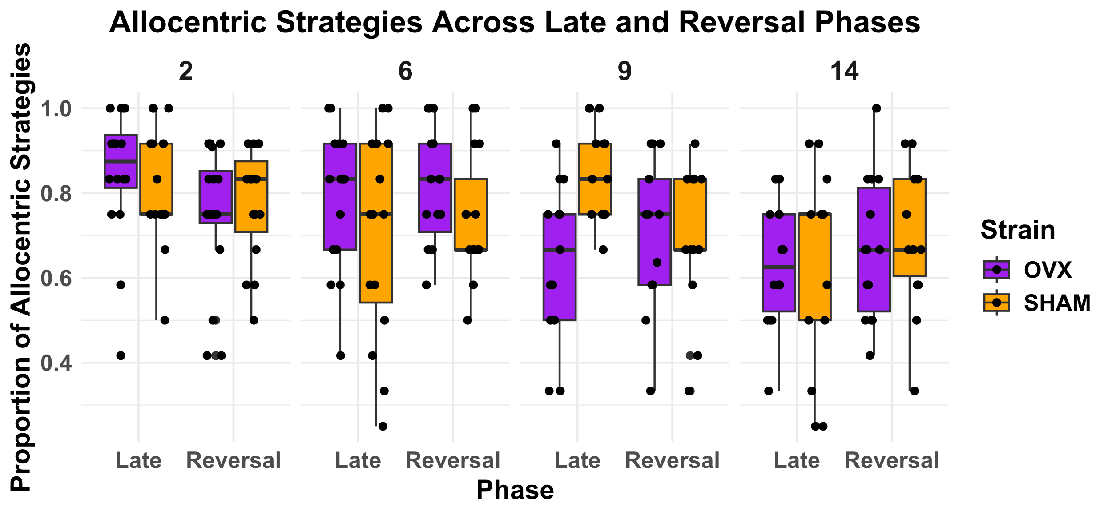

We can repeat – this is the same information. The above lumps all of the Allocentric together, and that is fine.

Redo all figures but for the REVERSAL only, just look at day 5, not lump together days 5,6

Double checked- animals that timed out were set to 60 seconds. Confirmed.

PROBE

FIGURE 4

Probe trial data? Might be missing 2mo, but we may indeed have it for other groups.

Figure: start with the head map – for just 2 individual – one for the OVX and one for sham on the reversal. And then the mean heat graph for all of the animals. This is something like day 7.

To assess first though lets generate these heat maps for ALL age groups. In the end we my just choose a subset for plotting.

Test if they are hovering where they recall the platform being.

Time spent in quadrant just on the probe trials – and just after day 6 as that is when the probe trial is given – this tells us how long the reversal is maintained and sustained after. - Proportional time in quadrant or number of times the platform was crossed – but with some control – the heatmaps really tell this – so that would be

1. Proportion of time in target quadrant
2. Something like the number of times the virtual platform was crossed. (see Garthe 2014 paper (fig below for idea) paper that has this information)

An example Tif is attached.

According to Prism GraphPad the color info is:

Hue 221

Sat 228

Lum 77

Red 159

Green 4

Blue 77

Let me know if there’s a different way I can extract color info for you?

Best,

Mandi