**Front Camera (Super Fast) Configuration Settings**

Configuration settings for both Streampix and MATLAB Image Acquisition

* We are switching software to Norpix/StreamPix Lite – MATLAB consistently crashes after ~20 minutes
* In MATLAB and Streampix output is LINE 3 (not Line 0). This is Line Selector in the Streampix config system seen itemized below.

**Streampix Vimba Settings**

* **ROI**
  + Width: 600
  + Height: 800
  + *uncheck Broadcast and Center ROI
* **Adjustments** – depends on the lighting, but these settings should give you ~360 FPS
  + Exposure: ~.1
  + Gain: ~7.5
  + Frame Rate: ~360
  + Gamma: ~.9
* **Settings** 
  + Image Format: Mono 8
  + Trigger Mode: Off
  + Trigger Source: **Line 3 (‘Software’ in MATLAB)**
  + Trigger Activation: Rising Edge
  + Acquisition Frame Rate Mode: Basic **(‘Off’ in MATLAB)**
  + Trigger Selector: Frame Start
  + Line Inverter: False
  + **Line Selector: Line 3**
  + Line Source: Exposure Active
  + Meta Data Mode: Off
  + DSP Subregion: Off

**MATLAB Image Acquisition Settings**

* Gain = 10
* Gamma = 1
* Exposure: this may depend – 2.5ms
* Continuous
* Output on Active Frame or Active Exposure.

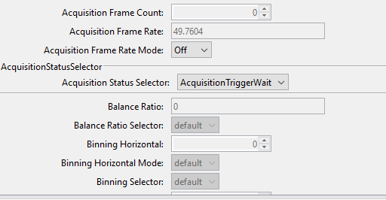

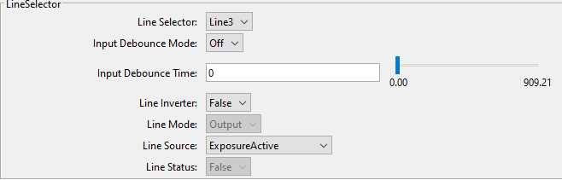

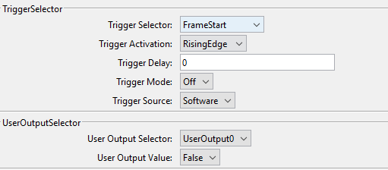

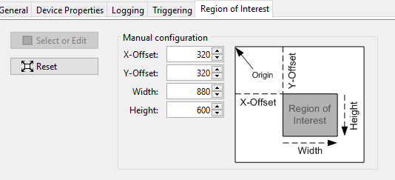

# Connecting the camera to the neural recording system

The Matlab Image Acquisition Toolbox Graphical User Interface (GUI) and a second circuit were used to configure the camera to send a TTL pulse to the Intan data acquisition system (Intan Technologies, Los Angeles, California, United States) every time a frame was exposed. This allowed the timing of each frame to be aligned with the recorded neural activity. This circuit consisted of an open collector trigger from the camera and a pull up resistor to process the signal for triggering the Intan system. After collection, video information was processed by DeepLabCut (Mathis et al., 2018) and custom Matlab code (github.com/GiaJordan/Behavior_Quantification).

NOTE: Open collector means no voltage goes out – do you need a **pullUP** resistor? According to <https://en.wikipedia.org/wiki/Open_collector> this is true ( I was mistakenly using a pulldown resistor)

Looks like the pullup can be in the range of 3KOhm to 6KOhm.