* 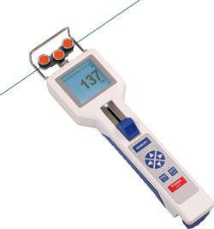Integrated tensiometer that does not add much string resistance. Wire resistance design.
  + <https://www.futek.com/applications/Wire-Tension-Meter>
  + <https://www.futek.com/applications/Wire-Tension-Measurement>
  + DTS Hand-Held Digital Tension Meter
* Capacity for 2 strings side-by-side.
* 2 levers also to the side.
* Food port integrated. Solenoid.
* Laser sensors for approach and food port.
* Integrated tracking with camera.
* Arduino or pico?
* Clear TTLs for sync with neural data.
* Integration with 28V Med Associates system.- I want an independent interface that connects med associates levers to any Arduino—just send out 5V pulses to extend/retract and just get 5V pulses (isolated) for when a lever is pressed. General purpose and will plug into any med associates lever system – one per lever – nothing complicated. Maybe smaller isolators? Noise Free.
* Simple laser-cut holder for string. All designs in Fusion 360.
* Simple and documented code.
* Ultimately – would like 3 such systems.

Other

* A way to incorporate a ‘ratchet’ so that the string only turns in one direction to train a novel movement direction.
* A way to angle the string?