Henry Hong

CSS 337 Secure Systems

Assignment 2

**One Time Password Generation and Authentication**

**Screen caps:**

Check 1st password:

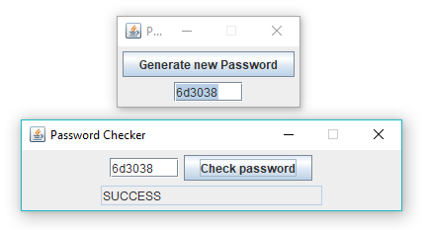

Generate 2nd password, and validate:

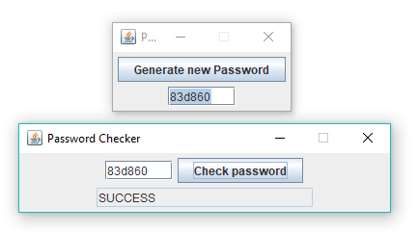

Check incorrect password:

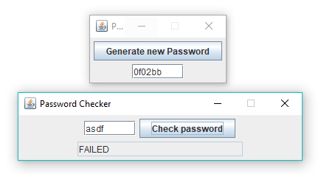

Check Desynchronized password that is valid (within 100 hashes of current OTP)

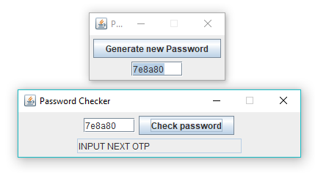

Confirm valid, and resynchronize

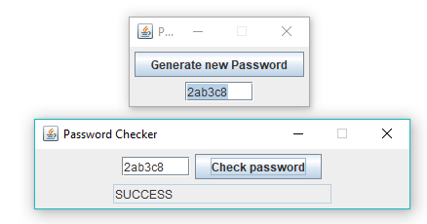

# collisions:

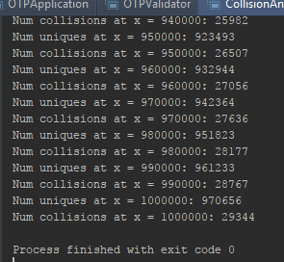

**Collision Analysis:**

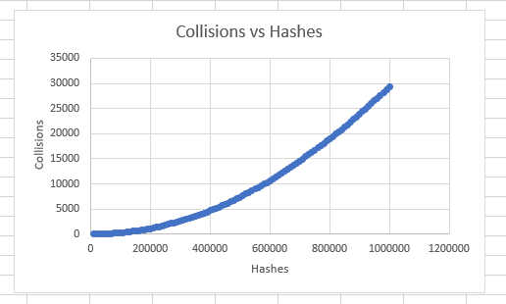

As the number of hashes increase, the # of collisions increase at what looks to be a rate of logn. After one million Hashes, there were only 29,344 collisions.

If this application were to be used in a very limited setting, there would not be an issue with collisions. However, if the application were used in a setting where many hashes are made, the number of collisions would increase up to the point where theoretically all possible hashes have been made, and every new hash is a collision with a previous hash. Practically speaking though, this would take a long time, and a lot of space.