Work-Case №1

Terms:

04.02.2022

**Team members:**

1.Ilya Afanasiev(Technical support)

2.Andrey Filipenko(Research and Content support)

3.Misha Kraschenko(Reporter)

**Tasks:**

1) Describe what git is used for, what are the main actions and commands in it

perform.

2) Register your own git account (gitlab, github or other platform).

3) Create a new public repository to use for

adding all completed work in the discipline "Operating Systems" (if

work in a team, invite other team members in its editors).

4) Post your first Work-Case №1 report (presentation, text file, html-page) in this repository.

**Used resources:**

1)Word by Microsoft

2) github.com

**Work progress**

(Andrey)**Task №1:**

GitHub is a code hosting platform for version control and collaboration. It lets you and others work together on projects from anywhere.

Basic commands on Github:

**1. Git clone**

Git clone is a command for downloading existing source code from a remote repository (like Github, for example).

## 2. Git branch

Branches are highly important in the git world. By using branches, several developers are able to work in parallel on the same project simultaneously.

## 3. Git checkout

This is also one of the most used Git commands. To work in a branch, first you need to switch to it. We use **git checkout** mostly for switching from one branch to another. We can also use it for checking out files and commits.

## 4. Git status

The Git status command gives us all the necessary information about the current branch.

## 5. Git add

When we create, modify or delete a file, these changes will happen in our local and won't be included in the next commit (unless we change the configurations).

## 6. Git commit

This is maybe the most-used command of Git. Once we reach a certain point in development, we want to save our changes (maybe after a specific task or issue).

## 7. Git push

After committing your changes, the next thing you want to do is send your changes to the remote server. Git push uploads your commits to the remote repository.

## 8. Git pull

The **git pull**command is used to get updates from the remote repo.

## 9. Git revert

Sometimes we need to undo the changes that we've made. There are various ways to undo our changes locally or remotely (depends on what we need), but we must carefully use these commands to avoid unwanted deletions.

## 10. Git merge

When you've completed development in your branch and everything works fine, the final step is merging the branch with the parent branch (dev or master).

(All)**Task №2:**

We registered our accounts on Github:

@xxxKoRoBoKxxx (Andrey)

@Coxaini (Ilya)

@

(Ilya)**Task №3:**

I created a new public repository and added members of our team. Then I created folder for work-cases.

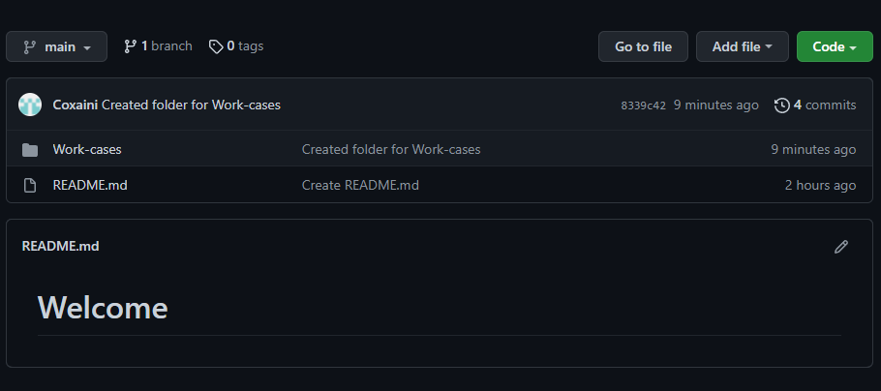

«<https://github.com/Coxaini/Operating-System> – repository»

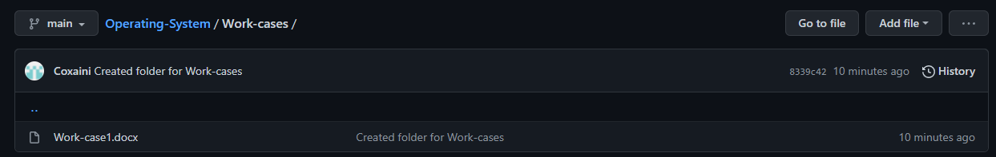

«<https://github.com/Coxaini/Operating-System/tree/main/Work-cases> - folder for workcases»

(Andrey)**Task №4:**

I posted final version of this file in our public repository.