Analytical report:

Monitoring citations to EIGE from academia (October-December 2024)

**Prepared for**: EIGE

**Reference**: FWC EIGE/2024/OPER/03 Lot 2

**Date**: 12 February 2025



Contents

**1.** **Summary 4**

**2.** **Introduction 5**

**2.1.** Objectives 5

**2.2.** Methodology 5

**2.3.** Report structure 6

2.4. Report web application 6

**3.** **Analysis 7**

3.1. Number of mentions 7

**3.2.** EIGE’s outputs cited 8

**3.3.** Documents citing EIGE 10

**3.4.** Impact evaluation of documents citing EIGE 11

3.5. Impact ranking 12

**4.** **Annex 1 – Quarterly report 14**

# Summary

On 24 September 2024, EIGE contracted Blomeyer & Sanz, in partnership with Policy Impact Lab, to conduct periodic impact monitoring reports and their analysis corresponding to the period 2024. The Terms of Reference (ToR) refer to a general objective and to five specific objectives:

* *General: To allow EIGE to better comprehend stakeholders’ use of EIGE data, evidence and outputs and thereby to produce more targeted outputs which fit better the needs of its stakeholders’. enable EIGE produce outputs which are used by its intended stakeholders.*
* *Specific: to provide EIGE with information on (1) which EIGE outputs are cited in academia; (2) what are the main articles citing EIGE’s outputs; (2) what are the main research fields (topics) where citations to EIGE are found; (4) what is the importance of the citations identified; and (5) what is the trend observed in the citations to EIGE.*

This analytical report presents the **main findings** regarding the data on academia citing EIGE’s outputs during the period **October to December 2024**. The analytical report includes a statistical overview of the recorded references.

During the monitoring period (Q4 2024) the monitoring team has identified **22 citations to EIGE** from fourteen documents. All the documents are **articles**.

All the citations have been published in **thirteen different** **journals**. Most articles include **one citation to EIGE** (except for one article with eight citations, and another article with two citations).

Regarding the authors of the articles citing EIGE, we have identified 42 different authors that belong to 20 different research centers (all being **EU based universities**, except for one Canadian, and one Turkish institution). University of Antwerpen cited 8 different EIGE tools. **October** is the month with the **highest number of publications** (10).

The collected data allow for a (partial) **qualitative monitoring** of the citations. Compared to Q3, the number of citations of EIGE has almost doubled.

The impact factor of the publishing journals for Q3 was published for approximately half of the documents. Four publications were published in journals with very strong impact, three publications were published in journals with strong impact, and one publications was published in a respectable journal.

**Most of the citations (12) are included on the main body of the article. All** the citations to EIGE are considered to be **positive.** Finally, using ‘Altmetric’ it appears that most of the references to the documents citing EGIE’s outputs in **social media** were made in X (former Twitter), there were also some mentions on Bluesky and Mendeley.

# Introduction

This section introduces the report by briefly commenting on the objectives (Section 2.1), the methodology (2.2) and the structure of this report (2.3).

## Objectives

The monitoring team will provide two types of deliverables:

**Quarterly monitoring reports**

The quarterly monitoring reports record all citations to EIGE and EIGE’s outputs from academia. The reports present the following information:

* Date of publication of the document citing EIGE;
* Name of the document citing EIGE;
* URL of the document citing EIGE;
* Name of the author/organisation citing EIGE;
* Name of the institutions where the authors work:
* Name of the journal citing EIGE;
* EIGE’s output cited;
* Type of EIGE’s output cited
* Year of publication of EIGE’s output cited;
* Topic.

The quarterly data are recorded on an Excel spreadsheet and presented as an annex to this report.

**Analytical reports**

The analytical report includes the main findings and trends for the monitoring period October-December 2024.

## Methodology

The report is based on the methodology agreed with EIGE on 12 December 2024. However, during the collection of data for the first quarterly report, we have identified several **caveats** (see point 8 below) that need to be taken into consideration for the current monitoring and analysis

For the monthly reports, we have monitored the keyword “European Institute for Gender Equality” using the tool **Scite** and double checking the results using the tool Google Scholar.

We will only search for results in **English**.

To enable a more accurate list of results, we will search for the term **using “…”**. Not using “…” produces an extremely high number of wrong and partial results. We propose not to search for the term “EIGE” as the search leads to numerous false results (such as EIG, or the German term ‘eigen’).

For the analytical report, we have produced graphs and trends only based on the data collected for the current quarter (Q4).

**Caveats**:

* Using the agreed search tools (Scite, Google Scholar) it is not possible to identify the documents by the exact **date** (only by year).
* Using the agreed search tools, it is not possible to access and read all the documents. Therefore, it is not always possible to identify the precise EIGE’s **output** that the document is referring to.
* For the same reason mentioned above, it is not possible to access all documents and therefore to identify the main **topics** where citations to EIGE are found.
* Being the third monitoring done for 2024, **trend** in citations to EIGE is rather limited.

## Report structure

The report is organised in two main sections and three annexes, namely:

* This Introduction (section 2), including detail on the objectives, methodology and report structure.
* The Analysis (section 3), presenting the analysis of the quarterly reports.
* Annex 1 presents the Excel file that contains all the citations (October-December 2024).

## Report web application

In addition to the text version, the report is also available as a web application. The application is written using Python and is hosted on the Streamlit platform. In the web application, users can access all previous quarterly reports, interact with some of the visualisations, and download the report data. Additionally, the app version is mobile-friendly and can be viewed from both a personal computer and a smartphone. The web application is available at <https://citation-monitoring.streamlit.app/>.

# Analysis

This section presents the findings and analysis of the quarterly reports (October-December 2024).

The presentation is organised as follows:

* Number of mentions to EIGE (3.1);
* EIGE’s output that has been referenced (3.2);
* Documents that have referenced EIGE (3.3).

## Number of mentions

***In general, the number of mentions to EIGE (22) by academia in Q4 seems to be higher than in previous quarters Q2 (17), Q3 (12).***

***The 22 citations identified correspond to fourteen different articles, including one article with eight, and one article with two citations to EIGE.***

***Figure 1. Number of EIGE citations per article, October-December, 2024***

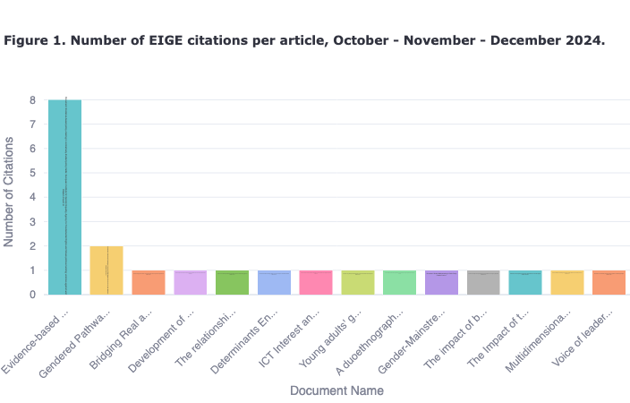

## EIGE’s outputs cited

***The academic articles identified refer to eight different EIGE’s outputs (reports, factsheet, thesaurus, web sections (index, BPfA, GM, and GBV), gender statistics database, and general reference to EIGE). It is impossible to determine the most frequently used output in Q4 due to the limited access. However, the second most cited type of output in Q4 is a report (4).***

***When compared to the previous monitoring period (Q3) it is worth noting that a wider variety of EIGE outputs was cited.***

***Figure 2. Trends of EIGE’s output cited, October-December, 2024***

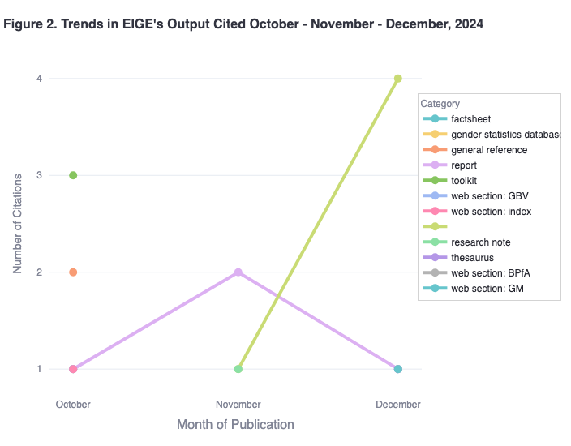

### Monthly data

The following figures present the types of EIGE output mentioned in the period October-December 2024. The yellow bar represents the articles the monitoring team was not able to access fully.

**Figure 3. Type of EIGE’s output cited, October-December 2024**

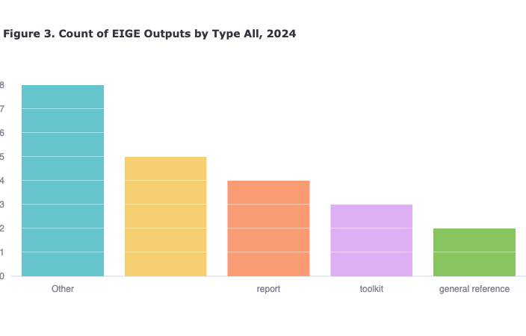

The sunburst chart in Figure 4 breaks down each output category into specific outputs. The interactive version of this chart is available at <https://citation-monitoring.streamlit.app/Q4_2024_Report>.

**Figure 4. Breakdown of EIGE’s output cited, October - December 2024**

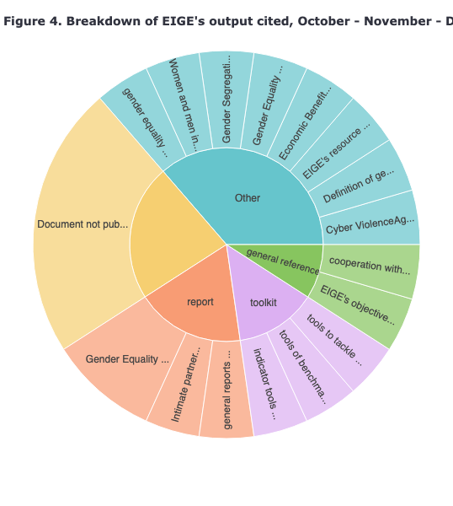

## Documents citing EIGE

Due to the nature of the academic publications monitored, it is not surprising to find that this type of documents are all research articles (except for one report on the OSF Platform, and one reference entry in an encyclopaedia). For Q4 we have not identified any books or monographs.

**Figure 5. Academic publications and journals citing EIGE, October-December 2024**

| **Document Citing EIGE** | **Journal Citing EIGE** | **Institution Citing EIGE** |
| --- | --- | --- |
| Determinants Encouraging Tourists to Use Public Transport in Their Vacation Destination | International Journal of Tourism Research | Munich University of Applied Sciences, University of Salento, University of Innsbruck, University of Bolzano |
| Bridging Real and Virtual: An Ecological Approach toPrevent Cyberviolence Against Women | Journal of Community and Applied Social Psychology | University of Modena and Reggio Emilia, University of Napoli Federico II, University of Foggia |
| Evidence-based policy-making in normatively divided policy fields: European Institute for Gender Equality, Agency for Fundamental Rights and Slovak policies tackling violence against women | European Journal of Politics and Gender | University of Antwerpen |
| Development of an Index to Evaluate Children’s Risk for Being Instrumentalized in Intimate Partner Violence against Women Contexts | The European Journal of Psychology Applied to Legal Contex | University of Jaén |
| The relationship between feminist collective action and social media engagement | Journal of Social Marketing | Ankara University |
| Young adults' gendered trajectories of routine housework time when leaving home | Journal of Marriage and Family | University of Bamberg |
| Gendered Pathways: How do STEM Majors Fare in the Labor Market? | OSF platform | Stockholm University, Institut National d’Études Démographiques, Åbo Akademi University |
| A duoethnography: female academics’ experiences of gendered health issues at the intersection of middlescence, ethnic origin, social and professional status in the neoliberal academy | Journal of Organizational Ethnography | Anglia Ruskin University |
| Gender-Mainstreaming in Public Policy | Encyclopedia of Public Policy. Springer | Concordia University of Montreal |
| The impact of board gender diversity on ESG disclosure. A contingency perspective | Meditari Accountancy Research | University of Insubria, University of Pavese |
| The Impact of the Covid-19 Pandemic on Human Rights | Logos Verlag Berlin | Frederick University |
| Multidimensional domestic gender inequality and the global diffusion of women’s ministries, 1975–2015 | International Journal of Comparative Sociology | University Carlos III Madrid |

The academic publications have been prepared by 42 different authors in thirteen different journals.

With the exception of one research institution in Canada, Turkey, and the UK, all the authors belong to different EU universities in Sweden, Finland, Belgium, Germany (2), Austria, Spain (2), Italy (4), and Cyprus.

The following map shows the location of the institutions that cite EIGE’s outputs.

**Figure 6. Location of institutions that cited EIGE, October-December 2024**

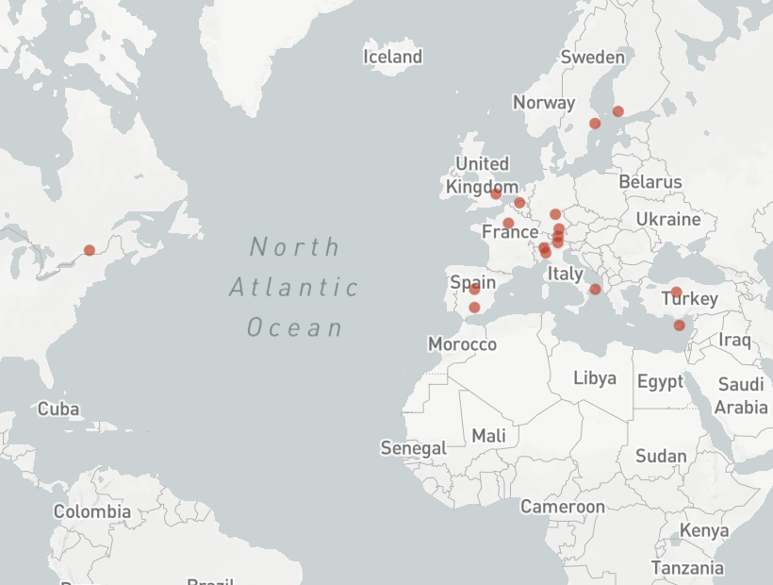

## Impact evaluation of documents citing EIGE

In addition to quantitative analysis of EIGE citation monitoring, quarterly and yearly reports also include a qualitative analysis that aims to assess the importance and impact of citations. Impact evaluation consists of four principal metrics: number of citations of a particular article, impact factor of a journal an article is published in, and sentiment of the citation, and location of the citation in an article.

The following figure shows the impact evaluation of articles citing EIGE, for Q4 2024.

**Figure 7. Impact evaluation of articles citing EIGE, October-December 2024**

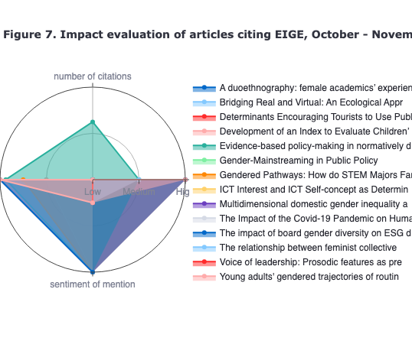

Overall, the sentiment of all citations in Q4 2024 was evaluated as positive. Furthermore, the majority of citations (12) were located in the body of the article, rather than just in the abstract.

For Q4, the impact factor of the journals that include citations to EIGE was generally stronger than in previous quarters, with 4 mentions being published in journals with very strong impact factor, and 9 mentions unpublished in journals with strong impact factor. However, it was not possible to record the impact factor of seven out of thirteen journals, as they have not been recorded on the tool that is used for allocating the impact factor, i.e. Scopus.

Regarding the use of the citations to EIGE by social media, we have observed that while X (formerly Twitter) remains the most frequent media used for citing EIGE’s outputs in Q4 (30), there was more presence in other social media channels, such as Mendeley (14), and Bluesky (12). Overall in 2024, Q4 was the strongest in terms of reposts on social media.

## Impact ranking

While the impact metrics described above provide us with a micro view on the academic and social impact of the articles citing EIGE, it does not allow us to conduct a less granular analysis. To ensure comparability between the articles, we attributed a weight to each metric: 0,3 for number of citations, 0,2 for the impact factor and the altmetric, and 0,15 for location and category of the citation.

**Figure 8. Weighted value of publications citing EIGE, October-December 2024**

| impact factor of the journal: 1 respectable; 2 strong; 3 very strong (using free version of scopus) | number of citations (using google scholar) | location of the citation: 3 body of the article; 2 introduction; 1 bibliography/reference | category of mention: 1 positive; 0 neutral; -1 negative | number of mentions in social media using altmetric | ranking/weight |
| --- | --- | --- | --- | --- | --- |
| 3 | 1 | 3 | 1 | 0 | 1.4 |
| 3 | 1 | 2 | 1 | 0 | 1.3 |
| 2 | 6 | 2 | 1 | 17 | 6.5 |
| 2 | 1 | 3 | 1 | 17 | 4.6 |
| 2 | 1 | 3 | 1 | 17 | 4.6 |
| 2 | 1 | 3 | 1 | 17 | 4.6 |
| 2 | 6 | 3 | 1 | 17 | 6.6 |
| 2 | 1 | 3 | 1 | 17 | 4.6 |
| 2 | 1 | 3 | 1 | 17 | 4.6 |
| 2 | 1 | 3 | 1 | 17 | 4.6 |
| - | 1 | 2 | 1 | 1 | 0.9 |
| 2 | - | - | - | 0 | 0.4 |
| - | 1 | - | - | - | 0.4 |
| 3 | 1 | 3 | - | 5 | 2.3 |
| - | 1 | 2 | 1 | 11 | 2.9 |
| - | 1 | 3 | 1 | 11 | 3 |
| 1 | - | - | - | - | 0.2 |
| - | - | - | - | 0 | 0 |
| 3 | 1 | 3 | 1 | 0 | 1.4 |
| - | 1 | 3 | 1 | 0 | 0.8 |
| - | - | - | - | 22 | 4.4 |
| - | - | - | - | - |  |

These rankings will serve as a baseline and will be used for trend comparison in the annual report.

# Annex 1 – Quarterly report

Annex 1 presents the data recorded for Q4 in a separate Excel file.