Architecture — City Enrichment BDD Harness
  - Visual companion to SPEC.md · Cozentus-Technologies/DSV-test-assignement
Ashutosh Nayak
Table of Contents

Architecture — City Enrichment BDD Harness

Reading this document
SPEC.md is the contract. This file does not restate or reinterpret it — it is a visual companion: the same rules, drawn as diagrams, with tables for the enumerable facts. Where a diagram needs a label that isn't a class, field, topic, reason, or threshold name taken directly from SPEC.md, that is called out in the prose next to it. If this document and SPEC.md ever disagree, SPEC.md wins.

1. Message flow
What it shows: a raw booking enters on booking.raw, EnrichmentProcessor is the only consumer, and its output lands on exactly one of the two output topics before booking.enriched reaches TMS.
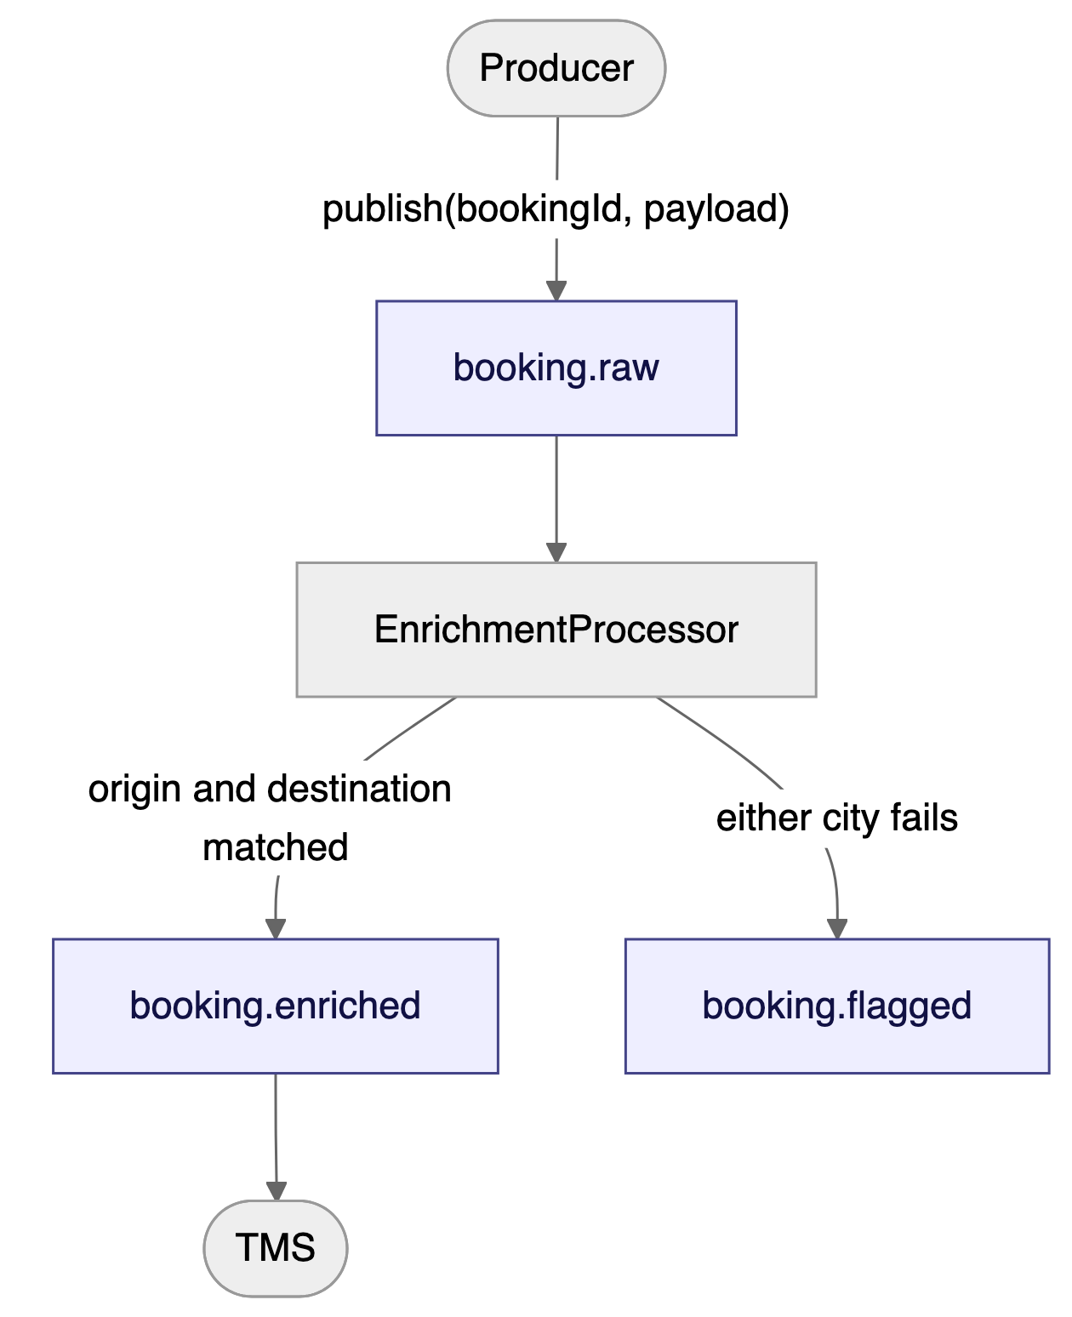{width=6.30in height=7.74in}
EnrichmentProcessor is the only class that knows topic names (SPEC §7), so the routing decision is centralised in one place. The whole-booking rule (SPEC §2) means there is no partial path: a booking never emits to both booking.enriched and booking.flagged, and it never emits to neither — every input produces exactly one output message.

2. The matching contract (SPEC §5)
What it shows: the full seven-step decision tree applied independently to origin and destination, in order, with the two fuzzy-matching gates and the three candidate-count outcomes.
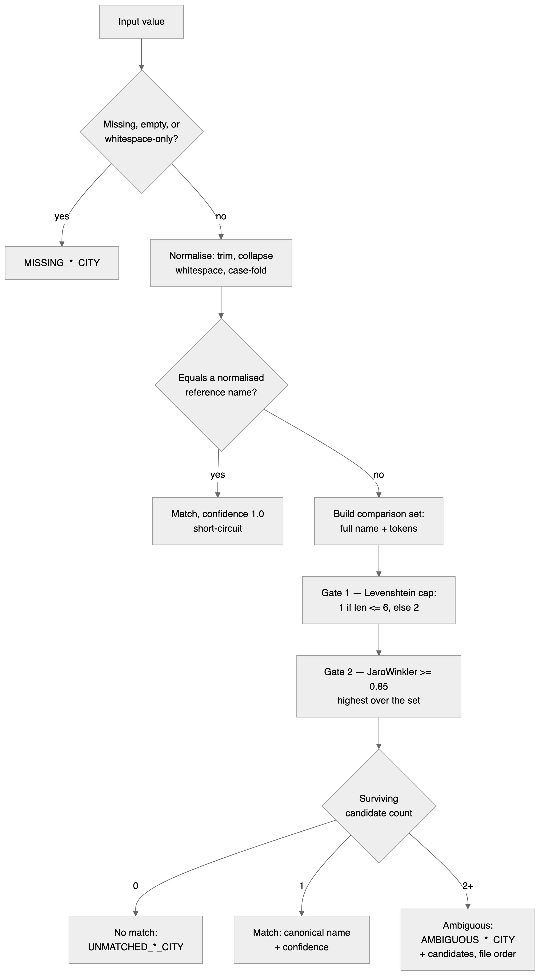{width=4.60in height=8.30in}
Exact match short-circuiting (step 3) is what guarantees an input equal to one reference name is never reported as ambiguous with another (SPEC §5.3). The two gates in step 4 are independent: a reference must clear both the distance cap and the 0.85 Jaro-Winkler floor to become a candidate at all, and only then does the candidate count decide the outcome.

3. Comparison-set construction
What it shows: how a multi-word reference name expands into several strings to compare against, each with its own distance cap, using New Delhi from the SPEC §5 worked example.
Comparison-set member | Length (normalised) | Distance cap
new delhi | 9 | 2
new | 3 | 1
delhi | 5 | 1
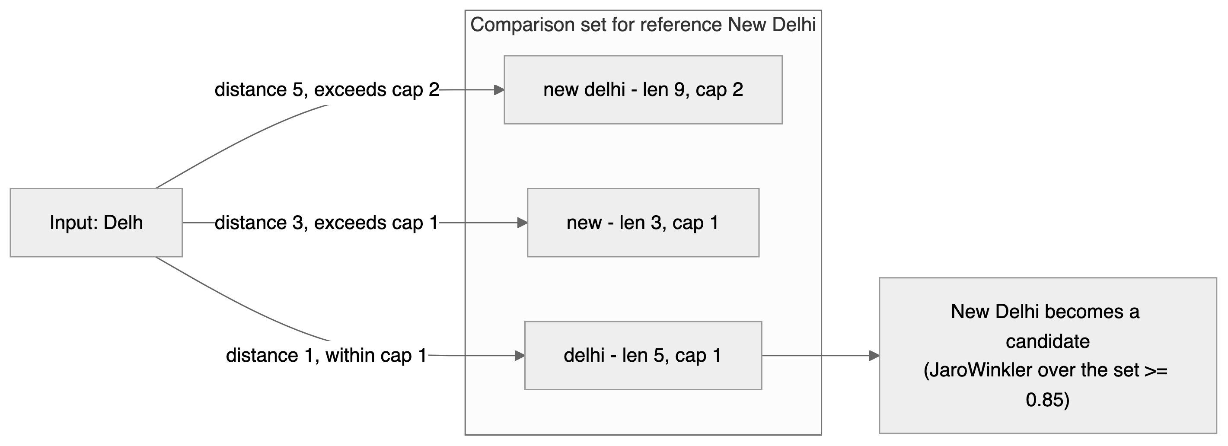{width=6.30in height=2.29in}
Without tokenisation, Delh is distance 5 from new delhi as a whole and would never reach it. Comparing against the token delhi instead brings the distance down to 1, inside the cap for a 5-character string — this is precisely the mechanism SPEC §5.4 describes as "what lets a short input reach a multi-word reference."

4. Package layering (SPEC §7)
What it shows: the six packages under com.cozentus.enrichment, the dependencies implied by their documented responsibilities, and the direction matcher/ and enrich/ must never point in.
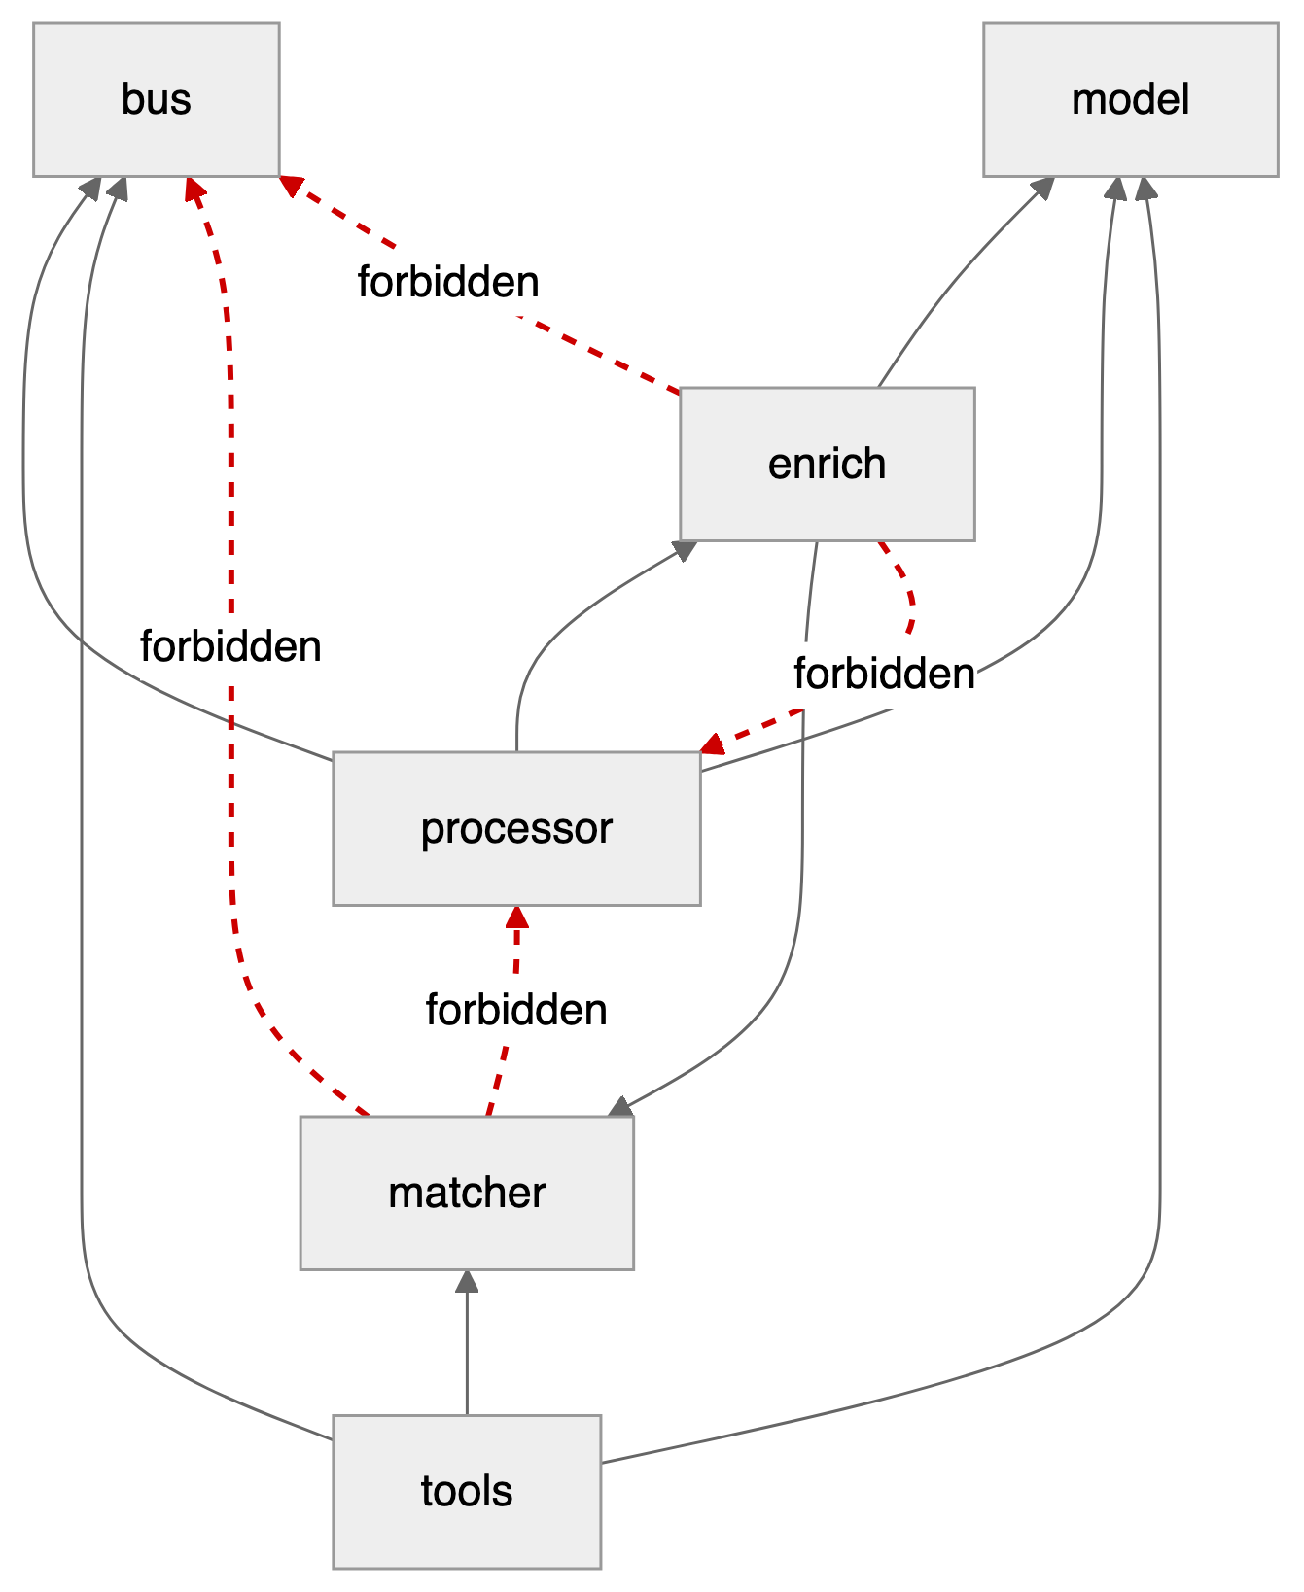{width=6.30in height=7.70in}
CityMatcher and BookingEnricher have no dependency on bus/ or processor/ (SPEC §7 rules); EnrichmentProcessor depends only on the MessageBus interface. This keeps the matching and enrichment logic testable in plain unit tests with no bus, no topics, and no I/O — the bulk of CityMatcherTest and BookingEnricherTest (SPEC §8.1) exercise matcher/ and enrich/ in complete isolation from bus/.

5. Class model
What it shows: the model, matcher, enrich, and bus types named across SPEC §4, §5, and §7, with the sealed MatchResult hierarchy and the MessageBus interface as given verbatim in SPEC §7. Fields on Booking, EnrichedBooking, FlaggedBooking, and FieldFlag are taken from the JSON payload shapes in SPEC §4; method names on CityMatcher and BookingEnricher are illustrative of the documented behaviour ("Booking -> EnrichedBooking | FlaggedBooking", SPEC §7), since SPEC does not give Java signatures for those two classes the way it does for MessageBus.
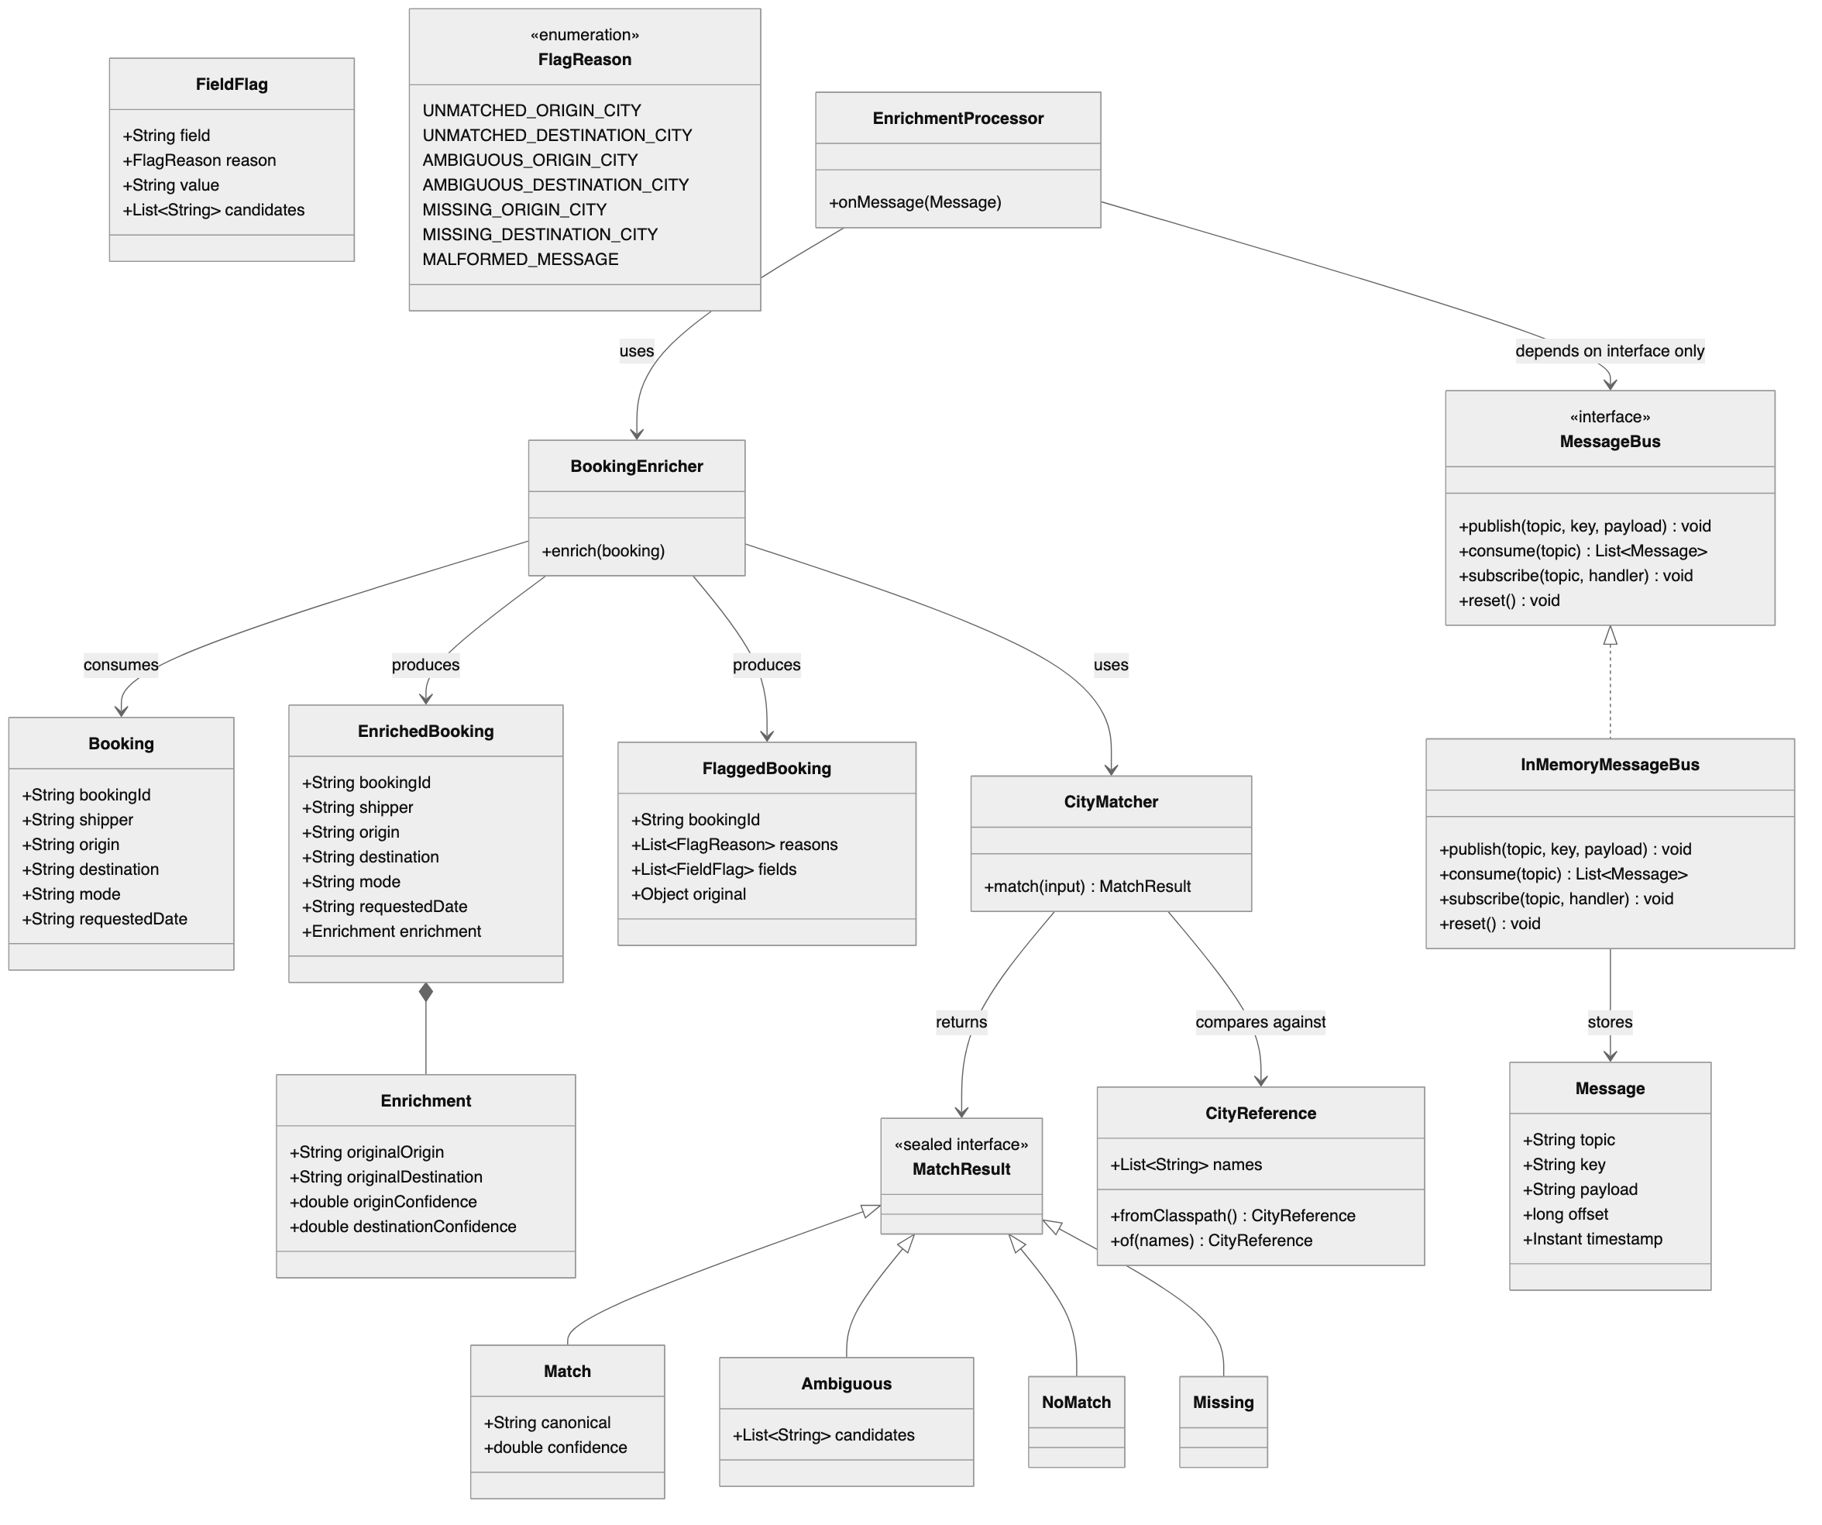{width=6.30in height=5.27in}
MatchResult is sealed to exactly the four outcomes SPEC §5 defines — a match, an ambiguous set, no match, or a missing value — so every consumer of a match result is forced (by the compiler, via exhaustive switch) to handle all four; there is no fifth silent case.

6. Sequence — a flagged booking
What it shows: a booking whose origin cannot be matched, from publish on booking.raw through to publish on booking.flagged, entirely inside one synchronous call.
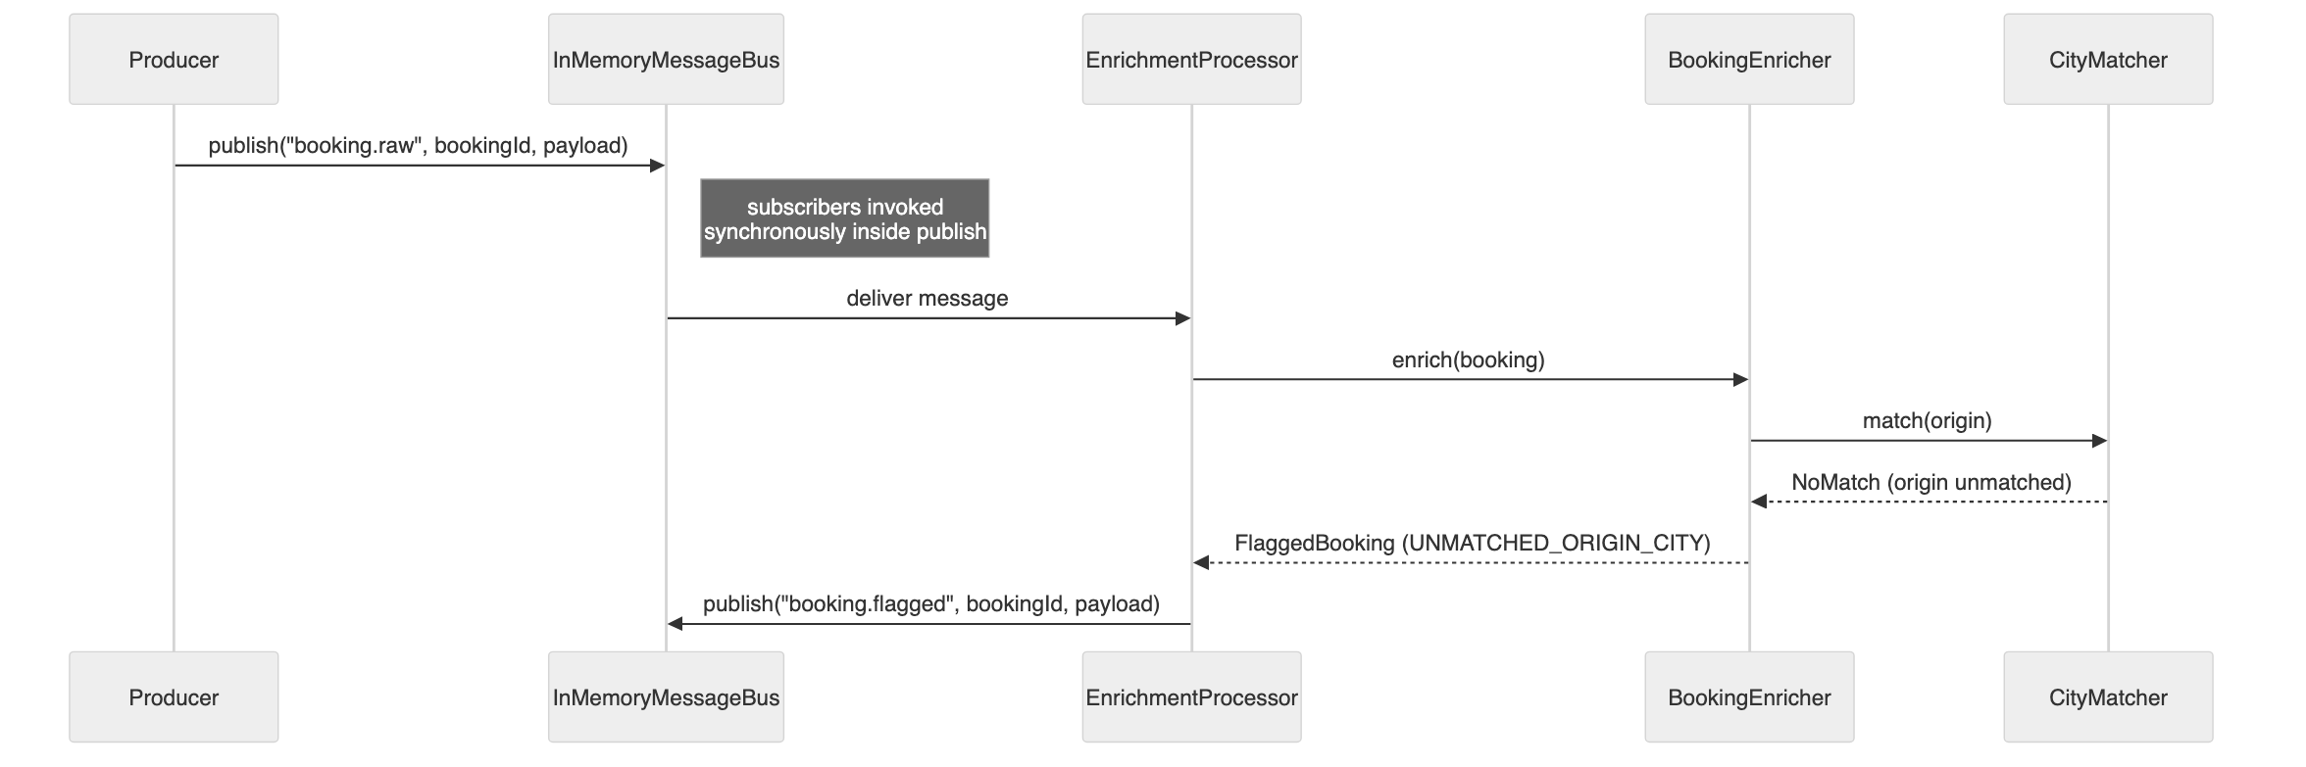{width=6.30in height=2.10in}
InMemoryMessageBus invokes subscribers synchronously inside publish (SPEC §7, MessageBus section) — by the time publish returns to the producer, the flagged booking has already been enriched, evaluated, and republished. This is what makes negative assertions ("no booking X appears on booking.enriched") deterministic without polling or timeouts.

7. Sequence — a malformed message
What it shows: an unparseable payload flagged as MALFORMED_MESSAGE, and the next, well-formed message still being processed afterward — the "processor never throws" invariant in action.
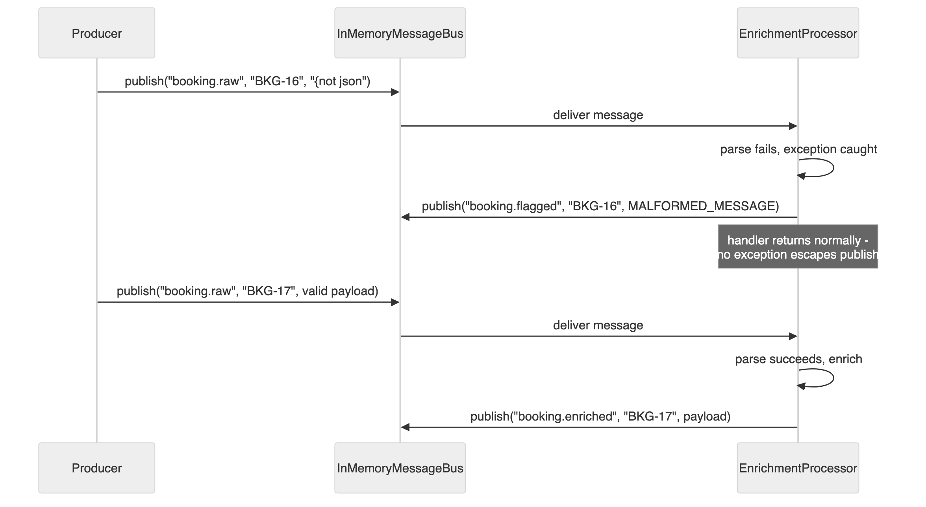{width=6.30in height=3.46in}
For MALFORMED_MESSAGE, fields is empty, original holds the raw string, bookingId is null, and the message key is the Kafka key if present, else "UNKNOWN" (SPEC §4). Catching the parse failure inside the handler — rather than letting it propagate — is what keeps one bad message from taking down the subscription and silently starving every message behind it.

8. Test pyramid (SPEC §8)
What it shows: the four test layers, from fastest/narrowest to slowest/broadest, and what each one proves that the others don't.
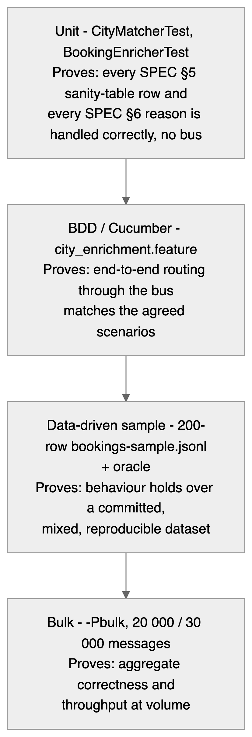{width=2.85in height=8.30in}
Each layer trades speed for scope: unit tests pin down the matching and enrichment logic itself; Cucumber pins down routing and message shape as agreed scenarios; the 200-row sample checks the same logic against a larger, committed, git-tracked fixture; the bulk profile checks it holds at the volumes the real service would see, and is excluded from the default mvn verify run precisely because it is slow (SPEC §8.4).

9. Task roadmap (CLAUDE.md)
What it shows: the seven build tasks in dependency order, with the mvn -q verify gate CLAUDE.md requires between each one. Task 1 (scaffold, matcher, CityMatcher, CityMatcherTest) is complete and green; tasks 2-7 are pending.
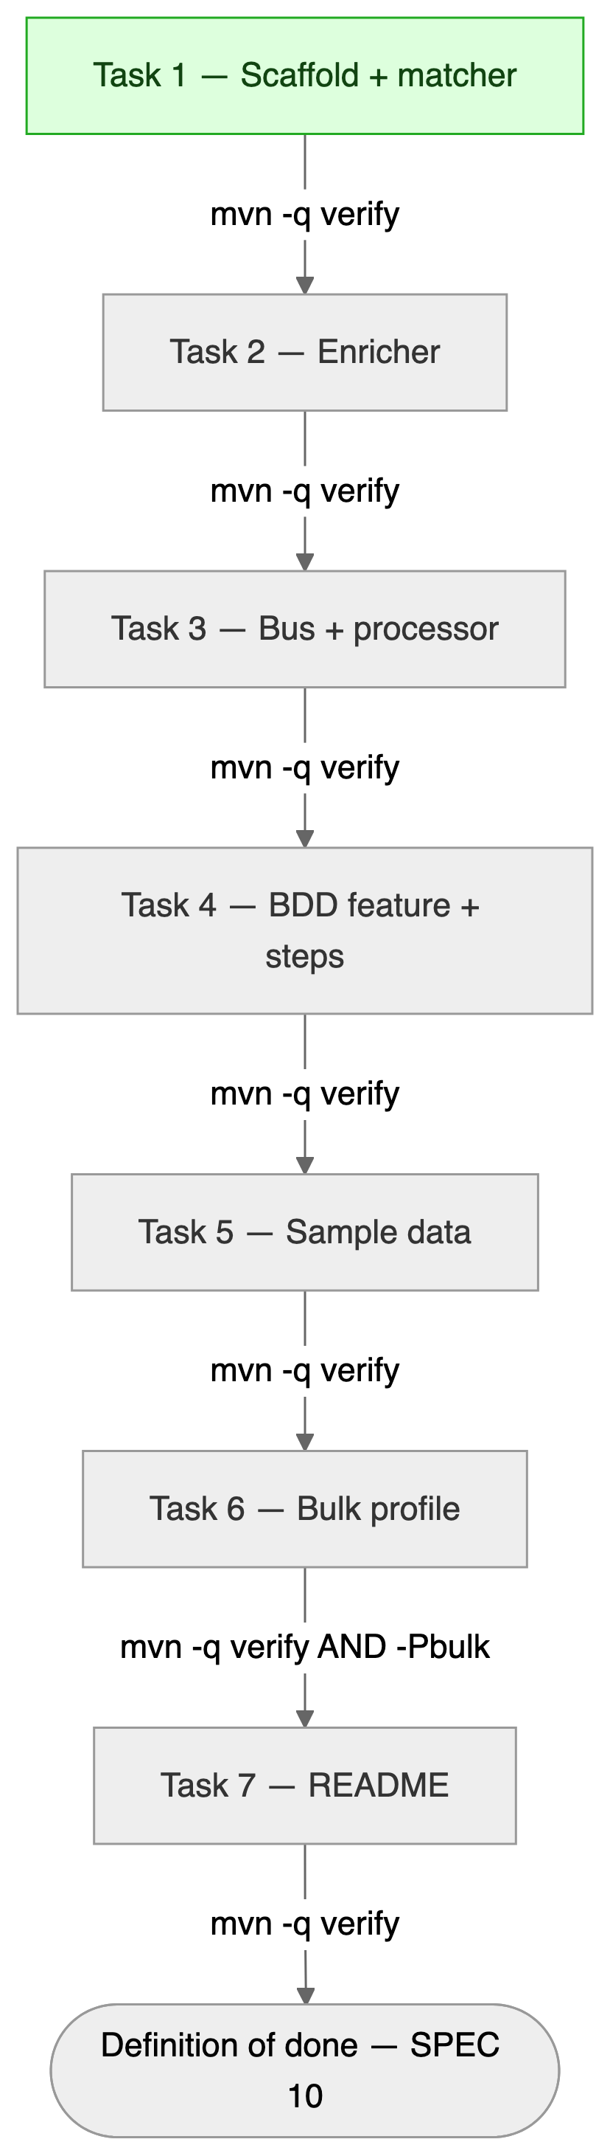{width=2.35in height=8.30in}
CLAUDE.md's task order is a strict sequence: "work one task at a time. After each, run the gate, summarise what changed, and stop for review." Task 6 additionally requires mvn -q verify -Pbulk at both 20 000 and 30 000 messages before it counts as done.

10. Data generator flow (SPEC §9)
What it shows: BookingDataGenerator's per-row algorithm — pick a city, pick a corruption from the configured --mix bucket, apply it, then label the row by running the real CityMatcher, never by inferring the outcome from the corruption's name.
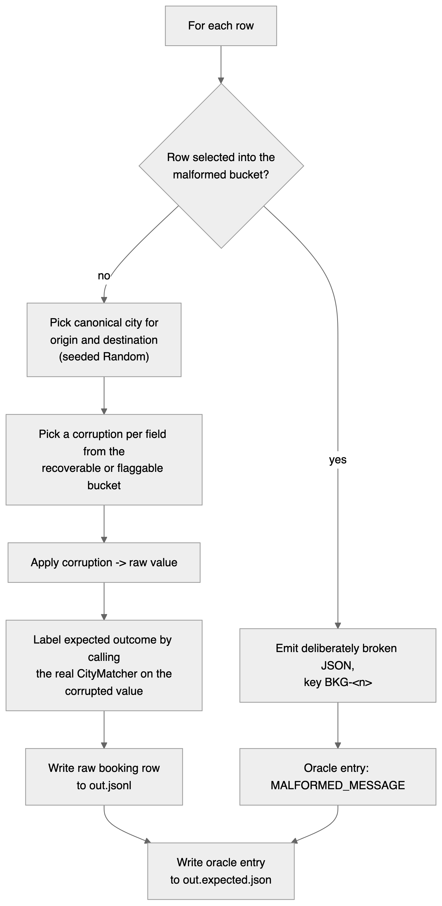{width=4.05in height=8.30in}
Labelling by re-running CityMatcher (step 4, SPEC §9) — instead of assuming recoverable always recovers — guarantees the generated data and the matching contract cannot drift apart: a recoverable corruption that happens to destroy a name still lands in the flagged oracle, because the matcher, not the bucket name, decides the truth.

11. Test plan
Testing is BDD-first: the Gherkin feature file in SPEC §8.2 is the contract, and it is never edited to make code pass (CLAUDE.md #1). The other three layers exist to support it — unit tests pin the algorithm's edges, the sample proves a realistic distribution, and the bulk run proves the invariants hold at volume.
Layer | Tool | What it proves | Gate | Status
Unit | JUnit 5 + AssertJ | Every SPEC §5 sanity-table row and every SPEC §6 reason, no bus | mvn -q verify | 31 tests green (task 1)
BDD | Cucumber-JVM 7 | End-to-end routing through the bus matches the 11 agreed scenarios | mvn -q verify | pending (task 4)
Data-driven | Cucumber + committed JSONL | Behaviour holds over a 200-row reproducible dataset vs. its oracle | mvn -q verify | pending (task 5)
Bulk | JUnit @Tag("bulk") | Aggregate invariants and throughput at 20 000 / 30 000 | mvn -q verify -Pbulk | pending (task 6)
Reports: Cucumber HTML + JSON to target/cucumber (SPEC §10).
Determinism. Fixed seeds, a synchronous bus, no sleeps, no Awaitility, no timeouts (CLAUDE.md #7). Because subscribers run inside publish, a negative assertion — "no booking X appears on booking.enriched" — is exact rather than a race against a wait.

12. BDD — the feature file
src/test/resources/features/city_enrichment.feature, reproduced from SPEC §8.2. 11 scenario declarations; the outline's 5 examples make 15 executable scenarios.
Feature: City enrichment before publishing to TMS
Background:
Given the reference cities are Mumbai, New Delhi, Bangalore, Chennai, Kolkata, Pune, Hyderabad, Ahmedabad
And the enrichment processor is consuming from "booking.raw"
Scenario Outline: Correctable cities are enriched and forwarded
When a raw booking "<id>" with origin "<origin>" and destination "<destination>" is published
Then a booking "<id>" is received on "booking.enriched"
And its origin is "<expectedOrigin>" and destination is "<expectedDestination>"
And the enrichment metadata retains original values "<origin>" and "<destination>"
And shipper, mode and requestedDate are unchanged
And no booking "<id>" appears on "booking.flagged"
Examples:
| id | origin | destination | expectedOrigin | expectedDestination |
| BKG-1 | Mumbi | now delhi | Mumbai | New Delhi |
| BKG-2 | bangalor | CHENNAI | Bangalore | Chennai |
| BKG-3 | pune | Hyderabad | Pune | Hyderabad |
| BKG-4 | New Delhi | Ahmedabd | New Delhi | Ahmedabad |
| BKG-5 | kolkatta | Mumbai | Kolkata | Mumbai |
Scenario: Unmatched origin is flagged, not forwarded
When a raw booking "BKG-9" with origin "Warsaw" and destination "Mumbai" is published
Then a booking "BKG-9" is received on "booking.flagged"
And its reasons are exactly "UNMATCHED_ORIGIN_CITY"
And the flagged field "origin" has value "Warsaw" and no candidates
And no booking "BKG-9" appears on "booking.enriched"
Scenario: Unmatched destination is flagged, not forwarded
When a raw booking "BKG-10" with origin "Mumbai" and destination "Lisbon" is published
Then a booking "BKG-10" is received on "booking.flagged"
And its reasons are exactly "UNMATCHED_DESTINATION_CITY"
And no booking "BKG-10" appears on "booking.enriched"
Scenario: Both cities unmatched produces both reasons
When a raw booking "BKG-11" with origin "Warsaw" and destination "Lisbon" is published
Then a booking "BKG-11" is received on "booking.flagged"
And its reasons are exactly "UNMATCHED_ORIGIN_CITY", "UNMATCHED_DESTINATION_CITY"
And no booking "BKG-11" appears on "booking.enriched"
Scenario: One valid city does not rescue an invalid one
When a raw booking "BKG-12" with origin "Mumbai" and destination "Warsaw" is published
Then no booking "BKG-12" appears on "booking.enriched"
Scenario: Ambiguous match is flagged with candidates
Given the reference cities additionally include "Delhi"
When a raw booking "BKG-13" with origin "Delh" and destination "Mumbai" is published
Then a booking "BKG-13" is received on "booking.flagged"
And its reasons are exactly "AMBIGUOUS_ORIGIN_CITY"
And the flagged field "origin" has candidates "New Delhi", "Delhi"
Scenario: Missing city is flagged
When a raw booking "BKG-14" with origin "" and destination "Mumbai" is published
Then a booking "BKG-14" is received on "booking.flagged"
And its reasons are exactly "MISSING_ORIGIN_CITY"
Scenario: Typo beyond threshold on a short name is flagged
When a raw booking "BKG-15" with origin "Pn" and destination "Mumbai" is published
Then a booking "BKG-15" is received on "booking.flagged"
And its reasons are exactly "UNMATCHED_ORIGIN_CITY"
Scenario: Malformed message is flagged and processing continues
When the raw payload "{not json" with key "BKG-16" is published to "booking.raw"
And a raw booking "BKG-17" with origin "Mumbai" and destination "Pune" is published
Then a message with key "BKG-16" is received on "booking.flagged" with reason "MALFORMED_MESSAGE"
And a booking "BKG-17" is received on "booking.enriched"
Scenario: Message key is the bookingId on every topic
When a raw booking "BKG-18" with origin "Mumbai" and destination "Warsaw" is published
Then the message for "BKG-18" on "booking.flagged" has key "BKG-18"
Scenario: Duplicate bookingId is processed each time it arrives
When a raw booking "BKG-19" with origin "Mumbai" and destination "Pune" is published twice
Then exactly 2 bookings "BKG-19" are received on "booking.enriched"

Scenario coverage matrix
Scenario | Input | Expected topic | Proves
Outline BKG-1 | Mumbi / now delhi | enriched | typo correction, both fields
Outline BKG-2 | bangalor / CHENNAI | enriched | typo + case-folding
Outline BKG-3 | pune / Hyderabad | enriched | already-canonical passes through
Outline BKG-4 | New Delhi / Ahmedabd | enriched | internal whitespace collapse
Outline BKG-5 | kolkatta / Mumbai | enriched | doubled char, long-name cap
BKG-9 | Warsaw / Mumbai | flagged | UNMATCHED_ORIGIN_CITY, empty candidates
BKG-10 | Mumbai / Lisbon | flagged | UNMATCHED_DESTINATION_CITY
BKG-11 | Warsaw / Lisbon | flagged | two reasons, ordered origin then destination
BKG-12 | Mumbai / Warsaw | flagged | whole-booking rule — no half-enrichment
BKG-13 | Delh (+Delhi) | flagged | AMBIGUOUS_ORIGIN_CITY, candidates in file order
BKG-14 | "" / Mumbai | flagged | MISSING_ORIGIN_CITY, distinct from unmatched
BKG-15 | Pn / Mumbai | flagged | the distance cap is enforced exactly
BKG-16/17 | {not json, then valid | flagged, then enriched | processor never throws
BKG-18 | Mumbai / Warsaw | flagged | message key is the bookingId
BKG-19 | published twice | enriched ×2 | no accidental de-duplication
Nearly every scenario also asserts the negative — "no booking X appears on booking.enriched" — checking the one-topic-per-booking invariant from both directions.

Known coverage gap
No scenario asserts the message key on booking.enriched; BKG-18 covers only booking.flagged, while SPEC §2 mandates bookingId as the key on all three topics. Closing this needs a new scenario, which is a change to the locked feature file and therefore a decision for the spec owner.

Flag reasons (SPEC §6)
Origin | Destination
UNMATCHED_ORIGIN_CITY | UNMATCHED_DESTINATION_CITY
AMBIGUOUS_ORIGIN_CITY | AMBIGUOUS_DESTINATION_CITY
MISSING_ORIGIN_CITY | MISSING_DESTINATION_CITY
Plus MALFORMED_MESSAGE, for unparseable input (not field-specific). reasons is a list; both cities failing yields two entries, ordered origin then destination.

Sanity table (SPEC §5)
Input | Result
Mumbi | Mumbai (d=1)
now delhi | New Delhi (d=1)
Bangalor | Bangalore (d=1)
MUMBAI | Mumbai (exact after normalise)
New Delhi | New Delhi (exact after normalise)
Pne | Pune (d=1 vs pune, length 4 <= 6 so d<=1 allowed; JW 0.925)
Pn | flagged (d=2 > 1)
Warsaw | flagged, no candidate within distance
Delh (base list) | New Delhi (token delhi, d=1)
Delh (list + Delhi) | flagged AMBIGUOUS, candidates New Delhi, Delhi
"" | flagged, MISSING

Key invariants
- One topic per booking. A booking appears on exactly one of booking.enriched / booking.flagged — never both, never neither (SPEC §2; CLAUDE.md #4: "A bookingId never appears on both booking.enriched and booking.flagged").
- The processor never throws. Bad input produces a booking.flagged message with MALFORMED_MESSAGE; the next message on booking.raw is still processed (SPEC §7, EnrichmentProcessor section; CLAUDE.md #5).

