Plot of Mass vs Elongation with given point (1000, 17.5)
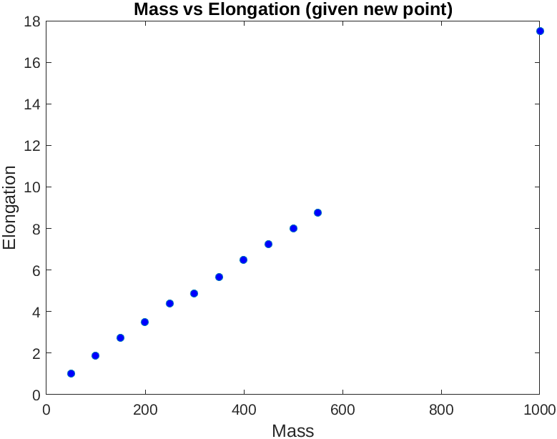
s

Model 1:

new_k1= (new_elongation(2)-new_elongation(1))/(new_mass(2)-new_mass(1));
new_slope = new_k1*new_mass; % model match for additional point

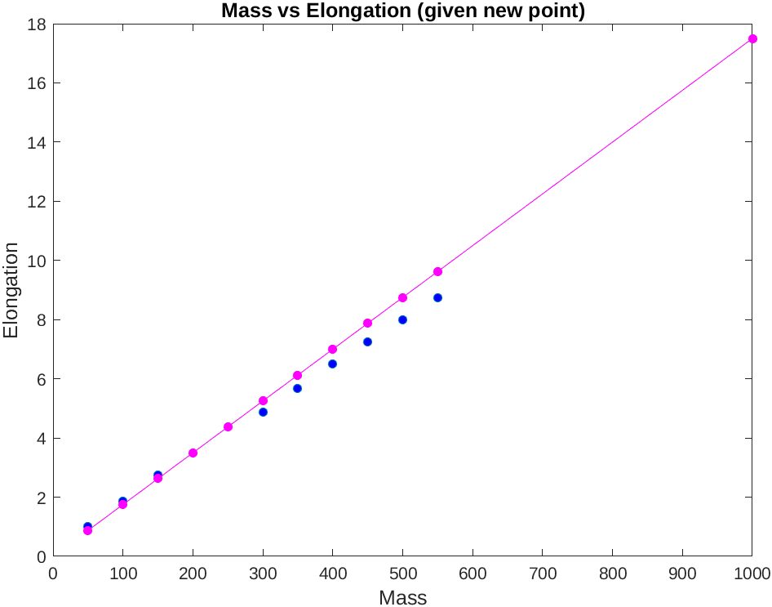

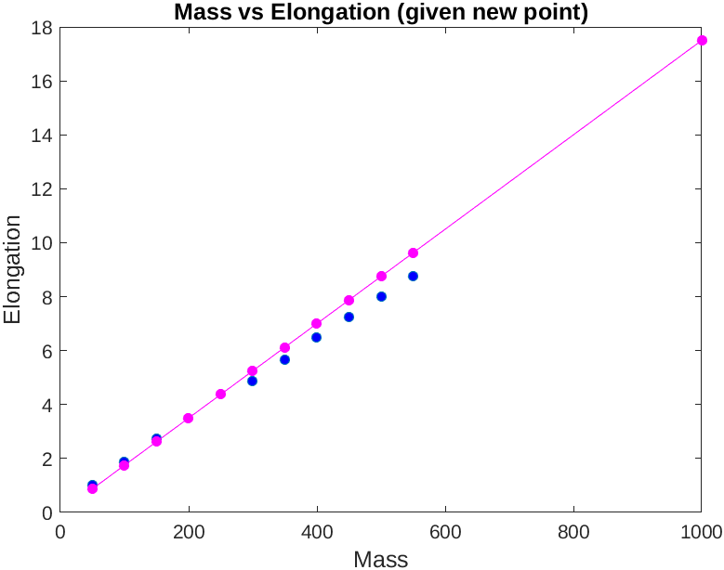
Model 3:

