Introduction to Data Mining
  - Lab 2: Evaluation

Be a classifier

In the second class, we are going to learn how to use datasets to evaluate data mining algorithms in Weka. (See the lecture of class 2 by Ian H. Witten, [1])
Interactive decision tree construction
- Follow the instruction in [1] to see how decision trees are created for different combinations of attributes in a dataset. Firstly, a dataset and a training set are selected. Secondly, we choose and start running UserClassifier to see a decision tree in the Tree Visualizer. In the Data Visualizer, thirdly, the attributes to use for X and Y are selected, we then select instances in a region in the graph and submit. At this point, the Tree Visualizer shows the tree.
- Examine iris.2D.arff dataset to draw a decision tree for the following pair of attributes by selecting and submitting classes one by one, then remark how many instances are predicted correctly.
Attributes | Split on Region-centroid-row and intensity-mean
Decision Tree | 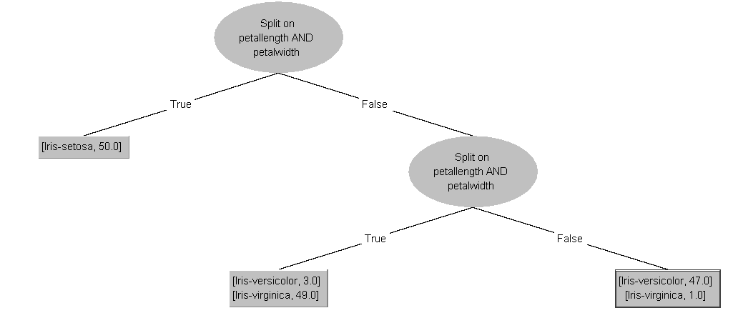
Remark | Number of leaves = 3  Correctly Classified Instances = 43/45 (95.56 %)

Build a tree, what strategy do you use?
Can you build a “perfect” tree?
- No, I can’t. It’s difficult to cover all possible situations.
- There’re two three leftovers Iris-versicolor in the selected area.
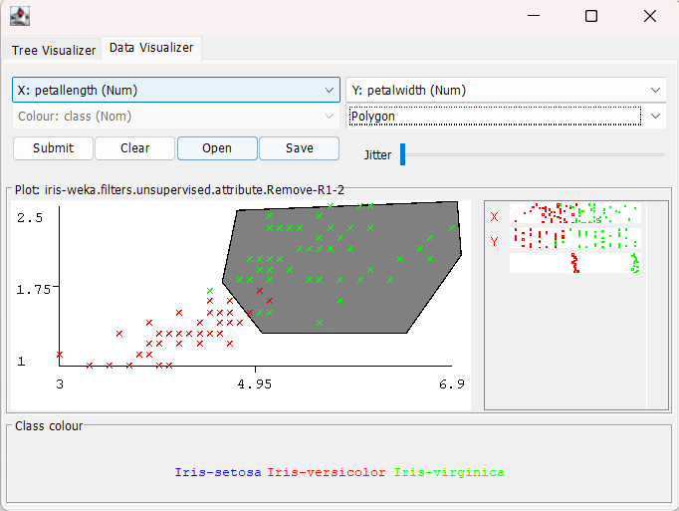

Training and testing
The lecture of evaluation (see [1]-2.2)
Follow the instructions in [1]-2.3: use J48 to analyze ionosphere.arff dataset, and write down how accuracy it can achieve with different seeds. (If a random number seed is provided, the dataset will be shuffled before the subset is extracted.)
Random number seeds | Percent accuracy (x) | Random number seeds | Percent accuracy (x)
1 | 84 | 6 | 96
2 | 99 | 7 | 95
3 | 98 | 8 | 89
4 | 94 | 9 | 93
5 | 94 | 10 | 97
Evaluation | Sample Mean | 93.9
Evaluation | Standard deviation | 4.48

Note:
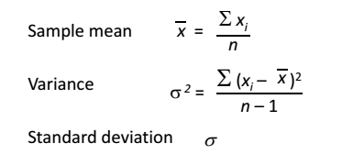

Remark?
- Using “Percentage Split” is very “random”. You can see the result with seed = 1, Percent Accuracy dropped significantly to 84 percent. This chart below illustrates the distribution of Correctly Classified Instances using J48 algorith with a 70-30 split.
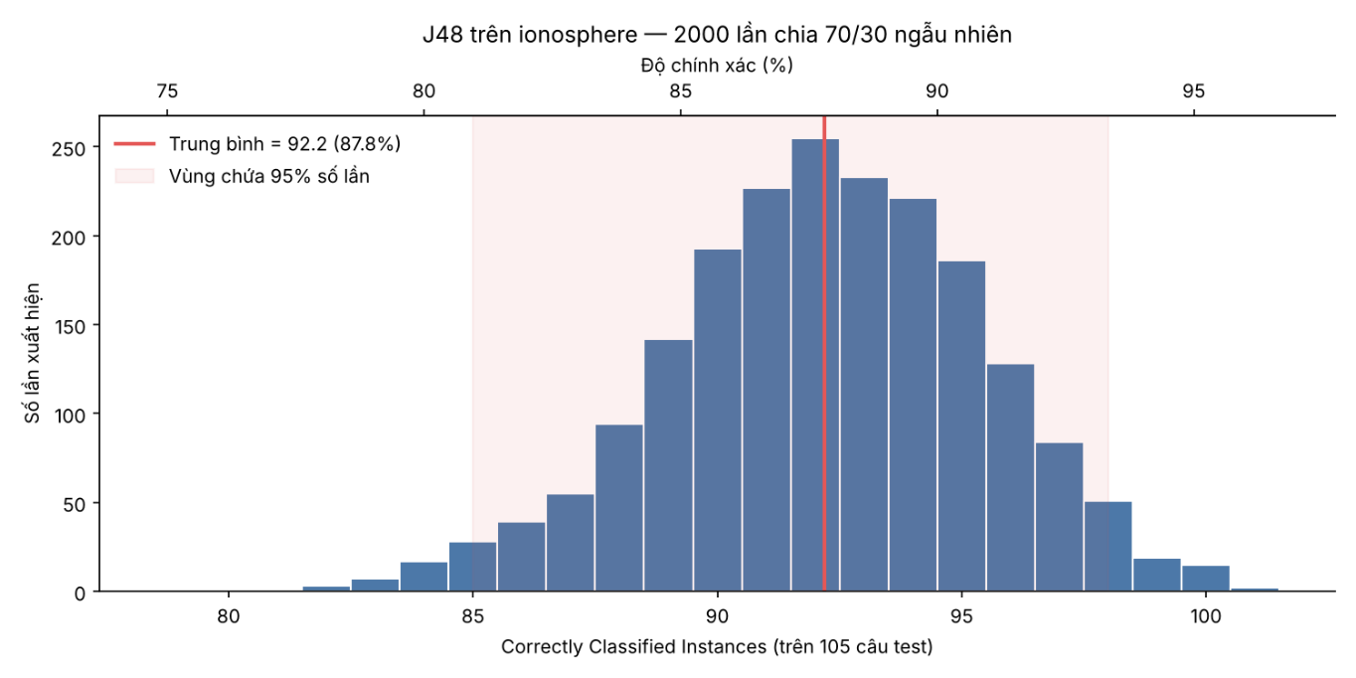

Baseline accuracy
Follow the instructions in [1]-2.4 to run some classifiers for breast-cancer.arff dataset:
Classifier | Accuracy
J48 | 216/286 (75.52%)
NaiveBayes | 205/286 (71.68%)
IBk | 207/286 (72.38%)
PART | 204/286 (71.33%)
ZeroR | 201/286 (70.28%)
What is Baseline accuracy? – 201/286 (ZeroR)
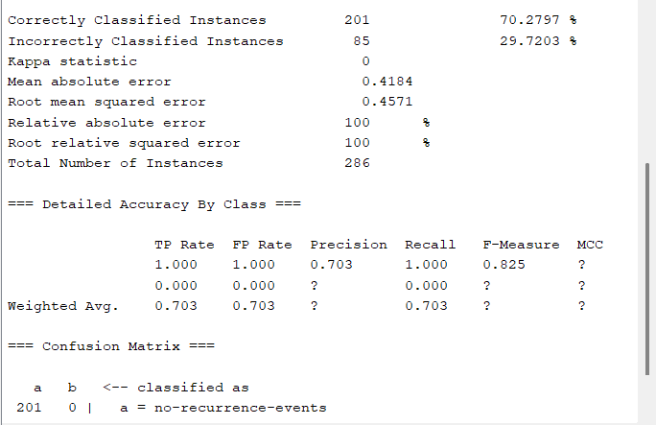

For unbalanced.arff dataset
Classifier | Accuracy
ZeroR | 844/856 (98.60%)
J48 | 844/856 (98.60%)
NaiveBayes | 777/856 (90.77%)
IBk | 836/856 (97.66%)
PART | 835/856 (97.55%)

Why do the classifiers achive lower accuracy? – Because there are a dramatically unbalanced between label “Inactivate” and label “Active” (844 vs 12)
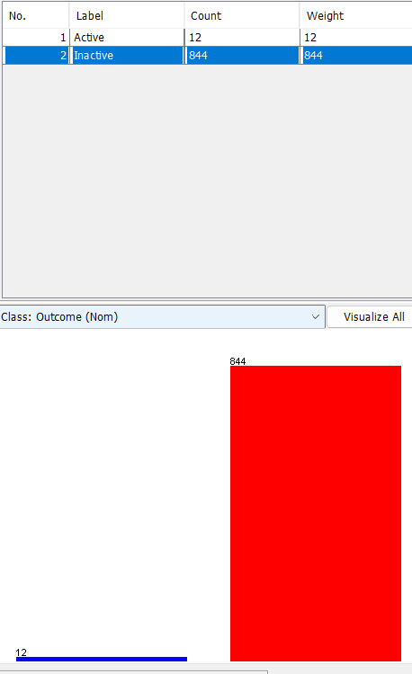

Cross-validation
The holdout procedure: a certain amount is held over for testing and the remainder used for training.
Stratification: each class is properly represented in both training and test sets.
The repeated holdout method of error rate estimation: In each iteration a certain proportion, say two-thirds, of the data is randomly selected for training (using different random-number seeds), possibly with stratification, and the remainder is used for testing. The error rates on the different iterations are averaged to yield an overall error rate.
The lecture of cross validation, 10-fold cross-validation, stratified cross-validation (see [1]-2.5).
In cross-validation, you decide on a fixed number of folds, or partitions, of the data. Suppose we use three. Then the data is split into three approximately equal partitions; each in turn is used for testing and the remainder is used for training. That is, use two-thirds of the data for training and one-third for testing, and repeat the procedure three times so that in the end, every instance has been used exactly once for testing. This is called three-fold cross-validation, and if stratification is adopted as well—which it often is—it is stratified three-fold cross-validation.
Weka does stratified cross-validation by default.
Follow the instructions in [1]-2.5, and examine J48 on credit-g.arff dataset.
Holdout (10%) | Percent accuracy (x) | 10-fold cross-validation | Percent accuracy (x)
Random seed: 1 | 74 | Random seed: 1 | 70.5
-- 2 | 77 | -- 2 | 72.3
-- 3 | 70 | -- 3 | 71.2
-- 4 | 74 | -- 4 | 71.2
-- 5 | 67 | -- 5 | 71.3
-- 6 | 67 | -- 6 | 71.5
-- 7 | 70 | -- 7 | 71.1
-- 8 | 71 | -- 8 | 70.9
-- 9 | 69 | -- 9 | 72.1
-- 10 | 72 | -- 10 | 70.4
Sample Mean | 71.10 | Sample Mean | 71.25
Standard deviation | 3.2128 | Standard deviation | 0.6078

Examine PART on credit-g.arff dataset:
Holdout (10%) | Percent accuracy (x) | 10-fold cross-validation | Percent accuracy (x)
Random seed: 1 | 77 | Random seed: 1 | 70.2
-- 2 | 77 | -- 2 | 71
-- 3 | 65 | -- 3 | 72
-- 4 | 73 | -- 4 | 70.4
-- 5 | 69 | -- 5 | 69
-- 6 | 67 | -- 6 | 70
-- 7 | 66 | -- 7 | 70.4
-- 8 | 72 | -- 8 | 68.8
-- 9 | 75 | -- 9 | 72.8
-- 10 | 75 | -- 10 | 70.8
Sample Mean | 71.60 | Sample Mean | 70.54
Standard deviation | 4.5509 | Standard deviation | 1.2186

Examine NaiveBayes on credit-g.arff dataset:
Holdout (10%) | Percent accuracy (x) | 10-fold cross-validation | Percent accuracy (x)
Random seed: 1 | 76 | Random seed: 1 | 75.4
-- 2 | 78 | -- 2 | 75.8
-- 3 | 80 | -- 3 | 74.8
-- 4 | 78 | -- 4 | 75.7
-- 5 | 71 | -- 5 | 74.8
-- 6 | 78 | -- 6 | 74.8
-- 7 | 72 | -- 7 | 74.8
-- 8 | 73 | -- 8 | 75.3
-- 9 | 77 | -- 9 | 75
-- 10 | 77 | -- 10 | 75.2
Sample Mean | 76.00 | Sample Mean | 75.16
Standard deviation | 2.98 | Standard deviation | 0.38

http://www.cs.waikato.ac.nz/ml/weka/mooc/dataminingwithweka/

