Introduction to Data Mining
  - Lab 3 – Simple Classifiers

Simplicity first!

In the third class, we are going to learn how to examine some data mining algorithms on datasets using Weka. (See the lecture of class 3 by Ian H. Witten, [1])
In this section, we learn how OneR (one attribute does all the work) works. Open weather.nominal.arff, run OneR, look at the classifier model, how is it?
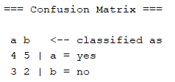
- Remarks:
Use OneR to build decision tree for some datasets. Compared with ZeroR, how does OneR perform?
Dataset (arff) | OneR - accuracy | ZeroR - accuracy
breast-cancer | 188/286 | 201/286
credit-g | 661/1000 | 700/1000
diabetes | 549/768 | 500/768
ionosphere | 284/351 | 225/351
iris.2D | 138/150 | 50/150
unbalanced | 844/856 | 844/856
vote | 188/296 | 201/296
weather.nominal | 6/14 | 9/14

Overfitting
What is “overfitting”? - overfitting occurs when a statistical model “describes random error or noise” instead of the underlying relationship, b/c of complex model, noise/error in the data, or unsuitable applied criterion, poor prediction. To avoid this, use cross-validation, or pruning... [ref: http://en.wikipedia.org/wiki/Overfitting]

Follow the instructions in [1], run OneR on the weather.numeric and diabetes dataset…
Write down the results in the following table: (cross-validation used)
Dataset | OneR | ZeroR
weather.numeric | Classifier model:  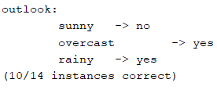  Accuracy: 6/14 | Classifier model: yes  Accuracy: 9/14
weather.numeric w/o outlook att. | Classifier model:  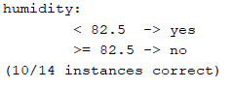  Accuracy: 7/14 | Classifier model: yes  Accuracy: 9/14
diabetes | Classifier model:  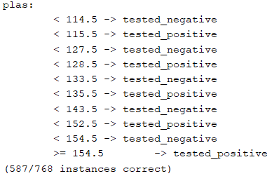  Accuracy: 549/768 | Classifier model: tested_negative (class column)  Accuracy: 500/768
Diabetes w/ minBucketSize 1 | Classifier model: There are 207 range here.  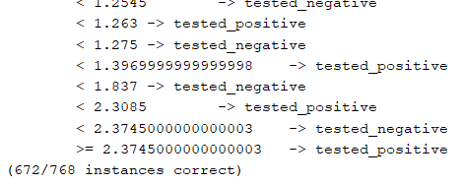  Accuracy: 439/768 | Classifier model: tested_negative (class column)  Accuracy: 500/768
Diabetes w/ minBucketSize 30 (myself) | Classifier model:  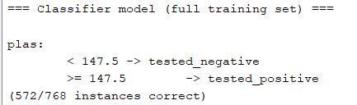  Accuracy: 569/768 | Classifier model: tested_negative (class column)  Accuracy: 500/768

MinBucketSize? – There is the number of instances (or values) in one bin.
Remark? – Chart below
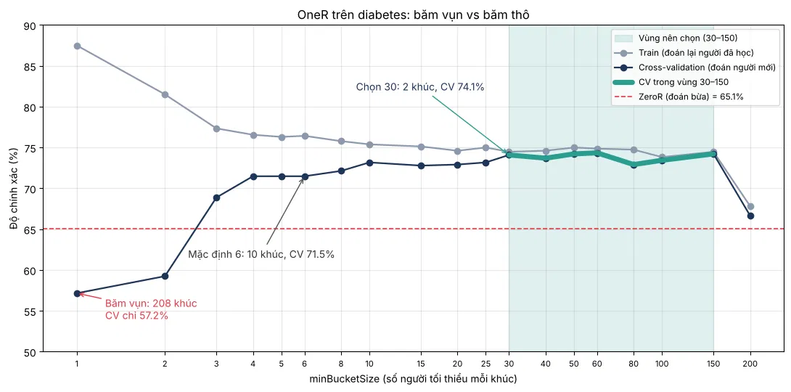

Using probabilities
Lecture of Naïve Bayes: [1]
- All attributes contribute equally and independently no “identical” attributes
Follow the instructions in [1] to examine NaiveBayes on weather.nominal

Dataset | Classifier model | Performance
weather.nominal | 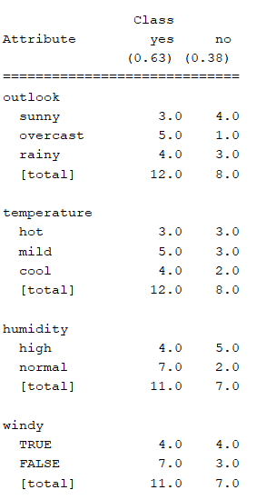 | (how many percent of total instances are classified correctly?)  - There is 8/14
weather.nominal without outlook  (I tested it because humidity and outlook are quite similar) | 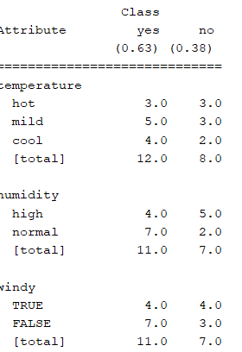 | - There are 7/14 (50%)

Decision Trees
Lecture of decision trees: [1]
How to calculate entropies and information gain?
Entropy measures the impurity of a collection.
$$Entropy\left(S\right)=-\sum_{i=1}^{c}{p_{i}\log_{2}}p_{i}$$
Information Gain measures the Expected Reduction in Entropy.
Info. Gain = (Entropy of distribution before the split) – (Entropy of distribution after the split)
$$Gain\left(S,A\right)≡Entropy\left(S\right)-\sum_{v∈Values\left(A\right)}{\frac{\left|S_{v}\right|}{\left|S\right|}}Entropy(S_{v})$$
Values(A) is the set of all possible values for attribute A and S_{v} is the subset of S for which attribute A has value.
Build a decision tree for the weather data step by step:
Compute Entropy and Info. Gain |  | Selected attribute
 | Entropy(S) = -(9/14)log2(9/14) - (5/14)log2(5/14) = 0.940  Outlook:  - sunny (2 yes, 3 no) → E = 0.971  - overcast (4 yes, 0 no) → E = 0  - rainy (3 yes, 2 no) → E = 0.971  - E_after = 5/14·0.971 + 4/14·0 + 5/14·0.971 = 0.694  - Gain(Outlook) = 0.940 - 0.694 = 0.247  Temperature:  - hot (2 yes, 2 no) → E = 1.000  - mild (4 yes, 2 no) → E = 0.918  - cool (3 yes, 1 no) → E = 0.811  - E_after = 4/14·1 + 6/14·0.918 + 4/14·0.811 = 0.911  - Gain(Temperature) = 0.029  Humidity:  - high (3 yes, 4 no) → E = 0.985  - normal (6 yes, 1 no) → E = 0.592  - E_after = 7/14·0.985 + 7/14·0.592 = 0.788  - Gain(Humidity) = 0.152  Windy:  - false (6 yes, 2 no) → E = 0.811  - true (3 yes, 3 no) → E = 1.000  - E_after = 8/14·0.811 + 6/14·1 = 0.892  - Gain(Windy) = 0.048 | Outlook won (Gain = 0.247)
Rainy | Entropy(S_rainy) = (3 yes, 2 no) = 0.971  Temperature:  - mild (2 yes 2/3, 1 no 1/3) -> E = 0.918  - cool (1 yes, 1 no) -> E = 1  - E_after = 0.918 * 3/5 + 1 * 2/5 = 0.951  - Gain = Entropy(S_rainy) – E_after = 0.02  Humidity:  - high (1 yes, 1 no) -> E = 1  - normal (2 yes, 1 no) -> E = 0.918  - E_after = 0.951  - Gain = 0.02  Windy:  - false (3 yes, 0 no) -> E = 0  - true (0 yes, 2 no) -> E = 0  - E_after = 0  - Gain = 0.971 | Windy won (Gain = 0.971):  - false -> yes  - true -> no
Sunny | Entropy(S_sunny) = 0.971  Temperature:  - hot (0 yes, 2 no) -> E = 0  - mild (1 yes, 1 no) -> E = 1  - cool (1 yes, 0 no) -> E = 0  - E_after = 0.4  - Gain = 0.571  Humidity:  - high (0 yes, 3 no) -> E = 0  - normal (2 yes, 0 no) -> E = 0  - E_after = 0  - Gain = 0.971  Windy:  - false (1 yes, 2 no) -> E = 0.918  - true (1 yes, 1 no) -> E = 1  - E_after = 0.951  - Gain = 0.02 | Humidity won (Gain = 0.971):  - high -> no  - normal -> yes
 | outlook = sunny  | humidity = high : no  | humidity = normal : yes  outlook = overcast : yes  outlook = rainy  | windy = false : yes  | windy = true : no | Final decision tree

Use Weka to examine J48 on the weather data.
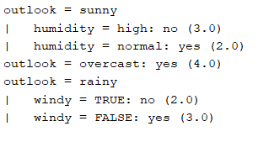

Pruning decision trees
Follow the lecture of pruning decision tree in [1] …
Why pruning? - Prevent overfitting to noise in the data.
In Weka, look at the J48 leaner. What are parameters: minNunObj, confidenceFactor?

Follow the instructions in [1] to run J48 on the two datasets, then fill in the following table:
Dataset | J48 (default, pruned) | J48 (unpruned)
diabetes.arff | 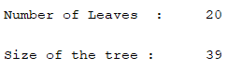  Accuracy: 567/768  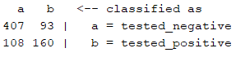 | 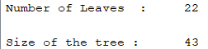  Accuracy: 558/768  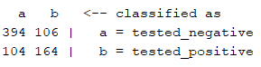
breast‐cancer.arff | 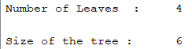  Accuracy: 216/286  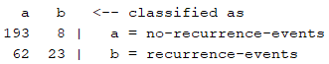 | 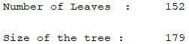  Accuracy:  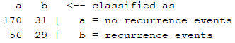

Nearest neighbor
Follow the lecture in [1]
“Instance‐based” learning = “nearest‐neighbor” learning
What is k‐nearest‐neighbors (K-NN)? – It’s the number of the nearest neighbor used in K-means algorithms.
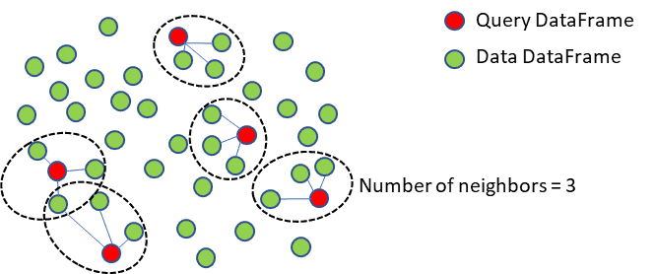
Follow the instructions in [1] to run lazy>IBk on the glass dataset with k = 1, 5, 20, and then fill its accuracy in the following table:
Dataset | IBk, k =1 | IBk, k =5 | IBk, k =20
Glass | 151/214 | 145/214 | 140/214

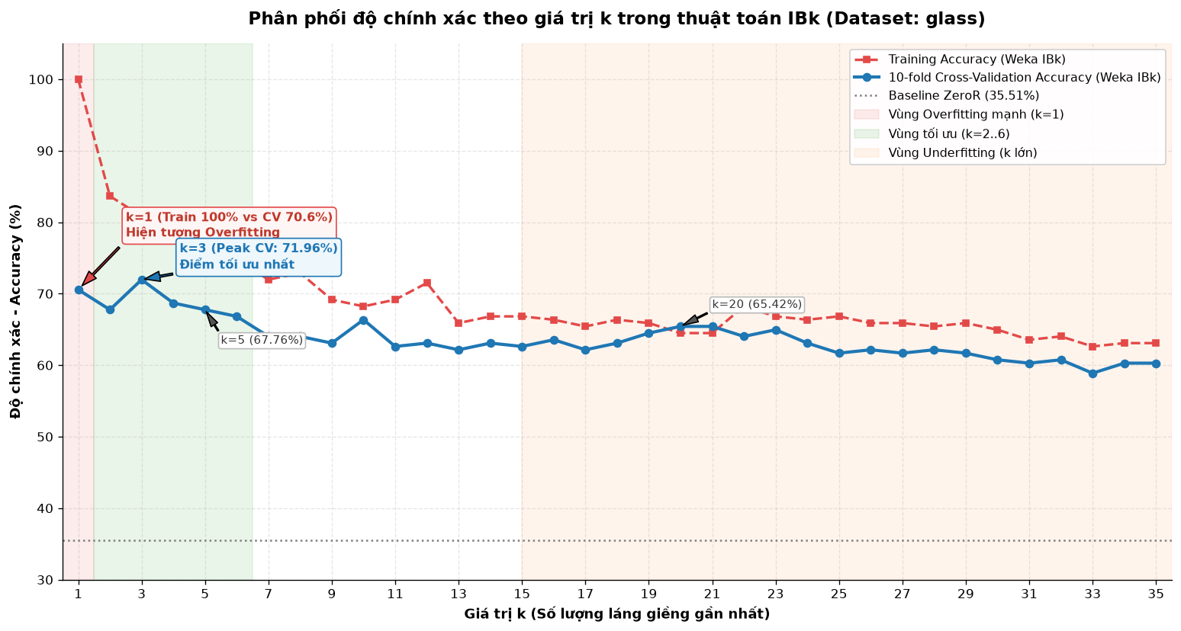

http://www.cs.waikato.ac.nz/ml/weka/mooc/dataminingwithweka/

