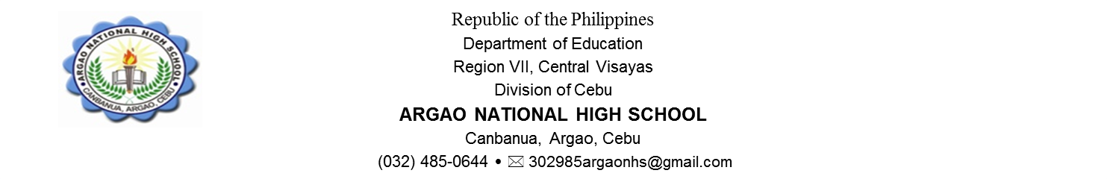

STUDENT’S REFLECTION PAPER

Name: _____________________________________________ Year an Section____________________________

Subject: ______________________________________ Date: _______________________________________

Topic: _________________________________________Name of Teacher: ___________________________

|  |
| --- |
| 1. As a result of this lesson, unit, or class, I am now able to: |
| 1. What was most helpful? |
| 1. What suggestions do you have to improve your learning from this lesson, unit, or class? |
| 1. Explain how this lesson, unit or class can be applied to your everyday life. |
| 1. What will you do to improve your work from this lesson, unit, or class? |