Daniel Clark

CTEC 298

Six Plots

Stack Plot

import matplotlib.pyplot as plt

days = [1,2,3,4,5]

great = [33,52,25,11,7]

decent = [25,23,28,39,12]

bad = [12,13,36,22,24]

terrible = [30,12,14,28,63]

plt.plot([],[],color='m',label=‘Great',linewidth=5)

plt.plot([],[],color='c',label=‘Decent',linewidth=5)

plt.plot([],[],color='r',label=‘Bad',linewidth=5)

plt.plot([],[],color='k',label=‘Terrible’,linewidth=5)

plt.stackplot(days,great,decent,bad,terrible,colors=['m','c','r','k'])

plt.xlabel('Day')

plt.ylabel('Ratings')

plt.title('Movie Survey Reviews')

plt.legend()

plt.show()

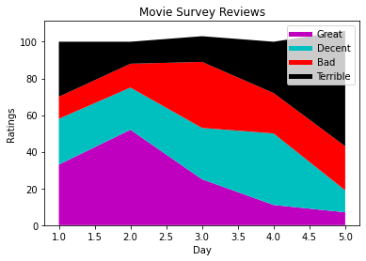

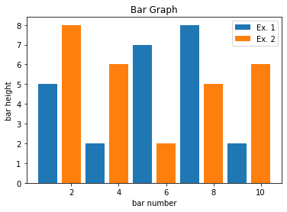Bar Graph

import matplotlib.pyplot as plt

plt.bar([1,3,5,7,9],[5,2,7,8,2],label="Ex. 1")

plt.bar([2,4,6,8,10],[8,6,2,5,6],label="Ex. 2")

plt.legend()

plt.xlabel('bar number')

plt.ylabel('bar height')

plt.title("Bar Graph")

plt.show()

Histogram

import matplotlib.pyplot as plt

pop=[22,55,62,45,21,22,34,42,42,4,99,102,110,120,121,122,130,111,115,112,80,75,65,54,44,43,42,48]

bins=[0,10,20,30,40,50,60,70,80,90,100,110,120,130]

plt.hist(pop,bins,histtype='bar',rwidth=0.8)

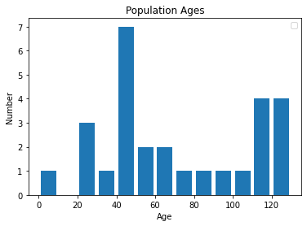plt.xlabel('Age')

plt.ylabel('Number')

plt.title('Population Ages')

plt.legend()

plt.show()

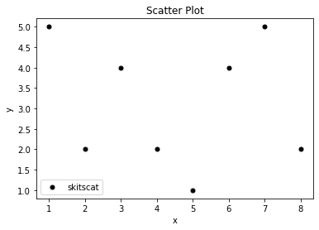Scatter Plot

import matplotlib.pyplot as plt

x=[1,2,3,4,5,6,7,8]

y=[5,2,4,2,1,4,5,2]

plt.scatter(x,y,label='skitscat',color='k',s=25,marker="o")

plt.xlabel('x')

plt.ylabel('y')

plt.title("Scatter Plot")

plt.legend()

plt.show()

Pie Chart

import matplotlib.pyplot as plt

slices=[7,2,2,13]

activities=['sleep','eat','work','playing']

cols=['c','m','r','b']

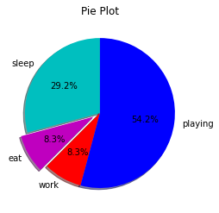plt.pie(slices,labels=activities,colors=cols,startangle=90,shadow=True,explode=(0,0.1,0,0),autopct='%.1f%%')

plt.title('Pie Plot')

plt.show()

Basic Plot

import matplotlib.pyplot as plt

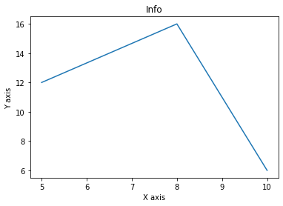x=[5,8,10]

y=[12,16,6]

plt.plot(x,y)

plt.title('Info')

plt.ylabel('Y axis')

plt.xlabel('X axis')

plt.show()