Daniel Clark

CTEC 298

Tableau Plots

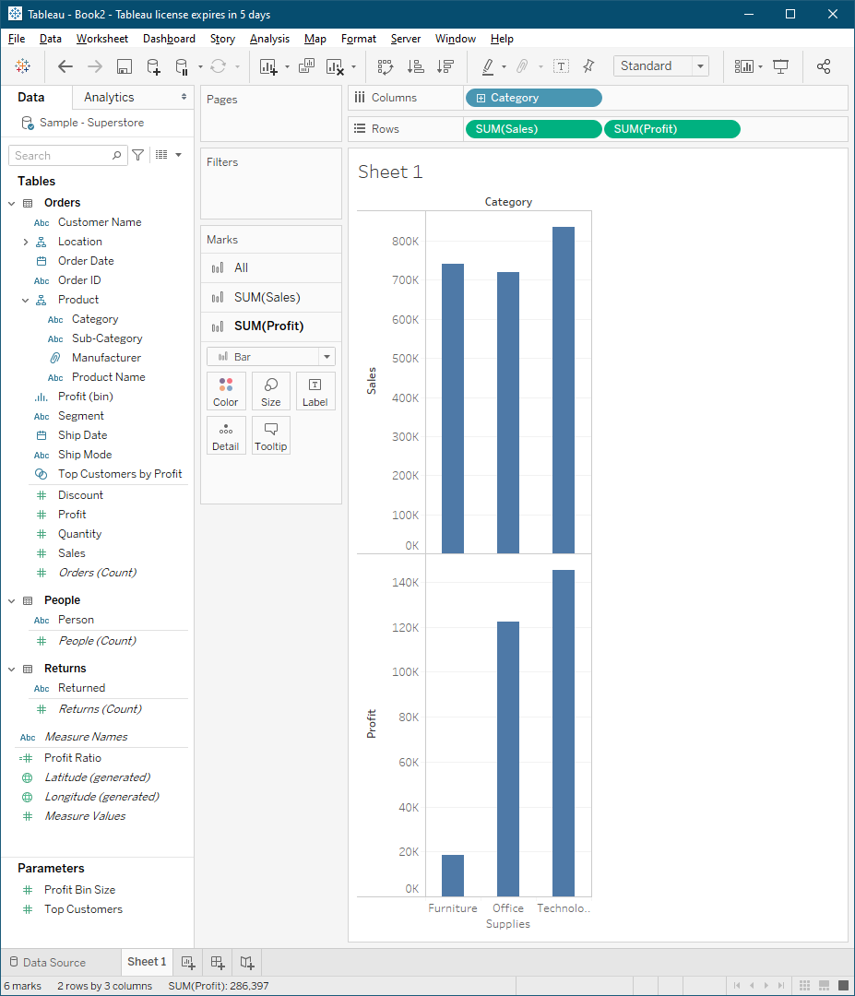

This graph is made from the Sample-Superstore dataset. It depicts the sales and profits grouped by category.

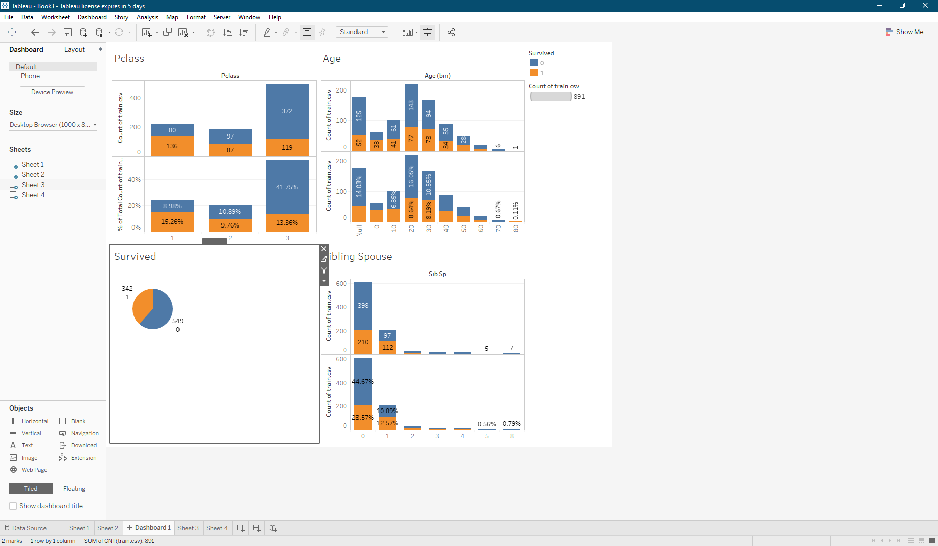

These graphs were made from the titanic records database from Kaggle. The records show the distribution of survival based on passenger class, age, total amount, and sibling or spouse survival.