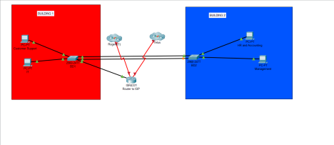We decided to implement 2 PCs on each switch because this is just a visual representation of the buildings and adding the other PCs won’t change what each building is supposed to represent and do. We chose to add a router in between the ISPs to allow it to do addressing, create subinterfaces, and provide a connection to the ISPs. We added the switches in between the buildings to share the traffic and allow connectivity between the buildings. We chose to add the ISPs (the clouds) to represent the internet that each building is going to be connected to through the main router.