Supplementary Information for:

Conformal Slicing Strategy for Robot-assisted Direct Ink Writing on Unstructured Curved Surfaces

Peng Chen¹, Qinxiang Liu¹, Jun Ren^{1, 2}, Yanqiu Chen^{1, 2}, Jian Zhang^{3,*}, Yu Liu^{1, 2, *}
1. School of Mechanical Engineering, Jiangnan University, 214122 Wuxi, China.
2. Jiangsu Key Lab of Advanced Food Manufacturing Equipment and Technology, Jiangnan University, 214122 Wuxi, China.
3. Shanghai Institute of Ceramics, Chinese Academy of Sciences, 201899, Shanghai, China.
*Corresponding author. E-mail: yuliu@jiangnan.edu.cn; Jianzhang@mail.sic.ac.cn

S1. Pseudocode of self-intersection processing
Algorithm 1: Self-intersection processing
Input: The self-intersection triangular mesh surface $S_{0}$ contains array $F_{0}$, and array $V_{0}$. offset distance $d_{offset}$.
Output: The Non-self-intersection triangular mesh surface $S_{1}$, contains array $F_{1}$, and array $V_{1}$.
- array ${SF}_{0}$, array $SV_{0}$← selfintersect($F_{0}$, $V_{0}$)
- if (length($SV_{0}$)＞length($V_{0}$))then
- array $D$ ← Calculate the distance from points $SV_{0}$ to the original surface $S_{0}$.
- for (i = 1:length($D$) do
- if ($D_{i}$＞$d_{offset}$)
- array ${Flag}_{i}$ ← 0;
- else
- array ${Flag}_{i}$ ← 1;
- end if
- end for
- for (j = 1:length(${SF}_{0}$) do
- if (${Flag(SF}_{0}(j,1)) \&\& {Flag(SF}_{0}(j,2))\&\&{Flag(SF}_{0}(j,3))$) then
- Delete triangle ${SF}_{0}(j,:)$;
- end if
- end for
- Delete the points in $SV_{0}$ that do not exist in ${SF}_{0}$'s index, Update ${SF}_{0}$;
- $F_{1}$←${SF}_{0}$; $V_{1}$←$SV_{0}$
- return $S_{1}$
- else if (length($SV_{0}$) == length($V_{0}$)) then
- $F_{1}$← $F_{0}$, $V_{1}$← $V_{0}$,
- strcut $S_{1}$ ←$F_{1}$, $V_{0}$
- return $S_{1}$
- else
- return 0
- end if

S2. Pseudocode of the model and surface intersection calculation
Algorithm 2: Model and surface intersection calculation
Input: The slicer triangular mesh surface $S_{s}$ contains array $F_{s}$, and array $V_{s}$. The STL format model $S_{m}$ contains array $F_{m}$, and array $V_{m}$.
Output: The trimmed triangular mesh surface $S_{t}$, contains array $F_{t}$, and array $V_{t}$.
- cellarray $E_{sm}$ , array $V_{sm}$ ← SurfaceIntersection($S_{s}$, $S_{m}$).
- array $F_{si}$ , array $V_{si}$ ← TriangleDivision($E_{sm}$, $V_{sm}$, $S_{s}$).
- strcut $S_{si}$ ←$F_{si}$, $V_{si}$.
- array $C_{si}$ TriangleCentroidCalculation($S_{si}$).
- for (j = 1 : length($E_{sm}$))do
- array InTriFlag ← InPolygonDetection($E_{sm}\{j\}$,$V_{sm}$,$C_{si}$).
- array MatrixInTri(:,j) ←InTriFlag.
- end for
- array NedDelFlag ← 1 - mod(sum(MatrixInTri, 2),2).
- $F_{s}$ ← $F_{s}$ (NedDelFlag == 0, :).
- update $V_{s}$.
- $F_{t}$← $F_{s}$, $V_{t}$← $V_{s}$.
- strcut $S_{t}$ ←$F_{t}$, $V_{t}$.
- return $S_{t}$

S3. Pseudocode of continuous path drawn in one stroke
Algorithm 3: Continuous path drawn in one stroke
Input: The isoline contours on surface $C$ contains array $E_{c}$, and array $V_{c}$.
Output: The continuous path $P$, contains array $V_{p}$.
- graph $G_{C}$ ← createContourGraph($C$).
- graph $T_{C}$ ← minspantree($G_{C}$).
- graph $T_{R}$ ← graph $T_{C}$.
- while(true)
- cellarray ${Regions}_{R3}$ ← GetDegreeMore2Nodes ($T_{R}$)
- if(length(${Regions}_{R3}$)=0)then
- graph ${Region}_{R}$ ← FermatsSpiralConnection($T_{R}$).
- $V_{p}$← Graph2Path(${Region}_{R}$).
- $P$ ←$V_{p}$
- return $P$.
- else
- cellmatrix ${Region}_{R2}$ ← GetDegreeLess2NodesConnected ($T_{R}$)
- for (i = 1 : length(${Region}_{R2}(1,:)$)) do
- for (j = 1 : length(${Region}_{R2}(:,1)$)) do
- graph $C_{rj}$ ←${Region}_{R2}\{i,j\}$.
- graph ${Region}_{j}$ ← FermatsSpiralConnection($C_{rj}$).
- graph $R\left\{i,j\right\}← {Region}_{i,j}$.
- end for
- end for
- graph $G_{R}$ ← createRegionGraph($R$).
- graph $T_{R}$ ← minspantree($G_{R}$).
- cellArray ${Region}_{R1}$ ← GetDegree1NodesConnected ($T_{R}$)
- for(index = 1 : length(${Regions}_{R3}$)) do
- ${Regions}_{R3}^{'}${index} ← RegionMerge(${Region}_{R1}$, ${Regions}_{R3}$)
- end for
- $R$ ← UpdateRegionGraph(${Regions}_{R3}^{'}$, $R$).
- graph $G_{R}$ ← createRegionGraph($R$).
- graph $T_{R}$ ← minspantree($G_{R}$).
- end if
- end while

S4. Convert print path points into executable files for the robotic arm
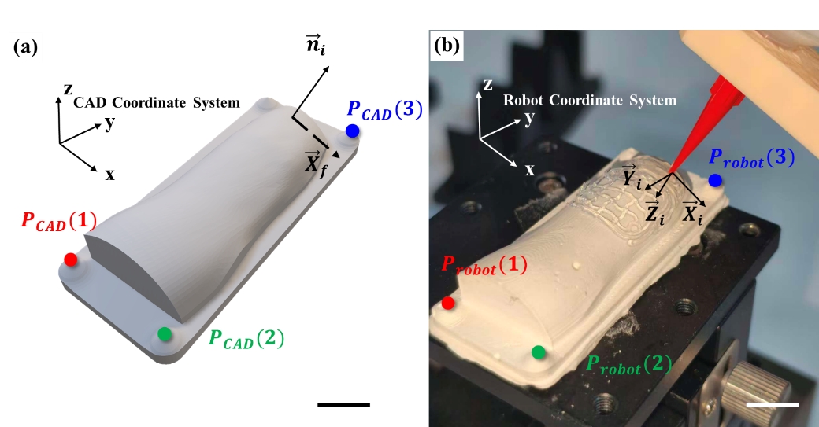
Fig.S1. Path points and marker points under the model coordinate system and the robot arm coordinate system are used for coordinate transformation and pose generation. (a) Substrate model and marker points in the CAD Coordinate System and $P_{path}(i)$ with reference vector $X_{f}$ ; (b) Physical substrate and marker points in the Robotic Arm Coordinate System and TCP pose at $P_{path}(i)$;
As shown in Fig.S1(a-b), in this study, three non-collinear marker points $P_{CAD}$, were designed on the substrate model, while three corresponding marker points $P_{robot}$ were fabricated on the physical substrate and located by move robot’s TCP to those points. Based on the coordinate values of these points, the translation and rotation matrices were calculated to obtain the spatial translation and rotation transformation function $f_{trans}$, The calculation of the transformation function is based on Eq. S1-4. Then, the path points were subjected to an overall transformation using this transformation function, thereby converting the coordinate values of the printing path points into the robotic arm coordinate system. The TCP pose is calculated from the normal information of the path points and a given reference axis, as specified in Eq. S5.
$$\begin{aligned}\begin{matrix}{\vec{X}}_{robot}= P_{robot}\left(2\right)-P_{robot}\left(1\right) \\ {\vec{Z}}_{robot}=corss\left({\vec{X}}_{robot},\left(P_{robot}\left(3\right)-P_{robot}\left(1\right)\right)\right) \\ \begin{matrix}{\vec{Y}}_{robot}=corss\left({\vec{Z}}_{robot},{\vec{X}}_{robot}\right) \\ R_{robot}=\left[{\vec{X}}_{robot},{\vec{Y}}_{robot},{\vec{Z}}_{robot}\right]\end{matrix}\end{matrix}\#\left(S1\right)\end{aligned}$$
In Eq.S1 where ${\vec{X}}_{robot}$ denotes the vector formed by two points in the robotic coordinate system, which serves as the X-axis, $P_{robot}$ denotes the set of marked points in the robotic coordinate system, ${\vec{Z}}_{robot}$ denotes the vector in the robotic coordinate system, which serves as the Z-axis, ${\vec{Y}}_{robot}$ denotes, the vector in the robotic coordinate system, which serves as the Y-axis, $corss$ denotes cross product of vectors and $R_{robot}$ denotes spatial transformation matrix established based on three vectors in robotic coordinate system.
$$\begin{aligned}\begin{matrix}{\vec{X}}_{CAD}= P_{CAD}\left(2\right)-P_{CAD}\left(1\right) \\ {\vec{Z}}_{CAD}=corss\left({\vec{X}}_{CAD},\left(P_{CAD}\left(3\right)-P_{CAD}\left(1\right)\right)\right) \\ \begin{matrix}{\vec{Y}}_{CAD}=corss\left({\vec{Z}}_{CAD},{\vec{X}}_{CAD}\right) \\ R_{CAD}=\left[{\vec{X}}_{CAD},{\vec{Y}}_{CAD},{\vec{Z}}_{CAD}\right]\end{matrix}\end{matrix}\#\left(S2\right)\end{aligned}$$
In Eq.S2, where ${\vec{X}}_{CAD}$ denotes the vector formed by two points in the CAD coordinate system, which serves as the X-axis, $P_{CAD}$ denotes the set of marked points in the CAD system, ${\vec{Z}}_{CAD}$ denotes the vector in the CAD coordinate system, which serves as the Z-axis, ${\vec{Y}}_{CAD}$ denotes, the vector in the CAD coordinate system, which serves as the Y-axis, $corss$ denotes cross product of vectors and $R_{CAD}$ denotes spatial transformation matrix established based on three vectors in CAD coordinate system.
$$\begin{aligned}\begin{matrix}R_{trans}={R_{robot}}/{R_{CAD}} \\ T_{trans}= P_{robot}\left(1\right)-R_{trans}*P_{CAD}\left(1\right)\end{matrix}\#\left(S3\right)\end{aligned}$$
In Eq. S3, where $R_{trans}$ denotes spatial rotation matrix for transformation from the CAD coordinate system to the robotic arm coordinate system, $T_{trans}$ denotes Spatial translation matrix for transformation from the CAD coordinate system to the robotic arm coordinate system.
$$\begin{aligned}\begin{matrix}M_{trans}=\left[R_{trans},T_{trans}\right] \\ f_{trans}:M_{trans}*P_{path}\end{matrix}\#\left(S4\right)\end{aligned}$$
In Eq.S4, where $M_{trans}$ denotes spatial rotation and translation matrix for transformation from the CAD coordinate system to the robotic coordinate system, $f_{trans}$ denotes function for transforming path points from the CAD coordinate system to the robotic coordinate system, $P_{path}$ denotes path points in CAD coordinate system.
$$\begin{aligned}\begin{matrix}{\vec{Z}}_{i}={{-\vec{n}}_{i}}/{\left\|{-\vec{n}}_{i}\right\|} \\ {\vec{Y}}_{i}={\left({\vec{Z}}_{i}×{\vec{X}}_{f}\right)}/{\left\|{\vec{Z}}_{i}×{\vec{X}}_{f}\right\|} \\ \begin{matrix}{\vec{X}}_{i}= {\left({\vec{Y}}_{i}×{\vec{Z}}_{i}\right)}/{\left\|{\vec{Y}}_{i}×{\vec{Z}}_{i}\right\|} \\ R_{i}=\left[{\vec{X}}_{i},{\vec{Y}}_{i},{\vec{Z}}_{i}\right] \\ \begin{matrix}ρ_{i}=rot2axang\left(R_{i}\right) \\ {pose}_{i}=\left[x_{i},y_{i},z_{i},ρ_{ix},ρ_{iy},ρ_{iz}\right]\end{matrix}\end{matrix}\end{matrix}\#\left(S5\right)\end{aligned}$$
In Eq.S1 where ${\vec{Z}}_{i}$ denotes the Z-axis of the TCP at path $i$ calculated from the normal vector of path point $i$, ${\vec{n}}_{i}$ denotes the normal vector of path point $i$, ${\vec{Y}}_{i}$ denotes the Y-axis of the TCP at path $i$, ${\vec{X}}_{i}$ denotes the X-axis of the TCP at path $i$, $R_{i}$ denotes the rotation matrix of the TCP at path point $i$, $ρ_{i}$ denotes axis-angle rotation of the TCP at path point $i$, ${pose}_{i}$ denotes the pose of the TCP at path point $i$.

S5. Ink preparation process
The preparation process of Ink 1 was as follows: the SE1700 PDMS matrix and curing agent were mixed in a material bottle at a mass ratio of 10:1, and homogenously stirred at a rotational speed of 1500 r/min using a planetary mixer (Model QM3SP2, Shenzhen Zhongyan Yichuang Technology Co., Ltd.); subsequently, the mixture was subjected to centrifugal defoaming at 3500 r/min for 5 min with a centrifuge (Model TG1650-WS, Shanghai Luxiangyi Centrifuge Instrument Co., Ltd.) to remove internal air bubbles, thus completing the preparation of Ink 1.
For the preparation of Ink 2, Sylgard 184 PDMS and curing agent were mixed in a material bottle at a mass ratio of 10:1 with the addition of carbon black at a mass fraction of 8%. The mixture was then homogenously stirred at 1500 r/min using a planetary mixer (Model QM3SP2, Shenzhen Zhongyan Yichuang Technology Co., Ltd.); thereafter, centrifugal defoaming was performed at 3500 r/min for 5 min with a centrifuge (Model TG1650-WS, Shanghai Luxiangyi Centrifuge Instrument Co., Ltd.) to eliminate internal air bubbles, and the preparation of Ink 2 was thus finished.

Movie S1. Needle printing pose adjustment (MP4, 23.0 MB).
Here is a demonstration of the movement effect of the printing nozzle on curved surfaces after its pose adjustment.
Movie S2. Continuous filling paths on different unstructured surfaces (MP4, 38.9 MB).
This is a path animation demonstration of one-stroke complete filling on various unstructured curved surfaces.
Movie S3. Continuous filling paths on different unstructured surfaces (Lattice Structure Embeded) (MP4, 29.0 MB).
This is a path animation demonstration of the partial embedding and filling of lattice structures with a one-stroke approach on various unstructured curved surfaces.
Movie S4. Muti-layer continous path printing (MP4, 43.1MB).
This is a video demonstrating the one-stroke complete filling of complex structures on multi-layered complex curved surfaces, which includes a full path animation demonstration and synchronous multi-perspective physical printing footage. The video has been speeded up due to the long printing duration.
Movie S5. Conductivity test of multilayer functional structures (MP4, 20.6 MB).
This is a video demonstrating the electrical conductivity of the printed multi-layered functional materials on curved surfaces by means of a digital multimeter.

