Divvy Bikeshare Data Pipeline Documentation
- Executive summary
This project is a local and fully orchestrated data pipeline for Divvy’s public bikeshare trip data. The purpose of the project is to provide business information about Chicago’s bikeshare riders that use the system: where do bikes stack up, what are the differences between the habits of members and casual riders, how riding habits have changed over the years and which stations changed their name.
- Dataset description
Source: Divvy Bikeshare trip data, published at https://divvybikes.com/system-data
Format: ZIP archive that contains a single CSV information about the trips in a month. Each trip has multiple information related to it (ride_id, rideable_type, started_at, ended_at, start/end station id and name, start/end latitude and longitude, member_casual)
Update frequency: monthly
Scoping decision: CSVs were downloaded manually.
Volume loaded: 25 distinct months between April 2020 and May 2026 in order to notice different changes related to the dataset and the habits of the customers
- Project structure walkthrough
dags/ingest_dag.py: the airflow DAG definition, it contains six tasks, retry logic, dependencies
scripts/extract_trips.py: converts source_csv/*.csv into raw/*.parquet idempotently
scripts/load_trips.py: loads raw/*.parquet into DuckDB bronze
dbt_project/models/staging/: stg_trips.sql(source) and schema.yml(tests)
dbt_project/models/intermediate/: int_station_observations.sql
dbt_project/snapshots/: dim_station_snapshot.sql; station name change snapshot definition
dbt_project/model/marts/: fct_trips.sql with the aggregated business information and the 5 marts that answer the business questions
dbt_project/tests/: assert_positive_trip_duration.sql
source_csv/: manually downloaded CSVs
raw/: parquet files for each CSV
warehouse.duckdb: database file
docs/project_documentation.docx: this document
screenshots/: screenshots used for the documentation/presentation
docker-compose.yml_env: airflow + postgres container definitions and their configurations

- Arhitecture overview
Three tools work with a single shared file: warehouse.duckdb. Airflow orchestrates when the work happens, DuckDB is where the data is located, dbt defines how the data is transformed.
Airflow task’s are python call scripts that open a DuckDB connection to land and load data and dbt tasks that use the dbt CLI.
Everything runs inside Docker via docker-compose - an Airflow webserver, an Airflow scheduler, and a Postgres database (used only for Airflow's own metadata, not for any pipeline data). The project's dags/, scripts/, dbt_project/, source_csv/, raw/, and warehouse.duckdb are all bind-mounted into the containers from the host filesystem, so a local edit to a dbt model or Python script is picked up by Airflow immediately, without rebuilding the image. dbt's DuckDB path resolves through the DIVVY_DUCKDB_PATH environment variable, which is unset (falling back to a relative path) for local development and explicitly set to an absolute container path in docker-compose.yml - letting the same profiles.yml work correctly in both environments.

- Data modeling explanation
The layers present are: staging, intermediate, snapshot, fact, mart.
stg_trips
- Grain: one row per trip
- Cleans(removes negative duration trips) and deduplicates(keep just one trip for an id)
int_station_observations
- Grain: one row per station sighting (either as start or as end)
- Brings all stations into a single stream, used for snapshotting
dim_station_snapshot
- Grain: one row per station
- SCD type 2 dimension tracking station identity: renames and relocations over time
fct_trips
- Grain: one row per ride/trip
- Incremental fact table, each trip has the start/end station set as the one that was actually valid at that the time the trip took place
mart_station_imbalance
- Grain: one row per station and rider type
- Average weekday departure/arrival imbalance
mart_monthly_trends
- Grain: one row per loaded month and rider type
- Trip volume, member/casual split and average duration over time
mart_station_history
- Grain: one row per station with more than one snapshot version
- Shows stations that were renamed or relocated
mart_station_utilization_by_hour
- One row per station
- Hourly departure activity relative to own station’s peak hour
Mart_od_efficiency
- One row per origin and destination and time of day and rider type
- Average speed and pace between station pairs
- Airflow DAG explanation
The pipeline follows an Airflow DAG with six sequential tasks:
extract: converts new CSV’s from source_csv/ into Parquet files at raw/, skipping months already loaded
load: rebuilds bronze.trips in DuckDB from every Paruqet file in raw/
validate_load: fails the DAG early if bronze.trips is empty
dbt_snapshot: runs dbt snapshot to capture the station dimension’s SCD Type 2 History
dbt_run: builds staging, intermediate, fact and mart models
dbt_test: runs the full dbt test suite
Every task is retried once.
The DAG (divvy_pipeline) is defined with schedule=None: it is triggered manually.
Re-running the DAG at any point does not create duplicate or corrupted results. The extract task skips any month whose Parquet file already exists in raw/; the load task rebuilds bronze.trips from a full glob over raw/, so it is naturally consistent regardless of how many times it runs; and fct_trips is materialized as an incremental dbt model with unique_key='ride_id' and a merge strategy, so re-processing a previously-loaded month updates existing rows rather than duplicating them.
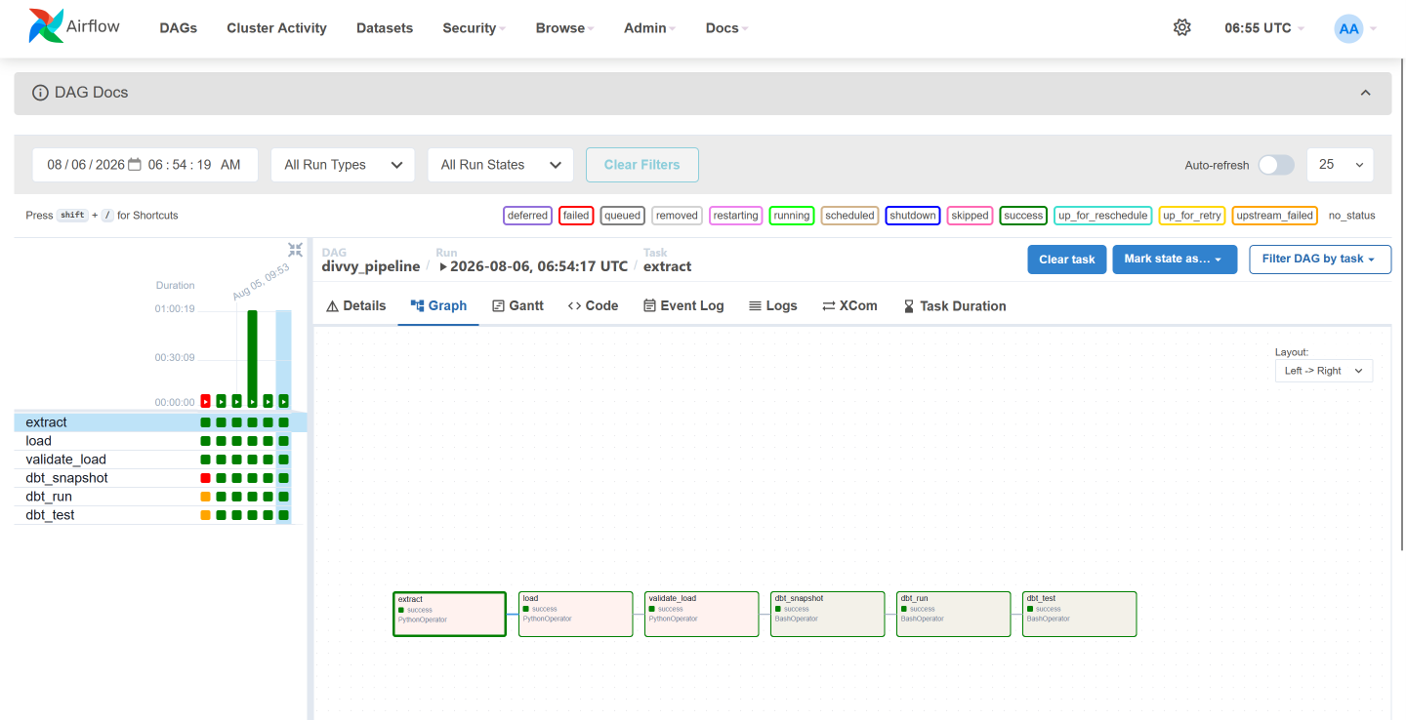
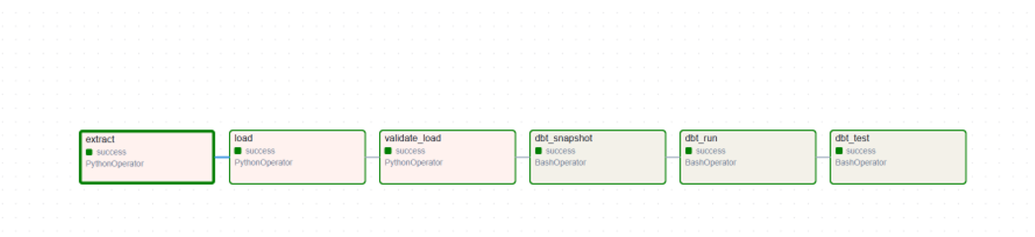
- dbt Lineage and Tests
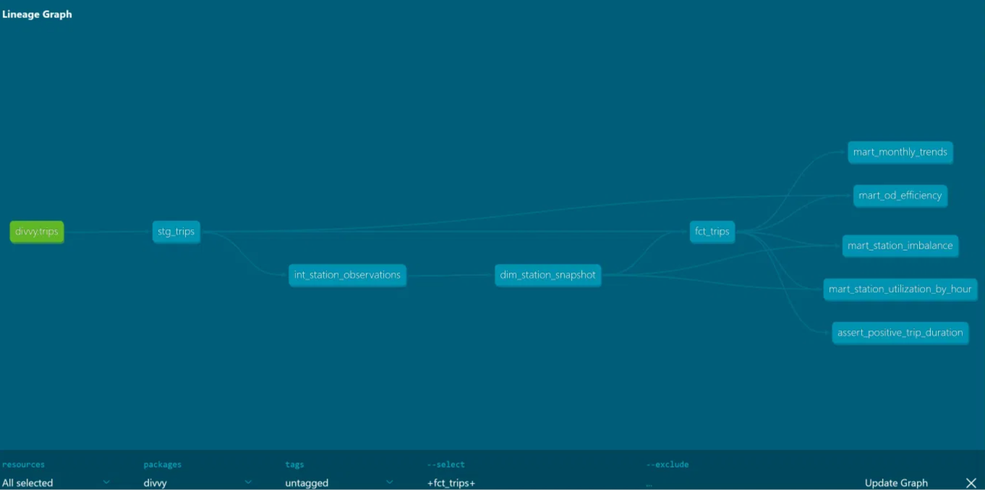
Tests:
- Unique: on stg_trips.ride_id. It passes. It tests primary key uniqueness at staging level so that downstream joins don’t work with duplicates.
- Not_null: on stg_trips.ride_id. It passes. Primary key is complete
- Unique: on fct_trips.ride_id. It passes. It confirms that the incremental merge never produces duplicate fact rows.
- Not_null: on fct_trips.ride_id. It passes. It confirms primary key in fact table is complete.
- Accepted_values: on fct_trips.rideable_type. It passes. It makes sure only classic_bike, electric_bike, docked_bike are tracked.
- Not_null: on fct_trips.start_station.id. Warning. Electric-bike trips have no start station since they dont require docking.
- Not_null: on fct_trips.end_station.id. Warning. Same as above
- Assert_positive_trip_duration. Warning. Trip duration must be positive.
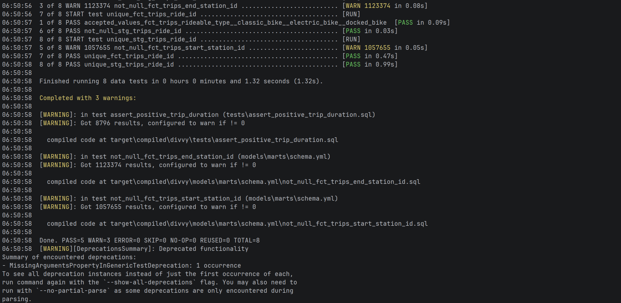
- How to run
From a clean checkout, with warehouse.duckdb, raw/ and dbt target directories deleted
- Place Divvy monthly CSVs (unzipped) into source_csv/ at the project root.
- Copy .env.example to .env and adjust ports/credentials if needed.
- From the project root, run: docker compose up - this provisions Postgres (Airflow's metadata DB), runs airflow-init, and starts the webserver and scheduler.
- Open the Airflow UI (the port configured in .env), log in, locate divvy_pipeline, unpause it, and trigger a manual run.
- Confirm all six tasks succeed in the Graph view.
- To inspect results directly: duckdb warehouse.duckdb -c "select * from fct_trips limit 5;" (or any mart).
- To regenerate dbt docs: cd dbt_project && dbt docs generate --profiles-dir . && dbt docs serve --profiles-dir . --port .
- Answers to the deliverable questions
Which stations have the largest net imbalance between departures and arrivals on an average weekday (useful for rebalancing), and does this differ between members and casual riders?
Model: mart_station_imbalance
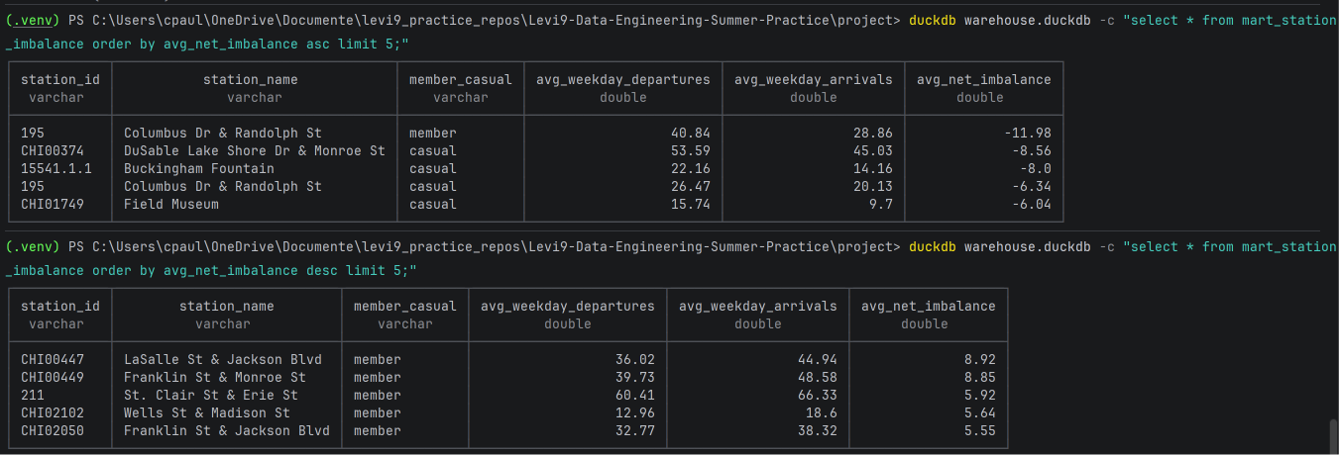
Interpretation: a commuter flow is present; residential-adjacent stations lose bikes in the morning, after that the bikes are present in the central city locations
How have average trip duration and the member/casual split changed month over month across the available history?
Model: mart_monthly_trends
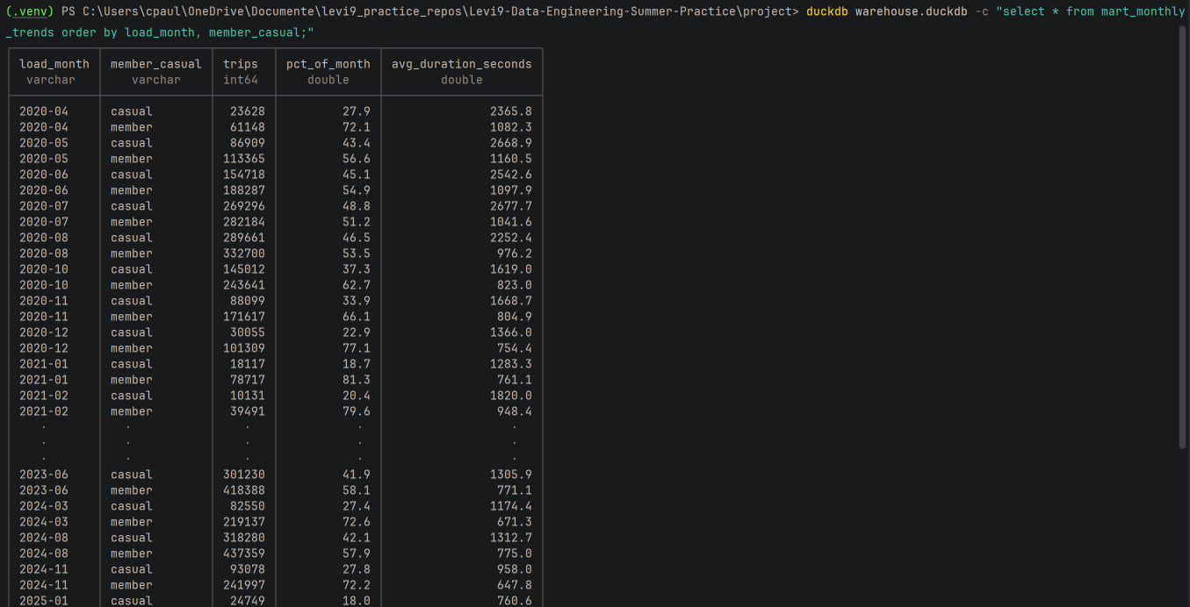
Interpretation: casual riders take longer rides, probably just for sightseeing/exploring the locations, while member riders have much shorter trips, probably travelling with a set purpose/destionation. Trips got shorter because more stations appeared and because electric bikes are faster.
Which stations were renamed, relocated, or re-issued a new ID over the available history, and how would trip counts be miscounted if that weren't corrected for?
Model: mart_station_history
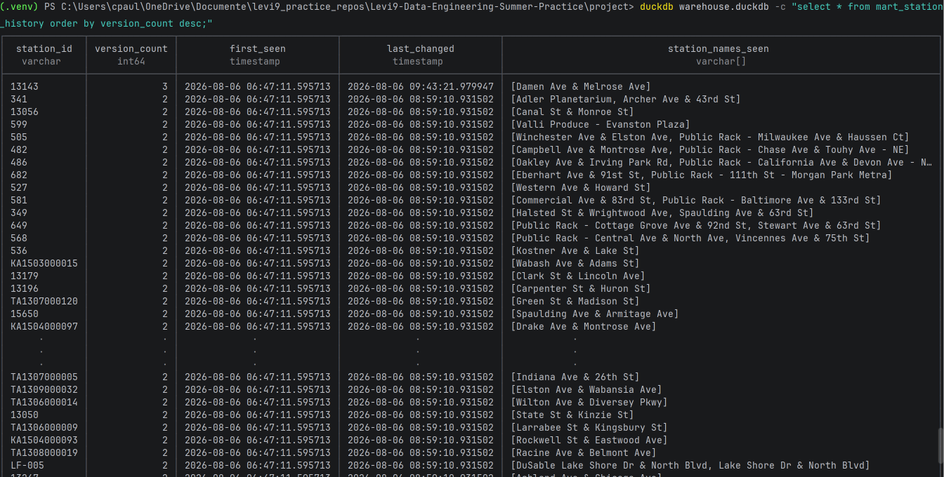
How does each station's departure activity vary across hours of the day relative to its own peak usage, and does the shape of that hourly pattern differ between members and casual riders?
Model: mart_station_utilization_by_hour
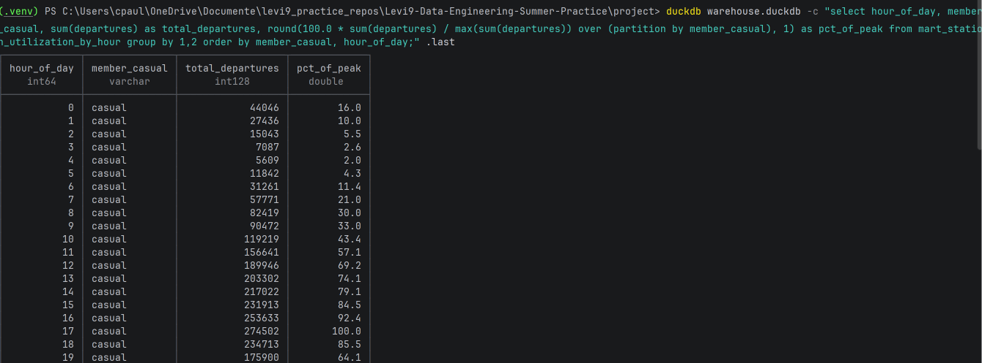
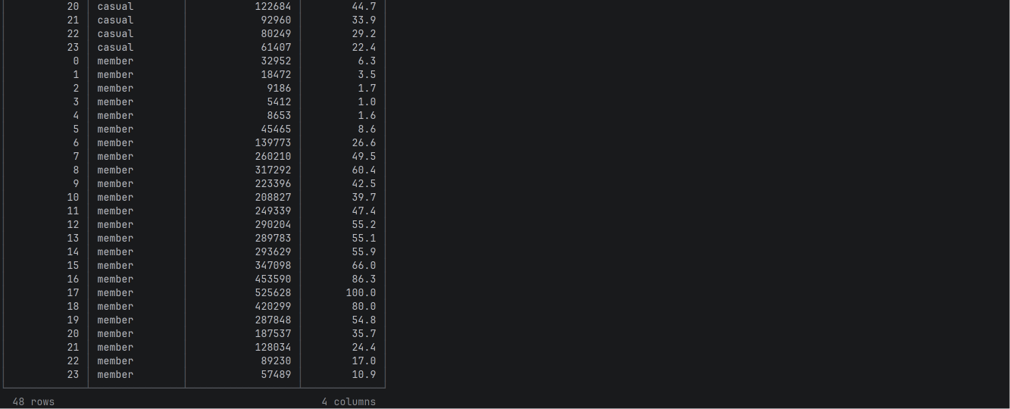
Interpretation: For members the morning peak is around 8am, the evening peak is around 5pm. This confirms the commuter pattern : members leave early in the morning for work and return in the evening. For casuals the peak is also around 5pm, but its after a slow rise, then followed by a slow reduction.
What is the average speed (or minutes per mile) for trips between each origin‑destination pair, and how does it vary by time‑of‑day and rider type?
Model: mart_od_efficiency
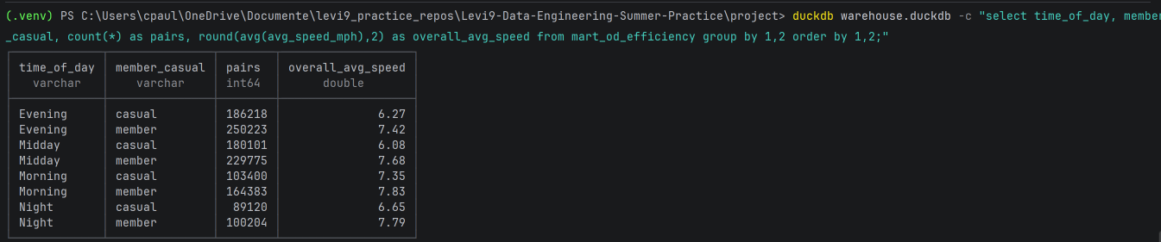
Interpretation: this enforces even further the idea that members travel with a purpose. They have a higher overall speed at all moments of the day

- Challenges and lessons learned
The same trip appearing in two different month file
- unique_stg_trips_ride_id and unique_fct_trips_ride_id both failed after loading November and December 2020 together, with 209 duplicate ride_ids.
- Investigation showed the same ride_id appearing in two different monthly files, Divvy’s month cuts are not clean so certain trips appear twice.
- Resolved by deduplicating in stg_trips on ride_id, keeping the earliest-loaded, chronologically valid copy (qualify row_number() ... order by load_month asc, (ended_at > started_at) desc)
- Lesson: a natural-key uniqueness test catches a row that appears twice may seem unnecessary but it can be really useful in practice.
Trips with negative duration
- mart_monthly_trends showed avg_duration_seconds = -1248.76 for December 2020; not a few outlier rows, but a negative average across all 131,364 trips that month.
- Resolved by filtering the duration average in mart_monthly_trends to a plausible 0-24 hour window (avg(trip_duration_seconds) filter (where trip_duration_seconds between 0 and 86400)), leaving trip counts and every other metric on the fact table untouched.
- Lesson: the same root cause (Nov/Dec file-boundary corruption) produced two different symptoms - a duplicated key in one case, a corrupted single row in the other
Electric-bike trips have no station ID by design
- not_null tests on fct_trips.start_station_id and end_station_id began failing at meaningful volume (1,057,655 and 1,123,374 rows respectively) once electric-bike trips entered the loaded dataset.
- Resolved by downgrading both tests to severity: warn with that specific, verified justification
- Lesson: a spike in nulls is not automatically a data-quality defect - it can be a legitimate change in what the data represents

