**select CWID**, **Name  
from** students  
**where** (  
 **CWID** =10115  
  
 )

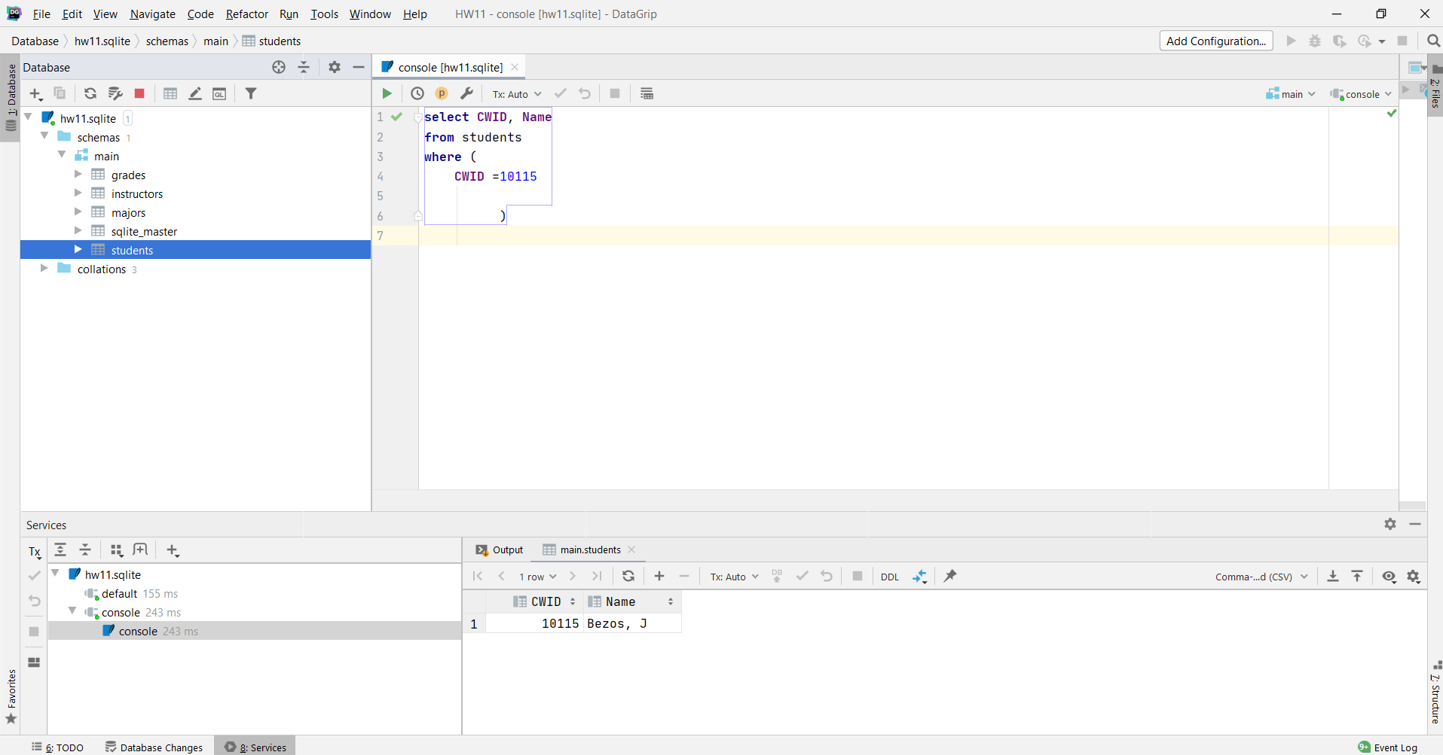

**select Major**, *count*(*\**) **as** cnt  
**from** students **group by Major**

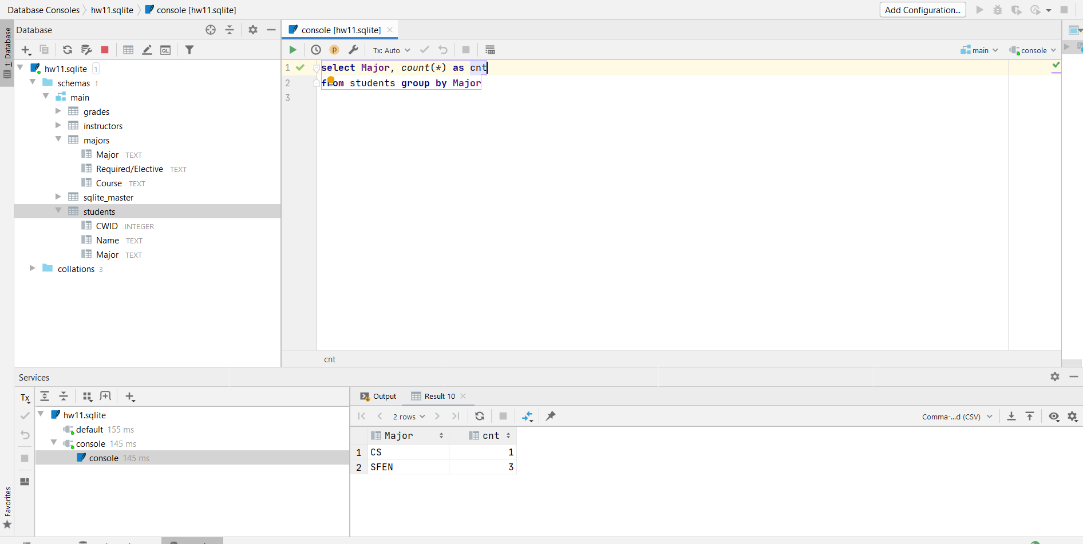

1. **select Course**, *count*(*\**) **as** cnt, **Grade  
   from** grades  
   **where Course** = **'SSW 810'  
   group by Grade  
   order by** cnt **DESC**

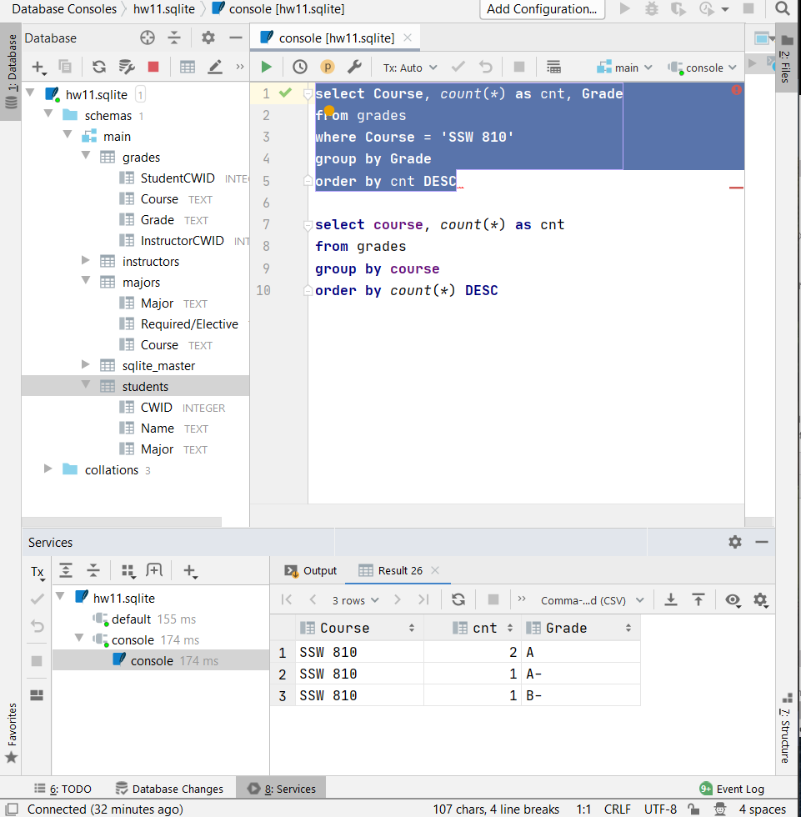

**select** students.**name**, *count*(*\**) **as** cnt, students.**major**, grades.**course**, grades.**grade  
from** students **join** grades **on** students.**cwid** = grades.**StudentCWID  
group by** students.**name**

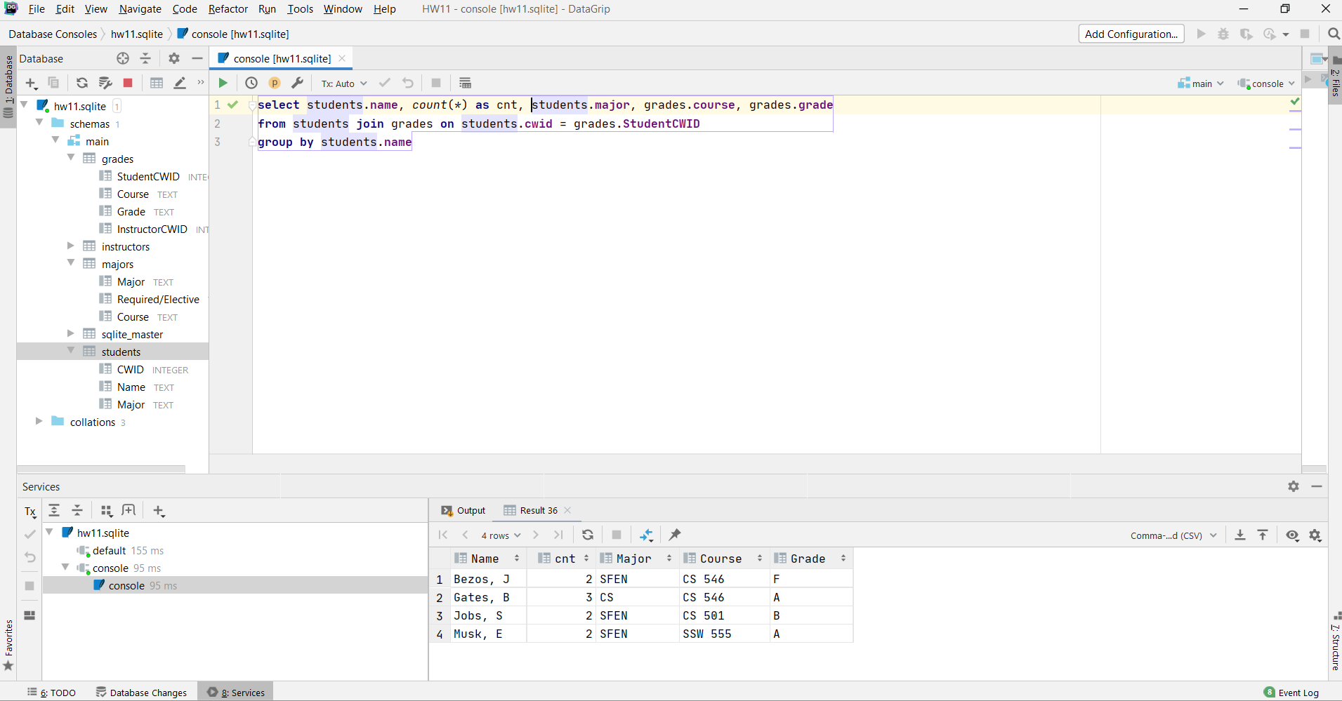

1. **select** students.**name**, students.**CWID**, grades.**course**, grades.**grade**, instructors.**Name  
   from** students **join** grades **on** students.**cwid** = grades.**StudentCWID  
   join** instructors **on** instructors.**CWID** = grades.**InstructorCWID  
   order by** students.**name**

