# Introduction:

The importance of understanding the average treatment effect of money allocation in schools on student performance cannot be overstated. Education is a critical factor in an individual's future success and well-being, and adequate funding for schools can significantly improve the quality of education and provide necessary resources to students and teachers. Policymakers must make informed decisions about how to allocate funds to schools to maximize their positive impact on student performance. Therefore, identifying the average treatment effect of money allocation is crucial in determining the most effective allocation of funds. Additionally, understanding the impact of funding on student performance can help identify areas where additional resources may be necessary to support struggling students, thus leading to a more equitable education system. This highlights the need for further research in this area to provide policymakers with empirical evidence to inform funding decisions and ensure that all students have access to high-quality education.

Nonetheless, a municipality's social economic status can have a significant impact on students' academic performance. While individual effort and ability are important factors in academic success, the resources, quality of education, home environment, and stressors that come with low SES can make it more difficult for students to perform at their full potential. It is important for schools and policymakers to recognize these challenges and work to provide resources and support to face these obstacles. Understanding the laying causality (if any) between SES and students’ performance can help Israel focus the efforts to overcome differences in students’ performance between low SES municipalities and high SES municipalities.

In addition, while it may seem as a result of funding and money allocation, the teachers quality might play an important role in the performance of the students in itself. This parameter can also be funded by the municipality. Instead of allocating funds to the student, the policymaker may want to consider encouraging teachers to expand their knowledge and learn new skills (such as MA studies). So, we would also like to see the average treatment effect of the teachers’ quality without reference to the money allocated. It is important since it is possible that allocation of money does not necessarily help the performance of students, but the teachers’ quality does and in this case, it is better to invest more in the teachers than the students directly, as explained earlier.

In any case, the results of the $ATE$ s of the 3 treatments mentioned above can lead to conclusions not necessarily implied nor “common sense”.

# Data:

The data was received from a researcher in Bar-Ilan University.

The data depicts allocations of over 200 cities all around Israel, over the years 2014-2020 (including both bounds).

The data contains attributes from general, economical information like social economic state and peripherality, to more of demographical information such as percentage of immigrants, percentage of Jews, special education, to even achievements information like percentage of 5pt. math students, teachers’ skills and so on.

Following is an in-depth explanation of all attributes.

|  |  |  |
| --- | --- | --- |
| Name | Details | Range |
| Rashut |  | Nominaly |
| ID |  | Nominaly |
| SES | מצב סוציו-אקונומי | [1=lowest,10=highest] |
| PERIPH | מיקום הרשות ביחס לריכוז האוכלוסיה | [1=far, 10=close] |
| JEWISH | מגזר הרשות | 1 – Jewish majority, 0 – non-Jewish majority |
| ALLOCATION | ממוצע הקצאה תוספתית לתלמיד | Non-negative number |
| YEAR | Year of allocation | 2014-2020 |
| DIST_FROM_TLV | Distance from Tel-Aviv | Non-negative number |
| JEWS_PERCENT | (%) of Jews | [0, 100]% |
| Teachers-skills | (%) of teachers with MA | [0, 100]% |
| Immigrant | (%) of immigrant students | [0, 100]% |
| Special-Education | (%) students in special education | [0, 100]% |
| Matriculation-eligibility | זכאות לבגרות - אחוז | [0, 100]% |
| Excellent-matriculation-eligibility | זכאות לבגרות בהצטיינות (אנגלית 5 יחל מתמטיקה 4 יחל מעורבות חברתית ומעל 90) - אחוז | [0, 100]% |
| Math | (%) students in 5 pt math class | [0, 100]% |
| Class-size | Average students in classroom | Non-negative number |
| Teacher-student-ratio | Average teacher-student ratio in schools – (1st to 12th grade) | Non-negative number |
| Social-involvement | בגרות חברתית – אחוז | [0, 100]% |
| Dropouts | (%) of dropouts | [0, 100]% |
| District | המחוז בו הרשות ממוקמת | Categorical |

The main problem in the dataset is missing data – almost all the columns have missing values. However, most of the columns contains over 90% of the values, so we imputed the data using mean imputation. “Social-involvement” did have much values missing (over 50%) so it was dropped after close examination, and consultation with the researcher.

Another problem was the inconsistency with the literature. That is the allocation should demonstrate the diminishing returns principle. Solution: apply the log transformation to get the ALLOCATION_LOG column. With that being coherent with the literature of economics.

Figure: municipalities' average supplemental allocation (per student) across ethnic diversity.

Source: Author calculations based on data from annual financial reports of municipalities provided on the Ministry of the Interior website, and student data provided on the Ministry of Education website.

The figure indicates that ethnic diversity is related to the size of the supplemental allocation, illustrating a gap in the extent of resources allocated to education.

In municipalities with predominantly majority populations (Jewish), the average supplemental allocation is around $1,235 (4,200 NIS), compared to an average supplemental allocation of about $440 (1,500 NIS) in LAs with predominantly minority group populations.

Furthermore, the variance across SES in the latter is very low. Therefore, we omitted these municipalities and focus on the municipalities with predominantly minority group populations.

# Assumptions

Assumption #1 – given the confounders provided in the dataset, the treatment and the outcomes are independent. This assumption may be incorrect. For example, the allocation (as treatment) may also be determined by the policy of the principals, that may also affect the outcomes.

Assumption #2 – as we didn’t learn in the course about a continuous treatment (like allocation), we assumed that splitting it by the median would be a fair solution to get a binary treatment (this was done also with the acknowledgement and approval from the researcher from Bar-Ilan).

Later, we tried lifting this assumption, and deal with a continuous treatment (see Continuous Treatment subsection in the Methods section for more details).

Assumption #3 – We assumed that increasing the allocation, quality of teachers or SES of a municipality does not help the performance of othermunicipalities.

# Methods

## Binary Treatment

We used the following methods:

1. Matching:  
   for a distance metric we used Euclidean distance.   
   Instead of using the closest sample from the “other group” (i.e. if the sample has $T=0$, a sample with $T=1$ and the other way around), we chose to use regression KNN with K=3.  
   In addition, to normalize the data we divided each column by its standard deviation.
2. IPW:  
   To calculate the propensity score for each sample, we used a regular logistic regression by skicit learn. The default solver did not converge so ‘liblinear’ was used (which did converge)
3. T learner:  
   Both the model for $T=0$ and $T=1$ were regression trees.
4. S learner:  
   The model we used is a decision tree.

## Continuous Treatment

Dealing with continuous treatment was no joke to us. Making it work, and work well, is a main aspect of this project.

Encountering this problem arise two main questions, the first is how to expand the already known methods to solve our continuous treatment problem, and the second being how to define ATE for a continuous treatment. We’ll try to answer the second question first.

ATE (Average Treatment Effect) is the difference between the outcome of treated and untreated groups. In a continuous treatment, this may not be well defined, because there is no such “treated” group.

Option #1: Plotting an Average Effect plot, that is for a given constant, print the ATE when the “treatment” is multiplying the given treatment (allocation for example) by the constant. With that we get a function that shows how a treatment of multiplication by the given x effects the outcome.

In this option we also used a decision tree.

Option #2: Differ the research question from ATE, to by how much one should multiple (or add to) the current treatment to get a X% improvement of the outcome. This question may be hard to answer because the models aren’t always linear, so reversing the equation becomes a complex non-trivial optimization problem.

Corollary: option#2 is the exact inverse function of option#1. Thus, in this project, we solved for option#1, and by the graph output of the method, one can answer option#2.

Option #3: Plotting an Average Effect plot, that is for a given constant, print the ATE when the “treatment” setting the value (allocation for example) to be that value and the “control” is setting the value as 0.

In this option we also used a decision tree.

# Results:

The Blue line is the confidence interval from bootstrap and the red dot is the ATE calculated on the entire dataset.

## Money allocation:

While not every confidence interval is strictly negative, most of them are and almost all the ATE calculated on the full dataset is negative.

From that we can understand that investing less money is probably better. While counterintuitive, we believe that there are a few explanations:

* In corporations with surplus budget, they may need to be more complicated to justify their budget, especially in government funded corporations.
* The municipalities that have a bigger allocation don’t spend in ‘wisely’. Meaning they have more money but don’t use it correctly.
* There may be missing confounders.
* We need to remember that the intuition is based on correlation and not causality.
* The researcher from Bar llan agreed that these results make sense.

For the continuous methods (option 1 is on the left and option 3 is on the right)

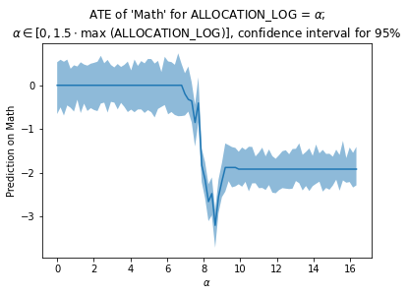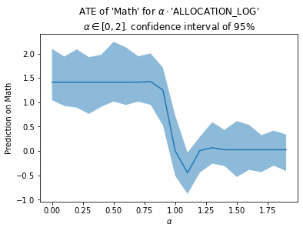

The left graph represents the ATE with option #1. i.e., treatment is multiplying the ‘Allocation log’ by $a∈\left[0, 2\right]$ and the control is keeping it the same.

The right graph represents the ATE with option #3. i.e., treatment is setting the ‘Allocation log’ to $a∈\left[0,1.5⋅\max{\text{ALLOCATION_LOG}}\right]$ and control is setting it to 0.

As we can see, the results are not monotonic.

As we can see in the graphs, there is a clear point of no return from which the outcomes significantly drops. We can explain this results in few different ways:

* The model we used is a regression decision tree and the changes are the threshold in the model. This seems unlikely because in the left graph, the “ALLOCATION_LOG” is multiplied and not set.
* Perhaps we tried to predict on values that do not really exist, like when we set   
  .

## SES

Here we can see that the IPW estimator has a very high variance. It can be explained by the common support graphs for SES, where the overlap is relatively small.

From looking at the coefficients, the main explanation is that the district heavily impacts the SES and so, it is easy to distinguish whether $T=1$ or $T=0$. For example, the coefficient for $I\left\{District=Yehuda and shomron\right\}$ is -1.3 and for Tel Aviv is 0.53.

In most of the methods, the CI is strictly positive and so, we can say with confidence that increasing the SES – the socioeconomic status – does in fact increase the performance of students.

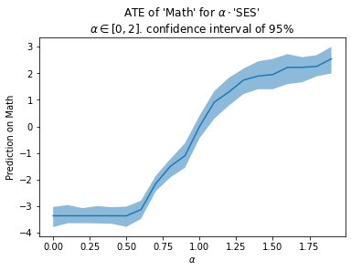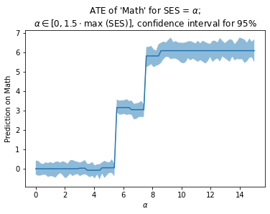

In contrast to the money allocation, the graphs here are mostly monotonically increasing.

An interesting result is that the “jumps” in the right graph correspond with the literature – 1-6 is considered lower class, 6-8 is considered middle class and 8-10 is considered upper class. This strengthens our believe that the SES has a big impact on the outcome of the students – a conclusion that makes sense.

Clearly, adding to the skills of teachers (that is encourage MA studies), causes an increase in the performance of students in various measurements, since all of the confidence intervals is strictly positive.

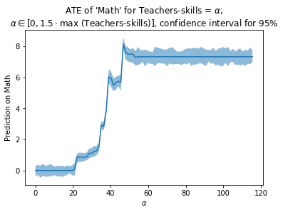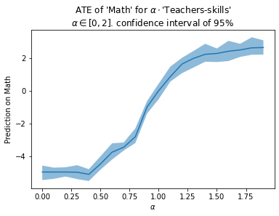In addition, one can observe that these results are superior to the results on SES and Allocations.

Here also, the graphs are mostly monotonically increasing.

All of the results above show with high confidence that increasing the teachers quality increases the performance of the students in the municipality.

On the right graphs, we can see 2 main results:  
An exponential growth up to $α=50$ and a plateau from there.

The main explanation we thought of is that the “good teachers” carry the “bad teachers”. For example, this can be explained if the “good teachers” take key positions in the school like coordinators and principals. However, when most of the teachers are “good”, the added effect of another “good teacher” is small.

## Weaknesses

As presented in the confidence intervals for the allocation, the ATE is not certain. That is, some confidence intervals contain 0, therefore no established conclusion can be inferred.

Thence, cases suffering from the mentioned drawback cannot contribute to determining based results.

Encountering this phenomenon, that in many cases confidence intervals contain 0, raised many questions. Expecting that to be less frequent led the project to examine the confounders.

# Discussion:

As we can see, for the allocation it is not certain that the $ATE$ is positive nor that it is negative.

However, in the Wilcoxon test, the values of the municipalities with higher allocations are statistically bigger. This shows that the connection between the allocation and performances is correlational and not causal.

The main conclusion from this project is: Instead of investing more and more money into the education system, it is better to use it in different ways like helping the lower and middle class or using it to trin better teachers.

## Stable Unit Treatment Value Assumption (SUTVA):

1. “The potential outcomes for any unit do not vary with the treatments assigned to other units”: As we already mentioned in the “Assumptions” part, we assumed that increasing the allocation, quality of teachers or SES of a municipality does not help the performance of **other** municipalities.
2. “For each unit, there are no different forms or versions of each treatment level, which lead to different potential outcomes”: The treatment has only 2 forms, above a certain quantile or not.

## Consistency:

* For a unit that receives treatment T, we observe the corresponding potential outcome $Y_{T}$: The data is from official sources, so we assume that it is consistent and correct.

## Ignorability – No Unmeasured Confounders:

Confounders in current settings can be split to three categories:

First, analytic, and numeric confounders. Those are easily measured, and one can assume that most of them are present in the data. Note that there might be some missing numeric confounders (for example municipalities that get additional allocations from companies “under the radar”. These allocations may not appear in our dataset), but after consultancy with the researcher from BIU, those missing confounders are much less important than the others which are been presented below.

Second, social confounders. These include the social aspects of the community bonding in the municipality, community demographics (like settlers in Gush A’Zion which may be associated with high motivation, and goal drive), and schools’ own communities.

For example, strong community bonds may improve motivation in students.

Lastly, personal confounders. These include, schools’ principal’s personal attributes, and other people-of-power in the municipality’s educational system.

For example, promoting students’ success in local newspaper. Or a highly charismatic principal that talks teachers into voluntarily tutor weak students or motivates students to study harder.

Unfortunately, social, and personal confounders cannot be well-defined and observed in any sort of numerical, tabular data formats, thus dealing with these missing confounders is non-trivial.

## Common Support:

As we can see in the next plots, common support does hold for the allocation:

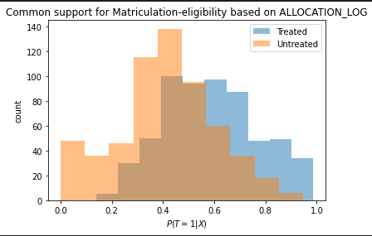

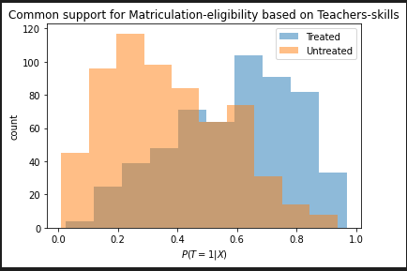It is also clear that common support holds for the teacher’s quality:

However, it does not seem to hold for the SES measurement, which explains the different results we received in the IPW method.

