Introduction

Defect Detection in manufacturing process

Christian Picon Calderón
Biomedical engineering
Email: c.picon@uniandes.edu.co

Automatic defect detection is an area of interest in the machine vision field. It occurs mainly because it is very adopted in many industries which have the needed to improve their quality product at low-level cost. Using automatic detection, the capability to improve and check the production chain is very rentable. The above because it is more efficient than hiring personal of supervising quality to find a defect in each one product [1]. The principal objective of an autonomous vision system is automatically examining specific visual patterns on a set of images in order to find anomalies undesirable. It is expected to overcome improve the performance of correction [2].

The manufacturing industry of steel produces 100 billion of revenue in U.S [3]. In Colombia, this industry has weighed in levels of hiring personal. This industry has grown by 13% from 2007 to 2017. Colombia is considered the third largest producer of this metal in South America and the fourth in Latin America. [4]. Moreover, the steel is an important material to infrastructure [5] as electrodomestic industry [6]. Therefore, the interest in this project seeks to solve the problem of automatic verification of defects to help the production of the metallurgical chain. For that, I will be predicting the location and type of defects found in steel manufacturing. To realize that goal I will use the dataset published by Kaggle which is currently used to establish competition of Steel Defect Detection proposed by the Severstal company [7].

Dataset

The dataset has a size of 1.3 Gb approximately. The dataset contains 14369 images. 12.568 in training set (87.5%) and 1.801 in testing set (12.5%).
The images are named with a unique ImageId. Each image may have no defects, a defect of a single class, or defects of multiple classes. Therefore, the are 4 possible labels stored with the variable ClassId ranged [1, 2, 3, 4]. Consequently, each image has its specific annotations which are necessary to get the evaluation metric. In the next figure, four images are visualizing with their specific mask annotation.

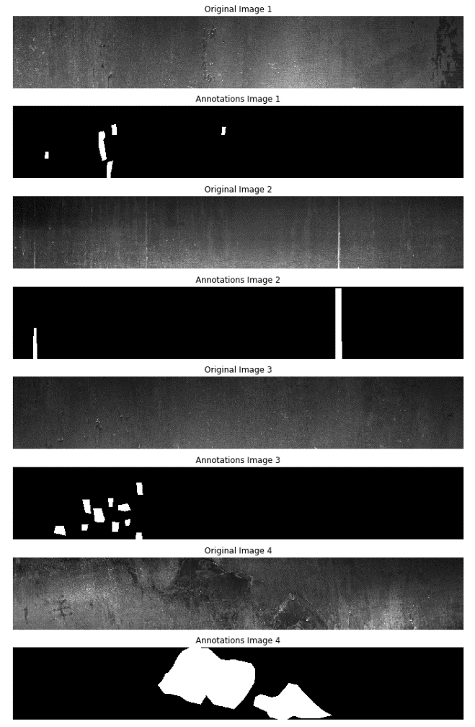
Figure 1. Each two rows correspond to same image. The first one is the original. The second is the annotations.

The code corresponding to this projects can be found in https://github.com/Cpicon/severstal_steel_defect_detection_kaggle_project

References
- Hajizadeh S, Nunez A, Tax DM. Semi-supervised rail defect detection from imbalanced image data. IFAC-PapersOnLine. 2016;49(3):78–83
- O. Essid, H. Laga, and C. Samir, “Automatic detection and classification of manufacturing defects in metal boxes using deep neural networks,” Plos One, vol. 13, no. 11, Sep. 2018.
- “Industry Market Research, Reports, and Statistics,” IBISWorld. [Online]. Available: https://www.ibisworld.com/industry-trends/market-research-reports/manufacturing/primary-metal/iron-steel-manufacturing.html.
- “¿CÓMO ESTÁ LA INDUSTRIA DEL ACERO EN COLOMBIA?,” Magento Commerce. [Online]. Available: https://gyj.com.co/noticias/acero-en-colombia/.
- “10 reasons to use steel in residential construction,” worldsteel. [Online]. Available: https://www.worldsteel.org/steel-by-topic/steel-markets/buildings-and-infrastructure/residential-housing.html.

