Evaluating Queue- and Heterogeneity-Aware Aging for CPU Scheduling: A Trace-Driven Ablation Study

Aditya Pratap
B.Tech Computer Science (Blockchain Technology)
Vellore Institute of Technology
Vellore, India
Reg. No. 24BKT0132
Deepanshu Kumar Jha
B.Tech Computer Science (Blockchain Technology)
Vellore Institute of Technology
Vellore, India
Reg. No. 24BKT0152

Abstract—Shortest Job First (SJF) keeps average waiting low but can leave long jobs waiting; Highest Response Ratio Next (HRRN) adds fixed aging. This paper reports the methodology and first experiments for QH-SJF, a non-preemptive policy whose aging strength adapts at every dispatch to the queued work (L) and the burst-length variability (H) of the ready queue. We built a deterministic single-CPU simulator in C11 and compared QH-SJF with FCFS, SJF, HRRN, linear aging, fixed quadratic aging, and L-only and H-only ablations on seven synthetic workload families (30 held-out seeds each) with exact and predicted burst lengths. Parameters were tuned on separate calibration seeds. In these preliminary results every tuned aging policy cut p99 waiting by about 22% to 23% relative to SJF at the price of about 8% to 11% more average waiting. Tuned QH-SJF matched HRRN on tail waiting (p99 ratio 0.772 vs 0.777) with a slightly lower average-waiting cost (1.093 vs 1.113), but did not beat tuned fixed quadratic aging (1.075), and the heterogeneity signal added no clear benefit. Trace-derived workloads and preemptive baselines are still to be run.
Keywords—CPU scheduling, shortest job first, HRRN, aging, burst prediction, ablation study, simulation, C11

Finalized System Architecture
A CPU scheduler must pick the next ready process, and the choice trades average waiting time against delay for long jobs. SJF minimizes mean completion time on a single machine [1] and SRPT is optimal for mean response time when preemption is allowed [5], but long jobs can wait behind a stream of short ones. HRRN raises a job's priority as it waits [6], yet it ages every job at one fixed rate. We evaluate QH-SJF, which sets the aging rate from two ready-queue signals, and we treat it as a hypothesis to test against HRRN and tuned fixed aging, not as a proven improvement.
The finalized architecture (Fig. 1) is a pipeline around one shared simulation engine. Workloads come from hand-checked CSV cases, a seeded generator for seven families, and a trace converter. A loader validates them and an experiment controller runs the calibrate, freeze, test protocol. The engine owns the clock, the ready set and idle-gap handling and runs the chosen process to completion. A policy never changes time or completion state; it only returns one index from the ready set. A burst predictor supplies predicted bursts to the decision, while execution always uses the true burst. Metrics are written to CSV and then analyzed statistically.
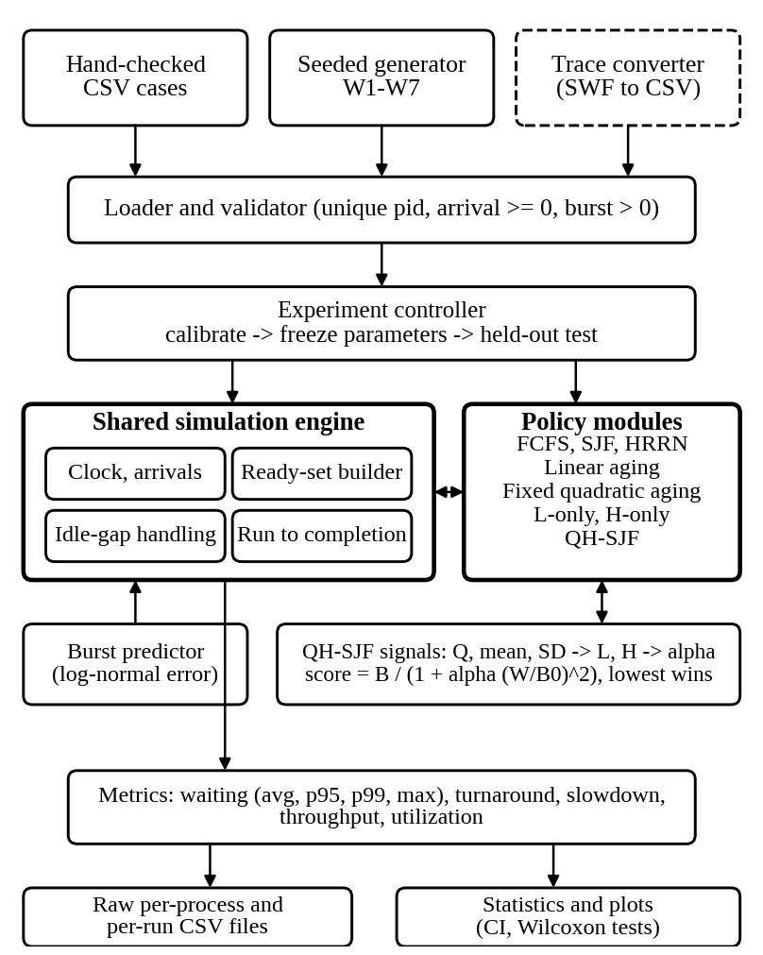
- Finalized system architecture. The dashed box (trace converter) is implemented and tested on a sample but not yet applied to a real log.
Three design decisions shape the rest of the paper. First, one engine serves every policy, so differences come only from the decision rule. Second, predictions drive decisions but true bursts drive execution, so prediction error costs the policy something. Third, all tunable policies are tuned on calibration seeds only and then frozen before any held-out run.

Detailed Methodology

Proposed Method: QH-SJF
At dispatch time t the ready set R_{t} holds every arrived, unfinished process. Let b_{i} be the predicted burst of process i, B_{i} its true burst, A_{i} its arrival and W_{i} = t − A_{i} its waiting time. The scheduler computes the queued work Q_{t} = Σ b_{j} over R_{t}, the mean μ_{t} and the population standard deviation σ_{t} of the predicted bursts, and then
L_{t} = Q_{t} / (Q_{t} + K B₀) (1)
H_{t} = σ_{t} / (μ_{t} + σ_{t}) (2)
α_{t} = α_{min} + (α_{max} − α_{min}) L_{t} H_{t} (3)
S_{i}(t) = b_{i} / (1 + α_{t} (W_{i} / B₀)²) (4)
The process with the lowest score S_{i} runs next; ties go to the earlier arrival and then the lower process ID. L_{t} and H_{t} lie between 0 and 1, so α_{t} always stays between α_{min} and α_{max}. With one queued job or equal bursts, H_{t} = 0 and aging is at its weakest. B₀ is a reference burst scale and K a saturation constant. Initial values were α_{min} = 0.10, α_{max} = 1.00, K = 5, and B₀ equal to the median burst of the calibration set.

Baseline Methods and Ablations
Table I lists the compared policies. FCFS, SJF and HRRN have no tunable parameters. Linear and fixed quadratic aging are the aging baselines. L-only and H-only keep one adaptive signal each, so they test whether queued work and burst variability matter separately.
- Policies compared
Policy | Lowest score or key wins | Tuned
FCFS | earliest arrival | none
SJF | smallest b_{i} | none
HRRN | largest (W_{i} + b_{i}) / b_{i} | none
Linear aging | b_{i} / (1 + β W_{i} / B₀) | β, B₀
Fixed quad. aging | Eq. (4) with fixed α_{f} | α_{f}, B₀
L-only | Eq. (4), α from α_{min} + (α_{max} − α_{min}) L | α_{min}, α_{max}, K, B₀
H-only | Eq. (4), α from α_{min} + (α_{max} − α_{min}) H | α_{min}, α_{max}, K, B₀
QH-SJF | Eq. (4) with α from Eq. (3) | α_{min}, α_{max}, K, B₀

Burst Prediction
The policies decide with predicted bursts b_{i} = B_{i} exp(s z_{i}), where z_{i} is standard normal and s is the error level. We use s = 0 (exact) and s = 0.5. The noise comes from its own seeded stream, so every policy sees identical predictions for the same workload.

Training and Testing Methodology
There is no learned model; the data-driven step is parameter calibration. For each family we generate 10 calibration seeds, and B₀ starts as the pooled median burst of those workloads. Every tunable policy is tuned independently on the same grid and with the same rule, so none gets an advantage. The rule is to minimize the mean p99 waiting time relative to SJF, subject to the mean average waiting time rising by at most 10% over SJF. If no setting meets the cap, the setting with the lowest average waiting is taken. Grids: β and α_{f} in {0.1, 0.25, 0.5, 1, 2, 4}; α_{min} in {0.05, 0.10, 0.25}; α_{max} in {0.5, 1, 2, 4}; K in {1, 5, 20}; and a B₀ multiplier in {1, 4, 16, 64}. The chosen parameters are frozen, and testing uses 30 unseen seeds per family at both error levels. No parameter is changed after a held-out run.

Algorithm / Flowchart
Algorithm 1 gives the QH-SJF dispatch loop and Fig. 2 gives the matching flowchart. The ready set is rebuilt at every dispatch, and idle gaps advance the clock to the next arrival.
Algorithm 1: QH-SJF dispatch loop
Input: sorted processes; a_min, a_max, K, B0
t = first arrival; done = 0
while done < n:
R = {i: arrival_i <= t, i not finished}
if R empty: t = next arrival; continue
Q = sum b_i; mu = mean b_i; sd = popstd b_i
L = Q/(Q + K*B0); H = sd/(mu + sd)
alpha = a_min + (a_max - a_min)*L*H
S_i = b_i/(1 + alpha*((t - arr_i)/B0)^2)
j = argmin S_i (ties: arrival, then pid)
start_j = t; t = t + B_j; done++
compute metrics; write CSV
Each dispatch scans the ready set once, so one workload of n processes costs O(n²) time. This is negligible at n = 100.
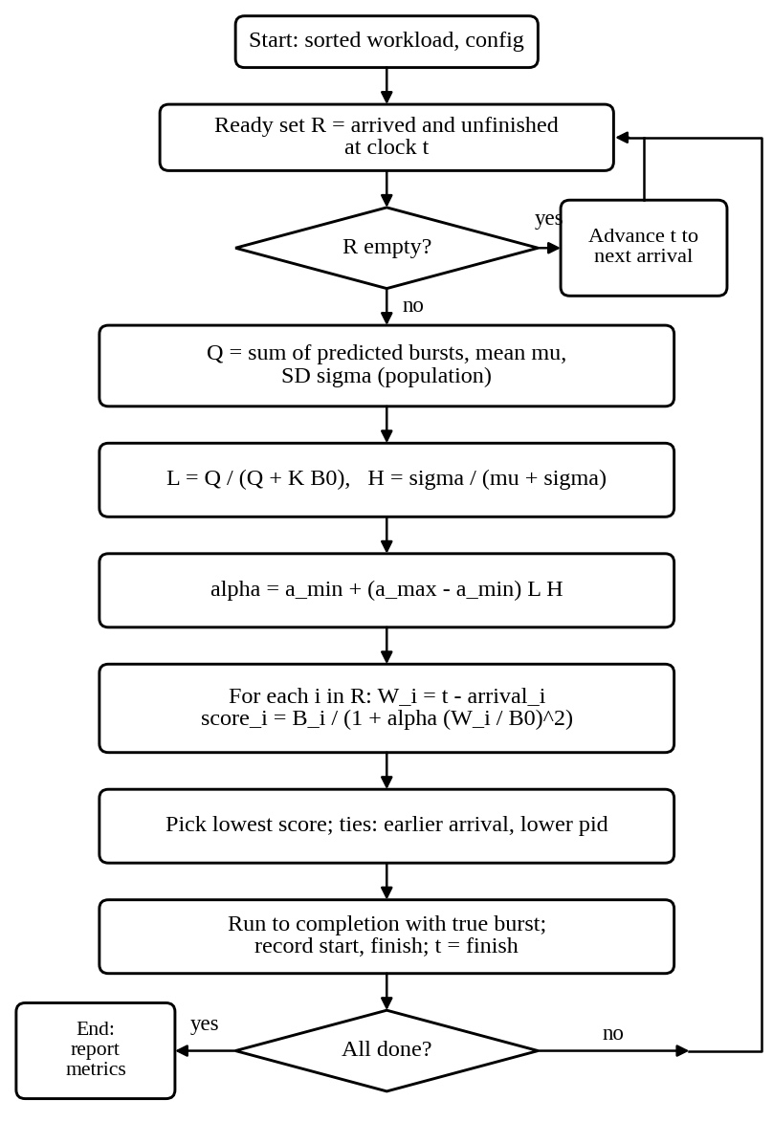
- Flowchart of the QH-SJF dispatch decision.

Module-wise Implementation
The simulator is about 360 lines of C11 plus 67 lines of tests. Table II lists the modules. Each policy is a branch of one decision function, and the QH-SJF math is isolated in its own module so it can be unit-tested.
- Implemented modules and lines of code
Module | Responsibility | Lines
process.h | process, result and config records | 9
rng.c | seeded generator: uniform, exponential, normal | 24
qh.c | Q, mean, SD, L, H, α and aging score | 36
policies.c | all eight selection rules, tie-breaks | 35
simulator.c | clock, ready set, idle gaps, run to completion | 44
metrics.c | waiting, turnaround, slowdown, percentiles, utilization | 36
workloads.c | seven workload families, prediction noise | 67
csv_io.c | CSV read with validation, CSV write | 41
main.c | command line, per-policy and all-policy runs | 68
test_all.c | 14 automated checks | 67
Python scripts | experiment driver, analysis, figures, SWF converter | 307

The tests check one job, an idle gap, equal arrivals, no preemption, equal bursts, the hand-worked example of the design (α = 0.2291, scores 1.044, 3.290, 3.254, and QH-SJF picks P1), the HRRN, SJF and FCFS choices on a known case, schedule invariants over 7 families and 8 policies, reproducibility, and bounds on L, H and α. All 14 checks pass.

Technologies and Tools Used
- Technologies and tools
Item | Version or setting
Language | C11
Compiler | GCC 13.3.0, -std=c11 -O2 -Wall -Wextra -Wpedantic (0 warnings)
Build | GNU Make
Analysis | Python 3.12.3, NumPy 2.4.4, SciPy 1.17.1, pandas 3.0.2
Plots | Matplotlib 3.10.8, Pillow 12.1.1
Statistics | Wilcoxon signed-rank test (SciPy)
Platform | Linux 6.18 container, Intel Xeon 2.10 GHz, 1 core

C was chosen because the problem needs only records, arrays and a loop, and it keeps memory handling explicit. Python is used only after simulation to aggregate CSV results, run tests and draw figures.

Dataset Description
All reported results use synthetic workloads, because the public trace archive could not be reached from the development sandbox (Section XI). Table IV describes the seven families. A workload has 100 processes. In the table, load ρ means exponential inter-arrivals with mean E[B]/ρ, and time is in arbitrary ticks.
- Synthetic workload families
ID | Burst lengths | Arrivals
W1 | uniform [9, 11] | Poisson, ρ = 0.90
W2 | 70% U[1,3], 20% U[8,12], 10% U[40,60] | Poisson, ρ = 0.90
W3 | 99 jobs U[1,3] plus one job of 60 at t = 5 | Poisson, ρ = 0.95 (short jobs)
W4 | as W2 | uniform over first 10% of total work
W5 | as W2 | groups of 10 within 3 ticks, load about 0.6
W6 | as W2 | Poisson, ρ = 0.30
W7 | log-normal(1.2, 1.0) clipped to [0.5, 150], two jobs set to 150 | Poisson, ρ = 0.90

Each family has 10 calibration seeds (70 workloads, 7,000 bursts) and 30 held-out seeds (210 workloads, 21,000 jobs per error level). Calibration and test seeds are disjoint (1 to 10 and 1001 to 1030). The Parallel Workloads Archive [14] is the planned source of trace-derived workloads; none has been used in the results yet.

Data Preprocessing
- Validation: the loader rejects duplicate process IDs, negative arrivals and non-positive bursts, then sorts by arrival and ID. Inputs are never modified, so each policy sees the same workload.
- Reference scale: B₀ starts as the pooled median calibration burst, which is 2.642 ticks, and its multiplier is tuned (Section VIII).
- Prediction noise: log-normal multiplicative noise b_{i} = B_{i} exp(s z_{i}) from a separate seeded stream.
- Trace conversion: for Standard Workload Format logs, the converter uses submit time as arrival and run time as burst, ignores the recorded wait time and processor count, drops jobs with missing or non-positive run time, re-bases arrivals to zero, and cuts windows of consecutive jobs.
The converter was tested only on a hand-written 8-job sample in SWF layout. It dropped the two invalid jobs and produced a valid CSV that the simulator ran. No real log has been processed.

Experimental Setup
Protocol: calibrate on 70 workloads, freeze parameters, then run every policy on 210 held-out workloads (7 families × 30 seeds) at two prediction error levels, giving 3,780 result rows across nine policy variants. The variants are the eight policies plus QH-SJF with its untuned initial values. All runs use one deterministic engine and fixed seeds, so the results are exactly reproducible.
- Performance metrics
Metric | Definition
Waiting time | W_{i} = start_{i} − arrival_{i}; average, p99 and maximum are reported
p99 waiting | nearest-rank percentile, rank ⌈0.99 N⌉ (N = 100)
Slowdown | D_{i} = (finish_{i} − arrival_{i}) / B_{i}; mean is reported
Turnaround | T_{i} = W_{i} + B_{i} (recorded in CSV)
Throughput, utilization | N / span and sum(B) / span; identical across policies

Comparison method: for each run, a metric is divided by SJF's value on the same workload with exact bursts, so SJF equals 1.00. Ratios are averaged over the 30 seeds of a family, then averaged over the seven families (macro-average). Policies are compared on the same 210 workloads with paired Wilcoxon signed-rank tests. The p-values are exploratory and uncorrected for multiple comparisons.
Calibration outcome (Table VI): the tuned B₀ multipliers were 16 for the quadratic and adaptive policies (B₀ ≈ 42.3 ticks) and 1 for linear aging. Several choices sit at a grid edge (K = 1 and α_{min} = 0.25), so the grids were not exhausted.
- Parameters chosen on calibration data
Policy | Selected values | Avg | p99
Linear aging | β = 2, B₀ × 1 | 1.099 | 0.816
Fixed quad. | α_{f} = 0.5, B₀ × 16 | 1.077 | 0.809
L-only | α 0.25–2.0, K = 5, B₀ × 16 | 1.099 | 0.805
H-only | α 0.1–2.0, K = 1, B₀ × 16 | 1.095 | 0.807
QH-SJF | α 0.25–2.0, K = 1, B₀ × 16 | 1.093 | 0.807
QH-SJF initial | α 0.10–1.00, K = 5, B₀ × 1 | 1.255 | 0.798

Avg and p99 in the table are calibration ratios to SJF (mean over 70 workloads).

Initial Implementation Screenshots
The figures below are captures of real terminal output from the implementation, rendered as images. Fig. 3 shows a clean build and the 14 passing checks, including the hand-worked example from the design.
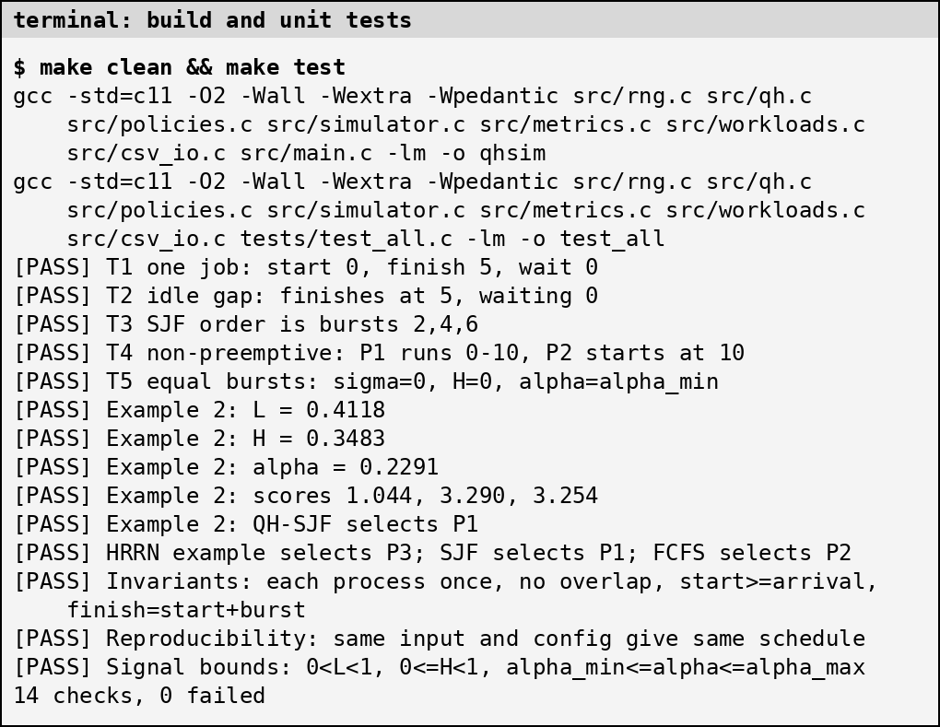
- Build with strict warnings and the 14 unit and invariant checks.
Fig. 4 shows the per-dispatch QH-SJF trace on a 12-process W2 workload. While only one job waits, H = 0 and α stays at its minimum 0.10. When six jobs of mixed size queue up, H rises to about 0.45 and α to about 0.31.
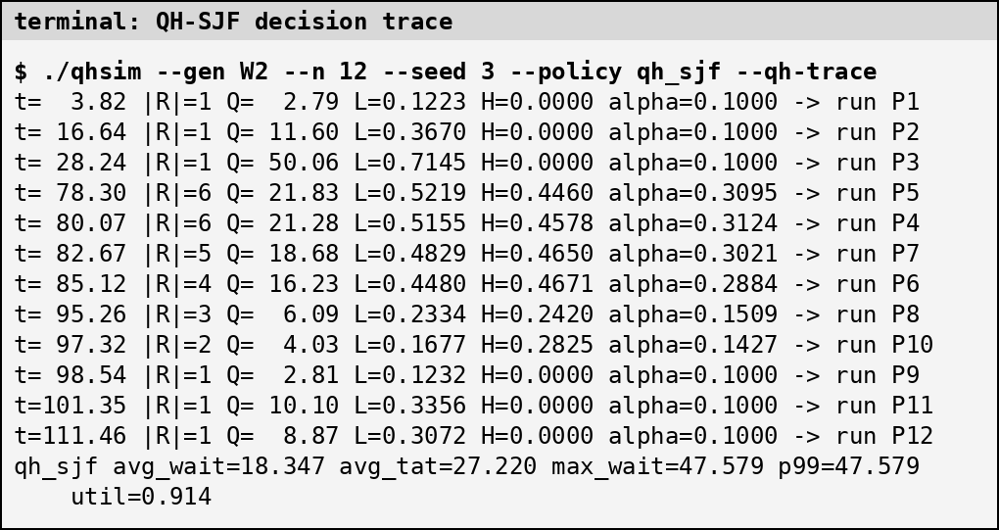
- QH-SJF decision trace: queued work Q, signals L and H, and aging strength α at each dispatch.
Fig. 5 runs the same workload under six policies, and Fig. 6 shows all policies on one long-job stress workload (W3), where SJF leaves the long job waiting far longer than any other policy.
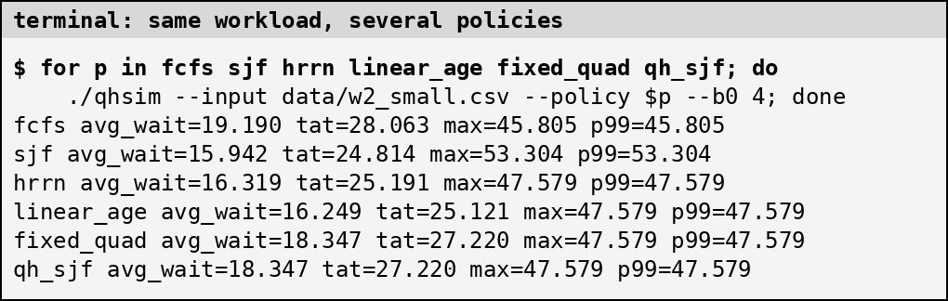
- Same 12-process workload under six policies.
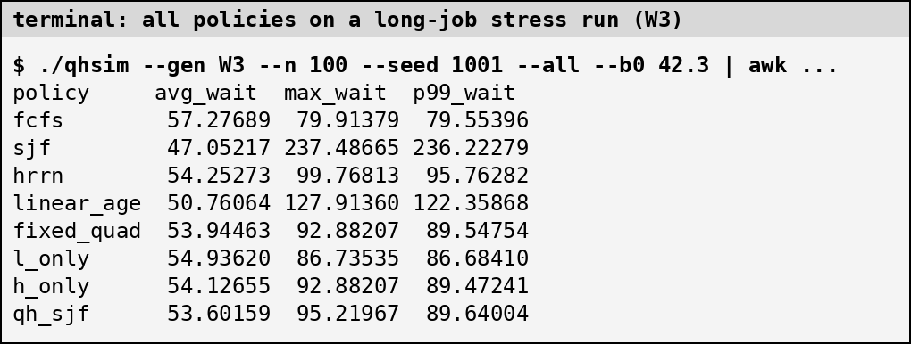
- All policies on one W3 run (seed 1001).

Preliminary Results
All numbers below come from the held-out runs on synthetic workloads. They are preliminary: one workload generator, one error model, no trace data, and non-preemptive policies only.

Main Results
Table VII gives the macro-averaged ratios to SJF with exact bursts and Table VIII gives the same with predicted bursts (s = 0.5). Throughput and utilization were identical across policies in every run (spread 0.0), as expected for non-preemptive work-conserving policies, so differences come only from waiting and slowdown.
- Ratio to SJF, exact bursts (macro-average of 7 families)
Policy | Avg wait | p99 wait | Max wait | Slowdown
FCFS | 2.099 | 0.977 | 0.840 | 4.051
SJF | 1.000 | 1.000 | 1.000 | 1.000
HRRN | 1.113 | 0.777 | 0.750 | 1.206
Linear aging | 1.100 | 0.775 | 0.752 | 1.185
Fixed quad. aging | 1.075 | 0.773 | 0.744 | 1.117
L-only | 1.105 | 0.769 | 0.740 | 1.184
H-only | 1.096 | 0.774 | 0.743 | 1.162
QH-SJF (initial) | 1.211 | 0.762 | 0.726 | 1.408
QH-SJF (tuned) | 1.093 | 0.772 | 0.743 | 1.155

- Ratio to SJF with exact bursts, predicted bursts (s = 0.5)
Policy | Avg wait | p99 wait | Max wait | Slowdown
FCFS | 2.099 | 0.977 | 0.840 | 4.051
SJF | 1.047 | 1.025 | 1.029 | 1.104
HRRN | 1.134 | 0.840 | 0.843 | 1.265
Linear aging | 1.126 | 0.841 | 0.845 | 1.252
Fixed quad. aging | 1.110 | 0.848 | 0.832 | 1.211
L-only | 1.128 | 0.837 | 0.820 | 1.260
H-only | 1.127 | 0.838 | 0.822 | 1.254
QH-SJF (initial) | 1.233 | 0.805 | 0.776 | 1.469
QH-SJF (tuned) | 1.125 | 0.843 | 0.827 | 1.250

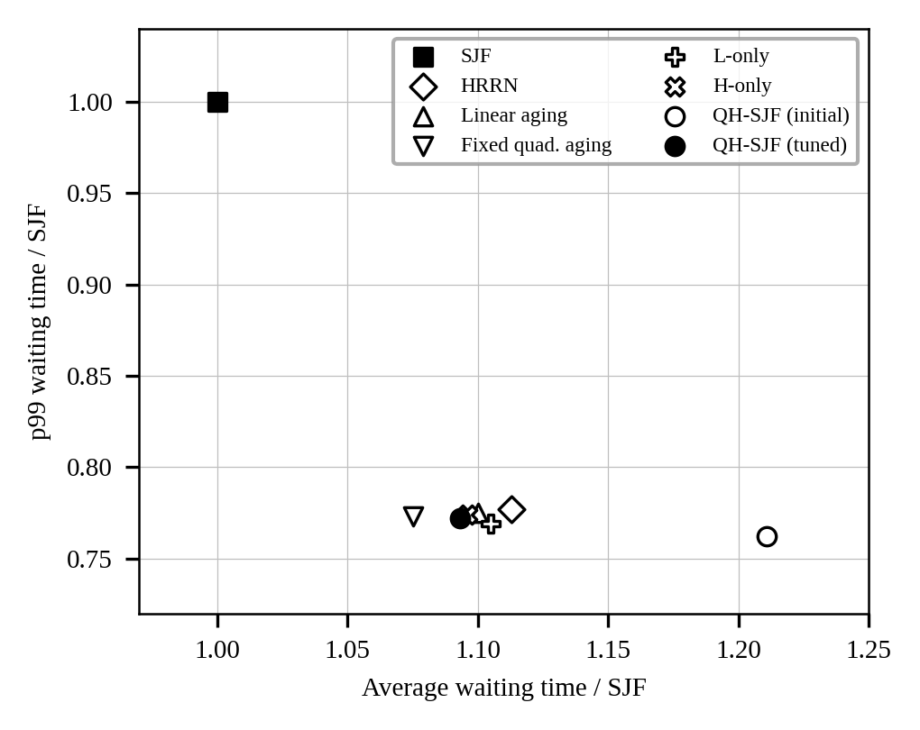
- Trade-off between average and p99 waiting time, exact bursts (FCFS, at 2.10 and 0.98, is off the plotted range).

Comparison with Existing Methods
- SJF: all tuned aging policies cut p99 waiting by 22% to 23% and maximum waiting by about 25% to 26%, but raise average waiting by about 8% to 11% and mean slowdown by about 12% to 21%.
- HRRN: tuned QH-SJF has a slightly lower average-waiting cost (1.093 vs 1.113; lower in 163 of 210 paired runs, p <0.001) and the same p99 (p = 0.342). The maximum-waiting difference is small (0.743 vs 0.750; QH better in 42 runs, worse in 28, p = 0.005).
- Fixed quadratic aging: it is as good or better. Its average-waiting cost is lower (1.075 vs 1.093; QH worse in 96 of 210 runs, better in 79, p <0.001) with equal p99 (p = 0.871). The adaptive signals did not beat a tuned fixed strength here.
- Ablations: L-only has a slightly lower tail (0.769 vs 0.772; QH worse in 49 runs, better in 7) and slightly higher average waiting (1.105 vs 1.093). Multiplying by H mainly weakens aging a little, which moves along the same trade-off curve rather than beating it.
- Initial values: untuned QH-SJF has the lowest tail (0.762) but the highest average cost (1.211), so calibration mattered.
- FCFS: average waiting is 2.099× SJF's, and mean slowdown 4.051×, so aging keeps most of SJF's efficiency.
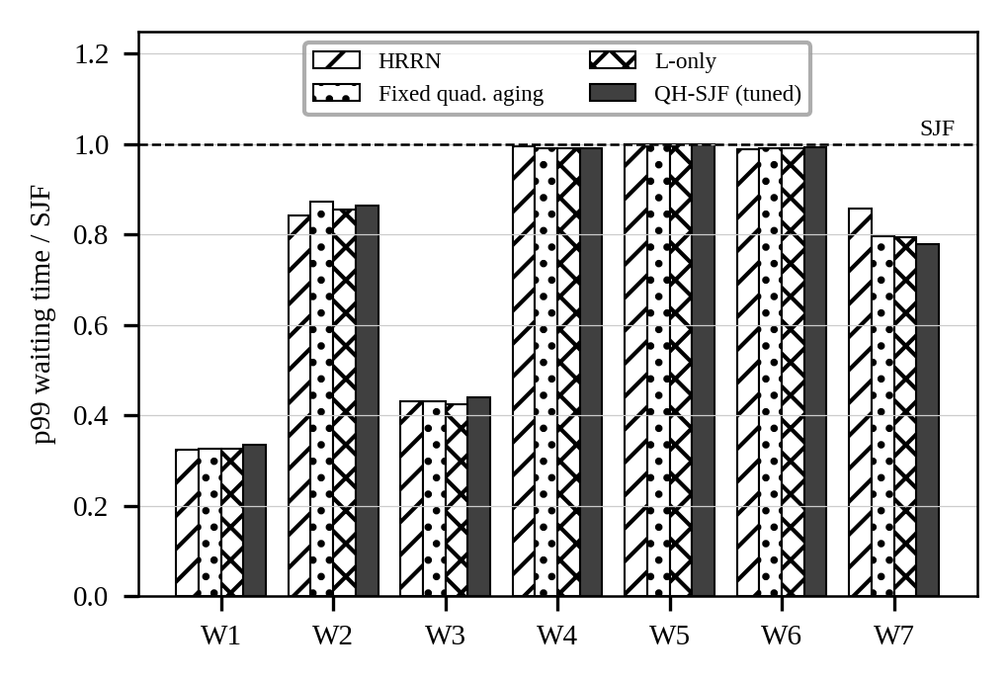
- p99 waiting time relative to SJF, by workload family, exact bursts.
Fig. 8 shows where the effect comes from. Aging helps most on W1 (about 0.33 of SJF's p99), W3 (about 0.43) and W7 (0.78 to 0.86), where SJF leaves some job waiting for very long. On W4, W5 and W6 (heavy backlog, bursty arrivals, light load) the policies are within about 2% of SJF, so adaptation has nothing to act on.

Effect of Prediction Error
With s = 0.5, SJF itself degrades to 1.047 (average) and 1.025 (p99) of its exact-burst values (Fig. 9). The aging policies also degrade by about 0.02 to 0.04 in average waiting and 0.06 to 0.08 in p99 waiting. QH-SJF keeps its relative position, so prediction error did not change the ranking in these runs.
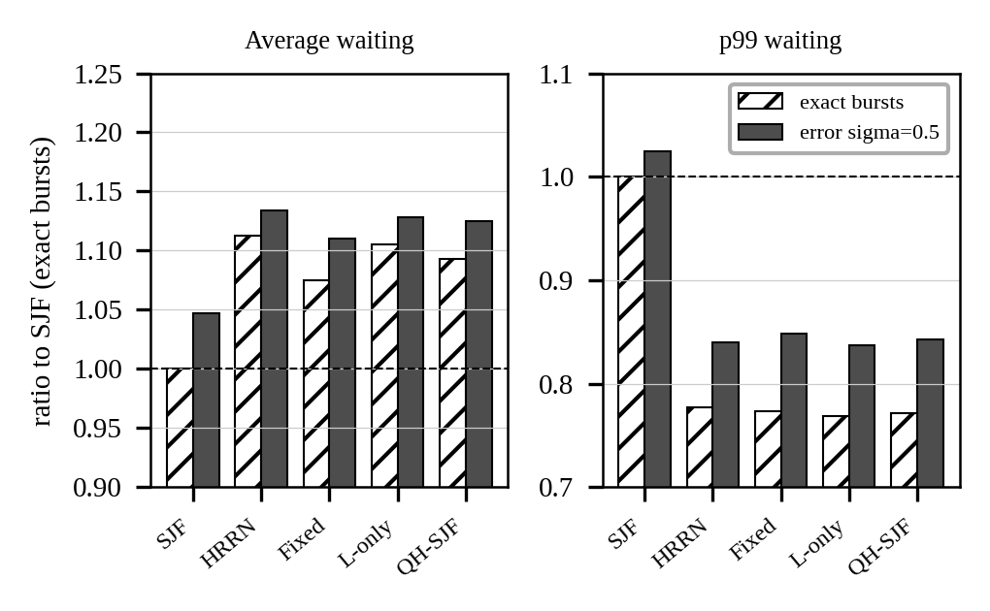
- Effect of prediction error on average and p99 waiting (ratio to SJF with exact bursts).

Parameter Sensitivity
Table IX varies one parameter of tuned QH-SJF at a time (exact bursts, held-out seeds). B₀ has the strongest effect: halving it raises average waiting to about 1.15 and lowers p99 to 0.76, while doubling it moves the policy toward SJF (average 1.035, p99 0.81). K and α_{max} move results by a few percent. This confirms that B₀ must be treated as a tuned parameter, not a constant.
- Sensitivity of tuned QH-SJF (ratio to SJF)
Parameter | Value | Avg wait | p99 wait
K | 1 * | 1.093 | 0.772
K | 5 | 1.078 | 0.779
K | 20 | 1.065 | 0.783
K | 100 | 1.050 | 0.787
alpha_max | 0.5 | 1.054 | 0.785
alpha_max | 2 * | 1.093 | 0.772
alpha_max | 4 | 1.120 | 0.771
B0 scale | 8 | 1.151 | 0.764
B0 scale | 16 * | 1.093 | 0.772
B0 scale | 32 | 1.035 | 0.814

* tuned value. B₀ scale is the multiplier on the calibration median.

Paired Tests
- Tuned QH-SJF against other policies, 210 paired runs
Versus | Metric | QH better / worse / tie | p
HRRN | Avg wait | 163 / 44 / 3 | <0.001
HRRN | p99 | 45 / 51 / 114 | 0.342
HRRN | Max | 42 / 28 / 140 | 0.005
Fixed quad. | Avg wait | 79 / 96 / 35 | <0.001
Fixed quad. | p99 | 26 / 41 / 143 | 0.871
L-only | Avg wait | 124 / 30 / 56 | <0.001
L-only | p99 | 7 / 49 / 154 | <0.001
SJF | Avg wait | 3 / 193 / 14 | <0.001
SJF | p99 | 130 / 17 / 63 | <0.001

Reading the Results
The preliminary evidence supports a modest claim: tuned aging of any kind trades about 8% to 11% more average waiting for about 22% to 23% lower p99 waiting, and tuned QH-SJF sits on the same trade-off curve as HRRN and tuned fixed aging. It does not support a claim that the queue-aware and heterogeneity-aware signals add a benefit. Limits: synthetic workloads only, p99 over 100 jobs is close to the maximum, tuning used one rule and a coarse grid, and no trace data or preemptive baselines have been run yet.

Problems Encountered and Solutions
- Tuning objective: the first rule, an equal-weight mix of average and p99 waiting, pushed every aging parameter to the weakest grid edge, so the tuned policies just reproduced SJF. We replaced it with the constrained tail rule of Section II before looking at any held-out result.
- Saturated aging term: with B₀ equal to the pooled median burst (about 2.6 ticks), waits are tens of B₀, so α had almost no effect. We added a B₀ multiplier to the calibration grid for all tunable policies equally.
- Fair baselines: HRRN has no parameter to tune, while the other policies do. All tunable policies use the same data, grid and rule, so tuning does not favour QH-SJF.
- Percentiles on 100 jobs: p99 is nearly the maximum, so both are reported and conclusions rely on their agreement.
- Identical utilization: non-preemptive work-conserving policies finish all jobs at the same time, so utilization and throughput cannot separate them. They are used as a sanity check, and comparison rests on waiting and slowdown.
- Compiler warning: a misleading-indentation warning in the percentile helper was fixed, and the build now has 0 warnings under strict flags.
- Public trace data: the trace archive host was not reachable from the development sandbox. We wrote and tested the converter on a hand-made sample and left real traces as the next step.

Updated References
- W. E. Smith, “Various optimizers for single-stage production,” Naval Research Logistics Quarterly, vol. 3, no. 1-2, pp. 59–66, 1956.
- F. J. Corbató, M. Merwin-Daggett, and R. C. Daley, “An experimental time-sharing system,” in Proceedings of the AFIPS Spring Joint Computer Conference (SJCC '62), vol. 21, pp. 335–344, 1962.
- L. Kleinrock, “Analysis of a time-shared processor,” Naval Research Logistics Quarterly, vol. 11, no. 1, pp. 59–73, 1964.
- L. Kleinrock, “A conservation law for a wide class of queueing disciplines,” Naval Research Logistics Quarterly, vol. 12, no. 2, pp. 181–192, 1965.
- L. E. Schrage, “A proof of the optimality of the shortest remaining processing time discipline,” Operations Research, vol. 16, no. 3, pp. 687–690, 1968.
- P. Brinch Hansen, “Short term scheduling in multiprogramming systems,” in Proceedings of the 3rd ACM Symposium on Operating Systems Principles (SOSP '71), pp. 1–10, 1971.
- D.-M. Chiu and R. Jain, “Analysis of the increase and decrease algorithms for congestion avoidance in computer networks,” Computer Networks and ISDN Systems, vol. 17, no. 1, pp. 1–14, 1989.
- I. Stoica, H. Abdel-Wahab, K. Jeffay, S. K. Baruah, J. E. Gehrke, and C. G. Plaxton, “A proportional share resource allocation algorithm for real-time, time-shared systems,” in Proceedings of the 17th IEEE Real-Time Systems Symposium (RTSS '96), pp. 288–299, 1996.
- M. Harchol-Balter and A. B. Downey, “Exploiting process lifetime distributions for dynamic load balancing,” ACM Transactions on Computer Systems (TOCS), vol. 15, no. 3, pp. 253–285, 1997.
- N. Bansal and M. Harchol-Balter, “Analysis of SRPT scheduling: Investigating unfairness,” in Proceedings of the ACM SIGMETRICS International Conference on Measurement and Modeling of Computer Systems (SIGMETRICS '01), pp. 224–235, 2001.
- M. Harchol-Balter, B. Schroeder, N. Bansal, and M. Agrawal, “Size-based scheduling to improve web performance,” ACM Transactions on Computer Systems (TOCS), vol. 21, no. 2, pp. 207–233, 2003.
- A. Wierman and M. Harchol-Balter, “Classifying scheduling policies with respect to unfairness in an M/GI/1,” in Proceedings of the ACM SIGMETRICS International Conference on Measurement and Modeling of Computer Systems (SIGMETRICS '03), pp. 200–211, 2003.
- D. Tsafrir, Y. Etsion, and D. G. Feitelson, “Backfilling using system-generated predictions rather than user runtime estimates,” IEEE Transactions on Parallel and Distributed Systems, vol. 18, no. 6, pp. 789–803, 2007.
- D. G. Feitelson, D. Tsafrir, and D. Krakauer, “Experience with using the Parallel Workloads Archive,” Journal of Parallel and Distributed Computing, vol. 74, no. 10, pp. 2967–2986, 2014.
- S. T. Mirtchev, “Generalised Pollaczek-Khinchine formula for the Polya/G/1 queue,” Electronics Letters, vol. 53, no. 20, pp. 1362–1364, 2017.

