Prerequisites

* Git
* CMake
* MinGW-w64

To install Git go to <https://git-scm.com/download/win>

To install CMake go to <https://github.com/Kitware/CMake/releases/download/v3.14.2/cmake-3.14.2-win64-x64.msi>

Make sure to add CMake to the system PATH.

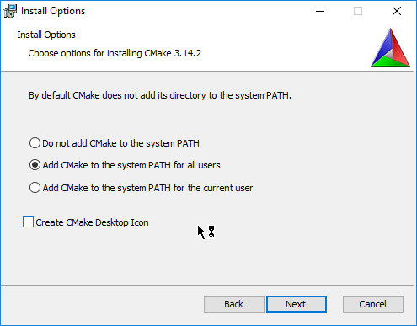

To install the MinGW-w64 Compiler go to <https://nuwen.net/files/mingw/mingw-16.1-without-git.exe>

It is assumed that the compiler is installed in the C:\nuwen directory. Regardless you can use any other path.

**Cloning the repository**

Open the git bash shell.

Use  
git clone https://github.com/CppPhil/ISP1.git --recursive  
to clone the repository.  
The --recursive flag is important!  
This will take a few minutes!

## Building

Open cmd.exe (Windows key + R (enter cmd.exe))

Execute

C:\nuwen\MinGW\set_distro_paths.bat

Then execute

cd C:\Users\Phil\Desktop\ISP1

(possibly adjust the path depending on where you cloned the repository to)

The application can then be built using

build.bat Debug

or

build.bat Release

The executable will be placed in the build subdirectory.

To build and run at once

buildAndRun.bat Debug

or

buildAndRun.bat Release

can be used.