Installation manual for Microsoft Windows

Table of Contents
Git 2
Python 3
CMake 4
mogasens_csv 5

Git
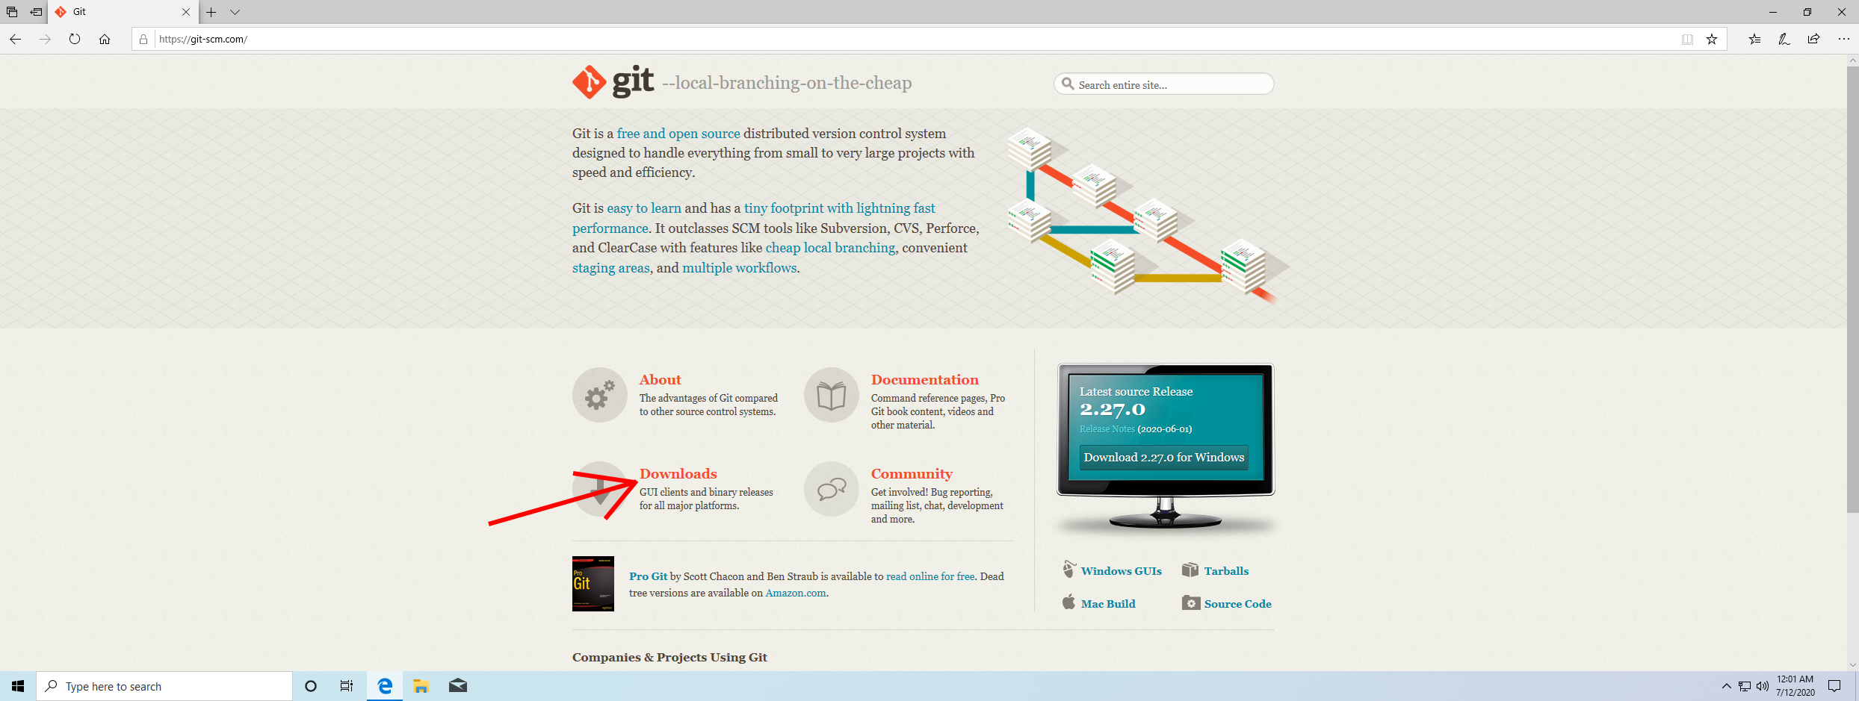
Open git-scm.com in Microsoft Edge and click on “Downloads”.
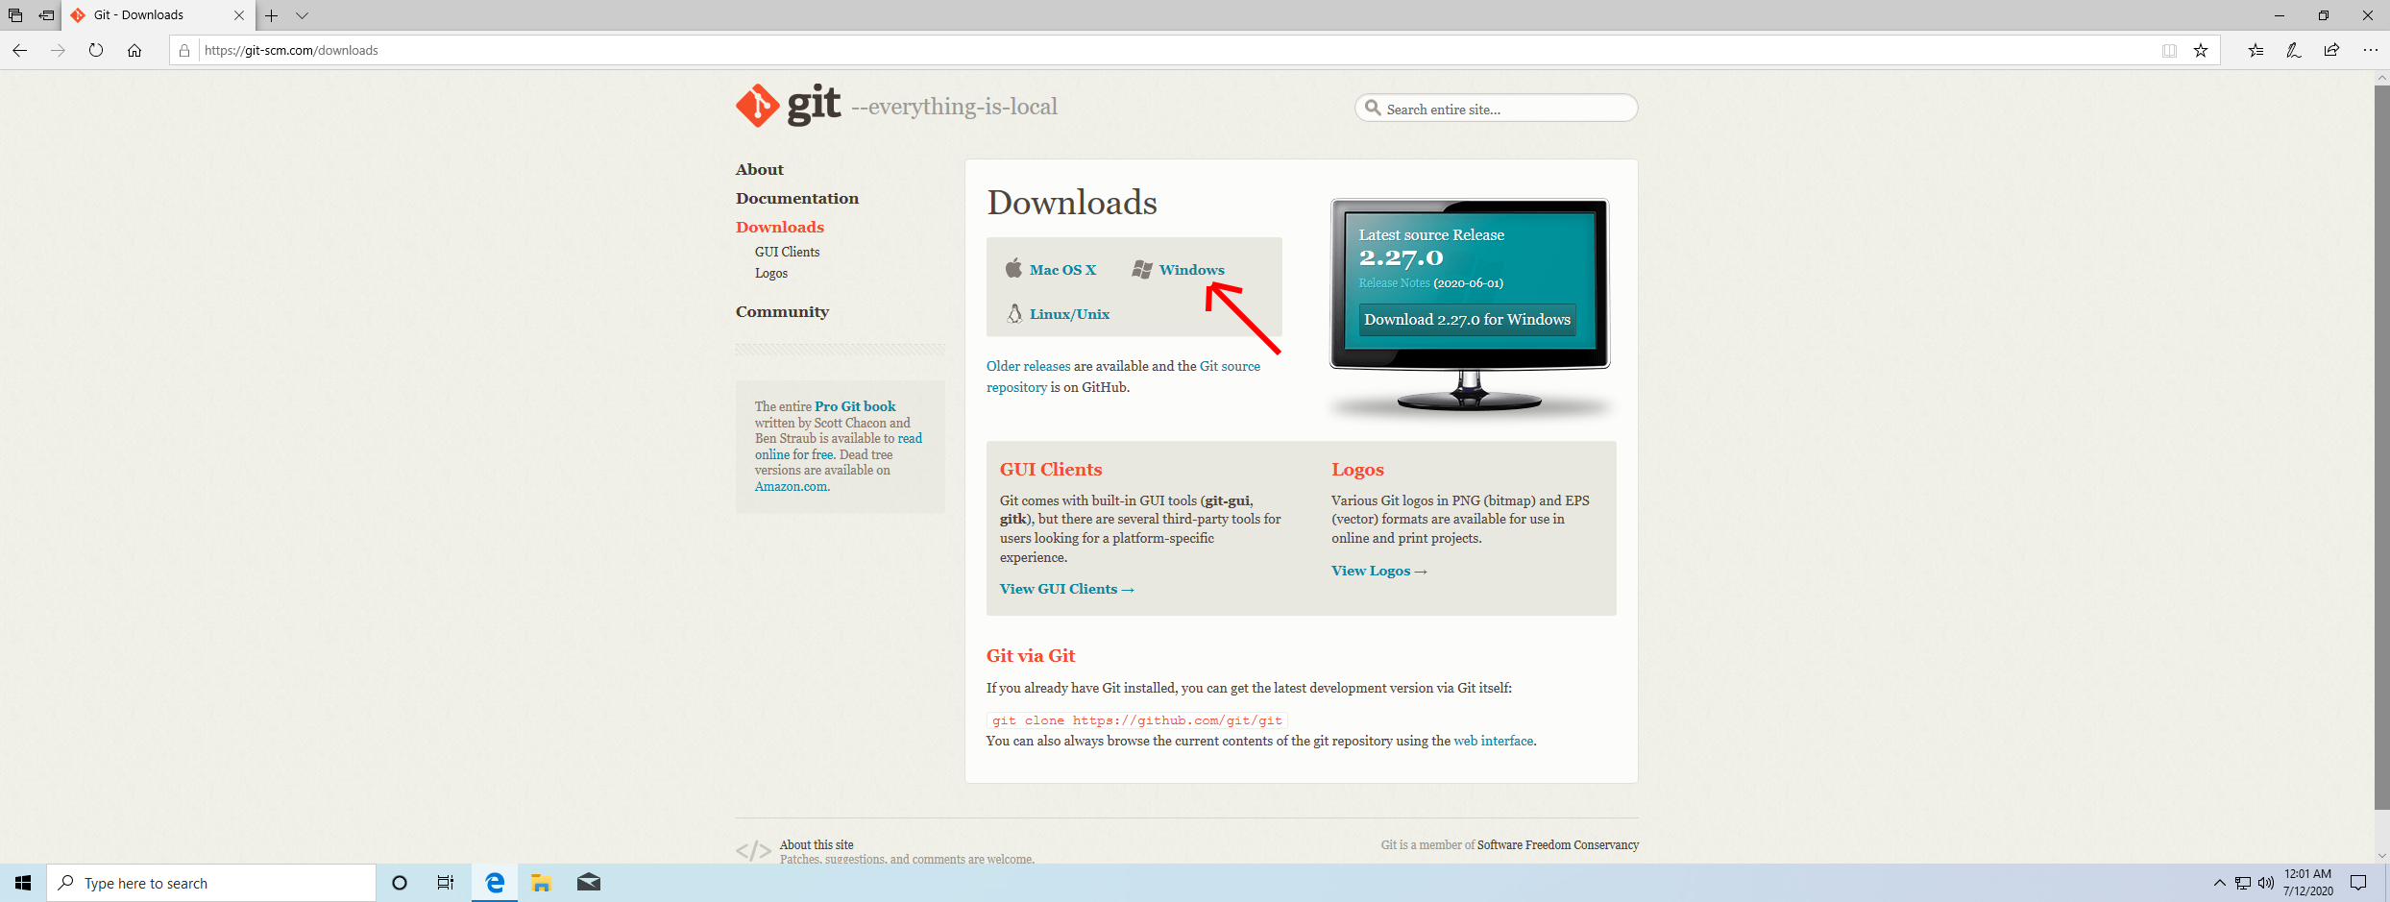
Click on “Windows”.
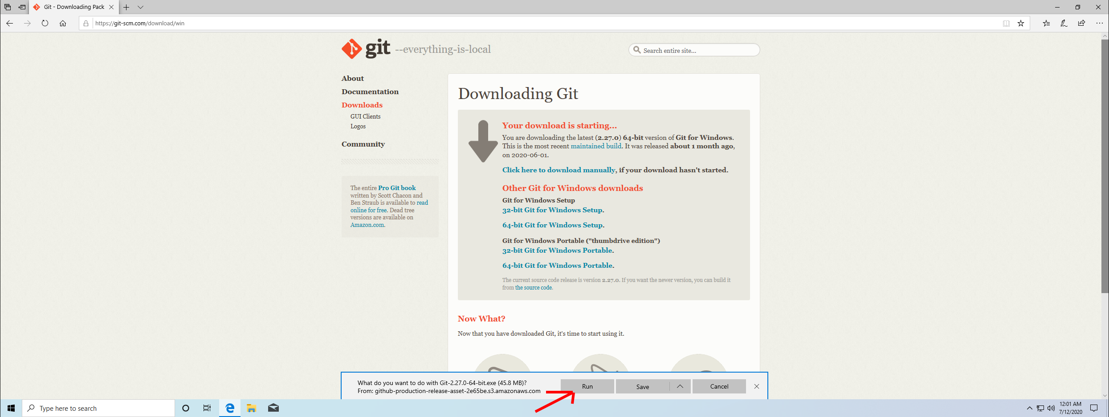
Microsoft Edge will show a prompt. Click on “Run”.

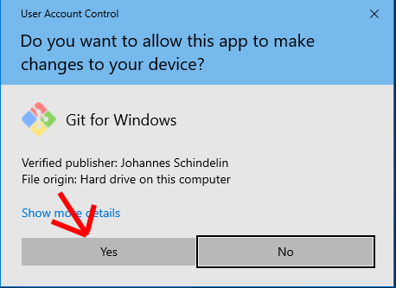
Microsoft Windows will show a UAC prompt, click on “Yes”.
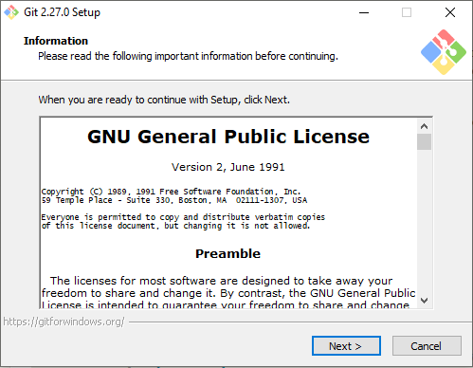
Click “Next”.
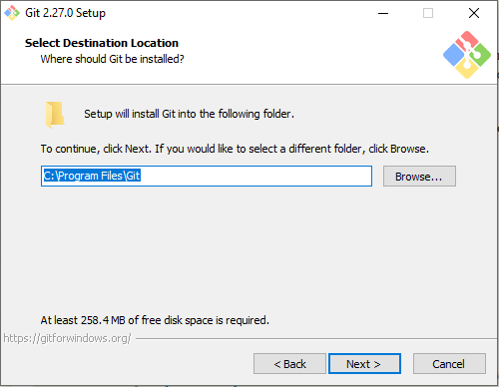
Select an installation directory, then click on “Next”.
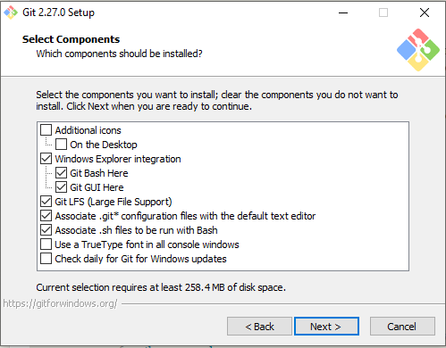
Select whichever components you want, then click on “Next”.

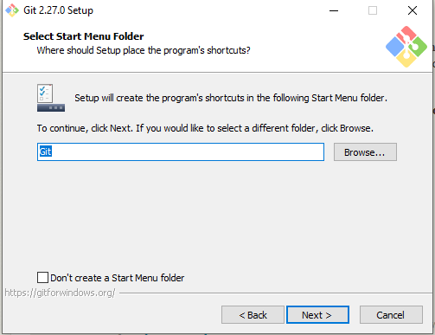
Select a “Start Menu folder”, then click on “Next”.
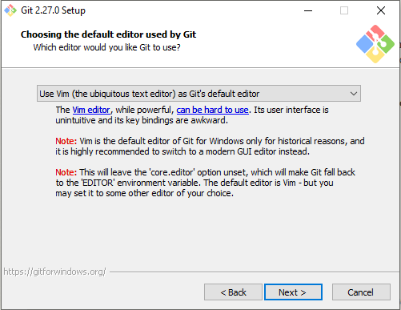
Choose whichever editor you want, then click on “Next”.

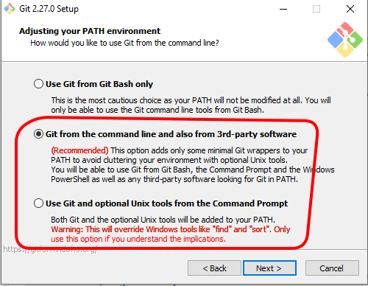
Choose “Git from the command line and also from 3rd-party software” or “Use Git and optional Unix tools from the Command Prompt” so that Git is available from within a Windows Command Prompt.
Then click “Next”.
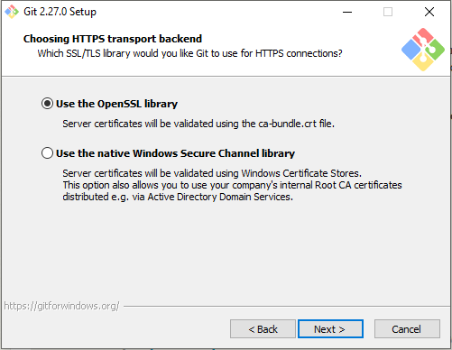
Choose whichever HTTPS transport backend you want, then click on “Next”.

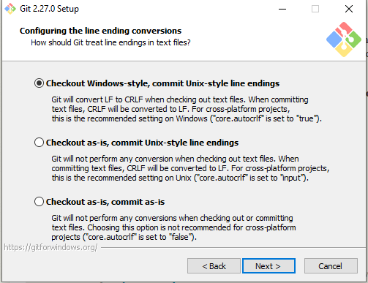
Configure the line ending conversions as you want, then click on “Next”.
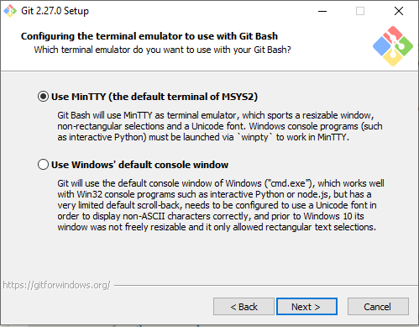
Choose whichever terminal emulator you want, then click “Next”.

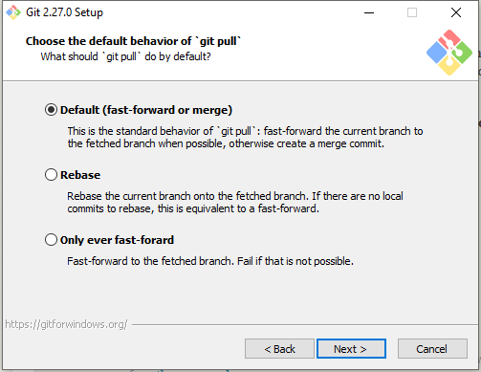
Choose whichever 'git pull' behavior you want, then click “Next”.
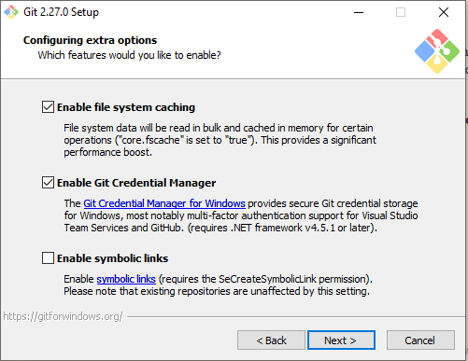
Choose whichever extra options you want, then click on “Next”.

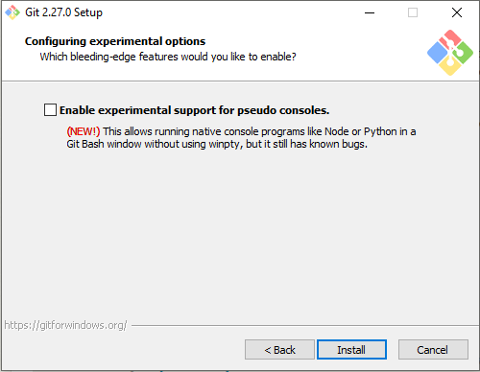
Choose whichever experimental options you want, then click “Install”.
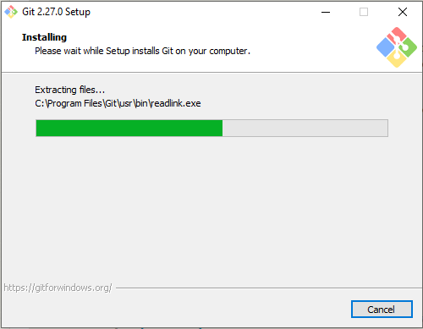
Finally Git will start installing.

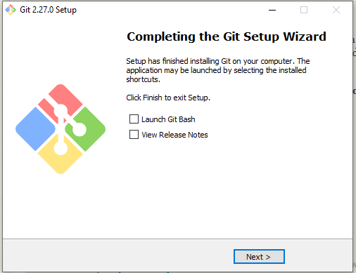
When it's done installing, click “Next” again.

Python
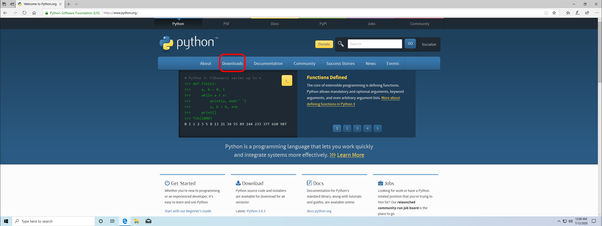
Open python.org in Microsoft Edge and click on “Downloads”.
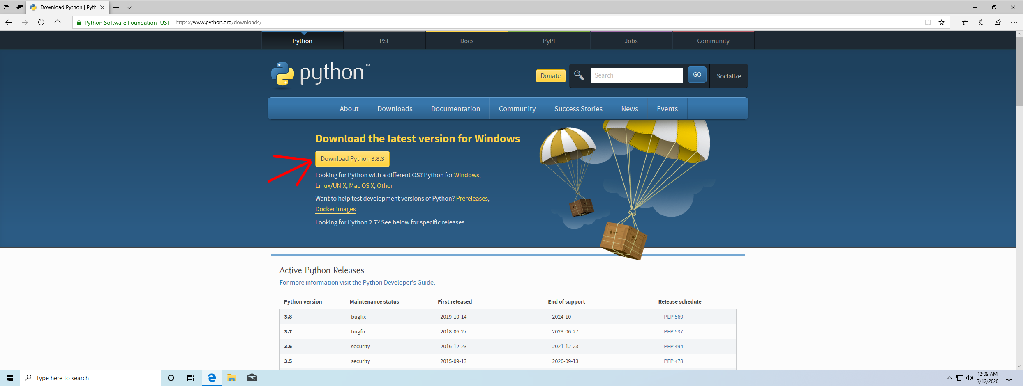
Click the “Download Python 3.8.3”-Button (or any newer version).
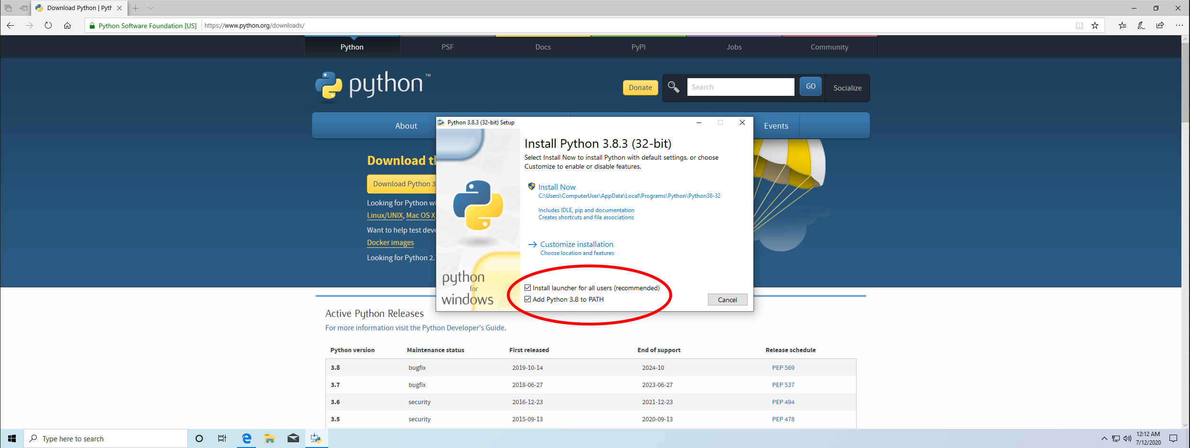
The installer will open. Don't forget to check “Add Python 3.8 to PATH”. Then click “Install Now”.

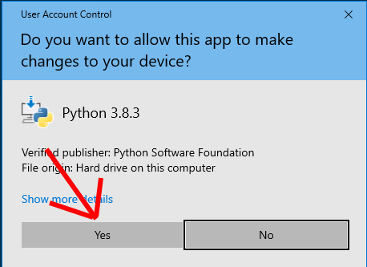
Microsoft Windows will show a UAC prompt. Click “Yes”.
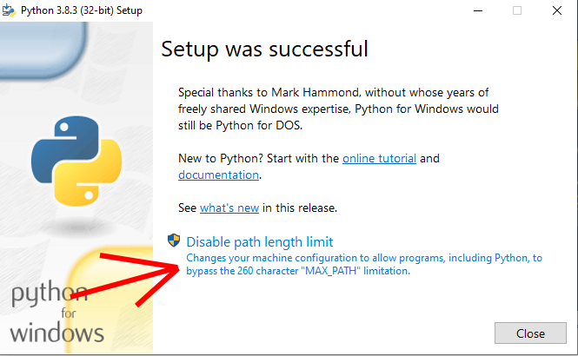
After Python is installed, it is recommended to click “Disable path length limit” to not run into problems with long automatically generated filesystem paths.

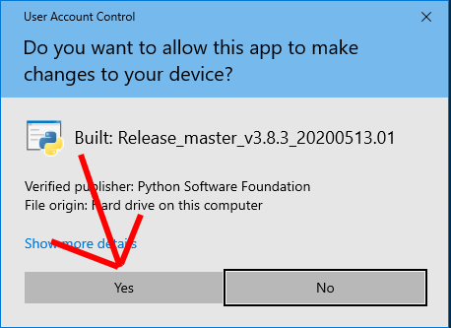
Microsoft Windows will show yet another UAC prompt, again click on “Yes”.
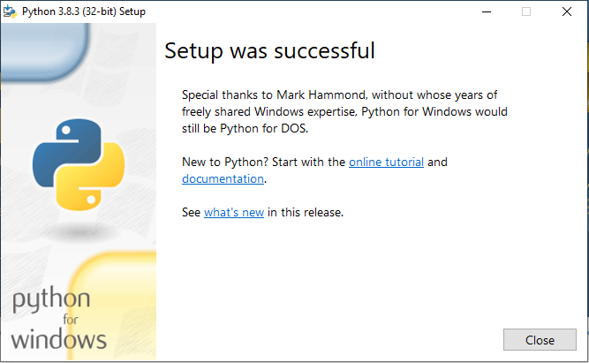
Python is installed, click “Close”.

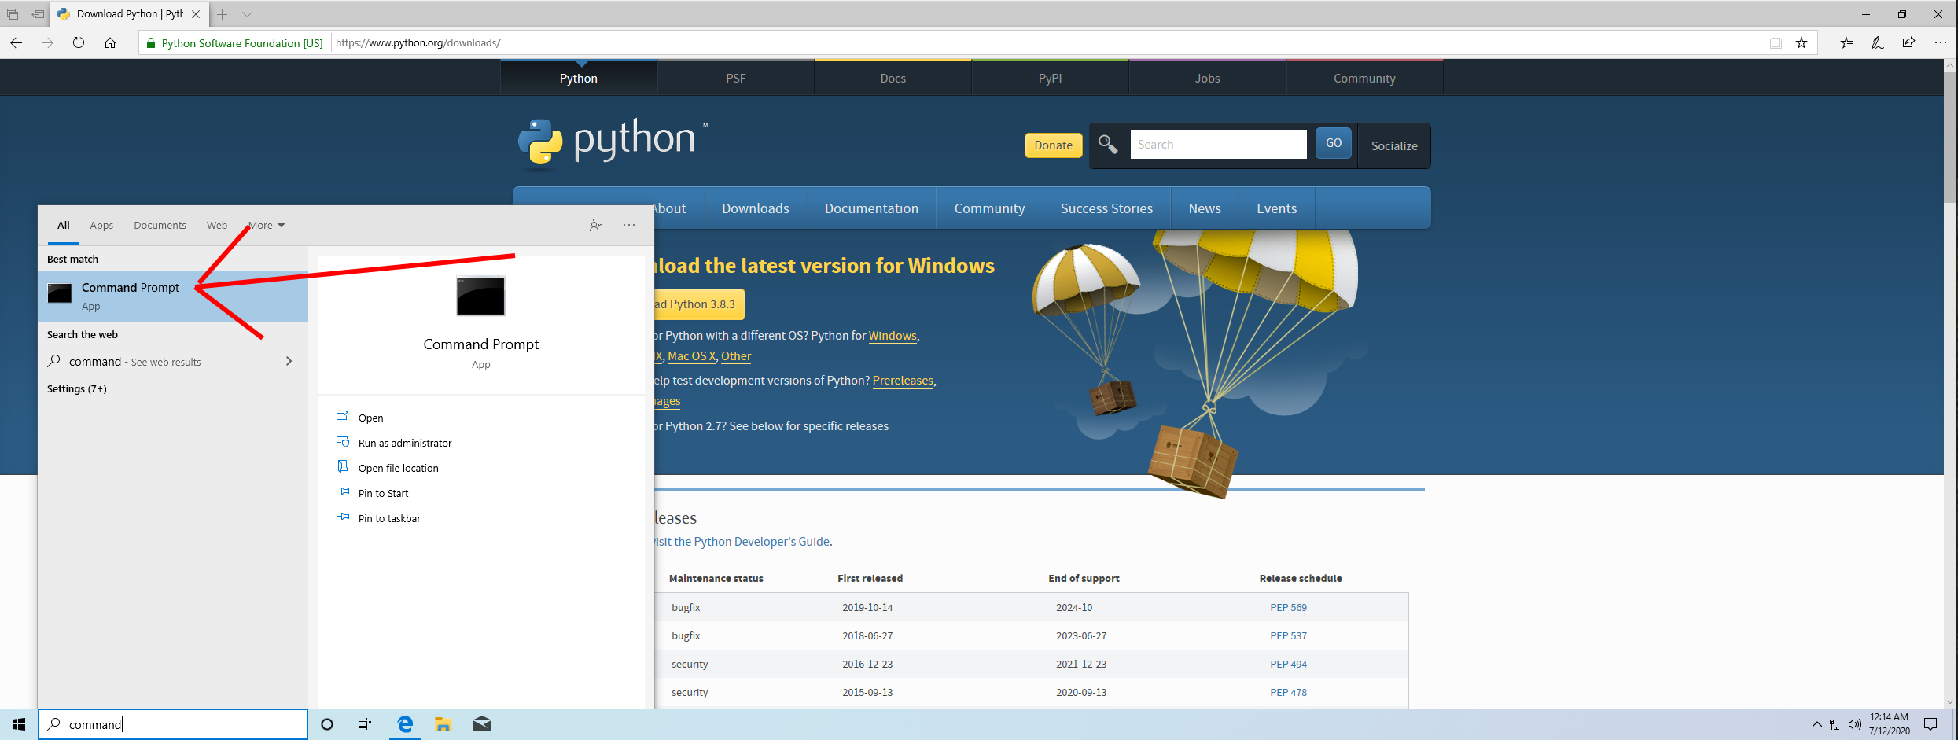
Search for “Command Prompt” in the bottom left search field. Then click on “Command Prompt”.
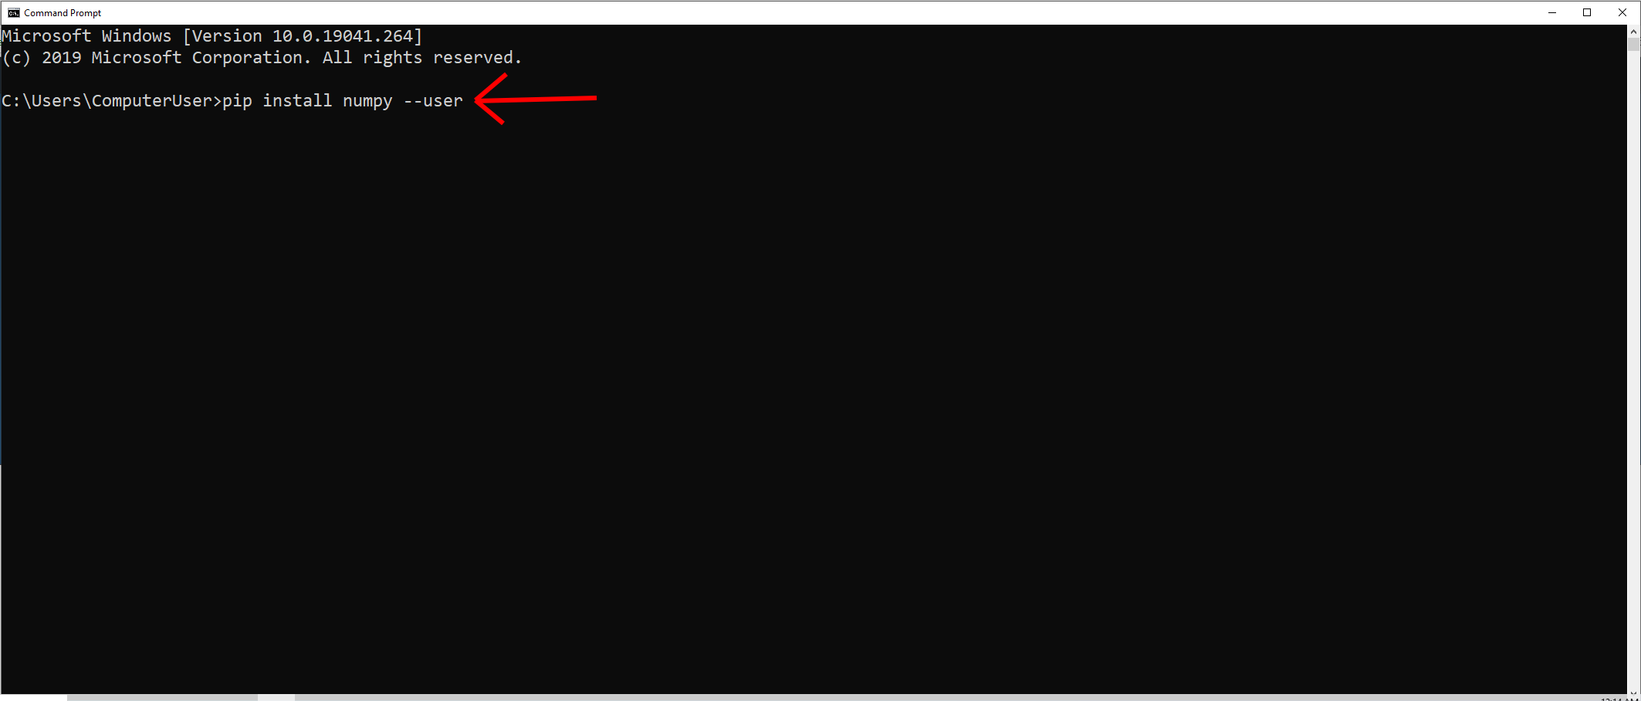
In the Command Prompt enter the following command: pip install numpy --user
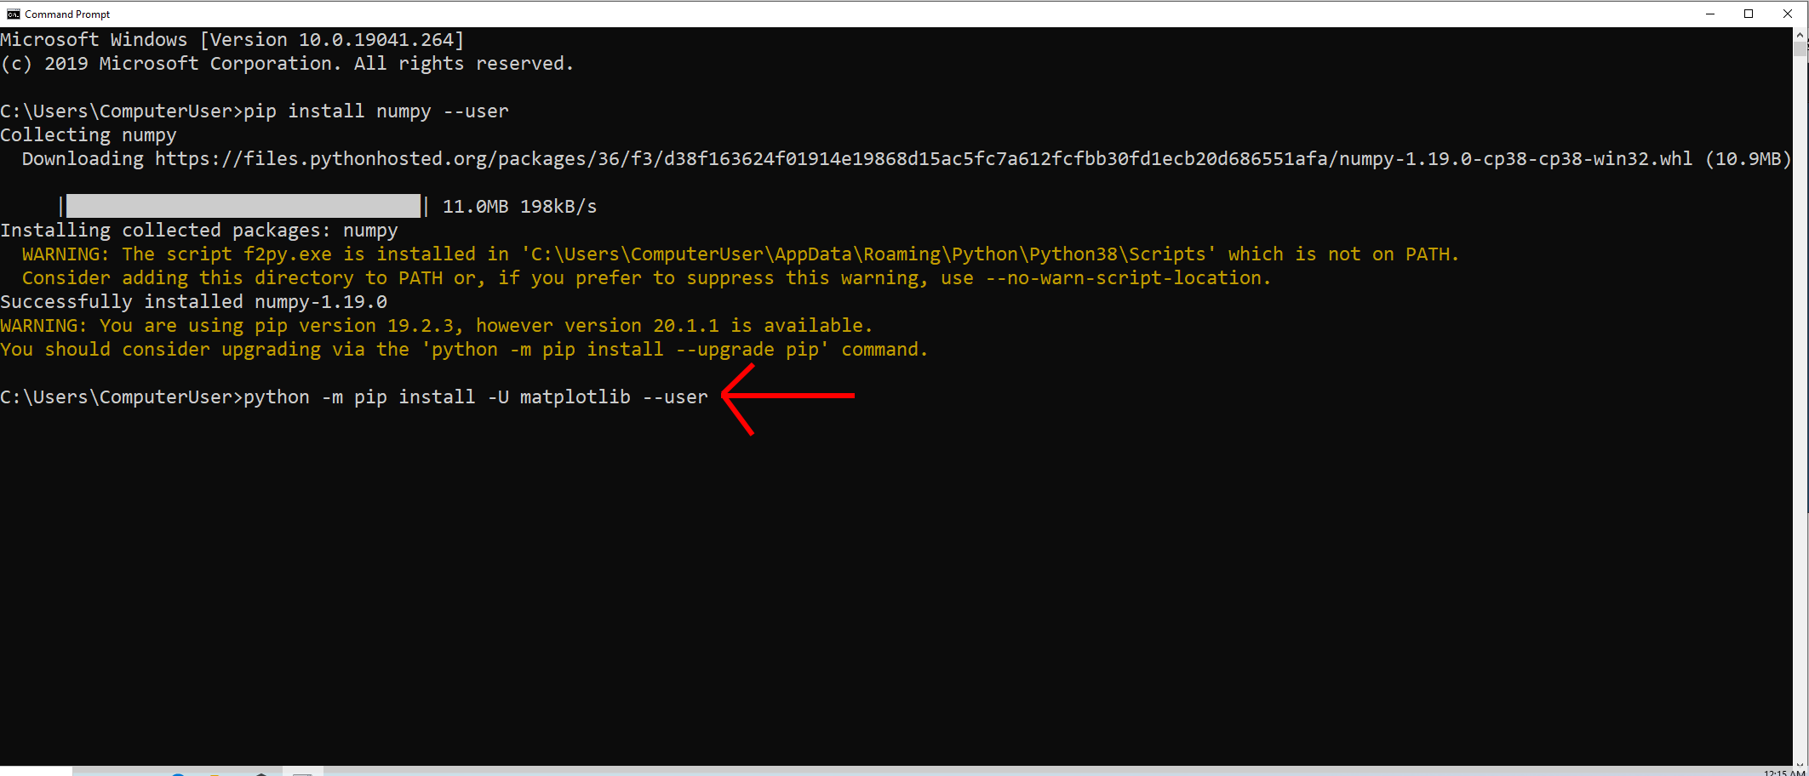
Then enter the following command: python -m pip install -u matplotlib --user
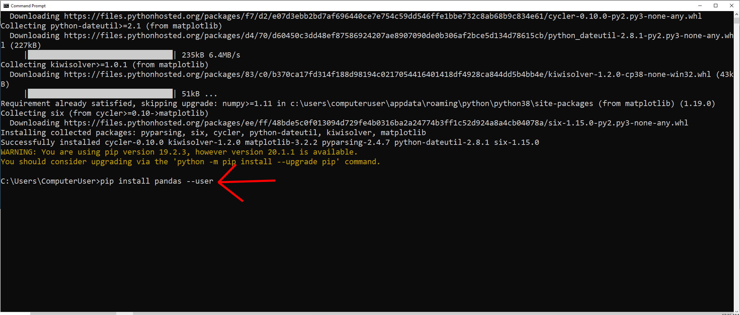
Then enter the following command: pip install pandas --user

CMake
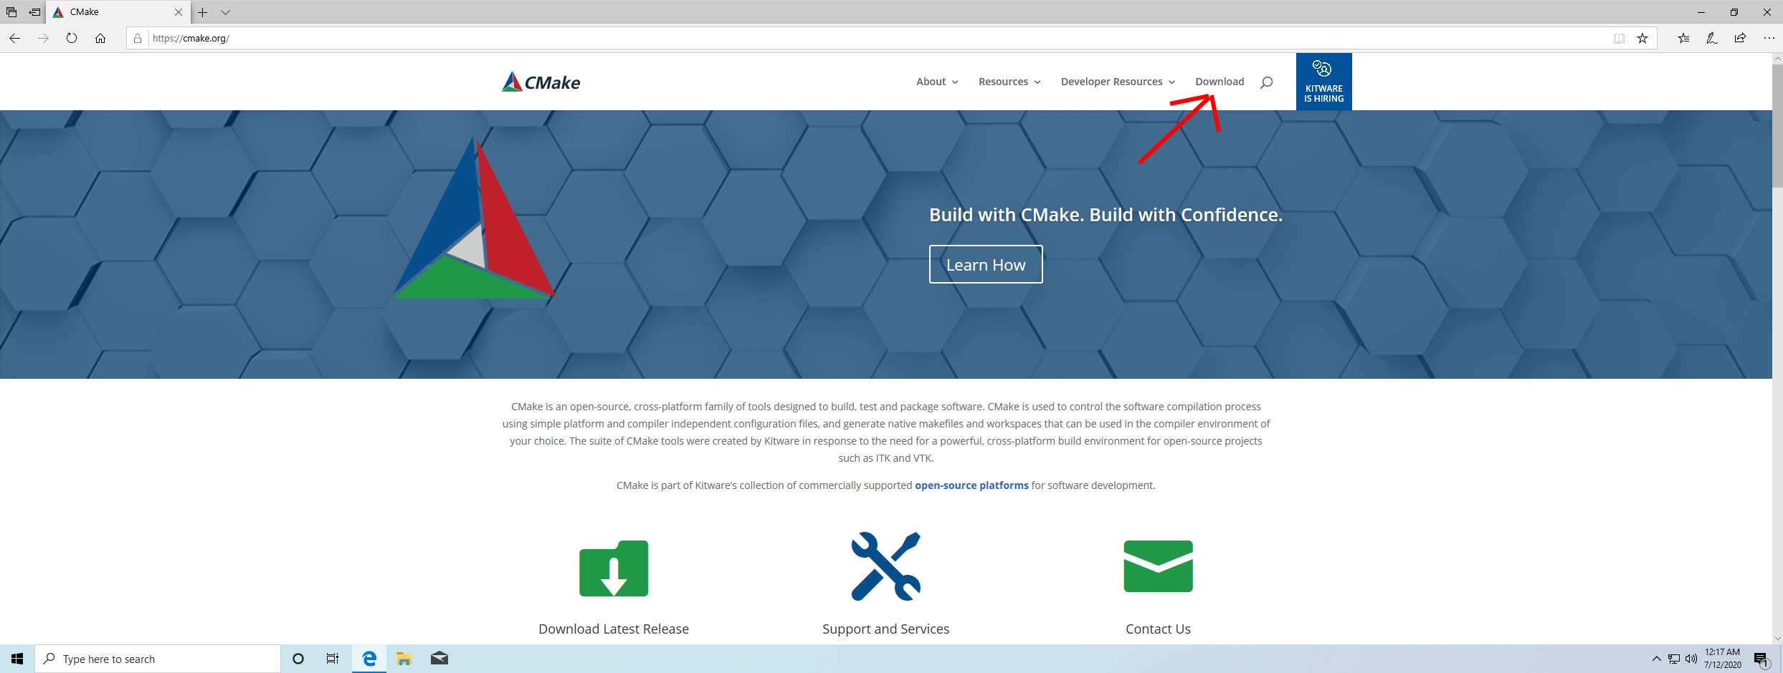
Open cmake.org in Microsoft Edge. Then click on “Download”.
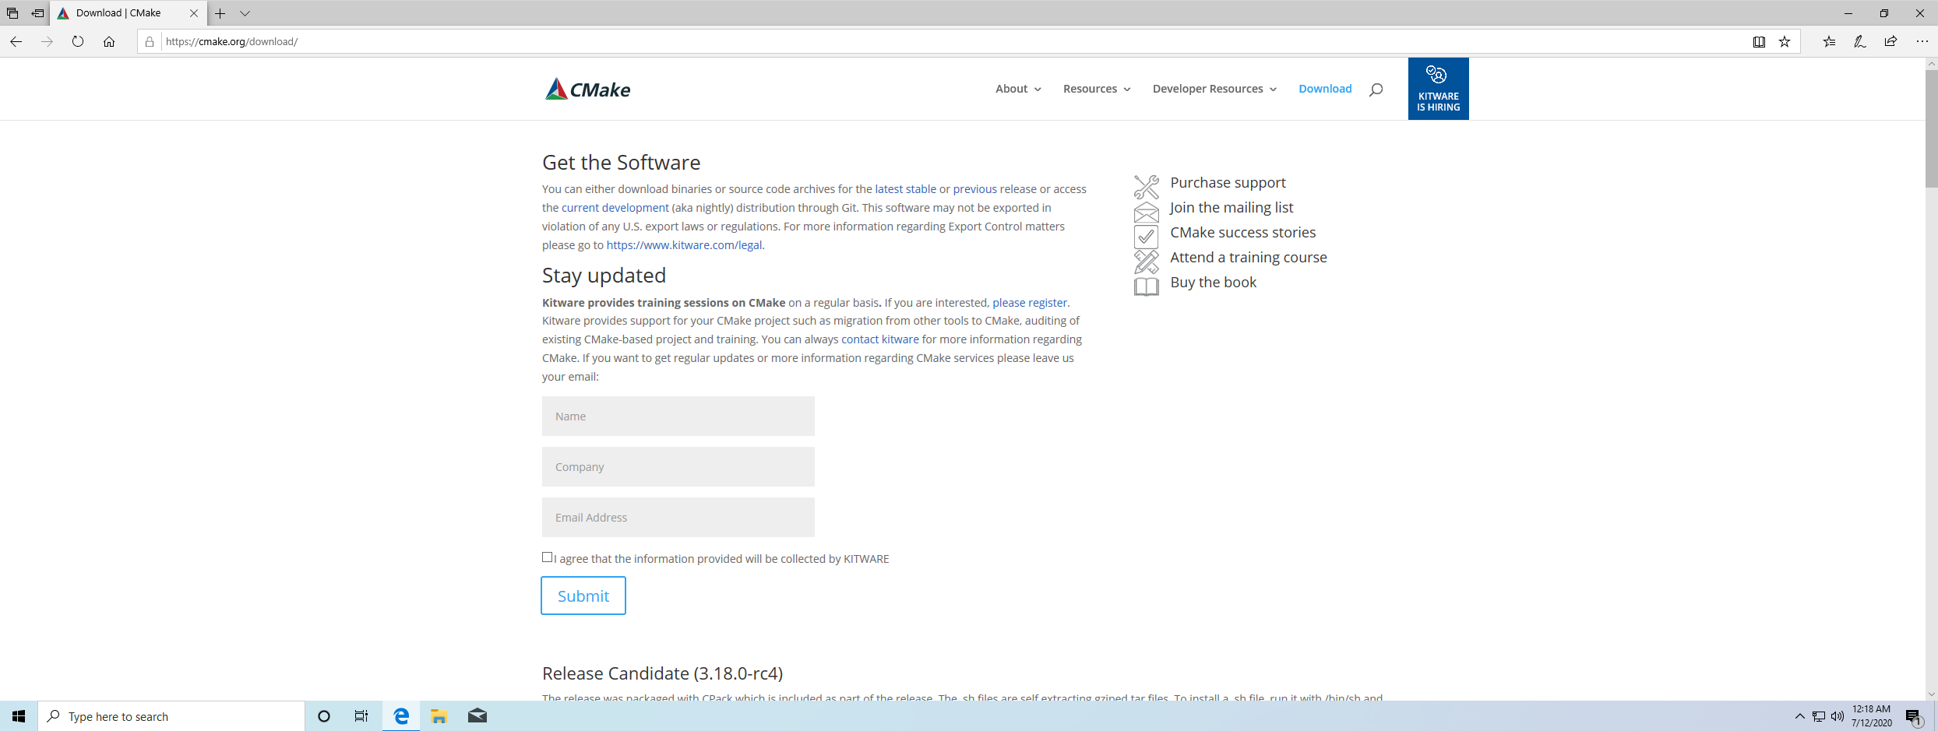
The Download page looks like this, scroll down to the installers.
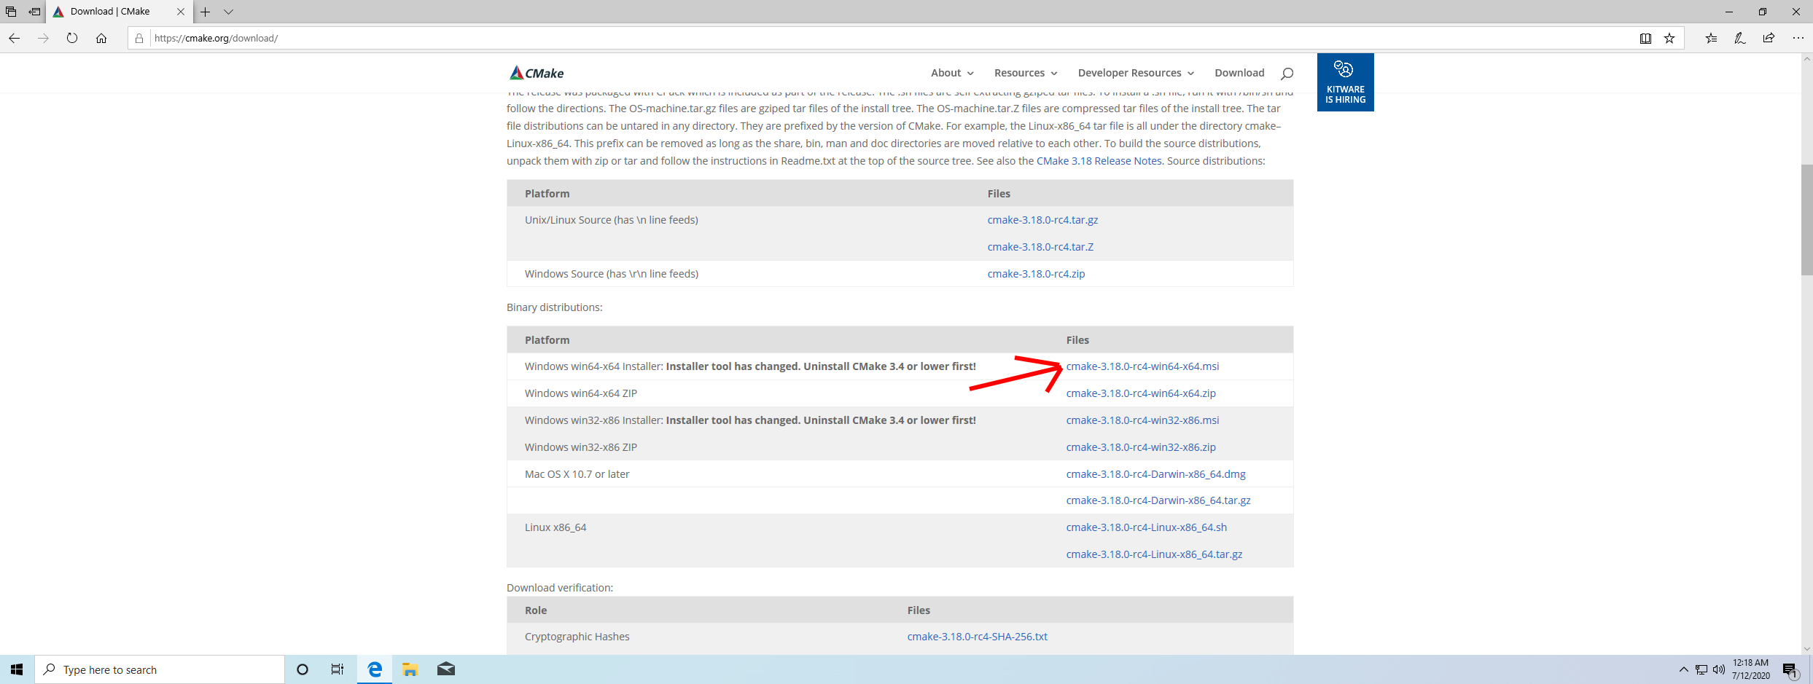
Click on “cmake-3.18.0-rc4-win64-x64.msi”. Any newer version is also fine.

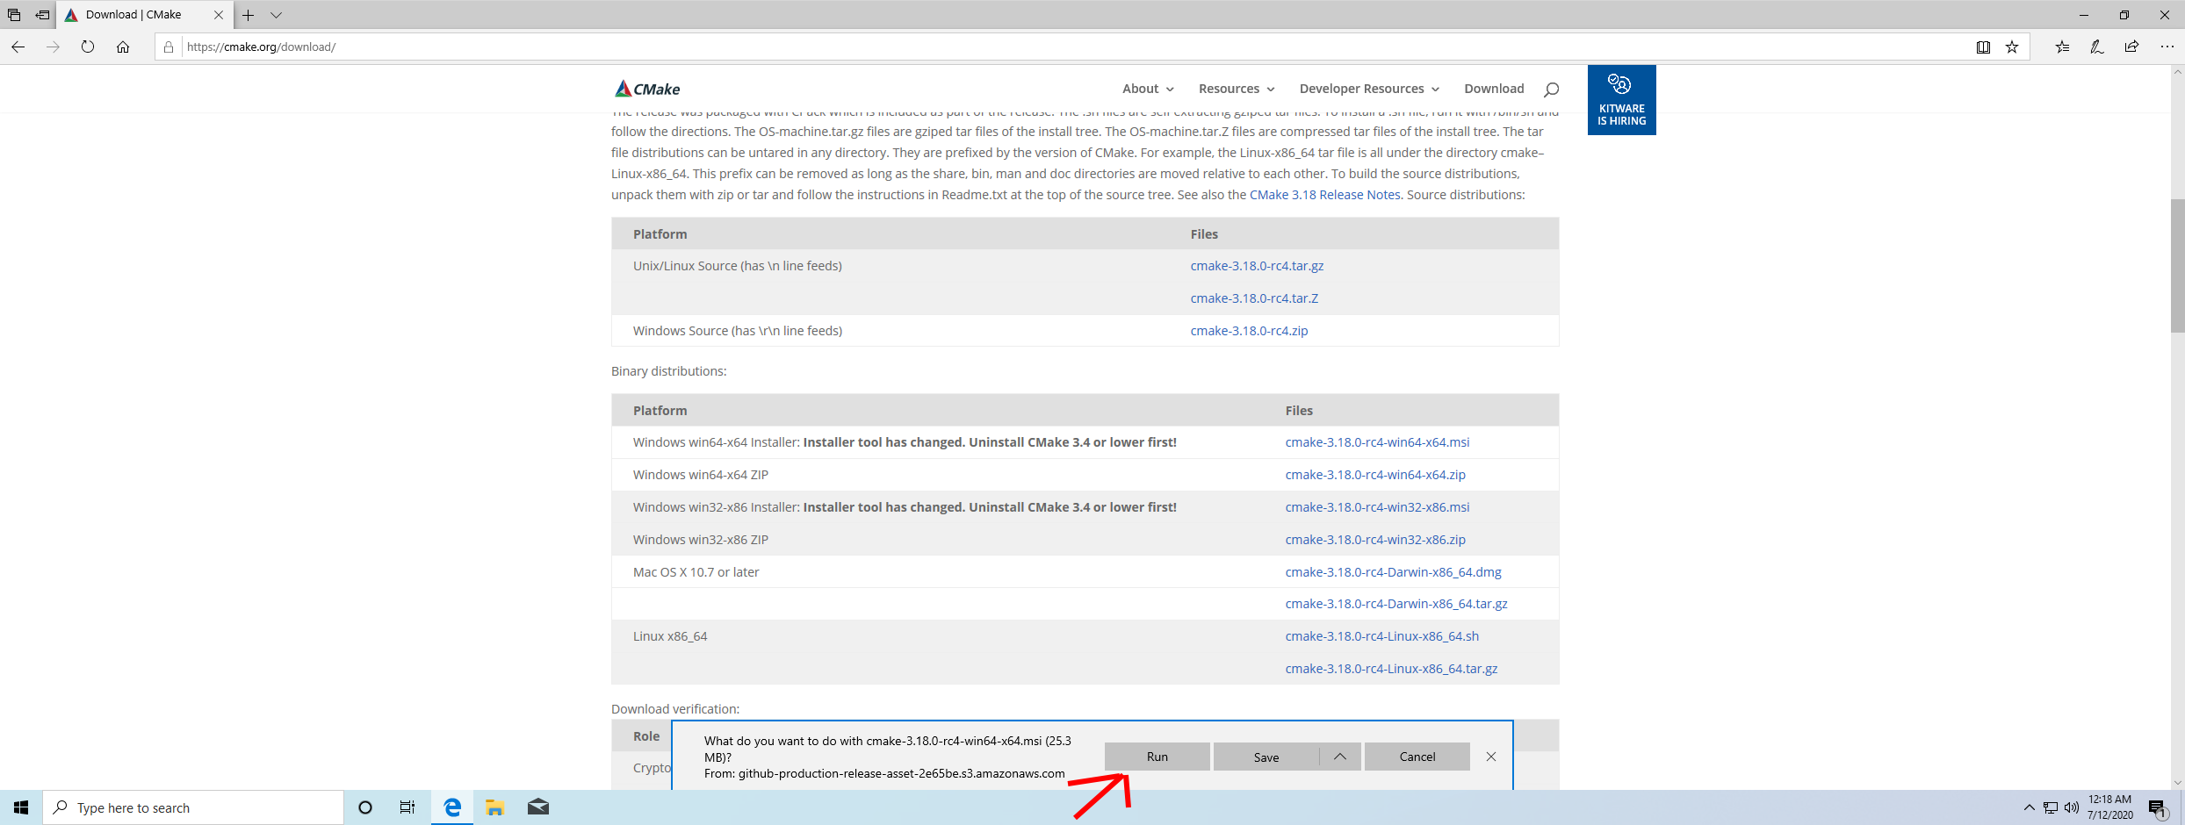
Microsoft Edge will show a prompt, click on “Run”.
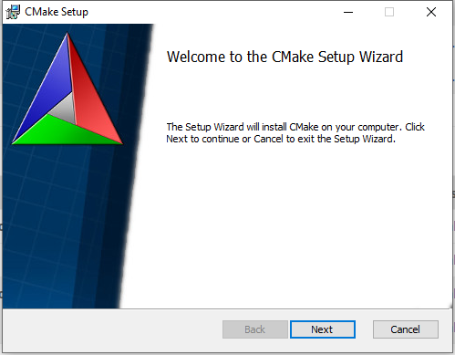
The installer will open, click on “Next”.
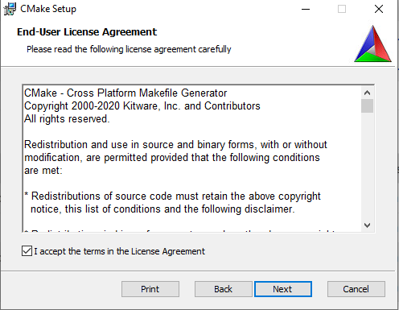
Check the “I accept the terms in the License Agreement” checkbox, then click on “Next”.
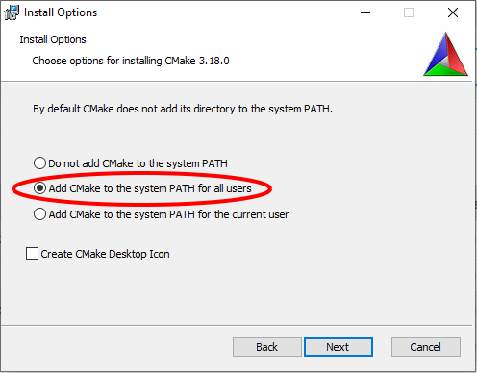
Set the radio button to add CMake to the system PATH, then click “Next”.

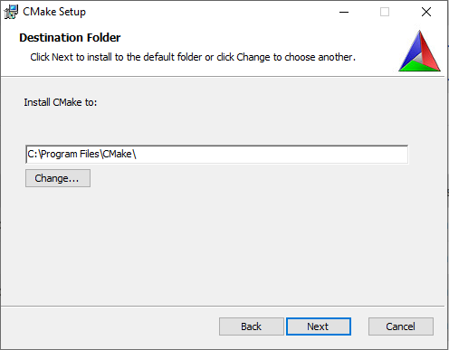
Choose an installation directory, then click “Next”.
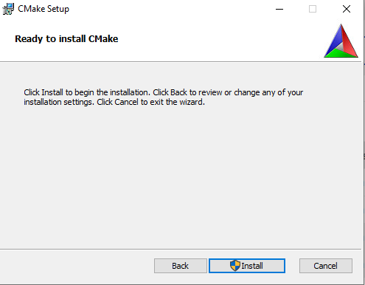
Click “Install”.

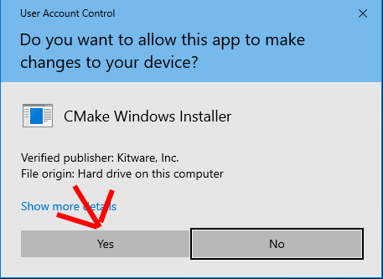
Microsoft Windows will show a UAC prompt, click “Yes”.
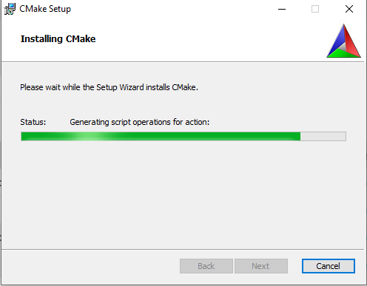
Installation will begin.

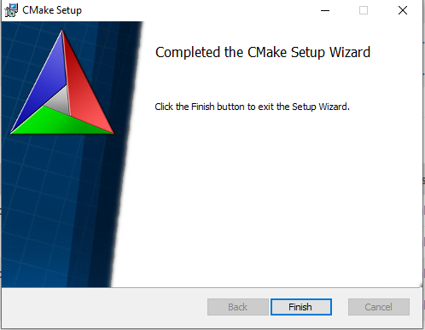
Once installation is finished, click on “Finish”.

mogasens_csv
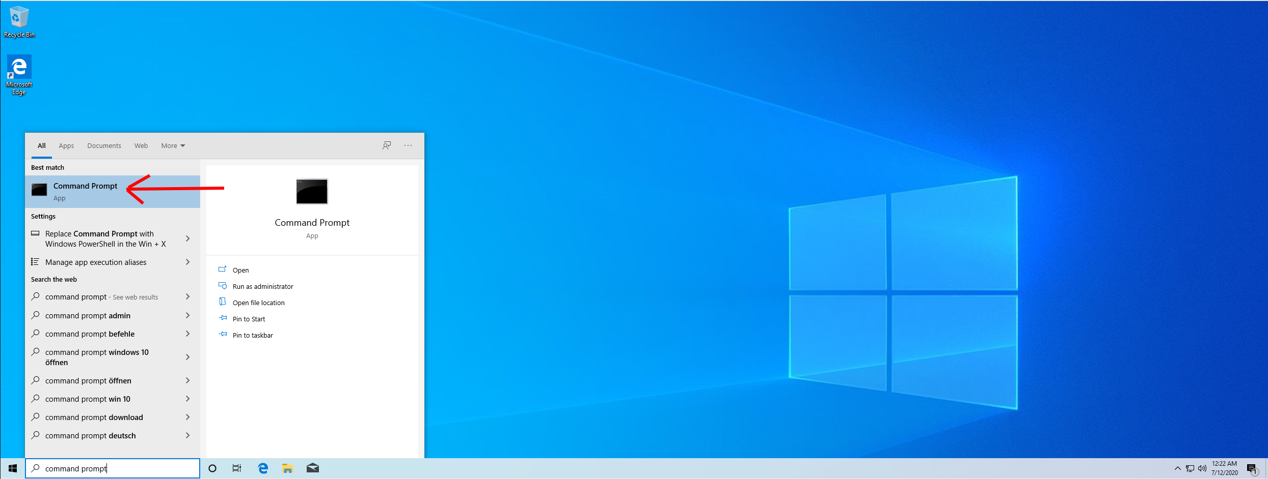
Type “Command Prompt” in the search field in the bottom left corner. Then click on “Command Prompt”.
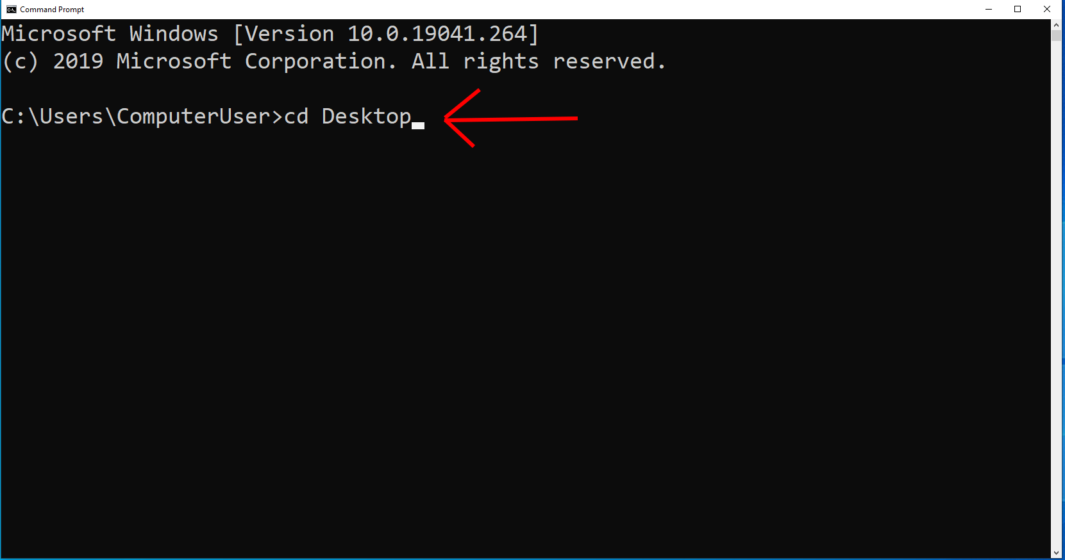
Navigate to the Desktop (or any other directory) using the following command: cd Desktop

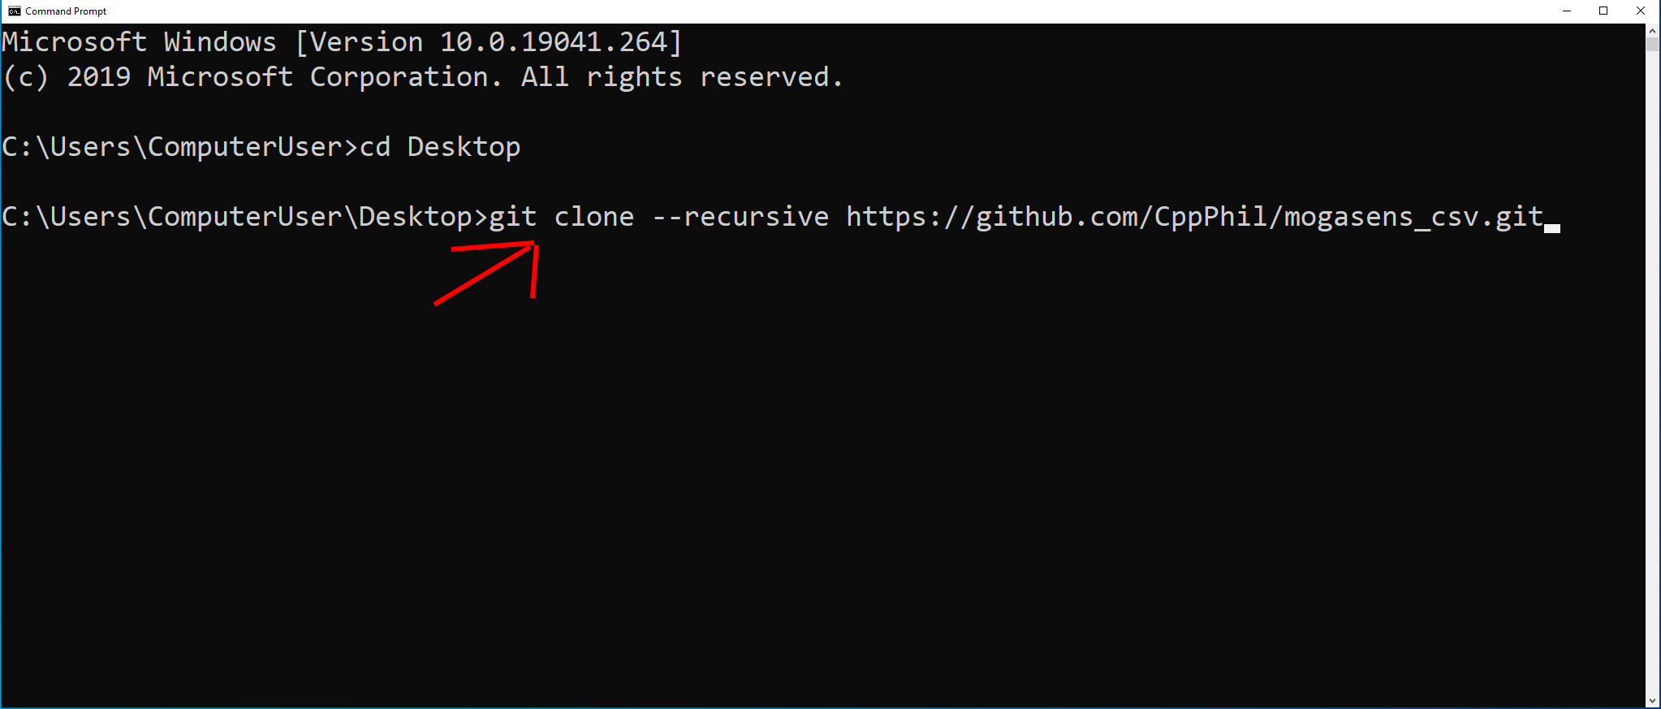
Clone the Git repository using the following command: git clone --recursive https://github.com/CppPhil/mogasens_csv.git

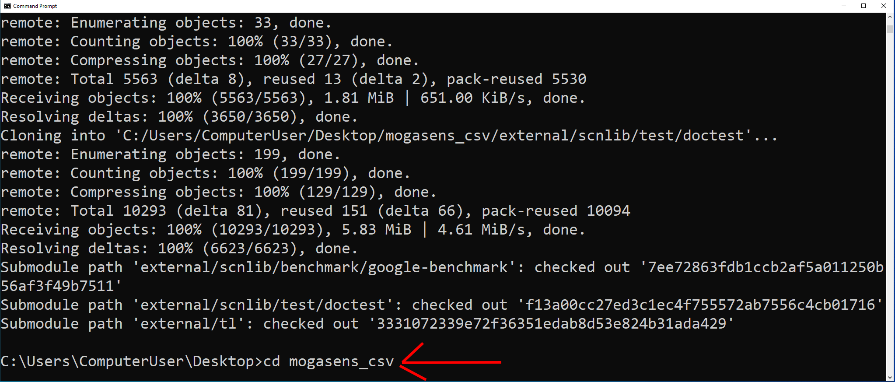
Navigate into the directory using the following command: cd mogasens_csv
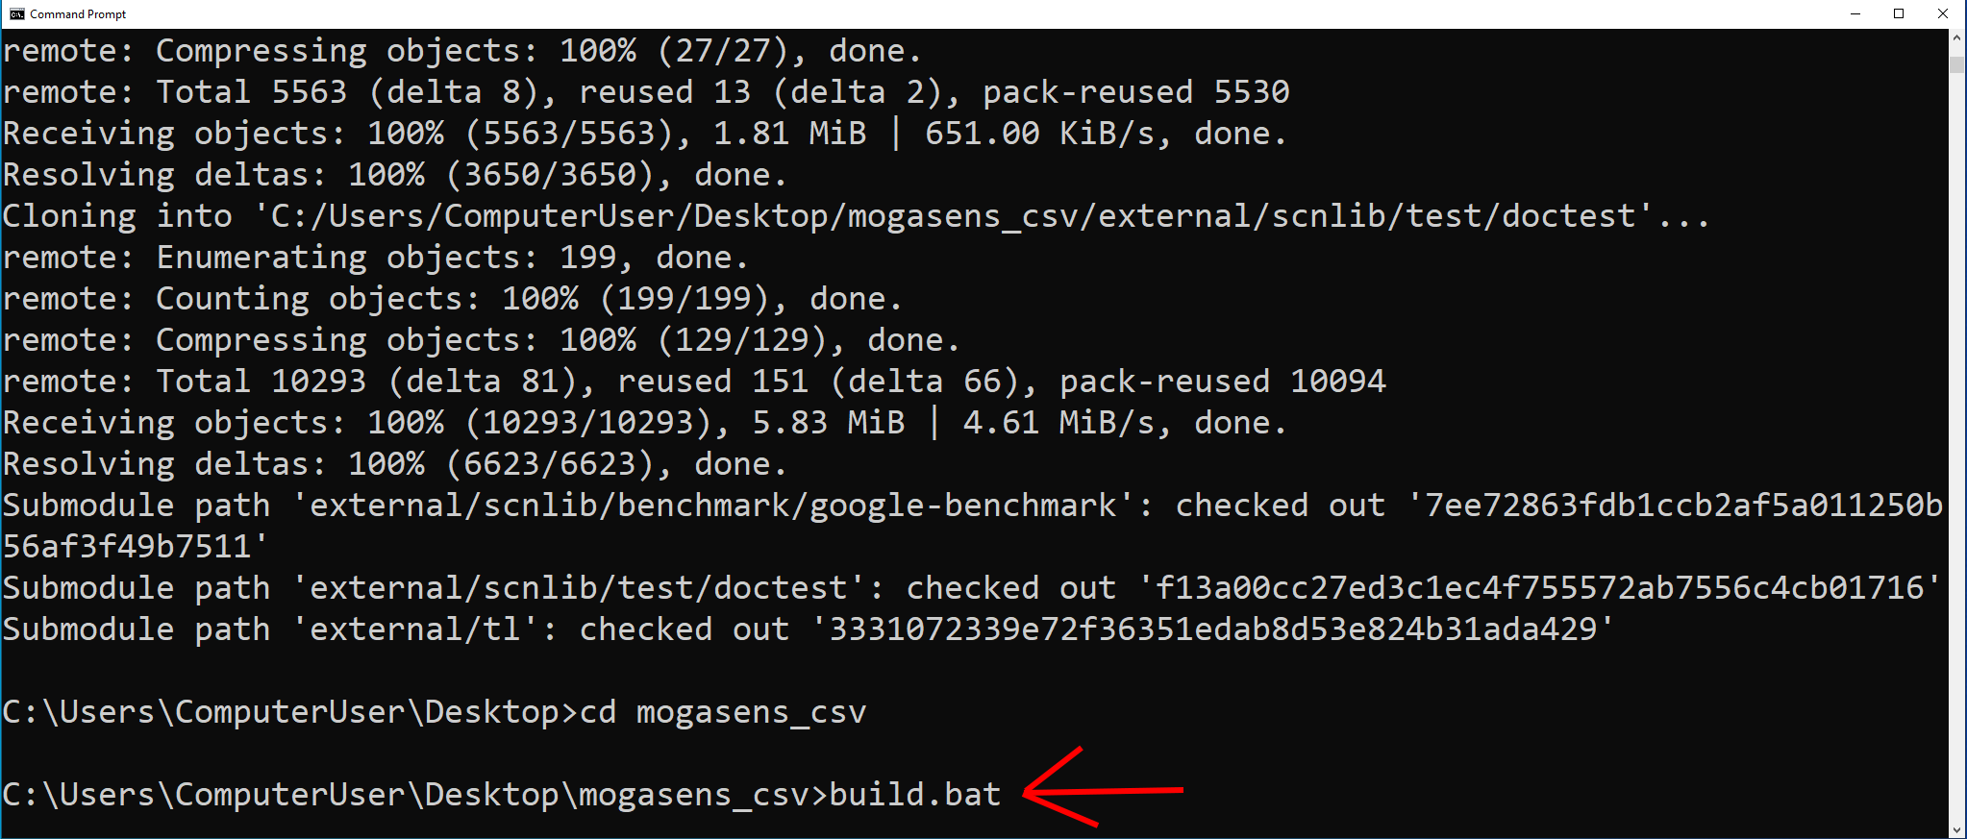
Start the build process using the following command: build.bat
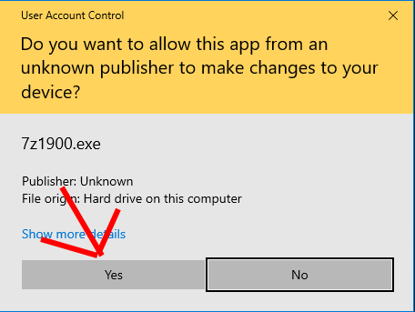
Microsoft Windows will show a UAC prompt for 7z1900.exe. This is the 7z installer of the goto-ruby Git submodule used to extract the portable Ruby distribution that is included. Click on “Yes”.
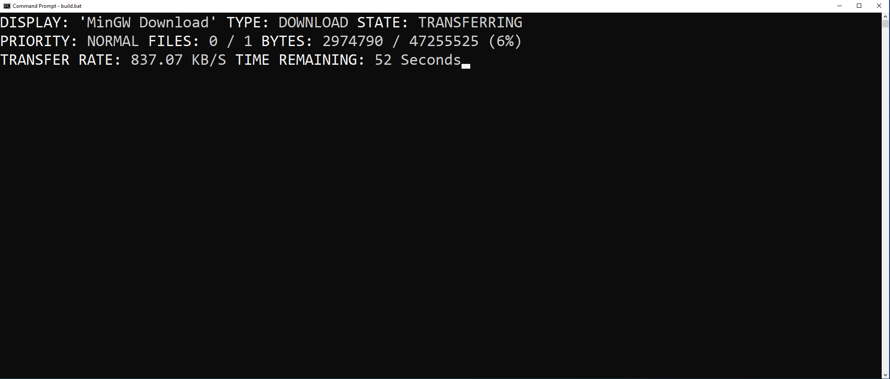
Next you can see Microsoft BITSADMIN downloading Stephan T. Lavavej's MinGW distribution from nuwen.net
This MinGW distribution includes a port of the GNU C++ Compiler as well as GNU Make so that the application can be built with the CMake generated Makefiles.
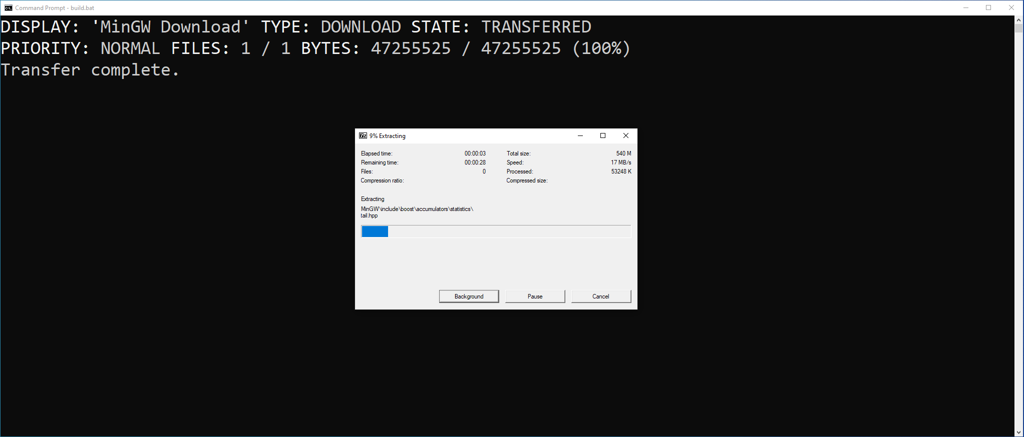
The MinGW distribution downloaded is a 7zip self extracting archive. Don't click any of the buttons, just wait for it to finish.

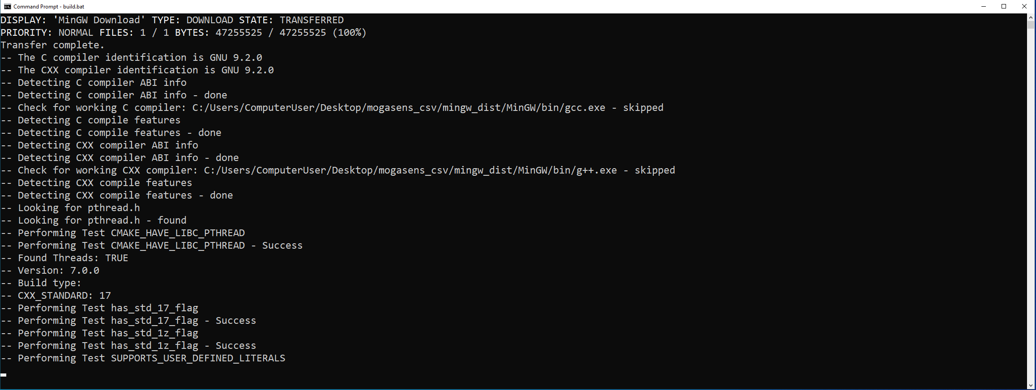
Next we can see the build process starting. CMake will generate MinGW Makefiles which will then be used to build the project.
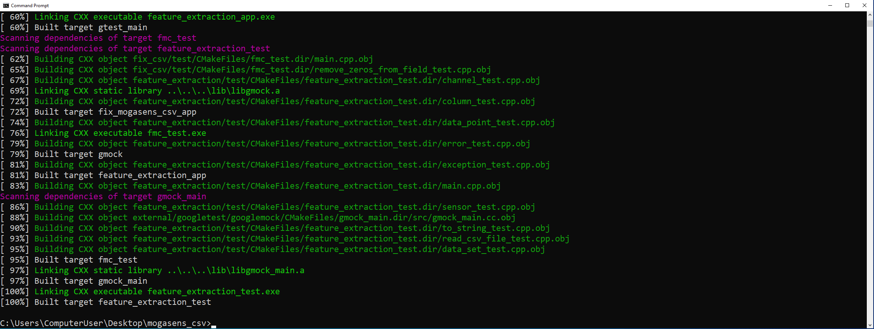
After a short while compilation has finished.
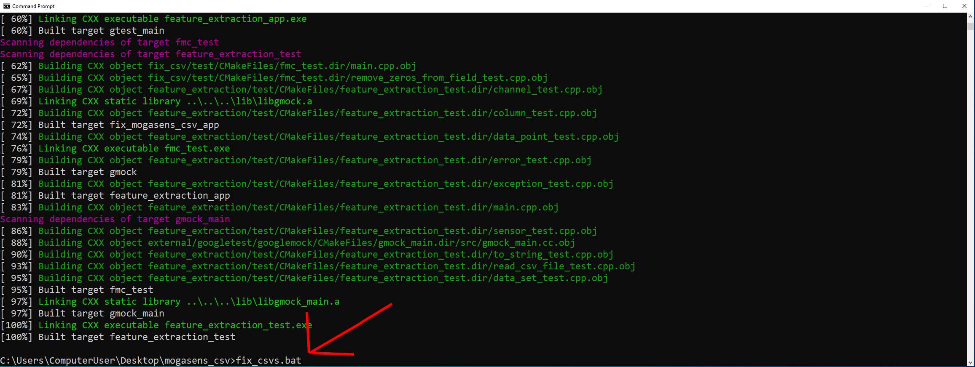
We can now generate the adjusted .csv files using the following command: fix_csvs.bat

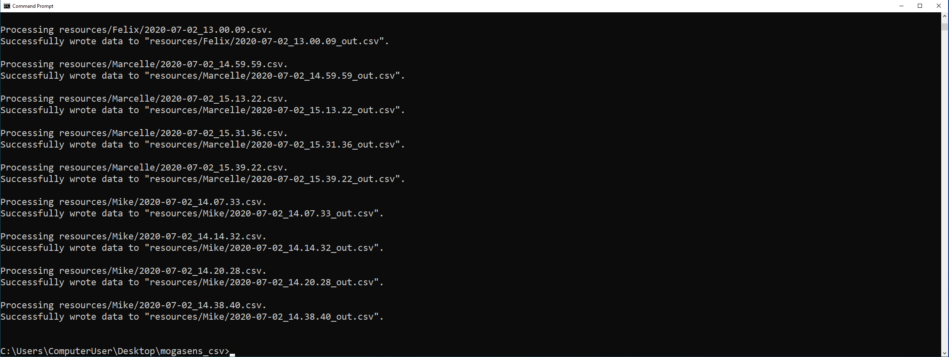
This is what it looks like after it's done.
As long as we don't delete the fix_csv application in the build directory we can invoke fix_csvs.bat again and again without rebuilding.
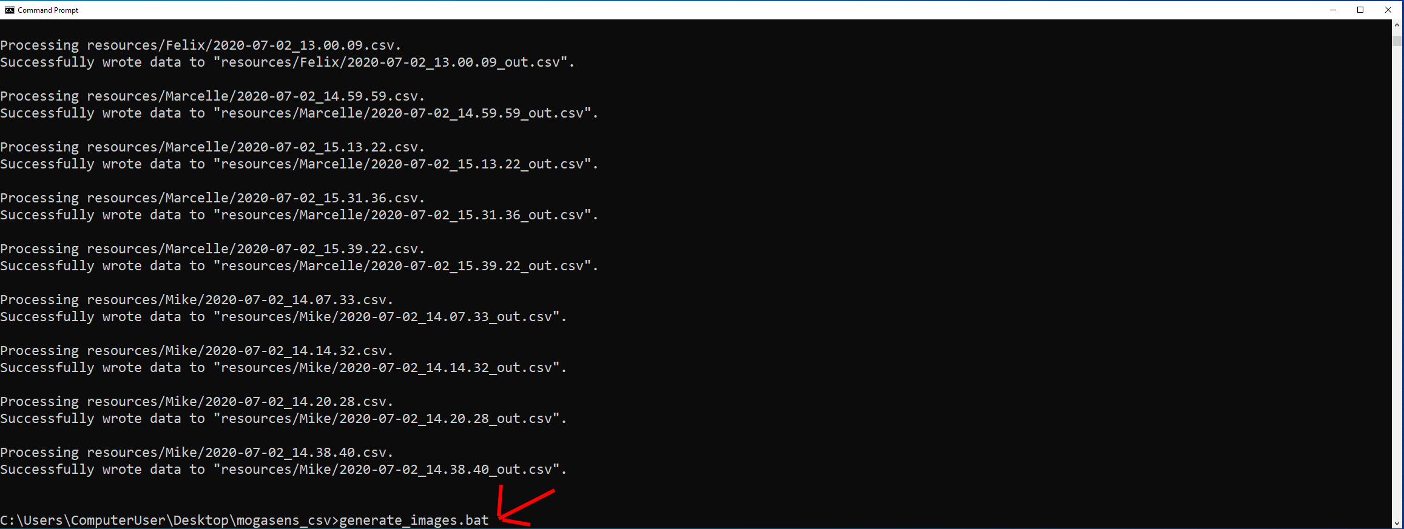
Now we can generate the images from the _out.csv files generated using the following command: generate_images.bat

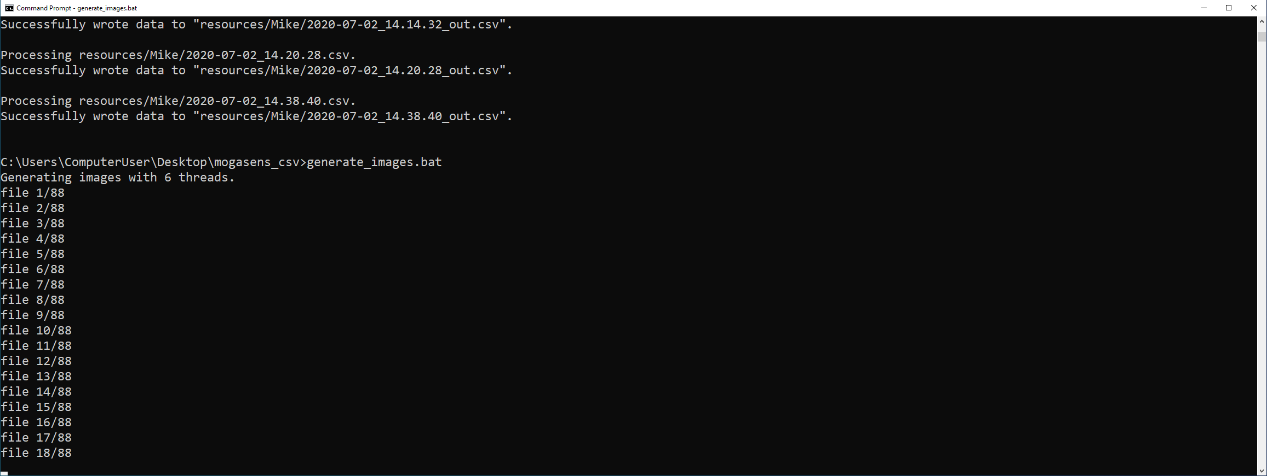
The images will be generated, this may take a moment.
As long as the _out.csv files are still around we can invoke generate_images.bat again and again without repeating any previous steps

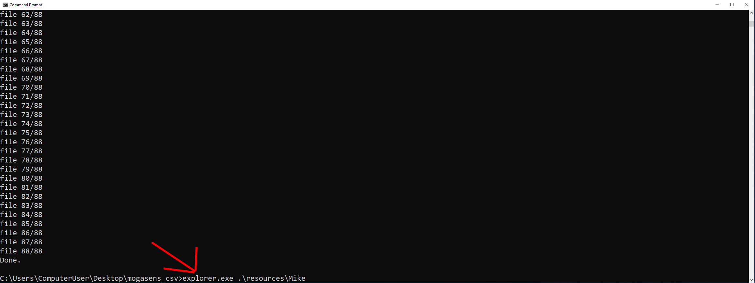
After the images are generated we can view them. Open one of the directories using Windows Explorer, for instance using: explorer.exe .\resources\Mike
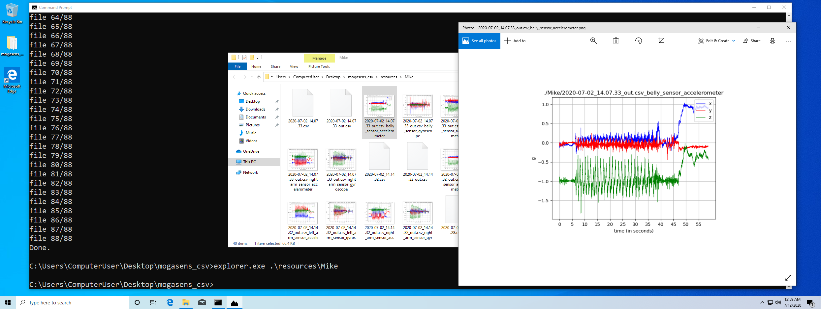
Viewing the images

