Cloud Computing
Project

For the final project of Cloud Computing I chose to implement the first part “Amazon Web Services”. I used Ruby programming language in order to write the code for the server and the client part. I chose ruby because is a relatively easy language to code with and because there are many gems (Ruby libraries) in order to handle AWS requests and services.

s3rv.rb
For the server application (s3rv.rb) and it executes by typing “ruby1.9.1 s3rv.rb” I used aws_s3 gem for AWS API which lets you to upload, download, delete, find files and create, delete buckets in S3 (amazon's service for data storage). RightAws is a different AWS API gem that also includes commands for handling requests for AWS but in this application is only used for SQS queue requests like create-delete queues and pop-push message. Rmagick is a ruby gem API for ImageMagick application. Imagemagick offers a variety of common functions that an image editor application has. In the server application I use it in order to produce the thumbnail and in order to extract the metadata I use Magick-metadata gem that lets you get the all metadata from an image with a single command and yaml gem is a walk around for making them into a string. Tempfile gem is included in Rdoc gem and is used it for the creation of a temporary file in order to store the image, the temporary file is deleted automatically after it's no longer needed.
I have uploaded s3rv.rb in an ubuntu EC2 instance on AWS. By placing the execute command “ruby1.9.1 home/ubuntu/s3rv.rb” in the /etc/rc.local file in my EC2 instance the application starts automatically every time the instance boots. As a result I don't need to log in to my instance to run the application, only if I need to make changes in the application's code. S3rv.rb is scanning input1 and input2 queues on SQS continuously until a message appears. When a message is received s3rv.rb downloads the image specified in the message from S3 and makes a copy of it in a temporary file in order to be able to edit it. Then depending on if the message contains the flag “metadata” or “thumbnail” s3rv.rb produces the required output. If a thumbnail is requested from input1, a thumbnail of the image specified in the message is produced and uploaded in S3 then the application produces the output message which contains the URL of the uploaded image and sends it on output queue. If metadata is requested from input2, the metadata of the specified image are extracted from the image and placed also in S3 as txt a file and a message is created in order to be send to output(stdout) queue. A message in SQS can be 64KB maximum, for this reason server application also sends the full string of the metadata in the output queue in order to be shown in the client application.
If an error occurs during the handling of a input message like “no file found”, “wrong data type” ,”no bucket found” ,”connection timeout”,etc s3rv.rb will place the error message in the error(stderr) queue in order to inform the client application. After a message is received and the appropriate message has been send the programs returns to the original state of searching for other incoming messages.

s3cl.rb
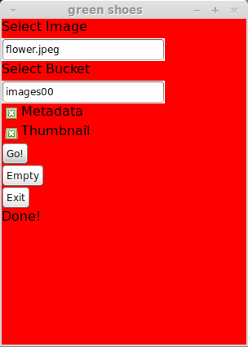
S3cl.rb is the client side application that sends the image to S3, up to two messages in input1 and input2 and waits for the responses in output (stdout) and input (stderr) queue. S3cl.rb uses almost the same ruby gems as s3rv.rb plus the green_shoes gem. Green_shoes is a fork (clone) of shoes which gives you the ability to make simple GUI (Graphical User Interface) relatively easy. I chose green_shoes over shoes because shoes current version is outdated, is not available as a gem and the package for Linux is broken. By running “ruby1.9.1 s3cl.rb” and by having the requested gems this windows comes up.
Upload function reads “Select Image” field in order to find the image file, reads “Select bucket” field for selecting a specific bucket and checks if we require metadata, thumbnail or both. If the image file is in the same folder as s3cl.rb we can just enter the image file (ex. flower.jpg) if it's not, we have to insert the full path (ex. /home/john/flower.jpg). If s3cl.rb can find the image and bucket then by clicking “Go!” the application uploads the image on S3 bucket and it creates one or two messages (it depends if we have selected only one or both procedures)which they include image's name, bucket's name ,unique key and what procedure we selected (metadata or thumbnail). A unique generated key is created in every “Go!” attempt in order for the client application to recognize the correct message response in output and error queue.
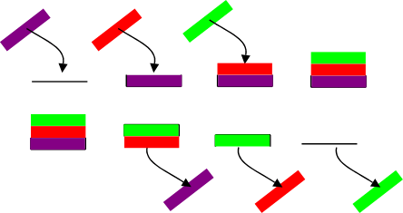
When this procedure has finished, the application starts to scan for messages in output and error queue. When the server application sends a message in one of those queues, client application reads it and deletes it from the queue. If message's unique key doesn't match with the previously generated key then the application resends the message in the queue (in the top of the stack) in order to receive the next message from the bottom until it finds a message with matching keys. By implementing FIFO (first in first out) method with the combination of matching client’s keys, we have the ability for more than one client applications to send requests simultaneously to the server without mixing up the resulting messages or for any client to receive and delete a message that was determinate for another client.

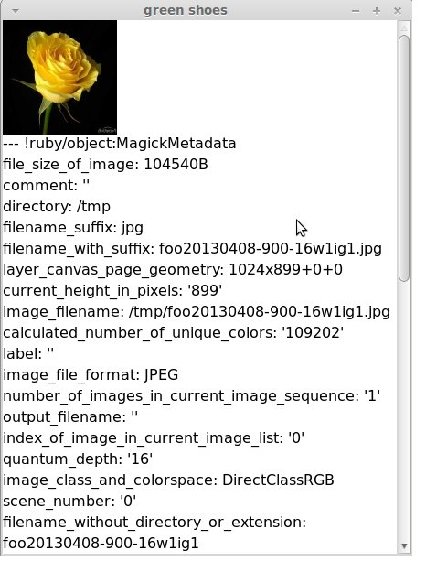
When the application receives the messages a pop-up window will appear that contains what we requested or an error from error queue if something went wrong. For example If we send a file that is not an image then the pop-up message will say “no decode delegate for this image format” and the main window will say “Server returned an error”. S3cl.rb deletes the uploaded image after the replies have been received but the requested thumbnail and metadata files are kept on S3.
If for some reason unclaimed messages have been left inside queues we can select “Empty” in order to delete all the messages from queues. If there are unread messages in queues the application will become slower as it checks all the messages until it finds the one that we requested. By normal use of the application unread messages shouldn't appear in queues, except if for example we are requesting procedures while the server application isn't running. Client application doesn't include a “connection timeout” error, because if for example 100 client applications make requests simultaneously, eventually all of them will receive their response but it is going to take some time.

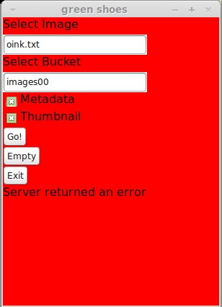
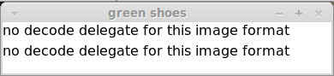

The message appears twice because we requested two procedures and the server returned an error for each one of them. If we request one procedure the message will only appear once.
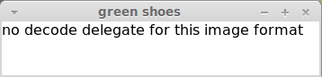

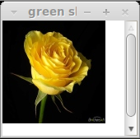
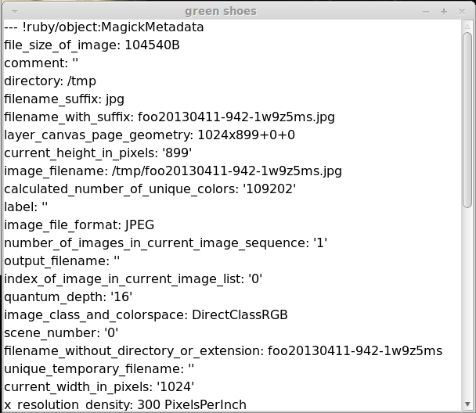
As mentioned before we can select only one procedure instead of both and receive only what we have requested

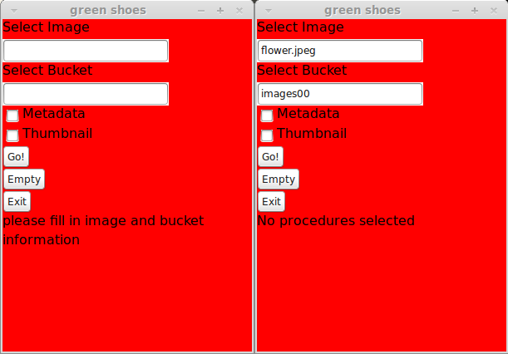
Error Handling
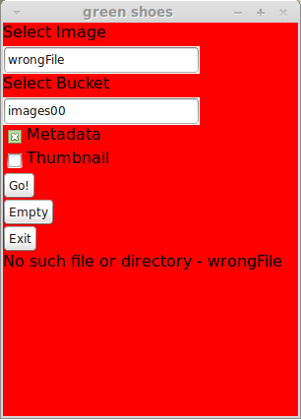
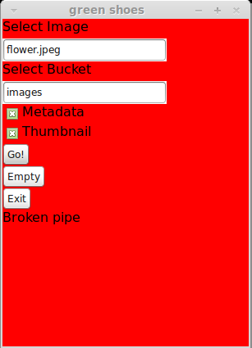
Except from errors that can return from the server s3cl.rb also handles local errors as well. If the application can't find our selected file a “no such file found” error will occur, if we select a bucket that doesn't exist a “bucket not found” or “broken pipe” error will occur (this application doesn't create buckets, they have to be created manually through amazon's website). Also errors like “No procedures selected” will occur if we haven't selected any procedures or “Please fill in image and bucket information” if we don't fill both fields.

S3term.rb
S3term.rb is a non-GUI terminal version I have included in the project, it is partially the same code as s3cl.rb but without the GUI and some functions like clean up. I recommend to use s3cl.rb as it is more integrated and easier to use. The way to use s3term.rb is by running is “ruby1.9.1 s3term [image file] [bucket] [yes/no] [yes/no]" where the first yes/no informs the application if we request for a thumbnail and the second yes/no if we request metadata.

Manual
By having ruby 1.9.3 and the appropriate gems both programs should be able to function in most operating systems, but so far it has been tested only on Linux. If we need to configure the application for other AWS accounts we must change access_key_id and secret_access_key in both s3cl.rb and s3rv.rb. If you need to use my AWS account just use it as it is and as a bucket select “images00”. For testing purposes we can run both applications locally without launching an EC2 instance, because both applications exchange information only with S3 and SQS it doesn't actually matter from where they are executing. If my EC2 instance is running, you can see a response only by running s3cl.rb with the correct bucket. If s3cl.rb stacks after we have send a request it probably means that s3rv.rb is not running from anywhere.

Installation
On Linux (debian-based) in order to install ruby we type:
Sudo apt-get install ruby1.9.3p0
And in order to install the gems:
Sudo gem1.9.1 install securerandom aws-s3 right_aws green_shoes RMagick exifr magick-metadata yaml
Those packages and gems should be enough for both server and client applications to work, although maybe more packages are required.

Conclusion
Using Amazon Web Services was much easier than I thought in the beginning. Most single actions considering requests with S3 and SQS didn’t require more than a line of code which made the coding a lot easier and faster. Amazon has publishes SDKs for most high level programming languages and platforms (Android, iOS, JAVA, PHP, Ruby, Python, .NET, VS ) and many more. It goes without saying that the documentation could be better and a little more detailed with more examples.
S3 has extremely fast response when saving and retrieving data and amazon promises unlimited saving storage without dropping the performance. On the other hand I wasn’t extremely impressed with SQS, in some occasions messages where stack “in flight” for a couple of seconds and besides that, every message can only be handled by only one computer at a time .In most occasions you don’t need more than one computer to handle a message but this also means that you can’t monitor the traffic of messages while there are being processed, if someone tries to monitor a queue all messages in that queue are becoming “locked” until monitoring stops.
From my point of view, SQS replaces the need for a middleware solution by acting as a middleman across multiple platforms, which is also very useful in cases where communicating machines are not in a local network and they don’t have static IPs or DNS, if every computer is communicating directly only with SQS we don’t even need any kind of routing. On the other hand, SQS doesn’t send messages, SQS only receives messages from computers and other computers are retrieving them from SQS, which forces all computers communicating with SQS to scan repeatedly for any messages in queues. The difference lays in “a server is waiting for a request” and “a server is looking for a message that includes a request”. If we need N computers to load balance the requests between them a load balancer will do the same job without forcing all computers to check for messages.

