Masterarbeit
Zur Erlangung des akademischen Grades Master of Science

Thema der Arbeit

Flood Justice in Germany: Analysis of Flood Exposure, Modelled Losses and Socio-Economic Vulnerability along the Elbe River Basin at Municipal Level

eingereicht von: Ahl, Maximilian

Gutachter/innen: Titel, Name Titel, Name

Eingereicht am Geographischen Institut der Humboldt-Universität zu Berlin am:

Table of Contents
Abstract 1
1. Introduction 2
1.1 Motivation and Problem Framing 2
1.2 Research Gap and Thesis Contribution 3
1.3 Research Questions and Analytical Orientation 4
2. Theoretical and Conceptual Background 6
2.1 Flood Risk Management in Germany 6
2.2 Area of Interest 7
2.3 Environmental and Flood Justice 10
2.4 Socio-Hydrology and the Human Dimension of Risk 12
2.5 Conceptual Framing of This Study 14
3. Research Design and Analytical Framework 16
3.1 Overall Approach 16
3.2 Study Area and Spatial Unit of Analysis 17
3.3 Equity Assessment Logic 18
3.4 Scope, Assumptions and Limits 18
4. Data and Methods 19
4.1 Data Sources 19
4.2 Spatial Preprocessing and Study Area Definition 21
4.3 Flood Hazard and Exposure Construction 21
4.4 Land-Cover-Sensitive Exposure Refinement 22
4.5 Exposure Quality Checks 24
4.6 Socio-Economic Data Processing 24
4.7 Indicator Screening and Candidate Vulnerability Variables 25
4.8 Vulnerability Index Construction and PCA Diagnostics 26
4.9 Multi-Return-Period Exposure Curves 28
4.10 Modelled Loss Portfolio and Derived Loss-Occurrence Return-Period Data 29
4.11 Statistical and Spatial Analysis 30
4.12 Software and Reproducibility 31
5. Empirical Results 33
5.1 Overview of Study Area 33
5.2 Flood Exposure Patterns 33
5.3 Socio-Economic Vulnerability Patterns 35
5.4 Distributive Relationship Between Exposure and Vulnerability 38
5.5 Land-Cover-Sensitive Exposure 41
5.6 Multi-Return-Period Exposure Dynamics 44
5.7 Modelled Loss Patterns 46
5.8 Results Synthesis 52
6. Discussion 55
6.1 Interpreting the Main Empirical Pattern 55
6.2 Why RP100 Area Exposure Does Not Show a Simple Social Gradient 56
6.3 Exposure Curves and Residual Risk 57
6.4 Modelled Loss Outcomes as a Clearer, but Model-Bound, Justice-Relevant Signal 58
6.5 Interpreting No-Event Municipalities 59
6.6 Relation to German Flood Risk Management 60
6.7 Methodological Contribution 61
6.8 Limitations and Critical Reflection 62
6.9 Implications for Flood Justice and Risk Governance 63
7. Conclusion 65
7.1 Summary of Key Findings 65
7.2 Contributions of the Thesis 66
7.3 Reflections on Flood Justice and Risk Governance 67
7.4 Outlook for Research and Practice 68
7.5 Final Remarks 68
Appendix A. Vulnerability Indicator Documentation 70

Abstract
Flood justice concerns not only where flood hazard occurs, but also how exposure, social vulnerability, and loss outcomes are distributed across places. This thesis examines these relationships at the municipal level in the German Elbe River Basin. The empirical study population is an RP500-defined flood corridor of 835 municipalities. Municipal flood exposure is derived from JRC river-flood hazard rasters for six return periods and refined at RP100 using DLR Land Cover DE to identify flooded Artificial Land. Socio-economic vulnerability is represented by a direction-coded, dimension-balanced index based on 23 BBSR INKAR indicators. A separate 5,000-year loss portfolio provides modelled loss occurrence, annual loss probability, and finite loss-occurrence return-period estimates.

The results do not show a positive corridor-wide vulnerability gradient in flood-area exposure. The correlation between the main vulnerability index and RP100 municipal flood share is approximately -0.05, and the relationship remains weak when exposure is restricted to Artificial Land. Modelled loss outcomes display a clearer, although still moderate and non-monotonic, social differentiation. Positive-loss municipalities are more common in the upper vulnerability groups, annual loss probability is positively associated with vulnerability (Spearman rho = 0.230), and finite loss-occurrence return-period estimates tend to be lower among more vulnerable municipalities within the positive-loss subset (Spearman rho = -0.198). PCA and indicator-removal checks preserve the contrast between weak exposure associations and the positive annual-loss association, while the finite loss-occurrence return-period relationship weakens under the PCA specification.

The findings show that flood justice along the Elbe cannot be reduced to a single exposure gradient. Area exposure, socio-economic vulnerability, and modelled loss frequency represent distinct dimensions of distributive risk. The interpretation remains model-bound: 555 municipalities record no simulated loss year in the supplied portfolio, but this does not establish an absence of real-world flood risk, particularly because smaller streams are not fully represented.

Keywords: flood justice; flood exposure; socio-economic vulnerability; modelled losses; Elbe River Basin

1. Introduction
"Floods are 'acts of God,' but flood losses are largely acts of man."
(White, 1945, p. 2)

1.1 Motivation and Problem Framing
Flooding affects millions of people and causes substantial economic losses worldwide. Jongman et al. (2012) show that coastal and fluvial floods affect several million people each year, while the population and value of assets in flood-prone areas have grown substantially over recent decades. Their global assessment also indicates a sharp rise in economic exposure to river and coastal flooding. Flood risk is therefore not only a matter of extreme hydrometeorological events. It is also shaped by the concentration of populations, infrastructure, and economic assets in flood-prone locations, making flooding a problem of both physical hazard and socio-economic development.

In Europe, this problem has become especially visible in the context of climate change and adaptation. Rojas et al. (2013) describe river flooding as one of the major climate-related risks facing the European Union and show that future damages may rise dramatically if current levels of protection are simply kept constant. Their analysis projects expected annual flood damages in the EU from around EUR 5.5 billion under current conditions to almost EUR 98 billion by the 2080s in a no-adaptation trajectory, while also showing that adaptation can substantially reduce these losses and may be highly cost-effective. For the present thesis, this shifts the question from whether flood risk matters to how it is governed. Once adaptation and protection become public tasks, the spatial distribution of their benefits and limits becomes relevant. Flood risk management is not only a technical response to hazard. It is part of a broader political and social negotiation over future safety, acceptable losses, and territorial priorities.

Germany offers a particularly strong setting in which to examine these issues, because major flood events have repeatedly triggered policy change and public debate. Thieken et al. (2016) identify the 2002 flood as a decisive turning point in the German shift toward integrated flood risk management, while the 2013 event revealed both the continuing severity of flood losses and the role of institutional learning. Within this national context, the Elbe stands out as one of the most visible and relevant river corridors. Grabs (2016) shows that the extreme Elbe floods of 2002 and 2013 triggered the Elbe Flood Protection Action Plan and became a benchmark for broader debates on integrated flood risk reduction. The Elbe is not only a hydrological space, but also a historically significant corridor of settlement, intervention, and policy learning. It is precisely this combination of repeated flood experience, extensive protection efforts, and wider governance relevance that makes the Elbe a compelling case for studying the distribution of flood-related burdens and benefits.

Aggregate damage figures alone cannot capture the significance of flooding. Flood impacts are socially differentiated. Tovar Reaños (2021) shows for Germany that expected flood damages affect households differently across income groups and that welfare losses after floods disproportionately harm low-income households. More recent evidence by Odersky and Löffler (2024) points in the same direction from another angle. Using actual damage data from the 2021 floods in Germany, they show that flood exposure was regressive at the local level, with poorer neighbourhoods displaying substantially higher exposure than better-off nearby areas. These findings suggest that flood-related harm is not distributed randomly across space or society. Exposure, coping capacity, and recovery potential are shaped by socio-economic conditions, which gives flood governance a social distributional dimension.

This is the practical puzzle from which this thesis starts. If flood risk is growing, if adaptation and protection are becoming more important, and if flood-related harms are socially differentiated, the key issue is no longer only how much flood risk exists. It is also who is exposed, where losses occur, and whether these patterns align with broader socio-economic inequalities. The Elbe is particularly suitable for asking these questions because it combines a long history of flood events and protection strategies with marked spatial variation in local social conditions. The thesis therefore examines modelled exposure and loss outcomes as potentially uneven and justice-relevant spatial patterns. It does not treat those outcomes as a direct measurement of protective infrastructure.

Under climate change, this puzzle becomes even more pressing because adaptation decisions are not judged by efficiency alone. As de Goër de Herve (2022) and Thaler and Hartmann (2016) show, flood risk management also raises questions of fairness, because protection measures allocate public resources and shape who receives greater safety and who remains more exposed. Liao et al. (2019) further argue that flood prevention can generate environmental injustice when interventions redistribute floodwater rather than removing it altogether. The thesis approaches flood risk through a distributive justice lens, while the deeper conceptual discussion of environmental and flood justice is developed in Chapter 2.

1.2 Research Gap and Thesis Contribution
The literature on floods, vulnerability, and flood risk management is already substantial, and this thesis does not start from an empty field. A large body of work has examined hydrological hazard, damage estimation, governance reform, and the social dimensions of vulnerability. In parallel, a growing international literature has shown that flood exposure is often socially uneven rather than randomly distributed. Qiang (2019) demonstrates this for the United States at national scale, while Poussard et al. (2021) show that environmental inequalities in flood exposure are strongly shaped by the spatial scale at which they are measured. More recent work for Latin America reaches a similar conclusion and stresses that substantial social disparities in flood exposure can also be identified at the local level (Kephart et al., 2025). German research has also moved in this direction. Tovar Reaños (2021) links flood damages to inequality in welfare terms, and Odersky and Löffler (2024) provide evidence that flood exposure in Germany was regressive at the local scale during the 2021 event. These studies make clear that the relationship between flooding and social inequality is no longer a marginal topic. It has become an increasingly visible research field in its own right.

Still, an important gap remains. Existing studies often focus on one dimension in relative isolation: physical hazard and damage, social vulnerability measurement, or governance and protection strategies. These strands are not always brought together within one coherent distributive framework. This matters because flood inequality is, as Poussard et al. (2021) argue, a question of scale. Patterns that appear weak or invisible at broader regional levels can become much clearer when the analysis moves to smaller spatial units. Older German work already pointed to this problem. Fekete (2010) argued that an overview of social vulnerability to river floods in Germany was missing and emphasised that only few studies had addressed the non-structural and socially differentiated dimensions of flood risk in a systematic way. Rufat et al. (2015) add a broader methodological caution by showing that there remains a large gap between the contextual complexity of social vulnerability and the generalised indicator practices often used to measure it. Rufat et al. (2019) make a similar point by arguing that many social vulnerability models remain primarily descriptive. For the purposes of this thesis, the implication is not that previous work is inadequate. Rather, there is still limited municipality-level evidence that directly links flood exposure patterns with socio-economic vulnerability in a justice-oriented way for the Elbe corridor.

This is where the present thesis is positioned. Its contribution lies in combining municipality-based exposure analysis, a multidimensional socio-economic vulnerability index, and modelled loss outcomes within one framework. Empirically, it examines how flood exposure and simulated loss occurrence are distributed across municipalities with different social characteristics in the Elbe flood corridor. This responds to the scale problem identified in the literature and to the need for more spatially explicit evidence on distributive flood-risk patterns. The study does not measure protective infrastructure, although protection and residual risk remain important for interpreting why exposure and loss outcomes may diverge. The contribution is both empirical and conceptual: it adds municipality-level evidence for the Elbe corridor and situates it within debates on flood justice, socio-economic vulnerability, and spatial inequality.

1.3 Research Questions and Analytical Orientation
1. How is modelled flood exposure distributed across municipalities with different socio-economic vulnerability profiles in the Elbe flood corridor?
2. How do modelled loss occurrence, annual loss probability, and finite loss-occurrence return-period estimates relate to flood exposure and socio-economic vulnerability across this corridor?

Both questions are examined as distributive and spatial questions at the municipal level. The analysis does not observe individual households or neighbourhood sorting. It tests whether municipalities with different socio-economic profiles occupy systematically different positions in the distribution of flood exposure, modelled loss occurrence, annual loss probability, and finite loss-occurrence return-period estimates.

The analytical aim is to determine whether the overlap between socio-economic vulnerability and flood-related outcomes is sufficiently systematic to raise distributive justice concerns within the context of German flood risk management.

Empirically, the Elbe River Basin provides the hydrological and governance context, while the statistical analysis is restricted to municipalities intersecting the RP500 flood extent. Socio-economic vulnerability is represented by the INKAR-based index and its three dimensions. A separate outcome layer comprises modelled loss occurrence, annual loss probability, and finite loss-occurrence return-period estimates. These outcomes are assessed alongside multi-return-period exposure curves, but neither dataset is treated as an inventory of dikes, flood walls, or other physical infrastructure.

2. Theoretical and Conceptual Background

2.1 Flood Risk Management in Germany
Flood risk management in Germany has changed substantially over the last decades. While earlier approaches were dominated by technical flood protection and the attempt to control water mainly through structural measures, more recent debates and policy developments increasingly frame flooding as a broader risk management problem. This shift was not purely conceptual, but strongly event-driven. According to Thieken et al. (2016), the 2002 flood marked an important reorientation toward integrated flood risk management in Germany. A similar point is made by Sairam et al. (2021), who note that the major events of 1993, 1995, and especially 2002 triggered policy decisions in favour of more systemic approaches. In this context, the European Floods Directive became a key institutional milestone, because it required member states to identify significant flood risks and prepare flood risk management plans. Germany implemented this broader orientation within its national legal and planning framework, which means that flood risk management today has to be understood as a combination of hazard assessment, spatial planning, emergency management, damage reduction, and long-term adaptation rather than as flood defence alone (Sairam et al., 2021; Thieken et al., 2016).

Major flood events make this shift easier to trace. Thieken et al. (2016) describe the 2002 flood as the most expensive natural hazard event in Germany up to that point, with damage of EUR 11.6 billion and 21 fatalities. The 2013 flood again caused very high losses, estimated at EUR 6 to 8 billion, but it also demonstrated that some improvements had already taken effect. Thieken et al. (2016) argue that by 2013 Germany had improved flood warnings, disaster response coordination, property-level mitigation, and the maintenance of flood defence systems. In a similar way, Grabs (2016) presents the Elbe floods of 2002 and 2013 as key triggers for the Elbe Flood Protection Action Plan and as a major moment in the broader acceptance of integrated flood risk management. These events matter not only because they caused severe damage, but because they exposed weaknesses in existing institutions and made flood governance a long-term political issue. Germany is thus a useful case because its current flood risk management system emerged through repeated extreme events, institutional learning, and ongoing policy adjustment.

German flood risk management operates across multiple governance levels and across different types of measures. At the European level, the Floods Directive created a common framework, while national and subnational actors remain responsible for implementation, planning, and financing in practice (Sairam et al., 2021). This multi-level structure means that flood risk management outcomes are shaped through coordination problems, regional variation, and institutional capacity, not only through technical necessity. The German debate has also moved beyond a narrow focus on dikes and flood walls. Grabs (2016) emphasises that integrated flood management includes a mix of structural and non-structural measures, including warning systems, land-use regulation, reactivation of former floodplains, and broader adaptation strategies. Thieken et al. (2016) likewise stress the importance of spatial planning, preparedness, and public involvement. More recent work also shows that flood risk management increasingly includes private and semi-private dimensions, such as insurance, household mitigation, and municipality-level communication. Surminski and Thieken (2017) argue that insurance should be seen as part of a broader anticipatory flood risk management field, while Osberghaus (2015) shows that private mitigation remains necessary because public protection cannot eliminate flood risk entirely.

Despite this broader framing, German flood risk management still contains important tensions. On the one hand, public policy increasingly recognises that absolute protection is neither technically nor economically feasible. Grabs (2016) explicitly argues that structural measures can mitigate flood hazards but cannot eliminate them, and that relying on engineering solutions alone may even increase residual risk and vulnerability in the event of failure. On the other hand, structural protection remains politically central because it is visible, state-led, and strongly associated with public safety. This creates a persistent tension between reactive and anticipatory approaches. Surminski and Thieken (2017) describe flood risk management in Germany and England as still largely reactive and event-driven, even though anticipatory approaches are widely discussed. Recent research on household adaptation in Germany supports this interpretation. Osberghaus (2015) and Dillenardt and Thieken (2025) both show that private adaptation, communication, and individual preparedness are important, but unevenly developed.
For this thesis, the German context is relevant in two ways. First, it provides an institutional setting in which flood risk management is formally broad enough to include hazard reduction, vulnerability reduction, planning, and preparedness. Second, structural protection infrastructure continues to play a major political and practical role. This duality matters for interpreting the distribution of exposure and modelled losses in the Elbe corridor, even though the thesis does not observe infrastructure directly. If German flood risk management is integrated in principle but uneven in practice, questions about the distribution of remaining burdens are unavoidable. Germany is therefore not merely the national background of the thesis, but the governance context that makes the research questions meaningful.

2.2 Area of Interest
The Elbe is one of the major river systems in Germany and has long been a central space of flood risk management, settlement development, and political intervention. In this thesis, the Elbe is not treated merely as a hydrological basin, but as a socio-spatial corridor in which flood dynamics, settlement patterns, and public protection strategies intersect. Repeated major flood events have made the Elbe one of the most visible river systems in German flood policy. Grabs (2016) highlights the Elbe floods of 2002 and 2013 as key triggers for the Elbe Flood Protection Action Plan, while Jüpner (2018) underlines that the Elbe flood disaster of 2013 again demonstrated both the destructive potential of extreme floods and the limits of technical protection. The Elbe is not just an empirically convenient case. It is a river corridor in which the relationships between hazard, protection, and social conditions can be observed especially clearly.

Figure 2.1 introduces this spatial framing visually by showing the Elbe context and the municipalities retained in the flood-relevant corridor.
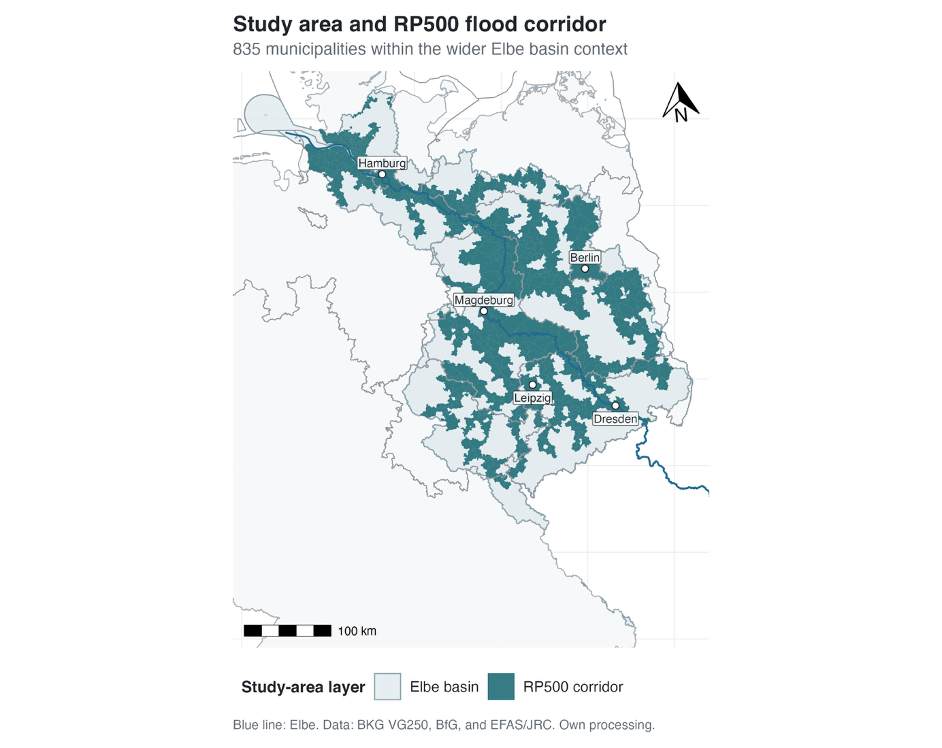

Figure 2.1. Study area and RP500 corridor municipalities in the Elbe context. The map shows the broader basin setting, the Elbe course, federal-state boundaries, and the municipalities retained in the flood-relevant corridor. Source: own analysis based on BKG VG250, BfG river and basin data, and JRC river-flood hazard data.

Historically, the Elbe has been shaped by a long interaction between settlement, river engineering, and flood experience. Jüpner (2018) shows that settlement along the Elbe originally concentrated on relatively elevated areas near the river, as in Magdeburg, where settlement historically remained more than 15 m above mean river level. Over time, however, population growth, land-use pressure, and hydraulic engineering transformed the river into an increasingly engineered system. According to Jüpner (2018), more than 500 km of the Elbe in Germany are now almost completely lined by dikes, and more than 83% of the natural floodplains along the river have been lost. For the present study, this illustrates that the Elbe is not a “natural” floodplain in any simple sense. It is a heavily modified river landscape in which exposure, protection, and residual risk are historically co-produced. Grabs (2016) makes a similar point by arguing that integrated flood management in the Elbe context must move beyond technical flood control alone and combine structural and non-structural strategies. The Elbe offers an especially useful setting for examining how flood exposure and flood protection are embedded in a broader socio-political landscape.

The Elbe is also a strong case because it has repeatedly been affected by severe flood events in recent decades. The major floods of 2002 and 2013 are especially relevant in this regard, but they are not the only events that matter. Barendrecht et al. (2018) discuss the Dresden case and show that the damage in 2013 was lower than in 2002 even though flood risk remained substantial, which they interpret as evidence that societal awareness and preparedness had changed after the earlier event. Jüpner (2018) likewise argues that the 2013 flood reopened debates on how flood risk should be managed, especially because two dike failures occurred and because areas assumed to be protected still suffered major damage. Earlier work by Lindenschmidt et al. (2006) further shows that large-basin risk assessment in the Elbe and Mulde context is methodologically demanding and was, at that time, still in its infancy. Together, these studies show that the Elbe is characterised not only by repeated flood exposure, but also by repeated institutional and social learning. The area of interest is not simply flood-prone; it is a landscape in which flood events have continuously reshaped risk perception, protection strategies, and governance debates.

The Elbe corridor is not only hydrologically heterogeneous, but also socially and economically uneven. This matters for the logic of the thesis because the river crosses regions that are embedded in broader East-West and urban-rural disparities within Germany. The 2024 report *Ost und West. Frei, vereint und unvollkommen* emphasises that the social and economic transformation of Germany after reunification remains incomplete and that eastern and western parts of the country still differ in structural respects (Der Beauftragte der Bundesregierung für Ostdeutschland, 2024). A similar picture emerges from the broader regional disparity literature. Heider et al. (2023) argue that existing socio-economic disparities may intensify if effective preventive measures are lacking and stress the role of reliable indicators for identifying emerging patterns of inequality. Helbig (2023), in turn, shows that socio-spatial inequality in German cities is expressed through persistent concentrations of poverty, wealth, education, and social segregation. For the purposes of this thesis, these sources show that the Elbe corridor runs through municipalities with very different social and economic profiles. The study area cannot be understood only in terms of river morphology or floodplains. It must also be understood as a socially differentiated space in which vulnerability and adaptive capacity are unevenly distributed.

This socio-spatial heterogeneity is one of the main reasons why the Elbe is suitable for a justice-oriented flood study. A flood-prone corridor that crosses municipalities with differing income structures, household profiles, demographic characteristics, and accessibility conditions creates a setting in which distributive questions become relevant. The issue is not only whether flood hazard exists, but whether modelled exposure and loss outcomes align with broader social inequalities. Odersky and Löffler (2024) show for the 2021 floods in Germany that exposure was regressive at the local level, with affected neighbourhoods displaying lower average incomes than nearby unaffected ones. Although their study concerns a different event and spatial setting, it reinforces the relevance of distributional analysis in Germany. Fekete (2010) similarly argues that social vulnerability analysis can reveal hidden strengths and weaknesses in relation to river floods. The Elbe combines repeated flood experience, a long history of structural intervention, and a socially differentiated regional setting. This makes it well suited for investigating how flood exposure and modelled loss outcomes relate to socio-economic conditions.

While the thesis remains framed in terms of the Elbe river basin, the empirical analysis focuses on the flood-relevant corridor rather than treating the full basin as a uniform analytical space. Not all municipalities that are hydrologically part of the basin are equally relevant for the exposure analysis. The basin provides the historical, hydrological, and institutional frame, whereas the RP500 corridor defines the empirical study population. This distinction keeps the analysis consistent with the title and research questions while focusing the comparison on municipalities that intersect the modelled extreme flood extent.

2.3 Environmental and Flood Justice
Environmental justice provides the broader normative lens for this thesis because it shifts attention from floods as purely physical events to floods as socially differentiated forms of harm. The environmental inequality literature does not assume burdens to be evenly distributed; it links unequal exposure particularly to differences in economic status and other social characteristics (Shao et al., 2022). This perspective is directly relevant for flood research, even though the field has often been dominated by hydrological and engineering approaches. Floods may be triggered by hydrometeorological processes, but who is exposed, who is protected, and who carries residual risk is not determined by nature alone. Liao et al. (2019), for example, argue that flood prevention is not a neutral technical exercise because interventions can redistribute floodwater rather than remove it. This theoretical insight provides the context for interpreting the empirical geography of exposure and modelled losses. The thesis does not, however, observe the spatial distribution of protection benefits directly.

Within this broader frame, flood justice refers more specifically to the fairness of how flood-related burdens, benefits, and decision-making processes are organised. A key insight of the recent literature is that justice in flood risk management has several dimensions. de Goër de Herve (2022), in a review of justice considerations in flood risk management, shows that distributive and procedural justice are the two most frequently discussed dimensions, while spatial, temporal, and ecological concerns are often less systematically addressed. Johnson et al. (2007) similarly argue that flooding is “not fair per se” because flood frequency and flood extent are inherently uneven across space, while public interventions may either reduce or reinforce these inequalities. Thaler (2021) adds an important critique to current resilience debates by showing that resilience-oriented flood policy often focuses on efficiency and recovery, but can overlook pre-disaster inequalities and the uneven distribution of burdens within communities. A further element is recognition. Liao et al. (2019) stress that injustice does not arise only from unequal outcomes, but also from the failure to acknowledge marginalised communities as legitimate stakeholders in flood-related decision making. This literature suggests that flood justice involves at least three connected questions: who bears flood exposure, who benefits from protective interventions, and whose interests are recognised when these outcomes are shaped. In this thesis, the main empirical emphasis lies on distributive justice, but this narrower focus is informed by the wider procedural and recognition debates.

The distributive dimension matters because flood risk management always allocates safety, insecurity, and public resources across space. Thaler and Hartmann (2016) formulate this very directly by asking who or what should be protected against inundation. Their argument shows that flood protection is not merely a technical response to hazard, but also a political decision about the allocation of resources, acceptable losses, and territorial priorities. O’Hare and White (2018) extend this line of thinking by proposing the concept of flood disadvantage. They argue that flooding interacts with broader social disadvantages across multiple policy domains and scales, and that technical flood risk analyses often struggle to capture these intersecting burdens because they tend to treat people and communities as overly homogeneous. In a similar way, Moulds et al. (2021) show that flood risk management can, under conditions of weak governance and strong inequality, reproduce or even intensify existing poverty and inequality rather than reduce them. These studies are especially useful for the present thesis because they make clear that justice is not only about the presence of hazard. It is also about whether the social benefits of flood management are distributed in ways that reduce disadvantage or, conversely, leave already vulnerable groups with a disproportionate share of residual risk.

A more critical reading of flood protection also requires asking how safety becomes tied to land values, settlement development, and the uneven capacity of places to attract political attention and investment. This does not mean that protection decisions can be reduced to market logic alone. It does mean that protection is never only a hydraulic problem. Where valuable assets, dense infrastructure, administrative capacity, and political visibility are concentrated, flood risk may be more likely to become a planning, insurance, and investment priority. Less visible or less asset-rich places may remain exposed through residual risk, weaker representation, or model boundaries that make their risks harder to see. The present thesis cannot reconstruct protection investment or trace capital flows, and it does not test whether these mechanisms caused the observed municipal patterns. It uses this critical literature to interpret modelled loss visibility and to identify questions that the available data cannot answer (Thaler and Hartmann, 2016; O’Hare and White, 2018; Moulds et al., 2021; Tovar Reaños, 2021).

This perspective is supported by an increasing body of empirical work showing that flood exposure is often socially uneven. Fielding (2012), for example, demonstrates for England and Wales that inequalities in flood exposure can coincide with inequalities in flood awareness, so that the most deprived groups may also be the least aware of the risks they face. Qiang (2019) finds comparable socio-economic disparities in the United States and shows that disadvantaged populations are more likely to reside in flood zones at the national scale, although local patterns vary between inland and coastal areas. Poussard et al. (2021) add a methodological point by showing that environmental inequalities in flood exposure are a matter of scale. Their findings suggest that the relationship between socio-economic status and flood exposure can look different depending on whether it is examined at larger regional scales or at finer local scales. This supports the decision to work at municipality level and to treat spatial scale as a substantive issue rather than as a purely technical one. For Germany specifically, the findings of Odersky and Löffler (2024) are particularly relevant. They show that the 2021 floods in Germany had a clearly regressive distribution at the local level, with lower-income neighbourhoods experiencing substantially higher exposure than nearby better-off areas. These studies suggest that flood exposure cannot be assumed to be socially neutral, and that fine-scale empirical analysis is necessary to reveal its distributive structure.

A justice perspective also requires going beyond exposure alone and considering social vulnerability. The social vulnerability literature shows that similar levels of physical flood exposure can produce very different social consequences depending on the characteristics and capacities of the affected population. Rufat et al. (2015), in a meta-analysis of flood case studies, identify demographic characteristics, socio-economic status, and health as leading drivers of social vulnerability, while also emphasising the importance of coping capacity and context. This matters for flood justice because unequal exposure does not exhaust the problem. Even where exposure is similar, poorer or otherwise disadvantaged groups may have fewer resources to prepare for, absorb, and recover from flood impacts. Tovar Reaños (2021) shows this clearly for Germany, arguing that welfare losses from floods disproportionately harm low-income households and can increase inequality. The implications are straightforward for the logic of this thesis: a distributive assessment of flood justice should not compare hazard patterns with social conditions in an isolated way, but should consider how socially differentiated vulnerability shapes the meaning and consequences of exposure.

Environmental and flood justice connect the physical geography of flooding with the social geography of inequality. In this thesis, the distributive question is whether municipalities with different socio-economic profiles also differ systematically in flood exposure and modelled loss outcomes. This does not test political intent or procedural fairness. It identifies spatial associations that can be interpreted in relation to debates about protection, residual risk, and unequal capacities (de Goër de Herve, 2022). The justice framework is therefore used to assess empirical patterns rather than to assume in advance that every spatial difference constitutes injustice.

2.4 Socio-Hydrology and the Human Dimension of Risk
Flood risk cannot be understood adequately if it is treated as a purely physical interaction between discharge, topography, and inundation depth. This is the central insight of socio-hydrology. Sivapalan et al. (2012) define socio-hydrology as the study of coupled human-water systems and their co-evolution over time. The key point is that hydrological processes and social processes do not simply run in parallel. They interact through feedbacks. Human settlement, land use, technical protection, institutional learning, memory of past events, and changing expectations all affect flood risk, while flood events in turn alter behaviour, policy, and spatial development. Flood losses are not determined by hazard alone, but by the long-term co-production of hazard, exposure, vulnerability, and adaptation. For this thesis, socio-hydrology provides the conceptual basis for linking flood exposure patterns to socio-economic structure. It suggests that the social geography of municipalities is not an external add-on to flood analysis, but part of the dynamics through which risk is produced and reproduced.

This argument is particularly relevant in river systems with long histories of settlement and protection. Socio-hydrological research has repeatedly shown that structural protection can reduce frequent flood damage in the short term while simultaneously contributing to higher long-term exposure and residual risk. Tobin (1995), in a classic critique of the “levee love affair”, argues that levees can generate a false sense of security, reduce preparedness, and encourage further development in areas that remain fundamentally flood-prone. More recent work has refined this insight. Ferdous et al. (2020) show for the Jamuna River in Bangladesh that higher levels of structural protection are associated with greater population growth and asset concentration in protected areas, while mortality can remain high when rare or extreme events occur. Serra-Llobet et al. (2022) similarly emphasise that even where levees are in place, a residual risk remains due to overtopping or breach, and that this residual risk must be incorporated into regulation, communication, and land-use planning. Fu et al. (2023) underline the same problem in the context of Aotearoa-New Zealand, where protective structures can encourage development in flood-prone areas and make the remaining risk politically difficult to manage. These studies are highly relevant here because they show that protection is not simply the opposite of risk. Rather, it can reshape where people live, how they perceive danger, and how much loss becomes possible when protection proves insufficient.

The socio-hydrological perspective also helps explain why similar hydrological events can produce different social outcomes over time. This is especially clear in research on the Elbe. Barendrecht et al. (2018) describe the Dresden case as one in which the 2013 flood caused lower damage than the 2002 flood, even though the later event was severe and the system had remained flood-prone. Their explanation is not that the hazard disappeared, but that awareness and preparedness changed after the earlier event. More generally, Kreibich et al. (2017), in their analysis of paired flood events across different countries, show that lower damage in later events is often linked to reduced vulnerability, for example through better awareness, preparedness, improved emergency management, and in some cases strengthened structural protection. Their results demonstrate that successful adaptation is often less a story of full hazard control than of changed societal response. The same event may have different consequences depending on the experience, preparedness, and institutional learning that precede it. This supports a core idea of the thesis: flood risk is dynamic and partly socially learned, which means that it cannot be interpreted exclusively through static hazard maps.

Once the human dimension of risk is taken seriously, questions of individual and household behaviour also become central. Public protection remains important, but it cannot eliminate flood risk completely. Osberghaus (2015) shows for Germany that private mitigation measures are an essential part of modern flood risk management precisely because public protection cannot fully prevent damage. His nationwide survey further indicates that mitigation behaviour increases with flood experience and expectations of future damage. Werg et al. (2013) provide a complementary psychological perspective by showing that risk perception alone is often not enough to explain precautionary action. What matters strongly is coping appraisal, especially whether households believe that protective measures are effective, feasible, and worth the effort. Recent German evidence by Dillenardt and Thieken (2025) points in the same direction. Across different flood types, they find that the perceived effectiveness of adaptive measures and a stronger sense of personal responsibility are key drivers of adaptive behaviour, while communication at the municipal level can strengthen these perceptions. This body of work shows that the human dimension of flood risk is not reducible to exposure alone. It also depends on knowledge, expectations, experience, trust, responsibility, and perceived room for action.

The social consequences of repeated flood experience are not straightforwardly positive. Repeated events may strengthen preparedness in some respects, but they can also produce fatigue, unequal recovery, and psychological strain. Kuhlicke et al. (2020), drawing on three surveys of households and companies affected by the 2013 flood in Germany, show that repeated flood experience may increase resilience in relation to some material impacts, while evidence for psychological and health-related resilience is much more mixed and may even point to erosion. This is a useful corrective to simplified narratives of “learning by disaster”. Experience can trigger adaptation, but it does not automatically generate stronger resilience in every dimension. Some households may become better prepared materially, while still facing long-term emotional or financial stress. The human dimension of risk is multidimensional: it includes material losses, behavioural responses, institutional support, and subjective capacities to withstand and recover.

For the present thesis, the main implication of socio-hydrology and the human-dimension literature is that flood exposure should not be interpreted as a purely physical outcome independent of social structure. Exposure patterns are shaped by long-term feedbacks between settlement, protection, memory, adaptation, and governance, while their social consequences depend on vulnerability, preparedness, and recovery capacity. This is why municipal flood exposure is analysed together with socio-economic vulnerability and modelled loss outcomes. The comparison does not imply that municipal social structure directly causes the hydrology of the Elbe. It recognises instead that flood risk emerges from coupled social and hydrological processes. Protection is part of this system, but the present data allow only an interpretation of its possible role, not a direct measurement of its distribution.

2.5 Conceptual Framing of This Study
The empirical framework distinguishes three related but non-equivalent layers: flood exposure, socio-economic vulnerability, and modelled loss outcomes. Exposure describes how far the modelled flood extent intersects municipal territory and, in the land-cover refinement, Artificial Land. Vulnerability refers to the social conditions that shape the capacity to anticipate, cope with, and recover from flooding. Following Rufat et al. (2015), it is treated as a multidimensional concept rather than a single attribute. German work by Fekete (2009, 2010) further shows how socio-demographic indicators can reveal spatially differentiated strengths and constraints in relation to river floods. The third layer records whether and how frequently the supplied loss portfolio produces municipal losses. It is an outcome measure, not an inventory of dikes, walls, or other protective infrastructure. Protection remains part of the conceptual context because it can influence the translation of hazard into loss, but its effects cannot be isolated here from asset exposure, vulnerability, and model scope.

These layers define the distributive comparison. The thesis asks how municipal flood exposure and modelled loss outcomes vary across socio-economic vulnerability profiles, and whether their spatial alignment indicates unequal burdens. Justice is understood primarily in a distributive sense. Following Thaler and Hartmann (2016) and de Goër de Herve (2022), the relevant concern is whether flood-related risks, losses, and risk-reduction benefits are patterned in ways that systematically favour or disadvantage particular social settings. An uneven pattern does not by itself prove injustice, political intent, or a specific causal mechanism. It does, however, become justice-relevant when municipalities with greater socio-economic vulnerability systematically face higher exposure or more frequent modelled losses.

This framing also implies a particular understanding of vulnerability measurement. Social vulnerability models are useful because they make multidimensional social conditions visible and comparable across space, but they are not neutral or self-evident. Rufat et al. (2019) note that most social vulnerability models are primarily descriptive and that their empirical validity cannot simply be assumed. Similarly, Tate (2013) shows that decisions about indicator selection, normalisation, weighting, and scale introduce substantial uncertainty into any index construction, while Schmidtlein et al. (2008) demonstrate that such models are sensitive to changes in scale, variable selection, and geographic context. These methodological cautions are highly relevant for this thesis. They imply that a vulnerability index should be treated as a structured analytical tool rather than as a direct measure of some fixed social reality. This does not weaken the usefulness of the concept. On the contrary, it means that vulnerability must be approached transparently, contextually, and with sensitivity to scale. This is one of the reasons why the thesis works at municipality level and relies on a multidimensional set of socio-economic indicators rather than on a single social marker such as income alone.

Protection remains important for interpreting the relation between exposure and loss. The literature shows that protective measures can reduce frequent losses, influence settlement decisions, generate a sense of security, and leave residual risk when rare events exceed design standards or protective systems fail (Fu et al., 2023; Serra-Llobet et al., 2022; Tobin, 1995). Protection should therefore not be understood as a binary state of “safe” versus “unsafe”. At the same time, the supplied loss outcomes cannot be used as a direct proxy for protective infrastructure. A finite loss-occurrence return-period estimate or a no-event result may be influenced by protection, but also by asset exposure, vulnerability functions, represented river processes, and other model assumptions. In this thesis, protection therefore informs the interpretation of residual risk and model boundaries; it is not treated as a separately measured empirical variable.

The resulting framework compares the geography of modelled flood exposure and loss with the geography of socio-economic vulnerability. It keeps these layers separate because flooded area and simulated loss describe different parts of flood risk. Protection and residual risk remain necessary interpretive concepts, but the empirical analysis does not claim to measure protective infrastructure. Chapters 3 and 4 translate this distinction into the research design and methods used for the Elbe corridor.

3. Research Design and Analytical Framework

3.1 Overall Approach
Building on Chapter 2, the thesis adopts a spatially explicit municipality-level design for the Elbe flood corridor. The study compares municipalities as local socio-spatial contexts rather than estimating individual household risk. Its purpose is to examine whether socio-economic vulnerability is systematically associated with flood exposure and modelled loss outcomes. This design follows research showing that environmental inequality patterns depend on spatial scale, indicator choice, and study-area definition (Poussard et al., 2021).

Within the corridor sample, the analysis follows two main stages. The first establishes the relationship between multi-return-period flood exposure and the municipality-level INKAR vulnerability index, including an RP100 Artificial Land refinement. The second examines modelled loss occurrence and frequency through the supplied loss portfolio. Exposure curves and loss outcomes are kept separate because flooded area, simulated damage, and physical protection infrastructure are not equivalent measures. The residual-risk literature nevertheless provides the conceptual basis for interpreting why these layers may diverge (Fu et al., 2023; Serra-Llobet et al., 2022; Tobin, 1995).

The analysis links municipal flood exposure and socio-economic vulnerability within one study population. Exposure is calculated for RP10, RP20, RP50, RP100, RP200, and RP500, with RP100 used as the main benchmark. A DLR land-cover refinement tests how much of each municipality’s Artificial Land intersects the RP100 flood footprint. Socio-economic vulnerability is represented by the INKAR-based index and its three dimensions. The outcome layer adds modelled loss occurrence, annual loss probability, finite loss-occurrence return-period estimates, and no-event status. Figure 3.1 summarises how these distinct physical, social, and modelled outcome layers enter the distributive assessment.

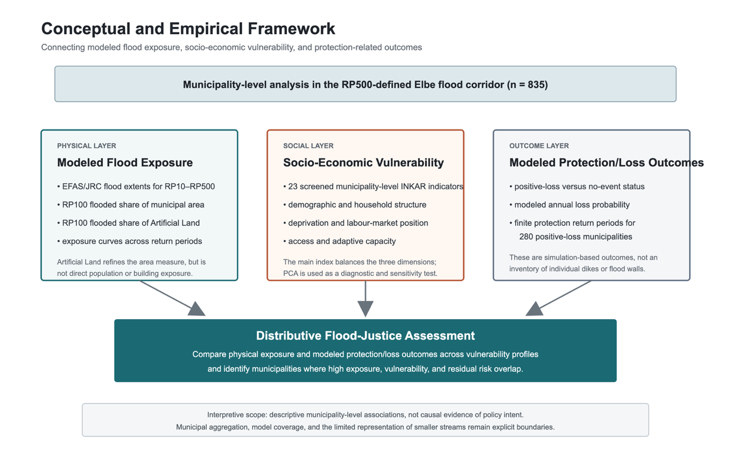
Figure 3.1. Conceptual and empirical framework. The physical layer combines multi-return-period flood exposure with an RP100 Artificial Land refinement. The social layer contains the three dimensions of the INKAR vulnerability index. The outcome layer comprises modelled loss occurrence, annual loss probability, finite loss-occurrence return-period estimates, and no-event status. Source: own design.

3.2 Study Area and Spatial Unit of Analysis
The Elbe river basin provides the broader hydrological, historical, and governance context, while the empirical study population is the flood-relevant corridor of municipalities intersecting the RP500 flood extent. This distinction avoids treating all basin municipalities as equally relevant to the exposure comparison. It also responds to the scale sensitivity of flood-risk assessment: study extent and spatial consistency affect both the resulting pattern and its interpretation (de Moel et al., 2015; Sairam et al., 2021).

The municipality is the smallest unit at which the available exposure, INKAR, land-cover, and loss data can be integrated consistently. It also represents a meaningful governance scale for spatial planning and public service provision. This middle scale retains more spatial variation than county or basin averages while supporting a uniform data join across the corridor. Its interpretation remains scale-dependent, as flood-exposure inequalities can change when analyses move between regional, municipal, neighbourhood, and household levels (de Moel et al., 2015; Poussard et al., 2021).

Municipalities are treated as local socio-spatial contexts, not as internally homogeneous communities. The analysis can compare municipal social conditions and flood-related outcomes, but it cannot identify which households or neighbourhoods within a municipality are exposed. The unit of analysis therefore supports ecological, municipality-level claims only.

3.3 Equity Assessment Logic
The equity assessment is distributive. It asks whether flood-related burdens are patterned systematically across municipalities with different socio-economic profiles. This follows flood-justice research, which shows that technical efficiency does not resolve questions about who benefits from protection and who remains exposed (Thaler and Hartmann, 2016; de Goër de Herve, 2022). Empirically, the comparison considers total-area and Artificial Land exposure, modelled loss occurrence, annual loss probability, and finite loss-occurrence return-period estimates. These variables identify spatial associations with vulnerability; they do not establish procedural fairness or policy intent.

The empirical comparison relates the vulnerability index and its dimensions to total-area exposure, Artificial Land exposure, exposure-curve characteristics, loss occurrence, annual loss probability, and finite loss-occurrence return-period estimates. RP100 is the main exposure benchmark, while the other return periods test whether its pattern persists across the hazard sequence. Spatial unevenness is not treated as injustice by definition. It becomes justice-relevant when flood-related burdens are systematically associated with socio-economic disadvantage (Johnson et al., 2007).

3.4 Scope, Assumptions and Limits
The design supports a bounded distributive claim. Its findings apply to municipalities in the RP500-defined corridor, not to every municipality in the Elbe basin. Municipal averages cannot describe within-municipality sorting or individual experience; area-based exposure does not equal population or asset exposure; the vulnerability index is a constructed contextual measure; and the loss portfolio remains specific to its model catalogue and river-network coverage. The analysis therefore identifies spatial associations among municipal contexts and model outputs. It does not establish individual risk, causal policy effects, or procedural justice.

4. Data and Methods
The workflow has five components. Administrative and hydrological layers are first harmonised to a common spatial reference. Multi-return-period flood-depth rasters are then converted into municipal exposure indicators. INKAR indicators are processed into the socio-economic vulnerability index, and the return-period sequence is used to derive exposure-curve metrics. Finally, the municipality-level loss portfolio is joined as a separate outcome module. This sequence keeps study-area definition, social vulnerability, exposure dynamics, and modelled losses analytically distinct (de Moel et al., 2015; Poussard et al., 2021).

4.1 Data Sources
The spatial unit of analysis is the municipality. Municipality geometries are taken from the VG250 administrative boundary dataset of the Bundesamt für Kartographie und Geodäsie (BKG), with territorial status 31 December 2024. VG250 is used because it provides a consistent national layer of German administrative units and can be linked to socio-economic data through official municipality identifiers. In this thesis, the municipal polygons define the unit of comparison, provide the area denominator for flood shares, and form the spatial join framework through which flood exposure and INKAR indicators are combined.

The broader hydrological context is represented by an Elbe river basin polygon from the Bundesanstalt für Gewässerkunde (BfG). The basin layer is not used to define the final empirical population of municipalities. Instead, it provides the contextual frame for the Elbe case and serves as a processing mask for the flood rasters. This distinction matters for the revised design of the thesis. The thesis remains framed around the Elbe basin, but the empirical sample is the flood-relevant Elbe corridor, defined through the RP500 flood extent.

Flood hazard information is taken from European multi-return-period river-flood hazard rasters associated with the Copernicus Emergency Management Service and the Joint Research Centre. The relevant dataset is the JRC *River flood hazard maps for Europe and the Mediterranean Basin region* collection (Baugh et al., 2024), with the modelling framework documented by Alfieri et al. (2014) and Dottori et al. (2022). The rasters represent modelled water depth for six flood return periods. Dottori et al. (2022) state that this framework includes rivers with an upstream drainage area greater than 500 km² and does not account for physical flood defences. The maps therefore represent continental-scale large-river hazard under an undefended configuration, not realised local protection conditions. They are neither official German hazard maps nor legal flood-zone delineations. In this thesis, they provide a spatially consistent basis for comparing modelled exposure across municipalities, but they are not used to infer municipal protection standards.

The analysis uses six return periods: RP10, RP20, RP50, RP100, RP200, and RP500. RP500 is used to define the empirical corridor because it identifies the broad flood-relevant municipality population under an extreme modelled event. RP100 serves as the main benchmark for comparative exposure analysis because it is widely interpretable in flood-risk work and provides a meaningful reference point between frequent and rare events. All return periods are retained, however, because they allow exposure to be represented as a sequence rather than as a single hazard snapshot.

To examine whether the main area-based exposure result is driven primarily by non-built floodplain land, the analysis also uses *Land Cover DE - Sentinel-2 - Germany, 2015* from the German Aerospace Center (DLR, 2020). The official metadata describe a 10 m by 10 m raster produced from Sentinel-2 imagery acquired between 2015 and 2017 and LUCAS 2015 reference data. It distinguishes seven land-cover classes: Artificial Land, Open Soil, High Seasonal Vegetation, High Perennial Vegetation, Low Seasonal Vegetation, Low Perennial Vegetation, and Water. The source raster is provided in EPSG:3035 (ETRS89 / LAEA Europe) and is licensed under CC BY-NC 4.0. The dataset is documented on the [DLR EOC Land Cover page](https://geoservice.dlr.de/web/datasets/landcover), available from the [DLR download service](https://download.geoservice.dlr.de/LCC_DE/files/), and identified by DOI [10.15489/1ccmlap3mn39](https://doi.org/10.15489/1ccmlap3mn39). In this thesis, DLR class 1, Artificial Land, is used as a built or artificial land-cover proxy. It is not treated as a cadastral building footprint or as a direct measure of exposed population.

Socio-economic data are taken from INKAR, the interactive online atlas of the Federal Institute for Research on Building, Urban Affairs and Spatial Development (BBSR). The analysis uses the INKAR 07/2025 edition, with data prepared on a consistent territorial status as of 31.12.2023. INKAR provides municipality-level indicators on demographic structure, socio-economic conditions, accessibility, labour-market conditions, housing, infrastructure, and other local characteristics. In this thesis, INKAR is not treated as a ready-made vulnerability dataset. Instead, the available indicators are reviewed, screened, and reduced to a final vulnerability-index input set, while PCA is retained as a diagnostic and robustness tool. This reflects the context-dependent character of social vulnerability indicators and the need to interpret them through both conceptual relevance and data structure (Rufat et al., 2015; Rufat et al., 2019).

The municipality-level file elbe_protection_level_mun.csv was supplied on 9 July 2026. It contains municipality identifiers and names, the number of simulated years with non-zero losses, modelled annual loss probabilities, and derived estimates of the return period of a non-zero-loss year. It is a municipality-aggregated positive-loss table rather than an infrastructure inventory. Written clarification from N. Sairam and T. N. M. Phan confirmed that the table was derived directly from the loss output without a minimum-event filter. Municipalities absent from the table are therefore retained as no-event cases in full-corridor summaries, while only positive-loss municipalities receive a finite loss-occurrence return-period estimate (personal communication, July 2026). The file has no separate version identifier or accompanying technical metadata record. Sairam et al. (2021) is therefore used as methodological context for the Regional Flood Model, including its 5,000-year event catalogue, coupled hydrological and hydrodynamic modelling, and sector-specific exposure and loss modules, rather than as proof that every configuration detail of the supplied extract is identical to the published application. Sairam and Phan further clarified that smaller streams are not fully represented, which limits municipality-level interpretation.

4.2 Spatial Preprocessing and Study Area Definition
All spatial data used in the active workflow are harmonised to EPSG:25832 (ETRS89 / UTM Zone 32N). This coordinate reference system is used because the core exposure metrics are area-based. Municipal flooded area and total municipality area must be calculated in a projected coordinate system with meter units; otherwise, the resulting flood shares would be difficult to interpret and potentially inconsistent across space. CRS harmonisation is not only a technical step, but a prerequisite for producing comparable exposure indicators.

The municipality layer required an additional cleaning step. In the VG250-derived workflow, municipalities can appear with different Geofaktor_GF attributes. For the purpose of flood-share calculation, only polygons with Geofaktor_GF = "mit Struktur Land" are used. This land-structure filter avoids using water-only or otherwise unsuitable geometry variants as the denominator for municipal areas. Without this step, flood shares can be distorted because the area denominator may no longer represent the municipality in the intended administrative sense. The filter is retained as a core methodological decision.

The flood rasters were first clipped to the Elbe basin frame to reduce processing volume and align the hazard inputs with the case-study context. The analytical sample was then defined more narrowly. Municipalities are included in the final corridor if they have non-zero flooded area in the RP500 flood raster. In practical terms, the workflow first identifies municipalities intersecting valid RP500 flood-depth pixels and then performs an exact flooded-area extraction for this preselected set. Municipalities with positive RP500 flooded area are retained.

The resulting analytical sample consists of 835 corridor municipalities. The Elbe basin is the broader hydrological and governance frame, while the empirical population is the RP500 flood corridor. This distinction prevents the analysis from mixing flood-relevant municipalities with large numbers of basin municipalities that have no modelled flood exposure in the selected raster data. It also makes the exposure-vulnerability comparison more defensible, because all municipalities in the sample belong to the same broad flood-relevant study population. The choice is consistent with the wider literature showing that flood-risk and flood-inequality results depend strongly on spatial scale and study extent (de Moel et al., 2015; Poussard et al., 2021).

4.3 Flood Hazard and Exposure Construction
Flood exposure is derived from the prepared flood-depth rasters. The rasters are interpreted as water-depth grids in which valid depth cells represent flooded areas and NoData cells represent non-flooded areas. The main workflow does not require raster polygonisation. Instead, it uses raster-based zonal extraction to calculate the area of valid flood-depth cells intersecting each municipality. This approach follows the general logic of exposure assessment, in which hazard footprints are spatially overlaid with exposed units of analysis (de Moel et al., 2015; Qiang, 2019).

For each return period, a cell-area raster is created and masked by the corresponding flood-depth raster. The masked cell areas are then summed within each municipality. This produces a flooded area value in square meters for each municipality and return period. Flood share is calculated as:

flood_share_rp = flood_area_rp_m2 / municipality_area_m2

The resulting wide exposure table contains municipality area, flooded area, and flood share for RP10, RP20, RP50, RP100, RP200, and RP500. The main empirical comparison uses flood_share_rp100, but the multi-return-period structure is retained throughout the workflow. This allows the analysis to describe not only how much of a municipality is exposed under one benchmark event, but also how exposure accumulates as return periods become rarer. Return-period choice affects the interpretation of flood-risk assessments, and multi-return-period data can reveal patterns that a single hazard layer would hide (Rojas et al., 2013; de Moel et al., 2015).

The main exposure metric is area-based rather than depth-weighted. This is a deliberate choice. Area-based flood share is transparent, stable across all return periods, and directly comparable across municipalities of different sizes. It is also well suited to the distributive comparison used in this thesis, because it captures the spatial overlap between modelled flood hazard and municipal territory. The limitation is clear: this indicator does not distinguish shallow inundation from deep inundation, and it does not measure population exposure, asset exposure, or monetary damage. A municipality with a high flood share is not automatically a municipality with high expected damage. It is a municipality with a larger share of its territory inside the modelled flood footprint.

This interpretation is consistent with the broader flood-risk literature, where exposure indicators depend strongly on the scale, unit, and purpose of the assessment (de Moel et al., 2015; Sairam et al., 2021). The exposure indicator used here is designed for a spatial distributive comparison, not for detailed hydraulic damage modelling. The main analysis therefore retains municipal flood share as its transparent benchmark. Section 4.4 adds an Artificial Land exposure measure as a robustness and substantive refinement, while population-weighted, building-weighted, and depth-weighted exposure remain beyond the scope of the present analysis.

4.4 Land-Cover-Sensitive Exposure Refinement
The land-cover extension addresses one specific limitation of the municipal flood-share measure: flooded administrative area may consist of built land, agricultural or open land, vegetation, or water. It therefore cannot be assumed to represent settlement exposure directly. The DLR raster is used to calculate how much of each land-cover class lies within the modelled RP100 flood footprint and, in particular, what share of each municipality's Artificial Land is flooded at RP100.

The DLR raster is first cropped to the RP500 corridor processing extent. The existing corridor-cropped EFAS/JRC RP100 raster provides the analysis template in EPSG:25832 with a 100 m grid. Each of the seven DLR classes is converted to a binary raster and reprojected separately from EPSG:3035 to the EFAS/JRC grid using area-weighted averaging. The resulting value in each 100 m cell represents the fraction of that cell covered by the respective DLR class. Multiplying these fractions by cell area in EPSG:25832 produces class-specific land-cover areas that preserve the mixed composition of the coarser flood grid more accurately than a nearest-neighbour majority assignment would.

For each class c and municipality i, the flooded class area at RP100 is calculated by retaining class-area cells where the RP100 flood raster contains a valid modelled flood-depth value and summing them within the municipality. The class-specific flood share is:

flood_share_rp100_i,c = flooded_landcover_area_rp100_i,c / total_landcover_area_i,c

For presentation and interpretation, the seven original classes are also grouped into four broader categories. Artificial Land forms the artificial group; Open Soil, High Seasonal Vegetation, and Low Seasonal Vegetation form open or seasonal; High Perennial Vegetation and Low Perennial Vegetation form perennial vegetation; and Water remains a separate group. These groups are descriptive land-cover categories. In particular, open or seasonal should not be read as an exact agricultural land-use class, and perennial vegetation should not be equated automatically with natural or protected land.

The main refinement used in the distributive analysis is the flooded share of Artificial Land. This variable asks whether the relationship between vulnerability and RP100 exposure changes when the denominator is limited to built or artificial land cover rather than the full municipal territory. The extension reduces the influence of large non-built floodplain areas, but it does not identify which artificial surfaces contain housing, industry, transport infrastructure, or public facilities. It also does not locate residents within the flooded Artificial Land class. The indicator is therefore best understood as a land-cover-sensitive exposure proxy and robustness check, not as a complete replacement for population or asset exposure.

The land-cover workflow was checked against the municipal geometry and the original flood output. All 835 corridor municipalities are retained. The aggregated DLR class areas reproduce municipal area to within raster-processing precision, the four grouped classes sum to the seven source classes, and all calculated Artificial Land flood shares remain within the interval from zero to one. One municipality has no DLR Artificial Land area and consequently no defined Artificial Land flood share. These checks support the internal consistency of the extension while preserving the conceptual limits of the indicator.

4.5 Exposure Quality Checks
The exposure pipeline includes automated quality checks because the analysis combines large raster layers with administrative geometries and area calculations. Three types of checks are applied. First, flood shares are checked to ensure that they fall within the valid range between 0 and 1. Second, flooded areas are checked to ensure that they do not exceed total municipality area. Third, monotonicity across return periods is checked. In principle, modelled flood extent should not decrease as return periods become rarer, so the expected order is:

RP10 <= RP20 <= RP50 <= RP100 <= RP200 <= RP500

Municipalities that violate any of these checks are exported for inspection. This does not automatically mean that the affected municipalities are unusable, because small non-monotonicities can arise from raster processing, reprojection, resampling, or model artifacts. However, the flags make such cases visible and prevent the analysis from treating the exposure table as unproblematic by default.

In the final output, all flood shares fall within valid bounds and no flooded area exceeds total municipal area. The only remaining issue concerns two small monotonicity deviations: 13076114 Plau am See, Stadt and 16077005 Fockendorf. Plau am See decreases by 0.010 percentage points between RP200 and RP500, while Fockendorf decreases by 0.025 percentage points between RP100 and RP200. Both deviations are treated as processing artefacts rather than substantive exposure reversals. For the exposure-curve metrics described below, observed non-monotonic cases are adjusted using a simple cumulative maximum transformation. This preserves the observed exposure sequence as far as possible while enforcing the logical condition that exposure should not decline with rarer return periods. The raw exposure values remain available in the underlying exposure table, while the adjusted values are used only for derived curve metrics that require monotonicity.

4.6 Socio-Economic Data Processing
The socio-economic workflow starts from the full INKAR long-format data file. Because the raw file is large, the import is handled with efficient tabular processing tools. The data are filtered to municipality-level records and prepared so that the latest available observation for each municipality and indicator is retained. Not all INKAR indicators are available for the same reference year. Rather than imposing one universal year that would drop many indicators, the workflow uses the latest available value per municipality-indicator combination and documents the resulting coverage.

After filtering and latest-value selection, the data are transformed from long to wide format. The municipality identifier AGS is used as the join key between INKAR and the corridor municipality layer. The final socio-economic table is aligned with the same municipal units used in the exposure workflow. AGS-prefix filtering is treated only as a processing step, not as the definition of the study area. The study area is defined spatially by the RP500 corridor; INKAR is then joined to this spatially defined sample.

The corridor contains 835 municipalities. In the processed INKAR table, 834 of these municipalities are matched with socio-economic records. One municipality, 16076094 Berga-Wünschendorf, remains missing in the processed INKAR data and is documented explicitly. As a result, vulnerability-index calculations that depend on INKAR are carried out for the municipalities with available INKAR records, while the exposure dataset itself remains available for all 835 corridor municipalities.

Within the corridor, 176 original INKAR indicators are available in the latest-build table. They are not all used directly in the final vulnerability index, because many indicators are redundant, ambiguous, weakly connected to vulnerability, or unsuitable because of coverage problems. The available indicator pool is screened both substantively and statistically. This step is consistent with the vulnerability literature, which treats indicator selection and aggregation as central methodological choices rather than as purely technical details (Fekete, 2009; Rufat et al., 2015; Tate, 2013).

4.7 Indicator Screening and Candidate Vulnerability Variables
The indicator-screening stage responds to a central challenge in social vulnerability measurement: vulnerability indices are sensitive to the variables included, the scale of analysis, the handling of missingness, and the aggregation method (Schmidtlein et al., 2008; Tate, 2013; Rufat et al., 2015; Rufat et al., 2019). The thesis does not move directly from all available INKAR indicators to a final index. Instead, the 176 available indicators are first reviewed and grouped into broad substantive dimensions, including socio-economic status, labour-market position, demographic structure, household structure, accessibility and services, digital infrastructure, housing and land-use context, and public finance or local context variables.

Coverage rates are calculated for all indicators. Indicators with poor coverage are flagged because they would reduce the number of usable municipalities or require extensive imputation. A correlation screening is then used diagnostically to identify very similar or nested variables. Inductive techniques such as PCA can overweight a latent construct if several near-duplicate indicators are included. Correlation screening is not used mechanically to remove variables, but it helps identify where conceptual judgment is needed.

Two retained variables require exact denominator-sensitive interpretation. a_ALGII_SGBII measures the share of unemployment benefit II within SGB-II benefits; it is not the municipal prevalence of SGB-II receipt. a_ewfBG_allein measures the share of single-parent employable SGB-II beneficiaries among all employable SGB-II beneficiaries; it is not the share of single-parent households in the municipality. Both are retained as specific indicators within their respective dimensions, but their labels are not generalised beyond these definitions and drop-variable sensitivity tests are reported. The strongly related a_Unterkunft_SGBII measure is not included in the same main index, and a_BG1P is excluded because one-person benefit communities cannot be interpreted as single-parent households. Student indicators, population density, and employment density are also excluded from the main specification because they primarily capture university-centre or settlement structure.

The screening process distinguishes between the complete indicator inventory, exploratory input sets, and the final main specification. The final set comprises 23 indicators and was selected to balance conceptual breadth, data coverage, and interpretability while avoiding duplicated constructs and variables dominated by university-centre or settlement structure. It represents demographic sensitivity, household structure, economic deprivation, labour-market conditions, accessibility, health-care access, and digital connectivity. Sensitivity to the two retained denominator-specific SGB-II indicators and to a PCA-based alternative is assessed separately in Section 4.8.

The final 23 indicators are grouped into three dimensions. Demographic and household structure contains the shares of residents aged 65 and older, households with children, single-person households, residents under six, and single-parent employable SGB-II beneficiaries among all employable SGB-II beneficiaries. Deprivation and labour-market position contains the share of unemployment benefit II within SGB-II benefits, low-income households, child poverty, long-term unemployment, unemployment among younger and older residents, marginal employment, and reverse-coded income tax, purchasing power, and employment rate. Access and adaptive capacity contains population-weighted distances to supermarkets, public transport, pharmacies, general practitioners, and primary schools, together with reverse-coded physician supply, 4G household coverage, and fixed broadband availability. The official INKAR definitions, reference years, directions, and missingness are documented in the indicator appendix.

4.8 Vulnerability Index Construction and PCA Diagnostics
The final vulnerability index is constructed as a direction-coded and dimension-balanced composite rather than as a mechanically weighted PCA score. This choice follows from both the literature and the empirical structure of the corridor data. German river-flood vulnerability work has used factor-analytic approaches to identify dimensions of social vulnerability, but also emphasises that aggregation and validation require substantive interpretation (Fekete, 2009). More broadly, social vulnerability indices are known to be sensitive to indicator choice, scale, weighting, and aggregation (Schmidtlein et al., 2008; Tate, 2013; Rufat et al., 2015). Rufat et al. (2019) further caution that vulnerability models should not be treated as self-validating simply because they produce an internally consistent score. PCA is used to inspect the structure and robustness of the selected indicators, while the main index is built to preserve the conceptual balance between the three vulnerability dimensions.

The index is calculated for the 834 corridor municipalities with available INKAR records. The one corridor municipality without a current INKAR match, 16076094 Berga-Wünschendorf, remains in the exposure dataset but receives no vulnerability-index value. For municipalities with INKAR records, remaining indicator-level missing values are imputed with the median of the respective variable. All 23 variables are then transformed to z-scores. Indicators for which higher values indicate greater capacity rather than vulnerability, such as purchasing power, income tax per capita, employment rate, physician supply, and broadband availability, are multiplied by -1 after standardisation. After this direction coding, higher values consistently indicate higher expected social vulnerability or lower adaptive capacity.

For each municipality i, the dimension score for dimension d is calculated as the mean of the direction-coded standardised variables belonging to that dimension and then standardised again:

D_id = z(mean(z*_ij))

where z*_ij is the direction-coded z-score of indicator j. The final vulnerability index is the standardised mean of the three dimension scores:

V_i = z(mean(D_i1, D_i2, D_i3))

This procedure gives equal weight to the three conceptual dimensions rather than to every individual indicator. Several variables in the accessibility and service-provision dimension are highly correlated, so a purely variable-level average or a purely inductive PCA score would allow the strongest covariance structure to dominate the index. The dimension-balanced approach instead keeps demographic/household sensitivity, deprivation/labour-market position, and access/adaptive capacity visible while still producing one municipality-level vulnerability score for the distributive comparison with flood exposure and modelled loss outcomes.

PCA is retained as a diagnostic and robustness tool. It is estimated from the same direction-coded 23-variable matrix using prcomp(). Eight components reach the 70% cumulative-variance threshold and explain 72.60% of total variance; six components meet the Kaiser criterion and explain 64.45%. For each retained component, the score direction is aligned with the dimension-balanced index and the aligned scores are combined using their explained-variance shares. The 8- and 6-component sensitivity indices are almost identical (Pearson r = 0.997), but the dimension-balanced index and the 8-component PCA score are only moderately correlated (Pearson r = 0.441; Spearman rho = 0.473). PCA gives greater weight to the dominant covariance structure, particularly accessibility and settlement-periphery patterns, whereas the main index gives equal weight to the three conceptual dimensions.
Two additional sensitivity checks assess whether the substantive results depend on the vulnerability specification. First, all principal exposure and loss associations are repeated with the 70%-variance PCA score. Second, the dimension-balanced index is recalculated after dropping a_ALGII_SGBII, a_ewfBG_allein, and both indicators together. These variants test the influence of the two definition-sensitive SGB-II variables while preserving equal weighting of the three dimensions.
The vulnerability index is interpreted as a descriptive municipality-level measure of socio-economic vulnerability, not as a causal estimate or a direct measure of individual household vulnerability. Modelled loss variables are excluded from the index. Loss occurrence, annual loss probability, finite loss-occurrence return-period estimates, and no-event cases are analysed separately. This separation prevents social susceptibility and adaptive capacity from being conflated with the flood-related outcomes against which vulnerability is compared.

4.9 Multi-Return-Period Exposure Curves
The multi-return-period exposure table is also used to construct municipality-level exposure curves. Each municipality has a sequence of flood shares across RP10, RP20, RP50, RP100, RP200, and RP500. These curves describe how much of the final RP500 exposure is already realised at more frequent return periods and how much is added only under rarer events. This preserves information that would be lost if the analysis relied only on RP100.

Several metrics are derived from these curves. onset_rp_any identifies the first return period with any positive flood share. onset_rp_1pct and onset_rp_5pct identify the first return period at which at least one or five percent of municipal area is flooded. slope_logrp measures the increase in flood share over the log-transformed return period scale. normalized_auc summarises the area under the normalised exposure curve; higher values indicate that final exposure is realised earlier. realised_by_rp100 measures the share of final RP500 exposure already present by RP100, while late_growth_share measures the share added after RP100. Finally, max_jump_interval and max_jump_rel identify where the largest increase occurs along the return-period sequence.

The indicators are combined into a rule-based descriptive typology. A municipality is classified as early exposure when at least 75% of its RP500 flood share is already realised by RP100. The same category is assigned when the 1% exposure threshold is reached by RP50 and at least 60% of RP500 exposure is realised by RP100. A delayed jump requires less than 50% realisation by RP100, at least 40% of final exposure being added after RP100, and the largest increase occurring between RP100 and RP200 or between RP200 and RP500. All remaining municipalities are classified as gradual increase. These thresholds are analytical classification rules rather than engineering protection standards.

The exposure curves describe how modelled flooded area accumulates across return periods. They do not measure dikes, flood walls, or engineering design standards, and an early or delayed increase cannot by itself be attributed to protection. The curve metrics nevertheless preserve information that is absent from a single RP100 benchmark and allow municipalities with different exposure dynamics to be compared. They are analysed alongside the loss portfolio because the two datasets represent distinct outcomes: the curves describe changes in flooded area, whereas the loss portfolio records simulated loss occurrence and its frequency.

The curve metrics are treated as exposure diagnostics rather than as substitutes for the modelled loss outcomes. They distinguish municipalities where most RP500 exposure is already present under more frequent events from those where exposure increases mainly under rarer events. Such differences are relevant to residual-risk interpretation, but they cannot identify the presence, design standard, or performance of individual flood-protection structures (Serra-Llobet et al., 2022).

4.10 Modelled Loss Portfolio and Derived Loss-Occurrence Return-Period Data
The modelled loss data are added after construction of the exposure and socio-economic datasets. The municipality-level file elbe_protection_level_mun.csv is joined to the RP500 corridor through the official municipality identifier AGS. The join is implemented as a separate analytical module: the corridor remains defined by EFAS/JRC RP500 exposure, whereas the supplied loss table contains municipalities with at least one simulated loss event and therefore a finite loss-occurrence return-period estimate.

The supplied table contains 301 municipalities, of which 280 match the 835 municipalities in the RP500 corridor. For a positive-loss municipality i, the modelled annual loss probability is calculated as p_i = n_i / 5,000, where n_i is the number of simulated years with non-zero losses. The corresponding finite loss-occurrence return-period estimate is T_i = 1 / p_i = 5,000 / n_i. The remaining 555 corridor municipalities do not occur in the supplied positive-loss table. Written clarification confirmed that no municipality had been removed by a minimum-event threshold and that no 30-event filter was applied. For full-corridor summaries, these municipalities are retained as no-event cases with n_i = 0 and p_i = 0 (N. Sairam and T. N. M. Phan, personal communication, July 2026).

This coding remains specific to the analysed model catalogue. A zero event count means that no loss-producing year occurs for the municipality in the 5,000-year simulation; it does not establish that the municipality’s underlying real-world annual flood-loss probability is exactly zero. No-event municipalities are therefore not described as risk-free and receive no finite loss-occurrence return-period estimate. For cities such as Hamburg and Magdeburg, Sairam and Phan considered the no-event result consistent with high modelled protection. However, the supplied table alone cannot distinguish this explanation from all other modelling effects. The omission of smaller streams is particularly relevant because it creates a coverage difference between the RP500 exposure corridor and the loss model (N. Sairam and T. N. M. Phan, personal communication, July 2026; Sairam et al., 2021).

Two diagnostic checks document the composition of the no-event group. First, a coverage map distinguishes municipalities with positive modelled losses and finite loss-occurrence return-period estimates from municipalities with no simulated loss event. Larger cities and Elbe-near municipalities are labelled to show whether no-event cases are confined to small peripheral municipalities. Second, a stream-context check overlays no-event municipalities with the Elbe main stem and WFD river-water-body data. Municipalities intersecting the Elbe line or lying within 1 km are assigned to the main-stem class. Larger WFD rivers are defined by RIVER_CAT values 1 or 100 or drawing categories N1, M1, A1, N2, M2, or A2; municipalities intersecting only other WFD river bodies are classified as minor or other. This diagnostic assesses the extent to which no-event cases are associated with smaller rivers or water bodies outside the represented river network. The diagnostic results are reported in Chapter 5.

The loss module therefore has two complementary parts. Full-corridor analyses compare loss occurrence and modelled annual loss probability across all 835 municipalities, retaining the 555 no-event cases with p = 0. Analyses of finite loss-occurrence return-period estimates are restricted to the 280 positive-loss municipalities. This preserves the information contained in the simulation output without assigning arbitrary finite values to municipalities with no simulated loss event.

In the Results chapter, no-event municipalities are displayed explicitly as “No simulated loss event”. They enter full-corridor probability summaries with a modelled annual loss probability of zero but are not assigned a finite loss-occurrence return-period estimate.

4.11 Statistical and Spatial Analysis
The empirical analysis proceeds in stages. First, descriptive statistics summarise the flood corridor, the distribution of flood shares across return periods, and the distribution of socio-economic vulnerability. Maps are used to show the RP500 corridor, RP100 exposure, and the spatial pattern of the vulnerability index. These maps are descriptive tools and help identify broad spatial patterns before statistical comparison.

Second, the main distributive comparison relates municipality-level vulnerability to flood exposure. The benchmark outcome is flood_share_rp100. Bivariate associations are used to assess whether more vulnerable municipalities tend to have higher or lower RP100 flood shares. The analysis combines Pearson and Spearman correlations with grouped comparisons across vulnerability quintiles and a bivariate tercile map of exposure and vulnerability. This is consistent with the distributive logic of the thesis: the main question is whether flood exposure aligns systematically with socio-economic vulnerability. Comparable exposure-disparity studies use this kind of spatial overlay and group comparison logic to connect flood hazard or exposure with social differentiation (Qiang, 2019; Poussard et al., 2021; Odersky and Löffler, 2024).

Third, the land-cover extension tests whether the main exposure result depends on the total municipal-area denominator. The analysis first summarises the composition of all RP100 flooded land by the four grouped DLR classes. It then maps the flooded share of Artificial Land and compares this indicator with the final vulnerability index and its three dimensions using Pearson and Spearman correlations and vulnerability-quintile summaries. This is a targeted robustness test: it asks whether a positive social gradient appears once non-built municipal land is removed from the denominator, without treating Artificial Land as a direct measure of exposed residents, buildings, or asset values.

Fourth, exposure-curve metrics are used to extend the analysis beyond RP100. Metrics such as realised_by_rp100, late_growth_share, and max_jump_interval allow the thesis to ask whether municipalities with different vulnerability profiles also differ in how exposure accumulates across return periods. The analysis compares vulnerability not only with one exposure benchmark, but also with the shape of the exposure curve.

Fifth, the modelled loss data are analysed in two parts. For the 280 positive-loss municipalities, finite loss-occurrence return-period estimates and annual loss probabilities are mapped and related descriptively to socio-economic vulnerability. The remaining 555 corridor municipalities are absent from the positive-loss table because no simulated loss year was recorded for them. Based on written clarification accompanying the data, they are retained in full-corridor summaries with n = 0 and p = 0, reported as no simulated loss event, and assigned no finite loss-occurrence return-period estimate. Pearson and Spearman correlations with RP100 total-area and Artificial Land exposure test whether the loss outcomes vary systematically with the spatial extent of municipal exposure.

The statistical analysis is deliberately descriptive and distributive. It uses maps, correlations, vulnerability quintile comparisons, bivariate exposure-vulnerability classifications, land-cover composition and Artificial Land exposure summaries, and modelled-loss comparisons. All municipality-level correlations and grouped summaries assign equal analytical weight to each municipality; they are not weighted by population, municipal area, or asset value. The thesis does not rely on a causal regression model as the primary evidentiary device, because the available data are better suited to identifying spatial-distributive patterns than to reconstructing the causal processes behind local flood-risk outcomes.

4.12 Software and Reproducibility
The workflow is implemented primarily in R. Vector spatial processing is carried out with sf, raster processing and zonal extraction with terra, large tabular imports with data.table, data wrangling with dplyr and tidyr, and mapping with ggplot2 and geom_sf(). QGIS is used for visual inspection and selected base-layer preparation, but the core analytical outputs are generated through scripted workflows.

The workflow separates flood-raster preparation, municipality-level exposure extraction, DLR land-cover processing, socio-economic data processing, vulnerability-index construction, PCA diagnostics, exposure-curve analysis, loss-data integration, and statistical comparison. Outputs are written to organised folders as CSV tables, GeoPackage layers, maps, plots, logs, and diagnostic files. This structure supports reproducibility because it allows the exposure data, land-cover refinement, INKAR preparation, PCA diagnostics, loss-coverage checks, and final analysis table to be inspected separately.

The main exposure outputs include the RP500 corridor layer, return-period-specific exposure tables, the wide all-return-period exposure table, and exposure quality-check files. The DLR module, implemented in ANALYSE_FINAL_CORRIDOR/LANDUSE/BUILD_LANDUSE_EXPOSURE.R, adds class-specific and grouped land-cover areas, RP100 flooded land-cover areas, Artificial Land exposure indicators, a combined analysis GeoPackage, and dedicated quality checks. The main corridor-analysis outputs include the RP100 analysis table, the corridor vulnerability map, the RP100 exposure map, and the corridor GeoPackage with exposure and PCA outputs. The exposure-curve workflow adds curve metrics, long-format curve tables, typology summaries, and maps of curve types. The loss-portfolio workflow adds a joined corridor GeoPackage, coverage and loss-occurrence return-period maps, positive-loss and no-event municipality tables, a large-municipality coverage table, and a stream-context diagnostic for municipalities without simulated loss events in the loss-model output. Final thesis graphics are regenerated through ANALYSE_FINAL_CORRIDOR/BUILD_THESIS_FINAL_FIGURES.R, which applies one cartographic and graphic design across maps and plots. Together, these outputs provide the empirical basis for the Results chapter.

5. Empirical Results
This chapter reports the municipality-level results in four steps: exposure and socio-economic vulnerability, the Artificial Land refinement, exposure dynamics across return periods, and modelled loss outcomes. The presentation remains descriptive; the wider flood-justice interpretation follows in Chapter 6.

The main sample consists of 835 municipalities intersecting the modelled RP500 extent. Total-area flood exposure is available for all of them. The final vulnerability index is available for 834 municipalities because 16076094 Berga-Wünschendorf has no current INKAR match. Artificial Land exposure is also defined for 834 municipalities because one municipality contains no DLR Artificial Land. The loss portfolio forms a different subset: 280 corridor municipalities have positive modelled losses and finite loss-occurrence return-period estimates, while 555 have no simulated loss event and enter full-corridor summaries with modelled annual loss probability zero, as described in Section 4.10.

5.1 Overview of Study Area
The empirical corridor is defined by the modelled RP500 flood extent. Figure 2.1 shows the municipalities that intersect the RP500 footprint in the wider Elbe context. The map makes visible that the corridor is not a narrow line along the river, but a set of municipal territories whose administrative boundaries extend beyond the immediate floodplain. This is a direct consequence of the municipality-level design: a municipality is included once any part of its area intersects the RP500 flood extent, but all subsequent indicators are calculated for the municipality as a whole.

This spatial definition has two consequences for the interpretation of the results. First, the analysis does not describe the entire Elbe basin. It describes the flood-relevant corridor of municipalities that intersect the extreme modelled flood extent. Second, flood shares are municipality-level proportions, not statements about the full settlement area or population of each municipality. A municipality may have a high flood share because a large part of its territory lies inside the modelled flood footprint, but this does not automatically mean that the same share of its population, buildings, or assets is exposed. The results should be read as a spatial-distributive analysis of municipal flood-area exposure and not as a building-level or household-level damage assessment.

5.2 Flood Exposure Patterns
The first result concerns the geography of modelled flood exposure. Figure 5.1 maps the RP100 flood share for all corridor municipalities. This variable is the main benchmark used later for the direct exposure-vulnerability comparison. The map shows a highly uneven exposure pattern. The highest flood shares are concentrated in municipalities close to the Elbe main corridor and in low-lying floodplain settings, while many outer corridor municipalities have only small parts of their territory affected at RP100. This produces a corridor with strong internal differentiation rather than a uniform exposure belt.

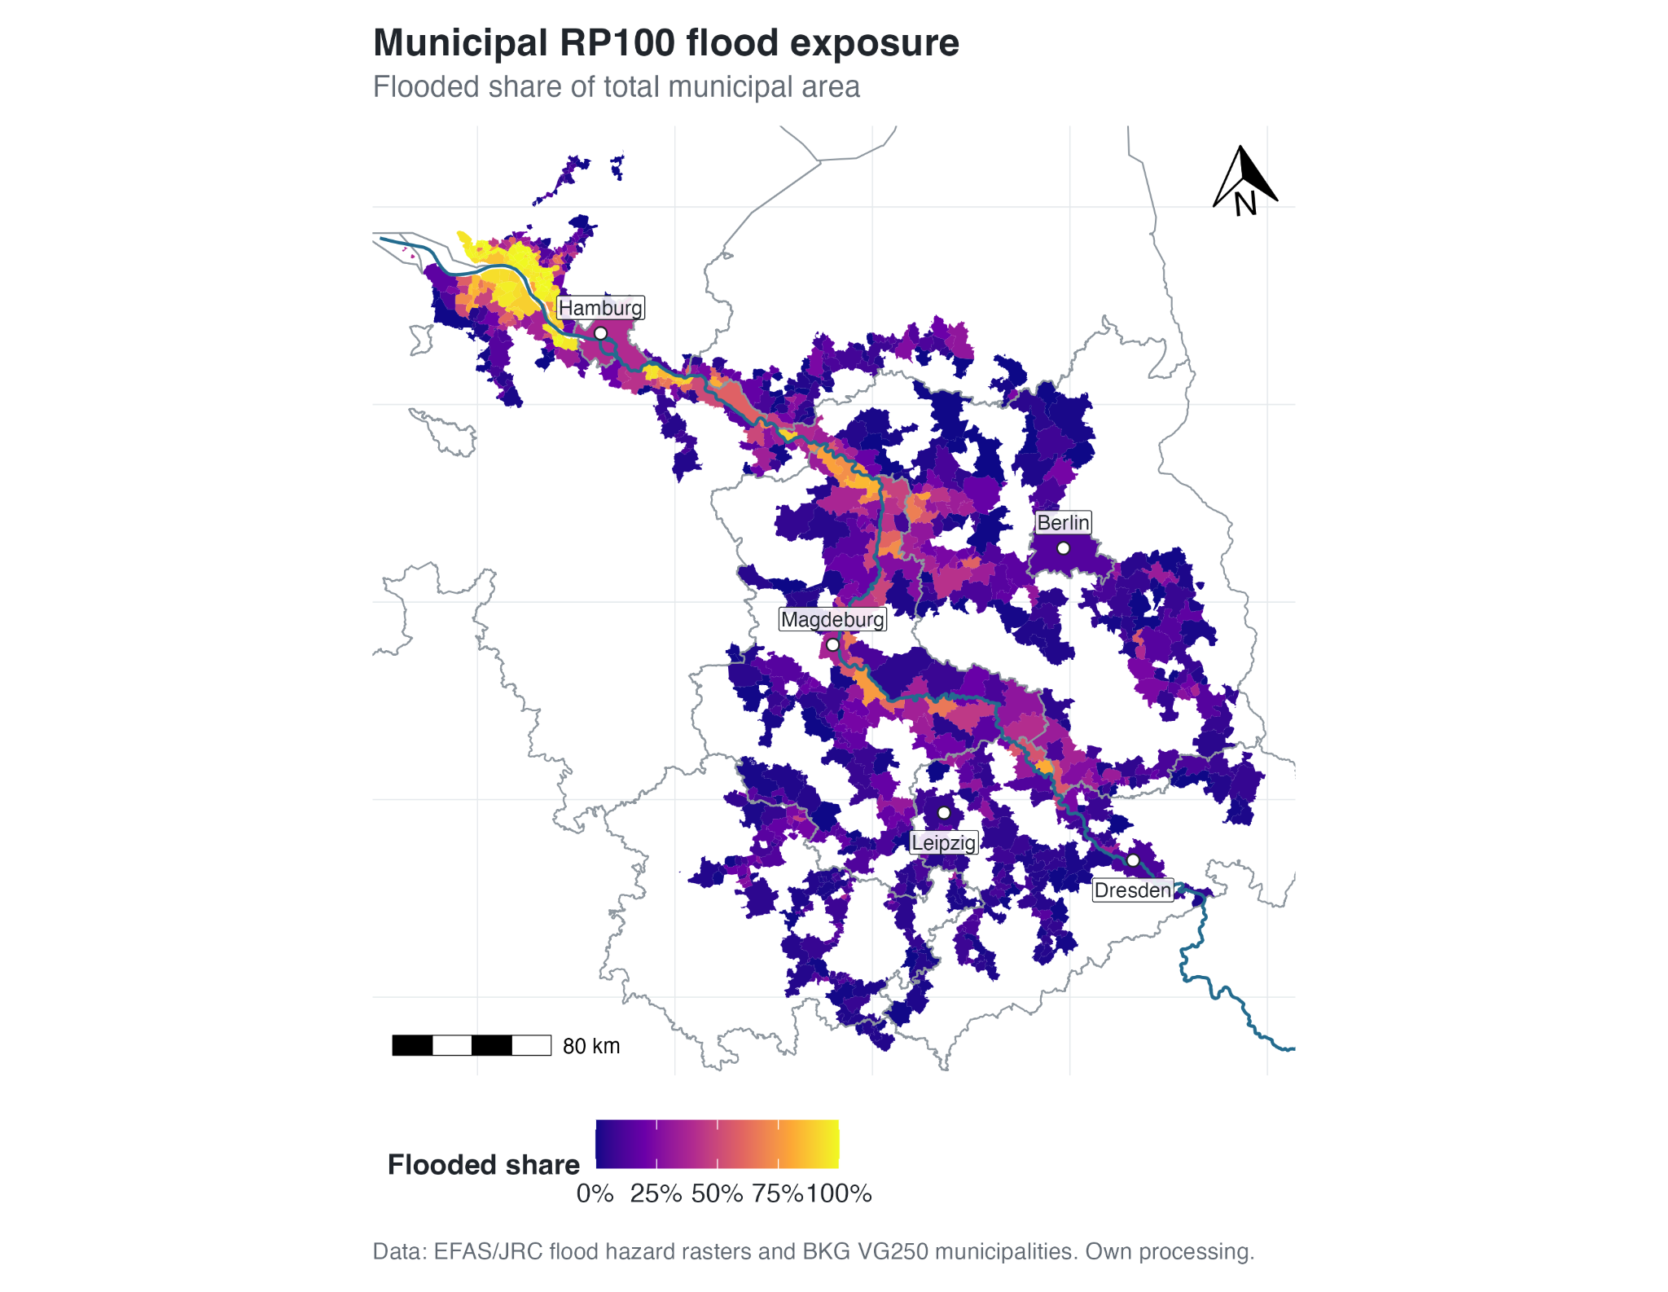
Figure 5.1. Municipal RP100 flood exposure in the RP500 Elbe corridor, measured as flooded share of municipal area. Source: own analysis based on JRC river-flood hazard data and BKG VG250.

The RP100 exposure distribution is strongly skewed. Across the 835 corridor municipalities, the mean RP100 flood share is 25.4%, while the median is only 12.9%. The lower and upper quartiles are 3.9% and 33.4%, respectively. In practical terms, many municipalities have comparatively small flood shares, but a smaller group has very extensive municipal exposure. At the upper end, several municipalities approach or reach complete modelled exposure; 8 municipalities have an RP100 flood share of at least 99.9%. At the lower end, 14 municipalities have no modelled RP100 flooded area even though they enter the study population through the RP500 corridor definition.

The multi-return-period exposure table shows that a substantial share of corridor exposure is already present at more frequent return periods. At RP10, the mean flood share is 20.3% and the median is 8.9%. By RP500, the mean rises to 27.0% and the median to 13.9%. The increase from RP10 to RP500 is real but moderate at the corridor level, especially compared with the large differences between municipalities at any single return period. The number of municipalities with zero modelled exposure declines from 67 at RP10 to 14 at RP100 and to 0 at RP500, which is consistent with the RP500-based corridor definition. Overall, the exposure results indicate that the Elbe corridor is characterised less by a simple transition from no exposure to exposure at rare events and more by a pattern in which many municipalities already show meaningful flooded-area shares at comparatively frequent or benchmark return periods.

5.3 Socio-Economic Vulnerability Patterns
The second empirical layer is socio-economic vulnerability. The final vulnerability index is available for 834 of the 835 corridor municipalities. It is standardised to a mean of zero, so positive values indicate above-average socio-economic vulnerability within the corridor and negative values indicate below-average vulnerability. The observed range extends from -2.75 to 4.02, with a median of -0.04. The upper tail is somewhat more pronounced than the lower tail, indicating a small number of municipalities with clearly above-average vulnerability scores.

Figure 5.2 maps the final dimension-balanced vulnerability index. The vulnerability geography is spatially differentiated and does not follow the RP100 exposure pattern in a simple way. Higher vulnerability values occur in several parts of the corridor, including municipalities away from the highest RP100 flood-share zones. Conversely, some municipalities with high RP100 exposure have comparatively low or medium vulnerability scores. This already suggests that flood exposure and socio-economic vulnerability should not be assumed to overlap automatically.
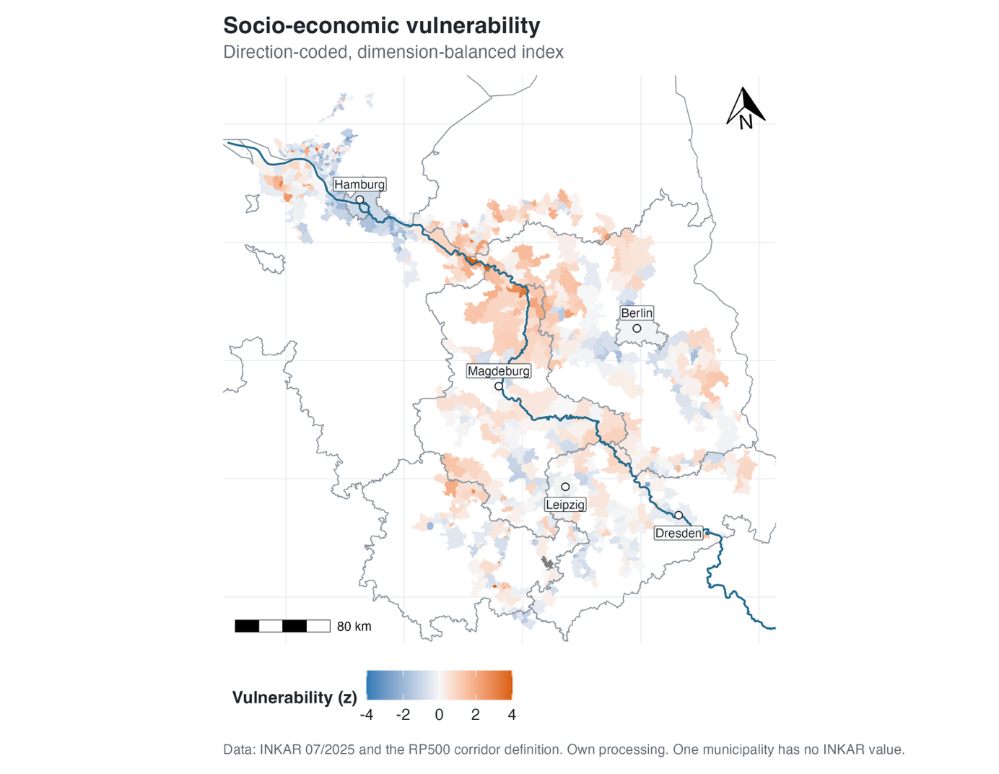

Figure 5.2. Final socio-economic vulnerability index in the RP500 Elbe corridor. Source: own analysis based on BBSR INKAR and BKG VG250.

Figure 5.3 opens the composite index into its three component dimensions: access and adaptive capacity, demographic and household structure, and deprivation and labour market. The dimension maps show why the index was not treated as a single poverty variable. Each dimension produces a partly different spatial pattern. The access and adaptive-capacity dimension captures a strong service-access and infrastructure component. The demographic and household dimension varies more locally and does not simply reproduce the access pattern. The deprivation and labour-market dimension again has its own geography, with several municipalities scoring high even where the other dimensions are less pronounced.
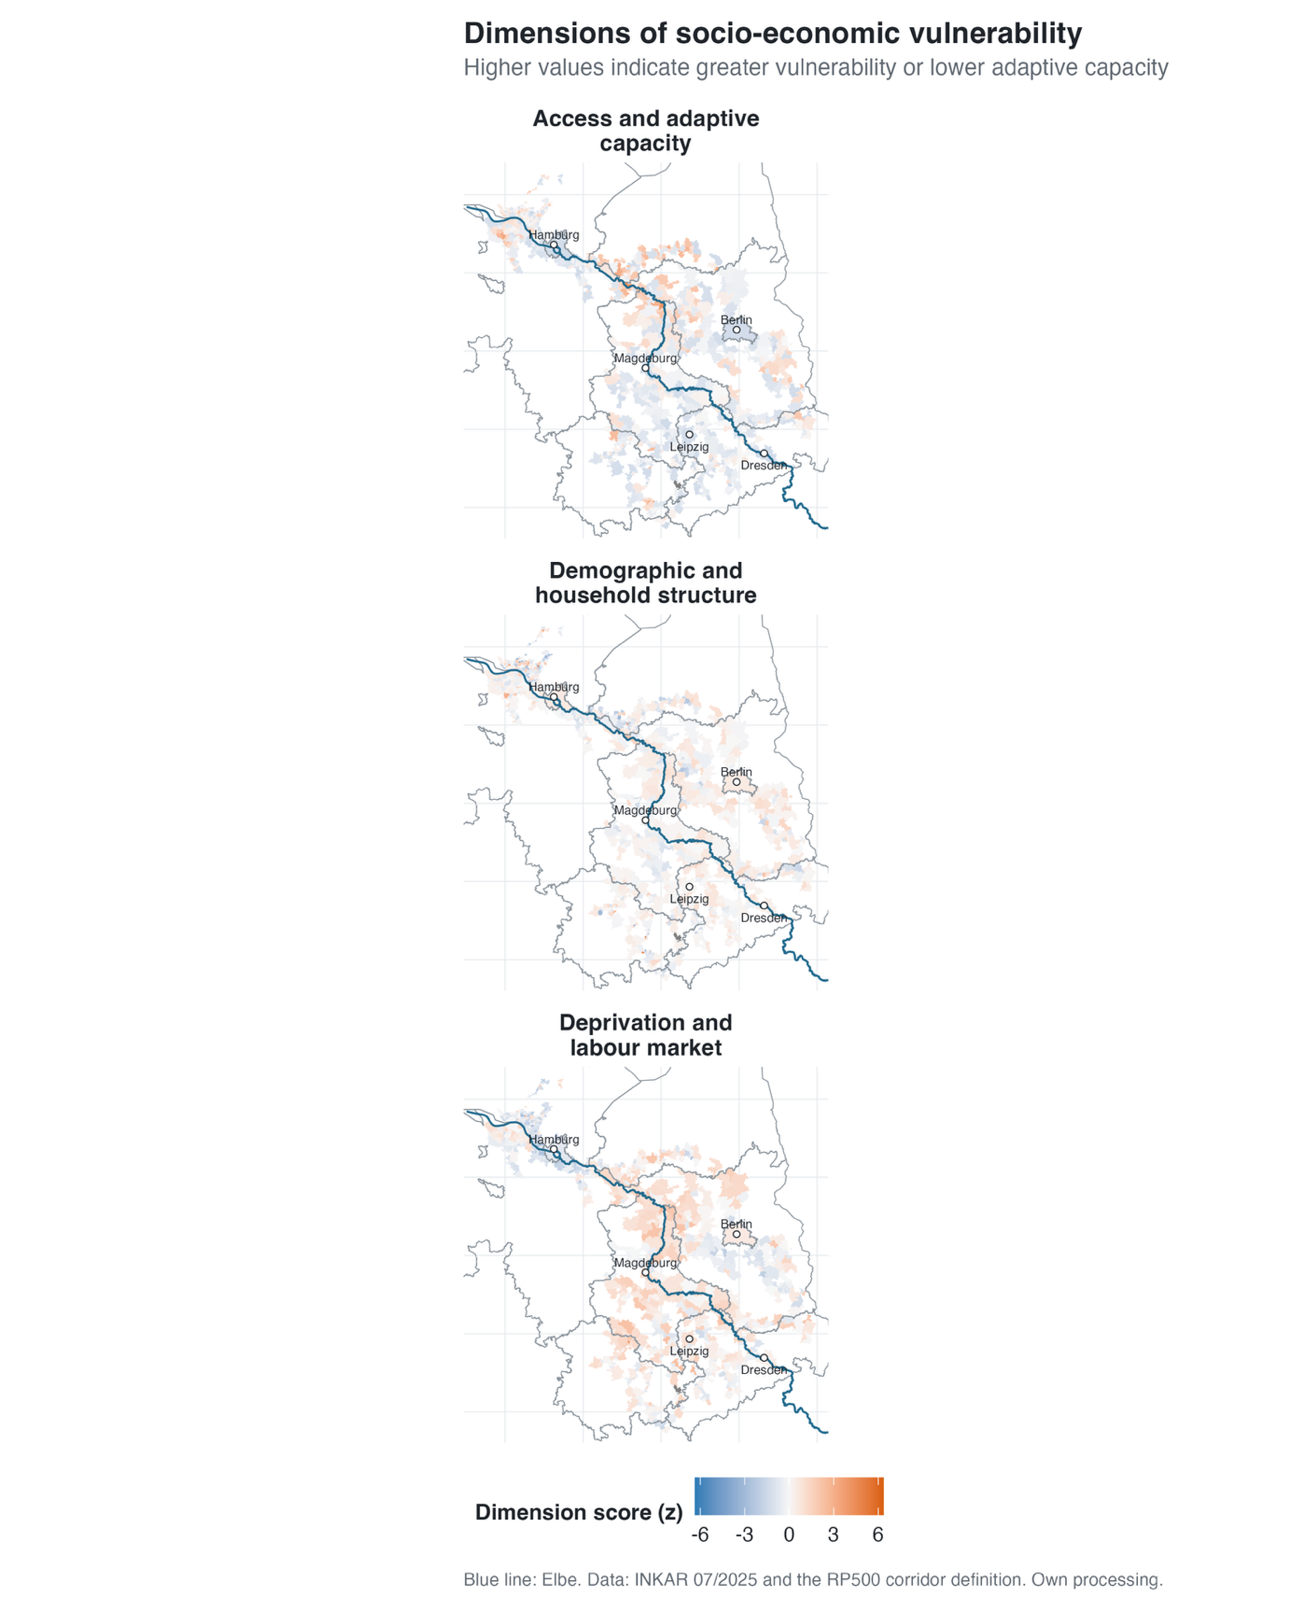

Figure 5.3. Three dimensions of the final vulnerability index: demographic and household structure, deprivation and labour market, and access and adaptive capacity. Source: own analysis based on BBSR INKAR.

The statistical relationship between the three dimension scores confirms this visual impression. The correlation between access/adaptive capacity and demographic/household structure is -0.215; the correlation between access/adaptive capacity and deprivation/labour market is -0.053; and the correlation between demographic/household structure and deprivation/labour market is 0.051. These weak relationships indicate that the three dimensions capture different aspects of municipal vulnerability rather than one single underlying gradient. This matters for the later distributive comparison, because the vulnerability index represents a balanced combination of several social conditions: demographic sensitivity, socio-economic deprivation, and access-related adaptive capacity.

5.4 Distributive Relationship Between Exposure and Vulnerability
The central distributive question is whether municipalities with higher socio-economic vulnerability also show higher flood exposure. Figure 5.4 plots the final vulnerability index against RP100 flood share for the 834 municipalities with available vulnerability data. The relationship is weak and slightly negative. The Pearson correlation is -0.050, and the Spearman rank correlation is also -0.050. In practical terms, the corridor does not show a simple linear pattern in which more vulnerable municipalities are generally more exposed at RP100.
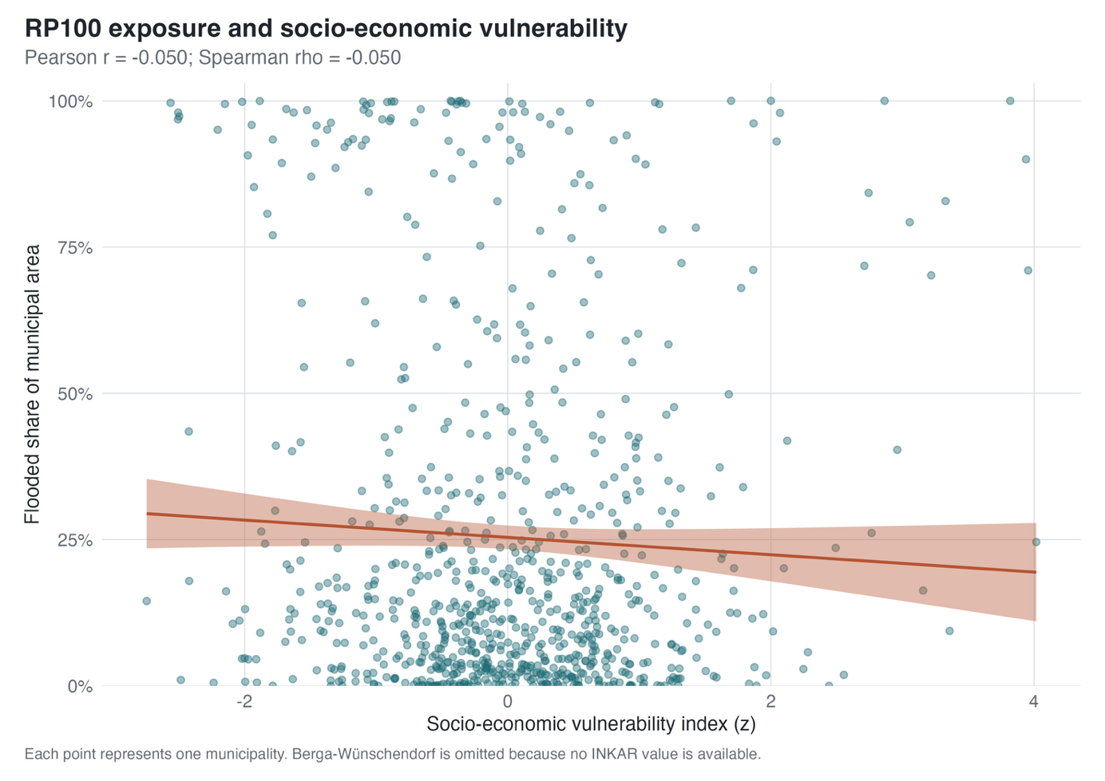

Figure 5.4. Municipality-level relationship between socio-economic vulnerability and RP100 flood share. Source: own analysis based on JRC river-flood hazard data and BBSR INKAR.

The scatterplot also shows why the correlation is weak. Municipalities with high RP100 flood shares occur across much of the vulnerability distribution. Some highly exposed municipalities have low vulnerability scores, while others have medium or high scores. Similarly, municipalities with high vulnerability scores range from low to very high RP100 exposure. The result is not an absence of flood exposure inequality. Rather, it is an absence of a clear corridor-wide linear gradient between municipal area exposure and the final vulnerability index.

Figure 5.5 shows the same relationship by vulnerability quintile. The lowest-vulnerability quintile has the highest mean RP100 flood share at 35.6%, with a median of 17.3%. The highest-vulnerability quintile has a mean RP100 flood share of 27.2% and a median of 16.3%. The middle quintiles are lower, with mean values of 21.9% in Q2, 23.0% in Q3, and 19.2% in Q4. The quintile pattern is non-monotonic. The highest-vulnerability municipalities are not the least exposed group, but they also do not form the most exposed group. The strongest mean exposure is found in the lowest-vulnerability quintile, while the highest-vulnerability quintile still contains many strongly exposed municipalities and has a higher mean exposure than Q2, Q3, and Q4.
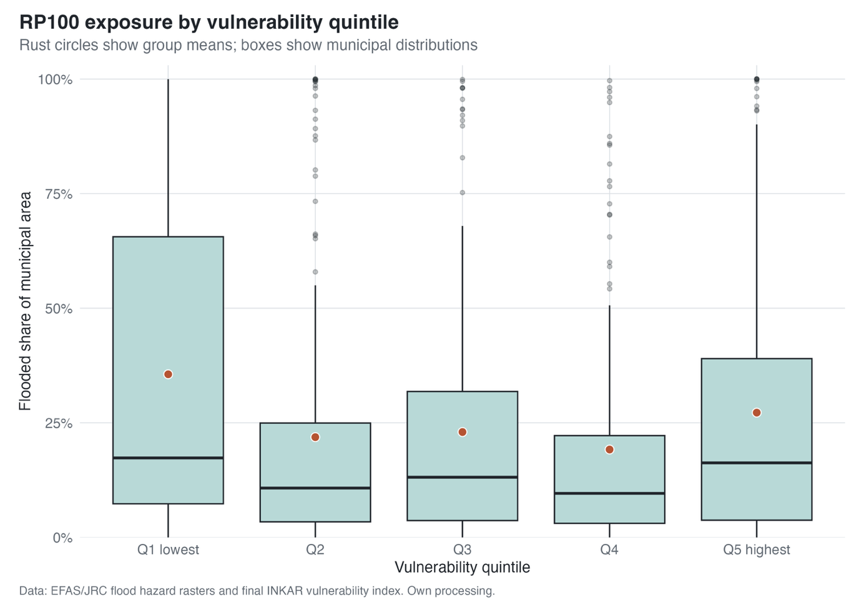

Figure 5.5. Distribution of RP100 flood share by vulnerability quintile. Source: own analysis based on JRC river-flood hazard data and BBSR INKAR.

The boxplots show wide within-group variation. Every vulnerability quintile contains municipalities with high RP100 flood shares, and the highest-vulnerability quintile includes municipalities with almost complete modelled exposure. The corridor therefore contains high-vulnerability and high-exposure cases, but they occur within a broader non-monotonic distribution.

Figure 5.6 maps this heterogeneity by classifying municipalities into terciles of RP100 exposure and vulnerability. The bivariate map highlights municipalities that combine high exposure with high vulnerability, but it also shows that high exposure is not restricted to high-vulnerability municipalities. Among municipalities in the highest RP100 exposure tercile, 104 fall into the low-vulnerability tercile, 81 into the medium-vulnerability tercile, and 93 into the high-vulnerability tercile. High-high municipalities exist and are relevant, but they do not dominate the high-exposure group.
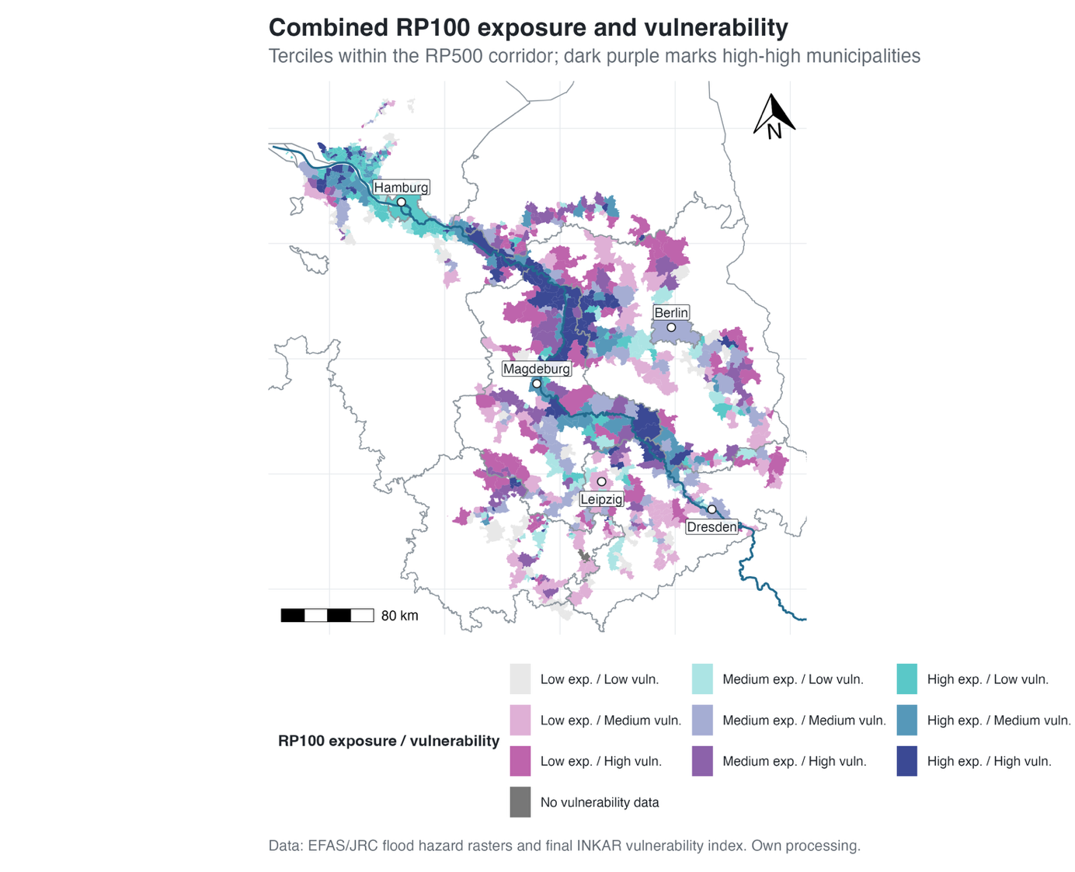

Figure 5.6. Bivariate classification of RP100 exposure and socio-economic vulnerability. High-high municipalities combine high flood share and high vulnerability. Source: own analysis based on JRC river-flood hazard data and BBSR INKAR.

The map is best read as a spatial diagnostic rather than as evidence of one uniform corridor-wide pattern. It identifies municipalities where flood exposure and socio-economic vulnerability coincide, and these municipalities are central for the justice-oriented interpretation in Chapter 6. However, it also shows that the Elbe corridor contains several other combinations: high exposure with lower vulnerability, lower exposure with high vulnerability, and medium cases in between. For the first research question, the main result is clear but cautious: RP100 municipal area exposure is spatially unequal, but it is not strongly or linearly aligned with the final socio-economic vulnerability index across the full corridor.

5.5 Land-Cover-Sensitive Exposure
The DLR land-cover extension clarifies what the total-area exposure measure represents. Figure 5.7 shows the composition of the modelled RP100 flooded land-cover area after aggregation to the four analytical groups. Artificial Land accounts for 499.4 km², or 6.0%, of the 8,355.2 km² classified as flooded. Open or seasonal land cover accounts for 3,883.8 km² (46.5%), perennial vegetation for 3,289.5 km² (39.4%), and water for 682.4 km² (8.2%). Most of the modelled RP100 flooded area is therefore not Artificial Land. This confirms that municipal flood share primarily describes the extent of the flood footprint across municipal territory, not settlement exposure alone.
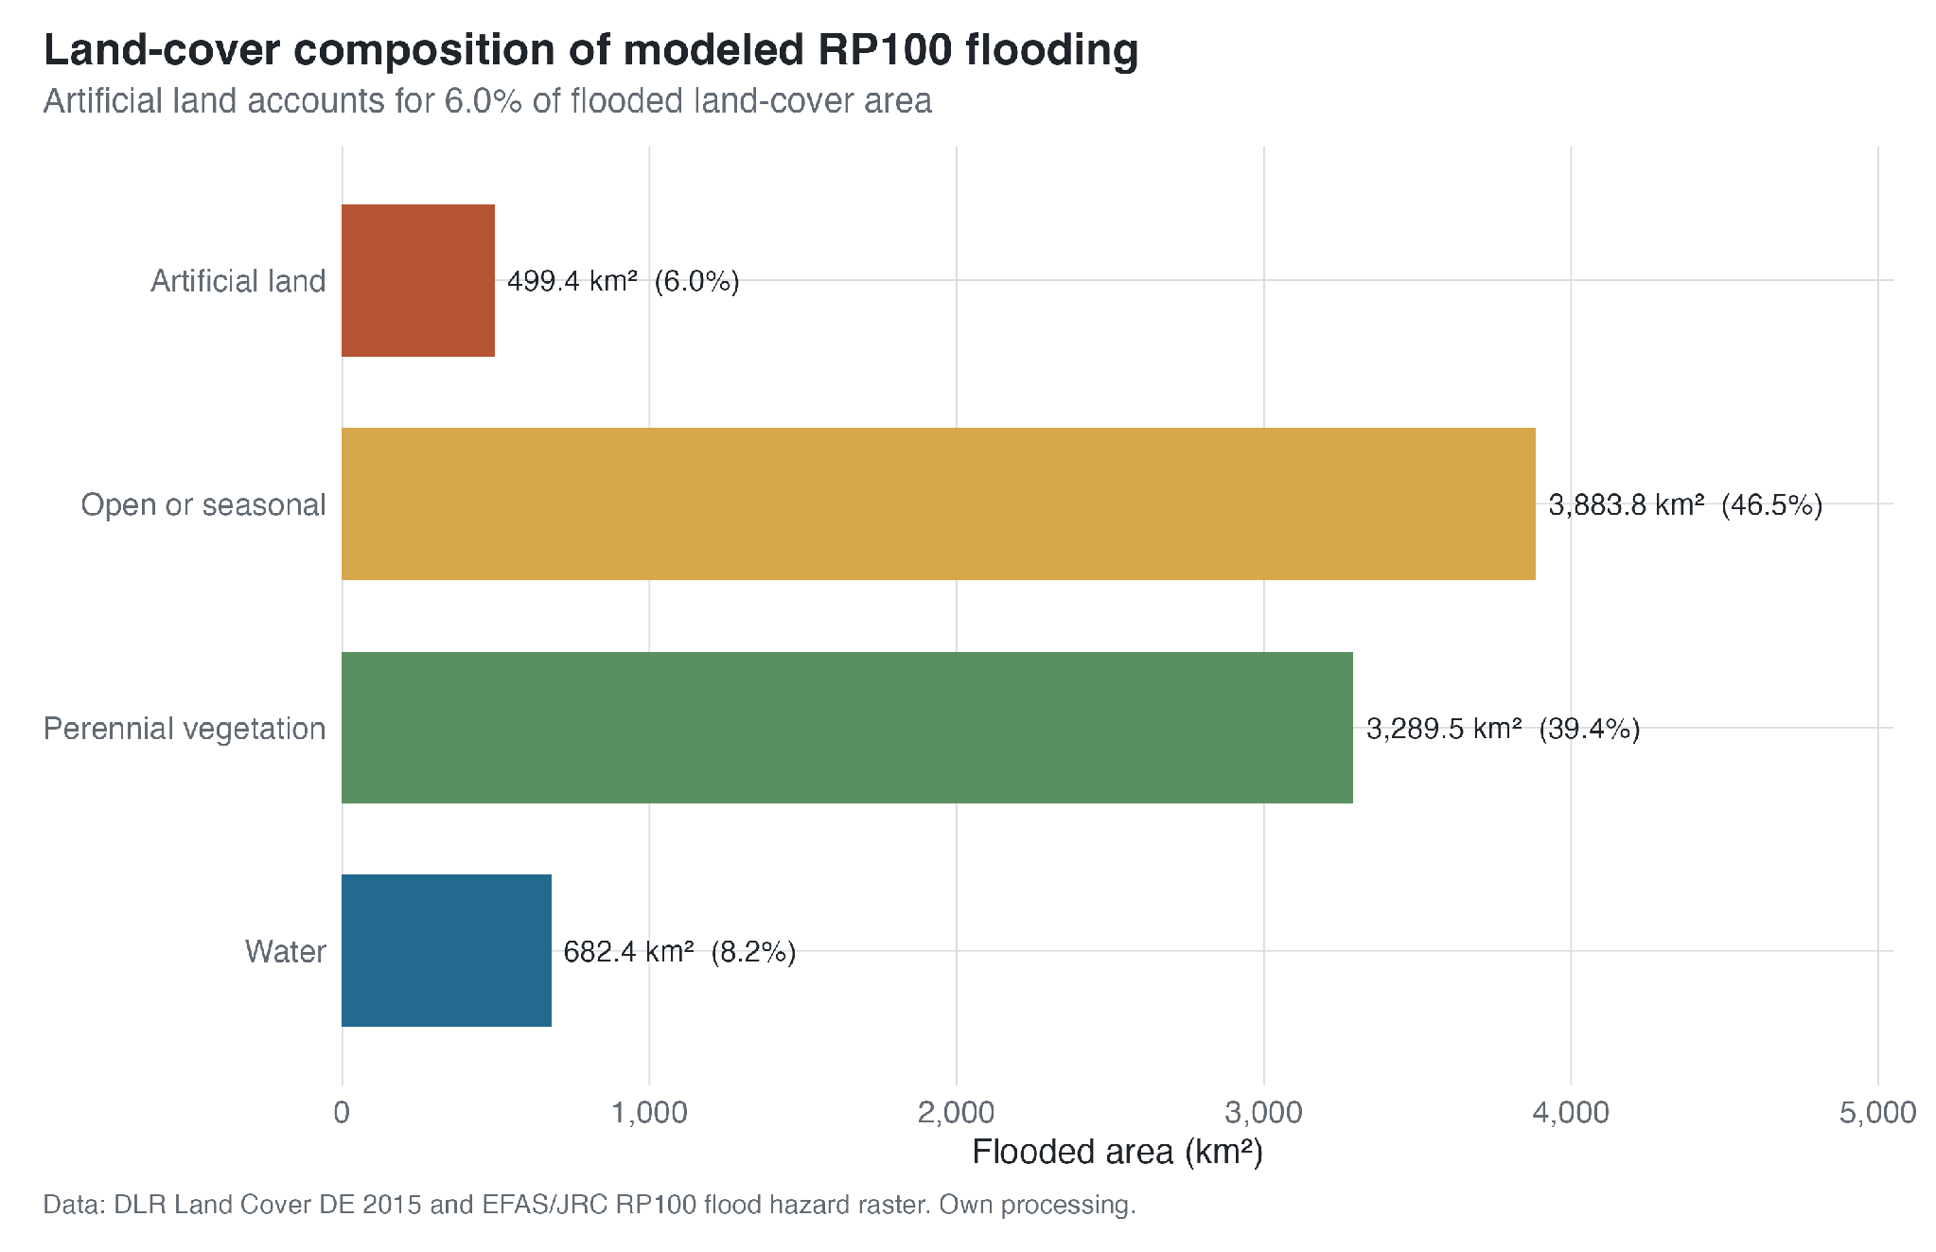

Figure 5.7. Land-cover composition of the modelled RP100 flooded area in the RP500 Elbe corridor. Source: own analysis based on JRC river-flood hazard data and DLR Land Cover DE.

Figure 5.8 maps the flooded share of DLR Artificial Land in each municipality. Of the 834 municipalities with any Artificial Land, 747 have a positive RP100 Artificial Land flood share. In 322 municipalities, at least 10% of Artificial Land is flooded, and in 165 municipalities the share reaches at least 25%. The municipal median is 6.2%, but the distribution has a long upper tail. High values occur in different parts of the corridor and are not confined to one vulnerability profile.
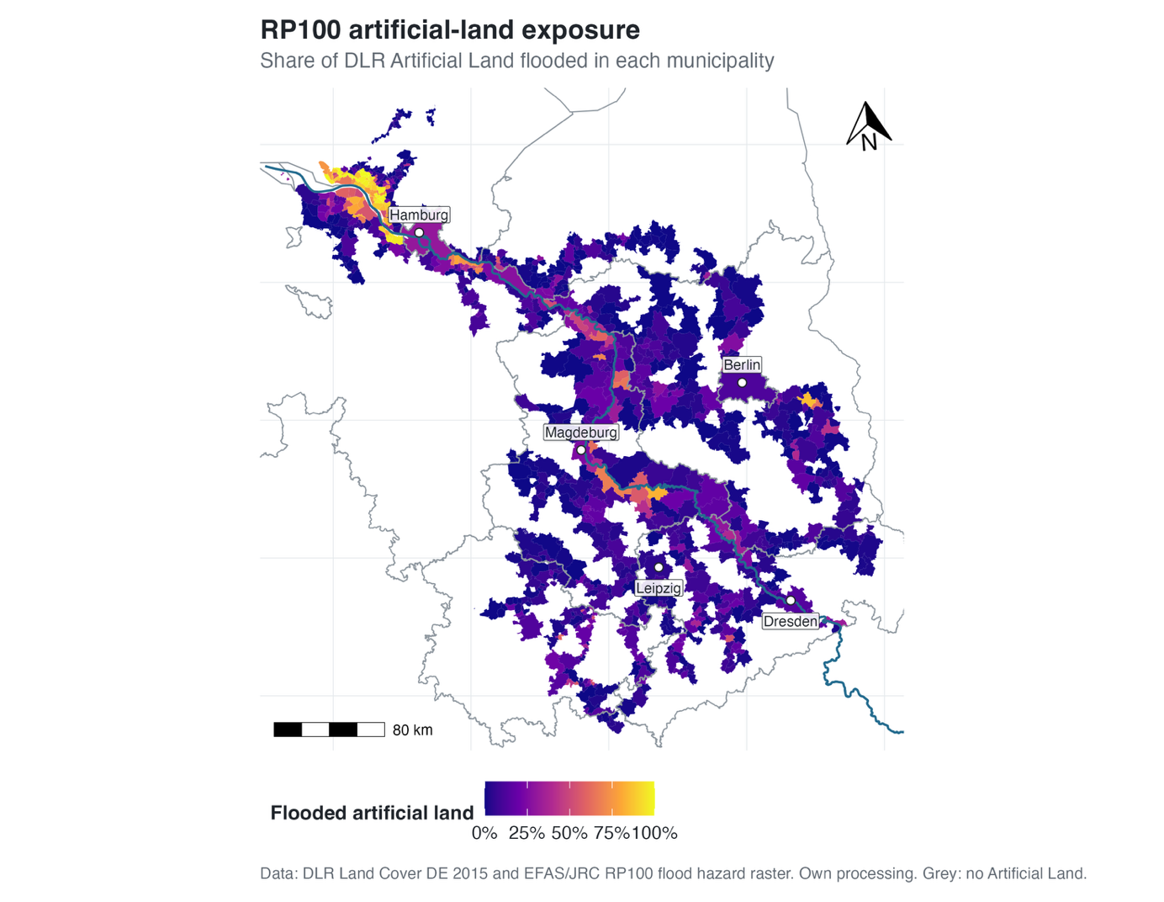

Figure 5.8. RP100 Artificial Land exposure in the RP500 Elbe corridor, measured as the flooded share of DLR Artificial Land in each municipality. Source: own analysis based on JRC river-flood hazard data and DLR Land Cover DE.

The vulnerability relationship changes little when the denominator is restricted to Artificial Land. The original RP100 total-area flood share has a Pearson correlation of -0.050 and a Spearman correlation of -0.050 with the final vulnerability index. For RP100 Artificial Land exposure, the corresponding correlations are -0.088 and -0.063 across the 833 municipalities with both indicators available. Both measures therefore show a weak and slightly negative corridor-wide association rather than a positive vulnerability gradient. Among the three vulnerability dimensions, deprivation and labour market has the most negative Pearson correlation with Artificial Land exposure (-0.165), while the other dimension-level correlations remain close to zero.

Figure 5.9 shows the grouped result. The lowest-vulnerability quintile has the highest mean Artificial Land flood share at 26.4%. Mean shares are 17.2% in Q2, 14.9% in Q3, 11.9% in Q4, and 16.7% in the highest-vulnerability quintile. The medians are much closer together, ranging from 5.5% to 7.5%, which indicates that the mean differences are influenced by a smaller number of municipalities with very high Artificial Land exposure. As with total municipal area, the quintile pattern is non-monotonic.
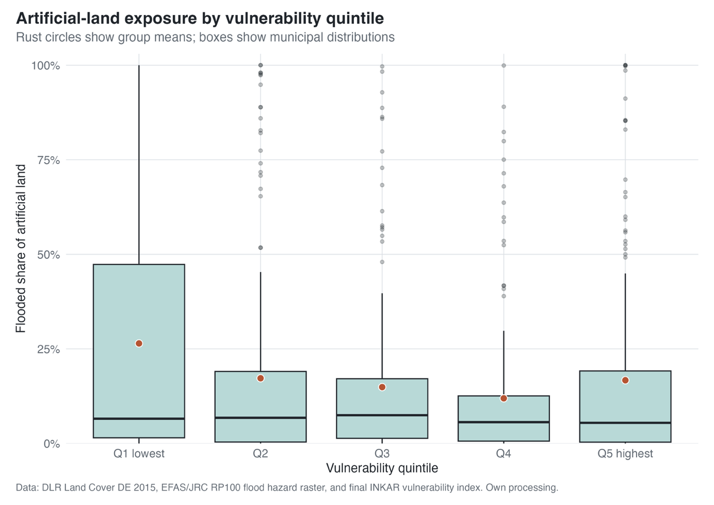

Figure 5.9. RP100 Artificial Land exposure by vulnerability quintile. Source: own analysis based on JRC river-flood hazard data, DLR Land Cover DE, and BBSR INKAR.

The land-cover extension refines rather than reverses the main exposure finding. The original flood-share measure clearly contains extensive non-built land, so it should not be described as direct social exposure. However, restricting the analysis to Artificial Land does not reveal a hidden positive association between vulnerability and RP100 exposure. Within the limits of a municipality-level built-land proxy, the weak and non-monotonic exposure-vulnerability relationship remains stable.

A cross-check with the loss portfolio shows that Artificial Land exposure does not determine modelled loss status on its own. The share of positive-loss municipalities is 24.5% in the lowest Artificial Land exposure tercile, 45.0% in the middle tercile, and 31.3% in the highest tercile. In the highest tercile, 87 of 278 municipalities have positive modelled losses, while 191 remain no-event cases. This non-monotonic pattern supports the analytical separation of flood exposure from modelled loss outcomes.

5.6 Multi-Return-Period Exposure Dynamics
The next step moves beyond the RP100 benchmark and examines how exposure accumulates across return periods. Figure 5.10 maps the exposure-curve typology derived from RP10, RP20, RP50, RP100, RP200, and RP500 flood shares. The dominant pattern is early exposure. 772 of the 835 corridor municipalities, or 92.5%, are classified as early-exposure municipalities. Only 46 municipalities, or 5.5%, show a delayed-jump pattern, and 17 municipalities, or 2.0%, show a gradual-increase pattern.
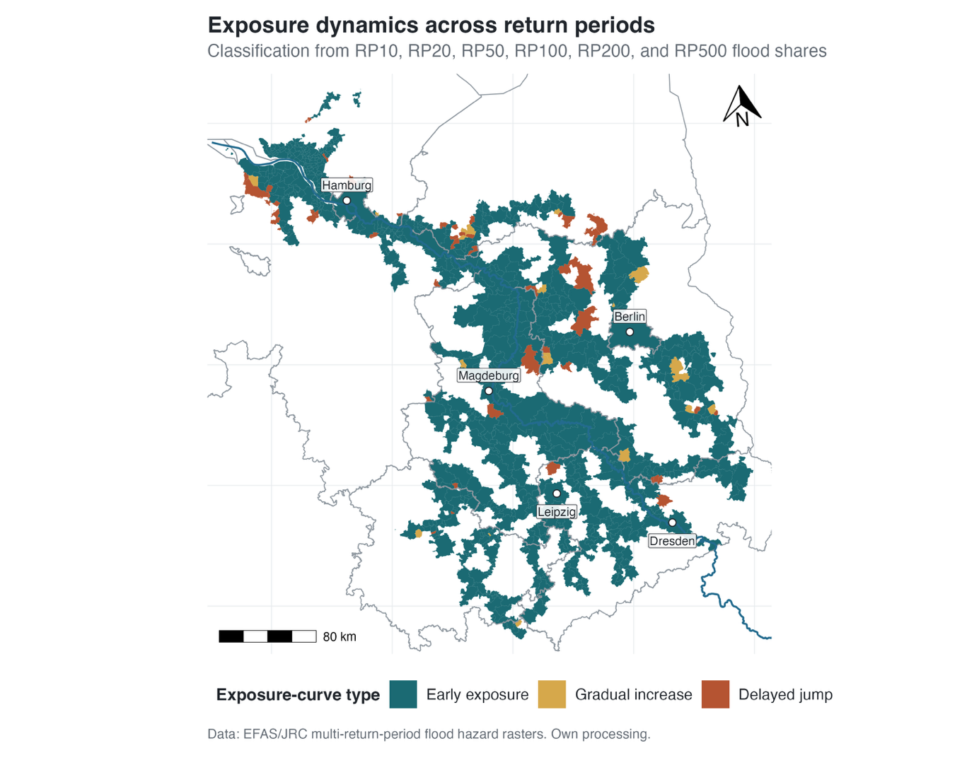

Figure 5.10. Exposure-curve typology across return periods. Source: own analysis based on JRC river-flood hazard data.

The typology confirms the descriptive pattern already visible in the return-period summary. For early-exposure municipalities, an average of 93.4% of the final RP500 flood share is already realised by RP100. For delayed-jump municipalities, only 15.6% of RP500 exposure is realised by RP100, and 84.4% is added only after RP100. Gradual-increase municipalities fall between these two extremes, with 55.6% of RP500 exposure realised by RP100. The curve typology separates a large majority of municipalities where exposure is already present by the benchmark return period from a much smaller set where modelled exposure appears mainly under rarer events.

Figure 5.11 compares mean exposure curves across vulnerability quintiles. The curves largely preserve the non-monotonic pattern observed at RP100. The lowest-vulnerability quintile has the highest mean flood share across all return periods, increasing from 31.4% at RP10 to 36.8% at RP500. The highest-vulnerability quintile is consistently above the middle groups, increasing from 20.8% at RP10 to 29.4% at RP500. Q4 remains the lowest group across most of the curve, with 14.5% at RP10, 19.2% at RP100, and 20.9% at RP500.
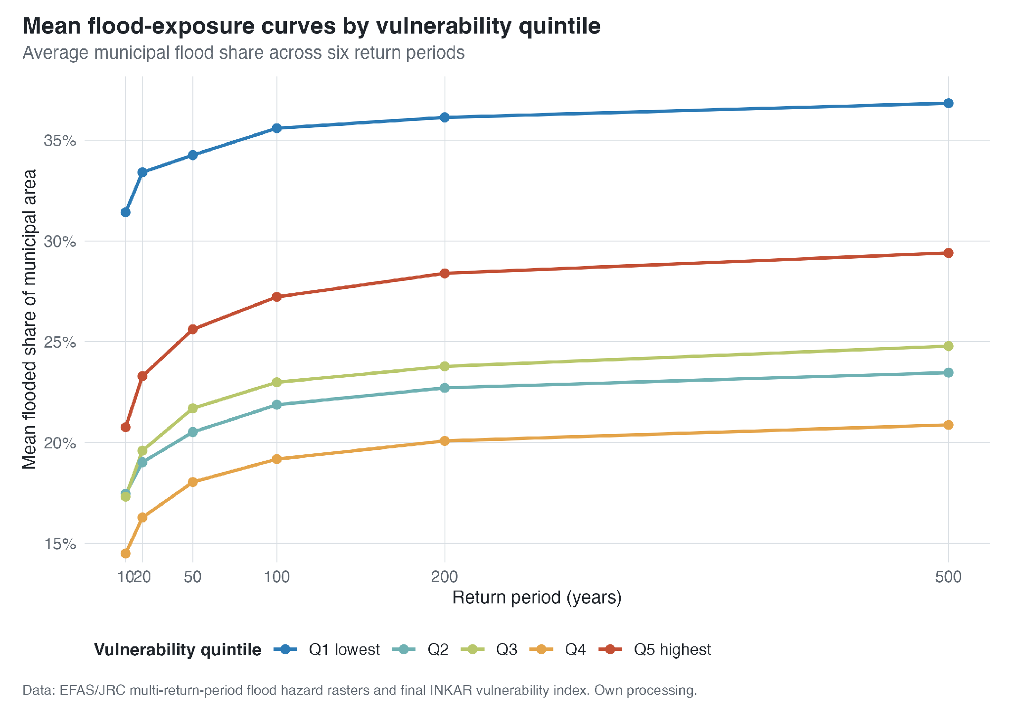

Figure 5.11. Mean municipal flood-exposure curves by vulnerability quintile. Source: own analysis based on JRC river-flood hazard data and BBSR INKAR.

The return-period sequence shows two features. First, most municipalities exposed at RP500 already reach a large share of their final exposure by RP100 or earlier. Second, the non-monotonic differences between vulnerability quintiles persist across the return periods. The highest-vulnerability quintile remains exposed and lies above most middle groups, while the lowest-vulnerability quintile has the highest mean exposure throughout the sequence.

5.7 Modelled Loss Patterns
The final empirical block introduces the supplied municipality-level loss portfolio. It differs from the EFAS/JRC exposure data because it includes only municipalities with at least one simulated loss year. Of 301 municipalities in the supplied table, 280 fall within the 835-municipality RP500 corridor. The other 555 corridor municipalities are retained as no-event cases rather than treated as missing observations. For full-corridor summaries, they enter with n = 0 and modelled annual loss probability p = 0; finite loss-occurrence return-period estimates are calculated only for the positive-loss subset.

Figure 5.12 maps the distinction between positive-loss and no-event municipalities. Positive-loss cases are concentrated particularly in the central and southern corridor, whereas large parts of the lower Elbe and several labelled cities record no simulated loss year. No-event status is therefore not confined to small peripheral municipalities. The map describes the spatial pattern of the model output; it does not identify why a municipality has no simulated loss event or distinguish protection effects from other model assumptions and domain limits.

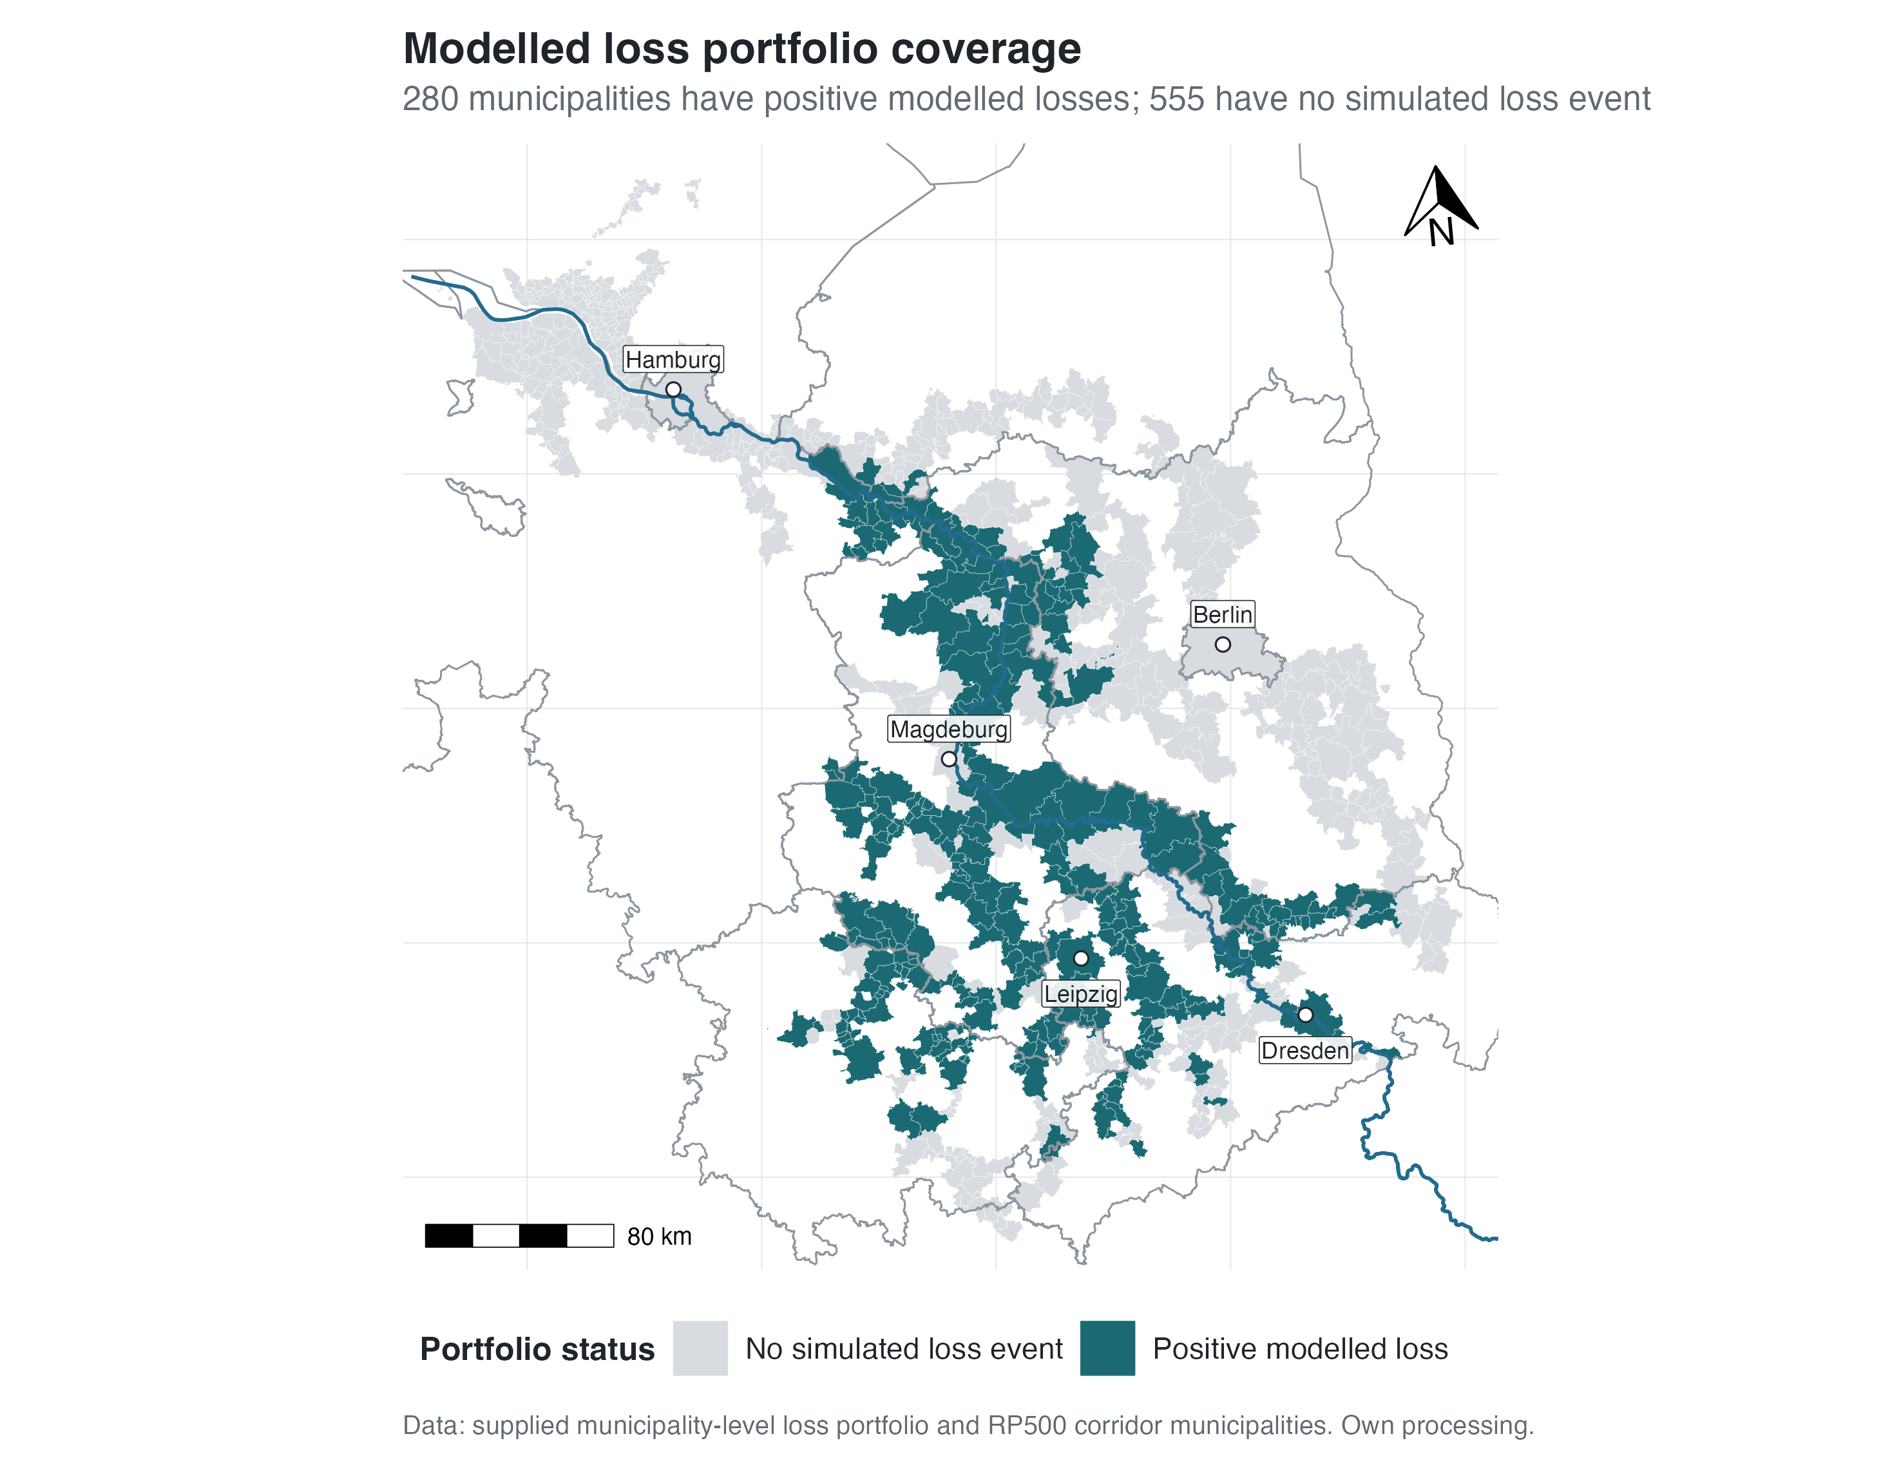

Figure 5.12. Municipalities with and without a simulated loss year in the RP500 corridor. Source: supplied municipality-level loss portfolio; own analysis.

No-event status is not equivalent to an absence of real-world flood risk. It records that the loss model produces no non-zero loss year for the municipality in the analysed catalogue. The stream-context diagnostic further divides the 555 no-event municipalities by their river setting. 339 municipalities (61.1%) intersect only minor or other WFD water bodies, and 16 (2.9%) do not intersect a WFD river body in the checked layer. By contrast, 138 (24.9%) intersect a larger WFD river or tributary, and 62 (11.2%) lie directly on or within one kilometre of the Elbe main stem. In total, 355 no-event municipalities (64.0%) are not directly associated with the Elbe main stem or a larger WFD river, while 200 (36.0%) are. The smaller-stream limitation can therefore account for part, but not all, of the no-event geography. These municipalities remain a separate empirical category, receive no finite loss-occurrence return-period estimate, and are interpreted further in Section 6.5.

Figure 5.13 maps finite loss-occurrence return-period estimates for the 280 positive-loss corridor municipalities. Lower values indicate more frequent simulated loss years, while higher values indicate less frequent loss occurrence among municipalities with at least one modelled loss year. Estimates range from approximately 1.13 to 5,000 years and are strongly right-skewed. The map therefore adds information beyond the binary loss-occurrence classification without being interpreted as a direct inventory of engineering protection standards.
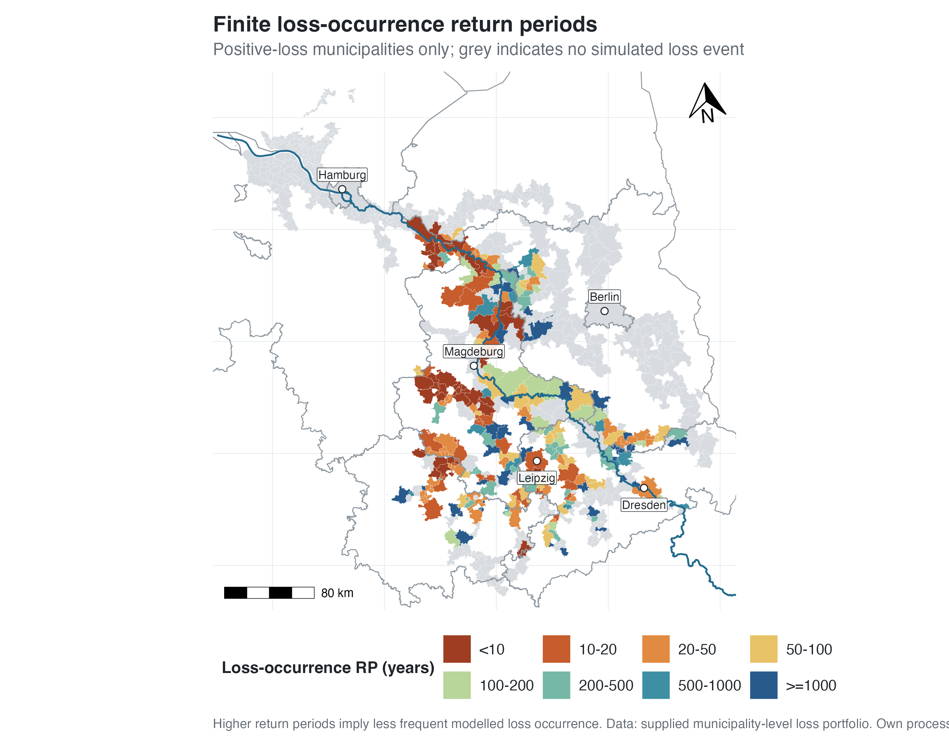

Figure 5.13. Finite loss-occurrence return-period estimates for positive-loss corridor municipalities. Source: supplied municipality-level loss portfolio; own analysis.

Figure 5.14 maps modelled annual loss probability for the full corridor. The 555 no-event municipalities are retained as p = 0, while the 280 positive-loss municipalities receive probabilities based on their number of non-zero loss years. Among the positive-loss subset, probabilities range from 0.02% to 88.72% (median 1.87%), corresponding to finite loss-occurrence return-period estimates from 5,000 to 1.13 years (median 53.49 years). The upper tail is therefore extreme: several municipalities record losses in most simulated years. These values are model outputs and should not be read as observed annual flood frequencies.
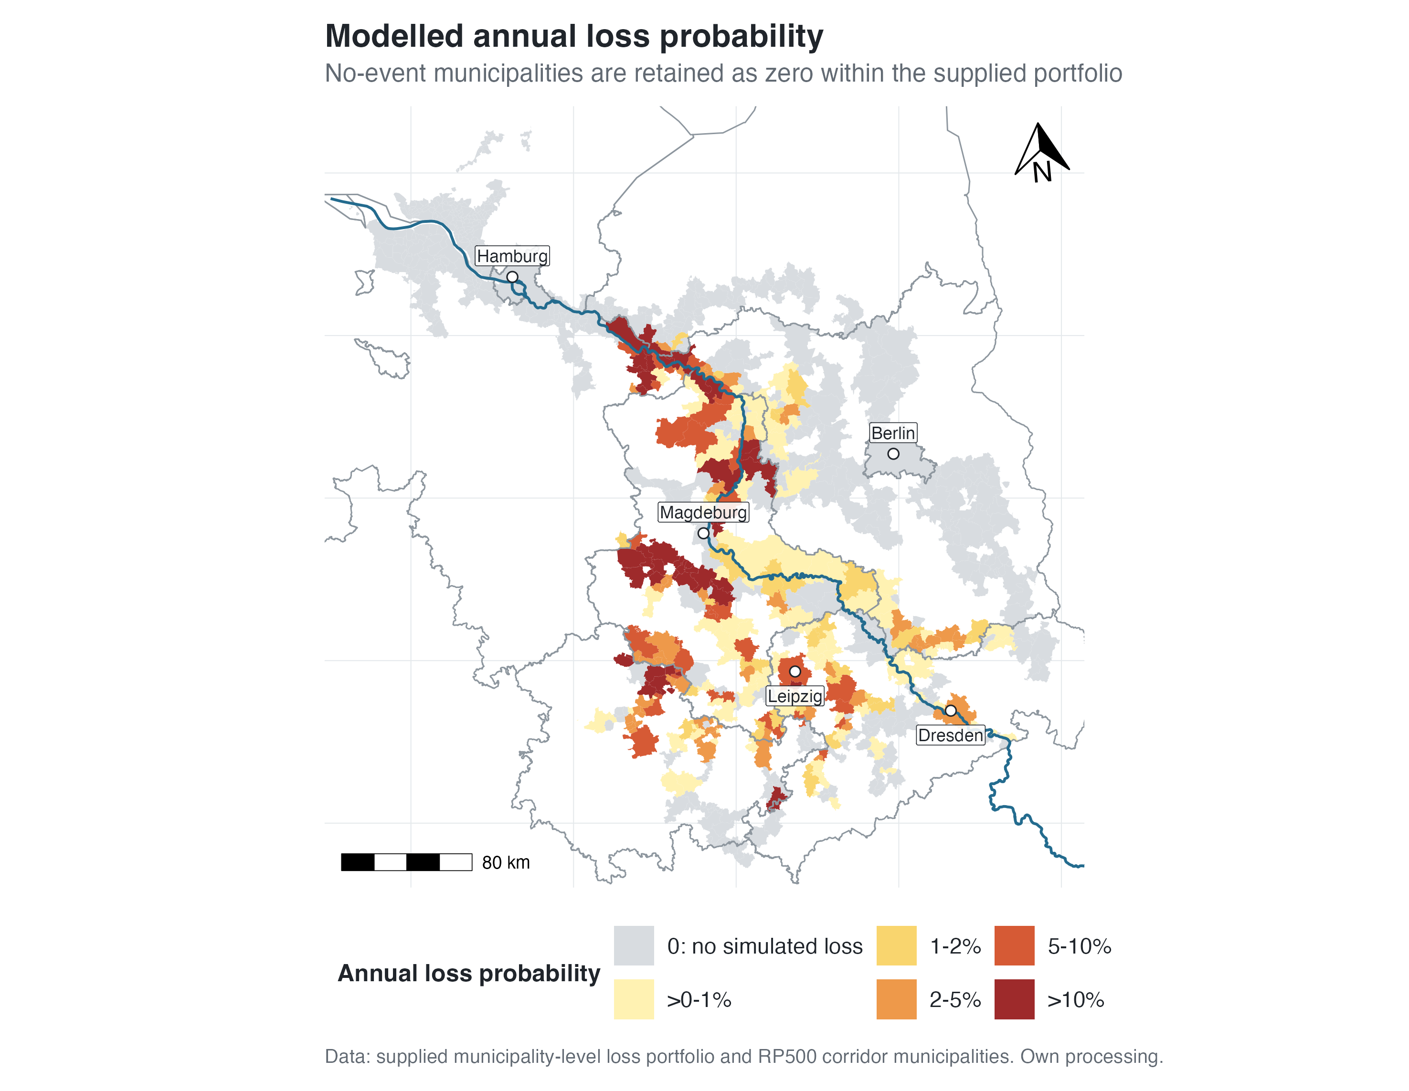

Figure 5.14. Modelled annual loss probability in the RP500 Elbe corridor. No-event municipalities are displayed as a separate zero-event class. Source: supplied municipality-level loss portfolio; own analysis.

Figure 5.15 compares the share of municipalities with at least one modelled loss year across vulnerability quintiles. The share rises from 16.2% in Q1 to 30.5% in Q2, 33.5% in Q3, and 46.7% in Q4, before declining to 41.0% in Q5. Q4 and Q5 are therefore both clearly above the lowest-vulnerability group, although the sequence is not monotonic.
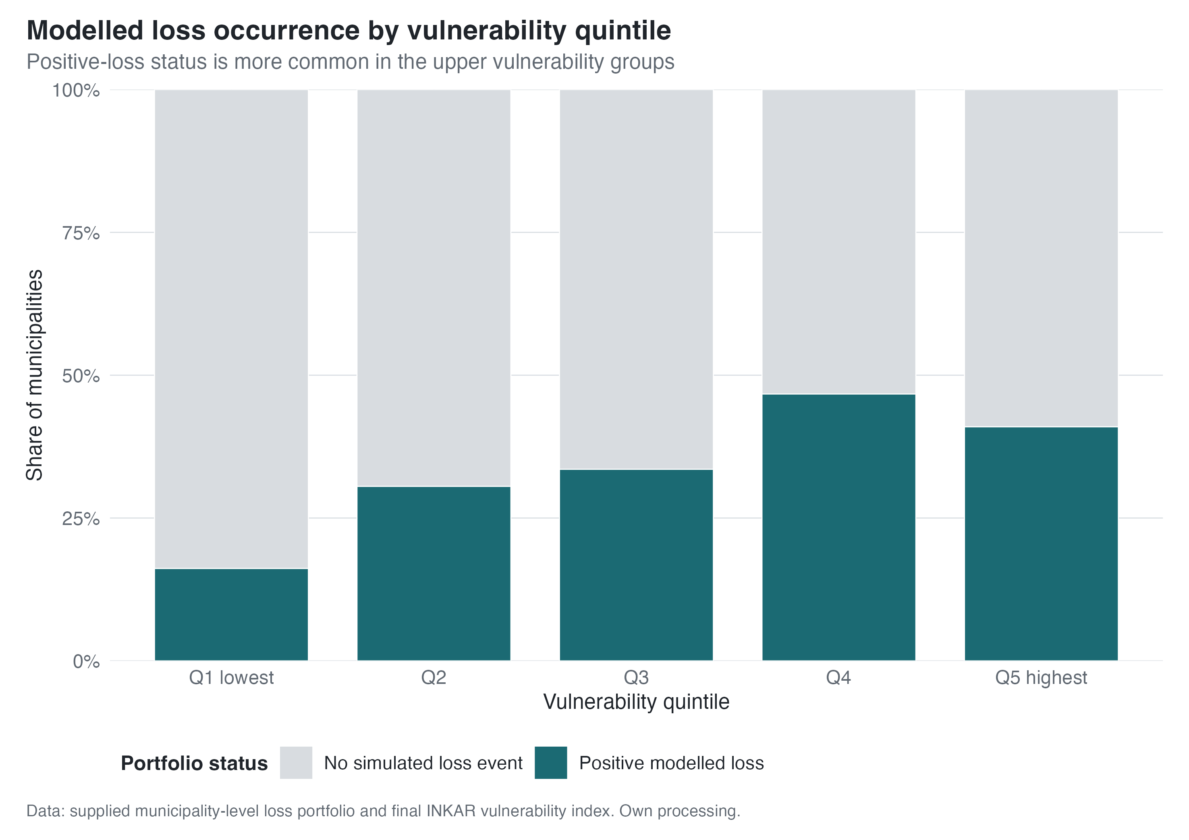

Figure 5.15. Share of municipalities with at least one modelled loss year by vulnerability quintile. Source: own analysis based on the supplied municipality-level loss portfolio and BBSR INKAR.

Figure 5.16 summarises modelled annual loss probability by vulnerability quintile while retaining no-event municipalities as p = 0. The median is zero in all quintiles because no-event cases form the majority of each group. Mean probability rises from 0.9% in Q1 to 1.3% in Q2, 2.0% in Q3, and 4.8% in Q4, before declining to 3.3% in Q5. The upper quartile rises from zero in Q1 to 1.8% in Q5. The pattern is positive overall but neither strong nor monotonic.
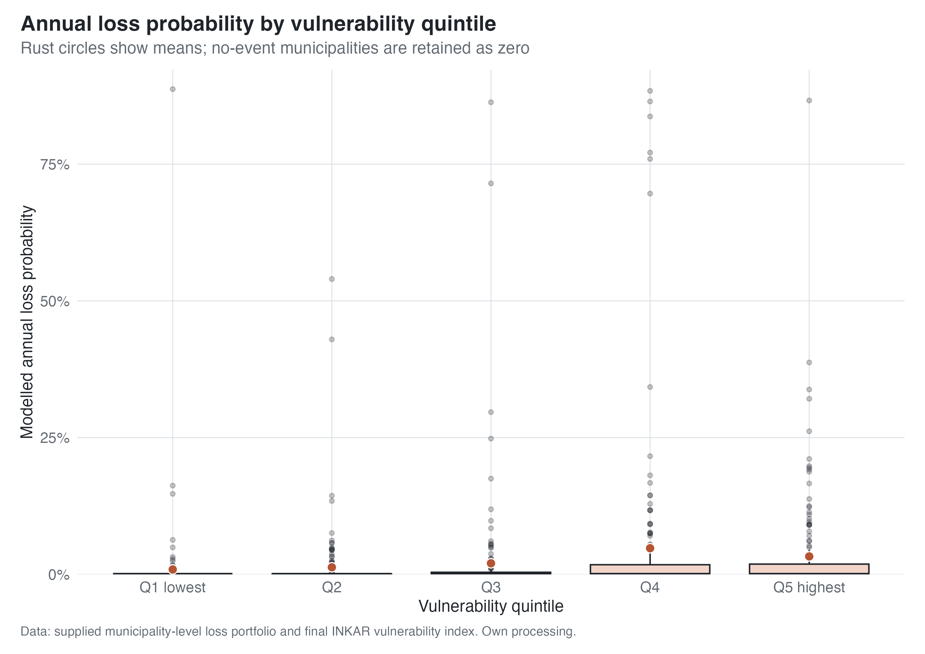

Figure 5.16. Modelled annual loss probability by vulnerability quintile, with no-event municipalities retained as zero-event cases. Source: own analysis based on the supplied municipality-level loss portfolio and BBSR INKAR.

Across the 834 corridor municipalities with vulnerability data, the Pearson correlation between the vulnerability index and modelled annual loss probability is 0.118 and the Spearman rank correlation is 0.230. These associations are weak, but both are more positive than the near-zero relationship between vulnerability and RP100 area exposure. The loss model therefore produces a social pattern that is not visible in the area-exposure comparison alone.
Direct comparisons with the exposure indicators are weak. Across all 835 municipalities, annual loss probability correlates at -0.027 (Pearson) and 0.043 (Spearman) with RP100 total-area flood share. With RP100 Artificial Land exposure, the corresponding correlations are -0.067 and 0.043 across 834 municipalities. Within the 280 positive-loss municipalities, finite loss-occurrence return-period estimates are weakly associated with total-area exposure (Pearson -0.117; Spearman -0.202) and show virtually no association with Artificial Land exposure (Pearson 0.009; Spearman -0.046). The loss outcomes therefore do not follow municipal exposure share in a simple linear or monotonic way.

Figure 5.17 focuses on the 280 positive-loss municipalities. The median finite loss-occurrence return-period estimate is 156 years in the lowest-vulnerability quintile, 61 years in Q2, 68 years in Q3, 40 years in Q4, and 28 years in Q5. The middle groups do not form a monotonic sequence. Because lower estimates correspond to more frequent simulated loss years, the comparison identifies a tendency towards higher modelled loss frequency in the more vulnerable part of the positive-loss subset. It does not measure an engineering design standard.
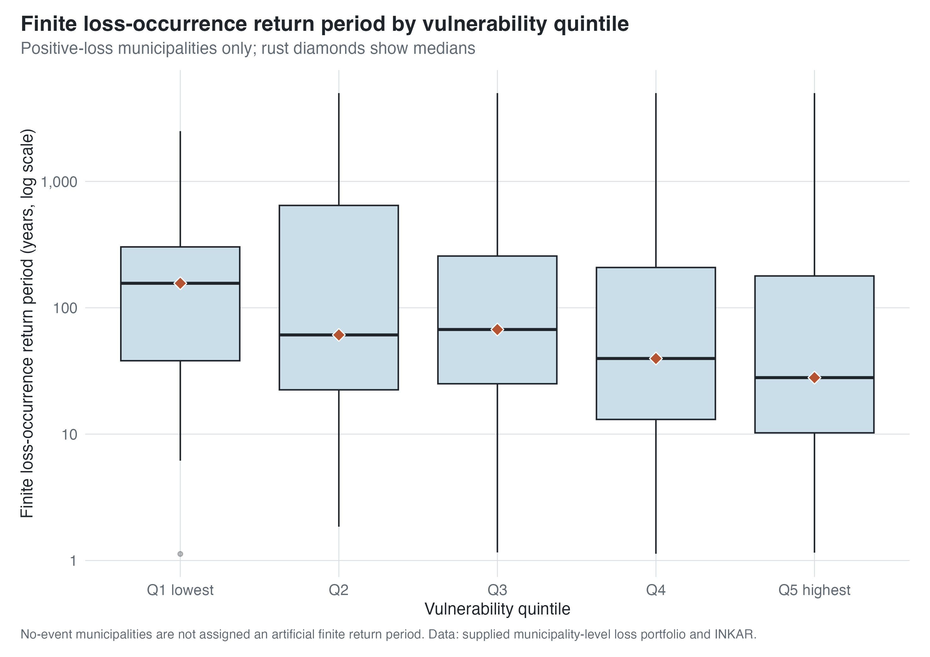

Figure 5.17. Finite loss-occurrence return-period estimates by vulnerability quintile among positive-loss municipalities only. Source: own analysis based on the supplied municipality-level loss portfolio and BBSR INKAR.

The positive-loss subset is highly dispersed. A small number of very large estimates strongly affect the means, so medians better represent central tendency across quintiles. The Spearman correlation between vulnerability and the finite loss-occurrence return-period estimate is -0.198, indicating a weak tendency for higher vulnerability to coincide with more frequent simulated loss years. This comparison applies only to the 280 municipalities with at least one modelled loss year and cannot be generalised to the no-event group.

5.8 Results Synthesis
The results answer the two research questions in different ways. For the first research question, the analysis does not find a simple positive relationship between socio-economic vulnerability and RP100 municipal area exposure. The RP100 exposure-vulnerability correlation is close to zero, and the quintile comparison is non-monotonic. The lowest-vulnerability quintile has the highest mean RP100 flood share, while the highest-vulnerability quintile still contains many strongly exposed municipalities but does not form a clear corridor-wide exposure maximum. The bivariate map confirms this: high-exposure and high-vulnerability municipalities exist, but high exposure also occurs among low- and medium-vulnerability municipalities. The exposure result is spatially heterogeneous rather than straightforwardly regressive.

The DLR extension makes this result more precise. Only 6.0% of the classified RP100 flooded land is Artificial Land, which confirms that the total-area indicator largely reflects floodplain territory rather than built land alone. However, restricting the denominator to Artificial Land does not reveal a hidden positive vulnerability gradient. Artificial Land exposure remains weakly and slightly negatively correlated with the final vulnerability index, and the quintile pattern remains non-monotonic. The land-cover analysis therefore strengthens the first result as a robustness check, while stopping short of a claim about population, building, or asset exposure.

The multi-return-period analysis strengthens this interpretation. Most corridor municipalities are classified as early-exposure municipalities, and the mean exposure curves by vulnerability quintile remain broadly consistent across return periods. The RP100 benchmark does not appear to hide a fundamentally different vulnerability pattern at rarer events. It captures a corridor in which much of the eventual RP500 area exposure is already present by RP100 or earlier. The main exposure finding is thus not that vulnerable municipalities are uniformly more exposed, but that flood-area exposure is widespread, uneven, and only weakly associated with the final vulnerability index at municipality level.

The second research question produces a different pattern. Municipalities in the upper vulnerability groups more often have at least one modelled loss year than those in the lowest group. With no-event cases retained as p = 0, mean annual loss probability rises from 0.9% in Q1 to 4.8% in Q4 and 3.3% in Q5. Within the positive-loss subset, the median finite loss-occurrence return-period estimate declines from 156 years in Q1 to 28 years in Q5, with variation across the middle groups. Direct correlations between the loss outcomes and RP100 exposure are near zero or weak and depend on the exposure denominator. Modelled losses are therefore more socially differentiated than the area-exposure measures, but they are neither a simple function of municipal flood share nor a perfectly monotonic vulnerability gradient.

The result depends on the treatment of no-event municipalities. Written clarification accompanying the loss data confirms that they were not removed by an event threshold and are not ordinary missing observations. At the same time, smaller streams are not fully represented, and the municipality table cannot identify the reason for each zero loss count. The defensible statement is therefore limited to the analysed catalogue: these municipalities have no simulated loss year, not no real-world flood risk.

Robustness checks preserve the contrast between the exposure and annual-loss results, while showing that the finite loss-occurrence return-period association is more specification-sensitive. Replacing the dimension-balanced index with the 70%-variance PCA score produces correlations of -0.240 (Pearson) and -0.140 (Spearman) with RP100 area exposure, and -0.222 and 0.006 with Artificial Land exposure. Correlations with annual loss probability remain positive at 0.183 and 0.398. By contrast, correlations with finite loss-occurrence return-period estimates weaken to -0.001 and -0.099. Dropping either or both definition-sensitive SGB-II indicators leaves the alternative indices highly correlated with the main index (Pearson r = 0.915 to 0.991) and preserves the direction of the principal exposure and annual-loss relationships. The absence of a positive exposure gradient and the positive annual-loss association are therefore robust in direction, whereas the strength of the finite-return-period result depends more clearly on index specification.

The combined result shows why the flood-justice question cannot be answered by one indicator alone. Total-area and Artificial Land exposure both describe heterogeneous geographies with no positive corridor-wide vulnerability gradient. Modelled loss occurrence and annual loss probability show a clearer social differentiation, although the associations remain moderate and non-monotonic. The contrast between these layers, rather than a claim of uniform inequality, provides the empirical starting point for Chapter 6.

6. Discussion
Chapter 5 reveals a clear contrast: municipality-level area exposure shows no positive vulnerability gradient, whereas modelled loss occurrence and annual loss probability are more socially differentiated. The finite loss-occurrence return-period association is weaker and more sensitive to the vulnerability-index specification.

Flood-area exposure, socio-economic vulnerability, and modelled loss outcomes are related but not equivalent. Their divergence is the main analytical result: the justice-relevant conclusion changes with the indicator and spatial scale used.

6.1 Interpreting the Main Empirical Pattern
The main empirical finding is not a simple null result. It would be misleading to conclude that flood risk in the Elbe corridor is socially neutral simply because RP100 municipal area exposure is only weakly associated with the final vulnerability index. The results show something more specific: the spatial distribution of modelled flooded area does not align strongly with socio-economic vulnerability at the municipality scale, but modelled loss occurrence and frequency show a clearer social differentiation. The interpretation shifts from a one-dimensional exposure question to a multi-dimensional risk question.

Municipal flood share is a territorial measure, not a measure of exposed people or assets. Large flooded floodplain or agricultural areas can produce a high municipal share while intersecting relatively few buildings, whereas a smaller flooded share can still affect a dense settlement or valuable assets. The loss portfolio also contains assumptions about represented assets and their vulnerability. Direct correlations confirm that its outcomes do not simply track municipal exposure share: annual loss probability is essentially unrelated to both RP100 total-area and Artificial Land exposure, while the finite loss-occurrence return-period estimate is only weakly associated with total-area exposure and unrelated to Artificial Land exposure. The exposure and loss models can therefore produce different spatial patterns.

The Artificial Land check tests whether non-built land drives the near-zero exposure-vulnerability association. It does not: the relationship remains weak when the denominator is limited to built or artificial land cover. This makes the exposure result more robust, but the indicator still cannot identify the number, location, or socio-economic composition of residents, buildings, and assets inside the flooded cells.

The findings do not show that flood inequality is absent. They show that it is not expressed as a positive municipality-wide gradient in either total-area or Artificial Land exposure. The clearer social differentiation appears in modelled loss occurrence and annual loss probability. This difference is compatible with previous research showing that flood-inequality patterns depend on spatial scale, study extent, and the selected indicator (Qiang, 2019; Poussard et al., 2021; Odersky and Löffler, 2024).

6.2 Why RP100 Area Exposure Does Not Show a Simple Social Gradient
The weak relationship between RP100 exposure and socio-economic vulnerability needs to be interpreted in light of the exposure metric used in this thesis. The main exposure variable measures the share of municipal area covered by modelled flood depth cells. This is a transparent and reproducible spatial indicator, but it is not equivalent to population exposure, building exposure, asset exposure, depth-weighted exposure, or monetary damage. This distinction matters especially in a municipality-level design. Municipalities differ substantially in size, settlement pattern, land use, and the location of built-up areas within the administrative boundary. A high municipal flood share can reflect extensive floodplain territory without necessarily implying equally high population or asset exposure.

This helps explain why the lowest-vulnerability quintile can have the highest mean RP100 flood share without implying that socially advantaged populations necessarily carry the highest flood burden. Some less vulnerable municipalities may include large areas of floodplain, agricultural land, or low-density territory. Some more vulnerable municipalities may have lower total municipal flood shares but still contain socially sensitive populations or assets in flood-relevant locations. The area-based exposure measure is well suited for comparing the spatial extent of flood hazard across municipalities, but it cannot by itself describe who within the municipality is exposed or how severe the consequences would be.

The DLR result directly tests part of this explanation. Artificial Land accounts for only 6.0% of the classified RP100 flooded land, confirming that the total-area measure is dominated by other land-cover classes. Yet the vulnerability relationship remains weak when exposure is redefined as the flooded share of Artificial Land (Pearson r = -0.088; Spearman rho = -0.063). The lowest-vulnerability quintile again has the highest mean, while the highest-vulnerability quintile does not form a corridor-wide maximum. This rules out the stronger claim that a positive vulnerability gradient is concealed solely by the inclusion of non-built land. It does not rule out inequalities at finer spatial scales or within specific functions of Artificial Land, because the DLR class combines residential, industrial, transport, and other artificial surfaces.

The municipality scale also smooths internal spatial inequalities. This is a necessary compromise in the present thesis because the available exposure, INKAR, and loss data can be integrated consistently at municipal level. However, it means that within-municipality variation remains invisible. Flood-inequality patterns that appear clearly at neighbourhood, block, or household scale may be weakened when aggregated to municipal boundaries. This is consistent with the broader methodological literature. de Moel et al. (2015) show that flood-risk assessments can vary substantially depending on spatial scale and assessment purpose, while Poussard et al. (2021) demonstrate that environmental inequalities in flood exposure are strongly scale-dependent. For social vulnerability measurement, Tate (2013), Schmidtlein et al. (2008), and Rufat et al. (2015, 2019) similarly caution that results depend on indicator selection, aggregation, and spatial context.

The weak RP100 exposure-vulnerability association should not be read as evidence that social inequality is irrelevant for flood risk in the Elbe corridor. It shows that neither the total-area nor the Artificial Land municipality-level exposure metric produces a simple regressive gradient. This finding prevents the thesis from forcing the Elbe case into an expected environmental-justice pattern. It also clarifies the limits of both measures as justice indicators. They reveal where modelled flooding intersects municipal territory and built or artificial land cover, but not who is exposed or how severe the social consequences would be.

6.3 Exposure Curves and Residual Risk
The multi-return-period exposure curves add a probabilistic dimension to the interpretation. Most corridor municipalities are classified as early-exposure municipalities, meaning that a large share of their RP500 flooded area is already present by RP100 or earlier. This supports the use of RP100 as a meaningful benchmark in the Results chapter. The RP100 comparison is not simply an arbitrary snapshot that hides a fundamentally different social pattern at rarer return periods. Across vulnerability quintiles, the exposure curves preserve the same non-monotonic structure seen in the RP100 analysis.

The exposure-curve results also show why a single return period cannot capture all residual-risk dynamics. The delayed-jump municipalities form a small group, but they are substantively relevant because their exposure increases mainly after RP100. For these municipalities, a benchmark event can understate the spatial extent of exposure that appears under rarer events. This matters for flood-risk interpretation because return periods are not only technical categories. They shape how risk is communicated, how protection standards are understood, and how remaining risk beyond a design level becomes visible. Rojas et al. (2013) already show at European scale that adaptation and protection assumptions strongly influence projected flood damages, while the residual-risk literature stresses that protected areas can still face risk under events that exceed design standards or when protective structures fail (Tobin, 1995; Serra-Llobet et al., 2022; Fu et al., 2023).

The exposure curves complement the loss data but cannot substitute for them. They describe how modelled flooded area increases across return periods. A late increase may reflect topography, floodplain geometry, hydraulic modelling, or raster processing. Because the JRC hazard maps do not account for physical flood defences, they cannot be interpreted as defence thresholds. The curves are useful for identifying whether exposure appears under frequent, benchmark, or rarer events, but they do not explain why that pattern occurs.

A municipality may show early area exposure but no simulated loss year, or positive losses despite moderate area exposure. It may also be a no-event municipality in the loss portfolio while still lying within the EFAS/JRC RP500 corridor. These combinations are not contradictions because flooded area and simulated loss are outputs of different modelling systems. Protection may contribute to their divergence, but it is not observed directly in this thesis.

6.4 Modelled Loss Outcomes as a Clearer, but Model-Bound, Justice-Relevant Signal
Within the available data, the clearest justice-relevant pattern appears in the modelled loss portfolio. RP100 area exposure is weakly and slightly negatively correlated with vulnerability, whereas modelled annual loss probability is weakly but positively associated with it. Positive-loss municipalities are more common in the upper vulnerability groups than in the lowest group. Within the positive-loss subset, median loss-occurrence return-period estimates are also lower in the more vulnerable quintiles. Lower estimates denote more frequent simulated loss years, not directly weaker engineering standards.

This contrast indicates that the social distribution of flood-related disadvantage is more visible in modelled loss outcomes than in municipal area exposure alone. A loss portfolio incorporates assumptions about hazard, represented assets, vulnerability functions, and protection. It is therefore closer to simulated damage occurrence, but it is not direct evidence of observed household impacts or physical infrastructure. The result is justice-relevant because it concerns where the model produces losses and how frequently loss-producing years occur across municipalities with different socio-economic profiles.

The pattern is not a monotonic vulnerability gradient. Q4 has the highest positive-loss share and mean annual loss probability, while Q5 remains high but does not exceed Q4 on every measure. The correlations are weak to moderate. These results do not show that flood-protection policy intentionally disadvantages vulnerable municipalities, nor do they reconstruct the history of local investment. They identify a descriptive distributive pattern in the model output: upper vulnerability groups contain more positive-loss municipalities, and the positive-loss subset tends to have lower finite loss-occurrence return-period estimates than the lowest-vulnerability group.

This is still justice-relevant. Thaler and Hartmann (2016) argue that flood risk management always involves questions about who or what should be protected, while de Goër de Herve (2022) shows that distributive justice is one of the central justice dimensions in flood risk management. O’Hare and White (2018) similarly emphasise that flood disadvantage emerges where flood risk interacts with broader social disadvantage, and Moulds et al. (2021) show that flood-risk management can reproduce inequality under certain governance conditions. In this light, the Elbe results should be read as evidence of a potential distributive concern, not as proof of intentional unfairness. The concern is that municipalities with higher socio-economic vulnerability are more frequently represented among municipalities with positive modelled losses.

The two research questions therefore produce different results. Municipal flood-area exposure is highly uneven but not strongly ordered by socio-economic vulnerability. Modelled loss occurrence and frequency show a clearer, although still moderate and non-monotonic, social pattern. The contrast between the exposure and loss layers is itself the central empirical finding.

6.5 Interpreting No-Event Municipalities
No-event municipalities require separate interpretation. Written clarification confirmed that they were not removed by an event-count threshold; they are absent from the positive-loss table because the portfolio contains no simulated loss year for them. They are therefore retained as zero-event cases with modelled annual loss probability p = 0 (N. Sairam and T. N. M. Phan, personal communication, July 2026). This coding is informative for the analysed catalogue but does not imply an exactly zero underlying real-world probability.

A no-event classification does not demonstrate an absence of real-world flood risk. It means that none of the 5,000 simulated years produces a modelled loss for that municipality. Written clarification from Sairam and Phan considered the no-event result for cities such as Hamburg and Magdeburg consistent with high protection in the model (personal communication, July 2026). That explanation is plausible within the modelling framework but is not independently verified by the supplied municipality table.

The no-event class reflects model scope as well as possible protection effects. Smaller streams are not represented in the simulation, and Sairam et al. (2021) describe the broader large-scale modelling framework within which this limitation arises. The stream-context diagnostic shows that many no-event municipalities intersect only minor or other WFD water bodies, or no WFD river body in the checked layer. A further group lies on or near the Elbe main stem or a larger tributary. The available data cannot allocate every no-event municipality to one mechanism. The category may reflect high modelled protection, the absence of simulated losses for other reasons, or river-network limitations.

The land-cover cross-check reinforces this ambiguity. Even in the highest tercile of RP100 Artificial Land exposure, 191 of 278 municipalities have no simulated loss event. No-event status cannot therefore be explained simply by an absence of built or artificial land within the EFAS/JRC flood footprint. It remains an outcome of the loss model, its representation of protection and assets, the river network included, and differences between the two modelling systems.

Treating all absent municipalities as ordinary missing values would discard information from the simulation, while treating them as risk-free would overstate what the data show. The analysis therefore retains them as zero-event cases with modelled annual loss probability p = 0 in full-corridor summaries. They receive no finite loss-occurrence return-period estimate and are never described as having no real-world flood risk. This convention preserves the simulation result while keeping its finite-catalogue and smaller-stream limitations explicit.

The no-event category also has a broader justice implication. Model visibility matters because flood-risk governance depends on what modelling systems represent and omit. Excluding smaller streams can make locally relevant processes less visible in a large-scale loss portfolio. The same written clarification considered some urban no-event cases consistent with high modelled protection, but the present data cannot separate these mechanisms municipality by municipality. The category therefore records both a substantive model outcome and the uneven visibility produced by model boundaries.

6.6 Relation to German Flood Risk Management
The findings fit the broader development of German flood risk management discussed in Chapter 2. German flood governance has moved from a narrow protection-oriented approach towards integrated risk management, especially after the major floods of 2002 and 2013 (Thieken et al., 2016; Grabs, 2016). The Elbe results illustrate why this shift matters. Extensive modelled area exposure, no-event status in the loss portfolio, and finite loss-occurrence return-period estimates cannot be reduced to a simple protected/unprotected distinction.

The results also resonate with the historical Elbe context. The Elbe is a heavily modified river system with long histories of settlement, diking, floodplain loss, and institutional learning (Grabs, 2016; Jüpner, 2018). In such a system, present-day flood-risk patterns are not only hydrological. They are shaped by past protection decisions, land-use development, and repeated flood experience. This helps explain why the spatial relationship between exposure and vulnerability is not straightforward. Areas with high floodplain exposure may also have strong protection or lower modelled losses, while other municipalities may remain loss-relevant despite not having the highest municipal flood shares.

The results support the integrated risk-management argument that residual risk must remain central. No-event municipalities should not encourage a false interpretation of complete safety, and finite loss-occurrence return-period estimates should not be read as stable guarantees. The socio-hydrological literature warns that structural protection can reduce frequent losses while encouraging settlement, confidence, and asset accumulation in areas that remain exposed to rare or extreme events (Tobin, 1995; Serra-Llobet et al., 2022; Fu et al., 2023). German research similarly emphasises that public protection needs to be complemented by spatial planning, preparedness, insurance, household adaptation, and risk communication (Osberghaus, 2015; Surminski and Thieken, 2017; Thieken et al., 2016).

The smaller-stream limitation also matters for German flood risk management. Large-river modelling is essential for a corridor-scale Elbe analysis, but local flood risk is not exhausted by the main stem or by larger represented river networks. Municipalities affected by smaller streams may still face relevant flood processes that are not fully captured in the loss portfolio. This affects the local usefulness of model outputs because risk perception, preparedness, and planning may depend on hazards that are less visible in large-scale datasets.

6.7 Methodological Contribution
The main methodological contribution of the thesis is the separation of flood exposure, socio-economic vulnerability, and modelled loss outcomes within one municipality-level framework. Instead of collapsing these elements into a single risk score, the thesis compares them as distinct layers. This matters because the results show that different layers produce different justice-relevant patterns. Area exposure alone suggests a highly uneven but weakly socially patterned flood geography. The modelled loss layer adds a more socially differentiated pattern. A single composite risk index could hide this difference.

The vulnerability-index approach also contributes to this separation. The final index is dimension-balanced and direction-coded, while PCA is used diagnostically rather than as the sole mechanical basis of the main score. This choice responds to the vulnerability-methods literature. Fekete (2009, 2010) shows the value of factor-analytic and indicator-based approaches for German river-flood vulnerability, but Tate (2013), Schmidtlein et al. (2008), and Rufat et al. (2015, 2019) caution that social vulnerability indices are sensitive to scale, variable selection, weighting, and validation. By preserving conceptual dimensions and avoiding a purely inductive PCA score as the main index, the thesis keeps the social interpretation of vulnerability more transparent.

The multi-return-period exposure curves prevent the analysis from relying on one return period alone. They show whether flooded area is already present under more frequent or benchmark events or appears mainly under rarer events. Because the underlying hazard maps omit physical flood defences, the curves do not measure protection. Combined with the loss portfolio, they distinguish area-exposure dynamics from modelled loss outcomes. This matters because indicator choice changes not only the size of an estimate, but also the social interpretation of the flood-justice pattern.

The DLR land-cover refinement is another part of this contribution. It responds directly to the possibility that municipal flood share mainly captures undeveloped floodplain land. By repeating the distributive comparison with the flooded share of Artificial Land, the thesis tests rather than assumes the sensitivity of its main exposure finding to land cover. The result remains weak and non-monotonic. This does not turn Artificial Land into a complete social exposure indicator, but it shows that the main conclusion is not produced solely by the total municipal-area denominator.

Empirically, the thesis does not demonstrate one simple inequality relationship for the Elbe corridor. It identifies where the relationship is weak, where it becomes clearer, and which data layers produce that difference. This is a cautious but useful contribution. Justice-oriented flood analysis should compare multiple dimensions of risk rather than assume that one exposure metric can stand in for the whole problem.

6.8 Limitations and Critical Reflection
Several limitations follow directly from the design of the thesis. The first is the municipality-level ecological design. Municipalities are meaningful administrative and analytical units, but they are internally heterogeneous. The analysis cannot identify household-level exposure, neighbourhood-scale segregation, or the social characteristics of the specific people and assets located inside the modelled flood footprint. It cannot make individual-level claims about who is personally exposed or harmed. This is a substantial limitation because flood inequalities often operate at fine spatial scales. The municipality-level results should be read as evidence about socially differentiated local contexts, not as direct evidence about individual households.

The second limitation concerns both the exposure metrics and the hazard source. Total-area flood share is not depth-, population-, building-, or asset-weighted. The Artificial Land extension narrows this limitation but still combines housing, industry, transport infrastructure, and other artificial surfaces without showing how many residents or assets are located in flooded cells. Its 2015 land-cover reference also does not match all socio-economic and model reference years, and the refinement is implemented for RP100 only. In addition, the JRC hazard framework represents rivers with upstream drainage areas greater than 500 km² and does not account for physical flood defences (Dottori et al., 2022). The rasters therefore describe continental-scale large-river hazard under an undefended configuration and omit smaller catchments. They support consistent comparison across the corridor, but they are not legal flood zones or locally validated hydraulic studies for individual municipalities (Baugh et al., 2024; Dottori et al., 2022).

The third limitation concerns the vulnerability index. The index is based on INKAR indicators and on decisions about indicator selection, direction coding, imputation, dimension construction, and aggregation. These choices are documented and theoretically motivated, but they remain choices. Other defensible specifications could produce somewhat different spatial patterns. One corridor municipality, Berga-Wünschendorf, lacks a current INKAR match and has no vulnerability-index value. More broadly, the index captures socio-economic vulnerability at the municipal level; it does not measure individual coping capacity, social networks, health status, household savings, insurance coverage, or previous flood experience directly.

The fourth limitation concerns the loss data. The supplied portfolio and the EFAS/JRC exposure layers are outputs of different modelling systems and do not represent identical flood processes or spatial domains. Finite loss-occurrence return-period analyses are restricted to 280 positive-loss municipalities; the remaining 555 municipalities enter probability summaries as zero-event cases only. This treatment follows written clarification accompanying the data but remains model-dependent. Smaller streams are not fully represented, and a zero event count in a finite catalogue cannot establish an exactly zero real-world probability. The thesis also lacks a physical inventory of dikes, design standards, maintenance conditions, and protection investments. Loss outcomes may be consistent with effects of protection, but they cannot identify or measure protective infrastructure directly.

Finally, the thesis does not make a causal claim about policy intent or procedural justice. It cannot show why a municipality has a particular modelled loss outcome, whether investment decisions were fair, or how local stakeholders were included in flood-risk governance. The analysis is distributive, spatial, and descriptive. Its strength lies in showing how exposure, vulnerability, and modelled loss outcomes align or fail to align across the Elbe corridor. It cannot explain all mechanisms behind those patterns, nor can it replace detailed local case studies, hydrodynamic validation, or institutional analysis.

6.9 Implications for Flood Justice and Risk Governance
The main implication for flood justice is that an exposure-only reading is insufficient. The results do not support the claim that more vulnerable municipalities in the Elbe corridor are generally more exposed, whether exposure is measured as RP100 municipal flood share or as the flooded share of Artificial Land. They do support a more specific concern: more vulnerable municipalities appear more often in the loss-relevant part of the portfolio, and within the positive-loss subset they tend to have shorter finite loss-occurrence return-period estimates. The first pattern is more robust than the second. The justice issue lies in how exposure, vulnerability, loss occurrence, and loss frequency combine, not in a uniform exposure gradient.

For risk governance, aggregate exposure indicators and modelled loss outcomes need careful interpretation. A municipality with high area exposure is not automatically the most socially vulnerable or the most loss-relevant. A municipality with no simulated loss event is not automatically free of flood risk. A municipality with a finite loss-occurrence return-period estimate is not necessarily unprotected; it is a member of the positive-loss subset in the analysed portfolio. These distinctions matter because flood-risk management decisions often depend on simplified categories of exposure, protection, and priority. Such categories can obscure important differences if they are not linked to social vulnerability and model limitations.

The results also underline that model boundaries are politically relevant. Flood-risk models make risk governable, but they also determine what becomes visible. The smaller-stream limitation affects which flood processes enter the loss analysis and which municipalities appear as no-event cases. Written clarification considered some large-city no-event results consistent with high modelled protection, although the municipality table cannot isolate that effect from other assumptions. Where model outputs inform planning or investment, a justice-oriented interpretation should therefore ask not only who is exposed, but also whose risks are represented in the underlying data and model domain.

Overall, the Elbe corridor illustrates why flood justice should be understood not as a search for one universal exposure gradient, but as an assessment of how different layers of risk and vulnerability become visible or invisible through the data and models used to describe them. Total-area exposure is widespread and uneven, and the Artificial Land refinement confirms that it is not strongly regressive at municipality level. Modelled loss outcomes, however, show clearer social differentiation. Flood justice in the Elbe corridor therefore cannot be reduced to where floodwater is modelled to go. It must also consider who remains socially vulnerable, where losses are modelled to occur, and how protection assumptions and model scope shape the visibility of residual risk.

7. Conclusion
This thesis assessed how modelled flood exposure and loss outcomes are distributed across municipalities with different socio-economic vulnerability profiles in the RP500-defined Elbe flood corridor. The results are not reducible to a single inequality gradient. At municipal scale, neither total-area nor Artificial Land exposure increases systematically with vulnerability, whereas modelled loss occurrence and frequency show clearer, though still non-monotonic, social differentiation. The justice interpretation therefore depends on keeping exposure, vulnerability, loss outcomes, and model scope analytically separate.

7.1 Summary of Key Findings
The study includes 835 corridor municipalities. Total-area exposure is available for all 835; the vulnerability index and Artificial Land exposure are each available for 834, for different data-related reasons. The loss portfolio contains 280 corridor municipalities with positive modelled losses and 555 no-event municipalities. These denominators refer to different empirical objects and are reported separately throughout.

For the first research question, the evidence does not support a corridor-wide regressive relationship between socio-economic vulnerability and RP100 municipal flood share. Pearson and Spearman correlations are both about -0.05, and vulnerability-quintile means do not form a monotonic sequence. Restricting the denominator to Artificial Land leads to the same substantive conclusion: the association remains weak and slightly negative. High-exposure, high-vulnerability municipalities exist and warrant attention, but they are not the dominant corridor-wide pattern.

The multi-return-period analysis supports RP100 as a useful benchmark without treating it as a complete risk measure. In 772 of 835 municipalities (92.5%), the criteria for early exposure are met, meaning that most of the final RP500 flood share is already realised by RP100 or earlier. The smaller delayed-jump group shows, however, that rarer events add substantial exposure in some municipalities. Exposure dynamics therefore supplement rather than overturn the RP100 result.

For the second research question, modelled loss outcomes show clearer social differentiation. Positive modelled losses occur in 16.2% of municipalities in the lowest-vulnerability quintile, 46.7% in Q4, and 41.0% in the highest-vulnerability quintile. Across the 834 municipalities with vulnerability data, including no-event cases as zero modelled annual loss probability, vulnerability is weakly positively associated with annual loss probability (Pearson r = 0.118; Spearman rho = 0.230). By contrast, direct correlations between annual loss probability and RP100 total-area or Artificial Land exposure are near zero. The loss pattern is therefore associated more clearly with municipal vulnerability than with municipal exposure share, although neither relationship is strong enough to make vulnerability the sole or dominant determinant of modelled loss.

Within the 280 positive-loss municipalities, the median finite loss-occurrence return-period estimate declines from 156 years in the lowest-vulnerability quintile to 28 years in the highest. The sequence across all five quintiles is not monotonic, and the corresponding correlations are weak to modest (Pearson r = -0.067; Spearman rho = -0.198). The evidence therefore indicates a tendency towards more frequent simulated loss occurrence among more vulnerable municipalities in this subset; it does not demonstrate unequal infrastructure provision or a causal protection mechanism.

The 555 no-event cases are retained as zero modelled annual loss probability only within the 5,000-year catalogue. They are not interpreted as municipalities without real-world flood risk. Written clarification accompanying the data considered some large-city cases consistent with high modelled protection and also noted that smaller streams are not fully represented. The table cannot identify the reason for each no-event case, so these municipalities remain a distinct, limitation-sensitive outcome class rather than a proxy for complete protection.

7.2 Contributions of the Thesis
Empirically, the thesis provides a consistent municipality-level comparison for the flood-relevant Elbe corridor. The corridor design focuses the analysis on municipalities intersecting the same extreme modelled flood extent, while the Elbe basin remains the hydrological and governance context. This avoids diluting the distributive comparison with basin municipalities outside the selected flood footprint.

Methodologically, the thesis demonstrates why flood-area exposure, land-cover-sensitive exposure, social vulnerability, exposure-curve dynamics, and modelled loss outcomes should not be collapsed into one composite risk score. Each layer answers a different question. Their separation makes visible the main empirical contrast of the study: weak social patterning of municipal area exposure and clearer social differentiation in modelled loss occurrence and frequency.

The direction-coded, dimension-balanced vulnerability index is a further contribution. It gives equal weight to demographic and household structure, deprivation and labour-market position, and access and adaptive capacity, while PCA is used to diagnose covariance structure and test robustness. This responds to established concerns about scale, indicator selection, weighting, and validation in social vulnerability research (Schmidtlein et al., 2008; Fekete, 2009; Tate, 2013; Rufat et al., 2015, 2019). The index remains a municipality-level analytical construct, not a measure of individual household vulnerability.

7.3 Reflections on Flood Justice and Risk Governance
The findings qualify, rather than reject, a flood-justice perspective. The absence of a positive municipality-wide exposure gradient means that the data do not support a claim that more vulnerable municipalities generally contain larger flooded shares. Justice concerns emerge more clearly in the modelled loss layer and in the identification of specific high-exposure, high-vulnerability municipalities. This is consistent with work that treats flood disadvantage as the interaction of hazard, social vulnerability, protection, and recovery capacity rather than exposure alone (O’Hare and White, 2018; de Goër de Herve, 2022).

The loss results must not be translated into a protected/unprotected binary. A municipality with no simulated loss event may be affected by modelled protection, by the represented river network, by portfolio assumptions, or by several of these factors. Conversely, a finite loss-occurrence return-period estimate identifies simulated loss occurrence, not the absence of protection. The thesis therefore provides evidence on modelled outcomes, not on the spatial distribution, condition, or investment history of flood-protection infrastructure.

This distinction also has a critical justice implication. Models influence which hazards and places become visible as priorities for policy and investment. If smaller streams or local processes are less well represented, the resulting absence of modelled loss can be mistaken for safety unless model boundaries are reported. At the same time, the present data do not permit claims about political intent, class-based allocation, or capital flows. They identify a distributive pattern and a problem of model visibility that more detailed institutional research should investigate.

7.4 Outlook for Research and Practice
The most immediate empirical extension is to add population-, building-, function-, and depth-weighted exposure measures. The DLR Artificial Land indicator reduces the influence of non-built floodplain area, but it cannot distinguish homes, industry, transport infrastructure, public services, or the number of residents exposed. Finer indicators are needed to assess who and what lies inside the flood footprint.

The loss portfolio should be compared with its exact spatial domain, represented river network, and underlying protection assumptions. Local inventories of dikes, design standards, maintenance, and historical investment would allow no-event cases and finite loss-occurrence return-period estimates to be evaluated against independent infrastructure evidence. This is necessary before drawing conclusions about the distribution of flood protection itself.

Research below the municipality scale would test whether neighbourhood or household inequalities are hidden by aggregation. Case studies of high-exposure and high-vulnerability municipalities, delayed-jump municipalities, and large no-event cities could combine hazard maps with settlement, household, preparedness, insurance, and governance data. They could also extend the distributive focus towards procedural and recognition justice. Climate and land-use scenarios would then show whether the present patterns persist under future hazard and adaptation conditions. For practice, flood-extent, vulnerability, and loss indicators should be interpreted together, and no-event municipalities should never be presented as automatically safe.

7.5 Final Remarks
The thesis answers its research questions with a differentiated result. Municipal flood exposure in the Elbe corridor is highly uneven, but not systematically concentrated in the most socio-economically vulnerable municipalities. Modelled loss outcomes are more socially differentiated: positive losses are more common and finite loss-occurrence return-period estimates tend to be shorter at higher vulnerability, although neither pattern is fully monotonic or causal.

Flood justice in the Elbe corridor is therefore not captured by one map or indicator. It lies in the relationship between physical exposure, social capacity, modelled loss, and the assumptions that determine which risks are represented. Keeping these layers distinct prevents both an exaggerated inequality claim and an equally misleading conclusion that the weak exposure correlation makes justice irrelevant.

Appendix A. Vulnerability Indicator Documentation
The appendix documents the exact indicators used in the dimension-balanced vulnerability index. Official INKAR definitions are reproduced in German to preserve their denominators and substantive meaning. The final column reports the indicator year range and whether the variable was reversed so that higher values consistently indicate greater vulnerability.

Table A.1. Final vulnerability-index indicators and coding decisions.

Code | Dimension | Indicator and official INKAR definition | Year(s); coding
a_bev65um | Demographic and household | Residents aged 65+ — Anteil der Einwohner 65 Jahre und älter an den Einwohnern in % | 2023; positive
a_hh_kind | Demographic and household | Households with children — Anteil der Haushalte mit Kindern an allen Haushalten in % | 2023; positive
q_HH1 | Demographic and household | Single-person households — Anteil der Einpersonenhaushalte an den Haushalten insgesamt in % | 2023; positive
a_bev_0006 | Demographic and household | Residents under 6 — Anteil der Einwohner unter 6 Jahren an den Einwohnern in % | 2023; positive
a_ewfBG_allein | Demographic and household | Single-parent employable SGB-II beneficiaries — Anteil der alleinerziehenden erwerbsfähigen SGBII-Leistungsberechtigten an den erwerbsfähigen SGBII-Leistungsberechtigten in % | 2021–2022; positive
a_ALGII_SGBII | Deprivation and labour | Unemployment benefit II within SGB-II benefits — Anteil Arbeitslosengeld II an SGBII-Leistungen in % | 2021–2022; positive
a_hheink_niedrig | Deprivation and labour | Low-income households — Anteil der Haushalte mit einem Nettoeinkommen von unter 1.500 € pro Monat an den Haushalten insgesamt in % | 2023; positive
q_einkst_bev | Deprivation and labour | Income tax per capita — Einkommensteuer in € je Einwohner | 2023; reversed
q_kaufkraft | Deprivation and labour | Purchasing power per capita — Kaufkraft je Einwohner in Euro | 2023; reversed
q_newfBGu15_bev | Deprivation and labour | Child poverty — Nicht erwerbsfähige SGBII-Leistungsberechtigte unter 15 Jahren je 100 Einwohner unter 15 Jahren | 2022; positive
a_aloLang | Deprivation and labour | Long-term unemployment — Anteil der Arbeitslosen, 1 Jahr und länger arbeitslos, an den Arbeitslosen in % | 2021–2023; positive
q_alo_u25_einw | Deprivation and labour | Unemployed under 25 — Anteil der Arbeitslosen unter 25 Jahren an Einwohnern von 15 bis unter 25 Jahren in % | 2023; positive
a_Minijobs | Deprivation and labour | Marginal employment — Anteil der geringfügig entlohnten Beschäftigten am Arbeitsort an den privatrechtlichen Beschäftigungsverhältnissen in % | 2020–2023; positive
q_alo_ü55_einw | Deprivation and labour | Unemployed aged 55+ — Anteil der Arbeitslosen 55 Jahre und älter an Einwohnern von 55 bis unter 65 Jahren in % | 2023; positive
q_svw | Deprivation and labour | Employment rate — SV Beschäftigte am Wohnort je 100 Einwohner im erwerbsfähigen Alter in % | 2023; reversed
m_G02_SUP_DIST | Access and capacity | Supermarket access — Einwohnergewichtete Entfernung zum nächsten Supermarkt oder Discounter | 2023; positive
m_OEV20_DIST | Access and capacity | Public transport access — Einwohnergewichtete Entfernung zur nächsten Haltestelle des ÖV mit mind. 20 Abfahrten am Tag | 2022; positive
m_Q01_APO_DIST | Access and capacity | Pharmacy access — Einwohnergewichtete Entfernung zur nächsten Apotheke | 2023; positive
m_Q07_HA_DIST | Access and capacity | General-practitioner access — Einwohnergewichtete Entfernung zur nächsten Hausarztpraxis | 2023; positive
q_ärzte_bev | Access and capacity | Physician supply — Ärzte je 10.000 Einwohner | 2022; reversed
a_bb_4G | Access and capacity | 4G household coverage — Anteil der Haushalte mit einer 4G-Mobilfunkversorgung in % | 2023; reversed
a_bb_50Mbits | Access and capacity | Fixed broadband coverage — Anteil der Haushalte mit einer leitungsgebundenen Bandbreitenverfügbarkeit von mindestens 50 Mbit/s in % | 2023; reversed
m_P01_PRIM_DIST | Access and capacity | Primary-school access — Einwohnergewichtete Entfernung zur nächsten Grundschule | 2023; positive

Note: Source: BBSR INKAR 07/2025, territorial status 31 December 2023. “Positive” means that larger values enter the index as higher vulnerability; “reversed” denotes a capacity indicator multiplied by -1 after standardisation. Berga-Wünschendorf has no matched INKAR record. Among the 834 matched municipalities, 9 values are missing for a_ALGII_SGBII and 11 for a_ewfBG_allein; all remaining indicator-level gaps are median-imputed before standardisation.

