# Cell 1: Importy
import sys
import os
import pandas as pd
import matplotlib.pyplot as plt
from sklearn.model_selection import train_test_split

sys.path.append(os.path.abspath(os.path.join('..', 'src')))
from data_generation import load_cicids_data
from feature_engineering import clean_cicids_data, engineer_features_cicids, normalize_data
from model_training import train_model, evaluate_model, analyze_errors_task3
from visualization import plot_distributions, plot_confusion_matrix, plot_roc_curve, plot_betas, plot_correlation_matrix, plot_learning_curve_manual

# Cell 2: Konfiguracja ścieżki
DATA_DIR = os.path.join('..', 'data', 'CICIDS2017')

# Cell 3: Wczytywanie danych
try:
print("Wczytywanie surowych danych CICIDS2017...")
df_raw = load_cicids_data(DATA_DIR, sample_size=50000)
print(f"Wczytano {len(df_raw)} wierszy.")
except FileNotFoundError as e:
print(e)
print("Upewnij się, że pliki CSV znajdują się w folderze data/CICIDS2017/")

Wczytywanie surowych danych CICIDS2017...
Wczytywanie: Monday-WorkingHours.pcap_ISCX.csv
Wczytywanie: Friday-WorkingHours-Afternoon-DDoS.pcap_ISCX.csv
Wczytywanie: Friday-WorkingHours-Afternoon-PortScan.pcap_ISCX.csv
Wczytano 150000 wierszy.

# Cell 4: Przetwarzanie i Inżynieria Cech
print("Czyszczenie danych...")
df_clean = clean_cicids_data(df_raw)
print("Tworzenie cech...")
X_df, y, labels_raw = engineer_features_cicids(df_clean)
feature_names = X_df.columns.tolist()

# 1. Przygotowanie ramki do wizualizacji (łączenie cech z etykietą)
df_vis = X_df.copy()
df_vis['Target'] = y.values # Dodajemy kolumnę Target, bo plot_distributions jej wymaga

# 2. Wyświetlenie rozkładów gęstości dla każdej cechy
print("Generowanie rozkładów gęstości...")
plot_distributions(df_vis, feature_names, title_prefix='[CICIDS2017]')

# 3. Wyświetlenie macierzy korelacji między cechami
print("Generowanie macierzy korelacji...")
plot_correlation_matrix(df_vis, feature_names)

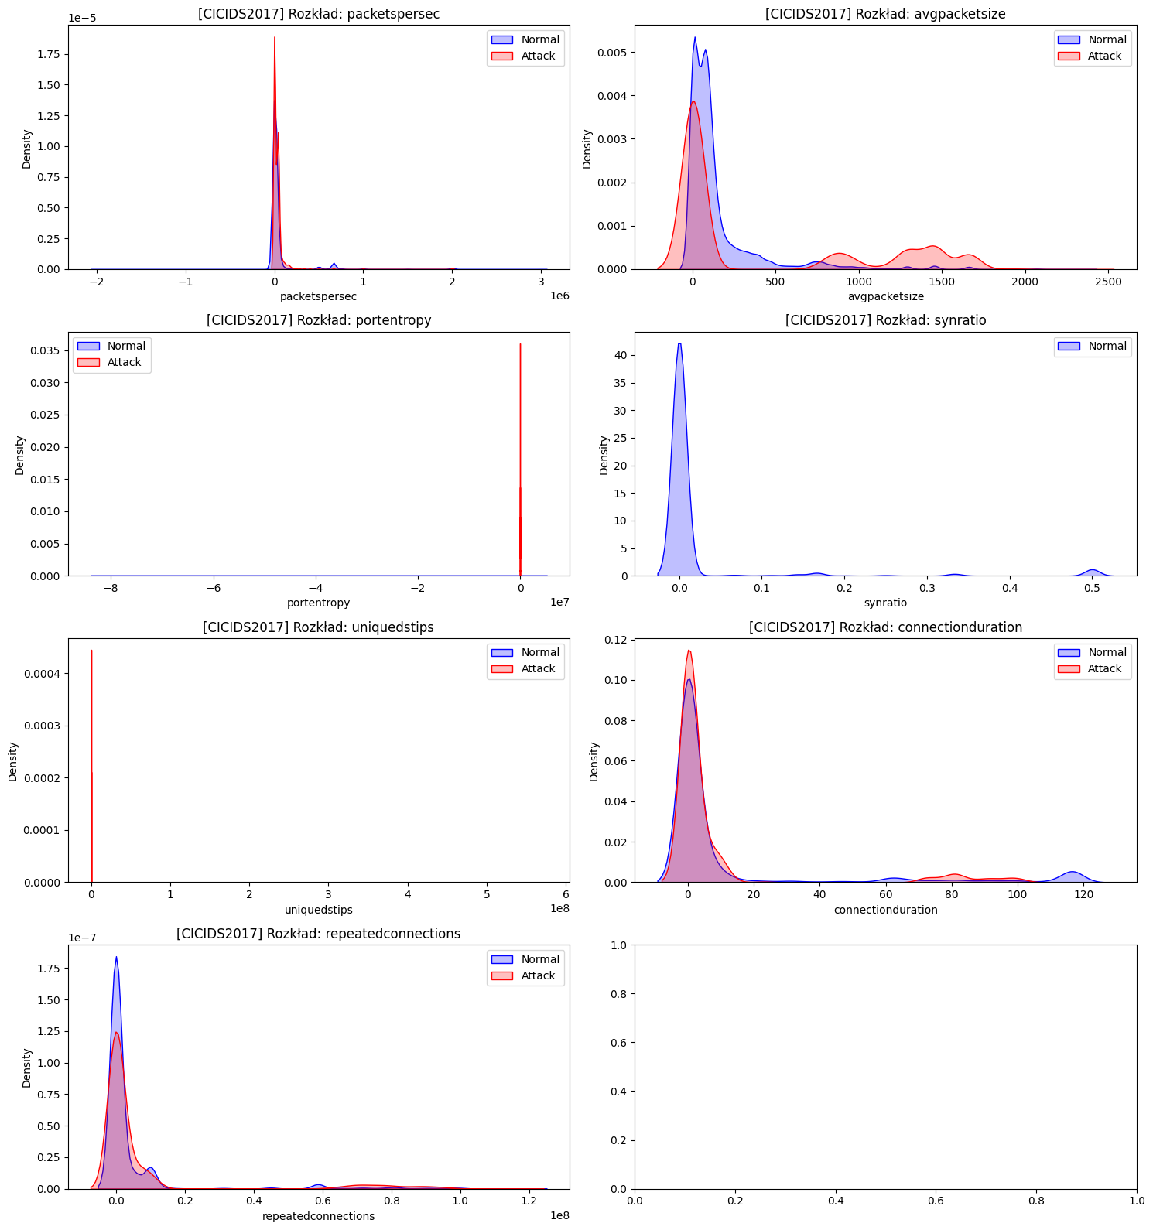
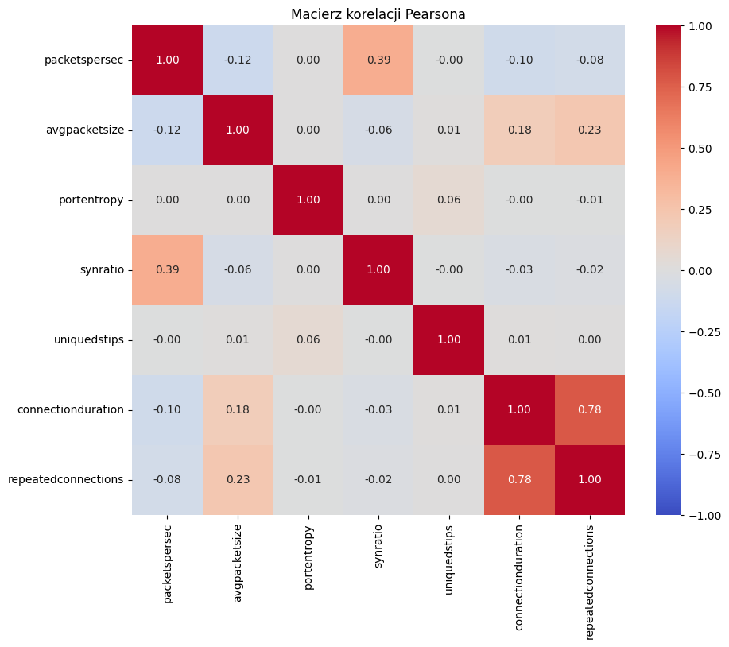

# Cell 5: Podział na Train/Val/Test (60/20/20)
X_train_val, X_test_raw, y_train_val, y_test = train_test_split(X_df.values, y.values, test_size=0.2, stratify=y, random_state=42)
X_train_raw, X_val_raw, y_train, y_val = train_test_split(X_train_val, y_train_val, test_size=0.25, stratify=y_train_val, random_state=42)

# Cell 6: Normalizacja
X_train, X_test, X_val, scaler = normalize_data(X_train_raw, X_test_raw, X_val_raw)

# Cell 7: Trenowanie (Balanced)
print("Trenowanie modelu (Balanced)...")
model = train_model(X_train, y_train, class_weight='balanced')

# Cell 8: Ewaluacja
metrics, y_pred, y_prob = evaluate_model(model, X_test, y_test)
print(f"Accuracy: {metrics['Accuracy']:.4f}")
print(f"Recall: {metrics['Recall']:.4f}")
print(f"AUC: {metrics['AUC']:.4f}")

Accuracy: 0.8534
Recall: 0.9840
AUC: 0.8918

# Cell 9: Wizualizacja
plot_confusion_matrix(y_test, y_pred)
plot_roc_curve(metrics)
plot_betas(model, feature_names)

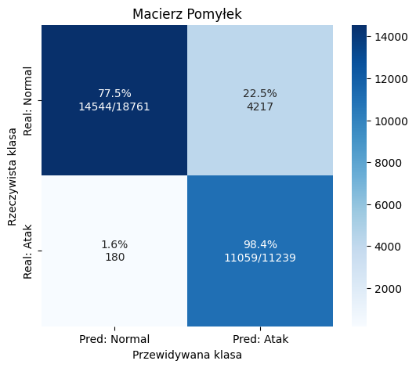
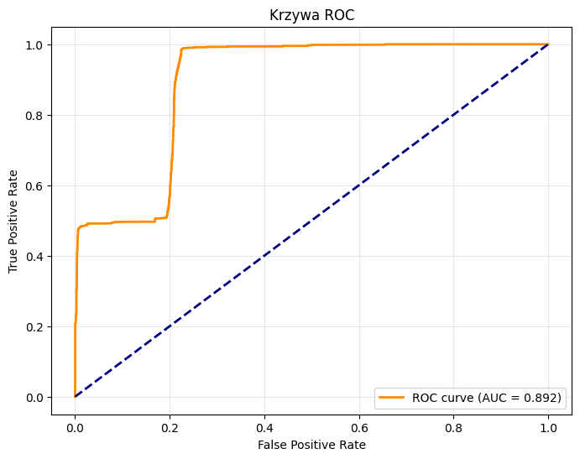
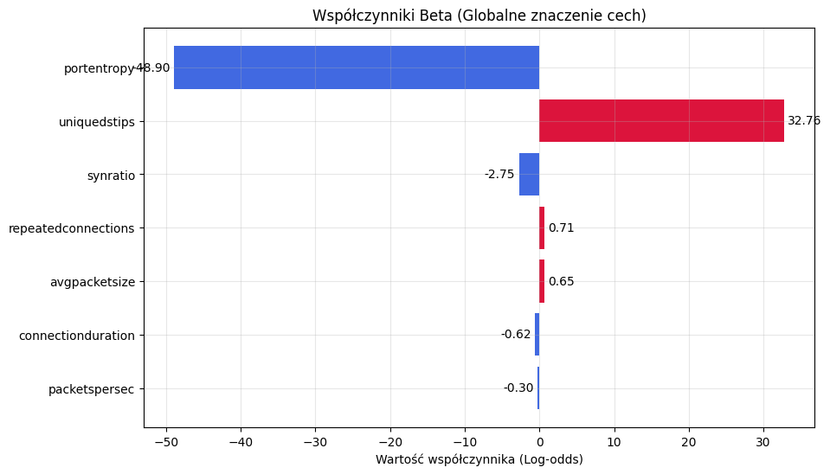

# Cell 9b: Generowanie i rysowanie krzywej uczenia
from sklearn.linear_model import LogisticRegression
from sklearn.metrics import accuracy_score

train_sizes_pct = [0.1, 0.25, 0.5, 0.75, 1.0]
train_scores = []
val_scores = []
train_sizes_abs = []

print("Generowanie krzywej uczenia...")
for pct in train_sizes_pct:
# Bierzemy podzbiór danych treningowych
n_samples = int(pct * len(X_train))
train_sizes_abs.append(n_samples)

X_sub = X_train[:n_samples]
y_sub = y_train[:n_samples]

# Trenujemy tymczasowy model
model_temp = LogisticRegression(class_weight='balanced', max_iter=1000, random_state=42)
model_temp.fit(X_sub, y_sub)

# Zapisujemy wyniki
train_scores.append(accuracy_score(y_sub, model_temp.predict(X_sub)))
val_scores.append(accuracy_score(y_val, model_temp.predict(X_val)))

plot_learning_curve_manual(train_sizes_abs, train_scores, val_scores)

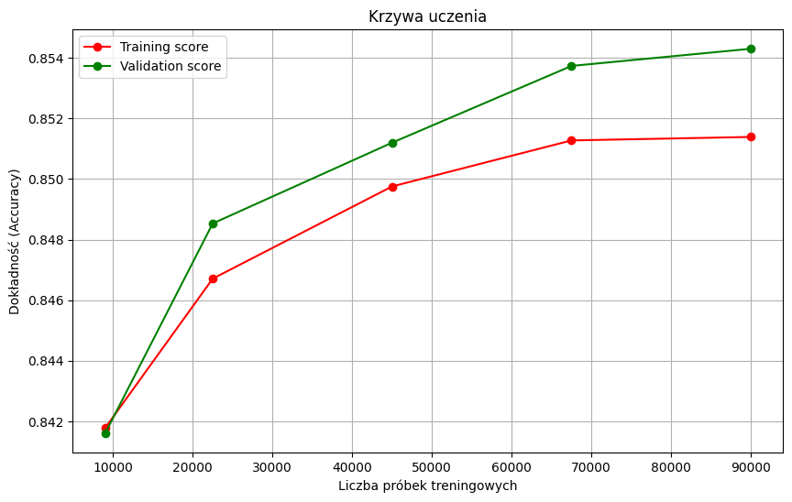
# Cell 10: Analiza Błędów
fn_samples, fp_samples, _, _ = analyze_errors_task3(X_test_raw, y_test, y_pred, y_prob, feature_names)

print("\nPrzykładowe False Negatives (Atak uznany za normę):")
display(fn_samples.head())

print("\nPrzykładowe False Positives (Norma uznana za atak):")
display(fp_samples.head())

Przykładowe False Negatives (Atak uznany za normę):
 | packetspersec | avgpacketsize | portentropy | synratio | uniquedstips | connectionduration | repeatedconnections
68 | 250000.000000 | 3.000000 | 20.0 | 0.0 | 6.0 | 0.000008 | 0.0
345 | 200000.000000 | 5.000000 | 20.0 | 0.0 | 6.0 | 0.000010 | 0.0
366 | 19.655075 | 1290.333333 | 200.0 | 0.0 | 11595.0 | 0.457897 | 456311.0
475 | 250000.000000 | 5.000000 | 20.0 | 0.0 | 6.0 | 0.000008 | 0.0
584 | 333333.333300 | 3.000000 | 20.0 | 0.0 | 6.0 | 0.000006 | 0.0

Przykładowe False Positives (Norma uznana za atak):
 | packetspersec | avgpacketsize | portentropy | synratio | uniquedstips | connectionduration | repeatedconnections
0 | 86956.521739 | 9.0 | 20.0 | 0.0 | 6.0 | 0.000023 | 0.0
2 | 18691.588790 | 9.0 | 20.0 | 0.0 | 6.0 | 0.000107 | 0.0
8 | 42553.191489 | 9.0 | 20.0 | 0.0 | 6.0 | 0.000047 | 0.0
19 | 26315.789474 | 9.0 | 20.0 | 0.0 | 6.0 | 0.000076 | 0.0
24 | 666666.666667 | 9.0 | 0.0 | 0.0 | 0.0 | 0.000003 | 3.0

