In this essay I will undertake three investigations to challenge the validity of Relative Purchasing Power Parity (RPPP). RPPP extends the idea of Purchasing Power Parity to national economies and looks to account for the influences of exchange rates and inflation rate differentials.

If RPPP holds then for some time period *Δt* the following equilibrium between exchange rates and inflation is observed:

*ΔS = πh - πf*

*S* = Spot exchange rate

*πh*= Inflation rate in home country

*πf* = Inflation rate in foreign currency

I have gathered historic Consumer Price Index (CPI) and spot exchange rate data from (OECD,2020) and will investigate the validity of RPPP under various economic situations. To help quantify RPPP I will be using the notion of an RPPP score, this is calculated by re-arranging our first equation as follows:

*RPPP score* = *ΔS - (πh - πf)*

This will be extended into the following form:

*RPPP score = (log(St) - log(St-1 )) \* 100 - ((log(Ph,t) - log(Ph,t-1)) - (log(Pf,t) - log(Pf,t-1))) \* 100*

*Ph,t* = Price in home country at time *t*

*Pf,t-1* = Price in foreign country at time *t-1*

RPPP score will be used in conjunction with statistical analysis and is primarily used to aid visualisation, conceptually a score of 0 would be a perfect RPPP equilibrium.

For the purposes of our investigations the home country will always be the USA, therefore the home currency is the US dollar and exchange rates are direct quotations. Both the CPI and spot rate data are annual averages and *Δt* is one year (Hazell,2020).

Investigation 1: RPPP for the USD against Exchange Arrangement Currencies

Exchange arrangement currencies such as the East Caribbean Dollar, the CFA Franc and the Euro present a conceptual barrier to the validity of RPPP. The issue comes from the fact that one exchange rate is used for comparison against several countries, each with their own inflation rates.

There are many influences upon the inflation rate some of which, such as money supply and base interest rates, are directly controlled by the central bank and will apply universally to all countries within the currency. However, there are some influences such as government policy and cultural differences that could lead to some inter-country variations in inflation.

Figure 1 shows the RPPP scores when *ΔS* = USD/EUR and *πf* is France or Germany.

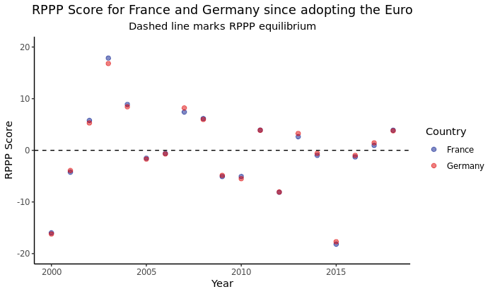

Figure 1

The above figure raises two interesting points. Firstly the RPPP scores of France and Germany mirror each other very closely suggesting our initial concerns around domestic factors creating divergence in RPPP do not appear to hold, at least not in this particular case.

The second point is around the scattering of RPPP scores and the fact that in only a handful of years the value comes close to the equilibrium score of 0. However, this dispersion should not be immediately taken as a failure of RPPP as to some degree it is the result of the scaling of our axis.

In order to determine if a statistically significant difference exists between our computed values of *ΔS* and (*πh - πf*) I ran a two tailed t-test where our hypotheses are:

H0 : µ *ΔS* = µ(*πh - πf*)

H1 : µ *ΔS* ≠ µ(*πh - πf*)

This results in p-values of 0.9242 when *πf* is France and 0.9329 when *πf* is Germany.

This tells us that we cannot declare a statistically significant difference between *ΔS* and (*πh - πf*).

Whilst this does not directly imply equivalence between the two sets of values it does offer some reinforcement to the theory that RPPP is operating at a macroeconomic level.

Investigation 2: RPPP for the USD against a pegged foreign currency

According to the IMF there are 63 countries that engage in pegging (IMF,2013), namely deliberately acting to maintain specific exchange rates with a target foreign currency. This presents an interesting challenge to RPPP.

If we presume that the attempts at pegging prove successful then *ΔS* is held very low, theoretically zero, then if RPPP is to be held the inflation rates differential must also be approximately zero.

Counter to this argument is the fact that the exchange rate pegging can involve creating new money and discouraging imports, a combination which could lead to increased inflation in the currency being supressed.

Figure 2 plots RPPP scores when *ΔS* = USD/CHY and *πf* is China.

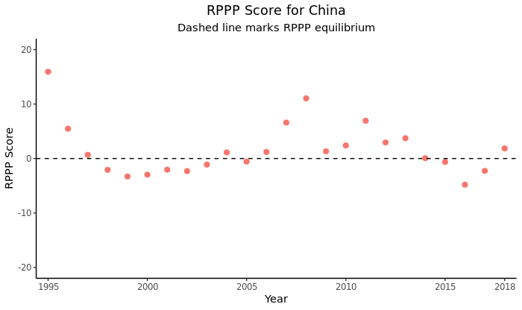

Figure 2

This presents some interesting contrasts to Figure 1, the range of values is smaller with many results having an RPPP score of 0±5 and some notable outliers that align with the 2008 financial crisis and China’s high inflation of the mid 1990’s.

Repeating our t-test when *πf* is China results in a p-value of 0.0679, once again outside of the generally accepted 95% confidence interval and illustrating that we cannot declare *ΔS* and (*πh - πf*) to be statistically different.

Once again this presents no challenge to the validity of RPPP.

Investigation 3: RPPP for the USD against freely floating currency

Finally I will investigate the validity of RPPP for the USD against the freely floating British Pound Sterling. This data set covers the entirety of the post Bretton-Woods era and the trade arrangements present between the two countries present no notable barriers to RPPP.

Figure 3 plots RPPP scores when *ΔS* = USD/GBP and *πf* is the United Kingdom.

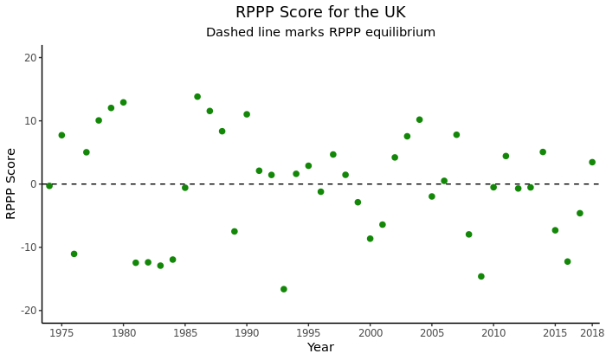

Figure 3

Interestingly the dispersion and range of the results is similar to Figure 1, with the Euro also being a freely floating currency. Furthermore during this time period Britain’s international trade arrangements were heavily influenced by its membership in the European Union.

Repeating our t-test when *πf* is the United Kingdom results in a p-value of 0.9308, this leads us to conclude that we cannot declare a statistical difference between values of *ΔS* and (*πh - πf*).

Conclusion

In this essay I have attempted to challenge the validity of RPPP by comparing the USA to France, Germany, China and the United Kingdom and looking for statistical difference in computed values for spot rate and exchange rate differentials. None of the three investigations were able to disprove RPPP in this manner and we cannot declare RPPP to be an invalid macroeconomic theory.

References

(OECD,2020) - Organization for Economic Co-operation and Development, Consumer Price Index: All Items for China [CHNCPIALLMINMEI], retrieved from FRED, Federal Reserve Bank of St. Louis; https://fred.stlouisfed.org/series/CHNCPIALLMINMEI, February 25, 2020.

(Hazell, 2020) - A repository for the code written to undertake the analysis can be found at:  
<https://github.com/CptnCrumble/rpp>

(IMF,2013) - *Annual Report on Exchange Arrangements and Exchange Restrictions 2013.*

https://www.imf.org/external/pubs/nft/2013/areaers/ar2013.pdf