Machine Learning-Driven Discovery of Thermoset Shape Memory Polymers with High Glass Transition Temperature Using Variational Autoencoders
Amir Teimouri, Guoqiang Li*
Department of Mechanical & Industrial Engineering, Louisiana State University, Baton Rouge, Louisiana 70803, United States
*Corresponding author. Tel.: 001-225-578-5302; E-mail: lguoqi1@lsu.edu.

Supporting Information

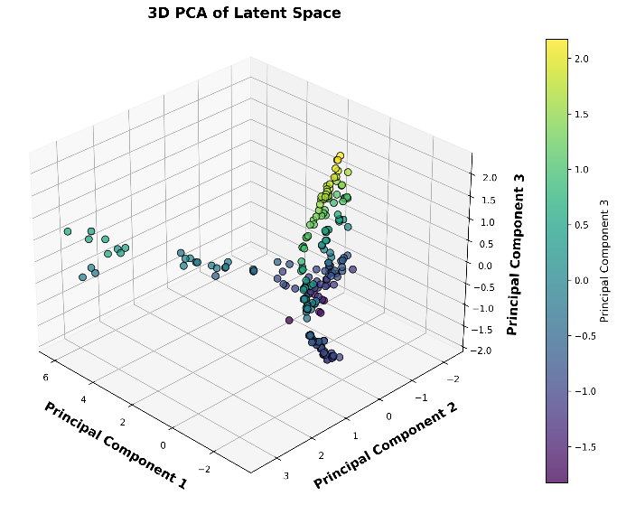  (a) | 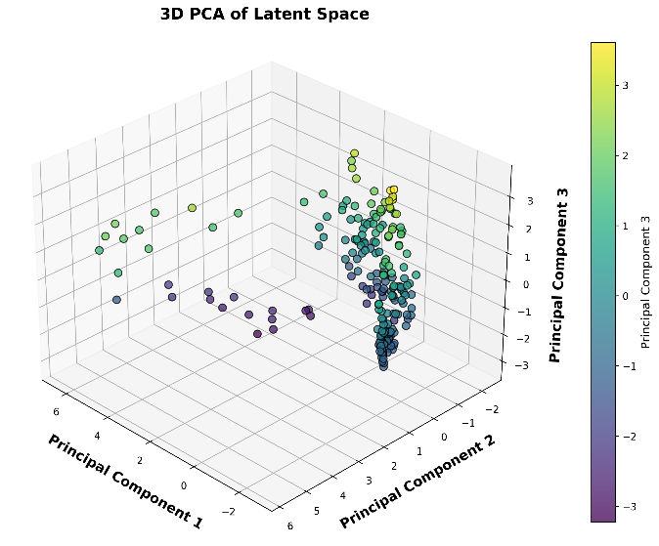  (b)
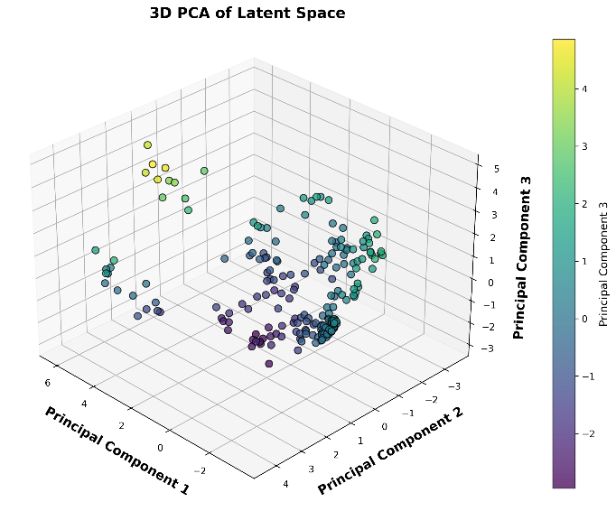  (c) | 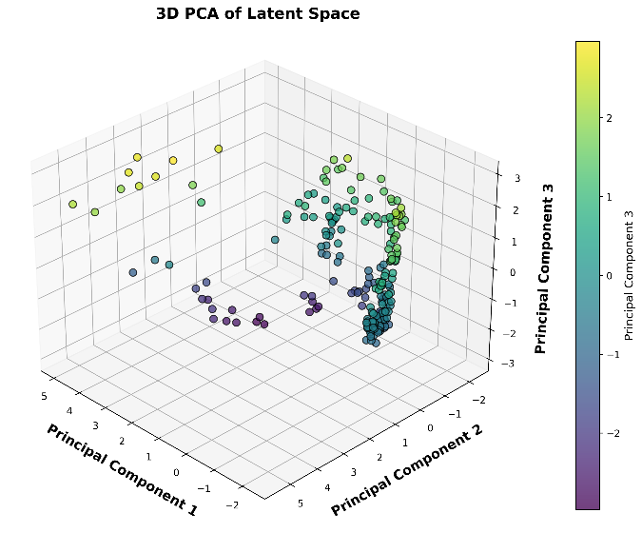  (d)
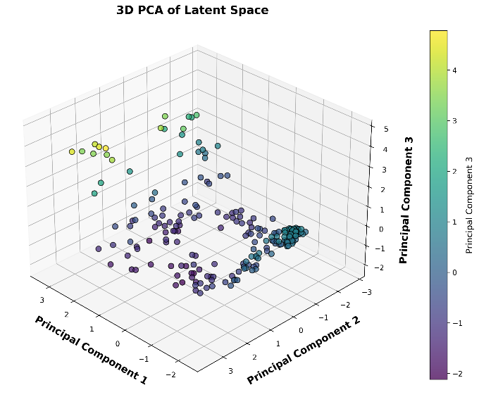  (e) | 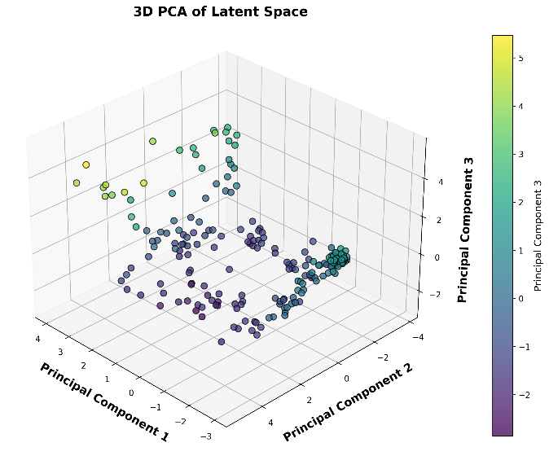  (f)
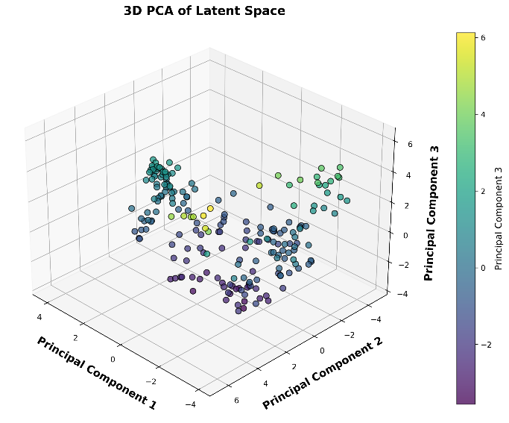
(g)
Figure S1. The PCA mapping for the VAE models with different latent sizes a) 16, b) 32, c) 64, d) 128, e) 256, f) 512, g) 1024.

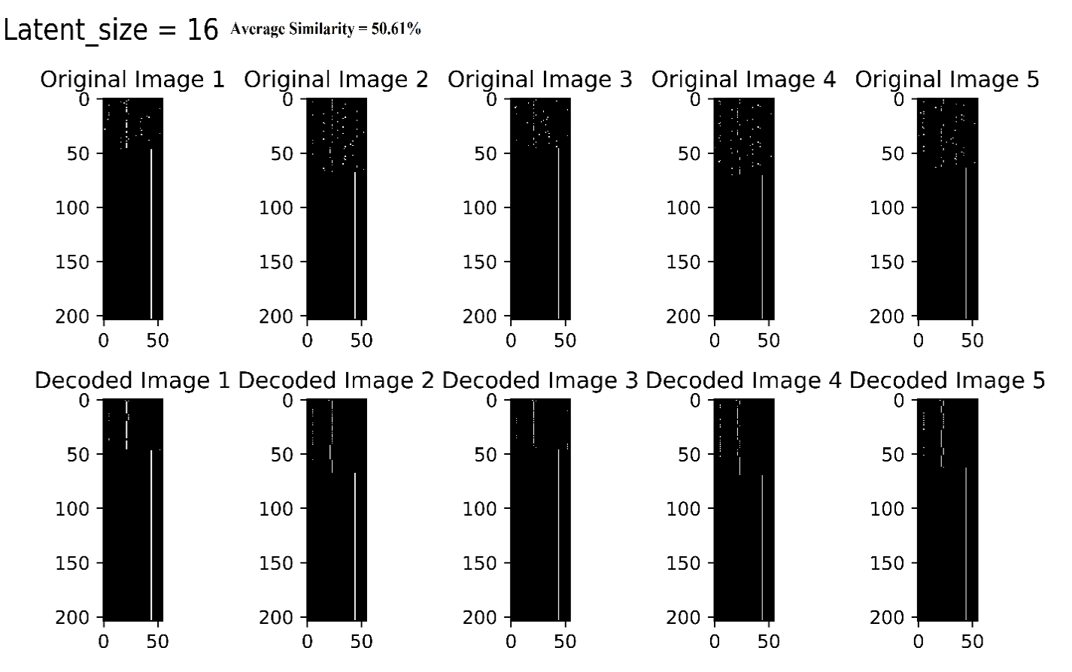  Latent Size = 16 | 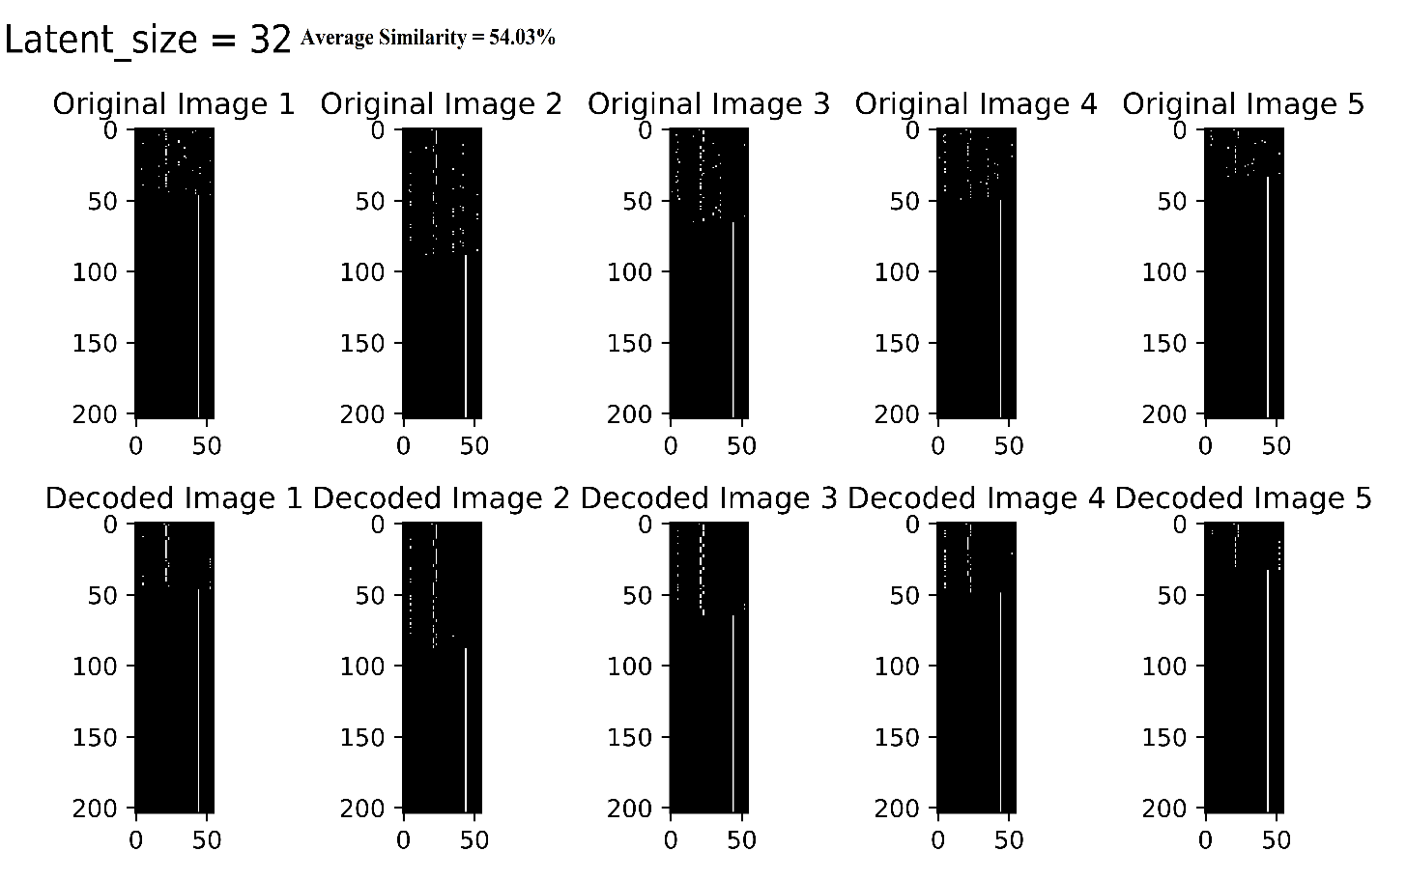  Latent Size = 32 | 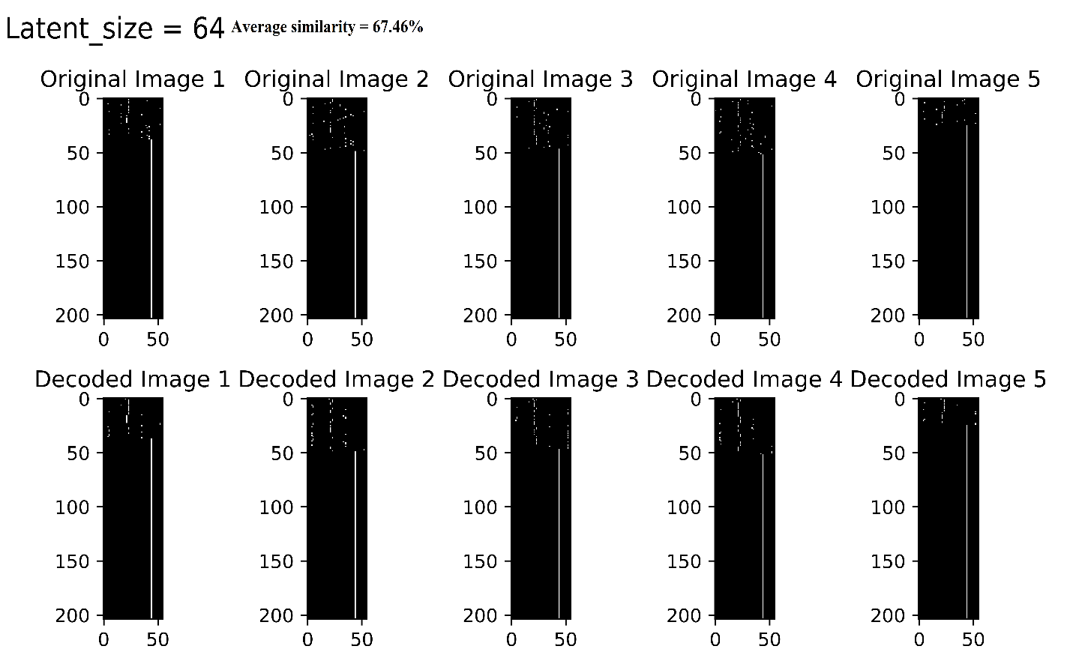  Latent Size = 64 |  | 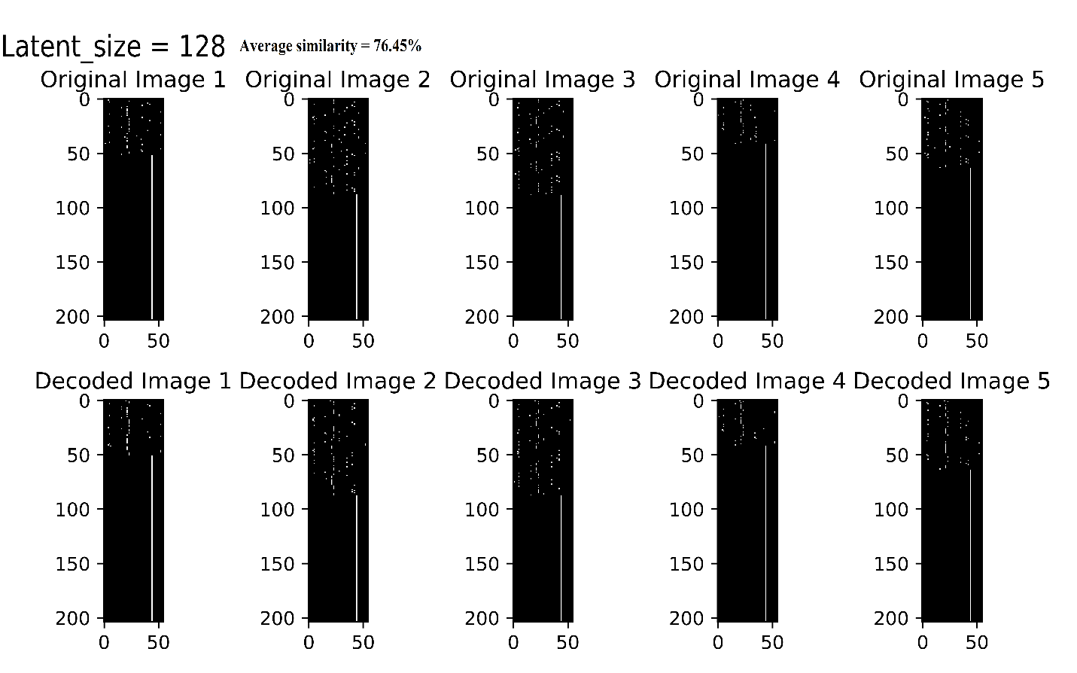  Latent Size = 128
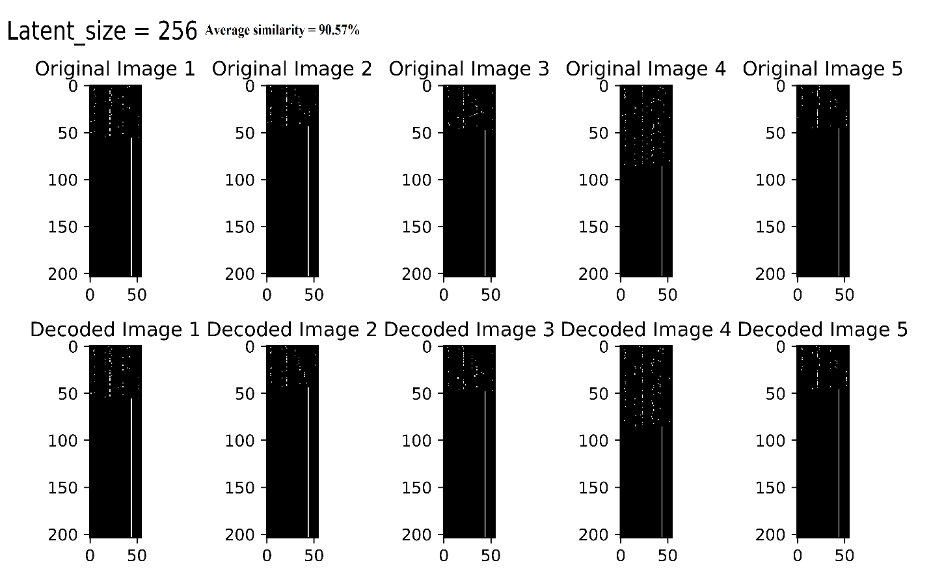  Latent Size = 256 | 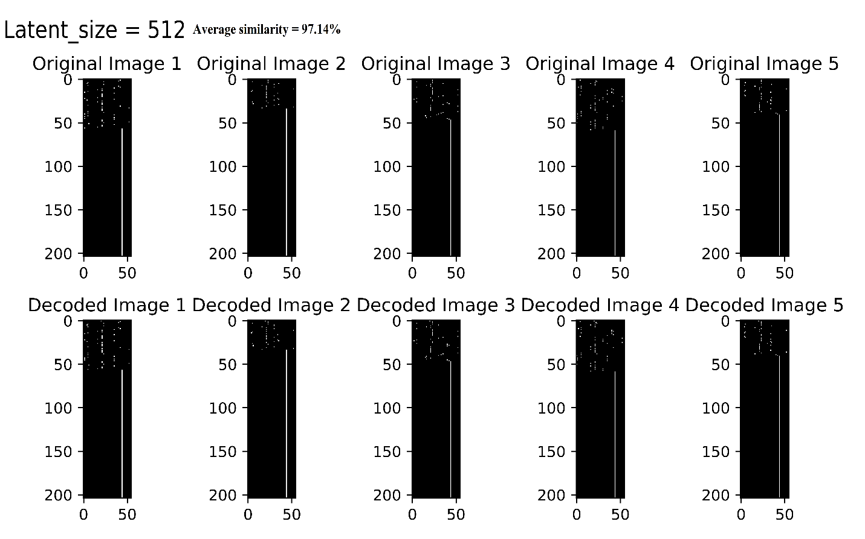  Latent Size = 512 |  | 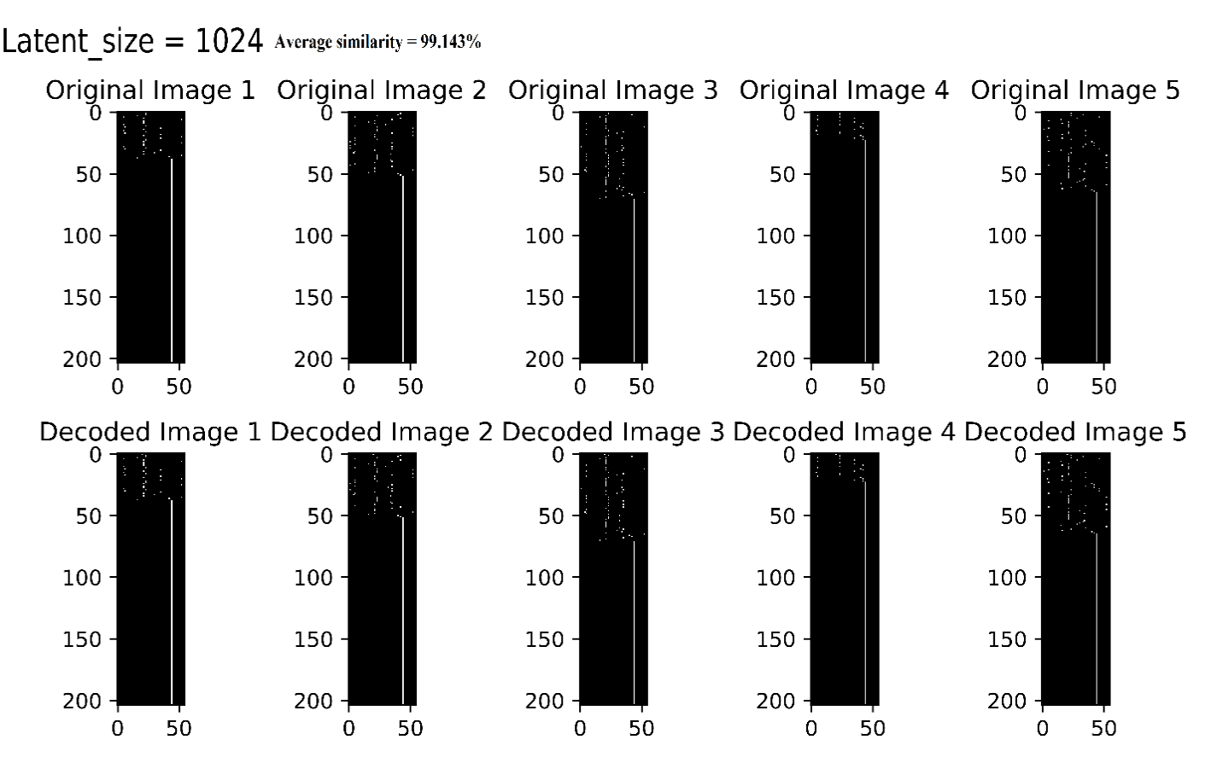  Latent Size = 1024
Figure S2. The input and decoded binary matrix of the pre-trained VAE models with various latent sizes.

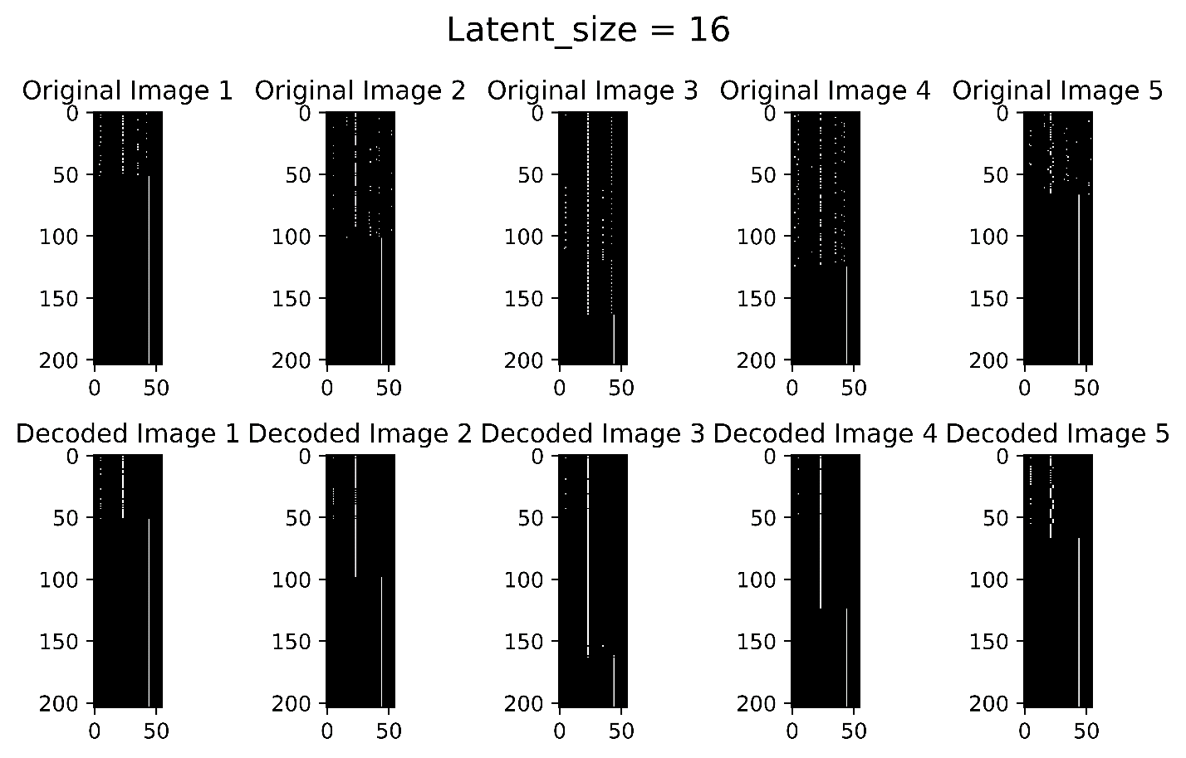  Latent Size = 16 | 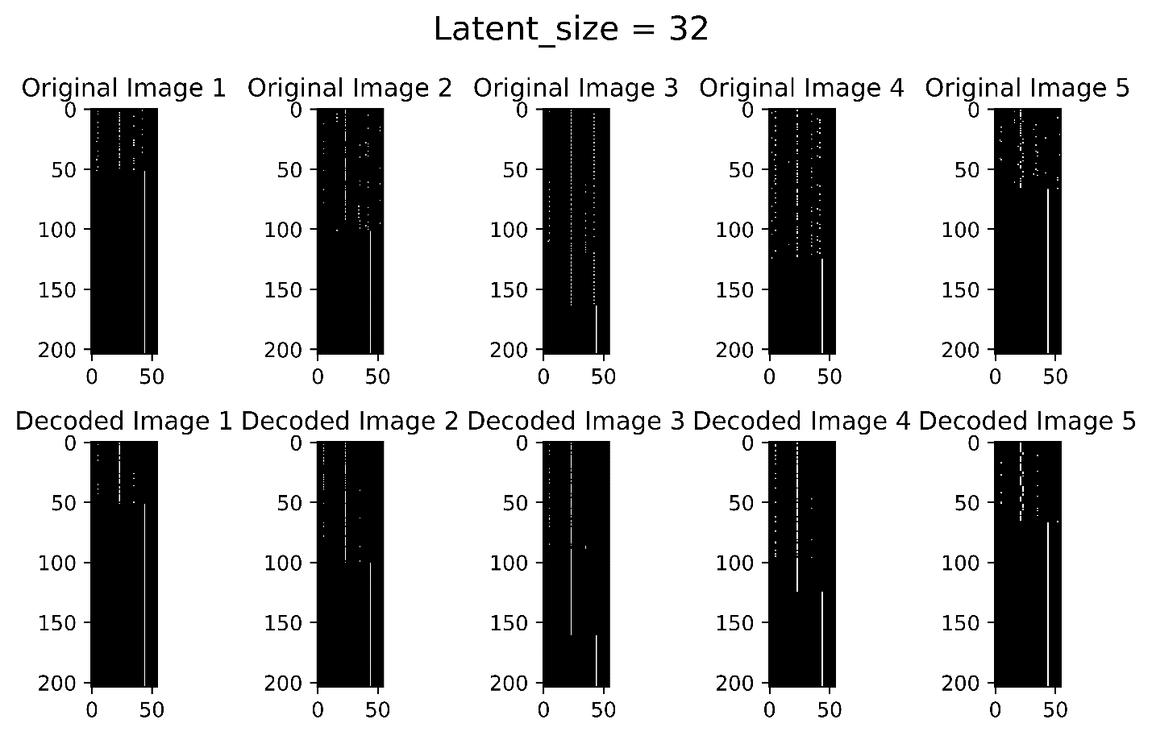  Latent Size = 32 | 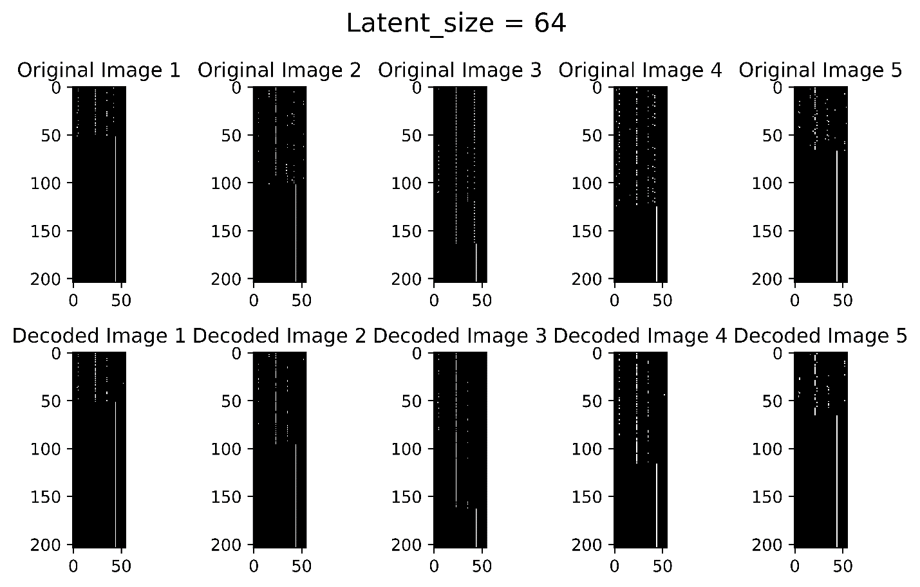  Latent Size = 64 |  | 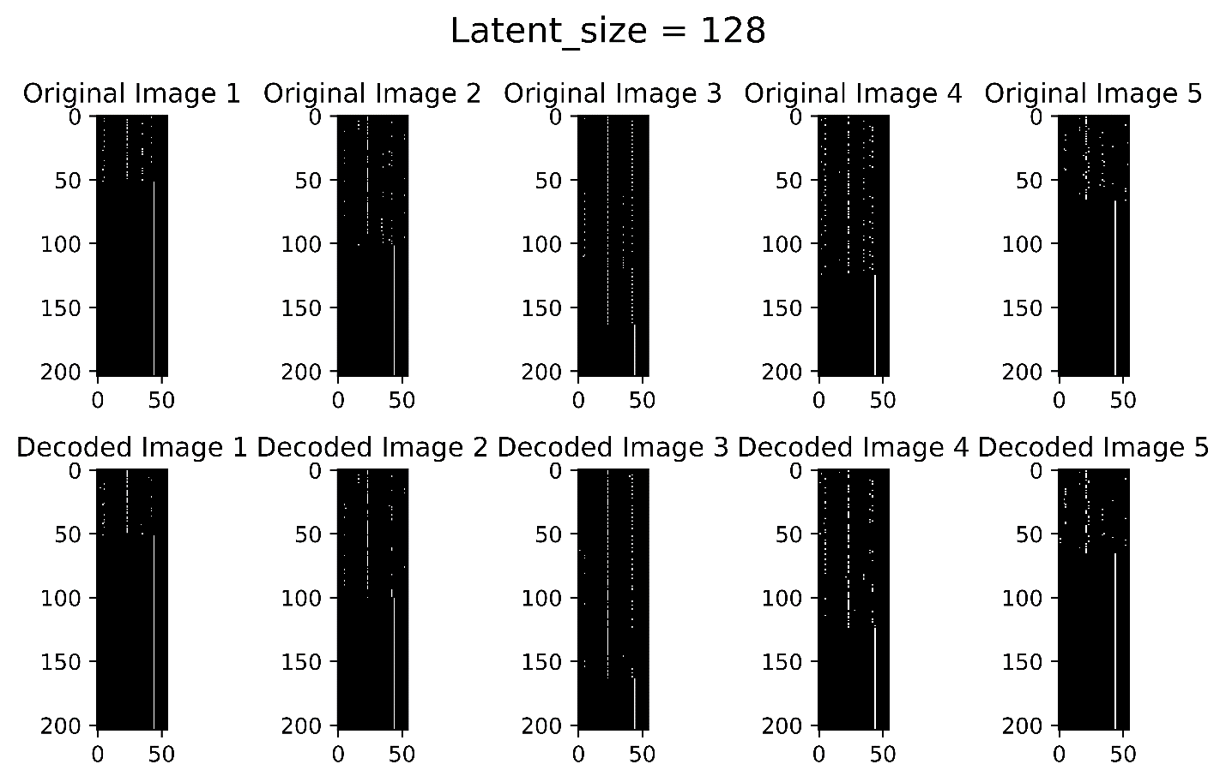  Latent Size = 128
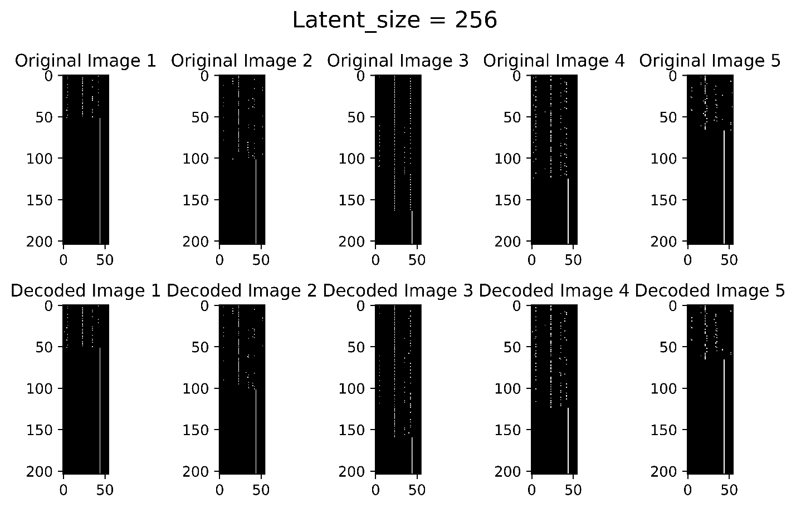  Latent Size = 256 | 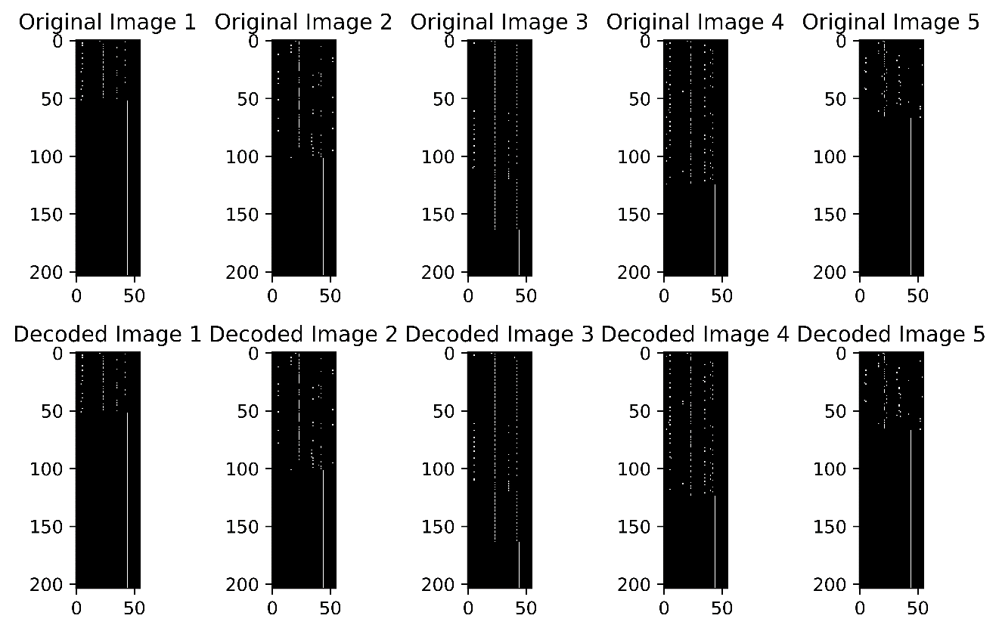  Latent Size = 512 |  | 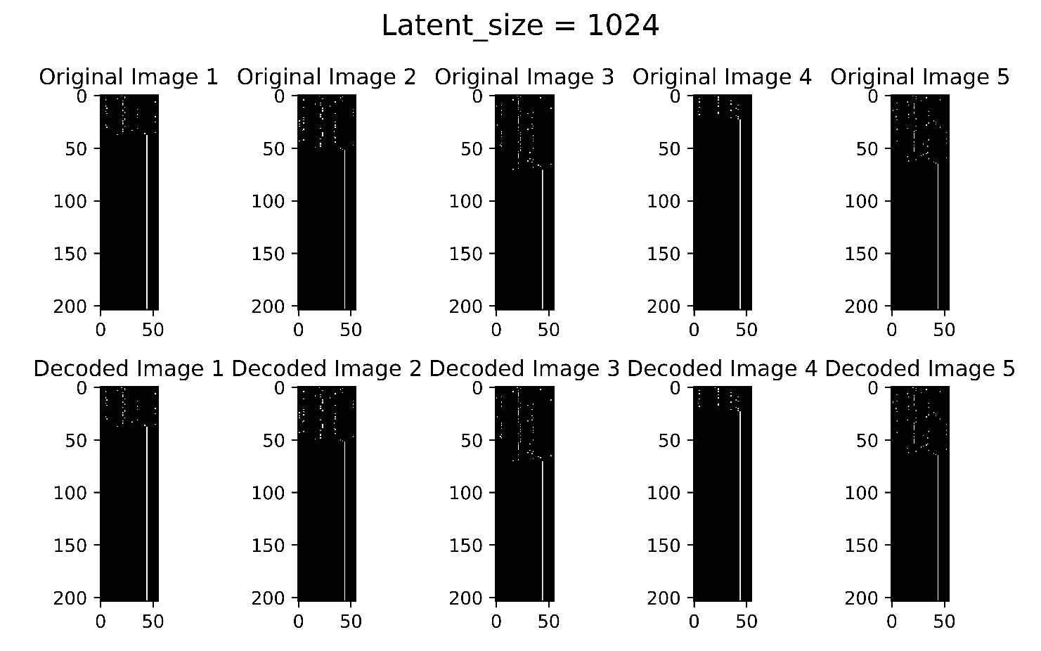  Latent Size = 1024
Figure S3. The input and decoded binary matrix of the fine-tuned VAE models with various latent sizes.

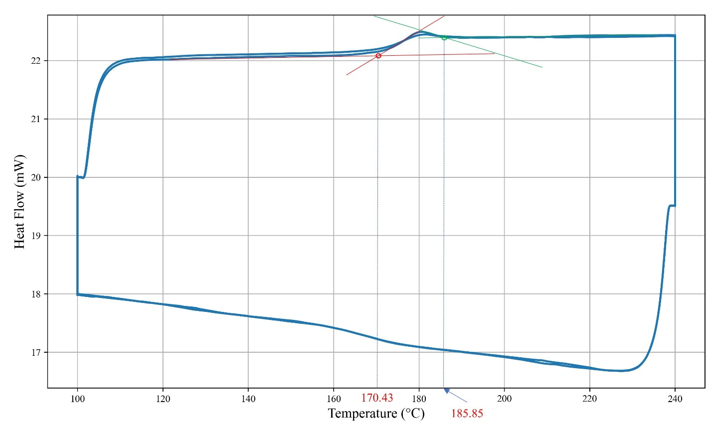
(a)
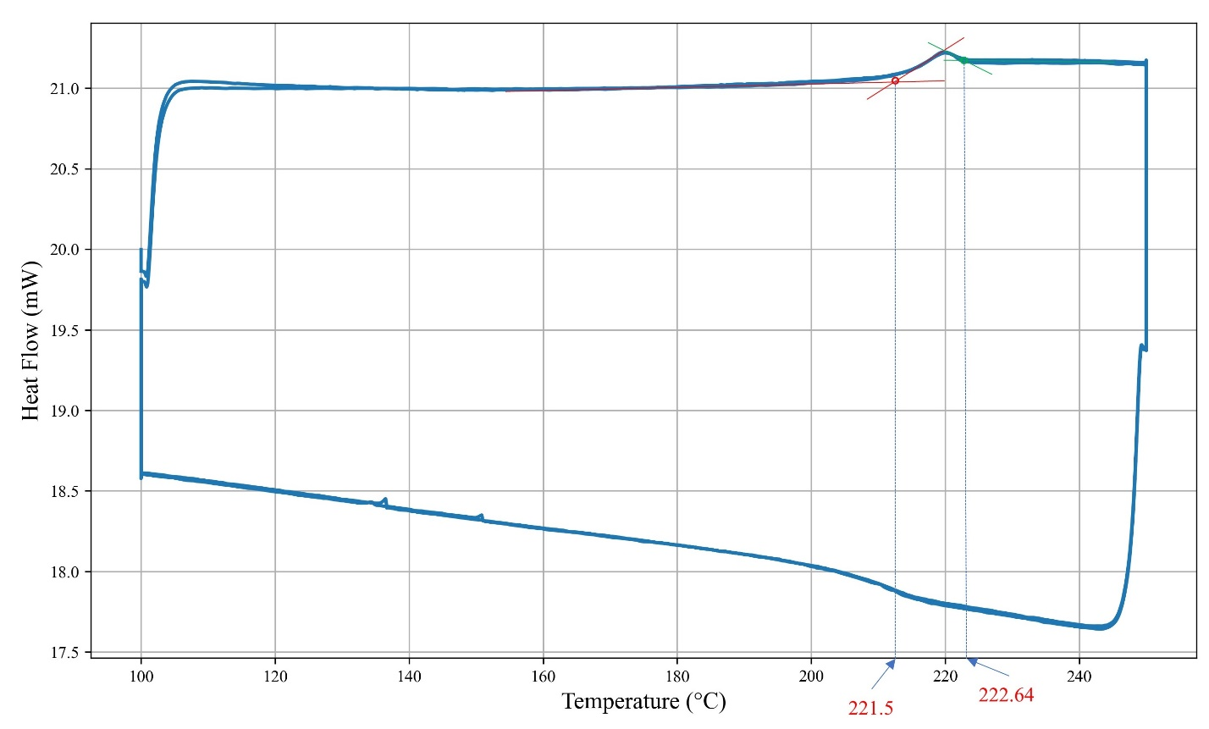
(b)
Figure S4. DSC curves of the sample. SMP with monomer ratios (a) 45%/55%, and b) 50%/50% (The Tg has been reported as the average of the onset and peak temperatures.)

Table S1 Hyperparameters of the CNN Model for SMP Property Prediction
Hyperparameters | Values or items
Batch Size | 16
Learning rate | 0.00001
Optimizer | Adam
Convolutional Layers | - Conv1 | In: 1, Out: 256, Kernel: 3
 | - Conv2 | In: 256, Out: 128, Kernel: 3
 | - Conv3 | In: 128, Out: 64, Kernel: 3
Fully Layers | - FC1 | In: 64, Out: 256
 | - FC2 | In: 256, Out: 64
 | - FC3 | In: 64, Out: 64
 | - FC4 | In: 64, Out: 64
 | - FC5 | In: 64, Out: 32
 | - FC6 | In: 32, Out: 32
 | - FC7 | In: 32, Out: 32
 | - FC8 | In: 32, Out: 1
Activation Function | ReLU
Weight Decay | 1e-3

Table S2 Hyperparameters of the SVR Model for SMP Property Prediction
Hyperparameters | Values or items
C (Penalty Parameter) | 1000
Kernel | RBF (Radial Basis Function)
Epsilon | 1.0

Table S3 The accuracy of ML models combined with CNN and different VAEs.
ML method | PCP Training dataset (%) | PCP test dataset (%) | MAPE Training dataset (%) | MAPE Test dataset (%) | R2 Training | R2 Test
VAE (16) + CNN | 67.53 | 43.10 | 12.65 | 21.65 | 0.97 | 0.85
VAE (32) + CNN | 84.41 | 70.69 | 9.14 | 14.40 | 0.98 | 0.94
VAE (64) + CNN | 87.01 | 51.72 | 7.07 | 16.76 | 0.99 | 0.60
VAE (128) + CNN | 88.74 | 50.00 | 7.39 | 18.37 | 0.99 | 0.64
VAE (256) + CNN | 91.77 | 58.62 | 5.49 | 16.04 | 0.99 | 0.89
VAE (512) + CNN | 93.51 | 53.45 | 4.98 | 20.02 | 0.99 | 0.65
VAE (1024) + CNN | 91.34 | 34.48 | 6.31 | 21.93 | 0.99 | 0.56

Table S4 The accuracy of ML models combined with RF and different VAEs.
ML method | PCP Training dataset | PCP test dataset | MAPE Training dataset | MAPE Test dataset | R2 Training | R2 Test
VAE (16) + RF | 84.71 | 67.44 | 7.07 | 12.81 | 0.96 | 0.55
VAE (32) + RF | 86.36 | 74.42 | 7.63 | 10.59 | 0.96 | 0.77
VAE (64) + RF | 86.78 | 65.12 | 6.97 | 12.48 | 0.97 | 0.69
VAE (128) + RF | 86.77 | 62.79 | 6.87 | 12.57 | 0.97 | 0.81
VAE (256) + RF | 85.95 | 62.79 | 7.83 | 13.68 | 0.97 | 0.73
VAE (512) + RF | 87.60 | 67.44 | 8.26 | 13.53 | 0.96 | 0.82
VAE (1024) + RF | 82.23 | 58.14 | 8.56 | 15.86 | 0.96 | 0.75

Algorithm 1: Training a VAE for SMILES Generation

Input:
Number of epochs (E)=20, Model (M), Optimizer (O)= Adam, Device (D), Training loader (T), Reconstruction weight (w_r)=1.0, Validity weight (w_v)=0.1, Latent Size (L).

Output:
Trained VAE model and loss logs

Steps:
1. **Initialize**:
- Load the training data and model (M).
- Set hyperparameters (w_r, w_v, E, L).
2. **Training Loop**:
- For (e = 1) to (E) do:
1. Set (M) to training mode.
2. For each batch in (T):
- Move features to device (D).
- Perform forward pass:
- Encode features to latent space: (z_{mean}, z_{log_var}).
- Decode latent representation into outputs.
- Compute reconstruction loss:
- Reshape decoded outputs and original features.
- Use categorical cross-entropy to calculate reconstruction loss.
- Compute validity penalty:
- Evaluate the validity of decoded SMILES.
- $Validity Penalty =\frac{invalid SMILES count}{batch size}.w_v$
- Calculate total loss:
- $Loss = w_r . Reconstruction Loss + Validity Penalty$
- Perform backpropagation and update (M) using (O).
3. **Save Model**:
- Save trained model weights.

Algorithm 2: Transfer Learning with VAE for SMILES Generation

Input:
Pretrained VAE model (M_p), New SMILES dataset (S_n), Latent size (L), Number of epochs (E) = 20, Device (D), Reconstruction weight (w_r)=1.0, Validity weight (w_v)=0.1.

Output:
Fine-tuned VAE model (M_f), Performance metrics

Steps:
1. **Initialize**:
- Load the pretrained model (M_p).
- Load the new SMILES dataset (S_n) from an external file.
2. **Prepare the Model**:
- Freeze the encoder weights in (M_p).
- Define a new optimizer for the decoder parameters in (M_p).
- Set the model to evaluation mode for encoder layers and training mode for decoder layers.
3. **Fine-Tune the Model**:
- For (e = 1) to (E) do:
1. Pass training batches through the encoder (frozen) to compute latent space representations.
2. Train the decoder layers to reconstruct SMILES from latent vectors.
3. Compute losses:
- Reconstruction loss: Cross-entropy between original and decoded SMILES.
- Evaluate the validity of decoded SMILES.
- $Validity Penalty =\frac{invalid SMILES count}{batch size}.w_v$
- $Loss = w_r . Reconstruction Loss + Validity Penalty$
4. Backpropagate and update decoder parameters using the optimizer.
4. **Save the Fine-Tuned Model**:
- Save (M_f) (fine-tuned VAE).

Algorithm 3: ML models for Glass Transition Prediction

Input:
SMILES dataset (S), Glass transition temperature data (T_{g}), Latent size (L), Random seed (R_s), Device (D), Learning parameters for ML models (CNN, SVR, and RF).

Output:
Trained ML models, and performance metrics (Train/Test R² Scores).

Steps:
1. **Data Preprocessing**:
- Load the SMILES dataset and associated glass transition temperatures (T_{g}).
2. **Prepare VAE Encoding**:
- Load the finetuned VAE model.
3. **Generate Latent Representations**:
- Convert each SMILES string into a one-hot encoded tensor.
- Compute the latent representation for each SMILES string using the VAE.
- Combine latent representations of SMILES strings based on their ratios to form a single vector per TSMP.
4. **Normalize Data**:
- Normalize the latent representations and (T_{g}) values using min-max scaling.
5. **Train ML Model**:
- Split the latent vectors and (T_{g}) data into training and testing sets.
- Train various ML models (CNN, SVR, and RF)
- Evaluate the model on training and testing sets to calculate R² scores.
6. **Output Results**:
- Save the trained models and scaling parameters for future use.

Algorithm 4: Generating SMPs with User-defined T_{g}

Input:
- SMILES dataset (S)
- Functional group mappings
- Pre-trained VAE model
- ML models and scaling parameters
- Target glass transition temperature range (T_{g}_target: 190-200°C)
- Molar ratio increments (0.05 steps)

Output:
- Selected SMP combinations with molar ratios and predicted T_{g}

Steps:
- Load SMILES dataset.
- Categorize SMILES strings based on functional groups.
- Define reasonable combinations of functional groups for SMP generation.
- Generate all possible SMP combinations using the pre-defined functional group mappings.
- For each SMP combination, calculate latent vectors using the VAE model:
- Vectorize SMILES strings and encode them into latent space.
- Combine latent vectors using molar ratios to form SMP representations.
- Normalize the latent vectors using pre-saved scaling parameters.
- Predict the glass transition temperature (T_{g}) for each SMP using the ML models.
- Filter SMPs with T_{g} values within the target range (190-200°C).
- Save selected SMPs along with their molar ratios and predicted T_{g}.

