TENSOR GPU

<http://www.heatonresearch.com/2017/01/01/tensorflow-windows-gpu.html>

<https://nitishmutha.github.io/tensorflow/2017/01/22/TensorFlow-with-gpu-for-windows.html>

Install Cudnn 5.1 not 6

For jupyter

$ source activate tensorflow  
$ sudo pip install ipykernel  
$ python -m ipykernel install --user --name tensorflow --display-name "conda env tensorflow"

PDC

salloc -t 1:00:00 -A edu17.DD2424

sbatch run_cnn.sh

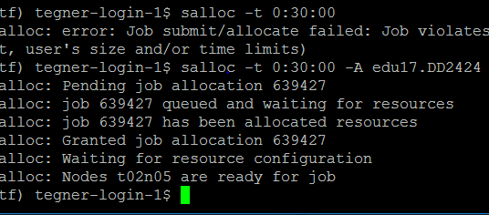

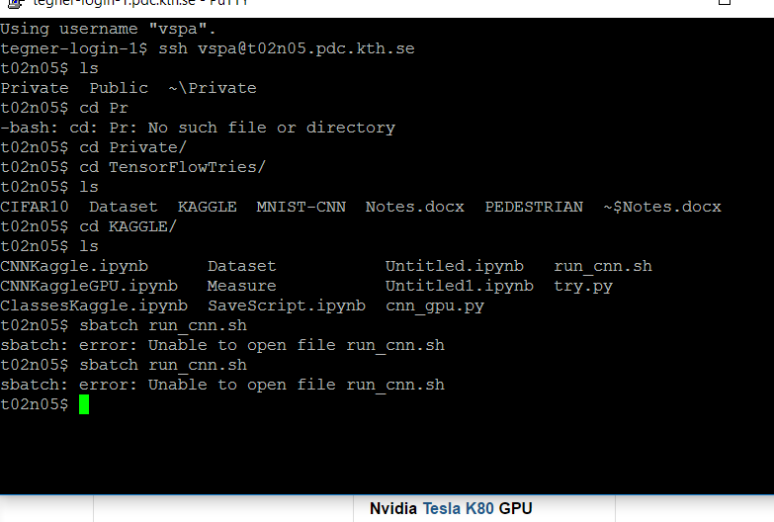

First CNN

Use the architecture <https://www.tensorflow.org/tutorials/deep_cnn>

Example

<https://github.com/aqibsaeed/Human-Activity-Recognition-using-CNN/blob/master/Activity%20Detection.ipynb>

Regression

<https://aqibsaeed.github.io/2016-07-07-TensorflowLR/>

Transfer Learning

<https://kratzert.github.io/2017/02/24/finetuning-alexnet-with-tensorflow.html>

<http://warmspringwinds.github.io/tensorflow/tf-slim/2016/10/30/image-classification-and-segmentation-using-tensorflow-and-tf-slim/>

Saver

<https://nathanbrixius.wordpress.com/2016/05/24/checkpointing-and-reusing-tensorflow-models/>

<https://blog.metaflow.fr/tensorflow-saving-restoring-and-mixing-multiple-models-c4c94d5d7125>

<http://cv-tricks.com/tensorflow-tutorial/save-restore-tensorflow-models-quick-complete-tutorial/>

Stop gradient

http://stackoverflow.com/questions/33727935/how-to-use-stop-gradient-in-tensorflow