A Project Report
on
Complainify
Submitted in partial fulfillment of the requirement of
Project-VI (BIT356CO)
Bachelor in Information Technology
Submitted To

Purbanchal University
Biratnagar, Nepal
Submitted By
Mridul Prakash Shah (360818)
Om Prakash Basnet (360820)
Samir Poudel (360831)
KANTIPUR CITY COLLEGE
Putalisadak, Kathmandu
October, 2026

A Project Report
on
Complainify
Submitted in partial fulfillment of the requirement of
Project-VI (BIT356CO)
Bachelor in Information Technology
Submitted To
Purbanchal University
Biratnagar, Nepal
Submitted By
Mridul Prakash Shah (360818)
Om Prakash Basnet (360820)
Samir Poudel (360831)
Project Supervisor
Er. Maryada Karki
Mr. Santosh Shah
KANTIPUR CITY COLLEGE
Putalisadak, Kathmandu
October, 2026

Abstract
Educational institutions often face difficulties in managing student complaints because traditional methods such as paper forms, emails, or manual records lead to delays, poor organization, and a lack of transparency in the complaint resolution process. To address these issues, this project proposes Complainify, an AI-Based Student Complaint Analysis and Decision Support System that provides a centralized and user-friendly platform for handling student grievances. Through this system, students can submit complaints related to academics, examinations, administration, infrastructure, or faculty issues at any time and from any location. The system uses Artificial Intelligence techniques, including sentiment analysis and automatic text classification, to analyze the complaint content, identify its category, and determine its urgency level. Based on the analysis, complaints are automatically assigned priorities such as High, Medium, or Low and forwarded to the appropriate authorities for faster action. The system also includes an administrative dashboard that provides real-time complaint statistics, tracking facilities, filtering options, and report generation features to support effective decision-making. Additionally, an integrated email notification service keeps students updated about the status of their complaints and alerts administrators when high-priority issues are reported. Developed using the Iterative Waterfall Software Development Life Cycle model and implemented with technologies such as HTML, CSS, JavaScript, Python Flask, MySQL, and machine learning libraries, the proposed system aims to improve efficiency, enhance transparency, and ensure quicker and more effective resolution of student complaints in educational institutions.

Acknowledgement
We’d like to express our heartfelt gratitude to everyone who has encouraged us to work on this project. First and foremost, we’d like to express our gratitude to the entire team of Kantipur City College (KCC) for this chance, especially to the Principal of Kantipur City College, who assisted us in furthering our knowledge in this field.
And we’d like to express our special gratitude to our supervisor, Er. Maryada Karki and Mr. Santosh Shah, who have consistently encouraged, inspired and provided us with a wealth of information that has been beneficial. Their advice was helpful in completing this project. We could not have asked for a better supervisor, counselor, or mentor. This project would not have been possible without the assistance of each member, as well as the entire class, who offered suggestions, shared their experiences, and provided advice throughout the project. We are grateful for this. Finally, we’d like to express our gratitude to our friends and colleagues who supported us directly and indirectly throughout this project.

Declaration
We declare that this project report titled “Complainify” submitted in partial fulfillment of the Bachelor of Information Technology is a record of original work carried out by us under the supervision of Er. Maryada Karki and Mr. Santosh Shah and has not formed the basis for the award of any other degree or Diploma, in this or any other institution or University. In keeping with the ethical practice of reporting scientific information, due acknowledgments have been made wherever the findings of others have been cited.

Mridul Prakash Shah (360818)
Om Prakash Basnet (360820)
Samir Poudel (360831)

Supervisor’s Approval
This is to certify that the project entitled “Complainify” undertaken and demonstrated by Mridul Prakash Shah, Om Prakash Basnet and Samir Poudel has been successfully completed under my supervision as a partial fulfillment of the requirements of the degree of IT 6th semester under Purbanchal University. I, henceforth, approve this project to be awarded the certificate by the concerned authority. During supervision, I found the students hardworking, skilled and ready to undertake any professional work related to this field in future.

Mr. Santosh Shah Er. Maryada Karki
Project Supervisor Project Supervisor
Department of IT Department of IT
Date: Date:

Certificate From Department
Following the Supervisor's Approval and Examiner’s Acceptance, the project entitled “Complainify” submitted by Mridul Prakash Shah, Om Prakash Basnet and Samir Poudel as a partial fulfillment of the requirements for the degree of BIT 6th Semester under Purbanchal University, has been officially awarded by this certificate. I wish the students all the best for their future endeavors.

Mr. Rubim Shrestha Mr. Saroj Pandey
Project Coordinator Head of Department
Department of IT Department of IT
Date: Date:

Table of Contents
Abstract iii
Acknowledgement iv
Declaration v
Supervisor’s Approval vi
Certificate From Department vii
List of Figures xi
List of Tables xii
List of Abbreviations xiii
1 Introduction 1
1.1 Overview: 1
1.2 Problem Statement: 1
1.3 Objectives: 2
1.4 Features: 2
1.5 Significance: 4
1.6 Scope and Limitations 4
1.7 Documentation Organization 5
2 Literature Review 6
2.1 Smart Complaint Management System with AI-Powered Prioritization and Escalation 6
2.1.1 Working Principle 6
2.1.2 Advantages 6
2.1.3 Limitations 7
2.2 Machine Learning-Based Smart Students' Complaint System 7
2.2.1 Working Principle 7
2.2.2 Advantages 7
2.2.3 Limitations 7
2.3 AI-Driven Real-Time Feedback System for Enhanced Student Support 8
2.3.1 Working Principle: 8
2.3.2 Advantages 8
2.3.3 Limitations 8
3 Methodology 9
3.1 System Development Cycle 9
3.2 Tools and Technologies Used 10
3.2.1 Programming Languages and Web Technologies 10
3.2.2 Database Management System 10
3.2.3 Python Libraries 11
3.2.4 Development Tools 11
3.2.5 Dataset Collection & Preprocessing 11
3.2.6 Model Training & Evaluation 12
3.3 Assignment of Roles and Responsibilities 12
4 System Design and Analysis 14
4.1 Requirements Analysis 14
4.1.1 Requirement Gathering 14
4.1.2 Functional Requirements 16
4.2 Feasibility Study 17
4.2.1 Technical Feasibility 17
4.2.2 Operational Feasibility 17
4.2.3 Economic Feasibility 18
4.2.4 Schedule Feasibility 21
5 System Design 23
5.1 System Architecture 23
5.1.1 Architectural Components 23
5.2 Procedure Oriented Diagram 25
5.2.1 Context Diagram (DFD Level 0) 25
5.2.2 Data Flow Diagram (Level 1) 26
5.2.3 Use Case Diagram 27
5.3 Database Design 28
5.3.1 E-R Diagram 28
6 System Development and Implementation 29
6.1 Programming Platforms 29
6.2 Hardware and Software Requirements 29
6.2.1 Hardware Requirements 29
6.2.2 Software Requirements 30
7 Testing and Debugging 31
7.1 Testing Approach 31
7.2 Testing Tools 31
7.3 Test Cases 31
7.3.1 Login Module 32
7.3.2 Sign Up Module 33
7.3.3 Forgot Password / Reset Password Module 34
7.3.4 Complaint Submission Module 35
7.3.5 AI Classification Module 36
7.3.6 Sentiment Analysis Module 36
7.3.7 Complaint Status Tracking Module 37
7.3.8 Admin Dashboard and Filtering Module 38
7.3.9 Email Notification Module 38
7.3.10 Report Generation Module 39
8 Conclusion 40
References 41

List of Figures
Figure 3.1: Iterative Waterfall Model 10
Figure 4.1: Gantt Chart 22
Figure 5.1: System Architecture 23
Figure 5.2: DFD Level 0 25
Figure 5.3: DFD Level 1 26
Figure 5.4: Use Case Diagram 27
Figure 5.5: ER Diagram 28

List of Tables
Table 3.1: Evaluation Metrics 12
Table 3.2: Assignment of Roles and Responsibilities 12
Table 4.1: Requirement Gathering 14
Table 4.2: Functional Requirements 16
Table 4.3: Initial Development Cost 18
Table 4.4: Net Cash Flow Analysis 19
Table 4.5: Calculation of NPV 20
Table 4.6: Summary of Financial Metrics 20
Table 5.1: System Architecture Components 23
Table 7.1: Testing Tools 31
Table 7.2: Login module 32
Table 7.3: Sign Up Module 33
Table 7.4: Forgot Password / Reset Password Module 34
Table 7.5: Complaint Submission Module 35
Table 7.6: AI Classification Module 36
Table 7.7: Sentiment Analysis Module 36
Table 7.8: Complaint Status Tracking Module 37
Table 7.9: Admin Dashboard and Filtering Module 38
Table 7.10: Email Notification Module 38
Table 7.11: Report Generation Module 39

List of Abbreviations
AI : Artificial Intelligence
API : Application Programming Interface
BERT : Bidirectional Encoder Representations from Transformers
CPU : Central Processing Unit
CSS : Cascading Style Sheets
DFD : Data Flow Diagram
ER : Entity Relationship
ERP : Enterprise Resource Planning
HTML : HyperText Markup Language
HTTP : HyperText Transfer Protocol
ID : Identification
IRR : Internal Rate of Return
ML : Machine Learning
MySQL : My Structured Query Language
NCF : Net Cash Flow
NPR : Nepalese Rupee
NPV : Net Present Value
PBP : Payback Period
PDF : Portable Document Format
PHP : Hypertext Preprocessor
RAM : Random Access Memory
SDLC : Software Development Life Cycle
SMTP : Simple Mail Transfer Protocol
SQL : Structured Query Language
XAMPP : Cross-Platform Apache MySQL PHP Perl

1 Introduction

Overview:
Complainify is an AI-Based Student Complaint Analysis and Decision Support System developed to automate the management of student complaints in educational institutions. Traditional complaint handling methods, such as paper forms and manual records, often lead to delayed responses, improper categorization, and a lack of transparency. To overcome these issues, the proposed system provides a centralized web-based platform where students can submit and track complaints efficiently. The system applies concepts from Artificial Intelligence and Data Mining, text classification, and sentiment analysis. When a complaint is submitted, the text is preprocessed and classified into categories such as Academic, Examination, Infrastructure, or Administration using the Naive Bayes Classification Algorithm, which is implemented from scratch in Python due to its simplicity and effectiveness in text classification tasks.
The system also performs sentiment analysis and assigns a priority level (High, Medium, or Low) to support administrators in making timely decisions which are developed from scratch using the collected data for training and testing, without using pre-trained machine learning models. Also, it supports voice-based complaint input which supports only English language. Data mining techniques are used to identify complaint patterns and generate reports, dashboards, and graphical statistics that help authorities understand recurring issues and make data-driven decisions. Additionally, an email notification system is integrated to send complaint acknowledgements, status updates, and alerts for high-priority complaints to both students and administrators. The system is implemented using HTML, CSS, JavaScript, Python Flask, and MySQL, along with supporting libraries such as Pandas.

1.2 Problem Statement:
Most educational institutions still manage student complaints manually through paper forms, emails, or unstructured communication channels. These traditional approaches suffer from several limitations:
- Complaints are not properly categorized.
- Urgent issues are often delayed due to the absence of prioritization mechanisms.
- Administrators lack analytical insights regarding complaint trends.
- Students do not receive timely updates regarding complaint status.
- There is no centralized platform to monitor and manage complaints efficiently.
Therefore, there is a need for an intelligent, automated, and centralized complaint management system that can analyze complaints, determine their priority, notify concerned authorities through email, and assist administrators in making data-driven decisions.

1.3 Objectives:
The main objective of the project is:
- To develop a web-based AI-powered system for automated student complaint analysis and prioritization

1.4 Features:
Complainify is designed with several features to ensure usability, efficiency, and reliability:
- User Registration and Authentication: Secure multi-role registration and login system for Students and Administrators, with email-based password reset and account verification features.
- Complaint Submission System: Students can submit complaints related to academics, examinations, infrastructure, administration, or faculty issues by providing complaint details and supporting information through an online portal.
- Anonymous Complaint Submission: Students can choose to submit complaints anonymously, ensuring privacy and encouraging the reporting of sensitive issues without fear of identification.
- AI-Based Complaint Classification: The system automatically analyzes complaint text using Artificial Intelligence and Natural Language Processing techniques to classify complaints into appropriate categories and departments.
- Voice Complaint Input: Allows users to enter complaints using voice through the Web Speech API which supports only English language.
- Sentiment Analysis: The system performs sentiment analysis on complaint content and identifies whether the complaint expresses positive, neutral, or negative sentiments to better understand the severity of issues.
- Automatic Priority Assignment: Based on complaint content, sentiment, and predefined rules, the system automatically assigns priority levels such as High, Medium, or Low to assist administrators in handling urgent complaints efficiently.
- Complaint Status Tracking: Students can monitor the status of their complaints, including Submitted, Under Review, In Progress, Resolved, or Rejected, ensuring transparency throughout the complaint resolution process.
- Search and Filter Functionality: Administrators can search and filter complaints based on category, department, priority, status, date, or student information for efficient complaint management.
- Dashboard and Analytics: Role-specific dashboards provide complaint statistics, category-wise distributions, monthly trends, priority analysis, and graphical reports to support data-driven decision-making.
- Email Notification System: Automated email notifications are sent for complaint submission confirmations, status updates, high-priority complaint alerts, and resolution notifications
- PDF and Excel Report Generation: Administrators can generate and export complaint reports in PDF and Excel formats containing complaint summaries, statistics, and analytical insights.
- Decision Support System: The system utilizes Data Mining and AI techniques to identify complaint patterns, frequently occurring issues, and departmental performance trends, assisting management in making informed decisions.
- Complaint History and Audit Trail: The system maintains a complete history of complaint activities, including submissions, status changes, and administrative actions for accountability and future reference.
- Responsive User Interface: A clean, modern, and user-friendly interface is provided for both students and administrators, ensuring accessibility across desktop and mobile devices with minimal technical knowledge.

1.5 Significance:
Complainify is significant because it provides an intelligent and centralized platform for managing student grievances efficiently by automating complaint submission, classification, prioritization, and tracking. The system improves transparency and communication between students and administrators through real-time status updates and email notifications while reducing manual effort and delays in complaint resolution. By integrating Artificial Intelligence and Data Mining techniques such as text classification, sentiment analysis, and pattern discovery, the system helps institutions identify recurring issues, analyze complaint trends, and make informed decisions through analytical dashboards and reports. The project demonstrates the practical application of AI and Data Mining concepts in solving real-world problems and contributes to improving student satisfaction and institutional performance.

1.6 Scope and Limitations
Scope
The scope of Complainify is to develop a web-based intelligent complaint management system that allows students to submit and track complaints while enabling administrators to manage and analyze them efficiently. The system uses Artificial Intelligence and Data Mining techniques such as Natural Language Processing, Naive Bayes Classification, and sentiment analysis to categorize complaints, assign priorities, generate reports, and provide email notifications, thereby improving transparency and supporting data-driven decision-making in educational institutions.
Limitations
While developing the project, some features could not be implemented due to time and resource limitations:
- Integration with external university management systems is not implemented.
- Multi-language support is currently unavailable.
- Advanced AI-based recommendation and predictive complaint resolution features are not included.
- Real-time mobile push notification functionality is not implemented, and the system currently relies on email notifications.
- The accuracy of complaint classification depends on the quality and quantity of training data available.

1.7 Documentation Organization
This report is organized into seven chapters followed by a conclusion. Chapter 1 introduces the project, outlining its purpose, importance, objectives, features, scope, and limitations to give an overview of the proposed system. Chapter 2 reviews existing complaint management systems, compares their strengths and limitations, and identifies the gaps that justify developing the proposed system. Chapter 3 describes the methodology, including the Software Development Life Cycle (SDLC), tools, technologies, programming languages, database systems, data collection and preprocessing, and team roles. Chapter 4 covers requirement analysis and system design, including functional requirements, the feasibility study, and a Gantt chart outlining the project schedule. Chapter 5 presents the system architecture and the system diagrams, namely Data Flow Diagrams, Entity Relationship Diagrams, and Use Case Diagrams, to illustrate the system workflow. Chapter 6 explains the development and implementation of the system, including hardware and software requirements. Chapter 7 discusses system testing and debugging, presenting the test cases and their results. Finally, the conclusion summarizes the project's achievements and suggests future improvements

2 Literature Review
Efficient complaint management is important in educational institutions to ensure that students' concerns are addressed effectively and within an appropriate timeframe. Traditional complaint handling approaches are mostly manual and often suffer from delayed responses, lack of categorization, and difficulties in identifying urgent issues. To overcome these problems, several intelligent complaint management and feedback analysis systems have been proposed. These systems employ machine learning, Natural Language Processing, sentiment analysis, and automated prioritization to improve complaint handling and support decision making. Since the proposed system is developed as a web-based application with AI-assisted analysis, reviewing existing systems helps identify their features, strengths, and limitations. Most existing systems focus on complaint classification or sentiment analysis, while the proposed system combines sentiment analysis, automatic categorization, priority assignment, and dashboard-based reporting

2.1 Smart Complaint Management System with AI-Powered Prioritization and Escalation
The Smart Complaint Management System with AI-Powered Prioritization and Escalation is an AI-based complaint handling system designed to improve the efficiency of complaint management through Natural Language Processing and automated prioritization. The system classifies complaints and determines their urgency to ensure timely responses and effective resolution (Deo et al., 2025).

2.1.1 Working Principle
The system provides a web interface through which users can submit complaints. After submission, Natural Language Processing techniques are used to analyze the complaint text and classify it into appropriate categories. Sentiment analysis and AI-based priority assignment are used to determine the severity of complaints and automatically escalate urgent cases to the concerned authorities (Deo et al., 2025).

2.1.2 Advantages
- Reduces manual effort in complaint categorization.
- Provides automatic priority assignment.
- Supports dashboard-based monitoring and reporting.
- Enhances transparency in complaint handling

2.1.3 Limitations
- Performance depends on the quality of training data.
- Incorrect sentiment analysis may affect priority assignment.
- Requires periodic model updates.
- Limited support for multilingual complaints

2.2 Machine Learning-Based Smart Students' Complaint System
The Machine Learning-Based Smart Students' Complaint System was developed to automate the handling of academic complaints and improve the efficiency of complaint resolution in educational institutions. The system employs machine learning and deep learning techniques to classify complaints according to departments and identify the corresponding issue categories (Javed et al., 2025).

2.2.1 Working Principle
Students submit complaints through the system, and the complaint data are processed using Natural Language Processing techniques. Various algorithms including Support Vector Machine, Random Forest, Decision Tree, Convolutional Neural Network, and BERT are applied for department classification and aspect identification. The classified complaints are then forwarded to the appropriate department for further action (Javed et al., 2025).

2.2.2 Advantages
- Automates complaint classification.
- Supports multiple machine learning algorithms.
- Improves efficiency of complaint resolution.
- Reduces dependency on manual processing.
- Provides department-wise categorization.

2.2.3 Limitations
- Accuracy depends on dataset quality.
- Limited ability to detect implicit meanings in complaints.
- Requires a large amount of training data

2.3 AI-Driven Real-Time Feedback System for Enhanced Student Support
The AI-Driven Real-Time Feedback System for Enhanced Student Support is a machine learning-based framework that integrates sentiment analysis and predictive algorithms to provide personalized support and improve student engagement. The system analyzes student interactions and emotional states to generate context-sensitive feedback (Prakash et al., 2024).

2.3.1 Working Principle
The system collects data from student interactions such as forum posts, assignment submissions, and feedback forms. Sentiment analysis is applied to identify emotional patterns, while machine learning algorithms such as Decision Trees, Support Vector Machines, Random Forest, and Deep Learning models are used to predict student engagement and performance. Based on the analysis, personalized recommendations and interventions are provided to support students academically and emotionally (Prakash et al., 2024).

2.3.2 Advantages
- Provides real-time analysis of student feedback.
- Enhances student engagement and satisfaction.
- Supports personalized recommendations.
- Improves prediction accuracy using sentiment information.
- Enables data-driven decision making

2.3.3 Limitations
- Deep learning models require high computational resources.

3 Methodology

3.1 System Development Cycle
For the development of Complainify: the Iterative Waterfall Model was selected as the software development methodology. The Iterative Waterfall Model is a structured and sequential approach that divides the development process into clearly defined phases. Each phase must be completed before moving to the next phase, ensuring systematic development, proper documentation, and effective project management.
The Iterative Waterfall Model was chosen for the following reasons:
- Clear and Fixed Requirements:
The Complainify system has well-defined requirements, such as user registration, complaint submission, complaint classification, sentiment analysis, priority assignment, dashboard generation, and email notifications. Since these requirements remain stable throughout development, the Iterative Waterfall Model is suitable for the project. However, feedback received during project reviews and defense sessions can be incorporated to refine and improve the system in subsequent iterations.
- Easy to Manage:
The project follows a step-by-step development approach where each phase has specific tasks and deliverables. This makes it easier to manage, monitor progress, and ensure that all modules are completed systematically, which is ideal for a student-level project.
- Better Documentation:
This Model emphasizes documentation at every stage, including requirement specifications, system design diagrams, database design, implementation details, and testing reports. Proper documentation is essential for academic projects and future maintenance.
- Better for Academic projects:
This Model is simple, easy to understand, and suitable for small teams. It helps students complete the project within a limited academic time frame while maintaining a structured development process.
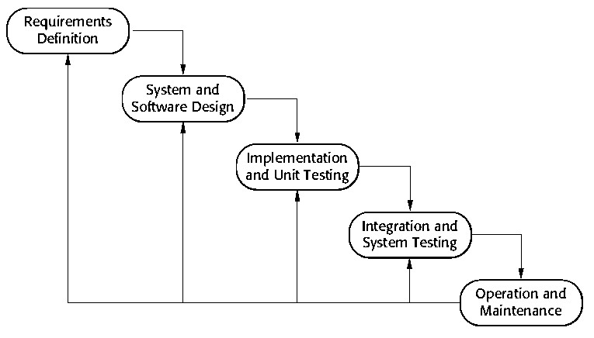
Figure 3.1: Iterative Waterfall Model

3.2 Tools and Technologies Used
Complainify is developed using modern web technologies, Artificial Intelligence techniques, and a relational database management system to provide an efficient and intelligent complaint management platform. The system combines frontend and backend technologies with machine learning and natural language processing techniques to automate complaint classification, sentiment analysis, priority prediction, complaint tracking, and report generation.

3.2.1 Programming Languages and Web Technologies
The system is developed using HTML5, CSS3, and JavaScript for the frontend, while Python and the Flask framework are used for backend development. HTML structures the web pages, CSS designs the user interface, JavaScript adds interactivity, and Flask handles routing, business logic, AI integration, and communication with the MySQL database.

3.2.2 Database Management System
MySQL is used as the database management system to store student information, administrator accounts, complaint records, AI prediction results, complaint status, uploaded files, and notification history. The database is designed using relational tables to ensure data consistency, integrity, and efficient data retrieval.

3.2.3 Python Libraries
The system uses several Python libraries to support different functionalities. Flask is used for web development, Pandas and NumPy for data processing, PyMySQL for database connectivity, and Flask-Mail for sending automated email notifications.

3.2.4 Development Tools
The project is developed using Visual Studio Code as the primary code editor and Anaconda for Python environment management. MySQL is managed through XAMPP, while Git and GitHub are used for version control and project management. Web Speech API is used for voice input for the complaint description.

3.2.5 Dataset Collection & Preprocessing
- Data Collection: Complaint data was collected from public sources like Kaggle and other internet sources.
- Category Dataset: Around 9,000 complaint records were collected and adapted to student complaints.
- Sentiment & Priority Dataset: 12,000 records were prepared.
- Cleaning: Removed irrelevant, incomplete, duplicate, and very short records.
- Encoding: Data was normalized using UTF-8 and unnecessary characters were removed.
- Label Encoding:
- For Sentiment analysis: Positive = 0, Neutral = 1, Negative = 2
- For priority based: Low = 0, Medium = 1, High = 2
- Category Encoding: Academics = 0, Hostels = 1, IT Support = 2, Infrastructure = 3, Financial Services = 4, Administrative = 5, Security = 6, Maintenance = 7, Transport = 8, Library = 9, Canteen = 10, and Other = 11.
- Tokenization: Lowercasing → noise removal → tokenization → stop word removal → short-word removal → stemming → bigrams.
- Train-Test Split: 80% training and 20% testing using stratified splitting.

3.2.6 Model Training & Evaluation
- Algorithm: Multinomial Naive Bayes, implemented from scratch
- Models: Category, Sentiment, and Priority classifiers.
- Evaluation Metrics: Accuracy, Precision, Recall, and F1-score.
Table 3.1: Evaluation Metrics
Model | Accuracy | Precision | Recall | F1-score
Category | 96.81% | 0.9690 | 0.9687 | 0.9687
Sentiment | 97.04% | 0.9504 | 0.9797 | 0.9628
Priority | 99.46% | 0.9939 | 0.9949 | 0.9944

3.3 Assignment of Roles and Responsibilities
Table 3.2: Assignment of Roles and Responsibilities
Group Member | Coding Responsibilities | Documentation Responsibilities
Mridul Prakash Shah | • Flask backend API  •MySQL database design  • Authentication & sessions  • ML model integration  • Priority assignment  • Admin dashboard  • Complaint management | • Feasibility Study  • Database Design  • Requirements Gathering  • Methodology
Samir Poudel | • Landing page & Login/Signup  • Forgot/Reset Password  • Student Dashboard  • Complaint form  • Complaint tracking  • Profile & Settings  • Data collection & labeling  • Naive Bayes training  • Email notifications | • Introduction  • System Architecture  • Use Case Diagram  • DFD Level 0  • Literature Review
Om Prakash Basnet | • Dashboard JavaScript  • Form validation  • Reports (PDF/Excel)  • Frontend–backend integration  • Sentiment Analysis Training  • Testing & debugging | • Functional Requirements  • DFD Level 1  • Test Cases

4 System Design and Analysis

4.1 Requirements Analysis
Complainify was developed to address the growing need for an intelligent, automated, and centralized platform for managing student grievances in educational institutions. The requirements were gathered through analysis of existing manual and paper-based complaint-handling practices, discussions among the team regarding common bottlenecks faced by students and administrative staff, and a review of similar AI-based complaint and feedback management systems examined in the literature review. The system aims to bridge the gap between students and institutional administration by offering a centralized platform for complaint submission, AI-based classification and prioritization, real-time status tracking, and dashboard-based decision support for administrators.

4.1.1 Requirement Gathering
Requirements were gathered by analyzing traditional complaint-handling methods, communication gaps between students and administrators, and existing AI-based complaint systems. The key requirements include role-based access, complaint classification, sentiment analysis, priority assignment, real-time tracking, email notifications, and dashboard analytics.
Table 4.1: Requirement Gathering
Requirement | Description
R1 | The system shall provide separate authentication mechanisms for Students and Administrators using email and password.
R2 | Students shall be able to register, log in, manage their profile, and securely update their account information.
R3 | Students shall be able to submit complaints by providing a title, description, category, and optional supporting attachments.
R4 | The system shall automatically classify submitted complaints into appropriate categories using a Multinomial Naive Bayes model.
R5 | The system shall perform sentiment analysis on complaint text using a Multinomial Naive Bayes model implemented from scratch.
R6 | The system shall automatically predict the priority level of each complaint based on its content.
R7 | Students shall be able to view the complete history and current status of their submitted complaints.
R8 | Students shall receive email notifications when a complaint is submitted, updated, or resolved.
R9 | Administrators shall be able to view, search, filter, and manage all submitted complaints
R10 | Administrators shall be able to update complaint status, assign priorities, and provide responses to students.
R11 | Administrators shall be able to manage student accounts, including activation, deactivation, and profile updates.
R12 | The system shall provide dashboards displaying complaint statistics, trends, and category-wise reports.
R13 | The system shall generate analytical reports based on complaint categories, priorities, and sentiments.
R14 | The system shall store all complaint records, AI prediction results, and user information securely in a MySQL database.
R15 | The system shall support secure file uploads for complaint evidence such as images and documents.
R16 | The system shall implement role-based access control to ensure that users can only access authorized resources.
R17 | The system shall validate all user inputs and prevent invalid or malicious data from being stored.
R18 | The system shall maintain logs of complaint activities and administrative actions for auditing purposes.
R19 | The system shall support voice-based complaint input using the Web Speech API.

4.1.2 Functional Requirements
The functional requirements define the specific behaviors and operations the system must perform to meet user needs and business objectives. Each functional requirement is mapped to one or more gathered requirements to ensure full coverage. Table 4.2 details all functional requirements for Complainify.
Table 4.2: Functional Requirements
Function ID | Description | Cross Reference
F1 | Authenticate Students and Administrators using secure login credentials. | R1
F2 | Register student accounts and manage user profiles. | R2
F3 | Submit complaints with title, description, category, and supporting attachments. | R3
F4 | Automatically classify complaints into predefined categories using the AI model. | R4
F5 | Perform sentiment analysis on submitted complaint text. | R5
F6 | Predict the priority level of complaints using AI. | R6
F7 | View complaint history and monitor complaint status. | R7
F8 | Send email notifications for complaint submission and status updates. | R8
F9 | View, search, and filter complaints using different criteria. | R9
F10 | Update complaint status, assign priorities, and respond to complaints. | R10
F11 | Manage student and administrator accounts | R11
F12 | Display complaint statistics and dashboard summaries | R12
F13 | Generate analytical reports based on complaint data. | R13
F14 | Store and retrieve complaint records securely from the MySQL database. | R14
F15 | Upload and manage supporting files for complaints. | R15
F16 | Enforce role-based access control for secure system access | R16
F17 | Validate user inputs and prevent invalid or malicious data from being stored. | R17
F18 | Maintain activity logs and ensure secure handling of complaint information. | R18
F19 | Support voice-based complaint input using the Web Speech API. | R19

4.2 Feasibility Study

4.2.1 Technical Feasibility
Technical feasibility evaluates whether the available technologies, tools, and technical expertise are sufficient to develop the proposed system successfully.
Complainify is developed using widely adopted technologies including HTML, CSS, JavaScript, Python (Flask), MySQL, Pandas, NumPy and the Multinomial Naive Bayes algorithm. These technologies are open-source, well documented, and supported by large developer communities, making system development and maintenance practical.
The project can be developed using standard computing hardware without requiring specialized infrastructure or expensive software licenses. The development team possesses the necessary knowledge of web development, database management, and machine learning to implement the proposed solution. Therefore, the project is considered technically feasible.

4.2.2 Operational Feasibility
Operational feasibility evaluates whether the proposed system can be effectively used and accepted by its intended users. It focuses on the practicality of implementing the system within the organization and determining whether it satisfies user requirements while improving existing operations.
Complainify is designed with a simple, user-friendly, and responsive web interface that enables students and administrators to perform their tasks efficiently. Students can easily submit complaints, monitor complaint status, and receive timely notifications, while administrators can manage complaints, monitor complaint trends, and generate reports through an intuitive dashboard.
The integration of Artificial Intelligence further reduces manual effort by automatically classifying complaints, predicting their priority, and analyzing sentiment, allowing administrators to respond more efficiently. Since the system requires only basic computer knowledge and web browser access, minimal user training is required. Therefore, the proposed system is considered operationally feasible.

4.2.3 Economic Feasibility
Complainify is economically feasible and demonstrates strong financial viability. The project requires an initial investment of NPR 175,000 to cover system development, AI model implementation, documentation, hardware, software setup, testing, training, and contingency costs. Annual operating expenses range from NPR 31,000 in Year 1 to NPR 40,000 by Year 5 for web hosting, maintenance, technical support, database management, and email services. The system provides measurable benefits by reducing manual complaint handling, improving administrative efficiency, enhancing transparency, and supporting AI-based complaint classification and sentiment analysis. These benefits are estimated to increase from NPR 120,000 in Year 1 to NPR 188,000 by Year 5, confirming the long-term financial sustainability of the proposed system.
Table 4.3: Initial Development Cost
Cost Component | Description | Estimated Cost (NPR)
Labor Cost (Development) | 3 developers × 2 months × NPR 15,000 | 90,000
System Design & Documentation | Diagrams, reports, and testing documents | 15,000
Hardware & Utilities | Laptop usage, hosting, internet, electricity | 20,000
Email Service Setup and Voice Input API Setup | Flask-Mail SMTP configuration, Web Speech API and deployment | 10,000
Training & Deployment | Administrator training, system deployment, and configuration | 20,000
Contingency Cost | Unexpected or miscellaneous expenses | 20,000
Total Initial Investment |  | 175,000
Table 4.4: Net Cash Flow Analysis
Year | Annual Benefits (NPR) | Operating Costs (NPR) | Net Cash Flow (NPR)
1 | 120,000 | 31,000 | 89,000
2 | 135,000 | 33,000 | 102,000
3 | 150,000 | 35,000 | 115,000
4 | 165,000 | 38,000 | 127,000
5 | 188,000 | 40,000 | 148,000

Payback Period (PBP)
The Payback Period determines how quickly the initial investment is recovered.
Formula:
PBP = Year before recovery + (Remaining Investment / Next Year NCF)
Cumulative Cash Flow:
- Year 1 = 89,000
- Year 2 = 191,000
Calculation:
PBP = 1 + (175,000 − 89,000) / 102,000
PBP = 1.84 years ≈ 1 year 10 months
The investment is recovered in less than 2 years, indicating low financial risk.
Net Present Value (NPV)
Formula:
PV = NCF/${\left(1+r\right)}^{t}$
NPV = ΣPV − Initial Investment
(Discount Rate = 12%)
Table 4.5: Calculation of NPV
Year | NCF (NPR) | Present Value (NPR)
1 | 89,000 | 79,464
2 | 102,000 | 81,314
3 | 115,000 | 81,855
4 | 127,000 | 80,711
5 | 148,000 | 83,979

NPV Calculation:
NPV = 79,464 + 81,314 + 81,855 + 80,711 + 83,979 − 175,000
NPV ≈ NPR 232,323
Positive NPV confirms the project is financially viable.
Internal Rate of Return (IRR)
The IRR is the discount rate at which NPV = 0.
Using financial calculation methods:
IRR ≈ 52.9%
This is significantly higher than the required return (12–15%), indicating high profitability.
Table 4.6: Summary of Financial Metrics
Metric | Value
Payback Period | 1 year 10 months
Net Present Value | NPR 232,323
Internal Rate of Return | 52.9%

Commercial Value and Selling Price
From a commercial perspective, Complainify has strong market potential. Its key features include:
- AI-based complaint category prediction
- Sentiment analysis and priority prediction
- Centralized digital complaint management
- Email notification system
- Complaint tracking and analytical reports
- Administrative dashboard with complaint statistics
The system can be marketed to:
- Schools
- Colleges
- Universities
- Educational training institutes
Estimated Selling Price: NPR 150,000 per system
Conclusion
The economic analysis shows that Complainify is financially sound. It offers:
- Short payback period
- High NPV
- Strong IRR
- Low operational cost
Thus, the system ensures quick investment recovery, low financial risk, and long-term sustainability, making it a highly feasible and profitable solution.

4.2.4 Schedule Feasibility
The schedule feasibility analysis confirms that the project can be completed within a planned 15-week timeframe, spanning from June to September. The project begins with discussion and initiation (June W2), followed by requirement analysis (June W2–W4). Data selection is carried out during July W1, followed by data exploration and preprocessing (July W2). System design is performed from July W2 to W3, while model training takes place during July W3–W4. Frontend development runs from July W4 to September W2, while backend development runs in parallel from August W2 to September W2. System testing is carried out from September W1 to W3, followed by bug fixing from September W3 to W4. Documentation is maintained continuously throughout the project from June W2 to September W4. The logical sequence of activities, parallel development, and continuous documentation demonstrate that the project is schedule feasible and can be successfully completed within the proposed timeframe.
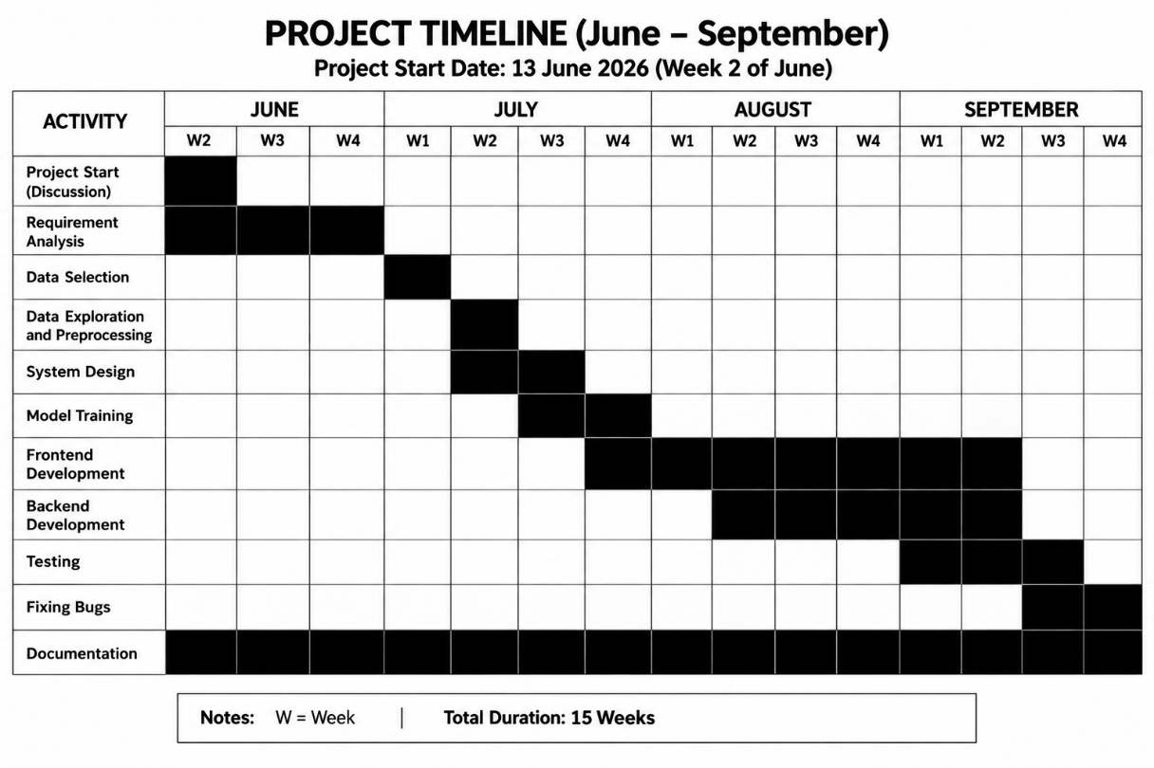
Figure 4.1: Gantt Chart

5 System Design

5.1 System Architecture
Complainify follows a multi-tier architecture consisting of the Presentation Layer, Business Logic Layer, Data Access Layer, Artificial Intelligence Layer, and External Integration Layer. This architecture improves modularity, maintainability, scalability, and security by separating different system functionalities into independent layers. Each layer performs a specific task and communicates with the adjacent layers through well-defined interfaces, making the system easier to develop, maintain, and extend with additional features in the future.
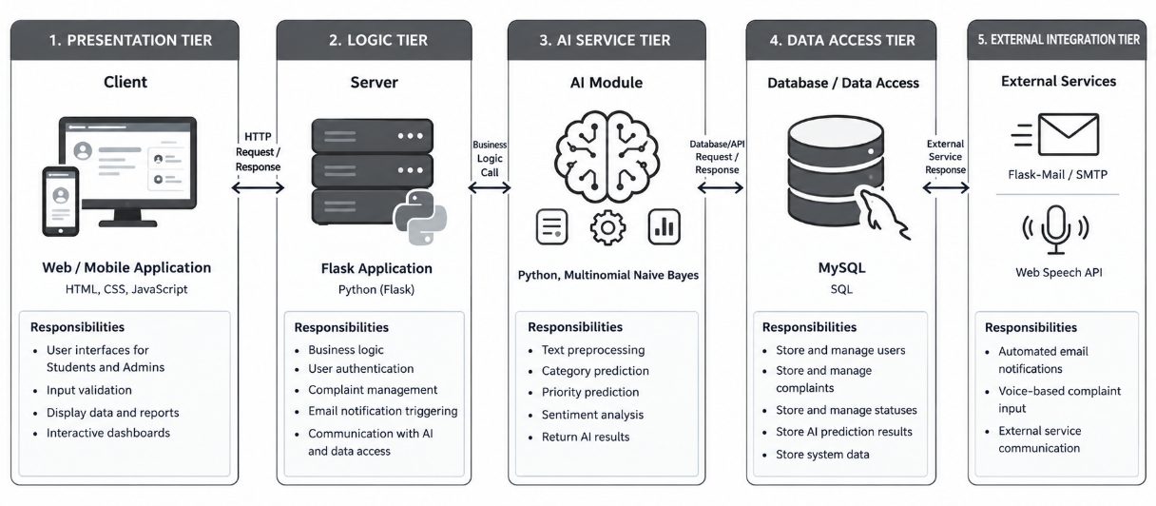
Figure 5.1: System Architecture

5.1.1 Architectural Components
Table 5.1: System Architecture Components
Layer | Technology | Description
Presentation Layer | HTML, CSS, JavaScript (Vanilla) | Provides interfaces for Students and Administrators, handles user input, and displays system information.
Business Logic Layer | Python (Flask) | Processes user requests, manages authentication, complaint handling, notifications, and business logic.
Artificial Intelligence Layer | Python, Multinomial Naive Bayes | Performs complaint classification, priority prediction, and sentiment analysis.
Data Access Layer | MySQL | Stores and manages user accounts, complaints, AI results, and other system data.
External Integration Layer | Flask-Mail (SMTP),  Web Speech API. | Sends automated email notifications and supports external services such as file uploads and Web Speech API used for the voice-based complaint input in the system.

5.2 Procedure Oriented Diagram

5.2.1 Context Diagram (DFD Level 0)

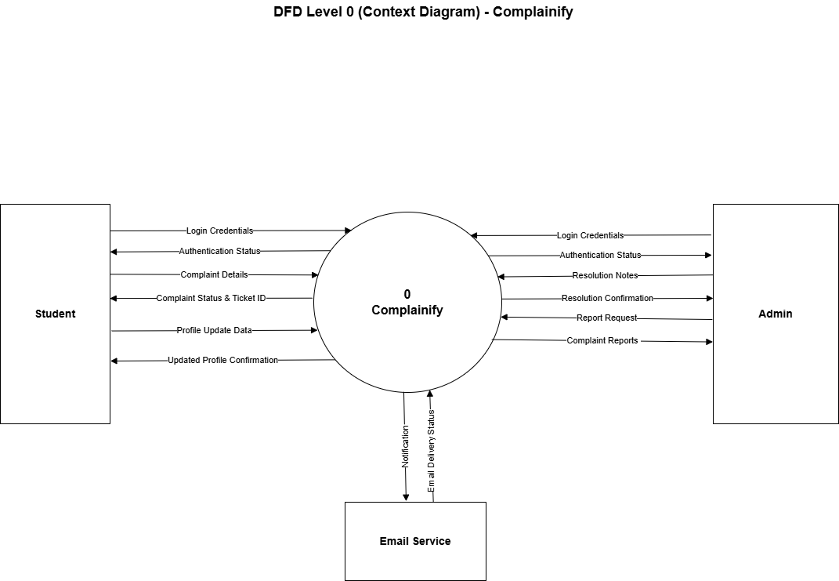
Figure 5.2: DFD Level 0

5.2.2 Data Flow Diagram (Level 1)

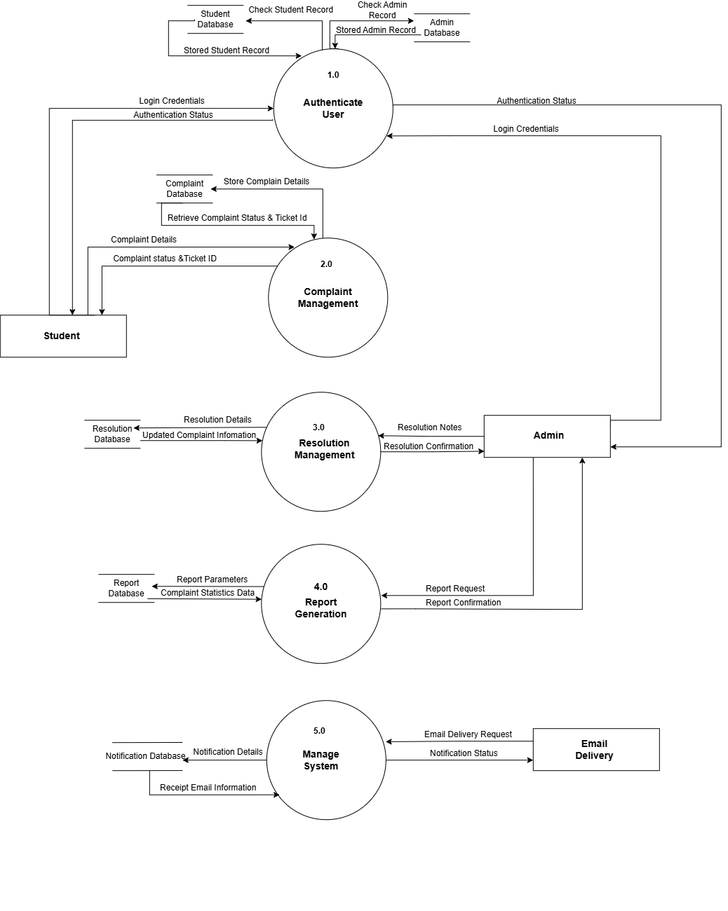
Figure 5. 3: DFD Level 1

5.2.3 Use Case Diagram

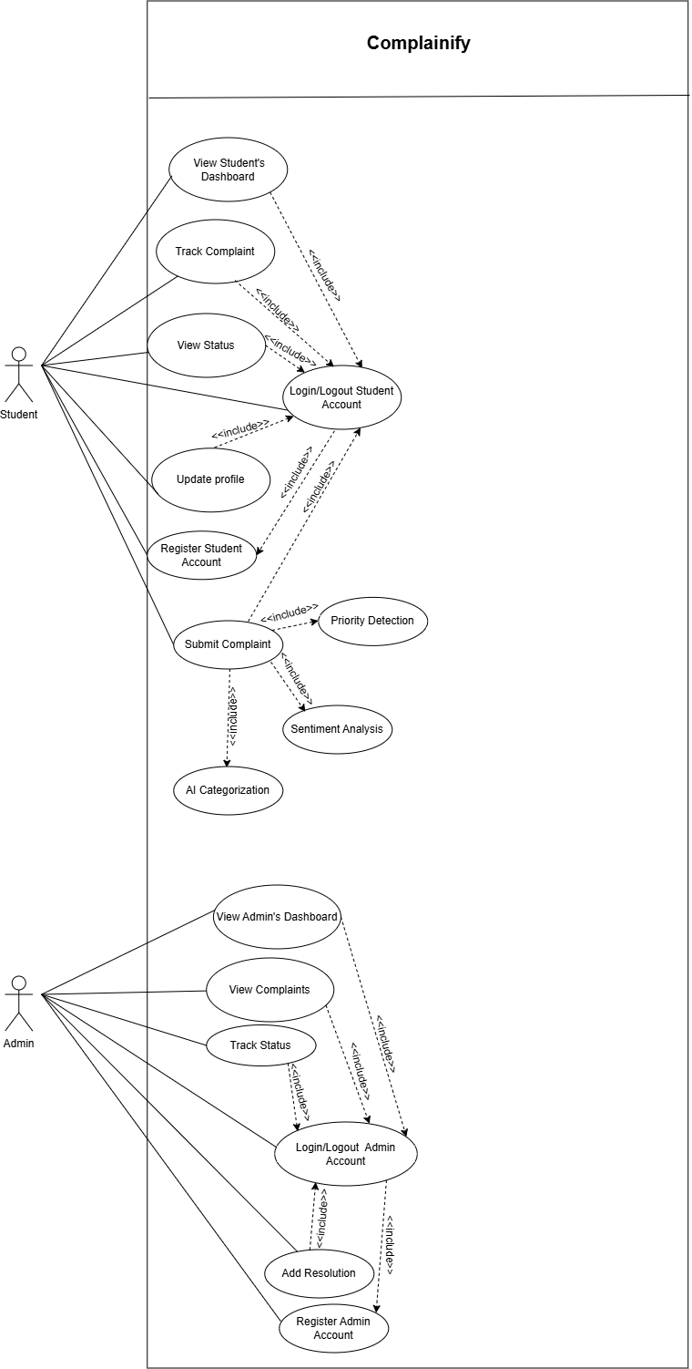
Figure 5. 4: Use Case Diagram

5.3 Database Design

5.3.1 E-R Diagram

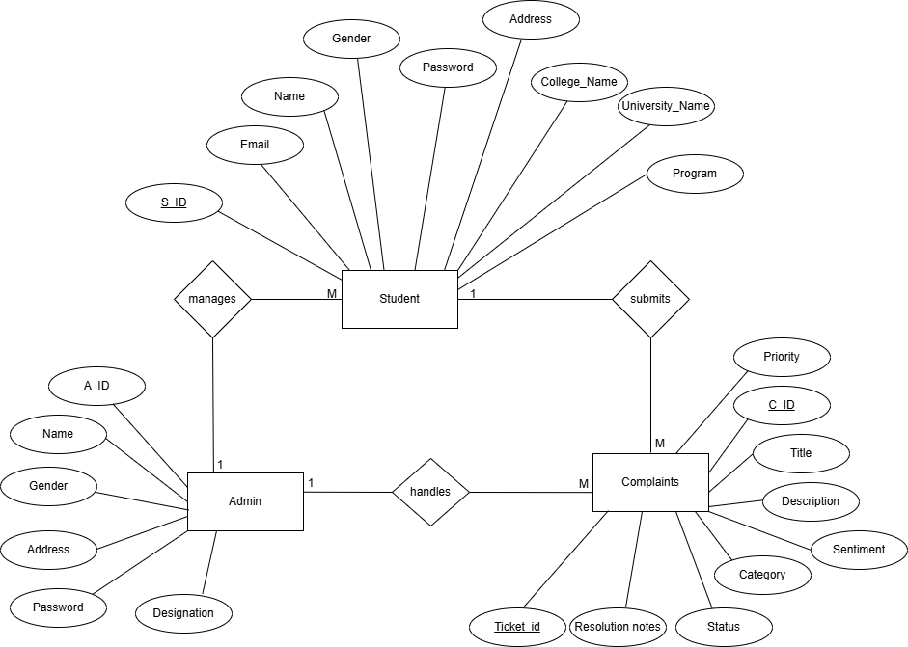
Figure 5. 5: ER Diagram

6 System Development and Implementation

6.1 Programming Platforms
1. Frontend Technologies: HTML, CSS, JavaScript
The frontend of the system is developed using HTML, CSS, and JavaScript. HTML is used to structure the web pages, CSS provides responsive styling and layout, while JavaScript adds interactivity, form validation, and dynamic content updates to enhance the user experience.
2. Backend Language: Python (Flask Framework)
The backend is developed using Python with the Flask framework. It manages user authentication, complaint processing, AI integration, database operations, email notifications, and communication between the frontend and the MySQL database.
3. Development Environment: Visual Studio Code
Visual Studio Code is used as the primary development environment for writing, debugging, and testing the application. It provides extensions, debugging tools, and integrated terminal support for efficient development.
4. Database System: MySQL
MySQL is used to store student accounts, administrator information, complaint records, AI prediction results, complaint status, and uploaded files. It provides reliable data storage and maintains relationships between database tables.
5. Additional Libraries and APIs
The system uses Flask-Mail for email notifications, Pandas and NumPy for data processing, Web Speech API is used for voice input, PyMySQL for MySQL database connectivity, and Matplotlib for generating analytical charts and reports and Web Speech API is used for voice input for the complaint description.

6.2 Hardware and Software Requirements

6.2.1 Hardware Requirements
Minimum Requirements
- Processor: Dual-Core CPU (Intel i3 or equivalent)
- RAM: 4 GB
- Storage: 500 MB free space
- Display: 1366 × 768 resolution
- Keyboard and Mouse required
Recommended Requirements
- Processor: Intel Core i5 or higher
- RAM: 8 GB
- Storage: 1 GB free space
- Display: Full HD (1920 × 1080)

6.2.2 Software Requirements
- Operating System: Windows, Linux, or macOS
- Web Browser: Google Chrome or any modern browser
- Code Editor: Visual Studio Code
- Python Environment: Anaconda
- Backend Framework: Flask
- Database: MySQL
- Programming Language: Python
- Frontend Technologies: HTML, CSS, JavaScript

7 Testing and Debugging

7.1 Testing Approach
Complainify was tested using a multi-level testing strategy. The testing covered unit testing, integration testing, and user acceptance testing. Unit tests checked individual functions such as form validation, login logic, and the Naive Bayes classification code in isolation. Integration tests confirmed that the frontend pages correctly send data to the Flask backend and that the data is saved properly in the MySQL database. User acceptance testing was done by simulating real student and admin usage scenarios to confirm that the system works correctly from the end-user point of view.

7.2 Testing Tools
Table 7.1: Testing Tools
S.N. | Tool | Specification / Purpose
1 | Hardware | Laptop with 8 GB RAM, Intel Core i5 processor used to run Flask server, MySQL, and browser at the same time
2 | Web Browser | Google Chrome (latest) and Mozilla Firefox used to open and test all frontend pages
3 | Flask Development Server | Local Python Flask server used to run the backend application during testing
4 | MySQL (XAMPP) | Relational database. Tables were checked using phpMyAdmin to confirm correct data storage
5 | Postman | API testing tool used to test email notification delivery with real Gmail addresses and to verify Flask API endpoints.
6 | VS Code | Code editor used for debugging Python code and checking console error messages

7.3 Test Cases
The following tables document test cases organized by module. Each test case records the test ID, description, input conditions, expected output, actual output observed during testing, and the final status (Pass or Fail). Where initial failures were encountered during development cycles, they have been resolved and confirmed as Pass in the final build. The test IDs follow the Module Number, Test Number for easy cross-referencing.

7.3.1 Login Module
Table 7.2: Login Module
TC ID | Description | Input | Expected Output | Actual Output | Status
TC-L01 | Login with correct credentials | Valid student email and password | Redirect to Student Dashboard | Student Dashboard opens | Pass
TC-L02 | Login with wrong password | Correct email + wrong password | Error: Invalid email or password | Error message shown | Pass
TC-L03 | Login with empty fields | Leave email and password blank | Validation message shown | Required field messages shown | Pass
TC-L04 | Admin login | Valid admin email and password | Redirect to Admin Dashboard | Admin Dashboard opens | Pass
TC-L05 | Unregistered email | Email not in database | Error: Invalid email or password | Error message shown | Pass

7.3.2 Sign Up Module
Table 7.3: Sign Up Module
TC ID | Description | Input | Expected Output | Actual Output | Status
TC-S01 | Register with valid data | Name, email, password filled correctly | Account created, redirect to login | Account created successfully | Pass
TC-S02 | Register with existing email | Email already in database | Error: Email already registered | Error message shown | Pass
TC-S03 | Password mismatch | Password and Confirm Password different | Error: Passwords do not match | Error message shown | Pass
TC-S04 | Weak password | Password less than 6 characters | Validation error for password | Validation message shown | Pass
TC-S05 | Empty required fields | Leave name or email blank | Required field messages | Validation messages shown | Pass

7.3.3 Forgot Password / Reset Password Module
Table 7.4: Forgot Password/Reset Password Module
TC ID | Description | Input | Expected Output | Actual Output | Status
TC-P01 | Reset request with valid email | Registered email + Send Reset Link | Success message + email sent | Email received with reset link | Pass
TC-P02 | Reset request with unknown email | Email not in database | Safe error message shown | Email not found message shown | Pass
TC-P03 | Reset with valid token | Open reset link and set new password | Password updated successfully | Password changed successfully | Pass
TC-P04 | Reset with invalid/expired token (First test) | Use old or wrong reset link | Error: Invalid or expired link | Blank page shown | Fail
TC-P04 | Reset with invalid/expired token (After fix & retest) | Use old or wrong reset link | Error: Invalid or expired link | Error message shown correctly | Pass

7.3.4 Complaint Submission Module
Table 7.5: Complaint Submission Module
TC ID | Description | Input | Expected Output | Actual Output | Status
TC-C01 | Submit complete complaint | Title, description, category filled | Complaint saved + Ticket ID generated | Ticket ID shown, success message | Pass
TC-C02 | Submit with file attachment | Upload image or PDF file | File uploaded and linked | File saved correctly | Pass
TC-C03 | Submit with empty fields | Leave title or description blank | Validation error shown | Required field messages shown | Pass
TC-C04 | Submit anonymous complaint (First test) | Tick anonymous option and submit | Student identity hidden from admin | Student name still visible in admin panel | Fail
TC-C04 | Submit anonymous complaint (After fix & retest) | Tick anonymous option and submit | Student identity hidden from admin | Student identity hidden correctly | Pass
TC-C05 | Submit long description | Description with 500+ words | System accepts and saves | Complaint saved successfully | Pass
TC- C06 | Voice Complaint Input | Voice Complaint | Voice complaint converted into text. | Voice was converted into text successfully. | Pass

7.3.5 AI Classification Module
Table 7.6: AI Classification Module
TC ID | Description | Input | Expected Output | Actual Output | Status
TC-A01 | Classify academic complaint | Text about exam or class issue | Category = Academics | Predicted as Academics | Pass
TC-A02 | Classify hostel complaint | Text about room, water or mess | Category = Hostels | Predicted as Hostels | Pass
TC-A03 | Classify fees complaint | Text about payment or scholarship | Category = Financial Services | Predicted as Financial Services | Pass
TC-A04 | Classify IT complaint | Text about computer or internet | Category = IT Support | Predicted as IT Support | Pass
TC-A05 | Priority assignment | Serious / urgent complaint text | Priority = High or Medium | Priority set correctly | Pass

7.3.6 Sentiment Analysis Module
Table 7.7: Sentiment Analysis Module
TC ID | Description | Input | Expected Output | Actual Output | Status
TC-V01 | Detect negative sentiment | Complaint with angry words | Sentiment = Negative | Marked as Negative | Pass
TC-V02 | Detect neutral sentiment | Simple factual complaint | Sentiment = Neutral | Marked as Neutral | Pass
TC-V03 | Detect positive sentiment | Polite or positive text | Sentiment = Positive | Marked as Positive | Pass

7.3.7 Complaint Status Tracking Module
Table 7.8: Complaint Status Tracking Module
TC ID | Description | Input | Expected Output | Actual Output | Status
TC-T01 | Student views own complaints | Login as student → My Complaints | List with Ticket ID and status | Complaints listed correctly | Pass
TC-T02 | Admin sets status to In Progress | Admin updates status | Status changes, student can see it | Status updated correctly | Pass
TC-T03 | Admin marks as Resolved | Admin sets status = Resolved | Status becomes Resolved | Status updated, student sees it | Pass
TC-T04 | Student cannot see others | Student A tries to open Student B complaint | Access denied / not visible | Complaint not visible | Pass

7.3.8 Admin Dashboard and Filtering Module
Table 7.9: Admin Dashboard and Filtering Module
TC ID | Description | Input | Expected Output | Actual Output | Status
TC-D01 | View dashboard statistics | Login as admin → Dashboard | Total count, charts visible | Statistics and charts shown | Pass
TC-D02 | Filter by category | Select category = Hostels | Only Hostels complaints shown | Filter worked correctly | Pass
TC-D03 | Filter by priority | Select priority = High | Only High priority listed | Filter worked correctly | Pass
TC-D04 | Search by Ticket ID | Enter valid Ticket ID | Matching complaint displayed | Correct complaint shown | Pass
TC-D05 | Filter by status | Select status = Resolved | Only resolved complaints shown | Filter worked correctly | Pass

7.3.9 Email Notification Module
Table 7.10: Email Notification Module
TC ID | Description | Input | Expected Output | Actual Output | Status
TC-E01 | Email after submission | Student submits complaint | Confirmation email with Ticket ID | Email received correctly | Pass
TC-E02 | Email on status update (First test) | Admin changes status | Student receives update email | No email was sent | Fail
TC-E02 | Email on status update (After fix & retest) | Admin changes status | Student receives update email | Email sent successfully | Pass
TC-E03 | Email on resolution | Admin marks as Resolved | Resolution email sent | Email received correctly | Pass

7.3.10 Report Generation Module
Table 7.11: Report Generation Module
TC ID | Description | Input | Expected Output | Actual Output | Status
TC-R01 | Generate Excel report | Admin clicks Export Excel | Excel file downloads | Excel file downloaded | Pass
TC-R02 | Generate PDF report (First test) | Admin clicks Export PDF | PDF file downloads | Error occurred, no file downloaded | Fail
TC-R02 | Generate PDF report (After fix & retest) | Admin clicks Export PDF | PDF file downloads | PDF downloaded correctly | Pass

8 Conclusion
Complainify is a web-based AI-powered student complaint management system that successfully achieves its primary objectives, such as secure multi-role login and registration, complaint submission with file upload support, anonymous complaint option, automatic category prediction using Multinomial Naive Bayes, priority assignment (High, Medium, Low), sentiment analysis (implemented from scratch), complaint status tracking with Ticket ID, admin dashboard with filtering and search, email notifications for status updates, voice-based complaint input (English Only) and report generation in PDF and Excel formats. The system is monitored by the administrator and is developed using the Iterative Waterfall model as an SDLC approach. During testing and debugging, a couple of features were identified as failed, but they were later fixed, and overall, the testing and debugging showed positive results.
Although it achieves its primary objectives, there are some limitations, such as a lack of multi-language support, no integration with existing university management systems, and the absence of advanced AI-based recommendation or predictive resolution features. Additionally, the system currently relies only on email notifications and does not support real-time mobile push notifications, which can be improved as a future enhancement. Other future improvements may include multi-language support (especially Nepali), AI-based chatbot for students, mobile application, and integration with the college ERP system. During development, we also faced several challenges, such as implementing Naive Bayes classification, Sentiment and Priority Analysis from scratch without using Scikit-learn, training the model with limited labeled data, integrating email services correctly, and occasional XAMPP port conflicts which sometimes caused temporary database connection issues. Overall, we enjoyed working on this project and gained practical knowledge of implementing core web technologies along with Artificial Intelligence and Data Mining concepts.

References
Deo, A., Ghule, T., Ghodechor, V., Gavhane, R., & Narode, P. (2025). Smart complaint management system with AI-powered prioritization and escalation. International Journal of Creative Research Thoughts (IJCRT), 13(10), f295–f300. Retrieved June 14, 2026, from https://ijcrt.org/papers/IJCRT2510624.pdf

Javed, R., Wasi, S., Mughal, M. H., & Bhutto, Z. A. (2025). Machine learning-based smart students' complaint resolution system. International Journal of Artificial Intelligence & Mathematical Sciences, 4(1), 36–55. Retrieved June 14, 2026, from https://doi.org/10.58921/ijaims.v4i1.135

Prakash, J., Swathiramya, R., Balambigai, G., Menaha, R., & Abhirami, J. S. (2024). AI-driven real-time feedback system for enhanced student support: Leveraging sentiment analysis and machine learning algorithms. International Journal of Computational and Experimental Science and Engineering, 10(4). Retrieved June 14, 2026, from https://doi.org/10.22399/ijcesen.780

