A Project Report
on
Complainify
Submitted in partial fulfillment of the requirement of
Project-VI (BIT356CO)
Bachelor in Information Technology
Submitted To

Purbanchal University
Biratnagar, Nepal
Submitted By
Mridul Prakash Shah (350560)
Om Prakash Basnet (350562)
Samir Poudel (350574)
KANTIPUR CITY COLLEGE
Putalisadak, Kathmandu
October, 2026

A Project Report
on
Complainify
Submitted in partial fulfillment of the requirement of
Project-VI (BIT356CO)
Bachelor in Information Technology
Submitted To
Purbanchal University
Biratnagar, Nepal
Submitted By
Mridul Prakash Shah (350560)
Om Prakash Basnet (350562)
Samir Poudel (350574)
Project Supervisor
Er. Maryada Karki
Mr. Santosh Shah
KANTIPUR CITY COLLEGE
Putalisadak, Kathmandu
May, 2026

Abstract
Medication non-adherence is a common healthcare problem in modern society, especially for patients with chronic diseases like blood pressure, diabetes, and thyroid, who need regular medicine intake. Many patients forget their medicines or rely on handwritten notes, which can lead to mistakes and health risks. To solve this issue, MedTracker is introduced as a web-based application that helps patients manage their medication and receive timely reminders. It includes three main roles: patient, health worker, and caregiver. Health workers enter prescriptions with dosage and quantity, and patients or caregivers set reminder times after receiving them. The system tracks medication intake, generates reports, and supports video consultation and messaging between patients and health workers. Caregivers can also verify whether the medicine has been taken, and reminders are sent through SMS or email. the admin is responsible for monitoring overall system activities and ensuring smooth operation The system is developed using the Waterfall model and implemented using web core technologies.

Acknowledgement
We’d like to express our heartfelt gratitude to everyone who has encouraged us to work on this project. First and foremost, we’d like to express our gratitude to the entire team of Kantipur City College (KCC) for this chance, especially to the Principal of Kantipur City College, who assisted us in furthering our knowledge in this field.
And we’d like to express our special gratitude to our supervisor, Mr. Bimochan Khadka and Er. Maryada Karki who has consistently encouraged, inspired and provided us with a wealth of information that has been beneficial. His advice was helpful in completing this assignment. We could not have asked for a better supervisor, counselor, or mentor. This project would not have been possible without the assistance of each member, as well as the entire class, who offered suggestions, shared their experiences, and provided advice throughout the project. We are grateful for this. Finally, we’d like to express our gratitude to our friends and colleagues who supported us directly and indirectly throughout this project.

Declaration
We declare that this project report titled “MedTracker” submitted in partial fulfillment of the Bachelor of Information Technology is a record of original work carried out by us under the supervision of Mr. Bimochan Khadka and Er. Maryada Karki and has not formed the basis for the award of any other degree or Diploma, in this or any other institution or University. In keeping with the ethical practice of reporting scientific information, due acknowledgments have been made wherever the findings of others have been cited.

Mridul Prakash Shah (350560)
Om Prakash Basnet (350562)
Samir Poudel (350574)

Supervisor’s Approval
This is to certify that the project entitled “MedTracker” undertaken and demonstrated by Mridul Prakash Shah, Om Prakash Basnet and Samir Poudel has been successfully completed under my supervision as a partial fulfillment of the requirements of the degree of IT 5th semester under Purbanchal University. I, henceforth, approve this project to be awarded the certificate by the concerned authority. During supervision, I found students hardworking, skilled and ready to undertake any professional work related to this field in future.

Mr. Bimochan Khadka Er. Maryada Karki
Project Supervisor Project Supervisor
Department of IT Department of IT
Date: Date:

Certificate From Department
Following the Supervisor's Approval and Examiner’s Acceptance, the project entitled “MedTracker” submitted by Mridul Prakash Shah, Om Prakash Basnet and Samir Poudel as a partial fulfillment of the requirements for the degree of BIT 5th Semester under Purbanchal University, has been officially awarded by this certificate. I wish the students all the best for their future endeavors.

Mr. Rubim Shrestha Mr. Saroj Pandey
Project Coordinator Head of Department
Department of IT Department of IT
Date: Date:

Table of Contents
Abstract i
Acknowledgement ii
Declaration iii
Supervisor’s Approval iv
Certificate From Department v
List of Figures ix
List of Tables x
List of Abbrevations xi
1 Introduction 1
1.1 Overview: 1
1.2 Problem Statement: 1
1.3 Objectives 2
1.4 Features 2
1.5 Significance 4
1.6 Scope and Limitations 5
1.7 Documentation Organization 5
2 Literature Review 6
2.1 Medicine Reminder System Using Java 6
2.1.1 Working Principle 6
2.1.2 Advantages: 7
2.1.3 Limitations: 7
2.2 Smart Pill Reminder System 7
2.2.1 Working Principle: 8
2.2.2 Advantages: 8
2.2.3 Limitations: 8
2.3 Smart Pill Box for Medicine Reminder and Monitoring System 9
2.3.1 Working Principle: 9
2.3.2 Advantages: 9
2.3.3 Limitations: 9
3 Methodology 10
3.1 System Development Cycle 10
3.2 Tools and Technologies Used 11
3.2.1 Programming Languages and Web Technologies 11
3.2.2 Database Management System 12
3.2.3 Additional Libraries and Tools 12
3.3 Assignment of Roles and Responsibilities 12
4 System Design and Analysis 15
4.1 Requirements Analysis 15
4.1.1 Requirement Gathering 15
4.1.2 Functional Requirements 17
4.2 Feasibility Study 21
4.2.1 Technical Feasibility 21
4.2.2 Operational Feasibility 22
4.2.3 Economic Feasibility 22
4.2.4 Schedule Feasibility 25
5 System Design 27
5.1 System Architecture 27
5.1.1 Architectural Components 27
5.2 Procedure Oriented Diagram 29
5.2.1 Context Diagram (DFD Level 0) 29
5.2.2 Data Flow Diagram (Level -1) 30
5.2.3 Use Case Diagram 31
5.3 Database Design 32
5.3.1 E-R Diagram 32
5.4 Role Based Design 32
6 System Development and Implementation 34
6.1 Programming Platforms 34
6.2 Hardware and Software Requirements 35
6.2.1 Hardware Requirements 35
6.2.2 Software Requirements 35
7 Testing and Debugging 36
7.1 Testing Approach 36
7.2 Testing Tools 36
7.3 Test Cases 37
7.3.1 Login Module 37
7.3.2 Sign Up Module 38
7.3.3 Forgot Password / Reset Password Module 40
7.3.4 Add Medicine Module (Patient) 41
7.3.5 Dose Logging and Stock Management Module 42
7.3.6 Health Worker Panel Module 43
7.3.7 Admin Panel Module 45
7.3.8 Password Management Module 46
7.3.9 Notification System Module 47
7.3.10 Video Consultation Module 48
7.3.11 Medicine Logging Verification Module 49
8 Conclusion 50
References 51

List of Figures
Figure 3.1: Waterfall Model 11
Figure 4.1: Gantt Chart 26
Figure 5.1: System Architecture 27
Figure 5.2: DFD Level 0 29
Figure 5.3: DFD Level 1 30
Figure 5.4: Use Case Diagram 31
Figure 5.5: ER Diagram 32

List of Tables
Table 3.1: Assignment of Roles and Responsibilities 12
Table 4.1: Requirement Analysis 15
Table 4.2: Functional Requirements 17
Table 4.3: Initial Development Cost 23
Table 4.4: Net Cash Flow Analysis 23
Table 4.5: Calculation of NPV 24
Table 4.6: Summary of Financial Metrices 25
Table 5.1: System Architecture Components 27
Table 5.2: Role Based Access Control Matrix 32
Table 7.1: Testing Tools 36
Table 7.2: Login module 37
Table 7.3: SignUp Module 38
Table 7.4: Forgot Password and Reset Password Module 40
Table 7.5: Add Medicine Module 41
Table 7.6: Dose Logging and Stock Management Module 42
Table 7.7: Health Worker Panel Module 43
Table 7.8: Admin Panel Module 45
Table 7.9: Password Management Module 46
Table 7.10:Notification System Module 47
Table 7.11: Video Consultation Module 48
Table 7.12: Medicine Logging Verification Module 49

List of Abbrevations
API : Application Programming Interface
CPU : Central Processing Unit
CSS : Cascading Style Sheets
CRUD : Create, Read, Update, Delete
DB : Database
DFD : Data Flow Diagram
ER : Entity Relationship
HD : Hard Disk
HTML : HyperText Markup Language
HTTP : HyperText Transfer Protocol
IDE : Integrated Development Environment
IoT : Internet of Things
IRR : Internal Rate of Return
JS : JavaScript
MySQL : My Structured Query Language
NCF : Net Cash Flow
NPR : Nepalese Rupee
NPV : Net Present Value
OTP : One Time Password
PBP : Payback Period
PDO : PHP Data Objects
PDF : Portable Document Format
PHP : Hypertext Preprocessor
RAM : Random Access Memory
SDLC : Software Development Life Cycle
SMS : Short Message Service
SMTP : Simple Mail Transfer Protocol
SpO2 : Peripheral Oxygen Saturation
SQL : Structured Query Language
TOC : Table of Contents
UI : User Interface
URL : Uniform Resource Locator
USB : Universal Serial Bus
XAMPP : Cross-Platform Apache MySQL PHP Perl

1 Introduction

Overview:
Medication adherence is essential for effective treatment and maintaining patient health. However, in developing countries like Nepal, many patients face difficulties in following proper medication schedules due to forgetfulness, complex prescriptions, and lack of monitoring systems. Traditional reminder methods such as handwritten notes or verbal instructions are often unreliable and may lead to missed doses, incorrect medicine timing, or overdose. These problems are more common among elderly individuals and patients suffering from chronic diseases who depend on regular medication.
MedTracker is designed to address these challenges by providing a user-friendly web-based platform for medication management. The system allows doctors or pharmacists or even users to input accurate dosage instructions, medicine timing, and special guidelines. Patients can securely access their medication schedules, track intake history, and receive automated reminders through SMS and email. The system also provides refill alerts, adherence monitoring, hydration measurement and centralized medication records. It is developed using HTML, CSS, JavaScript, PHP, and MySQL, along with tools such as TextBee and PHPMailer, the system aims to improve medication adherence and patient safety. Additionally, the system includes a Video Consultation module that allows patients and health workers to communicate through real-time messaging, schedule appointments, and join secure video calls directly within the platform.

Problem Statement:
Medication management is a major challenge, particularly among elderly individuals and patients undergoing long-term treatments. Several factors contribute to improper medication intake, which increases health risks and reduces treatment effectiveness. These challenges include:
- Forgetfulness in Medicine Intake: Patients often forget to take medicines on time, leading to missed doses or improper treatment.
- Complex Medication Schedules: Some patients are prescribed multiple medicines with different timings and meal instructions, which can be confusing.
- Lack of Tracking Mechanisms: Traditional reminder systems do not provide proper monitoring or record of medicine intake.
- Limited Monitoring by Caregivers: Family members or caregivers cannot easily track whether medicines are taken correctly.
- Need for Digital Management: A centralized and automated system is required to manage medication schedules, send reminders, and maintain proper intake records.
This project aims to solve these problems by developing a Smart Medicine Reminder System that automates medication tracking and reminder services.

Objectives
The main objective of the project is:
- To develop a simple, web-based, and user-friendly medicine reminder system using core web technologies

Features
MedTracker is designed with several features to ensure usability, efficiency, and reliability:
- User Registration and Authentication: Secure multi-role registration and login system for Patients, Health Workers, and Administrators, with OTP-based password reset via email.
- Medicine Prescription Entry (User and Health Worker): Both patients and health workers can add medicines with details like dosage, type, frequency, and instructions. Health workers assign prescriptions to linked patients; patients can self-add minor medicines independently.
- Medicine Management: Users can view, update, and delete their self-added medicines. Health workers manage prescriptions for assigned patients, and administrators have system-wide control over all medicine records.
- Medicine Scheduling: Medicines are scheduled with user-defined dose times, supporting fixed-course (with start and end dates) and ongoing/chronic treatment modes, with active, paused, and stopped status tracking.
- Reminder System: Automated SMS and email reminders notify users before a dose is due, at the exact scheduled time, and again if a dose is missed, using TextBee for SMS and PHPMailer for email.
- Medicine Intake Logging: Patients log each dose as Taken or Skipped, with optional skip reasons. A snooze option delays reminders up to 120 minutes, and stock quantity automatically decreases when a dose is marked taken.
- Adherence Tracking: Monitors daily intake patterns and generates adherence reports showing taken, skipped, pending, and late doses, along with streak tracking and missed-dose reason breakdowns.
- Low Stock Alerts: Notifies users when a medicine quantity falls to five or fewer doses remaining, prompting timely refills to avoid treatment interruption.
- Dashboard and Reports: Displays today's medicine schedule, intake history, adherence charts, hydration progress, and weekly overviews in role-specific dashboards for patients, health workers, and administrators.
- PDF Report Generation: Patients can export a monthly medication report as a PDF containing summary cards, adherence charts, refill insights, alerts, and a full daily dose breakdown.
- Admin Management: Administrators can monitor all users, reset passwords, delete accounts, view system-wide medicine and notification analytics, manage reminder timing settings, and review a full audit trail of system actions.
- Responsive User Interface: A clean, modern interface built with consistent design across all roles, accessible to users with basic digital knowledge on both desktop and mobile devices.
- Hydration Tracking: Patients can log daily water intake in milliliters, track progress toward a daily hydration goal, and view weekly hydration trends alongside their medication adherence data.
- Video Consultation and Appointment System: Patients and health workers can communicate through an integrated consultation room featuring real-time messaging, video calls powered by Jitsi Meet, and a structured appointment scheduling system. Health workers can set their availability status with optional notes, and patients can view their linked doctor's availability before initiating a session.
- Multi verification of medicine log: If the patient is login with the guardian details, then though the patient logs the medicine is already taken but after that guardian will verify it again whether the medicine was either taken or not.

Significance
MedTracker improves healthcare management by providing a digital platform that automates medication scheduling and tracking. It reduces the risk of missed or incorrect medicine intake, thereby improving patient safety and treatment effectiveness. The system enhances communication between patients, caregivers, and healthcare professionals by allowing both users and doctors or pharmacists to enter and manage prescription details, ensuring accurate dosage instructions and reducing medication errors.
The integration of automated reminders, centralized data storage, and adherence tracking supports digital healthcare development. This project demonstrates how simple web-based solutions can improve healthcare services and promote responsible medication management, especially in regions with limited healthcare monitoring systems. The Video Consultation module further strengthens this by enabling direct real-time communication between patients and health workers, reducing the need for in-person visits for routine medication follow-ups.

Scope and Limitations
Scope
The system provides a web-based platform that allows users to register, manage medicines, schedule intake timings, and receive reminder notifications. It includes medicine tracking, reporting, and refill alerts. The project covers system design, development, and testing using PHP, MySQL, and core web technologies. The system is developed using Visual Studio Code with version control through GitHub.
Limitations
- While developing the project, some features could not be implemented due to time and resource limitations:
- Integration with hospital or pharmacy systems is not implemented.
- Multi-language support is currently unavailable.
- Advanced AI-based medication recommendation features are not included.
- SMS reminder functionality depends on TextBee API credit limitations.

Documentation Organization
Chapter 1 introduces the MedTracker by explaining its purpose, importance, objectives, features, scope, and limitations, providing an overview of the system. Chapter 2 reviews existing medication reminder systems, compares their strengths and limitations, and identifies gaps that justify the development of the proposed system. Chapter 3 describes the methodology used to develop the project, including the Software Development Life Cycle, tools, technologies, programming languages, database systems, and team roles. Chapter 4 focuses on system design and requirement analysis, including functional and non-functional requirements, feasibility study, and system architecture. Chapter 5 presents system diagrams such as Data Flow Diagrams, Entity Relationship Diagrams, Use Case Diagrams, and Gantt charts to illustrate system workflow and project planning. Chapter 6 explains system development and implementation details, including hardware and software requirements. Chapter 7 discusses system testing and debugging, presenting test cases and results. Finally, the conclusion summarizes project achievements and suggests future improvements.

2 Literature Review
Medication adherence is essential for effective disease treatment and patient safety. However, many patients miss their prescribed medicines due to forgetfulness, complex medication schedules, or lack of monitoring systems. To overcome these challenges, several digital medicine reminder applications have been developed. These systems help users schedule medicines, receive reminders, and maintain digital medication records. For this project, which is developed using core web technologies, a review of existing medication reminder systems is conducted to understand their features, strengths, and limitations. Most existing medication reminder applications rely only on patient input, while the proposed system integrates healthcare professionals such as doctors or pharmacists to provide accurate dosage instructions and medication guidance.

2.1 Medicine Reminder System Using Java
A mobile-based medicine reminder application was developed using Java for backend logic and Kotlin for frontend user interface development, enabling timely medication reminders through an alarm system (Shekar et al., 2023). The system was developed by assistant professors at MLR Institute of Technology, and the research paper was published in the International Journal of Advanced Research in Science, Communication and Technology in September 2023. The application was developed using Java for backend logic and Kotlin for frontend user interface development.

2.1.1 Working Principle
The system operates as a mobile application that allows users to register and log in using authentication credentials stored in a local database. After successful login, users can enter their personal details and medication schedules, including medicine names and intake times such as before or after meals. The medication data is stored in a Realm database within the smartphone. The application uses Android alarm APIs like setExact() to schedule reminder notifications at specific times. When the alarm is triggered, the user receives a notification reminding them to take their medication. The system also allows users to update or delete medication schedules. Additionally, the system design includes an Admin role who can monitor user records and send notifications, while the End User manages their medication details and reminders.

2.1.2 Advantages:
- The system is cost-effective because it does not require additional hardware devices and works entirely through a smartphone.
- It provides automated and accurate reminders using the mobile alarm and notification system, reducing the chances of missed medication doses.
- The system includes authentication features such as registration, login, and OTP verification, which help protect user medical records.
- Users can easily manage medications by adding, editing, or deleting schedules, making the system flexible and user-friendly.
- The application is built using standard technologies like Java, Kotlin, Android platform, and Realm database, making it reliable and easy to upgrade.

2.1.3 Limitations:
- Privacy and Data Security Risk: Since the application stores sensitive medical information, there is always a risk of data leakage or unauthorized access if strong security measures are not properly implemented.
- No Integration with Healthcare Systems The system works as a standalone mobile application and does not connect with hospitals, doctors, or smart medical devices. Therefore, it cannot automatically update prescriptions or verify whether the medicine was actually taken.

2.2 Smart Pill Reminder System
This paper was developed by Chandana Mohanty, Saranya S., Carolina Jennifer S., and Remya Raj from SRM Institute of Science and Technology, Chennai, India. It was published in 2025 in the Journal of IoT in Social, Mobile, Analytics, and Cloud. Smart pill reminder system with configurable alerts and multi-modal notifications was developed to improve medication adherence among patients with complex conditions such as Alzheimer's and dementia (Mohanty et al., 2025).
The system uses IoT technology with components such as ESP32 and Arduino Nano microcontrollers. The ESP32 is programmed using the Arduino IDE using C/C++ programming language, while the Arduino Nano handles sensor data collection.

2.2.1 Working Principle:
The system uses a pillbox with three compartments for medication doses (morning, afternoon, and evening). The ESP32 board ensures accurate time synchronization using an NTP server. When a scheduled dose time is reached, the device triggers a combination of visual (LED), auditory (buzzer and speaker), and personalized (voice reminder) notifications. The Arduino Nano reads environmental and health sensor data, including temperature, humidity, heart rate, and SpO₂ levels. This data is transmitted to a web interface where caregivers or patients can monitor their health stats and adjust the medication schedule.

2.2.2 Advantages:
- Timely, Multi-modal Alerts: The combination of visual, auditory, and personalized alerts reduces missed doses, ensuring reminders are hard to ignore.
- Integrated Health Monitoring: The system tracks vital signs like heart rate and SpO₂ levels, providing real-time health data alongside medication reminders, improving overall patient health management.
- User Customization: Patients and caregivers can set medication names, schedules, and voice reminders via a user-friendly web interface.
- Cost-Effectiveness: The design uses affordable components, making it a low-cost solution with a low carbon footprint.
- Personalized Voice Reminders: Familiar voice recordings offer a personal touch, enhancing patient motivation to take their medication.

2.2.3 Limitations:
- Partial Portability: The device requires constant power and a Wi-Fi connection, making it semi-portable.
- Power and Connectivity Dependence: Any power or Wi-Fi disruptions can interrupt the reminders.
- Setup Complexity: The initial configuration of the device might be challenging for less tech-savvy users.
- Single-User Limitation: The system is designed for one user per device, which limits its scalability for multiple patients or integration with larger healthcare systems.

2.3 Smart Pill Box for Medicine Reminder and Monitoring System
This paper was developed by Diaa Salama Abdul Minaam and Mohamed Abd-ELfattah from Benha University, Egypt, and was published in 2018 which was proposed to remind patients to take their medications at the correct time, addressing the common problem of medicine non-adherence (Minaam & Abd-ELfattah, 2018)
The system is an IoT-based smart medication dispenser built using Arduino-compatible hardware, specifically a NodeMCU ESP8266 Wi-Fi module and an Arduino Nano microcontroller. The system is programmed in C/C++ using the Arduino IDE and connected to an Android application named RoboRemo, which allows users to schedule medication and receive alerts.

2.3.1 Working Principle:
The smart pill box contains nine compartments for medicines. A user sets medicine schedules using the Android app, which wirelessly connects to the device. At the scheduled time, the microcontroller activates servo motors that rotate the correct compartment to dispense one pill. At the same time, the system triggers a buzzer, LED light, and mobile notification to remind the user. This combination of mechanical dispensing and digital alerts ensures medicines are taken on time.

2.3.2 Advantages:
- Provides automatic audio, visual, and mobile reminders.
- Supports multiple medicines using nine programmable compartments.
- Allows remote monitoring and assistance from caregivers.

2.3.3 Limitations:
- Needs constant external power (no battery support).

3 Methodology

3.1 System Development Cycle
For the development of the Smart Medicine Reminder System (MedTracker), the Waterfall Model was selected as the software development methodology. The Waterfall Model is a structured and sequential approach that divides the development process into clearly defined phases. Each phase must be completed before moving to the next phase, ensuring systematic development and proper documentation. The Waterfall Model was chosen for the following reasons:
- Clear and Fixed Requirements: The Smart Medicine Reminder System has well-defined requirements such as user registration, medicine scheduling, reminder notifications, intake tracking, and reporting. Since these requirements remain stable throughout development, the Waterfall Model is suitable.
- Easy to Manage: The project follows a step-by-step development approach. Each phase has specific tasks and deliverables, making it easier to manage and monitor progress for a student-level project.
- Better Documentation: The Waterfall Model emphasizes documentation at every stage, including requirement specifications, system design diagrams, implementation details, and testing results. Proper documentation is essential for academic projects.
- Suitable for Academic Projects: The Waterfall Model is simple and easy to understand. It helps small project teams’ complete development within a limited time frame.
- Predictable TimeLine: Since development follows a sequential process, it is easier to estimate the time required for each phase and complete the project within the academic schedule.

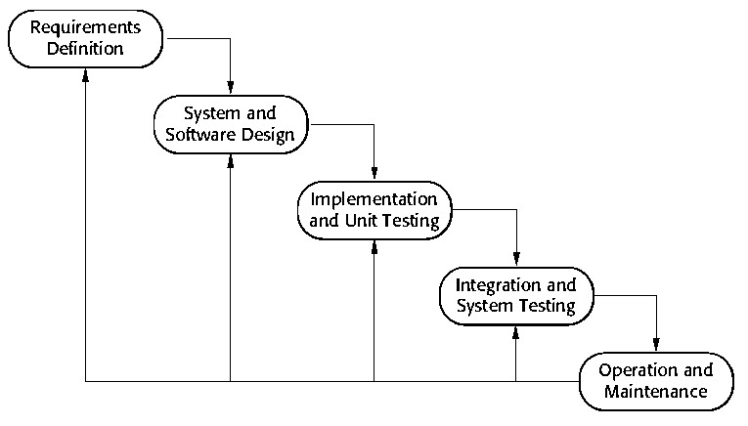
Fig 3. 1: Waterfall Model

3.2 Tools and Technologies Used
The MedTracker has been developed using a carefully selected set of web technologies and tools to ensure reliability, usability, and efficient performance. The system is designed as a web-based application that enables users to manage medicine schedules, receive reminders, and track medication intake effectively. The development utilizes core web technologies along with additional libraries and APIs to provide a complete medication management solution.

3.2.1 Programming Languages and Web Technologies
HTML is used to structure the web pages of the MedTracker system. It defines the layout of forms, dashboards, and medicine management interfaces, allowing users to easily enter and view medication details in an organized manner.CSS is used to design and style the user interface. It helps create a clean, readable, and user-friendly layout, ensuring that the system is visually simple and accessible for all users, including elderly patients. JavaScript is used to add interactivity and dynamic behavior to the system. It handles form validation, alerts, and responsive features that improve user experience and ensure smooth interaction with the web application.

3.2.2 Database Management System
MySQL is used as the database management system for MedTracker. It stores all system data such as user accounts, medicine details, schedules, and intake records. The database is designed with properly related tables to maintain data consistency and allow efficient storage and retrieval of medication information.

3.2.3 Additional Libraries and Tools
Several additional tools were integrated to enhance system functionality. PHPMailer is used for sending email reminders, and the TextBee API is used for SMS notifications. Chart.js is used to display reports and analytics, while jsPDF is used to generate downloadable PDF reports. Task schedulers are used to automate reminder notifications and Jitsi Meet is used for video conference call between patient and health worker.

3.3 Assignment of Roles and Responsibilities
Table 3.1: Assignment of Roles and Responsibilities
Group Member | Roles and Responsibilities
Mridul Prakash Shah (Backend Lead) | 1) Coding:  - PHP backend API — all endpoints (add prescription, login, signup, logout)  - MySQL database schema — users, prescriptions, dose logs, reminders tables  - Authentication system, session management,  - Add Prescription API with custom time slots and frequency validation  - Dose logging and adherence tracking logic  - All SQL queries including JOIN operations and filtered views  - XAMPP server configuration and .htaccess setup  2) Documentation:  - Methodology Chapter  - Feasibility Study (Technical, Operational, Economic, Schedule)  - Database Design: ER Diagram description  - Requirement Gathering table
Om Prakash Basnet  (Testing and Debugging) | 1) Coding:  - JavaScript (script.js) app initialization, localStorage session, logout  - Frontend-backend integration for all form submissions  - Doctor Dashboard and Doctor Schedule pages  - Admin Dashboard with user management views  - Reports module with adherence statistics  - Browser notification reminder system  - Testing and debugging all modules end-to-end  2) Documentation:  - Literature Review  - All Test Cases (Chapter 7)  - DFD Level 1  - ER Diagram  - Functional Requirement
Samir Poudel (Frontend Lead) | 1) Coding:  - Landing page (index.html) hero section, features, How It Works  - Login & Signup UI with password strength indicator  - Role Selection page with three-card expanded layout  - Forgot Password & Reset Password flows (OTP UI)  - Patient Dashboard layout and sidebar navigation  - Medications list page and Add Medicine form with dynamic time slots  - Schedule page (daily/weekly view)  - Settings & Profile page  - Video Conference Module  - SMS API Integration  2) Documentation:  - System Architecture and n-Tier layer description  - Use Case Diagram  - Introduction — Overview, Problem Statement, Objectives  - DFD Level 0 and Level 1  - Final editing and formatting of project report

4 System Design and Analysis

4.1 Requirements Analysis
MedTracker was developed to address the growing need for efficient medication management and adherence tracking across personal and clinical healthcare settings. The requirements were gathered through analysis of existing medication reminder systems, consultation with the multi-role user ecosystem — patients, health workers, and administrators — and study of real-world challenges faced by individuals managing complex medication schedules. The system aims to bridge the gap between patients and their healthcare providers by offering a centralized, role-based platform for medication scheduling, intake logging, adherence monitoring, stock tracking, and care coordination.

4.1.1 Requirement Gathering
Requirements were gathered through analysis of patient medication adherence challenges, identification of communication gaps between doctors and patients, and review of existing manual and digital prescription management practices. The gathered requirements emphasize role-based access control, automated medication reminders, real-time intake logging, stock tracking, water intake monitoring, audit trails, and privacy-preserving coordination between doctors and their linked patients. Table 4.1 summarizes the gathered requirements.
Table 4.1: Requirement Gathering
Requirement ID | Description
R1 | The system shall provide separate authentication mechanisms for Patients, Health Workers, and Admins using phone number and password.
R2 | Patients shall be able to register, link with one or more doctors using a unique doctor code, and manage their own profile and account settings.
R3 | Patients shall be able to view all their own medicines, see who prescribed each medicine, view reminder times, and filter or sort medicines by various criteria.
R4 | Patients shall be able to log doses as Taken, Snoozed, or Skipped when a reminder becomes due.
R5 | Patients shall be able to add self-managed (minor) medicines without affecting doctor-assigned prescriptions.
R6 | Patients shall be able to edit their own reminder times and update stock or refill quantities for their medicines.
R7 | The system shall track daily water intake for each patient.
R8 | The system shall generate adherence reports and progress summaries for patients to monitor their medication compliance.
R9 | Health Workers shall receive a unique doctor/worker code upon registration that patients can use to link with them.
R10 | Health Workers shall be able to view only their own linked patients and manage prescriptions exclusively for those patients.
R11 | Health Workers shall be able to add new prescriptions, manage timing and medicine details, and release or disconnect a patient.
R12 | Health Workers shall be able to monitor patient adherence alerts and view the patient queue from their dashboard.
R13 | Admins shall be able to view a system-wide overview dashboard including usage analytics and prescription audit data.
R14 | Admins shall be able to manage all user accounts including resetting passwords and deleting accounts.
R15 | Admins shall be able to monitor system activity logs and manage reminder settings or rules system-wide.
R16 | Both Patients and Health Workers shall be able to change their own passwords securely from Settings.
R17 | The system shall send automated email and SMS notifications for medication reminders, dose confirmations, missed doses, and refill alerts.
R18 | The system shall enforce privacy rules ensuring doctors cannot view another doctor's prescriptions and patients can clearly see the prescriber’s name for each medicine.
R19 | The system shall maintain a complete audit log of prescription changes, dose logs, and system events.
R20 | The system should track medication stock levels and alert patients when a refill is needed.
R21 | Patients and Health Workers shall communicate through an integrated consultation room that supports real-time text messaging, embedded video calls via Jitsi Meet, and structured appointment scheduling. Health Workers shall be able to set their availability status with an optional note, and patients shall view their linked doctor's availability before initiating a session. The contact panel shall display only role-relevant contacts, ensuring patients see only their linked health workers and vice versa.
R22 | If the patient is login with the guardian details then though the patient logs the medicine is already taken but after that guardian should verify it again whether the medicine was either taken or not.

4.1.2 Functional Requirements
The functional requirements define the specific behaviors and operations the system must perform to meet user needs and business objectives. Each functional requirement is mapped to one or more gathered requirements to ensure full coverage. Table 4.2 details all functional requirements for MedTracker.
Table 4.2: Functional Requirements
Function ID | Description | Cross Reference
F1 | User Authentication: The system shall validate login credentials for Patients, Health Workers, and Admins using phone number and password. Role-based redirection ensures each user lands on the correct dashboard after login. | R1
F2 | Patient Registration: New patients shall register with full name, phone number, email, and password. Role selection is made during signup. The system validates phone number uniqueness before account creation. | R1, R2
F3 | Doctor Linking: Patients shall link to one or more Health Workers by entering a unique doctor/worker code. The system validates the code, confirms the link, and displays the linked doctor's name on the patient dashboard. | R2, R10
F4 | Medicine Overview (Patient): Patients shall view all their medicines in a unified list showing medicine name, dosage, type, prescriber name (doctor or self), reminder times, and remaining stock. | R3
F5 | Medicine Filtering and Sorting (Patient): Patients shall filter medicines by doctor or self-added and sort by name, recently added, or upcoming schedule. | R3
F6 | Dose Logging: Patients shall log each dose as Taken, Snoozed, or Skipped when a reminder becomes due. The system records the action with a timestamp for adherence tracking. | R4
F7 | Self-Managed Medicine Addition: Patients shall add their own minor medicines without altering prescriptions assigned by a health worker. These entries are tagged as self-added and handled separately. | R5
F8 | Reminder Time Editing: Patients shall edit their own reminder times for any medicine and save updated schedules without affecting the prescribing doctor's original configuration. | R6
F9 | Stock and Refill Management: Patients shall update the stock quantity for any medicine. The system tracks remaining doses and triggers a low-stock alert when the quantity falls below a defined threshold. | R6, R20
F10 | Water Intake Tracking: Patients shall log daily water intake through a simple tracker on their dashboard. The system displays progress toward a daily hydration goal. | R7
F11 | Adherence Reports (Patient): The system shall generate patient-facing reports showing completed, missed, snoozed, and skipped doses with trends over time displayed using visual progress indicators. | R8
F12 | Doctor/Worker Code Generation: Upon registration, each Health Worker shall be assigned a unique worker code. This code is displayed on the doctor dashboard and used by patients to initiate a link request. | R9
F13 | Linked Patient Management (Health Worker): Health Workers shall view only their own linked patients on their dashboard. Each patient record shows linked medicines, adherence status, and alerts. | R10, R12
F14 | Prescription Management (Health Worker): Health Workers shall add new prescriptions for linked patients including medicine name, dosage, type, frequency, reminder times, and instructions. Doctors cannot view or edit another doctor's prescriptions. | R10, R11, R18
F15 | Patient Release: Health Workers shall disconnect a patient from their account. Upon release, the patient remains in the system but the doctor's prescriptions are no longer editable by the doctor. | R11
F16 | Patient Queue and Alerts: Health Workers shall view a real-time patient queue and receive alerts for patients with missed doses or critically low medication adherence. | R12
F17 | Admin System Dashboard: Admins shall view a system-wide overview including total users, active sessions, prescription counts, adherence averages, and platform usage analytics. | R13
F18 | User Account Management (Admin): Admins shall search, view, reset passwords for, and delete any Patient, Health Worker, or Admin account from the admin panel. | R14
F19 | System Logs and Audit Trail: Admins shall access detailed logs of all system events including login activity, prescription changes, dose logs, and notification dispatches. | R15, R19
F20 | Reminder Settings Management (Admin): Admins shall configure system-wide reminder rules including default reminder windows, snooze durations, and notification frequency caps. | R15
F21 | Password Management: Both Patients and Health Workers shall change their passwords from Settings after validating their current password. New password must meet minimum security requirements and match the confirmation field. | R16
F22 | Email Notifications: The system shall send HTML-formatted emails via SMTP for medication reminders, missed dose alerts, refill warnings, and appointment-related updates. | R17
F23 | SMS Notifications: The system shall send SMS messages for time-sensitive medication reminders and missed dose alerts. | R17
F24 | Privacy Enforcement: The system shall ensure that each Health Worker can only view patients linked to them and only medicines they personally prescribed. A patient's medicines from different doctors are shown to the patient but never cross-shared between doctors. | R18
F25 | Video Consultation: Patients and Health Workers shall communicate through a shared consultation room supporting real-time text messaging, video calls powered by Jitsi Meet, and structured appointment scheduling. Health Workers shall be able to set their availability status with an optional note. Patients shall view their linked doctor’s availability status before initiating a session. Both roles shall send and receive messages and book or view appointments within the platform. | R21
F26 | Multi verification of medicine log: If the patient is login with the guardian details then though the patient logs the medicine is already taken but after that guardian will verify it again whether the medicine was either taken or not. | R22

4.2 Feasibility Study

4.2.1 Technical Feasibility
The technical feasibility analysis confirms that MedTracker can be developed effectively with the technology stack and skills available to the development team. The system is built on widely adopted and well-documented technologies including HTML5, CSS3, JavaScript, PHP, and MySQL all of which are free to use and supported by large developer communities. The team possesses the required knowledge of frontend development, backend API design, relational database management, and REST communication. Additional integrations such as the TextBee API for SMS and SMTP for email are well-documented and straightforward to configure. The system is designed to run on standard web hosting infrastructure without requiring specialized hardware. A modular architecture ensures that individual components such as the notification engine, reporting module, and dose tracker can be developed, tested, and maintained independently. Therefore, MedTracker is technically feasible. The Video Consultation module is built using Jitsi Meet, a free and open-source video conferencing solution that requires no additional server setup or licensing cost. It is integrated via an embeddable external API, making it straightforward to implement within the existing web-based architecture. Real-time messaging and appointment scheduling are handled through standard PHP and MySQL, consistent with the existing technology stack. No specialized hardware or infrastructure is required to support this module.

4.2.2 Operational Feasibility
The operational feasibility analysis shows that MedTracker will be readily accepted and effectively used by its three primary user groups. The system resolves critical pain points: patients frequently forget doses or lose track of their stock, doctors lack a direct channel to monitor their patients' adherence, and administrators have no centralized view of system-wide medication activity. MedTracker addresses each of these with intuitive role-specific dashboards, automated reminders, stock alerts, and a comprehensive admin panel. The interface uses familiar web UI patterns, requiring minimal training for first-time users. The multi-role architecture means that patients, doctors, and administrators each see only what is relevant to them, reducing cognitive overhead. Privacy controls ensure that doctors cannot access another doctor's prescriptions, building trust across the user base. The system is browser-based and does not require installation, making adoption straightforward across devices. The Video Consultation module directly addresses a key gap in patient-doctor communication by eliminating the need for in-person visits for routine follow-ups. Patients can check their doctor's availability status before initiating a session, reducing wasted attempts. The familiar chat and video call interface requires minimal learning effort for both patients and health workers, fitting naturally into their existing care workflow. Overall, MedTracker fits naturally into existing healthcare and personal health management workflows and is operationally feasible.

4.2.3 Economic Feasibility
MedTracker is economically feasible and demonstrates strong financial viability. The project requires an initial investment of NPR 175,000 covering labor, documentation, hardware, API setup, training, and contingency. Annual operating costs range from NPR 31,000 in Year 1 to NPR 40,000 by Year 5, covering hosting, maintenance, technical support, and API fees. The system generates measurable annual benefits by improving patient adherence, reducing missed consultations, eliminating manual prescription tracking, and reducing administrative overhead for health workers. Benefits grow from NPR 120,000 in Year 1 to NPR 188,000 by Year 5.
Table 4.3: Initial Development Cost
Cost Component | Description | Estimated Cost (NPR)
Labor Cost (Development) | 3 developers × 2 months × NPR 15,000 | 90,000
System Design & Documentation | Diagrams, reports, and testing documents | 15,000
Hardware & Utilities | Laptop usage, hosting, internet, electricity | 20,000
SMS / Email / Video Conference API Setup | TextBee, Jitsi Meet SMTP initial configuration and credits | 10,000
Training & Deployment | Health worker and admin orientation and setup | 20,000
Contingency Cost | Unexpected or miscellaneous expenses | 20,000
Total Initial Investment |  | 175,000
Table 4.4: Net Cash Flow Analysis
Year | Annual Benefits (NPR) | Operating Costs (NPR) | Net Cash Flow (NPR)
1 | 120,000 | 31,000 | 89,000
2 | 135,000 | 33,000 | 102,000
3 | 150,000 | 35,000 | 115,000
4 | 165,000 | 38,000 | 127,000
5 | 188,000 | 40,000 | 148,000

Payback Period (PBP)
The Payback Period determines how quickly the initial investment is recovered.
Formula:
PBP = Year before recovery + (Remaining Investment / Next Year NCF)
Cumulative Cash Flow:
- Year 1 = 89,000
- Year 2 = 191,000
Calculation:
PBP = 1 + (175,000 − 89,000) / 102,000
PBP = 1.84 years ≈ 1 year 10 months
The investment is recovered in less than 2 years, indicating low financial risk.
Net Present Value (NPV)
Formula:
PV = NCF/${\left(1+r\right)}^{t}$
NPV = ΣPV − Initial Investment
(Discount Rate = 12%)
Table 4.5: Calculation of NPV
Year | NCF (NPR) | Present Value (NPR)
1 | 89,000 | 79,464
2 | 102,000 | 81,309
3 | 115,000 | 81,847
4 | 127,000 | 80,710
5 | 148,000 | 83,998
NPV Calculation:
NPV = 79,464 + 81,309 + 81,847 + 80,710 + 83,998 − 175,000
NPV ≈ NPR 240,559
Positive NPV confirms the project is financially viable.
Internal Rate of Return (IRR)
The IRR is the discount rate at which NPV = 0.
Using financial calculation methods:
IRR ≈ 48.7%
This is significantly higher than the required return (12–15%), indicating high profitability.
Table 4.6: Summary of Financial Metrics
Metric | Value
Payback Period | 1 year 10 months
Net Present Value | NPR 240,559
Internal Rate of Return | 48.7%
Commercial Value and Selling Price
From a commercial perspective, MedTracker has strong market potential. Its key features include:
- Automated appointment and medication reminders
- Centralized digital health records
- SMS/Email notification system
- Report generation (PDF)
- Improved healthcare workflow efficiency
The system can be marketed to:
- Clinics and hospitals
- NGOs and health organizations
- Government health centers
Estimated Selling Price: NPR 150,000 per system
Conclusion
The economic analysis shows that MedTracker is financially sound. It offers:
- Short payback period
- High NPV
- Strong IRR
- Low operational cost
Thus, the system ensures quick investment recovery, low financial risk, and long-term sustainability, making it a highly feasible and profitable healthcare solution

4.2.4 Schedule Feasibility
The schedule feasibility analysis confirms that the project can be delivered within a planned 16-week timeframe, spanning from February through May. The project begins with discussion and initiation (February W1–W3), followed by requirement analysis (February W2–W4) and system design (February W3–March W1). Frontend and backend development are carried out in parallel from March W2 to May W1, while testing runs from March W4 to May W1. Bug fixing is performed from April W2 to May W4, and documentation is maintained continuously from February W1 to May W4. The overlapping activities and proper task distribution confirm that the project is schedule feasible within the proposed timeframe.
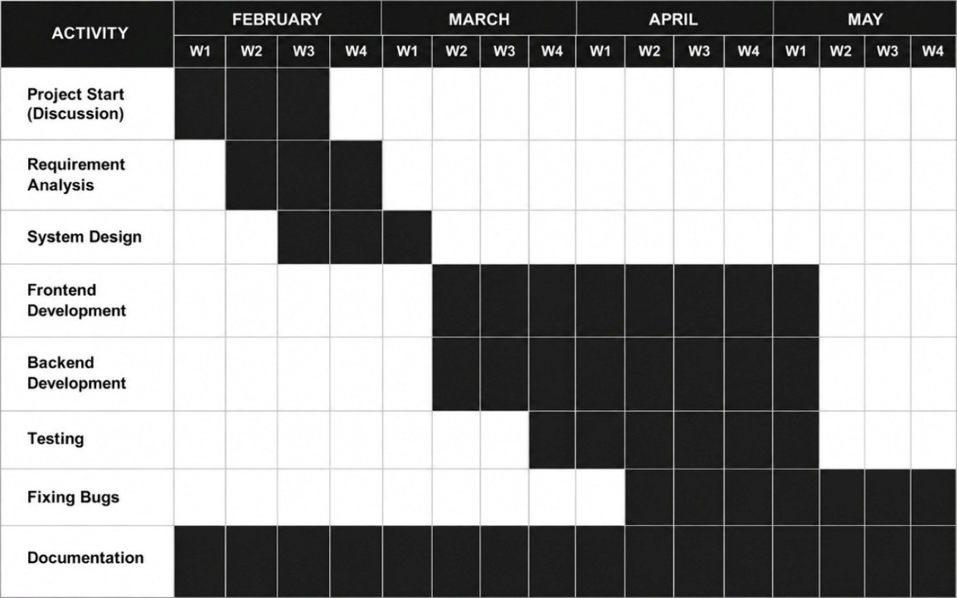
Fig 4.1: Gantt Chart

5 System Design

5.1 System Architecture
MedTracker follows a multi-tier architecture that separates the presentation layer, business logic layer, data access layer, and external integration layer. This architectural pattern ensures modularity, maintainability, and scalability of the system. Each layer has a well-defined responsibility and communicates with adjacent layers through clearly defined interfaces, preventing tight coupling and enabling independent modification of any layer. The architecture tier layer is described in architectural components below:

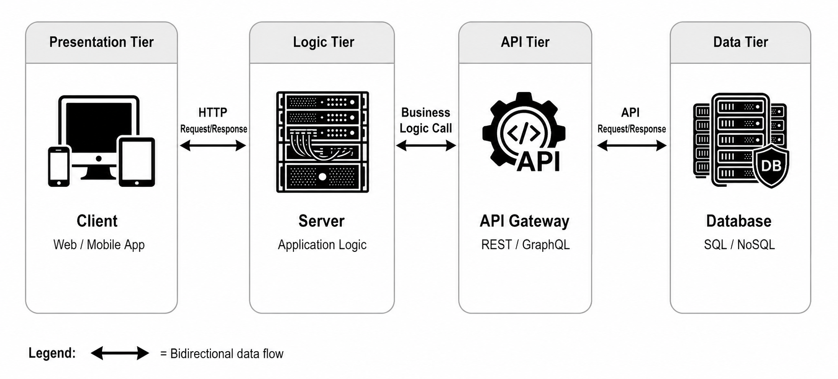
Fig 5.1: System Architecture

5.1.1 Architectural Components
Table 5.1: System Architecture Components
Layer | Technology | Description
Presentation Layer | HTML, CSS, JavaScript (Vanilla) | Provides role-based interfaces for Patient, Health Worker, and Admin. Handles user input validation, form interactions, and display of system responses. Includes all dashboard pages, auth screens, and settings.
Business Logic Layer | JavaScript (Frontend Logic) / PHP (Backend API) | Contains core application logic, role enforcement, medication scheduling calculations, adherence computations, snooze/skip logic, and notification triggering. Processes user requests and performs data validation before calling the database layer.
Data Access Layer | MySQL + PHP (PDO) | Handles all database interactions. Manages CRUD operations for users, medicines, prescriptions, dose logs, and audit records. Ensures data integrity through transactions and foreign key constraints.
External Integration Layer | TextBee API, SMTP (Email), SMS Gateway, Jitsi Meet | Delivers automated SMS and email notifications for reminders, missed doses, refill alerts, account events and video conferencing. Decoupled from core logic so notification channels can be swapped independently.

5.2 Procedure Oriented Diagram

5.2.1 Context Diagram (DFD Level 0)

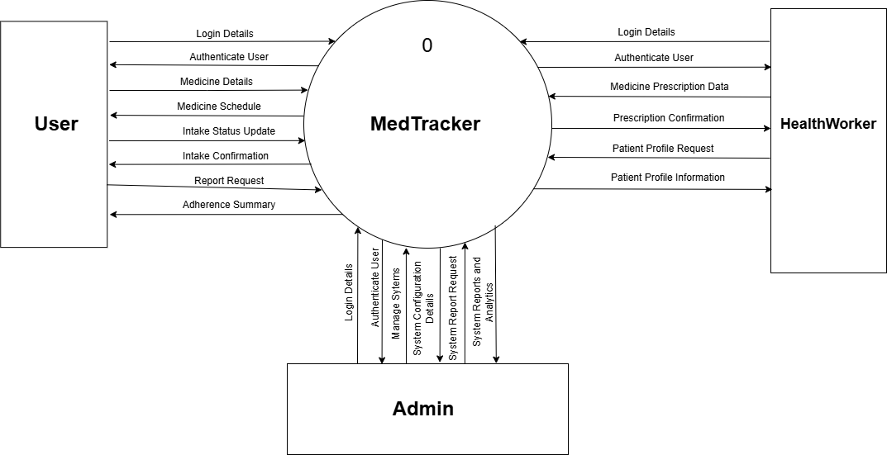
Fig 5.2: DFD Level 0

5.2.2 Data Flow Diagram (Level -1)

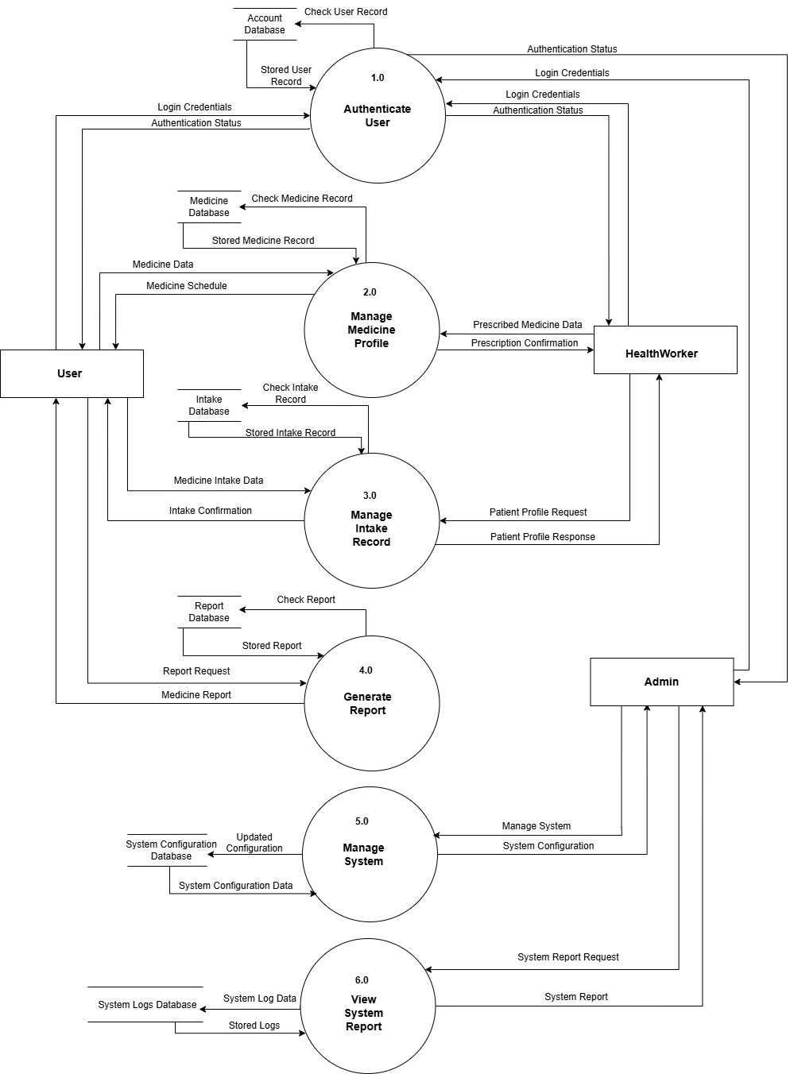
Fig 5. 3: DFD Level 1

5.2.3 Use Case Diagram

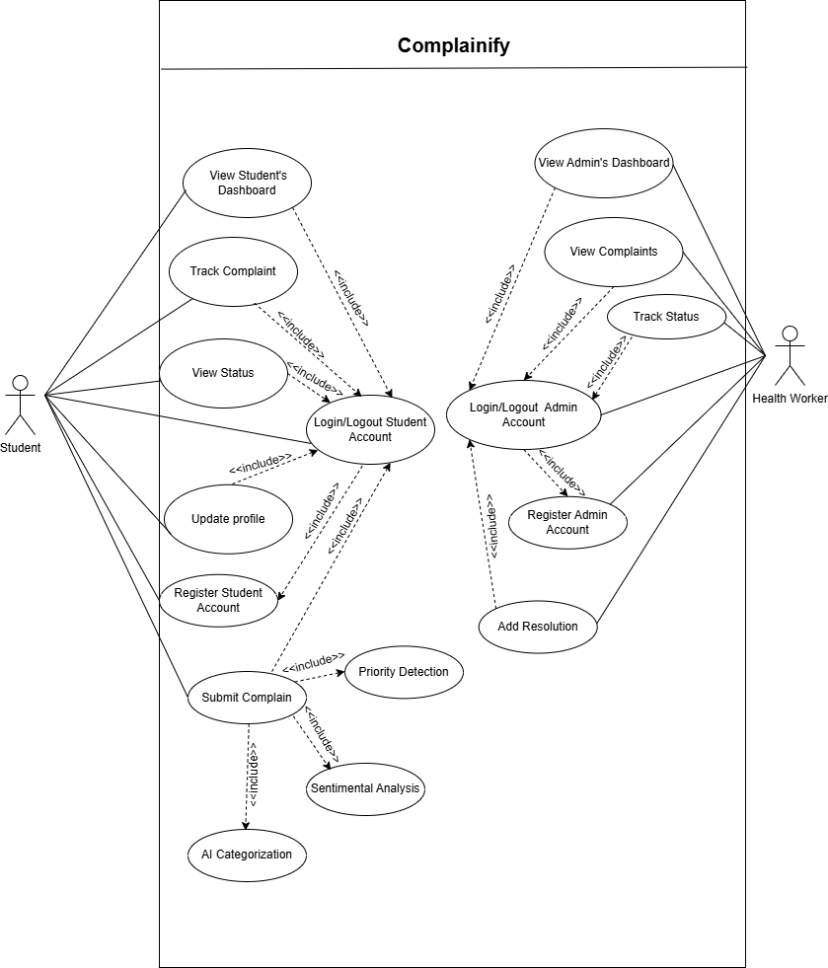
Fig 5. 4: Use Case Diagram

5.3 Database Design

5.3.1 E-R Diagram
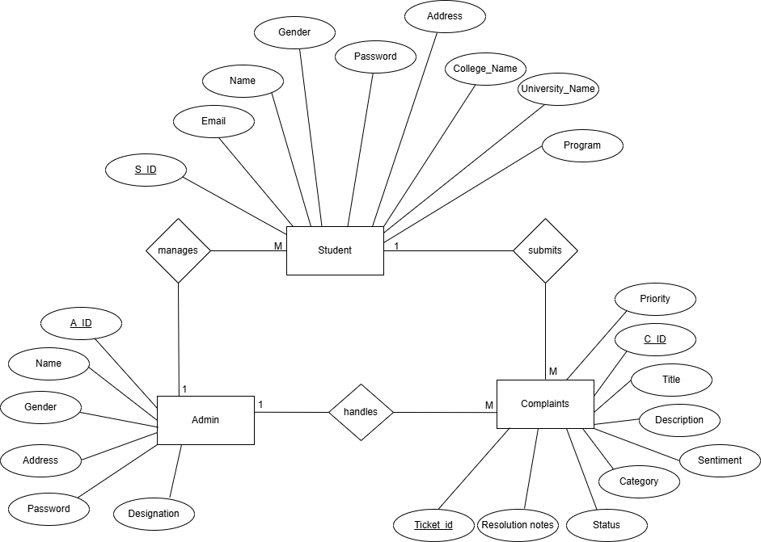

Fig 5. 5: ER Diagram

5.4 Role Based Design
Table 5.2: Role-Based Access Control Matrix
Feature / Action | Patient | Health Worker | Admin
View own medicines | Yes | No | No
Add self-managed medicines | Yes | No | No
Log dose (Taken / Snoozed / Skipped) | Yes | No | No
Edit own reminder times | Yes | No | No
Update stock / refill quantity | Yes | No | No
Track water intake | Yes | No | No
View adherence reports | Yes | No | No
Link / unlink doctor | Yes | No | No
View linked patients | No | Yes | No
Add / manage prescriptions | No | Yes | No
View patient adherence alerts | No | Yes | No
Release patient | No | Yes | No
View system overview dashboard | No | No | Yes
Manage all user accounts | No | No | Yes
Reset any user password | No | No | Yes
Delete user accounts | No | No | Yes
View system audit logs | No | No | Yes
Manage reminder rules | No | No | Yes
Change own password | Yes | Yes | Yes
Video Conference Meet | Yes | Yes | No

6 System Development and Implementation

6.1 Programming Platforms
1. Frontend Technologies: HTML, CSS, JavaScript
- Core technologies used to design and develop the user interface.
- HTML structures the web pages, CSS styles the layout, and JavaScript adds interactivity and validation.
- Together they create a simple and user-friendly web interface.
2. Backend Language: PHP
- Used to handle server-side logic and system functionality.
- Manages user authentication, medicine scheduling, reminders, and database operations.
- Provides secure communication between the frontend and database.
3. Development Environment: Visual Studio Code
- Used for writing, editing, and testing the project code.
- Provides useful extensions, debugging tools, and integrated terminal support.
- Helps maintain clean and organized project files.
4. Local Server Environment: XAMPP
- Used to run Apache server and MySQL database locally.
- Allows testing of the web application in a local environment before deployment.
- Provides PHP and database integration support.
5. Database System: MySQL
- Used to store user data, medicine details, schedules, and intake records.
- Ensures reliable data storage and retrieval.
- Maintains relationships between system tables.
6. Additional Libraries and APIs
- PHPMailer → Used to send email reminders.
- Twilio API → Used to send SMS notifications.
- Chart.js → Used to generate charts and reports.
- jsPDF → Used to generate PDF reports.
- Jitsi Meet→ Used for video conference between Patient/User and Health Worker.
- TextBee →Used for the SMS reminder system

6.2 Hardware and Software Requirements

6.2.1 Hardware Requirements
Minimum Requirements
- Processor: Dual-Core CPU (Intel i3 or equivalent)
- RAM: 4 GB
- Storage: 500 MB free space
- Display: 1366 × 768 resolution
- Keyboard and Mouse required
Recommended Requirements
- Processor: Intel Core i5 or higher
- RAM: 8 GB
- Storage: 1 GB free space
- Display: Full HD (1920 × 1080)

6.2.2 Software Requirements
- Operating System: Windows / Linux / macOS
- Web Browser: Google Chrome or any modern browser
- Code Editor: Visual Studio Code
- Server Environment: XAMPP
- Database: MySQL
- Backend Language: PHP
- Frontend: HTML, CSS, JavaScript

7 Testing and Debugging

7.1 Testing Approach
MedTracker was tested using a multi-level testing strategy covering unit testing, integration testing, and user acceptance testing. Unit tests verified the correctness of individual API endpoints and form validation logic in isolation. Integration tests confirmed that frontend pages correctly communicate with backend endpoints and that data flows as expected from user input through to database storage. User acceptance testing was performed by simulating real-world usage scenarios for each of the three user roles Patient, Health Worker, and Admin to confirm that the system behaves correctly from an end-user perspective.

7.2 Testing Tools
Table 7.1: Testing Tools
S.N. | Tool | Specification / Purpose
1 | Hardware | Laptop with 8 GB RAM, Intel Core i5 processor – used to run XAMPP, MySQL, and browser simultaneously during testing
2 | Web Browser | Google Chrome (latest) and Mozilla Firefox – used to render and interact with all frontend pages and inspect the frontend pages.
3 | XAMPP / Apache | Local web server environment hosting the PHP backend and MySQL database for development and testing
4 | MySQL 8.0 | Relational database; tables verified directly via phpMyAdmin to confirm correct data storage and constraint enforcement
5 | Postman | This API tool was used for testing SMS notification delivery tested using registered test phone numbers for TextBee and for testing email notifications with real Gmail addresses to verify formatting, delivery, and error handling for phpmailer library.

7.3 Test Cases
The following tables document test cases organized by module. Each test case records the test ID, description, input conditions, expected output, actual output observed during testing, and the final status (Pass or Fail). Where initial failures were encountered during development cycles, they have been resolved and confirmed as Pass in the final build. The test IDs follow the ModuleNumber.TestNumber for easy cross-referencing.

7.3.1 Login Module
Table 7.2: Login Module
TC ID | Description | Input | Expected Output | Actual Output | Status
1.1 | Valid login Patient role | Correct phone password (Patient account) | Patient dashboard opens | Patient dashboard opens | Pass
1.2 | Valid login Health Worker role | Correct phone password (Health Worker account) | Doctor dashboard opens | Patient dashboard opens | Fail
1.3 | Retest of 1.2 | Correct phone password (Health Worker account) | Doctor dashboard opens | Doctor dashboard opens | Pass
1.4 | Valid login Admin role | Correct phone password (Admin account) | Admin dashboard opens | Admin dashboard opens | Pass
1.5 | Empty phone field | Blank phone number, valid password | Validation error shown | Validation error shown | Pass
1.6 | Empty password field | Valid phone, blank password | Validation error shown | Validation error shown | Pass
1.7 | Wrong password | Valid phone, incorrect password | Error: Invalid credentials | Error: Invalid credentials | Pass
1.8 | Non-existent phone number | Phone not registered in system | Error: Account not found | Error: Account not found | Pass
1.9 | Password with less than 6 characters | 3-character password | Error: Password too short. | Password was accepted. | Fail
1.10 | Retest of 1.9 | 3-character password | Error: Password too short. | Error: Password too short. | Pass

7.3.2 Sign Up Module
Table 7.3: Sign Up Module
TC ID | Description | Input | Expected Output | Actual Output | Status
2.1 | Valid patient registration | Full name, valid phone, email, strong password, role=Patient | Account created, redirected to login | Account created, redirected to login | Pass
2.2 | Valid health worker registration | Full name, phone, email, password, designation, role=Health Worker | Account created, unique worker code assigned | Account created, unique worker code assigned | Pass
2.3 | Valid admin registration | Full name, phone, email, strong password, role=Admin | Account created, redirected to login | Account created, redirected to login | Pass
2.4 | Duplicate phone number | Phone number already registered in system | Error: Phone number already in use | Error: Phone number already in use | Pass
2.5 | Missing full name | Blank name field, valid rest of form | Validation error: Name required | Validation error: Name required | Pass
2.6 | Invalid email format | Email without '@' or domain | Error: Invalid email address | Error: Invalid email address | Pass
2.7 | Password strength indicator | Type password of varying lengths and complexity | Strength segments update in real time | Strength segments update in real time | Pass
2.8 | Patient links doctor code on signup | Valid health worker code entered in HW Code field | Doctor link established after account creation | Doctor doesn’t link established after account creation | Fail
2.9 | Retest of 2.8 | Valid health worker code entered in HW Code field | Doctor link established after account creation | Doctor link established after account creation | Pass
2.10 | Invalid doctor code on signup | Non-existent health worker code entered | Error: Doctor code not found | Error: Doctor code not found | Pass

7.3.3 Forgot Password / Reset Password Module
Table 7.4: Forgot Password and Reset Password Module
TC ID | Description | Input | Expected Output | Actual Output | Status
3.1 | Valid phone OTP sent | Registered phone number entered | OTP sent to phone, redirect to reset page | OTP sent, redirected to reset page | Pass
3.2 | Unregistered phone number | Phone not in system | Error: Phone not found | Error: Phone not found | Pass
3.3 | Empty phone field | Blank phone field submitted | Validation error: Phone required | Validation error: Phone required | Pass
3.4 | Valid OTP + new password | Correct OTP and new password entered | Password updated, redirected to login | Password updated, redirected to login | Pass
3.5 | Wrong OTP entered | Incorrect 6-digit OTP submitted | Error: Invalid or expired OTP | Error: Invalid or expired OTP | Pass
3.6 | OTP expiry | OTP submitted after expiry. | Error: OTP has expired | Error: OTP has expired | Pass

7.3.4 Add Medicine Module (Patient)
Table 7.5: Add Medicine Module
TC ID | Description | Input | Expected Output | Actual Output | Status
4.1 | Add self-managed medicine once daily | Name, dosage, type, quantity, 1x daily, 1 reminder time | Medicine saved, appears in list as self-added | Medicine saved, listed as self-added | Pass
4.2 | Add medicine twice daily | Name, dosage, type, 2x daily, 2 reminder times | Two reminders saved per day | Two reminders set and saved | Pass
4.3 | Add medicine three times daily | Name, dosage, type, 3x daily, 3 reminder times | Three reminders saved per day | Three reminders set and saved | Pass
4.4 | Submit without reminder times | Frequency set but no times entered | Error: Enter all required reminder times | Error message shown | Pass
4.5 | Missing medicine name | Blank name field | Validation error: Name required | Validation error shown | Pass
4.6 | Missing dosage field | Blank dosage | Validation error: Dosage required | Validation error shown | Pass
4.7 | Invalid quantity (0 or negative) | Quantity = 0 | Error: Quantity must be at least 1 | Error shown | Pass
4.8 | Edit own reminder times | Change existing reminder time for a self-added medicine | Updated reminder time saved | Reminder time updated | Pass
4.10 | Filter by doctor-prescribed | Apply filter: by doctor | Only doctor prescribed medicines shown | Only doctor-prescribed shown | Pass
4.11 | Sort by name | Select sort: name A-Z | List sorted alphabetically | Alphabetical order applied | Pass
4.12 | Sort by recently added | Select sort: recently added | Most recently added medicine appears first | Latest medicine appears first | Pass

7.3.5 Dose Logging and Stock Management Module
Table 7.6: Dose Logging and Stock Management Module
TC ID | Description | Input | Expected Output | Actual Output | Status
5.1 | Log dose as Taken | Click Taken when reminder is due | Dose logged as Taken with timestamp | Dose logged as Taken | Pass
5.2 | Snooze dose reminder | Click Snooze when reminder is due | Reminder rescheduled by snooze interval | Reminder rescheduled correctly | Pass
5.3 | Skip dose | Click Skip when reminder is due | Dose logged as Skipped with timestamp | Dose logged as Skipped | Pass
5.4 | Log dose no stock left | Attempt to log when stock quantity = 0 | Warning: Stock empty, prompt to refill | Warning shown, log blocked | Pass
5.5 | Stock decrements on Taken | Stock = 10, log one dose as Taken | Stock reduces to 9 | Stock updated to 9 | Pass
5.6 | Low stock alert triggered | Reduce stock to threshold level | Low stock alert appears on dashboard | Alert displayed on dashboard | Pass
5.7 | Refill stock | Update stock quantity to 30 | Stock updated, alert dismissed | Stock updated, alert cleared | Pass

7.3.6 Health Worker Panel Module
Table 7.7: Health Worker Panel Module
TC ID | Description | Input | Expected Output | Actual Output | Status
6.1 | Doctor code generated | Register as Health Worker | Unique doctor code displayed on dashboard | Unique code shown | Pass
6.2 | Patient links using doctor code | Patient enters valid doctor code on signup | Patient appears in doctor's linked list | Patient appears in list | Pass
6.3 | Add prescription for patient | Doctor selects patient, fills prescription form | Medicine saved under patient with doctor as prescriber | Medicine saved, prescriber shown as doctor | Pass
6.4 | Doctor cannot see other doctor's patients | Login as Doctor A, view patient list | Only Doctor A's patients shown | Only Doctor A's patients visible | Pass
6.5 | Doctor cannot see other doctor's prescriptions | Login as Doctor A | Only Doctor A's prescriptions visible | Other doctor's prescriptions hidden | Pass
6.6 | Release patient | Doctor clicks 'Release Patient' | Patient removed from doctor's list | Patient removed from list | Pass
6.7 | View patient queue | Navigate to patient queue | All linked patients listed with last activity | Queue displayed with activity data | Pass
6.8 | Add prescription missing dosage | Submit form without dosage field | Validation error: Dosage required | Validation error shown | Fail
6.9 | Retest of 6.8 | Submit form without dosage field | Validation error: Dosage required | Validation error not shown | Pass

7.3.7 Admin Panel Module
Table 7.8: Admin Panel Module
TC ID | Description | Input | Expected Output | Actual Output | Status
7.1 | View system dashboard | Login as Admin, open dashboard | User counts, prescription stats, usage data shown | Overview data displayed | Pass
7.2 | View all user accounts | Navigate to User Management | All patients, doctors, admins listed | All accounts listed | Pass
7.3 | Search user by name | Type name in search box | Matching user account displayed | Matching account shown | Pass
7.4 | Search user by phone | Type phone number in search box | Matching user account displayed | Matching account shown | Pass
7.5 | Reset user password | Admin selects user, clicks Reset Password | User's password reset to default; user notified | Password reset; notification sent | Pass
7.6 | Delete patient account | Admin selects account, clicks Delete | Account removed from system | Account deleted | Pass
7.7 | View audit logs | Navigate to Audit Logs section | Timestamped log of all system events shown | Audit log displayed | Pass
7.8 | Filter audit logs by date | Select date range in audit log filter | Logs filtered to selected date range | Filtered logs shown | Pass
7.9 | View prescription audit data | Navigate to Prescription Audit section | All prescription add/edit/delete events shown | Prescription events listed | Pass
7.10 | Manage reminder settings | Navigate to Reminder Settings, change snooze duration | New snooze duration saved and applied | Setting saved | Pass

7.3.8 Password Management Module
Table 7.9: Password Management Module
TC ID | Description | Input | Expected Output | Actual Output | Status
8.1 | Change password: Patient | Enter correct current password, new password, confirm | Password updated, session re-authenticated | Password updated | Pass
8.2 | Change password: Health Worker | Enter correct current password + new password | Password updated | Password updated | Pass
8.3 | Wrong current password | Enter incorrect current password | Error: Current password incorrect | Error shown | Pass
8.4 | New passwords don't match | Enter different values in new and confirm fields | Error: Passwords do not match | Error shown | Pass
8.5 | New password too short | Enter 3-character new password | Error: Minimum password length not met | Error shown | Pass

7.3.9 Notification System Module
Table 7.10: Notification System Module
TC ID | Description | Input | Expected Output | Actual Output | Status
9.1 | Email sent on reminder due | Reminder time reached, user has email registered | Email notification delivered to inbox | Email delivered | Pass
9.2 | SMS sent on patient side | Medicine was scheduled from the doctor side | SMS should be delivered to patient phone number | SMS delivered | Pass
9.3 | Medicine Verification Medicine alert to guardian | Patient log as medicine alert | SMS should send about that patient log the medicine | Email alert sent | Pass

7.3.10 Video Consultation Module
Table 7.11: Video Consultation Module
TC ID | Description | Input | Expected Output | Actual Output | Status
10.1 | Contact list loads by role | Login as Patient, open Video Consultation | Linked doctor(s) listed in contact panel | Linked doctor listed in contact panel | Pass
10.2 | Send a message to contact | Select contact, type message, click Send | Message appears in thread with sender name and timestamp | Message displayed in thread correctly | Pass
10.3 | Join Jitsi Meet video call | Select contact, click Start / Join Call | Jitsi Meet room loads in the video frame for both sides | Video room loaded; Leave button activated | Pass
10.4 | Leave video call | Click Leave while in active call | Video frame returns to placeholder, Leave button disabled | Call ended, placeholder shown | Pass
10.5 | Doctor sets availability to Active | Login as Health Worker, click Active in availability panel | Status saved as Active; green dot shown to linked patients | Active status saved and visible to patients | Pass
10.6 | Book a video appointment | Select contact, enter date/time and optional note, submit form | Appointment saved and listed in appointment panel for both sides | Appointment saved and shown in list | Pass
10.7 | Appointment without date/time | Submit appointment form with empty date/time field | Validation error: date and time required | Validation error displayed | Pass

7.3.11 Medicine Logging Verification Module
Table 7.12: Medicine Logging Module
TC ID | Description | Input | Expected Output | Actual Output | Status
11.1 | Email goes to user with button | Patient logs the medicine as taken if they login with caretaker | Email goes to the guardian for verification with two button which is Verified or No | Email delivered | Pass
11.2 | Medicine marked as taken after pressing Verified button | Verified button was pressed | Positive message should be display in next page and in dashboard be update. | Expected output met. | Pass

8 Conclusion
MedTracker is a web-based medication management system that successfully achieves its primary objectives, such as secure login, manual prescription entry, dosage and quantity management by health workers (doctors or pharmacists), scheduling reminder times by patients or caregivers after prescriptions are provided, adherence tracking and report generation, and video consultation and text messaging between patients/caregivers and health workers. It also includes verification of medicine intake by the guardian, while reminders are sent to patients and caregivers through SMS or email. The system is monitored by the administrator and is developed using the Waterfall model as an SDLC approach. During testing and debugging, a couple of features were identified as failed, but they were later fixed, and overall, the testing and debugging showed positive results.
Although it achieves its primary objectives, there are some limitations, such as a lack of multi-language support, no integration with individual hospitals or pharmacies, and the absence of advanced AI-based medication recommendation features. Additionally, the SMS reminder functionality depends on TextBee API credit limitations, which can be improved as a future enhancement. Other future improvements may include AI-based chatbots and payment integration for appointments with health workers. During development, we also faced several challenges, such as integrating the video conferencing API, finding an SMS API with sufficient free credits, and frequent XAMPP port crashes, which sometimes caused database loss. Overall, we enjoyed working on this project and gained practical knowledge of implementing core web technologies. Beyond classroom learning, the project provided us with an opportunity to explore and work with various APIs and libraries used during development.

References
Abdul Minaam, D. S., & Abd-ELfattah, M. (2018). Smart drugs: Improving healthcare using smart pill box for medicine reminder and monitoring system. Future Computing and Informatics Journal, 3(2), 443–456. Retrieved May 28, 2026, from https://doi.org/10.1016/j.fcij.2018.11.008

Mohanty, C., Saranya, S., Carolina Jennifer, S., & Raj, R. (2025). A smart pill reminder with configurable alerts, multi-modal notifications, and integrated health monitoring for medical adherence. Journal of ISMAC, 7(2), 125–140. Retrieved May 28, 2026, from https://doi.org/10.36548/jismac.2025.2.002

Shekar, K., Madhu, R., Naik, L., & Vinod, T. (2023). Medicine reminder system using JAVA. International Journal of Advanced Research in Science, Communication and Technology, 3(1), 87–91. Retrieved May 28, 2026, from https://doi.org/10.48175/IJARSCT-12917

