A Case Study
On
Personal Expense Tracker
Submitted partial fulfillment of the requirement of
Software Engineering (BIT 354CO)

Submitted By:
Samir Poudel (Roll No: 33)
Submitted To:
Ananta Bhadra Lamichhane
KANTIPUR CITY COLLEGE
Putalisadak, Kathmandu
August, 2026

Acknowledgement
I would like to express my sincere gratitude to our respected teacher, Mr. Ananta Bhadra Lamichhane, for his valuable guidance, support, and encouragement throughout the preparation of this case study for the Software Engineering subject. His teaching, knowledge, and suggestions helped us understand the concepts of software engineering and apply them practically while working on this case study.
I am truly thankful for the opportunity provided by him to explore real-world software engineering practices and enhance our analytical and problem-solving skills. I would also like to thank everyone who supported us directly or indirectly during the completion of this work. His dedication and continuous guidance have played an important role in making this case study successful.

Table of Contents

Acknowledgement 2
Table of Contents 3
Chapter 1: Introduction 5
1.1 Background 5
1.2 Problem Statement: 5
1.3 Introduction 6
1.3.1 Project Objectives 6
1.3.2 System Scope 6
1.3.3 Project Scope 6
1.3.4 Nature of Anticipated Software 7
1.3.5 Essential Characteristics of Anticipated Software 7
1.4 Project Packaging 7
1.4.1 Work Breakdown Structure (WBS) 7
1.4.2 Deliverance and Milestones 8
1.4.3 Acceptance Criteria 8
1.4.4 Project Approach 9
1.5 Project Resourcing 10
1.5.1 Quality Requirements 10
1.5.2 Process Requirements 10
1.5.3 Method Requirements 11
1.5.4 Resource Requirements 12
Chapter 2: Planning and Management 14
2.1 Project Risks 14
2.1.1 Identified Risk 14
2.1.2 Mitigation Risk 15
2.1.3 Contingency Plan 15
2.1.4 Risk Monitoring Plan 16
2.2 Project Estimation and Schedule 17
2.2.1 Estimation Method Used 17
2.2.2 Project Estimation 17
2.2.3 Project Schedule 18
2.3 Configuration Management Plan 18
2.3.1 Change Management Plan 18
2.3.2 Version Management Plan 19
2.3.3 Release Management Plan 19
Chapter 3: System Engineering 20
3.1 Requirements 20
3.1.1 Domain Requirements 20
3.1.2 Functional Requirements 20
3.1.3 Non-Functional Requirements 21
3.1.4 Requirement Management Process 21
3.2 Design 23
3.2.1 System Architecture 23
3.2.2 High Level Designs 24
3.2.3 Data Structure Design 25
3.3 Testing 26
3.3.1 Test Justification 26
3.3.2 Test Plan 27
3.3.3 Test Design 28
Chapter 4: Monitoring & Control 31
4.1 Monitoring & Control 31
4.1.1 Time Monitoring 31
4.1.2 Cost Monitoring 31
4.1.3 Control Measures 31
Annex 1: Requirement Models 32

Chapter 1: Introduction

Background
Managing personal finances has become increasingly important in today’s digital lifestyle. Individuals track daily expenses, income, and savings to maintain financial discipline. Traditional methods such as notebooks or simple spreadsheets are error-prone, time-consuming, and lack analytical features. A dedicated desktop application developed in Python can provide an efficient, offline, and user-friendly solution for recording, categorizing, and analyzing personal expenses.

Problem Statement:
Managing personal expenses effectively remains a major challenge for many individuals. Several limitations in existing methods and systems contribute to poor financial tracking and reduced control over spending. The major problems are:
Specific: Manual notebooks and spreadsheets fail to record daily income/expense transactions with proper categorization, leading to disorganized financial data.
Measurable: Over 70% of individuals using notebooks or spreadsheets report calculation errors or missing entries within a month of use.
Achievable: A lightweight, offline Python desktop application can be built within 8 weeks to automate recording, categorization, and reporting.
Relevant: Accurate expense tracking directly improves personal budgeting, savings, and financial decision-making.
Time-bound: The system must be capable of generating daily, monthly, and yearly reports instantly upon request, eliminating delays caused by manual calculation.

Introduction

1.3.1 Project Objectives
The objective of the project is:
Priority | Objective
1 | Develop a user-friendly Python desktop application for recording daily income and expenses
2 | Enable proper categorization of expenses and generation of summary reports
3 | Ensure reliable local data storage
4 | Create a simple, maintainable and easy-to-use system

1.3.2 System Scope
The system scope of the project is:
Priority | System Scope
1 | Users can add, edit, and delete income and expense records
2 | System supports predefined and custom expense categories
3 | System generates monthly totals and category-wise summary reports
4 | All data is stored locally on the user’s computer

1.3.3 Project Scope
The project scope of the project is:
Priority | Project Scope
1 | Requirements elicitation, analysis, and preparation of Software Requirements Specification
2 | Design of system architecture, user interface, and database
3 | Implementation of core modules using Python
4 | Testing, documentation, and final delivery of the desktop application

1.3.4 Nature of Anticipated Software
The nature of the Anticipated Software is:
- Stand-alone desktop application that runs offline
- Interactive transaction-based system
- Custom-built software for personal expense management
- Local data storage and processing using SQLite.

1.3.5 Essential Characteristics of Anticipated Software
The essential characteristics of anticipated software are:
- Usability: Simple and intuitive graphical user interface
- Reliability: Accurate calculations and consistent data storage
- Maintainability: Modular and well-structured Python code
- Portability: Runs on Windows and Linux operating systems
- Efficiency: Fast response for data entry and report generation

Project Packaging

1.4.1 Work Breakdown Structure (WBS)
The work breakdown structure of the project is depicted in below diagram:
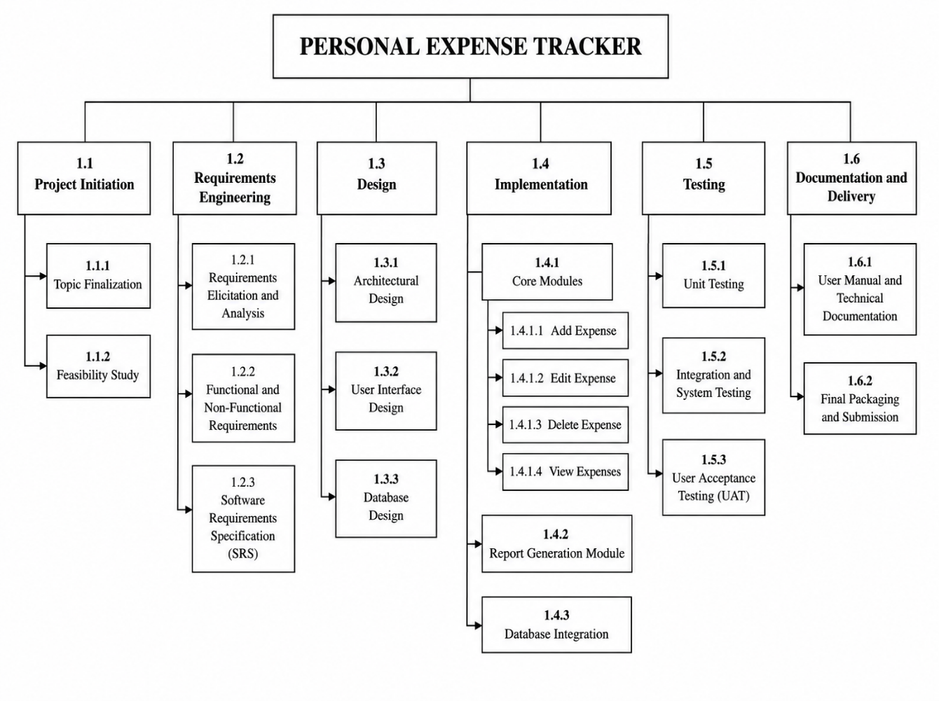
Fig 1.1 WBS Chart

1.4.2 Deliverance and Milestones
The list of deliverance and milestones are:
Sequence | Deliverable | Milestone (Completion Time)
1 | Validated Project Topic and Project Plan | Week 1
2 | Software Requirements Specification (SRS) | Week 2
3 | System Design Document (UML, Database & UI Design) | Week 3
4 | Working Prototype (Core Modules Implemented) | Week 5
5 | Complete Application with Testing | Week 7
6 | Final Documentation and Project Submission | Week 8

1.4.3 Acceptance Criteria
The list of acceptance criteria is:
S.N. | Acceptance Criteria
1 | The application installs and launches successfully on the target operating system (Windows).
2 | Users can add new expense records with details such as date, category, amount, and description.
3 | Users can edit and delete existing expense records without data loss.
4 | Users can view all recorded expenses in a clear and organized table.
5 | Users can search and filter expenses by date, category, or keyword.
6 | The application correctly calculates total expenses for a selected period.
7 | Reports (daily, monthly, or yearly) are generated accurately.
8 | All expense data is stored and retrieved correctly from the database.
9 | Input validation prevents invalid or incomplete data from being saved.
10 | The application performs without critical errors or crashes during normal operation.
11 | The application passes unit testing, integration testing, and User Acceptance Testing (UAT).
12 | User manual and technical documentation are completed and approved by the supervisor.

1.4.4 Project Approach
The Incremental Process Model was selected for the development of the Personal Expense Tracker because of the following reasons:
- Modular Development: The application consists of separate modules such as Expense Management, Category Management, Reports, and Database Management. Each module can be developed independently.
- Early Working Software: A functional version of the application is available after each increment, allowing progress to be evaluated throughout development.
- Continuous Testing :Every completed module is tested before integrating it with the next module, helping to detect and fix defects early.
- Easy Maintenance: Changes or improvements can be made to a specific module without affecting the entire application.
- Reduced Development Risk: Developing the project in smaller increments minimizes the risk of major errors and makes debugging easier.
- Better Project Management: The project can be planned, monitored, and completed in phases, making development more organized and manageable.
- Suitable for the Project: Since the Personal Expense Tracker is a desktop-based application with clearly defined and independent functionalities, the Incremental Process Model provides an efficient and systematic development approach.
- Fits the project scenario: With a single developer, an 8-week academic timeline, and clearly separable functionalities with stable requirements, incremental delivery provides a low-risk, well-managed path to completion — better suited here than models built for evolving requirements.
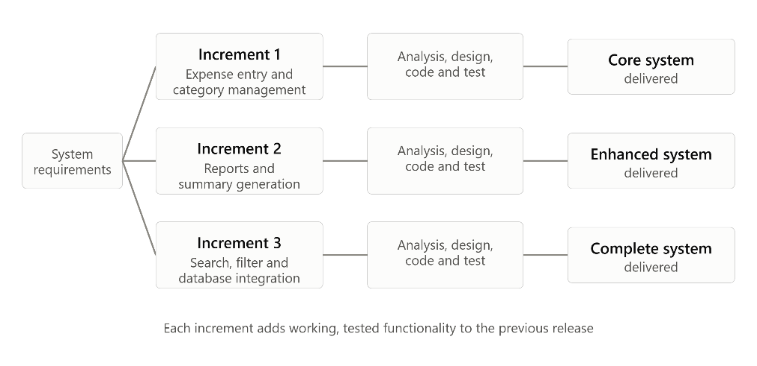
Fig 1.2: Incremental Model

1.5 Project Resourcing

1.5.1 Quality Requirements
The quality requirements the project aims to fulfil are:
- Correctness of calculations and data storage
- Reliability during normal use
- High usability through a simple interface
- Maintainable source code
- Completeness of core features

1.5.2 Process Requirements
The quality requirements are mapped to the Incremental Process Model as follows, to ensure each requirement is met throughout development:

S. N | Quality Requirement | Mapped Activity in Incremental Process | How Quality is Ensured
1. | Correctness | Testing phase of each increment | Every increment is tested individually before integration, catching calculation/logic errors early
2. | Reliability | Continuous validation across increments | Each new increment is validated against previously delivered increments to maintain stable behavior
3. | Usability | Design phase of each increment | UI is reviewed and refined incrementally based on feedback from early working versions
4. | Maintainability | Modular development structure | Each increment is built as an independent module, keeping code isolated and easy to modify
5. | Completeness | Incremental delivery sequence | Each increment adds a clearly defined feature set, ensuring no core functionality is missed by the final release

1.5.3 Method Requirements
Throughout the development of the Personal Expense Tracker, a set of key framework and umbrella activities shall be followed to ensure compliant and systematic process adoption.
The framework activities, representing the core process steps carried out within every increment, are as follows:
- Communication: Requirements are clarified and validated with the project supervisor before the start of each increment to ensure accurate understanding of expected functionality.
- Planning: Tasks for each increment are scheduled and organized to maintain a structured development timeline.
- Modeling: The architecture, user interface, and database design relevant to each increment are prepared prior to implementation.
- Construction: Each module is coded and unit-tested to verify correctness before integration with the rest of the system.
- Deployment: The completed and tested increment is integrated into the overall system and delivered as a working version of the application.
In addition to the framework activities, the following umbrella activities are carried out continuously throughout the project to ensure that the development process remains compliant, controlled, and of consistent quality:
- Project tracking and monitoring: Progress is regularly monitored against the planned schedule to ensure timely completion of each increment.
- Risk management: Potential risks are identified early and mitigation measures are applied to minimize their impact on the project.
- Software quality assurance: Reviews and testing are conducted at each stage to ensure that the software meets the defined quality requirements.
- Software configuration management: Version control is maintained using Git to track changes and manage different versions of the source code.
- Documentation management: All project documentation, including design, testing, and user manuals, is prepared and maintained systematically throughout the development lifecycle.

1.5.4 Resource Requirements
The successful development of the Personal Expense Tracker requires the following technological, platform, environment, and human resources.
Technological Resources
- Programming Language: Python 3.x
- GUI Framework: Tkinter
- Database: SQLite
- Development Tool: VS Code / PyCharm
- Version Control: Git
Platform and Environment
- Operating System: Windows 10/11 or Linux
- Hardware: Standard desktop/laptop with minimum 4 GB RAM
Human Resources
- Project Developer: 1 (Student)
- Project Supervisor: 1
- End Users for feedback: 2–3

Chapter 2: Planning and Management

2.1 Project Risks

2.1.1 Identified Risk
Each identified risk is rated on Probability and Impact using a scale of 1–5 (1 = Very Low, 5 = Very High). The Risk Priority Number (RPN) is calculated as RPN = Probability × Impact, and risks are sorted by RPN to determine which require the most urgent attention.
Risk ID | Risk Description | Category | Prob. (1-5) | Impact (1-5) | Risk Exposure | Priority
R1 | Underestimation of development effort/time due to limited prior project experience | Schedule Risk | 4 | 4 | 16 | High
R2 | Requirement changes after supervisor feedback (e.g., new report formats, added fields) | Product Risk | 3 | 3 | 9 | Medium
R3 | Database design flaws causing incorrect calculations or data loss | Performance Risk | 2 | 5 | 10 | High
R4 | Limited prior experience with Tkinter GUI framework slowing development | Technology Risk | 3 | 3 | 9 | Medium
R5 | Single-developer illness/unavailability delaying milestones | Staff Risk | 2 | 4 | 8 | Medium
R6 | Hardware failure or accidental file deletion causing loss of source code | Support Risk | 2 | 5 | 10 | High
R7 | Underestimated testing time leading to schedule slip before submission | Schedule Risk | 3 | 4 | 12 | High
R8 | Data validation gaps allowing invalid entries (negative amounts, wrong dates) | Cost Risk | 3 | 2 | 6 | Low

2.1.2 Mitigation Risk
To reduce the likelihood or severity of each identified risk before it occurs, the following preventive actions have been planned and will be applied throughout development.
Risk ID | Mitigation Strategy
R1 | Break work into small, testable increments (per WBS); track progress weekly against the 8-week schedule; build in a 3–5-day buffer before each milestone
R2 | Freeze core requirements after SRS approval (Week 2); route any new request through a documented Change Request before implementation
R3 | Design and normalize the database schema early (Week 3) and validate it with sample data before coding CRUD modules
R4 | Complete a short Tkinter tutorial/prototype (login/dashboard mock) before starting core module development
R5 | Maintain a personal task buffer and keep the supervisor informed of progress so deadlines can be renegotiated if needed
R6 | Maintain regular Git commits and push to a remote repository (GitHub) daily; keep a local backup copy
R7 | Allocate a dedicated testing phase (Week 6–7) in the schedule rather than testing only at the end
R8 | Implement input validation rules (type, range, format) during the Construction phase of each increment, not after

2.1.3 Contingency Plan
If a risk is not fully avoided despite mitigation efforts, the following fallback actions define how the project will respond to limit damage to the schedule and deliverables.

Risk ID | Contingency Action (if risk occurs)
R1 | Reduce scope to core acceptance criteria only (add/edit/delete, reports); defer "nice-to-have" features like advanced filters
R2 | Negotiate with supervisor to move the change to a "future enhancement" section of documentation instead of the current build
R3 | Roll back to the last stable schema backup and re-migrate data; re-run affected unit tests
R4 | Switch to a simpler Tkinter layout (basic widgets only) instead of custom-styled components to save time
R5 | Use documented code and commit history to resume quickly; extend working hours temporarily to recover lost time
R6 | Restore the latest Git commit from GitHub; rebuild the local environment from the repository
R7 | Prioritize testing acceptance criteria (Section 1.4.3) first; treat non-critical bugs as known issues in documentation
R8 | Patch validation logic immediately as a hotfix and add a regression test case for the specific input that failed

2.1.4 Risk Monitoring Plan
To ensure risks are caught early rather than discovered after damage occurs, each risk is tracked using a specific monitoring activity at a defined frequency throughout the project.
Risk ID | Monitoring Activity | Frequency
R1 | Compare planned vs. actual progress against the WBS/schedule | Weekly
R2 | Review requirements and any pending Change Requests with supervisor | Weekly
R3 | Verify database schema and run sample-data checks | Every development session
R4 | Track time spent per module against the WBS estimate to catch slippage early | Weekly
R5 | Self-check progress against milestone dates in Section 1.4.2 | Weekly
R6 | Check Git repository commit history and backup status | Weekly
R7 | Review completed vs. planned test cases | Weekly, and after every increment
R8 | Run validation test cases on each new input field | After every module completion

2.2 Project Estimation and Schedule

2.2.1 Estimation Method Used
The Basic COCOMO81 Model (Organic Mode) was selected for effort estimation. Justification:
- The project is small in size (single desktop application, well-understood problem domain), which fits the Organic project profile defined by COCOMO (small team, familiar requirements, not tightly constrained).
- It is developed by a single, small team (1 developer) with a stable, non-rigid requirement set — matching COCOMO's Organic criteria exactly.
- COCOMO is simpler to apply than Function Point Analysis for a solo academic project, since it only requires an estimated code size (KLOC) rather than detailed counts of Internal Logical Files, External Inputs, etc., which are harder to estimate accurately before design is finalized.
- COCOMO gives a quick, defensible, formula-based estimate suitable for early planning, consistent with what was taught for early/rough-order-of-magnitude estimation.

2.2.2 Project Estimation
Estimated Size: Based on the scope (expense/income CRUD, category management, report generation, local SQLite storage, and a Tkinter GUI), the project is estimated at 1.0 KLOC (1,000 lines of source code).
Basic COCOMO81 Formula (Organic Mode):
- Effort: E = 2.4 × (KLOC)^1.05
- Development Time: T = 2.5 × (E)^0.38
Calculation:
E = 2.4 × (1.0) ^1.05 = 2.4 Person-Months (PM)
T = 2.5 × (2.4) ^0.38 ≈ 3.49 months (≈ 14 weeks)
Team size = E / T = 2.4 / 3.49 ≈ 1 developer
Cost Estimation: Assuming a developer cost rate of NPR 30,000/month:
Cost = Effort (PM) × Monthly Rate
= 2.4 × 30,000 = NPR 72,000
Note on Schedule Compression: COCOMO's ~14-week estimate assumes typical industrial team overheads like coordination, communication delays, and onboarding. Since this project has a single developer working under direct supervisor guidance with a fixed, narrow scope, these overheads don't apply — allowing the 8-week schedule to be met through focused daily effort rather than by ignoring the estimate.

2.2.3 Project Schedule
The project schedule is presented using a Gantt Chart. It maps all major activities of the Personal Expense Tracker across the 8-week timeline along with the assigned resource (single developer).
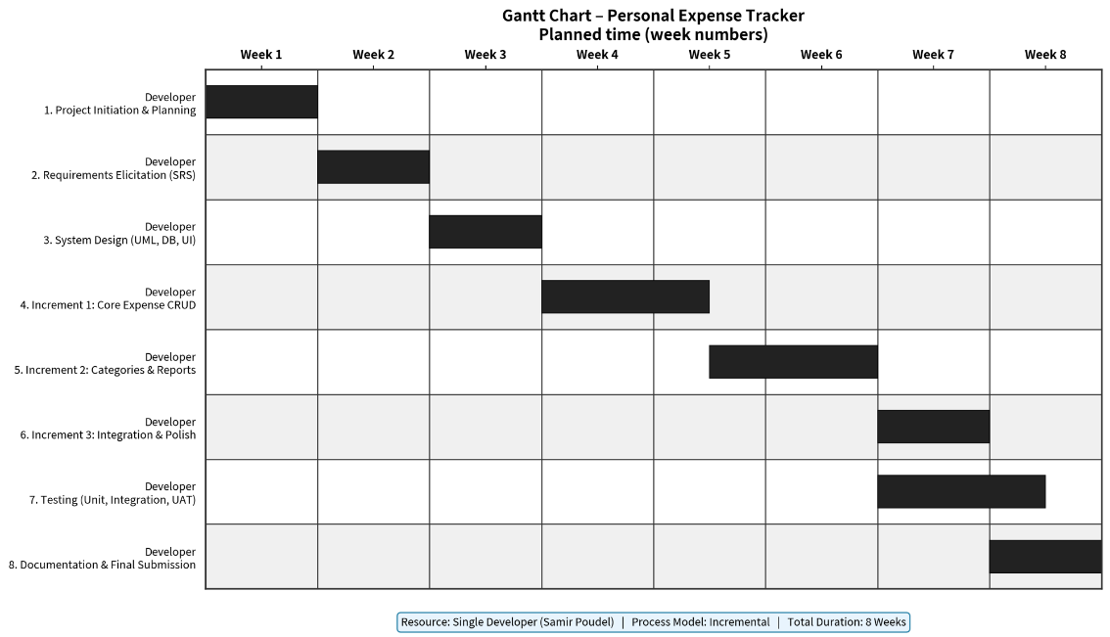
Fig 2.1: Gantt Chart

2.3 Configuration Management Plan

2.3.1 Change Management Plan
Any proposed change to the Personal Expense Tracker is first documented in a Change Request (CR) Log, recording the change description, reason, requester, priority, and expected impact on the schedule. Each change is reviewed against the current project scope and remaining schedule before a decision is made. Approved changes are incorporated into the next development increment, while rejected requests are archived along with the justification for rejection. All implemented changes are recorded against the software version in which they were introduced, ensuring full traceability throughout the project.
CR ID | Description | Priority | Status | Version Implemented
CR-01 | (example) Add yearly report export option | Medium | Approved | v0.8

2.3.2 Version Management Plan
Git is used as the version management tool throughout the project, following a semantic versioning scheme to track the evolution of the software. Each version is committed with a clear, meaningful commit message describing the change, and major development milestones are tagged in the repository for easy reference.
Version | Description
v0.1 | Initial prototype
v0.5 | Core modules completed
v0.8 | Testing version
v1.0 | Final project submission

2.3.3 Release Management Plan
Before each release, unit testing and integration testing are carried out to ensure stability. The final release is additionally validated through User Acceptance Testing (UAT) prior to submission, confirming that the application meets the acceptance criteria defined in Section 1.4.3.
Release | Description
Release 1 | Basic expense recording module
Release 2 | Category management and reporting
Release 3 | Testing and bug fixes
Final Release (v1.0) | Complete Personal Expense Tracker with documentation

Chapter 3: System Engineering

3.1 Requirements

3.1.1 Domain Requirements
S.N. | Domain Requirement
1 | The system must support recording of both income and expense transactions.
2 | Every transaction must have a date, amount, category, and optional description.
3 | Expense amounts must be positive numeric values; negative or zero amounts are invalid.
4 | Categories must be available for classification of expenses (e.g., Food, Transport, Bills, Others).
5 | The system must allow calculation of totals for a selected period (daily, monthly, yearly).
6 | All financial data must remain private and stored only on the user’s local machine.
7 | Reports must reflect accurate arithmetic based on recorded transactions.
8 | The system must operate offline without requiring an internet connection.

3.1.2 Functional Requirements
Priority | Functional Requirement | Description
High | FR-01: Add Transaction | User can add a new income or expense record with date, category, amount, and description.
High | FR-02: Edit Transaction | User can modify an existing transaction without data loss.
High | FR-03: Delete Transaction | User can delete a selected transaction from the system.
High | FR-04: View Transactions | User can view all recorded transactions in a clear tabular format.
High | FR-05: Category Management | System provides predefined categories and allows custom categories.
High | FR-06: Search and Filter | User can search and filter transactions by date, category, or keyword.
High | FR-07: Generate Reports | System generates daily, monthly, and yearly summary reports with totals.
High | FR-08: Local Data Storage | All data is stored and retrieved from a local SQLite database.
Medium | FR-09: Input Validation | System validates date format, amount range, and required fields before saving.
Medium | FR-10: Category-wise Summary | System displays expense totals grouped by category.

3.1.3 Non-Functional Requirements
S.N. | Category | Non-Functional Requirement
1 | Usability | The interface must be simple and intuitive so that a non-technical user can record expenses with minimal training.
2 | Reliability | Calculations and data storage must be accurate; the system should not lose data during normal operation.
3 | Performance | Report generation and data retrieval must complete within 2–3 seconds for typical personal usage volumes.
4 | Maintainability | Source code must be modular and well-structured to allow easy modification of individual modules.
5 | Portability | The application must run on Windows 10/11 and Linux without major changes.
6 | Security | Data is stored only locally; no external network transmission of financial information is permitted.
7 | Availability | The system must be usable offline at any time without dependency on external services.
8 | Efficiency | The application should run smoothly on a standard laptop with minimum 4 GB RAM.

3.1.4 Requirement Management Process
The requirement management process for the Personal Expense Tracker followed four main activities: elicitation, analysis, modeling, and specification. This process was selected because the project has a small and stable scope, a single developer, and a fixed 8-week academic timeline. It is consistent with the communication and concept-scoping activities described for defining software product scope.
1. Elicitation: Requirements were obtained through communication with stakeholders. A short questionnaire was prepared and discussed with the project supervisor to identify user needs, expected inputs/outputs, and constraints. Existing personal finance practices (notebooks and spreadsheets) were also reviewed. The problem statement and acceptance criteria from Chapter 1 were used as the primary basis for stakeholder needs. The written description of need was reviewed and refined with the supervisor (similar to a formal technical review of outputs and inputs).
2. Analysis: Elicited requirements were examined and classified into domain, functional, and non-functional categories. Customer-visible inputs and outputs were listed and checked for completeness. Conflicts (for example, advanced features versus the 8-week schedule) were resolved by prioritizing core acceptance criteria and deferring optional features. This ensured that the product scope remained unambiguous and achievable.
3. Modeling Requirements were modeled to define the functionality and behavior of the system:
- Use Case Model – shows interactions between the user and the system (see Annex)
- Data Flow Model (DFD) – shows how data moves through the system processes (see Annex)
- Process Flow Model – shows the sequence of activities for main operations (see Annex)
These models support visual verification of functions and behaviors before construction begins.
4. Specification: All validated requirements were documented in structured form (Sections 3.1.1–3.1.3) and linked to the acceptance criteria. A narrative scope description and the supporting models together form the Software Requirements Specification (SRS). The SRS was frozen after Week 2 to control later requirement changes.
Rationale for Process Selection
- Scope is defined after communication with stakeholders, as recommended for software product scope.
- A questionnaire and supervisor review help avoid misunderstanding of customer needs.
- Modeling of functions/behaviours provides clear work products before coding.
- Freezing the SRS reduces the risk of late requirement changes (Risk R2) and supports the single-developer, time-constrained project.

3.2 Design

3.2.1 System Architecture
The system architecture of the Personal Expense Tracker follows a layered architecture style. This architecture divides the application into multiple layers, where each layer has a specific responsibility and only communicates with the layer directly below it.
The layered architecture of the proposed system is shown in the figure below:

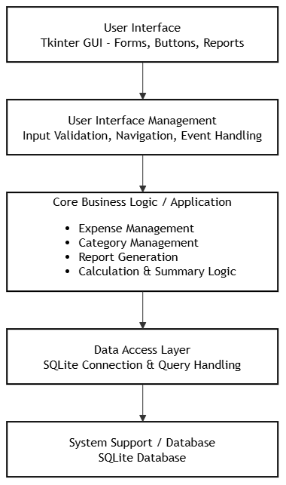
Fig 3.1: Layered Architecture

Description of Layers:
- User Interface Layer: Provides the graphical interface using Tkinter. It includes forms, buttons, and report displays for user interaction.
- User Interface Management Layer: Handles input validation, navigation between screens, and event handling.
- Core Business Logic / Application Layer: Contains the main functionalities of the system such as Expense Management, Category Management, Report Generation, and calculation logic.
- Data Access Layer: Manages the connection with the SQLite database and performs all query operations (Insert, Update, Delete, Select).
- System Support / Database Layer: The actual SQLite database that permanently stores all expense and category data.
This layered design ensures separation of concerns, easy maintenance, and better modularity of the Personal Expense Tracker application.

3.2.2 High Level Designs
The high-level design of the Personal Expense Tracker follows a modular structure. The system is divided into three major modules: User Interface Module, Business Logic Module, and Data Access Module. Each major module is further decomposed into specific features and interfaces.
The modular structure of the system is shown in the figure below:

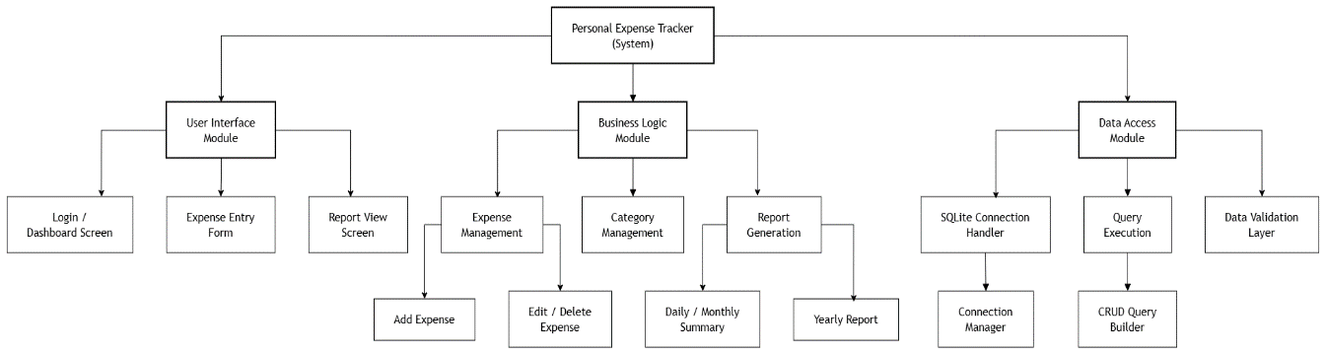
Fig 3.2: High Level Designs
Description:
- User Interface Module handles all interaction with the user. It includes the Login/Dashboard Screen, Expense Entry Form, and Report View Screen.
- Business Logic Module contains the core functionalities of the system such as Expense Management (further decomposed into Add Expense and Edit/Delete Expense), Category Management, and Report Generation (further decomposed into Daily/Monthly Summary and Yearly Report).
- Data Access Module is responsible for database operations including the SQLite Connection Handler (with its Connection Manager), Query Execution (with its CRUD Query Builder), and Data Validation
This modular design ensures separation of concerns, high cohesion, and low coupling. It also supports the Incremental Process Model by allowing each module to be developed and tested independently.

3.2.3 Data Structure Design
The Personal Expense Tracker uses a local SQLite database to store all application data. The data structures are designed around three core entities :User, Category, and Transaction which together support recording, categorizing, and reporting on income and expenses. The entities and their relationships are detailed below.
Entity: User
Stores basic profile information for the person using the application (single local user).
Field Name | Data Type | Description
user_id | INTEGER (PK) | Unique identifier for the user
username | TEXT | Display name shown on the dashboard
created_date | DATE | Date the profile was created

Entity: Category
Stores both predefined (system-provided) and custom (user-created) expense/income categories.
Field Name | Data Type | Description
category_id | INTEGER (PK) | Unique identifier for the category
category_name | TEXT | Name of the category (e.g., Food, Transport, Salary)
category_type | TEXT | Indicates "Income" or "Expense"
is_custom | BOOLEAN | TRUE if user-created, FALSE if predefined

Entity: Transaction
Stores every income and expense record entered by the user. This is the central entity of the system.
Field Name | Data Type | Description
transaction_id | INTEGER (PK) | Unique identifier for the transaction
user_id | INTEGER (FK) | References User.user_id
category_id | INTEGER (FK) | References Category.category_id
amount | DECIMAL | Transaction amount
transaction_type | TEXT | "Income" or "Expense"
date | DATE | Date the transaction occurred
description | TEXT | Optional note about the transaction

Relationships
- One User can have many Transactions (1-to-many).
- One Category can be applied to many Transactions (1-to-many).
- Each Transaction belongs to exactly one User and one Category.
Supporting Data Structures
- Report Summary (derived, not stored): Daily, monthly, and yearly reports are computed dynamically from the Transaction table using SQL aggregate queries (SUM, GROUP BY), rather than stored as a separate entity — avoiding data duplication and ensuring reports always reflect current data.
- In-memory structures: Within the application logic, transaction records are temporarily held as Python objects/dictionaries before being validated and committed to the SQLite database, supporting fast form validation and summary calculations before final storage.

3.3 Testing

3.3.1 Test Justification
Testing is a very important phase of the Personal Expense Tracker project. The main goal of testing is to make sure that the application works correctly, stores data safely, and is easy for users to operate.
1. Why Testing is Required
- To check that all features (Add, Edit, Delete, Reports) work properly.
- To find and fix errors before final submission.
- To ensure data is saved correctly in the SQLite database.
- To confirm that the application is user-friendly.
2. Test Coverage
- All major modules of the system will be tested.
- Both functional features and data validation will be covered.
- Special attention will be given to data persistence (data should remain after closing and reopening the application).
3. Types of Tests and Their Reasons
Type of Test | Reason for Using This Test
Unit Testing | To test small parts of the program (like add expense function) separately.
Integration Testing | To check whether different modules work correctly together.
System Testing | To test the complete application as a whole.
Acceptance Testing | To check whether the system meets the user’s requirements.
Regression Testing | To make sure old features still work after adding new features.

4. Testing Process Testing will be done step by step after every increment. First unit testing will be done, then integration testing, and finally system and acceptance testing will be performed before project submission.

3.3.2 Test Plan
1. Introduction:
This test plan describes the testing approach for the Personal Expense Tracker, a Python-based desktop application developed using Tkinter and SQLite.
2. Test Items
- Personal Expense Tracker Application
- User Interface Module
- Business Logic Module
- Data Access Module
- SQLite Database
3. Features to be Tested
- Add, Edit, and Delete Expense
- Category Management
- Report Generation (Daily, Monthly, Yearly)
- Data Validation
- Data Persistence after application restart
- Search and Filter functionality
4. Features not to be Tested
- Multi-user features
- Online / Cloud synchronization
- Advanced security features
5. Approach
- Manual testing for User Interface and overall functionality
- Unit testing for individual functions
- Integration testing between modules
- System testing of the complete application
- Acceptance testing based on defined acceptance criteria
6. Pass / Fail Criteria
- Pass: All critical features work correctly and no major defects remain.
- Fail: Data loss, incorrect calculations, or application crash in core features.
7. Suspension and Resumption Criteria Testing will be suspended if a critical defect blocks further testing. Testing will resume after the defect is fixed and verified.
8. Test Deliverables
- Test Plan
- Test Cases
- Defect Log
- Test Summary Report
9. Environmental Needs
- Operating System: Windows 10/11 or Linux
- Software: Python 3.x, Tkinter, SQLite
- Hardware: Standard desktop or laptop with minimum 4 GB RAM
10. Responsibilities
- Developer (Student): Prepare test cases, execute tests, and document results
- Supervisor: Review test outcomes
11. Schedule
- Unit Testing: After each increment
- Integration and System Testing: Week 6–7
- Acceptance Testing: Final week

3.3.3 Test Design
Test Design Specification – Personal Expense Tracker
1. Features to be Tested
- Expense Management
- Category Management
- Report Generation
- Database Operations
- User Interface
2. Approach Black-box testing will be used for functional requirements. Limited white-box testing will be applied for critical calculations and validation logic.
3. Test Case Design
Module 1: User Interface Module
Test Case ID | What to Test | Steps to Perform | Expected Result
UI-01 | Open Add Expense Form | Click on “Add Expense” button | Add Expense form should open
UI-02 | View Report Screen | Click on “View Reports” button | Report screen should open with data

Module 2: Expense Management Module
Test Case ID | What to Test | Steps to Perform | Expected Result
EM-01 | Add New Expense | Enter date, amount, category and click Save | Expense should be saved and shown in list
EM-02 | Edit Expense | Select an expense and change the amount | Updated amount should be saved
EM-03 | Delete Expense | Select an expense and click Delete | Expense should be removed from the list

Module 3: Category Management Module
Test Case ID | What to Test | Steps to Perform | Expected Result
CM-01 | Add New Category | Enter category name and click Save | New category should be added
CM-02 | Delete Category | Select a category and click Delete | Category should be removed

Module 4: Report Generation Module
Test Case ID | What to Test | Steps to Perform | Expected Result
RG-01 | Monthly Report | Select month and click Generate Report | Correct total amount of that month should show
RG-02 | Category-wise Report | Select a category and generate report | Expenses of that category should be displayed

Module 5: Database Module
Test Case ID | What to Test | Steps to Perform | Expected Result
DB-01 | Data Saving | Add an expense and close the application | Data should still be available after reopening
DB-02 | Invalid Amount Check | Enter text or negative number in amount | System should show error message

These test cases cover the main features of the Personal Expense Tracker and help ensure the system works correctly.

Chapter 4: Monitoring & Control

4.1 Monitoring & Control

4.1.1 Time Monitoring
Time monitoring is done using a Gantt Chart. The Gantt Chart shows the planned schedule of all major activities of the Personal Expense Tracker project.

4.1.2 Cost Monitoring
Cost monitoring of the Personal Expense Tracker project is carried out using Earned Value Management (EVM) technique. This method helps to measure project performance by comparing planned work, completed work, and actual effort.
Main Earned Value Parameters:
Parameter | Full Form | Meaning
PV | Planned Value | Budgeted cost of work scheduled
EV | Earned Value | Budgeted cost of work performed
AC | Actual Cost | Actual effort/cost spent
SV | Schedule Variance (EV – PV) | Indicates whether the project is ahead or behind schedule
CV | Cost Variance (EV – AC) | Indicates whether the project is under or over budget
SPI | Schedule Performance Index (EV/PV) | SPI > 1 means ahead of schedule
CPI | Cost Performance Index (EV/AC) | CPI > 1 means under budget
Monitoring Indicators:
- SPI < 1 → Project is behind schedule
- CPI < 1 → Project is consuming more effort than planned
- SPI ≈ 1 and CPI ≈ 1 → Project performance is healthy
These parameters and indicators will be used regularly to monitor the progress and performance of the project.

4.1.3 Control Measures
The following table shows possible deviations and the control measures that will be taken:
Type of Deviation | Possible Causes | Control Measures (Actions to be Taken)
Time Delay | Module taking more time than planned | Re-plan remaining tasks, work extra hours, reduce scope of less important features
Time Delay | Technical problems / bugs | Prioritize critical bugs, take help from supervisor
Cost Overrun | Spending more effort/time than planned | Focus only on core features, avoid unnecessary enhancements
Both Time & Cost Deviation | Poor estimation or changing requirements | Review the plan, freeze requirements, follow Incremental approach strictly
Schedule Behind | Delayed testing or documentation | Parallel work on documentation while testing

These control measures will help keep the project on track in terms of both time and cost.

Annex 1: Requirement Models

