Course: Design and Implementation of Embedded Operating Systems (2016 Spring)
班級：_______________
學號：_______________
姓名：_______________

考試時間：350分鐘
可翻閱書籍、也可Google搜尋
禁止使用編譯器或任何程式開發環境
以合法C語言撰寫程式碼，需列出完整程式碼

1. (30points) 給定一個 singly-linked list 結構:
typedef struct _List {
struct _List *next;
int val;
} List;
下列swap函式的作用是交換存在list中兩個節點(不直接修改內含資料val)，指出程式碼的不足或錯誤之處。並重寫正確行為的版本出來。
void swap(List *head, List *a, List *b)
{
List *curr = head;
List *prevA = NULL; List *prevB = NULL;
while (curr != a) {
prevA = curr; curr = curr->next;
}
curr = head;
while (curr != b) {
prevB = curr; curr = curr->next;
}
if (prevA && prevB) {
prevA->next = b; prevB->next = a;
List *tmp = a->next;
a->next = b->next;
}
}
提示: function prototype, assert, error handling, head

2. (25points) 承第 1 題， 對該singly-linked list作merge sort，需要沿用swap函式。附上執行時間和空間複雜度分析，以及你打算如何驗證這個 merge sort 的實做。

3. (5points) Assume a function f calls a function g using the C calling conventions of UNIX v6 on the PDP-11. The callee function g takes two arguments, as follows:
void g(int x, int y) { … }
Below is the stack at the point that f is about to call g. So far f’s own local variables and other private state are already on the stack, but nothing related to its call to g. Draw the stack at the point just before the processor executes the first instruction of g that does “real” work, after running g’s function prologue.
(Hint: the arguments y and x, the return address, and callee-saved registers.)
(sol as following)
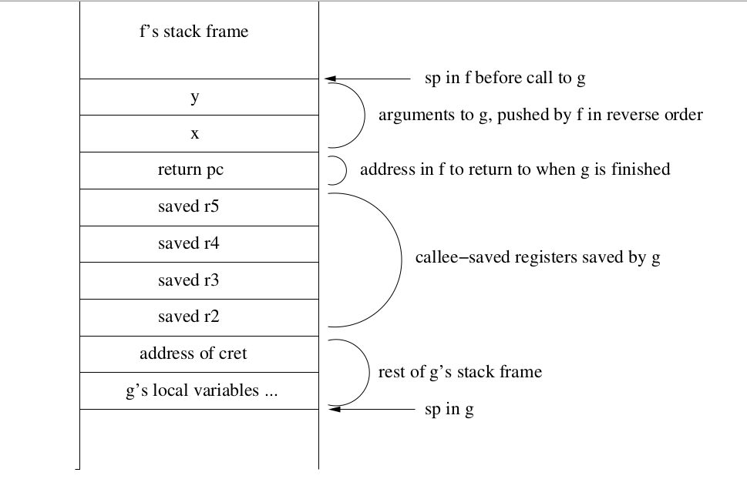
4. (5points) Consider the following C code that calls fork(). 在GNU/Linux上會有怎樣的輸出呢？ 並請解釋
int main()
{
int i;
for (i = 0; i < 3; i++) {
if (fork() == 0) {
printf("Child sees i = %d\n", i); exit(1);
} else { printf("Parent sees i = %d\n", i); }
}
}

5. (10points) List two key distinctions among a semaphore, mutex, and a monitor. 舉出在你過去開發的程式中，哪些地方用到semaphore，以及為何不用mutex。

6. (5points) What is distinction between deadlock and starvation?

7. (10points) Describe why direct memory access (DMA) is considered an efficient mechanism for performing I/O. 以手機系統為例，可提及LCD顯示、無線網路、LTE數據通訊等

8. (10points) Page fault must be preceded by a TLB miss, but a TLB miss does not necessarily mean a page fault. True or false? 請解釋，並以Linux/x86來解說

9. (15points) Suppose a system provides the following atomic hardware instruction:
boolean TestAndSet (boolean *target) {
boolean rv = *target;
*target = TRUE;
return rv:
}
Write the pseudo code (in C) for implementing counting semaphore.

10. (15points) 在一個32-bit little-endian處理器上，以下C程式會得到什麼結果呢？請列出lval, aval, uval的內含值，並解釋為何如此。
signed int lval = 0xFEDCBA98 << 32;
signed int aval = 0xFEDCBA98 >> 36;
unsigned int uval = 0xFEDCBA98u >> 40;
又，在32-bit RISC上，上述每行C程式對應到幾道組合語言指令呢？(可用ARM或MIPS舉例)

11. (20points) 考慮以下C程式，解說在32-bit架構下具體作用(不是逐行註解)，以及在什麼場合用得到。提示: 注意看bit-wise operator
int func(unsigned int x) {
int val = 0; int i = 0;
for (i = 0; i < 32; i++) {
val = (val << 1) | (x & 0x1);
x >>= 1;
}
return val;
}

12. (15points)
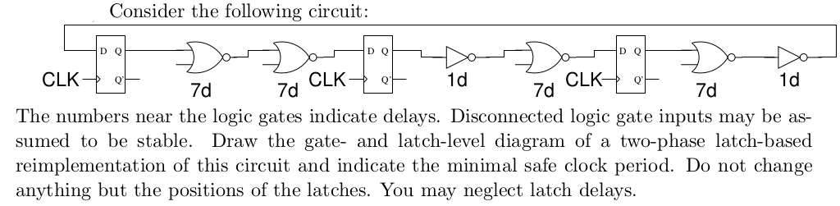

13. (15points) 考慮以下程式碼
typedef int arr[2][2];
void transpose(arr dst, arr src) {
int I, j;
for (I = 0; I < 2; i++)
for (j = 0; j < 2; j++)
dst[i][j] = src[i][j];
}
假設在一台具備以下特性的機器上運作前述C程式:
sizeof(int) = 4
src陣列從地址0x0開始，dst陣列則從地址0x10開始，硬體僅有L1 cache，而且是direct map、block size = 8 bytes，cache 大小為 16 bytes，一開始是空的。src和dst存取分別是read和write沒有hit的唯一來源。請回答以下問題：
(a) 對每個row和col，指出src[row][col]和dst[row][col]的存取是否hit，請製作表格
(b) 如果cache空間改為32bytes，又會如何？

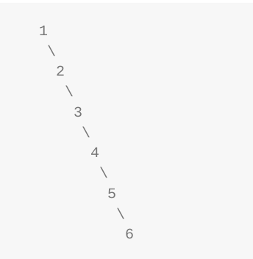
14. (20points) 給定以下C程式碼和提示圖片，解說程式碼的目的 (如有錯誤，則指出)，並用非遞迴的方式重寫
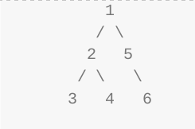

static struct TreeNode *_flatten(struct TreeNode *node){
if (node == NULL) return NULL;
if (node->right) node->right = _flatten(node->right);
if (node->left) {
struct TreeNode *tmp = node->right;
node->right = _flatten(node->left);
struct TreeNode *t = node->right;
while (t->right) t = t->right;
t->right = tmp;
node->left = NULL;
}
return node;
}
void flatten(struct TreeNode *node) { _flatten(node); }

15. (10points) What is the difference between “user mode” and “supervisor mode” in
the ARM processor? How does the microprocessor make the transition between these two modes? Take ARMv7-A as example.

16. (10points) A box contains 3 blue marbles and 3 red marbles. You select two at random. If they are the same color, you win 2 dollars. Otherwise you lose one dollar.
Let X be your winnings.
(a) What’s the probability of winning this game?
(b) What’s E[X]?
(c) What’s V ar(X)?
0.4
2.16

17. (5points) Assume we have the following code in a device driver:
lock();
ptr->x++;
unlock();
If ptr came from the kernel, what is broken about this code? How would you have to fix it?

18. (25points) 重寫以下merge sort的工具函式，讓branch predictor得以發揮更好的效能，至少在Intel x86架構下發揮作用。改寫後，請一併說明為何得以提昇效能。
提示：while敘述內的條件分支
void merge(int src1[], int src2[], int dst[], int n)
{
int i1 = 0, i2 = 0, id = 0;
while (i1 < n && i2 < n) {
if (src1[i1] < src2[i2])
dst[id++] = src1[i1++];
else
dst[id++] = src2[i2++];
}
while (i1 < n)
dst[id++] = src1[i1++];
while (i2 < n)
dst[id++] = src2[i2++];
}

