Dashboards for Clicker Data
  - INFO 4100 Learning Analytics
[[Maryam Albakry (ma878), Rafael Barrios (reb368), Abbie Goldstein (acg229), Tianyi Wang (tw324), Emma Benyaminy (esb276)]]
This project is about developing a learning analytics dashboard based on clicker data. You will work as a team to learn how to make a dashboard using R Shiny (official page with several tutorials: https://shiny.rstudio.com/tutorial/).
Learning Objectives
- Understand the structure of clicker data
- Create multiple different visualizations
- Design and implement an instructor and student dashboard
- Critically evaluate your own dashboard design
You are given aggregated clicker records for a CS course taught at Cornell. There are two datasets: the experience dataset and the quiz dataset.
Scenario
You are approached by a college instructor who uses iClickers in her CS class on Business Intelligence. She would like to gain insights about her students and how they are engaging/performing in order to better help them in class. She would also like to better support students by giving them feedback at scale about where they stand and perhaps how they compare to others in the class.
You offer to build a prototype of a dashboard using her clicker data: this is a dashboard for the instructor which offers an overview of the class characteristics, engagement, and performance; and it is a dashboard for students which offers a specific student an overview of their engagement and performance (and how it compares to others).
Data
The experience dataset contains one record per student who completed the CS course between 2016-2018. There are two sources to this dataset: Faculty Center and a Skills Survey (administered via the Blackboard LMS) where students self reported their skill level for various skills the first week of class. This data has been de-identified. Name, netid, emplid, major have all been removed and replaced with a unique numeric identifier. Note that not all students completed the skills survey, they will have null values for the survey result fields.
Attribute Name | Data Type | Definition
student_key | numeric Unique key | Assigned as part of de-identification process. Uniquely identifies student records for this data set only.
year | numeric | Four digit year student was enrolled in BI Class.
prog | character Values (GRAD, UGRAD) | Indicates whether the student was a graduate or undergraduate student when they were enrolled in BI course.
database_score | numeric (0-5) | Self reported experience level with database technology prior to taking course. 0= no experience, 5= expertise
sql_score | numeric (0-5) | Self reported experience level with SQL prior to taking course. 0= no experience, 5=expertise
programing_score | numeric (0-5) | Self reported experience level with Any Programing language prior to taking course. 0=no experience, 5=expertise
stored_proc_score | numeric (0-5) | Self reported experience level with stored procedure languages prior to taking course. 0=no experience, 5=expertise
etl_score | numeric (0-5) | Self reported experience level with Extract Transform Load (ETL) development prior to taking course. 0=no experience, 5=expertise
data_vis_score | numeric (0-5) | Self reported experience level using data visualization tools prior to taking course. 0=no experience, 5=expertise
requirement_gather_score | numeric (0-5) | Self reported experience level gathering customer requirements prior to taking course. 0=no experience, 5=expertise
skill_survey_score | numeric | Sum of the self reported skill level scores.
The quiz dataset contains one record per student per class session held where iClickers were used. Sources used in the creation of this data set include: iClicker session xml files, Blackboard gradebook (for quiz scores), and the Blackboard class schedule (used to map iClicker session to related quiz scores). Note that in some cases there are multiple iClicker sessions / lectures associated with a single quiz. This dataset may be joined to the experience dataset by the student_key field.
Attribute Name | Data Type | Definition
Acad_date_key | numeric | Date key in the form of YYYYMMDD indicating the date the class session was held.
student_key | numeric | Unique identifier for students who took BI class 2016-2018. This key is the primary key for the experience_data file.
year | numeric | Four digit year class session was held.
session_number | numeric | Identifies the session number for a particular semester. Session number is assigned by iClicker.
quiz_number | numeric | There are 10 quizzes throughout the BI course. This attribute indicates which quiz is associated with the iClicker session(s).
attended | numeric (0,1) | Binary indicating whether the student attended that particular class session / lecture. 0=no, 1=yes.
total_possible_clicker | numeric | The total number of iClicker questions asked that session.
total_completed_clicker | numeric | The number of iClicker questions answered by student that session.
completed_q_clicker | numeric | The number of completed Quiz iClicker questions
correct_q_clicker | numeric | How many correct Quiz answers by student that session.
completed_t_clicker | number | How many Temperature questions answered by student that session. Temperature questions are 0-5, 0= bad, 5=great. There is no correct answer to Temperature questions, they are used to guage how students are feeling about a particular subject, assignment, etc.
avg_t_clicker | number | The average temperature answer by student for that session. An average of 1 or 2 would be generally negative, while 4 or 5 would be generally positive responses.
quiz_score | numeric | Quiz score out of 20 points possible.

Part 1: Planning / Sketching
Go through the planning / sketching process described in the reading about dashboards. While some dashboards are certainly better than others, there is not one correct solution here. However, spending enough time to make a concrete plan is essential for the success of your project. Everything you do to make the dashboards will be easier if you have a clear plan, especially because you will be splitting up the work and everyone needs to know what they should work on.
Question 1: You will make a student dashboard and a teacher dashboard. Carefully consider the implications of this for design and content. To plan, answer the following prompts once for the student dashboard and then for the teacher dashboard. The more concrete you are here the easier it will be later. Focus on the concrete ideas that you will implement in the next steps. You can iterate on this step and modify your responses as your ideas for the dashboard become clearer. You should explore the dataset in R for 5-10 minutes to get a good sense of what the dataset has to offer.
Planning for the student dashboard
- For whom? Who will use it and what is their background?
  - Individual students enrolled in the BI course (both graduate and undergraduate), who range from little to moderate technical experience.
  - Students are familiar with their own quiz grades but may not know how they compare to classmates or how their attendance relates to performance.
- Why? What is the goal? What questions to answer?
  - Help each student understand their personal engagement (attendance, clicker participation) and performance (quiz scores) over the semester.
  - Answer: “How are my quiz scores trending?”, “How does my attendance compare to the class?”, “How engaged am I relative to my peers?”
- What? What data to show and what is its structure?
  - Quiz scores per quiz number (one row per student-session in quiz dataset, joined to experience for skill info).
  - Attendance rate across sessions, clicker completion rate, average temperature responses, and self-reported skill scores.
- How? How will visualizations support the goal?
  - A line chart overlays the selected student’s quiz scores against class averages so progress is immediately visible.
  - Bar charts show attendance and clicker engagement side-by-side with class benchmarks for easy self-assessment.
Planning for the teacher dashboard
- For whom? Who will use it and what is their background?
  - The course instructor, who is familiar with the course content and comfortable reading quantitative summaries but may not have time for deep data analysis.
  - The instructor wants a high-level overview with the ability to spot struggling students or session-level problems quickly.
- Why? What is the goal? What questions to answer?
  - Provide a class-wide view of attendance, engagement, and performance to support timely instructional decisions.
  - Answer: “Is attendance dropping?”, “Which quiz did students struggle with?”, “Do grad vs. undergrad students perform differently?”
- What? What data to show and what is its structure?
  - Aggregate quiz scores per quiz number, attendance per session, clicker engagement rates, and skill survey distributions broken out by program (GRAD/UGRAD).
- How? How will visualizations support the goal?
  - A boxplot per quiz number reveals score distributions and outliers at a glance.
  - A line chart of session-level attendance makes declining engagement obvious over time.
  - A grouped bar chart compares GRAD vs. UGRAD average performance on each quiz.
Question 2: Based on your plan above, make a sketch of what the dashboard would look like. See this week’s readings for examples. Be detailed about what kinds of data points and visualizations you want to see in different parts of the page. Consider the user experience and how you should position more general information compared to more specific information, and where you may need some additional explanation to help the viewer understand a graphic, for example. In your sketch, it is useful to give labels to different objects, because in the steps below you can split up work between team members and the labels will help you connect the UI with the data objects. Show your sketches in section to get feedback from the teaching team.
Each dashboard should contain at least 4 data visualizations. You may include any additional summary statistics (e.g. key percentages or tables).
Instructor Dashboard Sketch:
+----------------------------------------------------------+
| [inst.info1] Total Students | [inst.info2] Avg Attend | [inst.info3] Avg Quiz Score
+----------------------------------------------------------+
| [inst.plot1] Quiz Score Distributions (boxplot by quiz) |
+----------------------------------------------------------+
| [inst.plot2] Attendance by Session (line over sessions) |
+----------------------------------------------------------+
| [inst.plot3] GRAD vs UGRAD Avg Quiz Score (grouped bar) | [inst.plot4] Skill Survey Distribution (bar)
+----------------------------------------------------------+
Student Dashboard Sketch:
+----------------------------------------------------------+
| [Student selector dropdown] |
+----------------------------------------------------------+
| [stu.info1] My Avg Quiz Score vs Class | [stu.info2] My Attendance Rate
+----------------------------------------------------------+
| [stu.plot1] My Quiz Scores vs Class Avg (line) |
+----------------------------------------------------------+
| [stu.plot2] My Clicker Completion vs Class (bar) | [stu.plot3] My Temp Responses (line)
+----------------------------------------------------------+
| [stu.plot4] My Skill Profile (bar) |
+----------------------------------------------------------+

Part 2: Dashboard Wire-frame Implementation
This is where you generate the dashboard layout. You are given a very basic wire frame example for the dashboard below. For more information on how R Shiny Dashboards work, look at https://rstudio.github.io/shinydashboard/get_started.html and https://rstudio.github.io/shinydashboard/structure.html. You can add different types of content into a fuidRow(). In the starter code, there are 2 rows of content: the first has two little info boxes; the second has two larger viz boxes. You can add more rows and change what is in them as you wish. Follow the naming convention, e.g. inst.info1 is the first info box for instructors.
Your team can split up the tasks. Some work on creating the UI (this part), while others work on pre-processing the data and creating the statistics and visualizations that will populate the UI (next part).
Question 3: Create the layout for the dashboard tabs. You can have as many “tabs” as you like. Each tab is the content displayed when the user clicks on one of the menu items (so it is the page content). Here you are just specifying the wire frame i.e. what goes where on the pages, not what goes into it.
#######################################
####### BEGIN INPUT: Question 3 #######
#######################################
instructor_dash = tabItem(
tabName = "instructor",
h2("Instructor Dashboard"),
# Welcome context
fluidRow(
box(
width = 12,
background = "navy",
p(style = "color:#fff; margin:0; font-size:14px;",
strong("How to use this dashboard:"),
" The panels below summarise engagement and performance across all students ",
"enrolled in the Business Intelligence course (2016–2018). ",
"Use the quiz score distributions to identify difficult assessments, ",
"the attendance trend to spot session-level drop-offs, and the GRAD vs. UGRAD ",
"comparison to tailor instructional support by program level.")
)
),
# Row 1: summary info boxes
fluidRow(
infoBoxOutput("inst.info1"),
infoBoxOutput("inst.info2"),
infoBoxOutput("inst.info3")
),
# Row 2: quiz score distributions
fluidRow(
box(
title = "Quiz Score Distribution by Quiz Number",
width = 12,
p(style = "color:#888; font-size:12px; margin-bottom:8px;",
"Each box shows the spread of student scores for one quiz (out of 20). ",
"A low median or wide spread signals a quiz the class found difficult."),
plotOutput("inst.plot1", height = 300)
)
),
# Row 3: attendance trend
fluidRow(
box(
title = "Class Attendance Rate by Session",
width = 12,
p(style = "color:#888; font-size:12px; margin-bottom:8px;",
"Attendance rate per iClicker session. The dashed red line marks the overall average. ",
"Points that dip sharply below the average may indicate scheduling conflicts or ",
"difficult content weeks worth investigating."),
plotOutput("inst.plot2", height = 280)
)
),
# Row 4: GRAD vs UGRAD + skill gaps
fluidRow(
box(
title = "Average Quiz Score: Graduate vs. Undergraduate",
width = 6,
p(style = "color:#888; font-size:12px; margin-bottom:8px;",
"Tracks how each program group performs across all 10 quizzes. ",
"Persistent gaps may suggest a need for differentiated support."),
plotOutput("inst.plot3", height = 280)
),
box(
title = "Class Average Skill Level at Course Entry",
width = 6,
p(style = "color:#888; font-size:12px; margin-bottom:8px;",
"Self-reported skill scores from the Week 1 survey (0 = no experience, 5 = expert). ",
"Skills to the left of the midpoint dashed line are relative class weaknesses."),
plotOutput("inst.plot4", height = 280)
)
)
)
student_dash = tabItem(
tabName = "student",
h2("Student Dashboard"),
# Student selector with context
fluidRow(
box(
width = 5,
title = "Select Your Student ID",
selectInput("student_id", NULL, choices = NULL),
helpText(
style = "color:#888; font-size:12px;",
icon("info-circle"),
" Your anonymised Student ID was provided by the course instructor. ",
"All data below updates automatically once you select your ID."
)
),
box(
width = 7,
background = "navy",
p(style = "color:#fff; margin:0; font-size:14px;",
strong("How to use this dashboard:"),
" Select your Student ID on the left. The panels below show your quiz performance, ",
"attendance, clicker engagement, and self-reported skill profile — ",
"each compared against the class average so you can see where you stand.")
)
),
# Row 1: personal summary info boxes
fluidRow(
infoBoxOutput("stu.info1"),
infoBoxOutput("stu.info2")
),
# Row 2: quiz score trend vs class
fluidRow(
box(
title = "My Quiz Scores vs. Class Average",
width = 12,
p(style = "color:#888; font-size:12px; margin-bottom:8px;",
"Your score (red line) versus the class average (gray dashed) across all 10 quizzes. ",
"The shaded area highlights the gap. An upward trend means you are improving."),
plotOutput("stu.plot1", height = 300)
)
),
# Row 3: clicker completion + temperature
fluidRow(
box(
title = "Clicker Participation by Session",
width = 6,
p(style = "color:#888; font-size:12px; margin-bottom:8px;",
"Green bars = sessions where your participation matched or exceeded the class average. ",
"Red bars = sessions where you fell below. The dashed line is the class benchmark."),
plotOutput("stu.plot2", height = 280)
),
box(
title = "Engagement (Temperature) Responses",
width = 6,
p(style = "color:#888; font-size:12px; margin-bottom:8px;",
"Temperature questions ask how you are feeling about the material (0 = struggling, 5 = great). ",
"Scores below the neutral midpoint (3) may indicate sessions where you needed more support."),
plotOutput("stu.plot3", height = 280)
)
),
# Row 4: skill profile
fluidRow(
box(
title = "My Skill Profile vs. Class Average (Self-Reported at Course Start)",
width = 12,
p(style = "color:#888; font-size:12px; margin-bottom:8px;",
"Red dot = your self-reported score; gray dot = class average. ",
"Skills where your red dot is to the left of the gray dot are relative areas for growth."),
plotOutput("stu.plot4", height = 280)
)
)
)
#######################################
#######################################

Part 3: Data Pre-processing
Get the data ready for use in the dashboard. Before the next stage, you want to have the data ready in the right format for simple computations and plotting. To do this effectively, you need to know by now what you want to display in each dashboard. However, this is also an iterative process. Once you have completed a first iteration of the design, you can come back to this step and add further pre-processing for more visualizations you like to add. This step is also an opportunity to better understand the structure of the datasets.
The instructor dashboard should show information for all students. The student dashboard is typically focused on an individual student. You can either pick a student (at random or intentionally) and use them as the “reference student” for the student dashboard. Or, a bit more ambitious but also more rewarding to try out, you can create an interactive dashboard in which you select the student and then the dashboard updates to show the information for that student. I would recommend you start with the simpler version and get that to work before you try to make it dynamic.
Use the space below to be ready for your information visualizations in the dashboards.
#######################################
####### BEGIN INPUT #######
#######################################
# ── Instructor-level aggregations ──────────────────────────────────────────
# Average class attendance rate per session (for line chart)
session_attendance <- quiz %>%
group_by(SESSION_NUMBER) %>%
summarise(attend_rate = mean(ATTENDED, na.rm = TRUE), .groups = "drop")
# Quiz score distributions — one row per student-quiz (take first occurrence per student/quiz)
quiz_scores_by_quiz <- quiz %>%
filter(!is.na(QUIZ_SCORE)) %>%
distinct(STUDENT_KEY, QUIZ_NUMBER, .keep_all = TRUE)
# Average quiz score by GRAD/UGRAD per quiz
grad_ugrad_scores <- quiz %>%
filter(!is.na(QUIZ_SCORE)) %>%
distinct(STUDENT_KEY, QUIZ_NUMBER, .keep_all = TRUE) %>%
left_join(experience %>% select(STUDENT_KEY, PROG), by = "STUDENT_KEY") %>%
filter(!is.na(PROG)) %>%
group_by(QUIZ_NUMBER, PROG) %>%
summarise(avg_score = mean(QUIZ_SCORE, na.rm = TRUE), .groups = "drop")
# Skill survey score distribution (one row per student)
skill_dist <- experience %>%
select(STUDENT_KEY, SKILL_SURVEY_SCORE) %>%
filter(!is.na(SKILL_SURVEY_SCORE))
# ── Class-level benchmarks for student dashboard ───────────────────────────
# Class average quiz score per quiz number
class_avg_quiz <- quiz %>%
filter(!is.na(QUIZ_SCORE)) %>%
distinct(STUDENT_KEY, QUIZ_NUMBER, .keep_all = TRUE) %>%
group_by(QUIZ_NUMBER) %>%
summarise(class_avg = mean(QUIZ_SCORE, na.rm = TRUE), .groups = "drop")
# Class average clicker completion rate per session
class_avg_clicker <- quiz %>%
mutate(completion_rate = ifelse(TOTAL_POSSIBLE_CLICKER > 0,
TOTAL_COMPLETED_CLICKER / TOTAL_POSSIBLE_CLICKER,
NA_real_)) %>%
group_by(SESSION_NUMBER) %>%
summarise(class_completion = mean(completion_rate, na.rm = TRUE), .groups = "drop")
# Overall class average quiz score (deduplicated: one score per student-quiz)
overall_class_avg_score <- quiz %>%
filter(!is.na(QUIZ_SCORE)) %>%
distinct(STUDENT_KEY, QUIZ_NUMBER, .keep_all = TRUE) %>%
summarise(m = mean(QUIZ_SCORE, na.rm = TRUE)) %>%
pull(m)
# Class average skill scores (for comparison in student profile)
skill_cols <- c("DATABASE_SCORE","SQL_SCORE","PROGRAMING_SCORE",
"STORED_PROC_SCORE","ETL_SCORE","DATA_VIS_SCORE","REQUIREMENT_GATHER_SCORE")
class_avg_skills <- experience %>%
summarise(across(all_of(skill_cols), ~ mean(.x, na.rm = TRUE))) %>%
pivot_longer(everything(), names_to = "skill", values_to = "class_avg") %>%
mutate(skill = recode(skill,
DATABASE_SCORE = "Database",
SQL_SCORE = "SQL",
PROGRAMING_SCORE = "Programming",
STORED_PROC_SCORE = "Stored Proc",
ETL_SCORE = "ETL",
DATA_VIS_SCORE = "Data Vis",
REQUIREMENT_GATHER_SCORE = "Req. Gathering"
))
#######################################
#######################################

Part 4: Prepare All Data Visualizations
This is where you create the content for the wire frames you created above. Again, you can refer to the examples and documentation in https://rstudio.github.io/shinydashboard/get_started.html and https://rstudio.github.io/shinydashboard/structure.html for guidance. You can also find many examples online just by searching with Google.
Question 4: For each of the pieces of content you planned for in the wire frames above, generate the relevant content. You need to assign them all to the output variable by referencing the name of the wire frame element you chose above like this output$name.of.element.
server = function(input, output, session) {
#######################################
####### BEGIN INPUT: Question 4 #######
#######################################
# Populate student selector with all unique student IDs
observe({
ids <- sort(unique(quiz$STUDENT_KEY))
updateSelectInput(session, "student_id", choices = ids, selected = ids[1])
})
# ── INSTRUCTOR INFO BOXES ──────────────────────────────────────────────────
output$inst.info1 = renderInfoBox({
infoBox("Total Students",
length(unique(quiz$STUDENT_KEY)),
icon = icon("users"), color = "purple")
})
output$inst.info2 = renderInfoBox({
infoBox("Avg Attendance",
paste0(round(100 * mean(quiz$ATTENDED, na.rm = TRUE)), "%"),
icon = icon("calendar"), color = "blue")
})
output$inst.info3 = renderInfoBox({
avg_score <- quiz %>%
filter(!is.na(QUIZ_SCORE)) %>%
distinct(STUDENT_KEY, QUIZ_NUMBER, .keep_all = TRUE) %>%
summarise(m = mean(QUIZ_SCORE, na.rm = TRUE)) %>%
pull(m)
infoBox("Avg Quiz Score",
paste0(round(avg_score, 1), " / 20"),
icon = icon("graduation-cap"), color = "green")
})
# ── INSTRUCTOR PLOTS ───────────────────────────────────────────────────────
# inst.plot1: Boxplot of quiz scores by quiz number
output$inst.plot1 = renderPlot({
ggplot(quiz_scores_by_quiz, aes(x = factor(QUIZ_NUMBER), y = QUIZ_SCORE)) +
geom_boxplot(fill = cornell_red, color = cornell_dark,
alpha = 0.15, linewidth = 0.6,
outlier.colour = cornell_orange, outlier.alpha = 0.7, outlier.size = 2) +
stat_summary(fun = mean, geom = "point", shape = 18, size = 4, color = cornell_red) +
scale_y_continuous(limits = c(0, 20), breaks = seq(0, 20, 5)) +
labs(x = "Quiz Number", y = "Score (out of 20)",
subtitle = "Diamond = class mean · Circles = outliers") +
theme_cornell()
})
# inst.plot2: Attendance rate per session — area + line
output$inst.plot2 = renderPlot({
avg_att <- mean(session_attendance$attend_rate)
ggplot(session_attendance, aes(x = SESSION_NUMBER, y = attend_rate)) +
geom_area(fill = cornell_navy, alpha = 0.08) +
geom_line(color = cornell_navy, linewidth = 1.3) +
geom_point(color = cornell_navy, size = 2.8, shape = 21,
fill = "white", stroke = 1.5) +
geom_hline(yintercept = avg_att, linetype = "dashed",
color = cornell_red, linewidth = 0.8) +
annotate("text", x = max(session_attendance$SESSION_NUMBER),
y = avg_att + 0.03,
label = paste0("Avg: ", round(avg_att * 100), "%"),
hjust = 1, color = cornell_red, size = 3.5, fontface = "bold") +
scale_y_continuous(labels = percent_format(accuracy = 1), limits = c(0, 1)) +
scale_x_continuous(breaks = pretty(session_attendance$SESSION_NUMBER)) +
labs(x = "Session Number", y = "Attendance Rate") +
theme_cornell()
})
# inst.plot3: GRAD vs UGRAD avg quiz score — connected dot plot (numeric x)
output$inst.plot3 = renderPlot({
ggplot(grad_ugrad_scores, aes(x = QUIZ_NUMBER, y = avg_score, color = PROG, group = PROG)) +
geom_line(linewidth = 0.8, alpha = 0.6) +
geom_point(size = 4) +
scale_color_manual(values = c(GRAD = cornell_red, UGRAD = cornell_blue),
labels = c(GRAD = "Graduate", UGRAD = "Undergraduate")) +
scale_x_continuous(breaks = 1:10) +
scale_y_continuous(limits = c(0, 20), breaks = seq(0, 20, 5)) +
labs(x = "Quiz Number", y = "Average Score (out of 20)") +
theme_cornell()
})
# inst.plot4: Mean score per skill — horizontal bar (actionable: which skills do students lack?)
output$inst.plot4 = renderPlot({
ggplot(class_avg_skills, aes(x = class_avg, y = reorder(skill, class_avg))) +
geom_col(fill = cornell_navy, alpha = 0.80, width = 0.65) +
geom_text(aes(label = round(class_avg, 1)),
hjust = -0.2, color = cornell_dark, size = 3.5, fontface = "bold") +
geom_vline(xintercept = 2.5, linetype = "dashed",
color = cornell_red, linewidth = 0.8) +
annotate("text", x = 2.6, y = 0.6, label = "Midpoint",
hjust = 0, color = cornell_red, size = 3, fontface = "bold") +
scale_x_continuous(limits = c(0, 5.5), breaks = 0:5) +
labs(x = "Class Average Score (0–5)", y = NULL) +
theme_cornell() +
theme(panel.grid.major.y = element_blank())
})
# ── STUDENT REACTIVE DATA ─────────────────────────────────────────────────
stu_quiz <- reactive({
req(input$student_id)
quiz %>%
filter(STUDENT_KEY == as.numeric(input$student_id),
!is.na(QUIZ_SCORE)) %>%
distinct(QUIZ_NUMBER, .keep_all = TRUE)
})
stu_sessions <- reactive({
req(input$student_id)
quiz %>%
filter(STUDENT_KEY == as.numeric(input$student_id))
})
stu_exp <- reactive({
req(input$student_id)
experience %>%
filter(STUDENT_KEY == as.numeric(input$student_id))
})
# ── STUDENT INFO BOXES ─────────────────────────────────────────────────────
output$stu.info1 = renderInfoBox({
my_avg <- mean(stu_quiz()$QUIZ_SCORE, na.rm = TRUE)
delta <- round(my_avg - overall_class_avg_score, 1)
sign_str <- if (delta >= 0) paste0("+", delta) else as.character(delta)
box_col <- if (delta >= 0) "green" else "red"
infoBox("My Avg Quiz Score",
paste0(round(my_avg, 1), " / 20 (", sign_str, " vs class)"),
icon = icon("star"), color = box_col)
})
output$stu.info2 = renderInfoBox({
my_att <- mean(stu_sessions()$ATTENDED, na.rm = TRUE)
cl_att <- mean(quiz$ATTENDED, na.rm = TRUE)
delta <- round((my_att - cl_att) * 100, 1)
sign_str <- ifelse(delta >= 0, paste0("+", delta, "%"), paste0(delta, "%"))
infoBox("My Attendance Rate",
paste0(round(my_att * 100), "% (", sign_str, " vs class)"),
icon = icon("calendar"), color = ifelse(delta >= 0, "green", "yellow"))
})
# ── STUDENT PLOTS ──────────────────────────────────────────────────────────
# stu.plot1: Student quiz scores vs class average — connected line with ribbon
output$stu.plot1 = renderPlot({
stu_data <- stu_quiz() %>%
select(QUIZ_NUMBER, QUIZ_SCORE) %>%
rename(my_score = QUIZ_SCORE)
plot_data <- class_avg_quiz %>%
left_join(stu_data, by = "QUIZ_NUMBER")
ggplot(plot_data, aes(x = QUIZ_NUMBER)) +
geom_ribbon(aes(ymin = pmin(my_score, class_avg, na.rm = TRUE),
ymax = pmax(my_score, class_avg, na.rm = TRUE)),
fill = cornell_gray, alpha = 0.18, na.rm = TRUE) +
geom_line(aes(y = class_avg, color = "Class Average"),
linewidth = 1.0, linetype = "dashed") +
geom_line(aes(y = my_score, color = "My Score"),
linewidth = 1.4, na.rm = TRUE) +
geom_point(aes(y = class_avg, color = "Class Average"), size = 2.5) +
geom_point(aes(y = my_score, color = "My Score"),
size = 3.5, shape = 21, fill = "white", stroke = 2, na.rm = TRUE) +
scale_color_manual(values = c("My Score" = cornell_red,
"Class Average" = cornell_gray)) +
scale_x_continuous(breaks = 1:10) +
scale_y_continuous(limits = c(0, 20), breaks = seq(0, 20, 5)) +
labs(x = "Quiz Number", y = "Score (out of 20)") +
theme_cornell()
})
# stu.plot2: Clicker completion rate per session — bar + class avg line
output$stu.plot2 = renderPlot({
stu_comp <- stu_sessions() %>%
mutate(completion_rate = TOTAL_COMPLETED_CLICKER / TOTAL_POSSIBLE_CLICKER) %>%
select(SESSION_NUMBER, completion_rate) %>%
left_join(class_avg_clicker, by = "SESSION_NUMBER") %>%
mutate(above_avg = as.character(completion_rate >= class_completion))
ggplot(stu_comp, aes(x = SESSION_NUMBER)) +
geom_col(aes(y = completion_rate,
fill = above_avg), alpha = 0.8, na.rm = TRUE) +
geom_line(aes(y = class_completion, color = "Class Avg"),
linewidth = 1.1, linetype = "dashed") +
scale_fill_manual(values = c("TRUE" = cornell_green, "FALSE" = cornell_red),
labels = c("TRUE" = "At/above avg", "FALSE" = "Below avg")) +
scale_color_manual(values = c("Class Avg" = cornell_dark)) +
scale_y_continuous(labels = percent_format(accuracy = 1), limits = c(0, 1.05)) +
labs(x = "Session Number", y = "Clicker Completion Rate") +
theme_cornell()
})
# stu.plot3: Temperature / engagement over sessions
output$stu.plot3 = renderPlot({
temp_data <- stu_sessions() %>%
filter(!is.na(AVG_T_CLICKER), COMPLETED_T_CLICKER > 0)
if (nrow(temp_data) == 0) {
return(
ggplot() +
annotate("text", x = 0.5, y = 0.5,
label = "No temperature data for this student.",
color = cornell_gray, size = 5) +
theme_void()
)
}
ggplot(temp_data, aes(x = SESSION_NUMBER, y = AVG_T_CLICKER)) +
geom_area(fill = cornell_orange, alpha = 0.10) +
geom_line(color = cornell_orange, linewidth = 1.3) +
geom_point(color = cornell_orange, size = 3,
shape = 21, fill = "white", stroke = 1.8) +
geom_hline(yintercept = 3, linetype = "dashed",
color = cornell_gray, linewidth = 0.8) +
annotate("text", x = min(temp_data$SESSION_NUMBER),
y = 3.15, label = "Neutral (3)", hjust = 0,
color = cornell_gray, size = 3.2) +
scale_y_continuous(limits = c(0, 5), breaks = 0:5) +
labs(x = "Session Number", y = "Avg Engagement Response (0–5)") +
theme_cornell()
})
# stu.plot4: Skill profile — dot plot vs class avg
output$stu.plot4 = renderPlot({
exp_row <- stu_exp()
if (nrow(exp_row) == 0 || all(is.na(exp_row[, skill_cols]))) {
return(
ggplot() +
annotate("text", x = 0.5, y = 0.5,
label = "No skill survey data for this student.",
color = cornell_gray, size = 5) +
theme_void()
)
}
stu_skills <- exp_row %>%
select(all_of(skill_cols)) %>%
pivot_longer(everything(), names_to = "skill", values_to = "my_score") %>%
mutate(skill = recode(skill,
DATABASE_SCORE = "Database",
SQL_SCORE = "SQL",
PROGRAMING_SCORE = "Programming",
STORED_PROC_SCORE = "Stored Proc",
ETL_SCORE = "ETL",
DATA_VIS_SCORE = "Data Vis",
REQUIREMENT_GATHER_SCORE = "Req. Gathering"
)) %>%
left_join(class_avg_skills, by = "skill")
ggplot(stu_skills, aes(y = reorder(skill, my_score))) +
geom_segment(aes(x = class_avg, xend = my_score,
yend = reorder(skill, my_score)),
color = "#DDDDDD", linewidth = 2) +
geom_point(aes(x = class_avg, color = "Class Avg"), size = 4, na.rm = TRUE) +
geom_point(aes(x = my_score, color = "Me"), size = 5, na.rm = TRUE) +
scale_color_manual(values = c("Me" = cornell_red, "Class Avg" = cornell_gray)) +
scale_x_continuous(limits = c(0, 5), breaks = 0:5) +
labs(x = "Self-Reported Score (0–5)", y = NULL) +
theme_cornell() +
theme(panel.grid.major.y = element_blank(),
panel.grid.major.x = element_line(color = "#EEEEEE"))
})
#######################################
#######################################
}

Part 5: Produce Dashboard and Reflect
You should be able to simply run the code below as is to see your dashboard.
Note: Unfortunately, you cannot knit this part into a pdf. So I added eval=FALSE to let the knitting run smoothly and you can submit your PDF.
#######################################
### This code creates the dashboard ###
#######################################
cornell_css <- tags$head(
# Google Fonts: Spectral (serif headings) + Source Sans 3 (body)
tags$link(rel = "stylesheet",
href = "https://fonts.googleapis.com/css2?family=Spectral:wght@400;600;700&family=Source+Sans+3:wght@300;400;600&display=swap"),
tags$style(HTML("
/* ── Base fonts ──────────────────────────────── */
body, .content-wrapper, .main-sidebar {
font-family: 'Source Sans 3', Arial, sans-serif;
}
h1, h2, h3, h4, .box-title, .info-box-text {
font-family: 'Spectral', Georgia, serif;
}
/* ── Header ─────────────────────────────────── */
.skin-red .main-header .navbar,
.skin-red .main-header .logo {
background-color: #B31B1B !important;
border-bottom: 3px solid #8a1414 !important;
}
.skin-red .main-header .logo {
font-family: 'Spectral', Georgia, serif !important;
font-weight: 700;
font-size: 18px;
letter-spacing: 0.3px;
}
.skin-red .main-header .navbar .sidebar-toggle:hover {
background-color: #8a1414 !important;
}
/* ── Sidebar ─────────────────────────────────── */
.skin-red .main-sidebar,
.skin-red .left-side {
background-color: #073949 !important;
}
.skin-red .sidebar-menu > li > a {
color: #c8d8df !important;
font-size: 14px;
font-weight: 400;
border-left: 3px solid transparent;
transition: all 0.2s;
}
.skin-red .sidebar-menu > li.active > a,
.skin-red .sidebar-menu > li > a:hover {
background-color: rgba(255,255,255,0.08) !important;
border-left: 3px solid #B31B1B !important;
color: #ffffff !important;
}
.skin-red .sidebar-menu > li > a .fa {
color: #A2998B !important;
}
.skin-red .sidebar-menu > li.active > a .fa {
color: #B31B1B !important;
}
/* ── Content area ────────────────────────────── */
.content-wrapper, .right-side {
background-color: #F7F7F7 !important;
}
/* ── Dashboard boxes ─────────────────────────── */
.box {
border-radius: 4px !important;
box-shadow: 0 1px 4px rgba(0,0,0,0.10) !important;
border-top: 3px solid #B31B1B !important;
}
.box .box-title {
font-size: 13px;
font-weight: 600;
color: #073949;
text-transform: uppercase;
letter-spacing: 0.5px;
}
.box-header {
border-bottom: 1px solid #f0f0f0;
padding: 10px 15px;
}
/* ── Info boxes ──────────────────────────────── */
.info-box {
border-radius: 4px !important;
box-shadow: 0 1px 4px rgba(0,0,0,0.10) !important;
min-height: 80px;
}
.info-box-text {
font-size: 12px;
text-transform: uppercase;
letter-spacing: 0.5px;
font-weight: 600;
}
.info-box-number {
font-family: 'Spectral', Georgia, serif;
font-size: 22px;
font-weight: 700;
}
/* ── Select input ────────────────────────────── */
.selectize-input {
border: 1px solid #ddd !important;
border-radius: 3px !important;
font-family: 'Source Sans 3', Arial, sans-serif;
font-size: 13px;
}
.selectize-input.focus {
border-color: #B31B1B !important;
box-shadow: 0 0 0 2px rgba(179,27,27,0.15) !important;
}
/* ── Page heading ────────────────────────────── */
.content-header h1 {
font-family: 'Spectral', Georgia, serif;
font-weight: 700;
color: #073949;
}
h2 {
font-family: 'Spectral', Georgia, serif;
color: #073949;
font-size: 22px;
border-bottom: 2px solid #B31B1B;
padding-bottom: 6px;
margin-bottom: 16px;
}
"))
)
dhead = dashboardHeader(title = "Cornell BI Clicker Dashboard")
dside = dashboardSidebar(
sidebarMenu(
menuItem("Instructor View", tabName = "instructor", icon = icon("dashboard")),
menuItem("Student View", tabName = "student", icon = icon("th"))
)
)
dbody = dashboardBody(
cornell_css,
tabItems(
instructor_dash,
student_dash
)
)
ui = dashboardPage(dhead, dside, dbody, skin = "red")
shinyApp(ui, server)
Question 5: Add screenshots of your group’s dashboards below using this syntax or simply add them to the Word document after knitting:
Note: Screenshots below were captured by running the shinyApp(ui, server) chunk in RStudio and taking screen captures of each view. Replace the image paths with your actual screenshot files before final submission.
Screenshot 1 — Instructor Dashboard: KPI summary and quiz score distributions
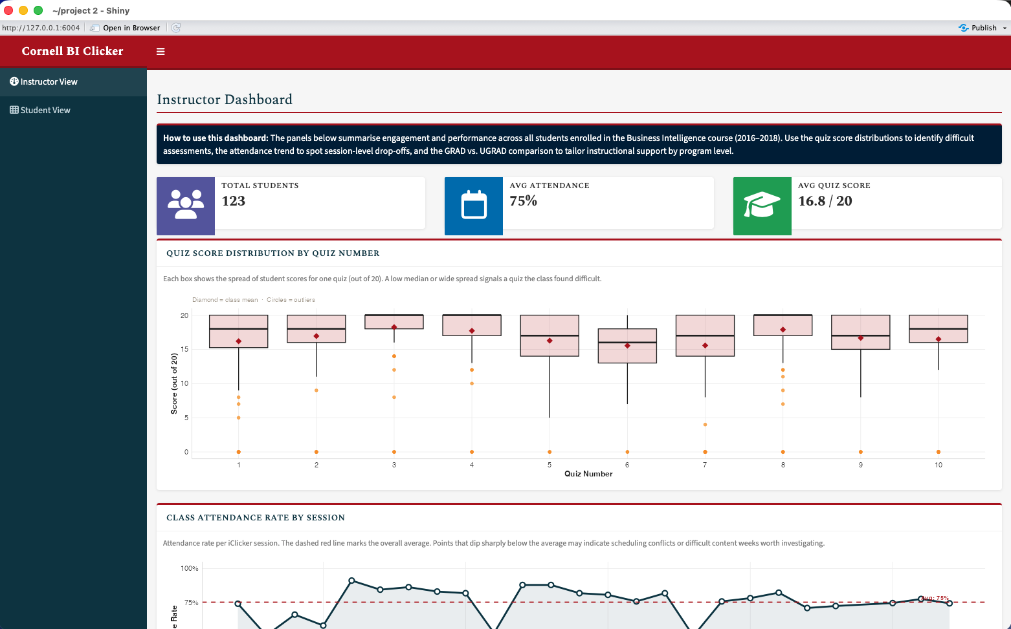
Instructor Dashboard — KPI info boxes (total students, attendance, avg score) and quiz score boxplots by quiz number
Screenshot 2 — Instructor Dashboard: Attendance trend and program comparison
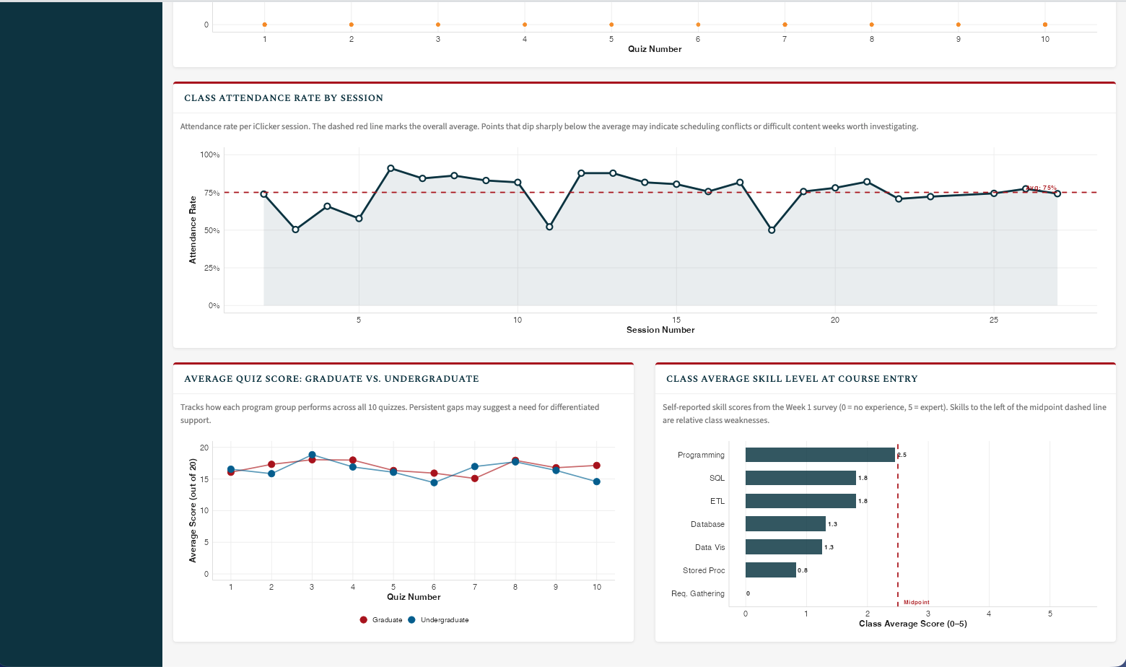
Instructor Dashboard — session attendance rate over time and Graduate vs. Undergraduate average quiz scores
Screenshot 3 — Student Dashboard: Personal performance overview
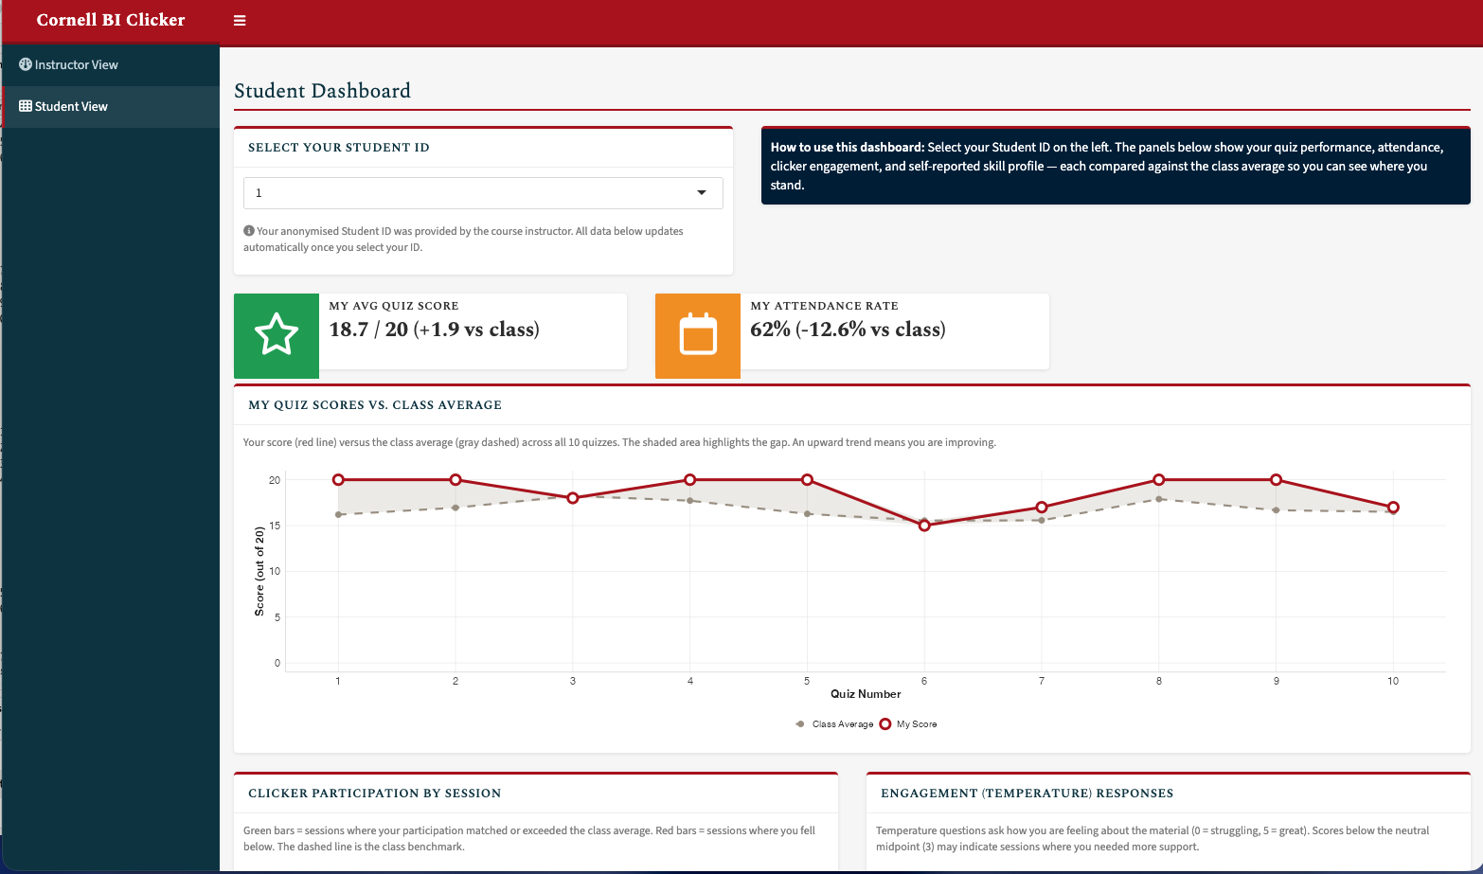
Student Dashboard — student selector, personal KPI info boxes, and quiz score line chart vs. class average
Screenshot 4 — Student Dashboard: Engagement and skill profile
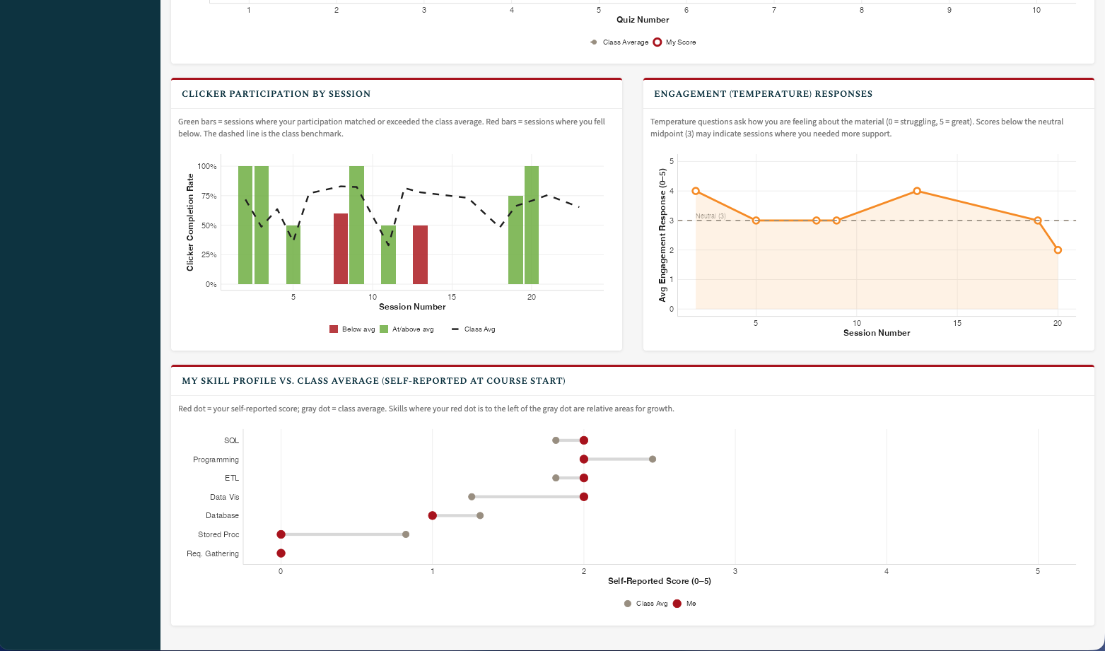
Student Dashboard — clicker participation bars, temperature engagement responses, and skill profile dumbbell chart
Question 6: Evaluate your group dashboard from the perspective of the instructor (teacher dashboard) and from the perspective of the student (student dashboard). What do you like about it, what would you change or add to it if you had more time?
Reflection for the student dashboard
- What do you like about it?
  - We like the direct personal-vs-class comparison built into every panel. The info boxes at the top give an instant “+/-” signal so a student can gauge their standing without reading the charts at all. The quiz score line chart makes it easy to see whether performance is improving or declining over time, and the skill profile bar chart puts the student’s self-assessment in context against their peers.
- What would you change or add to it if you had more time?
  - We would add a “predicted final grade” estimate based on the regression of attendance and quiz scores. We would also add a heatmap of which specific quiz sessions a student missed, and allow the student to filter by year so they could see whether they are keeping pace with prior cohorts.
- What was the biggest challenge you faced? How did you address it?
  - The biggest challenge was handling students who had missing skill survey data or no temperature responses. We addressed this with explicit nrow == 0 / all(is.na()) guards that render a friendly message rather than crashing the plot.
Reflection for the teacher dashboard
- What do you like about it?
  - The boxplot of quiz score distributions gives an immediate picture of where the class struggled and where there was high variability. The GRAD vs. UGRAD comparison bar chart answers a question instructors often have intuitively but rarely have data to answer directly. The attendance line chart makes session-level drop-offs visible at a glance, which could prompt the instructor to investigate what happened on a particular day.
- What would you change or add to it if you had more time?
  - We would add an individual-student drill-down table so the instructor could click a quiz number in the boxplot and see which students scored below a threshold. A correlation plot between skill survey scores and final quiz averages would also help the instructor understand whether prior background predicts success.
- What was the biggest challenge you faced? How did you address it?
  - Handling duplicate student-quiz rows (multiple iClicker sessions per quiz) was tricky. We addressed it by using distinct(STUDENT_KEY, QUIZ_NUMBER, .keep_all = TRUE) so each student contributes one score per quiz to the distribution, matching the conceptual unit the instructor cares about.

Estimate time spent
We want to give students an estimate of how much time this homework will take. Please indicate how many hours you spent to complete this homework here.
- I spent approximately 8 hours across team members completing this project.

Generative AI usage
As stated in the course syllabus, using generative AI is allowed to help you as you complete this homework. We are interested in how it is being used and whether it is helpful for you.
- We used generative AI (ChatGPT) for some of the coding portions, particularly in helping out in some chunks of the Shiny reactive logic and ggplot2 syntax.

Submit Project
This is the end of the group project. Please Knit to Word (if you run into an issue, you can knit to PDF). The resulting file has to show both the R code and R output. Upload it on Canvas before the due date.

