- Testing environment
…
- Testing steps
- Task 1: In the program directory, run sudo python3 networkTopo.py to establish the SDN topology through Mininet. This will open six XTerm Windows, which respectively correspond to the client (client), two servers (server1,server2), switch (s1), and controller (c1). As shown in Figure 2, we run ifconfig in the XTerm window. It can be confirmed that the client, Server1 and Server2 use the correct IP and MAC.
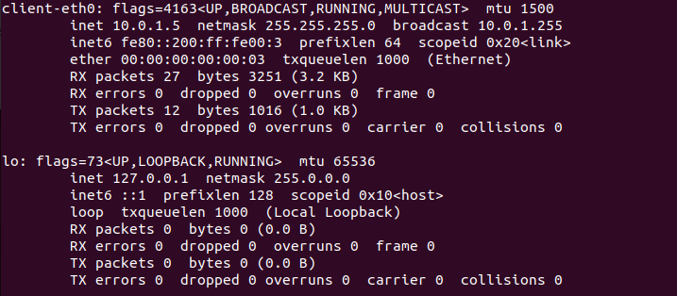

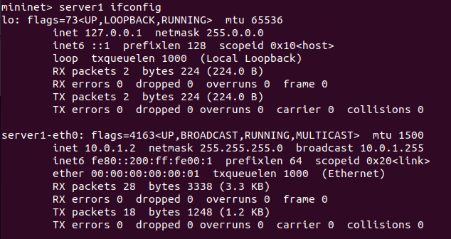

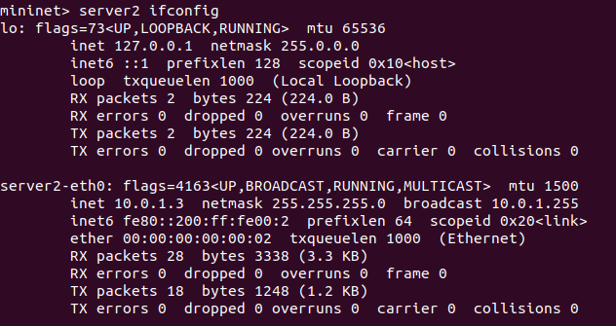
- Task 2: We run ryu-manager ryu_forward.py and then use Client to ping the IP addresses of Server1 and Server2 respectively. Figure x shows that the client successfully sent ICMP Ping requests to Server1 and Server2. The ping results indicate that both servers responded, suggesting that the controller has installed the rules required by the ryu_forwards.py application and also verifying that the forwarding logic on the switch is working properly. Further, We verify the link topology intercommunication through pingall.
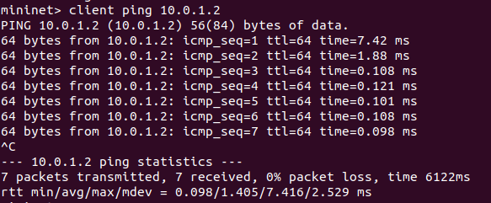

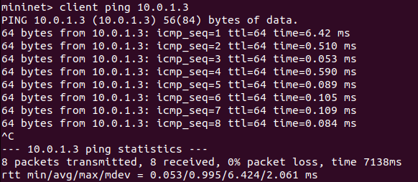

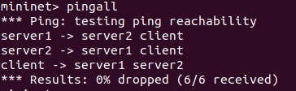

- task 3: We run server.py on the xterm terminals of server1 and server2 and then wait for the idle flow entry generated by the ICMP ping datagram in task 2 to expire (5 seconds) to ensure that the previously installed traffic has cleared the switch rules. Then run client.py on the xterm terminal of the client. In Figure X, a screenshot of the flow entry (flow entry) and the traffic logic of Server1 and the client are shown. This confirms the logic of the 5-second timeout of the flow entry: once the idle timeout occurs after the data packet arrives, the forwarding logic of the controller is triggered again. Generate new flow items. As shown in Figure X, the traffic from the client was successfully forwarded to the server.
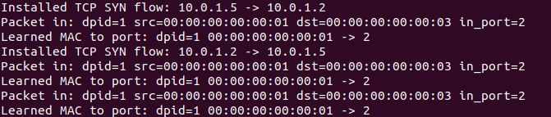

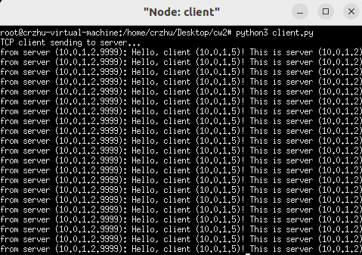

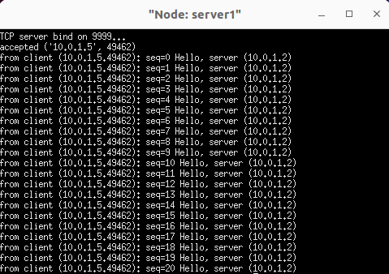

- task 4
task 4.1: According to Figure X a (the test results completed in task3), we successfully verified that the first TCP SYN successfully triggered Packet_In, and the SDN controller could correctly install the bidirectional flow tables of Client→Server1 and Server1→Client. The controller correctly forwards the initial SYN using Packet_Out. All subsequent TCP traffic is directly forwarded through the switch flow table without triggering Packet_In.
task4.2: In the xterm terminal of the client, execute tcpdump -i client-eth0 -w forward-.pcap, specify the packet capture at the eth0 network interface of the listening client, and directly write the captured packets into forward-.pcap. It is convenient to directly analyze the data using wireshark. Figure X shows that 67 packets were successfully received in our verification without any packet loss. The analysis of the packet capture results will be reflected in the testing result
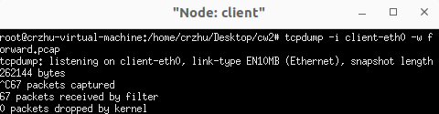

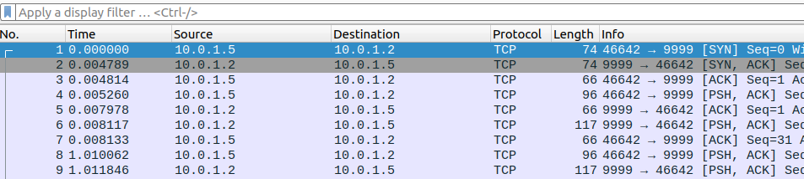

- task 5
task 5.1: We run ryu redirect.py on the Controller and use the Client ping the IP address of Server1 and the IP address of Server2. Figure X shows that the client successfully pings Server1 and Server2 under the ryu Redirece.py application of the controller.
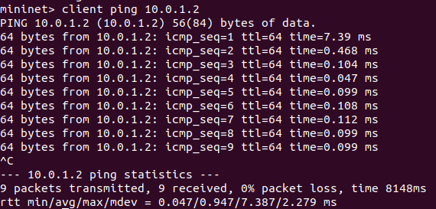

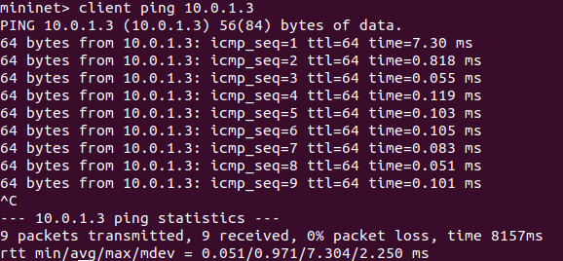

As before, we run server.py on both Server1 and Server2, and wait for the idle timeout (i.e., 5 seconds) of the flow entry generated by the previous ICMP ping. Then we run client.py on the Client and initiate a new traffic redirection mode. We observed that the client successfully passed traffic to the specified server2 (figure X) and no flow to server1, which explains the successful installation of the redirection rule by the controller.
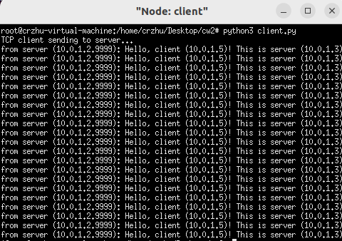

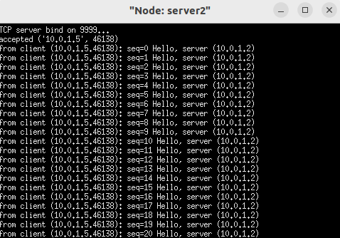

Furthermore, by observing the flow table output of the controller, we verified that the controller can correctly detect TCP connection initiation and execute server redirection. As shown in the runtime log (figure X), when a client with IP of 10.0.1.5 sends a TCP SYN packet to Server1 10.0.1.2, the controller recognizes it as a new stream and redirects the SYN to server2 10.0.1.3 according to the load balancing strategy. The log output clearly shows that the controller has rewritten the destination IP and destination MAC fields and forwarded the modified message to the corresponding output ports. After detecting SYN, the controller installs two flow items with a 5-second idle timeout: one for the client →server2 (redirect) direction and the other for the server2→ client. The source field is rewritten to maintain the illusion of server1. This confirms that bidirectional stateful redirection works as expected.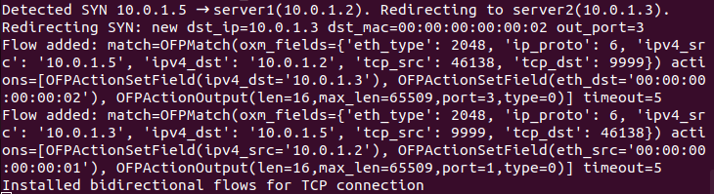

Task 5.2
In the xterm terminal of the client, execute "tcpdump -i client-eth0 -w redirect.pcap" to specify packet capture at the eth0 network port of the listening client, and directly write the captured packets to redirect.pcap. wireshark can be used to conveniently analyze data directly. Figure X shows that in our verification; 70 data packets were successfully received without packet loss. The analysis of the packet capture results will be reflected in the testing result.
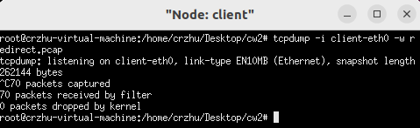

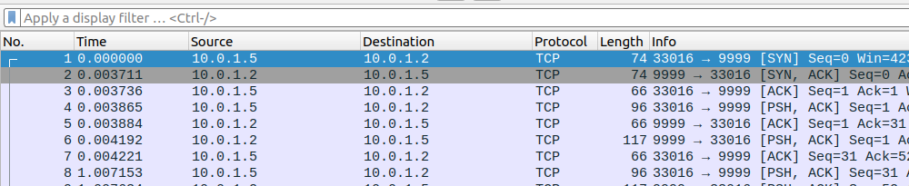

- Testing results
Performance analysis of forwarded cases
In the forwarding scenario, the experimental results show that the delay of the TCP three-way handshake is relatively consistent, and the calculated average delay is approximately 2.9 ms. As shown in the line graph (Figure X), the initial test reveals a significant outlier with a peak delay of 4.814 ms, which may be attributed to cold start overhead, such as the initial ARP resolution or rule installation delay. After this initialization stage, the system stabilized significantly, and the subsequent delay (Experiments 2-10) oscillated within a narrow range between 2.370 ms and 3.321 ms. The relatively low variance observed in the steady-state stage indicates that the forwarding mechanism maintains a deterministic processing path

Performance analysis of Redirection cases
On the contrary, the redirection scenario shows a lower overall average latency (approximately 1). It is 2.7ms, but its characteristic is significantly higher volatility and unpredictability. As shown in Figure X, the delay distribution is non-uniform; Although this mechanism achieved excellent performance in the middle of the experiment, reaching a minimum of 1.596 ms (Experiment 4), it failed to maintain this efficiency. It is worth noting that the subsequent tests (Tests 7-10) demonstrated a significant performance degradation, with the peak delay reaching up to 4.033 ms. This obvious fluctuation indicates that although the redirection method can theoretically outperform forwarding under ideal conditions, in different operational states, it may be vulnerable to instability caused by control plane overhead, resource contention, or delay in flow table updates.