This documents contains some exercises. This document is optional.
NO answers will be provided.
How to use this document: try to write your answers without reading the learning materials, and then go back to the learning materials to check the related knowledge

Q1. Suggest the most appropriate software process model for the following systems, justify your suggestion:
- The rocket control system
- Software to control X-ray machines in hospital and to analyse the results
- A new mobile app to support group chats and share news
- An upgraded version to our sport centre app, with a new function to share my sport photos with my friends in the same sport club.

Q2. Write Java source code to implement Java interface for decoupling, for the following situation.
- The object ‘traveller’ can control different types of vehicles.
- A JAVA interface ‘vehicle’ to allow loose coupling implementation.
- A car class implements the vehicle interface.
- A bike class implements the vehicle interface.

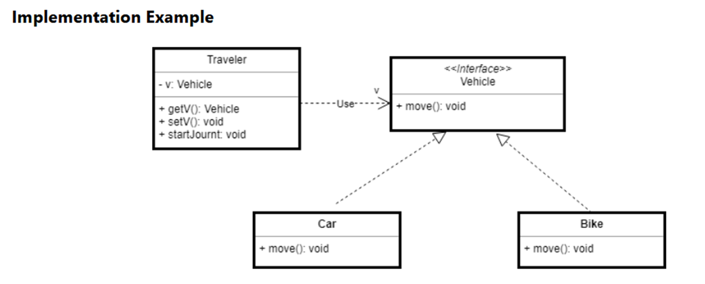

Q3. to draw a logical view, a process view, a development view, and a physical view for ‘ Software to control X-ray machines in hospital’ and to analyse the results.

Q4. To draw and explain the following: model view controller, Layered, Repository pattern, Client-server and Pipe and filter.

Q5. Two software engineers are arguing on how to modularize their software design. One engineer decomposes the design into too few modules while the other engineer decomposes the design into too many modules. What factors must the engineers be considering when decomposing a software design?
How an answer to be marked:
- Just answer the two correct factors - cost of effort (per module) and number of modules -> not full marks
- name the correct factors AND explain that designers should balance the cost of each module and the number of modules based on the intersection point of the two curves -> a good mark

The following image is from the lecture note:
