XI’AN JIAOTONG-LIVERPOOL UNIVERSITY

西 交 利 物 浦 大 学

COURSEWORK SUBMISSION
COVER Page

Group Number
Students' ID Number | 2361387
Module Code
Assignment Title
Submission Deadline
By uploading this coursework submission with this cover page, we certify the following:
- We have read and understood the definitions of collusion, copying, plagiarism, and dishonest use of data as outlined in the Academic Integrity Policy of Xi’an Jiaotong- Liverpool University.
- This work is entirely our own, original work produced specifically for this assignment. It does not misrepresent the work of another group or institution as our own.
- This work is not the product of unauthorized collaboration between ourselves and others.
- This work has not been shared wholly or in part outside of the group. Each member has performed the duty to protect the submission until the feedback is released.
- It is a submission that has not been previously published, or submitted to any modules.
- Students who would like to submit the same or similar work from previous years to the current module or other modules must receive written permission from all instructors involved in advance of the assignment due date.
- All group members are equally and collectively responsible for the entire submission. Violations of academic integrity including failure to monitor group member contribution originality constitutes negligence.
- Unreported suspicious academic misconduct by one group member will be attributed to ALL members in terms of penalties. ALL members share the responsibilities.
- Use of generative AI is strictly prohibited for all assessments involved in this module.
We understand collusion, plagiarism, dishonest use of data, and submission of procured work are serious academic misconducts. All group members are held jointly accountable for the integrity of the entire submission. By uploading or submitting this cover page, we acknowledge that we are jointly subject to penalties and disciplinary actions if we are found to have committed such acts.
~~~~~~~~~~~~~~~~~~~~~~~~~~~~~~~~~~~~~~~~~~~~~~~~~~~~~~~~~~~~~~~~~~~~~~~~~
We acknowledge that the university late submission policy will be applied if applicable.
~~~~~~~~~~~~~~~~~~~~~~~~~~~~~~~~~~~~~~~~~~~~~~~~~~~~~~~~~~~~~~~~~~~~~~~~~
Please list the ID number of any group member NOT contributing to the submission:

Please indicate whether based on your individual contributions you meet the learning outcomes (LOs) covered by this coursework and confirm your submission meets with all above requirements by signing your name, handwritten in ink, in English (Foreign students) or PINYIN (local students):
Student ID | (tick) box to confirm you contributed to all cw tasks | (tick) box to confirm you meet all LOs covered by this cw | Signed
 | □ | □
 | □ | □
 | □ | □
 | □ | □

Date: ……………………………………

Q1. Class Diagram (15 marks).
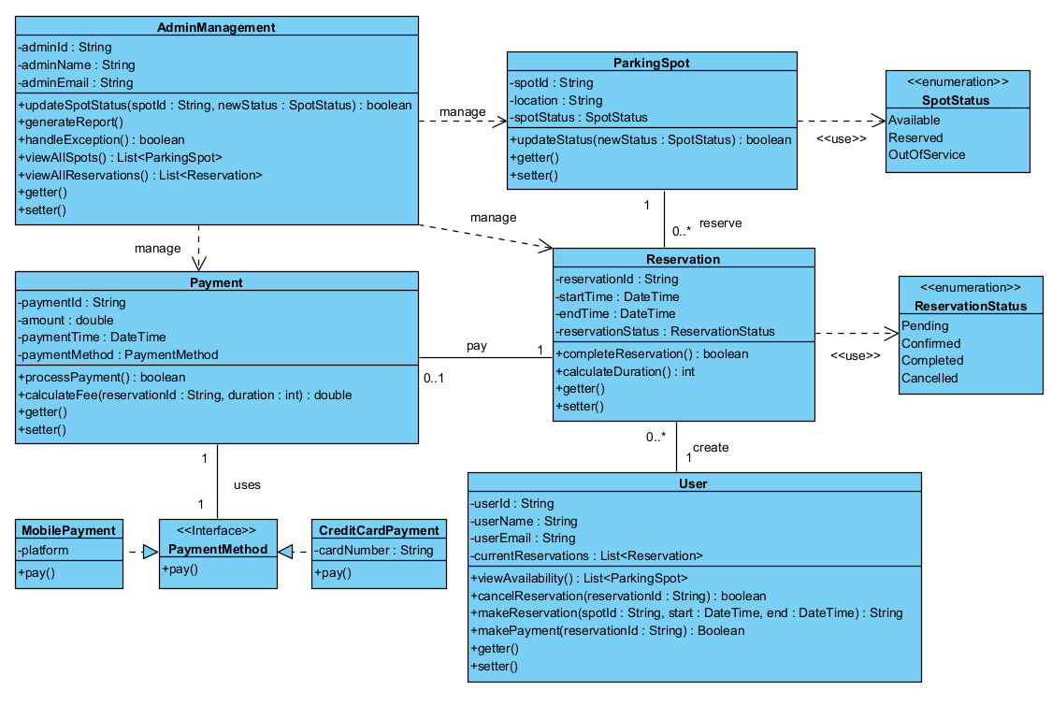
Figure 1 Class Diagram

Q2. Software Design Concepts (15 marks).
1. Abstraction Principle
In the SPS class diagram, abstraction is used to keep each component focused on essential responsibilities while hiding operational details. This avoids unnecessary complexity and supports later system expansion.

1.1 Data Abstraction
Each class exposes only the data required for its role. In our design, ParkingSpot only reveals spotId, location, and spotStatus, without exposing how availability is internally managed. Reservation stores only the identifiers(reservationId) and time needed to represent a booking. Similarly, payment presents payment-related fields without showing how fees are stored or processed. Because modules interact only with the data they need, dependencies remain controlled and changes to internal representations do not affect other classes. This improves maintainability and makes it easier to scale the system if more attributes or new parking-spot types are added later.

1.2 Procedural Abstraction
Methods describe high-level behaviours while hiding implementation logic. Examples from the class diagram include Calling viewAvailability() gives users a list of open spots without revealing how filtering is done. updateStatus() in ParkingSpot provides a single point for status changes instead of exposing internal state updates. The pay() method in PaymentMethod provides one unified entry point for different payment types. Because modules rely on behaviours rather than internal steps, extending the system—such as adding new payment workflows—can be done without touching existing logic. This strengthens maintainability and allows scalability when the university introduces additional services.

2. Modularity Principle
The SPS is divided into clear modules: User, ParkingSpot, Reservation, Payment, AdminManagement, and PaymentMethod. Each handle one aspect of the system: User → user actions (view, reserve, pay) Reservation → booking logic ParkingSpot → spot information Payment → payments & fees, AdminManagement → administrative monitoring, PaymentMethod → extensible payment options. This separation keeps responsibilities within each module. For instance, Reservation interacts with ParkingSpot and Payment only through methods, not through direct access to internal state. As a result, updates to one module— such as adding a new report function in AdminManagement— do not require changes elsewhere, improving maintainability and enabling the system to scale with new features.

3. Functional Independence Principle
3.1 Low Coupling
My design minimizes direct connections between distinct components. A key example is the Payment module. The Payment class depends on the PaymentMethod interface rather than concrete classes like CreditCardPayment. This means Payment is decoupled from the specific implementation of payment providers. Furthermore, Reservation interacts with Payment but does not need to know how the payment is processed. This loose coupling makes the system highly scalable; adding a new payment type (e.g., "tokenPayment") requires no changes to the Reservation or User classes.

3.2 High Cohesion
Each module is focused on a single purpose: ParkingSpot → spot state Reservation → booking behaviour Payment → payment operations AdminManagement → administrative tasks. Because responsibilities are tightly grouped, each class is easier to understand and maintain. High cohesion prevents logic mixing and helps the system grow smoothly as new parking services or reservation rules are introduced.

4. Object-Oriented Design Principles
4.1 Encapsulation
Encapsulation ensures internal state is changed only in controlled ways. For example: ParkingSpot’s status can only be modified using updateStatus(). Payment hides internal fee calculation logic and exposes only final behaviours. This protects data integrity and avoids unintended interactions between modules. It also supports maintainability since internal logic can change without affecting the calling modules.

4.2 Inheritance
Inheritance appears primarily through the PaymentMethod interface. CreditCardPayment and MobilePayment both implement pay(), allowing the system to support multiple payment options cleanly. This reuse of structure avoids rewriting shared logic. It also makes scalability easier—new payment types can be added without altering existing classes.

4.3 Polymorphism
Because different payment objects share the same interface, the system can call pay() without knowing whether it is a credit card, mobile wallet, or a future method. This simplifies Reservation and Payment logic and reduces branching code. Polymorphism increases flexibility and allows future extensions without major structural change, supporting long-term scalability.

Q3. Architecture Selection (15 marks)
We selected Layered Architecture as the most suitable style for the Smart Parking System (SPS).
1. Structural Diagram
In Figure 2

2. The reasons for choosing this architecture
2.1 Separation of concerns in business logic
SPS contains complex business rules, such as dynamic fee calculation and parking space allocation, which must be separated from the user interface and data storage. In our design, if there is an error in the pricing logic - for instance, the system fails to apply the "student discount" correctly - developers can fully focus on the business logic layer. Due to strict separation, fixing this algorithm in the payment module will not disrupt the layout of the mobile application (presentation layer) or the database schema (data layer). This isolation significantly reduces maintenance time and risks.

2.2 Clear data flow
Clear data flow is conducive to the isolation of erroneous logic. In the SPS system we designed, when a user initiates the makeReservation () operation, the request follows a predictable path: the application captures the input, the business layer verifies availability and calculates the cost, and the data layer submits the transaction. If a billing error occurs, the strict layering enables us to easily isolate the fault: is it the duration of the application sending error or the failure of the calculation logic? This traceability makes it more efficient for developers to debug key financial transactions.

2.2 Scalability
The layered architecture we have chosen better supports the university's demand for future functional expansion. For instance, if the school makes payments with student ID cards next year, these changes will largely be included in the business layer. We can add an interface to the student ID payment logic to inherit pay() without rewriting the underlying transaction record system or rebuilding the entire mobile application interface. The modular feature of the layer ensures that the system can be iteratively developed.

3. Future limitations of layered architecture
3.1 Performance limitations
With the growth of user traffic, high-concurrency scenarios are increasing. In future scenarios, such as university events (for example, graduation ceremonies), thousands of users may simultaneously check the availability of the site. In strict layered architecture, even simple read requests must traverse the presentation layer, business layer, and data layer. Each layer will increase processing overhead. This accumulated delay may lead to slower response times or timeouts during peak traffic periods, which can have a negative impact on the user experience.

3.2 Difficult to maintain clear stratification
The upper level may be forced to access the lower level directly. For SPS, if we introduce high-performance functions such as real-time indoor navigation, to achieve low latency, transmitting data in strict layers (UI-Business-Data) is too slow. Developers may allow the mobile application interface to bypass the business logic layer. Direct access to the data layer (or sensor flow). Over time, the hierarchical structure was disrupted.

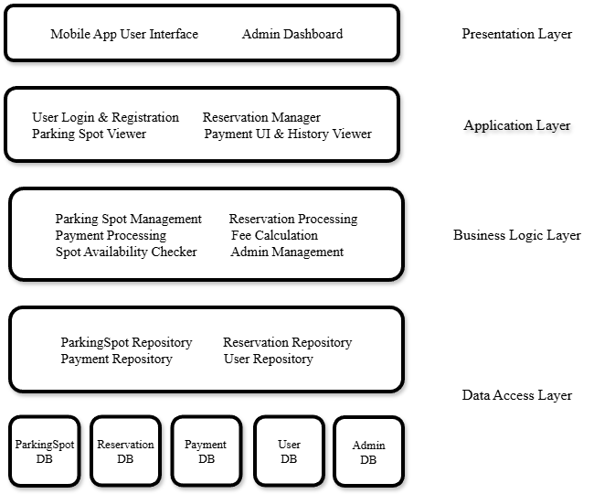
Figure 2 Structural Diagram

Q4. Test Case Design. (10 marks)
By default, each test is a black-box test.

Category | Test Objective | Input type | Input Value | Output | Note
Valid Test Case 1 | Verify the system can create a reservation under normal conditions (no conflict, within valid time range). | String,  DateTime, DateTime | spotId:"A01"  start: "2026-01-01 10:00"  end: "2026-01-01 12:00" | The system returns a Reservation ID and a confirmation message. A new reservation record is created in the database, and the spot status updates to "Reserved". | Assume spot "A01" is currently "Available".
Valid Test Case 2 | Verify the system can handle another valid reservation, ensuring the same spot can be reserved for a different time slot. | String,  DateTime, DateTime | spotId: A01  start: "2026-01-01 14:00"  end: "2026-01-01 16:00" | The system returns a Reservation ID and a confirmation message. A new reservation record is created in the database, and the spot status updates to "Reserved". | Assume spot "A01" is currently "Available".
Invalid Test Case 1 | Verify the system's response when the End Time is before or equal to the Start Time. | spotId  DateTime  DateTime | spotId: "A01"  start: "2026-01-01 14:00"  end: "2026-01-01 10:00" | Returns an error message("End time cannot be earlier than start time"), no new record is created in the database. | Assume spot "A01" is currently "Available".
Invalid Test Case 2 | Verify the system behavior when a user attempts to reserve a spot that is "Reserved". | String, DateTime, DateTime | Spot ID: A01  start: "2026-01-01 14:00"  end: "2026-01-01 16:00" | Returns an error message(“The parking spot is now reserved”), no new record is created in the database. | Assume spot "A01" is currently "Reserved".
Boundary Test Case | Verify the system behavior when the start time is exactly equal to the current system time (immediate booking). | String, DateTime, DateTime | spotId: "D04"  start: [now]  end: [now + 1 hr] | The system accepts the input and proceeds to reserve the spot immediately. Returns success message. | Assume the lower boundary of the start time is current time.
Table 1 Test Case Design

Q5. JUnit Testing (15 marks)
1.Junit code
import org.junit.jupiter.api.*;
import java.time.LocalDateTime;
import java.util.concurrent.TimeUnit;
import static org.junit.jupiter.api.Assertions.*;
@DisplayName("Reservation Tests")
class ReservationTest {
private Reservation res;
private ParkingSpot spot;
private LocalDateTime now;
// Initialize a fixed LocalDateTime value
@BeforeEach
void setUp() {
now = LocalDateTime.now();
spot = new ParkingSpot(101, ParkingSpot.Status.AVAILABLE);
// Default valid reservation: 1 hour duration
res = new Reservation(1, 99, spot, now.plusHours(1), now.plusHours(2));
System.out.println("Setup completed for a new test.");
}
// Reset objects used in the test
@AfterEach
void tearDown() {
res = null;
spot = null;
now = null;
System.out.println("Test cleanup completed.");
}
@Test
@DisplayName("Case 1: Invalid Time Range")
void testInvalidTime() {
// Case: Start time is after End time
Reservation badTimeRes = new Reservation(2, 99, spot, now.plusHours(2), now.plusHours(1));
assertThrows(IllegalArgumentException.class,
badTimeRes::processReservation,
"Should throw exception if start >= end");
}
@Test
@DisplayName("Case 2: Spot Not Available")
void testUnavailableSpot() {
// Case: Spot status is RESERVED
spot.setStatus(ParkingSpot.Status.RESERVED);
assertThrows(IllegalStateException.class,
res::processReservation,
"Should throw exception if spot is not AVAILABLE");
}
@Test
@DisplayName("Case 3: Success Path")
@Timeout(value = 100, unit = TimeUnit.MILLISECONDS)
void testSuccess() {
// Case: Valid input should return true and confirm reservation
boolean result = res.processReservation();
assertTrue(result);
assertTrue(res.isConfirmed());
assertEquals(ParkingSpot.Status.RESERVED, spot.getStatus());
}
}

2.Result
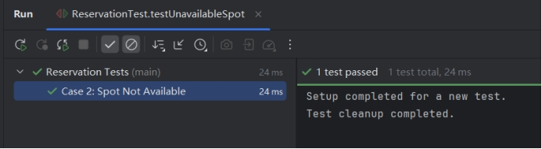
Figure 3 Test Case 1

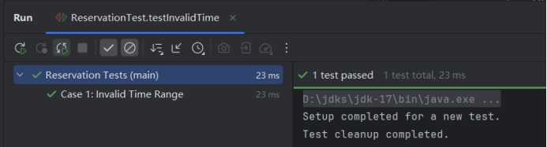
Figure 4 Test Case 2

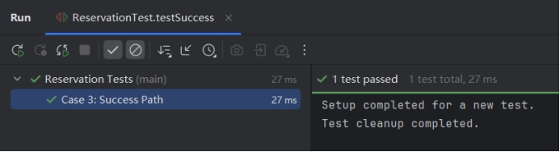
Figure 5 Test Case 3

Q6. Risk Management. (15 marks)
1.Risk Identification and assessment
Risk 1: Database Concurrency Conflict (Double Booking)
When multiple users simultaneously reserve the same parking space, due to the delay in database reading and writing, the system may mistakenly return "Reservation successful" to both, resulting in a double reservation.
Category: Product
Source: Technology
Assessment: Likelihood is Medium; Seriousness is High.

Risk 2: External Payment Gateway Response Failure
The system relies on third-party payment services. If the external service goes down or times out, the payment process will be blocked, the exit gate will not open, and vehicles may get stuck at the parking lot exit.
Category: Product
Source: External Dependency
Assessment: Likelihood is Medium; Seriousness is High.

Risk 3: Low User Adoption
Some drivers such as those who are not familiar with mobile phones may find the operation complicated and refuse to use the app, resulting in insufficient system user numbers and thus affecting the revenue.
Category: Business
Source: User Behavior
Assessment: Likelihood is Medium; Seriousness is High.

Risk 4: Scope Creep
Stakeholders may continuously put forward new demands like car washing and charging services, and if not controlled, it may affect the timely completion of the core functions.
Category: Project
Source: Requirement Management
Assessment: Likelihood is High; Seriousness is Medium.

2.Prioritization and Justification
Based on the comprehensive consideration of "Likelihood" and "Seriousness" in the risk assessment, we have identified risk 1 (database concurrency conflict) and risk 2 (external payment gateway failure) as the priorities that the project must prioritize.

Regarding the priority definition of risk 1, this is the most crucial function of the system. If there is a double reservation, the data will be incorrect, users will have disputes on the spot, and the system will lose its credibility. Data errors are usually difficult to fix afterwards, so they must be addressed as a priority.

Regarding the priority definition of risk 2, this is a problem that will cause "vehicles to be unable to leave the site", and it is a high-risk situation that immediately affects operations. External services cannot be controlled by the team, so backup procedures must be designed in advance.

3.Risk Response Plan
Regarding the risk of concurrent reservations(risk 1), we adopt the avoidance strategy. Since we cannot prevent multiple users from simultaneously claiming parking spaces, our goal is to ensure that no duplicated data is stored in the database. When a user attempts to reserve a specific location at a particular time (for example, A01), the system will first obtain a lock key in Redis (for example, lock:booking:A01:time). If another user attempts to retain the same location at the same time, their request will not be locked and will be rejected immediately before any database transaction begins. By serializing requests at the cache layer, we eliminate the possibility of race conditions reaching the database, ensuring 100% data integrity is retained.

Regarding the risk of payment failures(risk 2), we adopt the contingency strategy because we cannot control whether the third-party service goes down. To prevent vehicles from getting stuck at the exit, the system will monitor the payment interface. Once it detects consecutive timeouts, it will automatically alert the administrator. The administrator can remotely open the gate through the back-end system or manually release the vehicles on-site. The system will mark this order as "pending manual processing", and after the network recovers, the payment will be made up. This ensures that even if the payment system fails, the parking lot can operate normally and avoid congestion.

Q7. Continuous Improvement. (15 marks)
1.Continuous improvement strategy
1.1 Scrum Retrospective
1.1.1 Application in SPS
Every two weeks after the sprint, the SPS development team holds a review meeting to analyze the workflow of "reserved parking Spaces" and "payment". For instance, if the data log indicates a high failure rate of gate opening during peak hours, the team will identify the root cause (such as slow API response) and assign action items to optimize the code in the next sprint.

1.1.2 Impact on improvement
System quality: By proactively identifying bottlenecks (such as payment delays), the team can fix issues before they affect a large user base.
Team performance: Publicly communicating the progress of work (for example, when back-end developers and application developers are not in sync) will lead to better collaboration.
User satisfaction: Continuously address user pain points (such as confusing UI) to enhance the user parking experience.

1.2 CI/CD Pipeline
1.2.1 Application in SPS
The team will adopt automated pipelines (tools such as Jenkins or GitHub Actions) for code integration and deployment and automatically trigger the test suite when submitting the code. For SPS, this includes running automated concurrency tests to ensure that no duplicate bookings occur. Once the test is passed, the system automatically deploys the update to the temporary storage environment for final verification and then pushes the update to the real-time parking system during off-peak hours (such as 3 a.m.).

1.2.2 Impact on improvement
System quality: Automated regression testing ensures that new features (such as "Car Wash Reservation") do not disrupt existing core functions, while also reducing the risk of bugs and enhancing the overall stability of the system.
Team performance: Reduce manual testing time, allowing developers to focus on building new features rather than fixing deployment errors.
User satisfaction: Allows for faster delivery of bug fixes. If a serious error is found in the payment module, the fix can be deployed within minutes instead of days, which helps to improve the user experience.

2. Three Metrics for Continuous Improvement
For Development: Deployment Frequency
SPS operates in dynamic environments (for example, constantly changing campus rules, special event parking). A high deployment frequency (for example, once a week) indicates that the team can adapt to these constantly changing business requirements and continuously deliver value to the driver without long waiting times.

For Product Quality: Mean Time to Recovery
In physical services like parking, availability is the key. If the exit door system crashes, the vehicle will be trapped. Tracking MTTR ensures that the team focuses on monitoring and rapid incident response. A lower MTTR (for example, less than 15 minutes) is crucial for preventing traffic congestion and user frustration.

For Customer and User: Customer Satisfaction
This is a direct measure of "user experience". Customer satisfaction will be measured by user feedback, with the goal of having at least 80% positive feedback on the availability of the parking reservation system and payment process. If the satisfaction rate drops below 70%, we will immediately focus on optimizing these core user interactions. Similarly, for the team, it is possible to verify whether the recent UI changes or performance optimizations have indeed improved the subjective experience of drivers.
Appendix
Peer review
CPT203 Coursework
Peer review
Individual Contribution for Group Report

Group Number: <x>

Name | ID Number | Contribution (%)  The sum of this column should be 100 | Signature
1. <my name> | <123456> | 16.67 (supposing all 6 member contributing equally, each one is ~16.67)
2.
3.
4.
5.

END

