Discovering Requirements
Core characteristics of interaction design
1. Users should be involved throughout the development of the project
2. Specific usability and user experience goals need to be identified, clearly documented, and agreed to at the beginning of the project
3. Iteration is needed through the core activities

Importance of involving users
1. Understanding of users' goals leading to better products
2. Expectation management
Realistic expectations, No surprises, no disappointments; Timely training; Communication, but no hype
3. Ownership
Make the users active stakeholders; More likely to forgive or accept problems; Can make a big difference in acceptance and success of product

Degrees of user involvement
Member of the design team
- Full-time: constant input, but lose touch with users
- Part-time: patchy input, and very stressful
- Participatory design: involve all stakeholders in the early stages of design
Face-to-face group or individual activities
Online contributions from thousands of users
- Online Feedback Exchange (OFE) systems
- Crowdsourcing design ideas
- Citizen science
User involvement after product release (Customer review analysis)

Usability goals:
1. Effective to use (effectiveness)– how good it is
2. Efficient to use (efficiency)– how easy / fast it is
3. Safe to use (safety)
4. Have good utility (utility)
5. Easy to learn (learnability)
6. Easy to remember how to use (memorability)

User experience:
Desirable aspects: Satisfying Helpful Fun Enjoyable Motivating Provocative Engaging Challenging Surprising Pleasurable Enhancing Sociability Rewarding Exciting Supporting Creativity Emotionally fulfilling
Entertaining Cognitively stimulating Experiencing flow
Undesirable aspects: Boring Unpleasant Frustrating Patronizing
Making one feel guilty Making one feel stupid Annoying Cutesy
Childish Gimmicky

Usability and user experience goals difference
→ There is no clear cut between them
→ Usability goals differ from user experience goals
→ Usability is more objective: how useful or productive a system is from its own perspective
→ User experience is more subjective: how users experience an interactive product from their own perspective

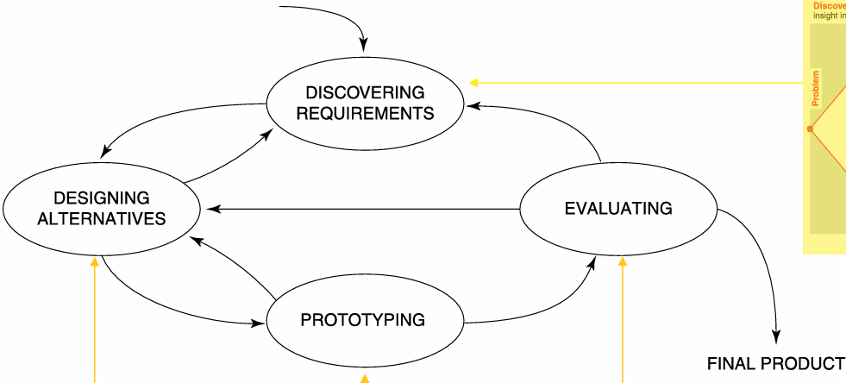
4 basic activities of interaction design (lifecycle model, double diamond)
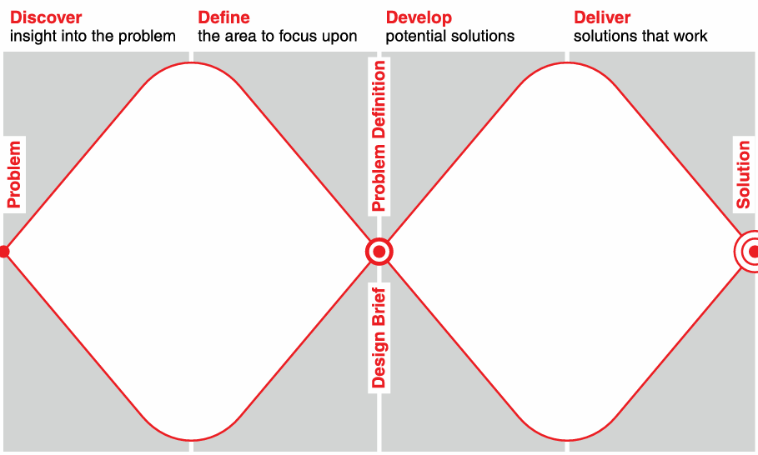
Practical practice in develop: We followed this by first [collecting user requirements through interviews/questionnaires/observation], then [creating alternative interface ideas], then [building low- or high-fidelity prototypes], and finally [testing/evaluating them with users or experts and revising the design].
Discover explores the problem space and gathers insights(explores users, context, and the current experience 问卷…). Define narrows the problem and clarifies requirements. Develop generates and prototypes alternative solutions(低保真原型，纸面草图、Figma wireframe). Deliver evaluates, refines, and produces the final design.(usability testing 交付)

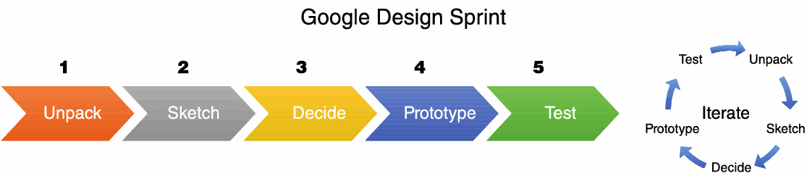
Understanding the problem space:
1. Explore
- what is the current user experience - why is a change needed - how will this change improve the situation
2. Articulating 明确 the problem space
- Team effort – explore different perspectives – Avoid incorrect assumptions and unsupported claims

What is involved in Interaction Design?
It is a process: → Focused on discovering requirements, designing to fulfil requirements, producing prototypes and evaluating them → Focused on users and their goals → Involves trade-offs to balance conflicting requirements
Generating alternatives and choosing between them is key

User-centered approach: 3 principles
1. Early focus on users and tasks: directly studying cognitive认知, behavioral, anthropomorphic, and attitudinal characteristics态度特征
2. Empirical measurement实证测量: users' reactions and performance to scenarios, manuals, simulations, and prototypes are observed, recorded, and analyzed
3. Iterative design: when problems are found in user testing, fix them and carry out more
Early focus on users and tasks
1. Users' tasks and goals are the driving force behind the development.
2. Users' behavior and context of use are studied, and the system is designed to support them. 3. Users' characteristics are captured and designed for. 4. Users are consulted throughout development from earliest phases to the latest. 5. All design decisions are taken within the context of the users, their activities, and their environment

Who are the users/stakeholders?
Users are the people who directly interact with the product
stakeholders: The individuals or groups that can influence or be influenced by the success or failure of a project. Identifying stakeholders helps identify groups to include in interaction design activities

The purpose of the requirements activity
→ Explore the problem space to gain insights
→ Establish a description of what will be developed
Requirements is a statement about an intended product that specifies what it is expected to do or how it will perform
How to capture requirements once discovered?
→ In prototypes or operational product → Through structured or rigorous notations → Good to be explicit to keep record of key requirements → Different capturing mechanisms emphasize and de-emphasize different aspect

7 product dimensions
Users, interface, action, data, control, environment, quality attribute
6 most common types of requirements:
1. Functional requirements: Describe what functions the system should do.
2. Data requirements: Describe what kinds of data need to be stored and how will they be stored.
3. Environment requirements or context of use: - Physical: Under what physical conditions will the product operate. - Social - Organizational: user support, communications structure - Technical
4. User characteristics: Nationality, educational background, attitude to computers. System user: novice—Prompted, constrained, clear. Expert—flexibility, access/power. Frequent—shortcuts. Casual/infrequent—clear menu paths. User profile
5. Usability goals 6. User experience goals

Data gathering techniques for requirements:
→ Interviews, observations, and questionnaires
→ Studying documentation
- Procedures and rules are often written down in manuals
- Good source of data about the steps involved in an activity
and any regulations governing a task
- Good for understanding legislation and getting background
Information
- Does not involve stakeholder time
→ Researching similar products: Good for prompting requirements
More: Diaries; Surveys; Think-aloud evaluation; Working prototype evaluation; Studying documentation; Ethnographic study; Usability tests

Contextual Inquiry 情景调查 4 main principles
→ Context: Going to the user, wherever they are, and seeing what they do as they do it
→ Partnership: User and interviewer explore user's life together
→ Interpretation: Observations interpreted by user and interviewer together
→ Focus: Project focus to understand what should be paid

Personas:
→ Capture a set of user characteristics (user profile)
→ Synthesized from real people based on user research
→ Typical, not idealized
→ Bring to life with name, characteristics, goals, and personal background (Relevant to product under development)
→ Two goals of persona: Helps designer with design decisions and Reminds team about who will use the product
→ Develop a small set of personas with one primary
Scenario:
Defines when, where and how the story of the persona takes place. The scenario is the narrative that describes how the persona behaves as a sequence of events.
Use cases
→ Focus on functional requirements and capture interaction
→ Can be used in design or to capture requirements
→ Use cases are step-by-step descriptions of interactions, user stories focus on outcomes and user goals
→ Two styles: 1. Essential use cases: division of tasks, no implementation detail 2. Use case with normal and alternative courses: more detail
Prototyping
Why prototype? ➔ Evaluation and feedback are central to interaction design ➔ Stakeholders can see, hold, interact with a prototype more easily than a document or a drawing ➔ Team members can communicate effectively ➔ You can test out ideas for yourself ➔ It encourages reflection: very important aspect of design ➔ Prototypes answer questions, and support designers in choosing between alternatives
Characteristics of Prototyping
Goal-Oriented: A good prototype is built to answer a specific question. (e.g., "Will a user intuitively know how to find the 'submit' button?"). It prevents aimless design.
Disposable & Flexible: The true value lies in the knowledge gained, not the artifact itself. Teams must be willing to throw a prototype away if it doesn't serve the user's ultimate needs.
Iterative: It is not a one-and-done process. Prototypes evolve continuously through cyclical phases of creation, user testing, and refinement based on direct feedback.

Prototype aims (How do we use Prototype):
1. Understanding & ideation: Understanding avoid false assumptions. Prototype could help u to understand - Design alternatives. - Strategy. - User-centered processes. (Prototype could build empathy between designers and users with concrete ideas) useful tools: Empathy map User journey map
2. Communication: Communication increase the efficiency in making decision. Prototype could help u to communicate with 1. Same "language" 2. Different stakeholder 3. No "maybe"
3. Test and reflection (Main aim): Examine and improve the current design. Prototype could help u to test and reflect on 1. Hypotheses and assumptions. 2.Othere's comments

Tools:
1. Storyboards: --Often used with scenarios, bringing more detail, and a chance to role play. --It is a series of sketches showing how a user might progress through a task using the device. --Used early in design.场景
Benefits: By placing the product in a realistic environment, storyboarding builds deep empathy and highlights environmental constraints that standard wireframes miss.
2. Sketching is important to low-fidelity prototyping. 草图(Focus details too early can stifle divergent thinking 过早关注细节会抑制发散性)
3. Index cards (3x5 inches): Each card represents one screen. Often used in 1. Website development 2. Application. 3. Mini Program.
4. ‘Wizard-of-Oz’: The user thinks they are interacting with a computer, but a developer is responding to output rather than the system. Usually done early in design to understand users' expectations. But it lacks authenticity. It has scalability issues. Unable to test all aspects of the system. User feedback may be inaccurate.
5. User Journey: Map Actor & Scenario: Defines strictly who the map is about (the persona) and what their specific goal is.
Phases: The high-level, chronological stages of the user's journey (e.g., Discover, Compare, Purchase)
Actions & Thoughts: Details exactly what the user is doing, thinking, and feeling at each discrete stage.
Emotional Journey: A plotted curve visually representing user sentiment, capturing the highs of delight and lows of frustration.
Opportunities: The strategic takeaways derived from the pain points on how to improve the overall experience.

Fidelity
The fidelity of a prototype refers to how it conveys the look-and-feel of the final product (basically, its level of detail and realism). It should be treated as a measurement rather than a strict low/high classification
Fidelity Scale - Strategic Value 保真度量表
Treating fidelity as a variable dial (rather than a fixed state) gives designers a powerful strategic advantage:
Resource Allocation: It prevents overengineering. Why spend 40 hours coding a high-fidelity dropdown menu if a 10-minute sketch can prove that users don't even want a dropdown menu in the first place?
Directing Feedback: Lower fidelity forces stakeholders to focus on structure and flow. If you show a 90% fidelity mockup too early, executives will argue about the shade of blue instead of the core user journey
Multi-Dimensional: Testing It teaches us that fidelity isn't just visual! You can have a prototype that looks terrible (low visual fidelity) but functions perfectly with real data (high functional/data fidelity).

Understanding Trade-offs
➔ Prototyping is inherently a compromise. You cannot achieve absolute high fidelity, zero cost, and immediate delivery simultaneously. Recognizing these tensions is key to effective product strategy.
- A paper sketch is fast to create but yields little interaction data. A coded prototype yields rich data but limits your ability to rapidly pivot if the core idea fails.
- You must decide whether to test a shallow version of the entire user journey (horizontal prototype) or a highly detailed version of a single specific feature (vertical prototype).
- Internal executives often require polished, high-fidelity visuals to secure funding, whereas end-users provide better structural feedback on unpolished wireframes where they aren't distracted by colors
Design Principles and Design Alternatives
Accessibility and inclusiveness 可访问性与包容性
➔ Accessibility: the extent to which an interactive product is accessible by as many people as possible. Focus is on people with disabilities.
➔ Inclusiveness: making products and services that accommodate the widest possible number of people.
For example, smartphones designed for all and made available to everyone regardless of their disability, education, age, or income

Design Principles:
1. Visibility: The more visible functions and system status are, the more likely users will be able to know what to do next. (a clearly labelled primary button) (Violation: hiding an important function in an unclear menu, which can be improved by making it visible in the main task flow.)
2. Feedback: Feedback refers to the system sending immediate and appropriate feedback to users about the results of their operations. (showing a success message after submission) (Violation: leaving users unsure whether their action worked, which can be improved with immediate status messages)
3. Constraints: restricting the possible actions that can be performed; Helps prevent user from selecting incorrect options. (disabling the “Reserve” button when a seat is unavailable) (Violation is allowing users to select an already booked seat, which can be improved by preventing invalid actions and explaining the reason.)
4. Consistency: Consistency refers to the use of similar operating methods and elements to accomplish similar tasks when designing UI. (using the same icon and wording for the same action) (Violation: using different labels for the same function, which can be improved by standardizing terminology and layout.)
4.1. Internal consistency: refers to designing operations to behave the
same within an application
- Consistency with other elements in the system
- Cultivates a sense of orientation and trust
- Indicate the system is well thought out and planned
- Difficult to achieve with complex interfaces
4.2. External consistency: refers to designing operations, interfaces, to be the same across applications and devices. Also refers to the meaning and action are consistent to improve learnability and understanding
5. Affordance: The physical or digital properties of an object that show users what actions are possible.由于虚拟界面没有实际的物理形态，因此他们不具备物理对象那样的自然可供性。因此虚拟界面的可供性是感知可供性（Perceived Affordance）It refers to the mapping relationship between interface operations and effects.(making available seats look clickable on the seat map) (Violation: displaying seats as plain static icons, which can be improved by using hover effects, button-like shapes, or clear labels to show that users can interact with them.)

Example: The Learning Mall login page should be judged using design principles rather than personal preference. For example, if the login button, username field, password field, and error messages are easy to see, it follows visibility. If the page clearly tells users when login fails and why, it follows feedback. If terminology, layout, and button styles match other XJTLU/Learning Mall pages, it follows consistency. If required fields and valid input formats are constrained, it can prevent errors. Design principles inform interaction design by providing general rules for judging whether users can understand available actions, receive system responses, avoid mistakes, and learn the interface efficiently.

Shneiderman’s 8 golden rules of interface design:
1. Strive for consistency努力保持一致: Consistent sequences of actions should be required in similar situations; identical terminology should be used in prompts, menus, and help screens; and consistent commands should be employed throughout.
2. Enable frequent users to use shortcuts: Allow experienced users to improve efficiency through shortcut keys or operations
3. Offer informative feedback: The system should provide timely and clear feedback to users on their actions, letting them know whether their actions were successful and the status of the system. (Relevant; Fits importance and urgency; Comprehensible and meaningful; Within appropriate context (time and place))
4. Design dialog to yield closure: Interface design should enable users to clearly know when a task or operation is completed, that is, when it reaches a closed state. (Grouping of actions; Explicit completion of an action; Well-defined options for the next step)
5. Offer simple error handling: When an error occurs, the system should provide a simple and intuitive error handling mechanism to help users correct the error and continue their tasks. (Error prevention over error correction; Automatic detection of errors; Clear error notifications; Hints for solving the problem)
6. Permit easy traversal of actions: Users should be able to easily undo or redo operations to return or move forward when needed.(No interference with workflow; More freedom for the user)
7. Support internal locus of control 支持内部控制点: Design should make users feel that they have control over the system, that is, users believe that their actions can directly affect the results of the system.
8. Reduce short-term memory load: The limitation of human information processing in short-term memory requires that displays be kept simple, multiple page displays be consolidated, window-motion
frequency be reduced, and sufficient training time be allotted for codes and sequences of actions. (Implicit help)

How to generate alternatives?
➔ Humans tend to stick with something that works
➔ Considering alternatives helps identify better designs
➔ Where do alternative designs come from?
⇾ ‘Flair and creativity’: research and synthesis
⇾ Cross-fertilization of ideas from different perspectives
⇾ Users can generate different designs
⇾ Product evolution based on changing use
⇾ Seek inspiration: similar products and domain, or different products and domain
➔ Balancing constraints and trade-offs
Methods: Brainstorming, Crazy eights, Morphological Analysis(将产品分解为其基本属性, 然后以新颖随机的方式组合这些属性,以生成意想不到的替代概念)
Evaluating: Heuristic Evaluation, A/B testing, Qualitative User Feedback
Heuristic Evaluation (Questionnaire/Interview)
Questionnaires
Questions can be closed-ended or open-ended
➔ Closed questions are easier to analyze, and may be distributed and
analyzed by computer 可以通过web/email/paper分发问卷
➔ They can be administered to large populations

Questionnaire Design
1. 结果受顺序影响 2. 对于不同的population可能需要不同的版本问卷 3. Provide clear instructions on how to complete 4. 避免长问题 5. Decide on whether phrases will all be positive, all negative, or mixed.
Pros and cons
1. You can collect data from many people, at a relatively low cost
2. You can get an overview of a population of users in a short amount of time 3. Surveys do not require any special equipment
4. Surveys are generally approved by institutional review boards because they are typically non-intrusive 不侵入性的
BUT 1. Surveys are good at getting shallow data from many people, but are not good at getting “deep” data
2. Since surveys are usually self-administered, it is usually not possible to ask follow-up questions
3. Surveys can lead to biased data when the questions are related to patterns of usage, or feelings about a previous experience, rather than clear factual phenomena

Interview
Unstructured(没脚本 内容丰富可复制); Structured: (严格脚本 可复制但是内容不丰富像问卷); Semi-structured(按脚本指导 不过可以有更深入有趣的问题); Focus groups: A group interview
Running the interview
Avoid long questions, Compound sentences, Jargon and language that the interviewee may not understand, Leading questions that make assumptions, Unconscious biases 无意识偏见
Process: 1. Introduction: Introduce yourself, explain the goals of the
interview, reassure about the ethical issues, ask to record,
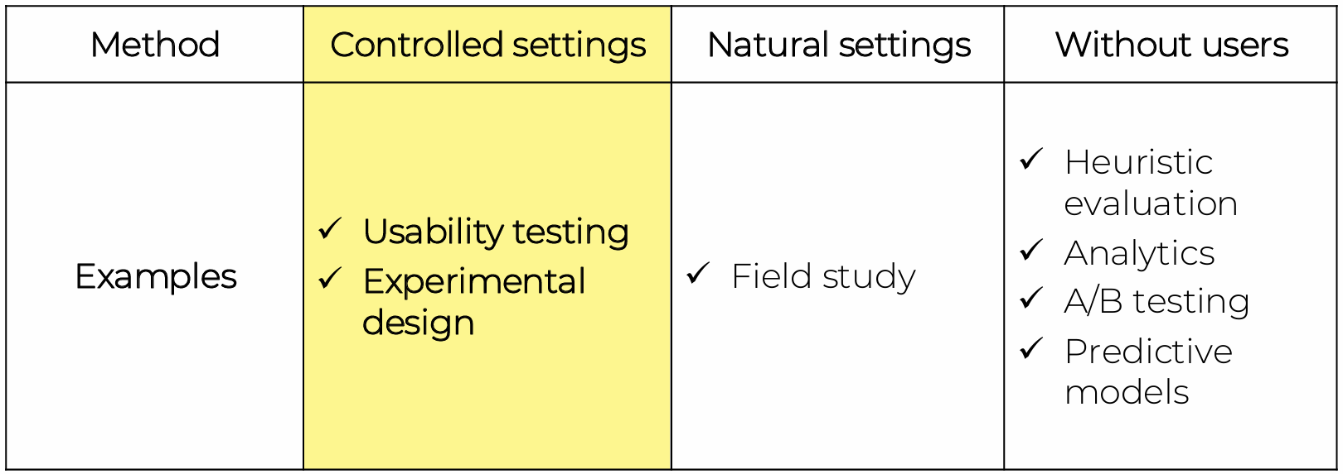
and present the informed consent form. 2. Warm-up: Make first questions easy and non-threatening. Build rapport (a close and harmonious relationship)3. Main body: Present questions in a logical order 4. A cool-off period: Include a few easy questions to defuse tension at the end 5. Closure: Thank interviewee, signal the end, for example, switch recorder off
Pros and cons
Pros ⇾Go deep: encourage reflection and consideration ⇾ Flexible: open-ended and exploratory
Cons ⇾Skill to manage ⇾ Time and resource intensive ⇾ Data analysis ⇾ Recall problems

5 key issues of data gathering
1. Setting goals: What information to collect? How to analyze data once collected
2. Identifying participants: from whom to gather data, how many
3. Relationship with participants: Clear and professional, Informed consent when appropriate
4. Triangulation; Look at data from more than one perspective, Collect more than one type of data
5. Pilot studies 试点研究

Nielsen’s heuristic evaluation
1. Visibility of system status 2. Match between system and real world 3. User control and freedom 4. Consistency and standards 5. Error prevention 6. Recognition rather than recall 7. Flexibility and efficiency of use 8. Aesthetic and minimalist design 9. Help users recognize, diagnose, recover from errors 10. Help and documentation

Heuristic evaluation procedure
1. Know what to test and how
2. Know your users and have clear definitions of the target audience’s goals, contexts, etc.
3. Select 3–5 evaluators, ensuring their expertise in usability and the relevant industry.
4. Define the heuristics (around 5–10) – This will depend on the nature of the system/product/design. Nielsen heuristics or …
5. Brief evaluators on what to cover in a selection of tasks, suggesting a scale of severity codes (e.g., critical) to flag issues.
6. 1st Walkthrough – Have evaluators use the product freely so they can identify elements to analyze.
7. 2nd Walkthrough – Evaluators scrutinize individual elements according to the heuristics. They also examine how these fit into the overall design, clearly recording all issues encountered.
8. Debrief evaluators in a session so they can collate results for analysis and suggest fixes
Pros: 1. Few ethical and practical issues to consider because users are not involved.
Cons: 1. Can be difficult and expensive to find experts. 2. Best experts have knowledge of application domain and users. 3. Biggest problems: Important problems may get missed. Many trivial problems are often identified, such as false alarms. Experts have biases.
Prototyping Fidelity Dimensions
Low-fidelity prototypes are fast, cheap, flexible, and useful for early feedback because stakeholders focus more on structure and flow. High-fidelity prototypes are useful later when the team needs to test visual details, touch/accessibility details, realistic content, or more exact interaction behavior. Both have trade-offs: low fidelity may not validate detailed interactions, while high fidelity can be time-consuming and may cause premature over-engineering.

5 dimensions in prototyping
➔ Visual: Refers to the devotion and granularity put into the design for visual interfaces and physical objects
➔ Interaction: Refers to the objective degree of exactness with which real-world interactions can be reproduced
➔ Breadth: Refers to the scope of features available
➔ Depth: Refers to the degree of functionality in a single feature.
➔ Content: Refers to the degree of realism for the content.
Example: For a photography system, low visual fidelity could be rough sketches of gallery, camera, and editing screens; high visual fidelity could include realistic colors, icons, spacing, and photo thumbnails. Low interaction fidelity could be static screens; high interaction fidelity could allow users to tap, swipe, zoom, crop, and apply filters. Low breadth fidelity could cover only photo capture and viewing; high breadth fidelity could cover capture, albums, editing, sharing, search, and backup. Low depth fidelity could make the filter function shallow with only one fake filter; high depth fidelity could make one editing flow work with real controls and error states. Low content fidelity could use placeholder photos; high content fidelity should use realistic photo data and labels.

Horizontal prototype vs. Vertical prototype
A horizontal prototype models the surface layer of the entire UI. ➔ Testing Navigation & Categorization ➔ Stakeholder Alignment & Buy-In ➔ Rapid Conceptual Iteration
A vertical prototype acts as a vertical slice through the application's layers —from the frontend user interface down to the backend logic, and occasionally the database.
➔ Evaluating Complex Task Usability ➔ Assessing Technical Feasibility ➔ Testing Error Recovery States
Balancing them matters because a prototype cannot achieve full breadth, full depth, high fidelity, zero cost, and immediate delivery at the same time.

Physical design: 根据尼尔森的启发式原则以及施耐德曼的八个法则
1.Menu design:
1.1. The length of the menu: We need to decide how many items should be included in the menu. Too many menu items may make it difficult for users to find the desired options, while too few may not cover all functions.
1.2. Order of menu items: Determine the logical order of menu items, usually based on frequency of use, relevance, or logical grouping.
1.3. The structure of the menu: Determine the structure of the menu, including whether to use submenus or dialog boxes to organize and display menu items. Submenus can be used to group related options, while dialog boxes may be used for more complex selection processes.
1.4. Categories used to group menu items: Determine the categories used to logically group menu items, which helps users find the desired functionality faster.
1.5. Grouping representation method: Determine how to distinguish different groups of menus, such as using different colors, separators, or other visual cues to help users identify and navigate menu items.
1.6. Number of menus: The number of menus should be based on functional requirements and the organizational structure of the UI.
1.7. Terminology used: The terminology should be clear, intuitive, and match the functionality and user needs of the application.
1.8. How to adapt to physical limitations: Consider how to adapt the menu to the physical limitations of different devices, such as phone screen size, touch targets, etc.
2.Icon design:
2.1. always draw on existing traditions or standards
2.2. concrete objects or things are easier to represent than actions
3.Screem design:
3.1. Split across screens: Task analysis as a starting point; Keep information available⇾ multiple screens open at once
3.2. Individual screen design: Draw user attention to salient point, e.g., color, motion, boxing (Visibility?)
⇾ Animation is very powerful but can be distracting
⇾ Good organization helps grouping, physical proximity
➔ Tradeoff between sparse population and overcrowding
4.Information display:
➔ Relevant information available always
➔ Different types of information imply different kinds of display
➔ Consistency between paper display and screen data entry
Usability Testing Experimental Design
Why, what, where, and when to evaluate
Iterative design and evaluation is a continuous process.
➔ Why: To check users’ requirements and confirm that users can utilize the product and that they like it
➔ What: A conceptual model, early and subsequent prototypes of a new system, more complete prototypes, and a prototype to compare with competitors’ products
➔ Where: In natural, in-the-wild, and laboratory settings
➔ When: Throughout design; finished products can be evaluated to collect information to inform new products
Types of evaluation methods:
1. Controlled settings that directly involve users.
2. Natural settings involving users. E.g. online communities.
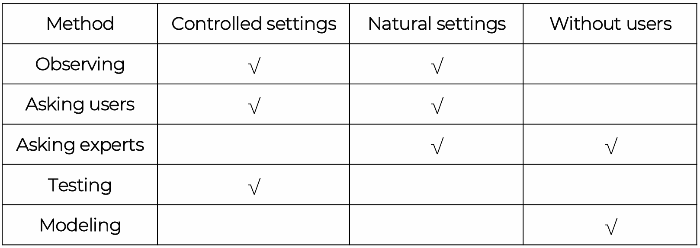
3. Any setting that doesn’t directly involve users.
Practical challenges of evaluation
Participants’ consent (Informed consent forms) 被评估的目的，需要做什么
Interpreting data 解释数据
➔ Reliability: Does the method produce the same results on separate occasions?
➔ Validity: Does the method measure what it is intended to measure?
➔ Ecological validity: Does the environment of the evaluation distort the results?
➔ Biases: Are there biases that distort the results?
➔ Scope: How generalizable are the results?

Usability Testing
➔ Controlled settings ➔ Users are observed and timed
➔ Data is recorded on video, and key presses are logged
➔ The data is used to calculate performance times and to identify and explain errors
➔ User satisfaction is evaluated using questionnaires and interviews
➔ Field observations may be used to provide contextual understanding
➔ Involves recording performance of typical users doing typical tasks

Usability Testing conditions
➔ Usability lab or other controlled space
➔ Emphasis on: ⇾ Selecting representative users ⇾ Developing representative tasks
➔ 5-10 users typically selected ➔ Tasks usually around 30 minutes
➔ Test conditions are the same for every participant ➔ Informed consent form explains procedures and deals with ethical issues

Quantitative performance measures 量化性能指标 CSUQ/SUS
➔ Number of users successfully completing the task ➔ Time to complete task ➔ Time to complete task after time away from task ➔ Number and type of errors per task ➔ Number of errors per unit of time
➔ Number of navigations to online help or manuals ➔ Number of users making a particular type of error ➔ Count and calculate data

Types of hypotheses
➔ Null hypothesis: typically states that there is no difference between experimental treatments
➔ Alternative hypothesis: a statement that is mutually exclusive with the null hypothesis 与null假设互斥
➔ The goal of an experiment is to find statistical evidence 统计证据to reject the null hypothesis to support the alternative hypothesis
e.g. H0: There is no difference in academic performance between students who are in a relationship and those who are not.
H1: There is a difference in academic performance between students who are in a relationship and those who are not

Usability Testing and Experiments
Usability Testing ➔ Improve products ➔ Few participants ➔ Results inform design ➔ Usually not completely replicable ➔ Conditions controlled as much as possible ➔ Procedure planned ➔ Results reported to developers
Experiments for Research ➔ Discover knowledge ➔ Many participants ➔ Results validated statistically ➔ Must be replicable ➔ Strongly controlled conditions ➔ Experimental design ➔ Scientific report to scientific community

Experimental designs
➔ Between subjects design ⇾ Different participants
⇾ Single group of participants is allocated randomly to the experimental conditions
⇾ Advantages: No order effects
⇾ Disadvantages: Many subjects and individual
differences is a problem
➔ Within subjects design ⇾ Same participants
⇾ All participants appear in both conditions
⇾ Advantages: Within-subjects Few individuals, no individual differences
⇾ Disadvantages: Counterbalancing needed because of ordering effects

Experimental design lifecycle
通常预测两个/更多变量之间的关系 研究者操控自变量
1. Identify a research hypothesis
2. Specify the design of the study
3. Run a pilot study to test the design, the system, and the study instruments
4. Recruit participants 招募参与者
5. Run the actual data collection sessions
6. Analyze the data
7. Report the results

招募参与者的例子
Three recruitment strategies are recruiting through clinics/hospitals, recruiting through online patient communities, and recruiting through university/community channels. Clinic recruitment can reach real patients and physicians but must handle privacy and consent carefully. Online recruitment can reach people with varied conditions and schedules. Community recruitment can include older adults, caregivers, and people with different technology experience. To ensure diversity, the sample should include different ages, genders, education levels, health conditions, digital skills, and disability needs.

Experiment procedure (Data collection)
1. Preparation 2. Greet participants 3. Introduce the purpose of the study and the procedures 4. Get consent 5. Assign participants to a specific experiment condition 6. Training task(s) 7. Actual task(s) 8. Participants answer questionnaires (if any) 9. Debriefing session 10. Payment (if any)

Experimental design example
AR prototypes for learning cultural heritage
Independent variable: two AR prototypes
⇾ Postcard AR ⇾ Cube Museum AR
➔ Dependent variable
⇾ User motivation
➔ Hypothesis
⇾ H0: There is no difference in User motivation between 2 prototypes.
⇾ H1: There is a difference in User motivation between 2 prototypes.
Interface Research Considerations
Interface metaphors
Why: Interface designed to be like a physical entity but also has own properties
➔ Can be based on activity, object, or a combination of both
➔ Exploit user’s familiar knowledge, helping them to understand ‘the unfamiliar’
➔ Conjures up the essence of the unfamiliar activity, 唤起不熟悉的本质enabling users to leverage this to understand more aspects of the unfamiliar functionality
Benefits: ➔ Makes learning new systems easier ➔ Helps users understand the underlying conceptual model ➔ Can be very innovative and enable the realm of computers and their applications to be made more accessible to a greater diversity of users
Problems: ➔ Break conventional and cultural rules ⇾ For instance, recycle bin placed on desktop ➔ Can constrain designers in the way that they conceptualize a problem space ➔ Conflicts with design principles ➔ Forces users to understand only the system in terms of the metaphor ➔ Designers can inadvertently use bad existing designs and transfer the bad parts over ➔ Limits designers’ imagination in coming up with new
conceptual models

Interaction Types:
1. Instructing指导: The user tells the system what operation to perform through clear instructions. E.g. Tell the time, print a file, or save a file.
Very common conceptual model underlying a diversity of devices and systems. E.g. Word processors, and vending machines.
The main benefit is that instructing supports quick and efficient interaction. Good for repetitive kinds of actions performed on multiple objects.
2. Conversing交谈: Underlying model of having a conversation with another human.
Ranges from simple voice recognition menu-driven systems to more complex ‘natural language’ dialogs.
Examples include timetables, search engines, advice-giving systems, and help systems, virtual agents, chatbots, toys, and pet robots designed to converse with you.
Pros: Allow users, especially novices, to interact with a system in a way that is familiar to them. It can make them feel comfortable, at ease, and less scared.
Cons: Misunderstandings can arise when the system does not know how to parse what the user says. E.g. voice assistants can misunderstand what children say.
3. Manipulating操纵: Exploits users ‘knowledge of how they move and manipulate in the physical world.
Involves dragging, selecting, opening, closing and zooming actions on virtual objects.
Can involve actions using physical controllers (e.g., Nintendo Switch) or air gestures (e.g., Microsoft Kinect) to control the movements of an on-screen avatar.
Tagged physical objects (e.g., balls) that are manipulated in a physical world result in physical/digital events (e.g., animation being played).
3.1. Direct Manipulation: - Continuous representation of objects and actions of interest. - Rapid reversible actions with immediate feedback on object of interest. 快速可逆动作以及即时反馈 - Physical actions and button pressing instead of issuing commands with complex syntax.
e.g. Drag and drop to move files.
Pros: 1. Novices新手 can learn the basic functionality quickly 2. Experienced users can work extremely rapidly to carry out a wide range of tasks − even defining new functions 3. Intermittent 偶尔使用users can retain operational concepts over time 4. Error messages rarely needed 5. Users can immediately see if their actions are furthering their goals, and if not, do something else 6. Users experience less anxiety 7. Users gain confidence and mastery and feel in control.
Cons:1. Some people take the metaphor of direct manipulation too literally E.g., playing guitar on iPad 2. Moving a cursor using a mouse or touchpad can be slower than pressing function keys to do the same actions E.g., find all and replace 3. Repetitive tasks are not well supported. 4. Some gestures 手势can be more error-prone than typing. E.g., drag a drop a picture width to 2.00 cm.
4. Exploring: Involves moving through virtual or physical environments.
Users can explore aspects of a virtual 3D environment
Physical environments can also be embedded with sensors that when detect the presence of someone will trigger digital or physical events to happen
Many examples of virtual environments, including cities, parks, buildings, rooms, and datasets. Enable users to fly over them and zoom in and out of different parts.
5. Responding: System takes the initiative to alert user to something that it “thinks” is of interest. 主动提醒用户
System does this by 1. Detecting the location and-or presence of someone in a vicinity and notifies them on their phone or watch 2. What it has learned from their repeated behaviors.
E.g., Alerts the user of a nearby coffee bar where some friends are meeting. User’s fitness tracker notifies them of a milestone reached.
The core feature of responsive interaction is that the system actively pushes notifications or reminders to the user without requiring the user to actively request them.

Example: Through instructing, users enter a username/password and click login or submit assignments. Through conversing, the platform may support messages, announcements, or forum communication between teachers and students. Through manipulating, users click menus, upload files, open course pages, and manage resources. Through exploring, users browse course materials, weekly folders, grades, and links. Through responding, the system reacts to user actions with confirmations, loading states, errors, and notifications.
Instruction在校园座位预约系统里，学生点击 “Reserve Seat” 按钮预约座位 Conversing学生问 chatbot：“图书馆三楼还有空座位吗？” 系统回答可用座位 Manipulating学生在座位地图上直接点击某个座位，或者拖动时间条选择预约时间Exploring学生查看不同楼层、不同时间段的座位可用情况Responding系统弹出 “你的预约将在10分钟后过期，是否延长？” 用户选择 Yes / No

Choosing an interaction type
1.Direct manipulation is good for ‘doing’ types of tasks, for example, designing, drawing, flying, driving, or sizing windows.
2.Issuing instructions is good for repetitive tasks, for example, spell checking and file management.
3.Having a conversation is good for certain services, for instance, finding information or requesting music.
4.Hybrid conceptual models are good for supporting multiple ways of carrying out the same actions. 如在图像编辑软件中

Interfaces:
1.Command line Interfaces: The command-line interface is an interface where users interact with a computer system through text commands.
Pros: Efficient, precise, and fast.
Cons: Large overhead to learning set of commands.
Considerations: Form, name types and structure are key research questions Consistency is the most important design principle
2. Graphical user interfaces (GUIs):
Windows (Window): A window is an area on the screen that can be scrolled, stretched, overlapped, opened, closed, and moved.
Icons: Icons are graphical symbols that represent applications, objects, commands, and tools.
Menus: A menu is a scrollable list of options from which users can choose different actions.
Pointing device: A pointing device (such as a mouse) is used to control the cursor on the screen, serving as the entry point for users to interact with windows, menus, and icons.
2.1. Window design:
The invention of windows was to overcome the physical limitations of computer displays.
Windows allow users to view more information and perform more tasks within limited screen space, improving work efficiency and flexibility.
The scrollbar in the window allows you to view more information.
To solve the problem from multiple windows:
列表（Listing）：显示所有打开窗口的列表，用户可以从列表中选择所需的窗口。选项卡（Tabbing）：使用选项卡来组织和管理多个窗口或文档，用户可以通过点击不同的选项卡来切换窗口。缩略图（Thumbnails）：显示所有打开窗口的缩略图预览，用户可以通过查看缩略图来快速找到所需的窗口。
2.2 Menu styles:
1.Flat list平面列表: Good for showing large number of options at the same time when display is small
Pros: Suitable for displaying many options in situations where display space is limited, as all options are on the same plane and users can easily see all available commands or options briefly.
2.Drop down (dropdown menu): Shows more options on same screen (for example, cascading)
Pros: More options can be displayed in the same screen space, especially when menu options have hierarchical relationships (such as cascading menus).
3.Pop up (pop-up menu): Pop-up: When pressed, command key for relevant options
Pros: Provides a quick way to access commonly used commands, especially those related to specific projects or tasks.
4.Contextual menu: Provide commonly used commands related to the user's current operation or selected item.
Pros: Improved efficiency as users can directly access the commands most relevant to their current task without having to search through multiple menus.
5.Collapsible menu: Menu items can be expanded or collapsed by clicking the+/- icon next to the title.
Pros: Allow users to display or hide menu items as needed, which helps save screen space and improve menu manageability.
6.Mega (Super Menu): All options shown using 2D drop-down layout Pros: Display all options in one menu, allowing users to quickly find the commands they need through a hierarchical structure without having to switch between multiple menus.
Considerations
➔ Window management ⇾ Enables users to move fluidly between different windows (and monitors) ➔ How to switch attention between windows without getting distracted ➔ Design principles of spacing, grouping, and simplicity should be used ➔ Which terms to use for menu options (for example, “front” versus “bring to front”)➔ Mega menus are easier to navigate than drop-down ones
2.3. Icon design:
Icons are assumed to be easier to learn and remember than commands.
Icons can be designed to be compact and variably positioned on a screen.
Now pervasive in every interface. （在每一个界面中普遍存在）
The mapping between the representation and underlying referent can be: ⇾ Similar (for example, a picture of a file to represent the object file)
⇾ Analogical (for instance, a picture of a pair of scissors to represent
‘cut’) ⇾ Arbitrary (such as the use of an X to represent ‘delete’)
Considerations 1. There is a wealth of resources for creating icons: Guidelines, style guides, icon builders, libraries, online tutorials. 2. Text labels can be used alongside icons to help identification for small icon sets. 3. For large icon sets (for instance, photo editing or word processing) can use the hover function.
3. Multimedia:
Combines different media within a single interface with various forms of interactivity. Including Graphics, text, video, sound, and animation.
Users click on links in an image or text—1. Another part of the program. 2. An animation or a video clip is played. 3. Users can return to where they were or move on to another place.
Can provide better ways of presenting information than a single media can.
Pros:1. Facilitates rapid access to multiple representations of Information.2. Can provide better ways of presenting information than can any media alone.3. Can enable easier learning, better understanding, more engagement, and more pleasure. 4. Can encourage users to explore different parts of a game or story.
Cons: 1. Tendency to play video clips and animations while skimming through accompanying text or diagrams.
Considerations:1. How to design multimedia to help users explore, keep track of, and integrate the multiple representations
⇾ Provide hands-on interactivities and simulations that the user has to complete to solve a task⇾ Provide quizzes, electronic notebooks, and games 2. Multimedia good for supporting certain activities, such as browsing, but less optimal for reading at length
4. Virtual reality:
Virtual reality is a three-dimensional graphical simulation generated through computer technology, providing users with immersive experience.
Provide new kinds of experience, enabling users to interact with objects and navigate in 3D space. Create highly engaging user experiences.
Pros:1. Can have a higher level of fidelity with objects that they represent compared to multimedia. 2. Induces a sense of presence where someone is totally engrossed by the experience. 3. Provides different viewpoints: first and third person.
Cons:1. Early head-mounted displays were uncomfortable to wear and could cause motion sickness and disorientation. It was solved by lighter VR headsets.
Application Area: ➔ Video games➔ Arcade games for social groups
➔ Therapy for fears ➔ Experience how others feel emotions ➔ Enrich user’s planning experience for travel destinations ➔ Architecture, design, and education
Considerations 1. Much research on how to design safe and realistic VRs to facilitate training ⇾ For example, flying simulators ⇾ Help people overcome phobias (for example, spiders or talking in public) 2. Design issues ⇾ How best to navigate through them (for instance, first versus third person) ⇾ How to control interactions and movements (for example, by using head and body movements) ⇾ How best to interact with information (for instance by using keypads, pointing, and joystick buttons) ⇾ Level of realism to aim for to engender a sense of presence
5. Website design:
➔ Early websites were largely text-based, providing hyperlinks
➔ Concern was with how best to structure information to enable users to navigate and access them easily and quickly
➔ Nowadays, more emphasis is on making pages distinctive, striking, and aesthetically pleasing
➔ Need to think of how to design information for multiple platforms—keyboard or touch? ⇾ For example, smartphones, tablets, and PCs
Breadcrumbs are category labels: 1. Enable users to look at other pages without losing track of where they have come from 2. Very usable 3. Enable one-click access to higher site levels 4. Attract first time visitors to continue to browse a website having viewed the landing page
Considerations: Where am I? Where can I go? What’s here?
6. Mobile interfaces:
➔ Handheld devices intended to be used while on the move. It includes phones, fitness trackers, tablets, and smartwatches.
Considerations: 1. Mobile interfaces can be cumbersome to use for those with poor manual dexterity or ‘fat’ fingers.
2. Key concern is hit area: - Area on the phone display that the user touches to make something happen, such as a key, an icon, a button, or an app. - Space needs to be big enough for all fingers to press accurately. - If too small, the user may accidentally press the wrong key. - Fitts’ law can be used to help design right spacing. -- Minimum tappable areas should be 44 points x 44 points for all controls.
7. Appliances 电器:
It is used for short periods. E.g. starting the washing machine, watching a program, buying a ticket, changing the time, or taking a snapshot.
Need to be usable with minimal. If any, learning.
Considerations 1. Need to design as transient interfaces with short interactions. 2. Simple interfaces. 3. Consider trade-off between soft and hard controls.
8. Voice User interfaces:
➔ Involves a person talking with a spoken language app, for example, timetable, travel planner, or phone service. ➔ It is used most for inquiring about specific information, e.g., flight times or to perform a transaction, such as buying a ticket. ➔It is also used by people with visual impairments. E.g., speech recognition word processors, page scanners, web readers, and home control systems.
Considerations: 1. How to design systems that can keep conversation on track ⇾ Help people navigate efficiently through a menu system ⇾ Enable them to recover easily from errors ⇾ Guide those who are vague or ambiguous in their requests for information or services 2. Type of voice actor (for example, male, female, neutral, or dialect) ⇾ Do people prefer to listen to and are more patient with a female or male voice, a northern or southern accent?
9. Pen-based devices:
➔ Enable people to write, draw, select, and move objects at an interface using light pens or styluses. It capitalizes on the well-honed drawing skills developed from childhood.
Pros: 1. Allows users to annotate existing documents quickly and easily.2. Can be used to fill in paper-based forms that can readily be converted to a digital record using standard typeface.3. Can be used by remote teams to communicate and work on the same documents.
10. Touchscreens:
➔ Single touchscreens are used in walk-up kiosks (such as ticket machines and ATMs) to detect the presence and location of a person’s touch on the display. ➔ multi-touch surfaces support a range of more dynamic fingertip actions, for example, swiping, flicking, pinching, pushing, and tapping. ➔ They do so by registering touches at multiple locations using a grid. ➔ And be widely used now. It supports one and two hand gestures, including tapping, zooming, stretching, flicking, dwelling, and dragging.
Considerations: 1. Provides fluid and direct styles of interaction involving freehand and pen-based gestures for certain tasks. 2. Core design concerns include whether size, orientation, and shape of touch display effect collaboration. ➔ Much faster to scroll through wheels, carousels, and bars of thumbnail images or lists of options by finger flicking. ➔ Gestures need to be learned for multi-touch, so a small set of gestures for common commands is preferable. ➔ More cumbersome, error-prone, and slower to type using a virtual keyboard on a touch display than using a physical keyboard.
11. Gesture-based systems:
➔ Gestures involve moving arms and hands to communicate.
➔ Uses camera recognition, sensor, and computer vision techniques to recognize people’s arm and hand gestures in a room. Gestures need to be presented sequentially to be understood (compare with the way sentences are constructed).
Considerations: 1. How does computer recognize and delineate user’s gestures? ➔ Start and end points. ➔ Difference between a deictic gesture (a deliberate pointing movement) and hand waving (an unconscious gesticulation). The mirrored graphical representation must be realistic.
12. Haptic interfaces触觉界面:
➔ Provide tactile feedback by applying vibration and forces to a person’s body, using actuators that are embedded in their clothing or a device they are carrying, such as a smartphone. ➔ Vibrotactile feedback can be used to simulate the sense of touch between remote people who want to communicate. ➔ Ultra haptics creates the illusion of touch in midair using ultrasound to make the illusion of 3D shapes.
Considerations: 1. Where best to place actuators on body. 2. Whether to use single or sequence of ‘touches. 3. When to buzz and how intense. 4. How does the wearer feel it in different contexts? 5. What kind of new smartphone/smartwatch apps can use vibrotactile creatively? E.g. slow tapping to feel like water drops meant to indicate that it is about to rain, and heavy tapping to indicate a thunderstorm is looming.
13. Multimodal interfaces多模态界面:（多种与系统的交互方式）
➔ Provide enriched user experiences by multiplying how information is experienced and detected using different modalities, such as touch, sight, sound, and speech. It supports more flexible, efficient, and expressive means of human computer interaction.
*触摸 语音 手势 眼动 键盘
Most common is speech and vision.
➔ It can be combined with multi-sensor input to enable other aspects of the human body to be tracked. E.g., eye gaze, facial expression, and lip movements. It can provide input for customizing user interfaces.
Considerations: 1. Need to recognize and analyze user behavior, for example, speech, gesture, handwriting, or eye gaze. 2. Much harder to calibrate these than single modality systems. 3. What is gained from combining different input and outputs. 4. Is talking and gesturing, as humans do with other humans, a natural way of interacting with a computer?
14. Shareable interfaces
➔ It is designed for more than one person to use: 1. Provide multiple inputs and sometimes allow simultaneous input by co-located groups.2. Large wall displays where people use their own pens or gestures.3. Interactive tabletops where small groups interact with information using their fingertips.
Pros:1. Provide a large interactional space that can support flexible group working. 2.Can be used by multiple users: Can point to and touch information being displayed. Simultaneously view the interactions and have the same shared point of reference as others. 3. Can support more equitable participation compared with groups using single PC.
Considerations: 1. Core design concerns include whether size, orientation, and shape of the display have an effect on collaboration. 2.Horizontal surfaces compared with vertical ones support more turn taking and collaborative working in co-located groups. 3. Providing larger-sized tabletops does not improve group working but encourages more division of labor. 4. Having both personal and shared spaces enables groups to work on their own and in a group.
15. Tangible Interfaces: 可触摸实体交互界面
* 教育玩具/儿童编程工具/博物馆互动展览/建筑/城市规划模型/音乐控制器/医疗或训练模拟系统
➔ Type of sensor-based interaction, where physical objects, for example, bricks, are coupled with digital representations. ➔ When a person manipulates the physical object/s, it causes a digital effect to occur, e.g., an animation. ➔ Digital effects can take place in a number of media and places, or they can be embedded in the physical object.
Pros: 1. Can be held in one or both hands and combined and manipulated in ways not possible using other interfaces: - Allows for more than one person to explore the interface together. - Objects can be placed on top of each other, beside each other, and inside each other. - Encourages different ways of representing and exploring a problem space.
2. People can see and understand situations differently: - Can lead to greater insight, learning, and problem-solving than with other kinds of interfaces. - Can facilitate creativity and reflection.
Considerations:
1. What kinds of conceptual frameworks to use to help identify novel and specific features.
2. What kind of coupling to use between the physical action and digital effect: If it is to support learning, then an explicit mapping between action and effect is critical. If it is for entertainment, then it can be better to design it to be more implicit and unexpected.
3. What kind of physical artifact to use: Bricks, cubes, and other component sets are most used because of flexibility and simplicity. Stickies and cardboard tokens can also be used for placing material onto a surface.
4. With what kinds of digital outputs should tangible interfaces be combined? E.g., animations, sounds, visual effects.
16. Augmented Reality:
Augmented reality: Virtual representations are superimposed on physical devices and objects. E.g., Pokémon go and other applications including medicine, navigation, air traffic control, games, and everyday exploring.
Considerations: 1.What kind of digital augmentation: When and where in physical environment? Needs to stand out but not distract from ongoing task. Needs to be able to align with real world objects. What happens if the AR is slightly off? 2.What kind of device? Smartphone, tablet, head up display or other?
17. Wearables
It enables user to record what was seen and to access digital information. Applications include automatic diaries, tour guides, cycle indicators, and fashion clothing.
Considerations: 1. Comfort: Needs to be light, small, not get in the way, fashionable, and preferably hidden in the clothing. 2. Hygiene: Need to be easy to clean to maintain hygiene. 3.Ease of wear: Need to be easy to wear and take off. 4. Usability: Users need to be able to easily control devices embedded in clothing.
18. Robots: *Drone 无人机
➔ Remote robots used in hazardous settings. ➔ Domestic家用 robots helping around the house. ➔ Pet robots as human companions. ➔ Sociable robots that work collaboratively with humans.
Considerations: 1. How do humans react to physical robots designed to exhibit behaviors (for example, making facial expressions) compared with virtual ones? 2. Should robots be designed to be human-like or look like and behave like robots that serve a clearly defined purpose? 3. Should the interaction be designed to enable people to interact with
the robot as if it was another human being or more human-computer-like (for example, pressing buttons to issue commands)? 4. Is it acceptable to use unmanned drones to take a series of images or
videos of fields, towns, and private property without permission or
people knowing what is happening.
19. Brain-computer interfaces: ➔ Brain-computer interfaces (BCI) provide a communication pathway between a person’s brain waves and an external device, such as a cursor on a screen. ➔ Person is trained to concentrate on the task, e.g., moving the cursor.
20. Smart interfaces: ➔ Smart refers to having some intelligence and connected to the internet and other devices. ➔ It includes context-aware (Understand what is happening around them and execute appropriate actions, for example, a Nest thermostat) and human-building interaction(Buildings are designed to sense and act on behalf of the inhabitants but also allow them to have some control and interaction with the automated systems).
Field Study and Analytics
Observation types:
1.Direct observation: In the field/ in controlled environments. 2. Indirect observation: tracking users’ activities, interaction logging, Video and photographs collected remotely by drones or other equipment

Direct observation in the field 3 easy-to-remember parts
⇾ The person: Who? ⇾ The place: Where? ⇾ The thing: What?

Direct observation in the field 现场直接观察
1. Divide on how involved you will be (passive observer/active participant). 2.How to gain acceptance. 3. How to handle sensitive topics, e.g., culture, private spaces. 4. How to collect the data (What data to collect, What equipment, when to stop).

Observations and materials that might be collected
➔ Activity or job descriptions
➔ Rules and procedures that govern particular activities
➔ Descriptions of activities observed
➔ Recordings of the talk taking place between parties
➔ Informal interviews with participants explaining the detail of
observed activities
➔ Diagrams of the physical layout, including the position of artifacts
➔ Other information collected when observing activities:
⇾ Photographs of artifacts (documents, diagrams, forms, computers, and so forth)
⇾ Videos of artifacts
⇾ Descriptions of artifacts
⇾ Workflow diagrams showing the sequential order of task

Field Study
➔ Field studies are done in natural settings 在自然设置下
➔ “In the wild” is a term for prototypes being used freely in natural settings
➔ Seek to understand what users do naturally and how
technology impacts them
➔ Field studies are used in product design to:
⇾ Identify opportunities for new technology
⇾ Determine design requirements
⇾ Decide how best to introduce new technology
⇾ Evaluate technology in use
Without users?
More precisely, without direct involvement of users.
➔ Experts knowledge codified in heuristics⇾ Heuristic evaluation ⇾ Walkthroughs
➔ Data collected remotely ⇾ Analytics ⇾ A/B testing
➔ Models that predict users’ performance ⇾ Predictive modeling

Analytics
A variety of users’ actions can be recorded by software automatically
➔ Advantages of logging activity automatically
⇾ It is unobtrusive provided the system’s performance is not
Affected ⇾ Large volumes of data can be logged automatically and then
explored and analyzed using visualization and other tools.
➔ Disadvantage ⇾ It raises ethical concerns about observing participants if this is
done without their knowledge
Web Analytics
➔ A form of interaction logging that analyses users’ activities on website
➔ Designers use the analysis to improve their designs
⇾ When designs don’t meet users’ needs, they will not return to the site, they become one-time users
➔ Enable designers to track the activities of users on their site
⇾ How many people come to the site, how long they stay, and
where they go
➔ Offer designers the “big picture” about how their site performs
based on user activity
Analytics Tools
➔ Moz Analytics Tracks search marketing, social media marketing, brand activity, links, and content marketing, and it is particularly useful for link management and analysis:➔ TruSocialMetrics Tracks social media metrics, and it helps calculate social media marketing return on investment➔ Clicky Comprehensive and real-time analytics tool that shows individual visitors and the actions they take, and it helps define what people from different demographics find interesting ➔ KISSmetrics Detailed analytics tool that displays what website visitors are doing on your website before, during, and after they buy➔ Crazy Egg Tracks visitor clicks based on where they are specifically clicking, and it creates click heat maps useful for website design, usability, and conversion ➔ ClickTale Records website visitor actions and uses meta-statistics to create visual heat map reports on customer mouse movement, scrolling, and other visitor behaviors
A/B Testing
➔ A large-scale experiment (thousands of participants or more)
➔ Offers another way to evaluate a website, application of app running on a mobile device ➔ Often used for evaluating changes in design on social media applications ➔ Compares how two groups of users perform on two versions of a design➔ May create ethical dilemmas if users don’t know they are part of the test
Predictive modelling
➔ Provide a way of evaluating products or designs without directly involving users, less expensive than user testing ➔ Use formulas to derive various measures of user performance 使用公式来推导
➔ Usefulness limited to systems with predictable tasks, for example, voicemail systems, smartphones, and dedicated mobile devices

