


CONTRIBUTES TO:
AUTHORS:
Charles B. Capagngan
Gabrielle Q. Calibo
Cristian R. Saldua
Patricia Marie D. Valera

CO-AUTHORS:
Gonzalo Gumogda
AY 2025-2026
Mobile AI-Assisted Personal Campus Information Hub
NotifiED
Table of Contents
List of Figures iv
List of Tables v
Introduction 1
Project Context 1
Statement of the Problem 1
Objectives 1
Significance of the Project 2
Scope and Limitations 2
Review of Related Literature / Systems 3
Current System 4
Technical Background 4
List of Processes 4
SWOT Analysis 5
Proposed Solution 5
Technical Background 5
Feasibility 5
Operational Feasibility 5
Economic Feasibility 5
Technical Feasibility 5
Schedule Feasibility 5
Requirements Analysis 5
Project Vision 5
Prototype (Mock Flow / Wireframe) 5
Project Lean Canvas 6
User Classes and Characteristics 6
Product Backlog 7
Product Roadmap 7
Release Plan 7
Use Case Diagram 7
Use Case Full Description 7
Conclusion 8
References 9
Appendices 10
Appendix A: Roles and Responsibilities 10
Appendix B: Minutes of the Meetings 11
Appendix C: Methodology 12
Appendix D: Project Sharepoint Link 13
Appendix E: Requirements Traceability Matrix 13
Appendix F: RACI Matrix 13

Introduction

In many schools, effective communication between students, faculty, and organizations is essential for keeping everyone informed and engaged in campus activities. While announcements are widely shared through platforms such as social media, messaging apps, and email, each organization typically uses its own channel. Because of this, students often struggle to identify where to find official updates or which platform to follow for specific organizations.

As a result, important information, events, and opportunities are overlooked not due to lack of availability, but because of the absence of a unified access point. At the same time, faculty members and student organizations face challenges in ensuring that their announcements consistently reach their intended audience.

To address this issue, this project introduces NotifiED, an AI-assisted mobile inquiry module designed to help students manage fragmented campus communication channels within educational institutions. Rather than replacing existing communication systems, the application functions as a personalized digital secretary that retrieves and organizes campus-related information from a student’s authorized platforms such as institutional email accounts, messaging applications, and organization social media pages. The system provides students with a unified and accessible interface where they can view announcements, explore organizations, browse campus events, and receive AI-assisted summaries of important updates without manually searching across multiple platforms. In addition, NotifiED features an AI-powered chatbot that assists users by answering questions, summarizing announcements, and guiding them through relevant campus information. The application also incorporates automated push notifications and scheduling support features that help students stay informed about activities that match their availability, ultimately making campus engagement more organized, efficient, and personalized.

Project Context

NotifiED: Mobile AI-Assisted Personal Campus Information Hub is a scalable, mobile-based inquiry application designed to improve how students access and interact with campus-related information. Rather than replacing existing institutional communication systems, the application focuses on retrieving, organizing, and presenting campus information from multiple communication channels into a unified and user-friendly mobile interface. Through AI-assisted retrieval and summarization features, the system helps students conveniently access announcements, explore events, and manage relevant campus information without manually monitoring multiple platforms.

The application is initially implemented within Asia Pacific College (APC) as a testing ground to evaluate its usability, accessibility, and overall effectiveness in addressing communication challenges among students. The long-term objective is to develop a scalable solution that can be adapted and deployed across multiple educational institutions.

Target Users:

The system is designed to serve the following primary users:

- Students (Primary Users):
Students serve as the main users of the application. They are provided with a personalized mobile interface where they can conveniently access announcements, discover campus events, and manage relevant schedule information retrieved from authorized communication platforms. The system is designed to minimize the need to manually search across multiple platforms, thereby improving accessibility, organization, and engagement.
- Campus Organizations and Administrators (Information Sources):
These groups act as sources of information by providing announcements, event details, and updates that are made accessible through the platform. Their contributions ensure that students receive relevant and timely information.

The Current System

At present, students encounter difficulties in engaging with campus activities due to the decentralized nature of information dissemination. Announcements and event details are distributed across multiple platforms, including social media, messaging applications, email, and physical bulletin boards.

While this approach increases the visibility and reach of information, it also introduces several challenges:

- Platform Ambiguity: Each organization utilizes its own preferred communication channel, making it difficult for students to determine where to access official updates or which platforms to follow.
- Inconsistent Access to Information: Despite the wide availability of announcements, the absence of a unified access point makes it challenging for students to stay consistently informed.
- Limited Accessibility: There is no single interface where students can conveniently view all relevant and verified information.

As a result, students may miss important announcements and opportunities not due to a lack of information, but because of the absence of a centralized and accessible system that consolidates these updates effectively.

Project Goal

The primary goal of this project is to develop an AI-assisted, student-centered mobile inquiry application that enhances access to campus-related information and improves overall user experience. The system aims to help students efficiently retrieve, organize, and interact with announcements, events, and organizational updates gathered from multiple existing communication platforms through a unified and personalized mobile interface.

Alignment with Institutional Goals

Educational institutions continuously aim to enhance communication efficiency, increase student engagement, and adopt digital solutions to improve operational processes. NotifiED supports these objectives by:
• Providing students with a unified mobile interface for accessing campus-related information retrieved from multiple communication platforms
• Improving student awareness by simplifying the retrieval and organization of announcements and event updates from existing institutional channels
• Minimizing communication gaps caused by fragmented and platform-dependent information dissemination
• Supporting the integration of AI-assisted and user-centered technologies within educational environments without requiring institutions to replace their current communication systems

Contribution to Long-Term Vision

This project contributes to the long-term vision of establishing a more connected and technologically adaptive educational environment. By providing students with an AI-assisted interface that organizes campus-related information from existing communication channels, NotifiED improves students’ ability to stay informed and participate in institutional activities more efficiently.

Furthermore, the system is designed with scalability in mind, allowing the inquiry framework to be adapted and implemented across various educational institutions. As a mobile-based AI-assisted retrieval solution, the project demonstrates potential for broader adoption in improving how students manage fragmented campus communication systems while maintaining compatibility with existing institutional platforms.

Statement of the Problem

Effective communication is essential within educational institutions to ensure that students remain informed and actively engaged in campus activities. However, many schools rely on multiple independent communication platforms for disseminating institutional information. Different student organizations and departments often use their own preferred channels, such as social media platforms, email services, messaging applications, and group chats, to distribute announcements and event updates. As a result, students frequently have trouble identifying where to access official information or which platforms to monitor for specific organizations and campus-related updates. This fragmented communication environment creates inconsistency in information accessibility and makes it challenging for students to remain consistently informed about campus activities.
In response to these issues, this study proposes the development of an AI-assisted mobile inquiry application that helps students retrieve, organize, and access campus-related information from multiple existing communication channels through a unified and personalized mobile interface.

Specifically, the study seeks to address the following problems:

Problem 1: Difficulty Managing Fragmented Campus Information

There is no intelligent system that helps students efficiently organize and access campus-related announcements, events, and updates distributed across multiple communication platforms. As a result, different departments and student organizations continue to rely on their own preferred channels, such as social media, emails, group chats, and bulletin boards, for information dissemination.

This fragmented setup creates multiple challenges for students, including difficulty identifying where to access official information, the need to manually monitor multiple platforms, and exposure to excessive and uncoordinated content. Consequently, communication becomes inconsistent, important announcements are overlooked, and some events receive limited visibility. These factors contribute to reduced student awareness, lower engagement, and missed opportunities for participation in campus activities.

Problem 2: Difficulty in Accessing Event Information

Students often encounter challenges in efficiently accessing complete, organized, and relevant details regarding campus events. Because event-related information is distributed across multiple independent communication platforms, students need to manually search through emails, social media posts, messaging groups, and organization pages to gather important details. This fragmented retrieval process can result in inconvenience, delayed access to information, and reduced participation in campus activities.

Problem 3: Poor User Experience in Existing Information Channels

Current platforms used for campus communication, such as social media applications, emails, and messaging services, are not specifically designed to organize and personalize campus-related information for students. As a result, students often have trouble navigating through large volumes of unrelated or unstructured content, identifying relevant updates, and efficiently retrieving important announcements.

This lack of intelligent organization and user-centered information presentation leads to frustration, reduced efficiency in information retrieval, notification fatigue, and decreased engagement with campus-related content.

Objectives

Main Objective

The primary objective of this study is to develop an AI-assisted mobile inquiry application that improves how students access and manage campus-related information by retrieving, organizing, and presenting announcements, events, and institutional updates from multiple existing communication platforms through a unified and personalized mobile interface.

Specific Objectives

- To develop an AI-assisted mobile inquiry platform for campus information access
To design and implement a mobile application that retrieves and organizes school-related announcements, events, and updates from existing communication channels, reducing platform ambiguity and improving accessibility of institutional information for students.
- To improve the accessibility and clarity of event information
To present complete, organized, and easily understandable event details within the application through AI-assisted retrieval and information organization, minimizing confusion caused by fragmented communication sources and reducing the need for students to manually monitor multiple platforms.
- To enhance user experience in accessing campus information
To develop a user-friendly and personalized mobile interface that allows students to efficiently navigate retrieved campus information, access relevant updates, and stay informed with minimal effort, thereby improving engagement with campus activities and reducing information overload.

Significance of the Project

The primary beneficiaries of the NotifiED project are the students who serve as the main users of the application. The system provides students with a personalized and organized mobile interface where campus-related announcements, events, and updates retrieved from existing communication platforms can be conveniently accessed without the need to manually monitor multiple channels. This helps reduce information overload, improve accessibility to relevant institutional information, and create a more organized campus information experience.
If this project is successful, it may help address the challenges caused by fragmented campus communication by providing students with a more efficient way of retrieving and organizing information from multiple platforms. Instead of requiring students to constantly switch between different communication applications, the system enhances accessibility through AI-assisted retrieval, intelligent organization, and personalized notification features, which may improve awareness and participation in institutional activities. Additionally, NotifiED supports United Nations Sustainable Development Goal 4: Quality Education by improving equitable access to educational and institutional information, while also supporting Sustainable Development Goal 9: Industry, Innovation, and Infrastructure through the integration of AI-assisted and mobile-based technologies that enhance digital communication and information accessibility within educational environments.

Scope and Limitations

This section outlines the specific focus and boundaries of the NotifiED project. The project is designed to develop a functional AI-assisted mobile inquiry application that helps students retrieve, organize, and access campus-related information from multiple communication platforms while maintaining a focused set of features to ensure system efficiency.

Scope

Specific Field of Study: This project is situated within the fields of Information Technology and Mobile Application Development. It addresses communication challenges in educational institutions by developing an AI-assisted mobile inquiry system that organizes and presents campus-related information retrieved from existing communication channels through a personalized student interface.
Fundamental Concepts: The core principles of this study are AI-assisted information retrieval, information organization, and real-time information accessibility. The system aims to reduce the inefficiencies caused by fragmented communication channels by helping students efficiently retrieve and access announcements, event-related updates, and campus information from multiple existing platforms.

Target Users and Beneficiaries: The primary users and beneficiaries of the application are students who utilize the system to access announcements, browse events, explore organizations, and receive campus-related updates retrieved from authorized communication platforms. The system focuses specifically on improving the student-side experience of accessing and organizing institutional information.

Target Environment: The platform is designed for educational institutions, specifically targeting academic environments such as colleges and universities. It provides a structured and dedicated mobile interface that assists students in managing campus-related information gathered from existing communication systems.

System Output: The output of this study is a functional mobile inquiry application that retrieves, organizes, summarizes, and presents campus-related announcements, events, and organization updates through an AI-assisted and student-centered mobile interface.

Limitations

To ensure the successful completion and reliability of the system, the following boundaries have been established:
Institutional Scope: The system is strictly limited to educational institutions. It is not intended for commercial use, e-commerce, or general-purpose social networking.

Connectivity Requirements: The application requires a stable internet connection to retrieve and process campus-related information from authorized communication platforms. Offline functionality is not supported.

Supplementary Nature: The system serves as a supplementary inquiry and information organization tool. It does not replace official institutional communication systems, academic portals, grading systems, or formal institutional emails.

Development Focus: This project focuses specifically on the frontend mobile inquiry experience and AI-assisted information retrieval features for students. The development and maintenance of institutional backend infrastructures, administrative systems, servers, and databases are outside the implementation scope of this study.

Functional Boundaries: The platform is designed solely for retrieving, organizing, and presenting campus-related information for students. It does not include private peer-to-peer messaging, financial transaction processing, institutional record management, or direct administrative posting management within the application.

Privacy and Access Limitations: The system only accesses communication platforms and information streams explicitly authorized by the user. Retrieved information is processed solely for personalized organization and viewing within the user’s application environment.
.

Review of Related Literature / Systems

The development of NotifiED exists within a broader academic and technological context that underscores both the urgency and viability of centralized, AI-assisted campus communication platforms. This chapter reviews existing literature and studies relevant to the core themes of the project, namely: the challenges posed by fragmented digital communication in educational settings, the role of mobile technology in improving student engagement and institutional operations, the application of artificial intelligence in educational platforms, and the fatigue introduced by disorganized multi-platform environments. Together, these bodies of literature establish the conceptual and empirical foundations upon which NotifiED is built.

The Problem of Fragmented Campus Communication A recurring finding in recent literature is that decentralized information dissemination creates systemic communication barriers in educational institutions. Cheong and Nyaupane (2022) examined how smart campus applications have been adopted across universities to consolidate student services into connected digital portal experiences, noting that networked systems are recognized for their role in sustaining student security, well-being, and community engagement. Their work surfaces the growing institutional demand for unified digital infrastructure, a demand directly mirrored in the communication gaps that motivated NotifiED's design. Complementing this, Orhani et al. (2024) found that integrated ICT platforms reduce administrative friction by automating routine tasks such as event announcements and communications, ensuring that information reaches the appropriate audience in a timely and organized manner. This consolidation, they argue, is no longer a matter of preference but a prerequisite for operational quality in modern educational institutions. Hidayat and Farhan (2025) further establish that the fragmentation of announcements across informal channels such as Messenger, Viber, and Facebook generates significant cognitive load among students, contributing to information avoidance and increased academic anxiety, a phenomenon they describe as digital clutter that buries critical updates beneath unrelated social content.
Digital Fatigue as a Barrier to Student Engagement Parallel to the fragmentation problem, literature from the Philippine context highlights the psychological toll of navigating multiple, uncoordinated digital platforms. Tolentino and Miranda (2024) documented significant levels of general and visual fatigue among Filipino students in state universities caused by the constant need to switch between different interfaces and manage multiple digital feeds, a condition they associate with reduced motivation and diminished academic involvement. Oducado et al. (2024) similarly found a high prevalence of digital learning fatigue among Filipino nursing students, demonstrating a significant correlation between platform overload and lower online learning satisfaction, a condition that worsens as the number of uncoordinated digital streams a student must manage increases. These Philippine-specific findings lend local grounding to the global problem of digital burnout and reinforce the argument that consolidating campus information into a single, non-redundant platform is not merely a matter of convenience but a measurable contributor to student well-being and academic performance.

Mobile Applications and Student Engagement in Higher Education On the technological response side, studies consistently affirm the capacity of well-designed mobile applications to improve student engagement and institutional responsiveness. Ibrahim (2024) examined mobile applications across ICT and computer science education contexts, identifying positive correlations between specific application functionalities and heightened student engagement levels, while cautioning that benefits are contingent on thoughtful, user-centered design rather than technology deployment alone. A 2023 national survey by Inside Higher Ed and College Pulse further validated this direction, reporting that students as digital natives actively seek campus technology that fosters connection and reduces the friction of accessing institutional information. Hossain et al. (2023) demonstrated at the departmental level that Android-based university applications improve coordination, promote transparency, and provide round-the-clock accessibility for both students and administrators, effectively replacing fragmented manual communication systems with a more responsive and organized digital alternative.
AI-Assisted Communication Tools in Education The integration of artificial intelligence further distinguishes NotifiED from conventional centralized platforms. Wollny et al. (2021), in a systematic review of 74 publications on chatbots in education, identified that AI-powered chatbots offer scalable and accessible possibilities as communication and information tools for digital learning environments, serving objectives that include skill support, education efficiency through task automation, and the provision of time-saving services for students. The vmedulife Software (2025) discussion on centralized communication tools reinforces this architecture from a governance standpoint, arguing that a centralized information hub functions as a single source of truth for all campus constituents, minimizing conflicting information and enabling a structured, verified flow of announcements and organizational data.

Synthesis and Conclusion Collectively, the literature reviewed in this chapter presents a converging body of evidence in support of NotifiED's core design rationale. The fragmentation of campus communication across multiple platforms has been empirically linked to cognitive overload, digital fatigue, missed announcements, and reduced student engagement, problems documented both globally and specifically within the Philippine higher education context. The literature equally demonstrates that centralized mobile platforms, when designed with user-centered principles, measurably improve engagement and institutional efficiency, while AI-assisted features extend those platforms' responsiveness beyond static information delivery. These findings directly inform NotifiED's architecture: its centralized announcement feed addresses documented fragmentation and cognitive load issues; its mobile-first interface aligns with established evidence on student technology engagement; and its AI-powered chatbot responds to the literature's consistent identification of intelligent, scalable communication tools as a meaningful enhancement to student support. The combined evidence positions NotifiED not as a novel experiment but as a research-grounded response to a well-documented and locally validated institutional problem.

Current System

Technical Background

The current communication landscape within the institution is decentralized and relies on a mix of third-party platforms and traditional physical methods. This environment relies on multiple independent communication channels, leading to the fragmented information experience currently observed among students.

- Hardware and Infrastructure:
- Personal Computing Devices: The primary hardware used by students and staff to access school-related updates through personal smartphones, tablets, and laptops.
- Physical Information Boards: Traditional corkboards and walls located in high-traffic areas (e.g., cafeteria, hallways) used for displaying printed posters and flyers.
- Institutional Network Infrastructure: The existing campus Wi-Fi that facilitates user access to external social media and messaging applications while on school grounds.
- Software and Digital Platforms
- The current setup utilizes several "siloed" digital platforms that operate independently and are not integrated into a unified student-centered information experience:
- Social Media (Facebook/Instagram): Student organizations and departments use dedicated pages for broadcasting. Official updates are often lost in "overflowing feeds" due to platform algorithms.
- Collaboration and Messaging (Microsoft Teams/Messenger): Important logistics and event details are frequently buried in various group chats, making it difficult for users to retrieve specific data later.
- Email Services (Microsoft Outlook): Administrators and organizations send mass email blasts, which contribute to "notification fatigue" and the risk of critical updates being overlooked.
- Cloud Storage (SharePoint/Google Drive): Used for internal document storage by organizations, but these files are rarely accessible to the general student body for information discovery.
- Peopleware (Human Actors)
- Information Sources (Admins/Organizations): Responsible for manually creating promotional materials and cross-posting them across multiple uncoordinated platforms.
- Primary Users (Student Body): Acts as the end-user who must manually search for information across different applications and physical boards to stay informed.
- Oversight (School Administration): Provides general institutional oversight while relying on multiple communication platforms for information dissemination, which may contribute to inconsistencies in how students access campus-related information.
- Network and Communication Methods
- Platform Ambiguity in Information Sources: There is no clearly defined reference point for official announcements, as each organization utilizes its own communication platform. As a result, students often do not know where to access specific updates, leading to difficulty in consistently staying informed.
- Manual Information Retrieval: Students must rely on word-of-mouth or their own individual effort to piece together a clear understanding of the campus schedule and active events.

List of Processes
Table 1 List of Processes in the Current System
Process ID | Process Name | Process Details
P001 | Check Social Media Platforms | 1. Student opens Facebook or Instagram.  2. Student scroll through organization pages and personal feeds.  3. Student searches for announcements or event posts.  4. Student attempts to identify which organization posted relevant updates.
P002 | Check Messaging Applications | 1. Student opens Messenger or similar messaging apps.  2. Student scroll through multiple group chats.  3. Student searches for event details or announcements buried in chat history.  4. Student attempts to piece together complete event information from fragmented messages.
P003 | Check Email and Teams | 1. Student opens Microsoft Outlook or Microsoft Teams.  2. Student sorts through mass email blasts and group notifications.  3. Student searches for specific announcements among unrelated messages.  4. Student flags or saves relevant updates to revisit later.
P004 | Check Physical Bulletin Boards | 1. Student visits high-traffic areas such as hallways or the cafeteria.  2. Student reads TV monitors.  3. Student notes event details manually or photographs the poster.  4. Student determines whether posted information is still current or outdated.
P005 | Manual Information Retrieval and Verification | 1. Student asks classmates or organization members for updates through word-of-mouth.  2. Student cross-references information gathered from multiple platforms.  3. Student determines whether the collected information is complete and accurate.  4. Student decides whether to attend or participate based on available information.

Check Social Media Platforms
- Student opens Facebook or Instagram.
- Student scrolls through organization pages and personal feeds.
- Student searches for announcements or event posts.
- Student attempts to identify which organization posted relevant updates.
Check Messaging Applications
- Student opens Messenger or similar messaging apps.
- Student scroll through multiple group chats.
- Student searches for event details or announcements buried in chat history.
- Student attempts to piece together complete event information from fragmented messages.
Check Email and Teams
- Student opens Microsoft Outlook or Microsoft Teams.
- Student sorts through mass email blasts and group notifications.
- Student searches for specific announcements among unrelated messages.
- Student flags or saves relevant updates to revisit later.
Check Physical Bulletin Boards
- Student visits high-traffic areas such as hallways or the cafeteria.
- Student reads printed posters and flyers posted on corkboards.
- Student notes event details manually or photographs the poster.
- Student determines whether posted information is still current or outdated.
Manual Information Retrieval and Verification
- Student asks classmates or organization members for updates through word-of-mouth.
- Student cross-references information gathered from multiple platforms.
- Student determines whether the collected information is complete and accurate.
- Students decide whether to attend or participate based on available information.

SWOT Analysis

Strengths (Internal)
- AI-Assisted Information Retrieval: Retrieves and organizes campus-related announcements, events, and updates from multiple communication platforms into a single personalized mobile interface, helping reduce the effects of fragmented communication channels.
- AI-Powered Assistance: Features a built-in chatbot capable of summarizing lengthy announcements and answering user queries, which enhances the speed and convenience of information access.
- Personalized Scheduling Support: Helps students organize campus-related activities alongside their personal schedules, making it easier to identify events that match their availability.
- Student-Centered Mobile Experience: Tailored specifically for educational environments, providing students with a more organized and focused platform for accessing campus-related information compared to general social media applications.
Weaknesses (Internal)
- Frontend-Focused Development Scope: The current development team primarily focuses on the frontend mobile inquiry experience, while backend infrastructure and server management remain dependent on separate project components.
- Connectivity Dependency: The system requires a stable internet connection to retrieve and process information from authorized communication platforms and does not currently support offline functionality.
- Functional Limitations: The application focuses mainly on information retrieval and organization and does not include features such as private peer-to-peer messaging, institutional record management, or advanced administrative controls.
- Initial Testing Scope: Currently limited to Asia Pacific College (APC) as a testing environment, which may require additional adjustments before implementation in other educational institutions.
Opportunities (External)
- Institutional Digital Transition: Aligns with the growing adoption of AI-assisted and student-centered digital technologies within educational institutions.
- Scalability for Other Schools: Designed with a flexible framework that allows the mobile inquiry system to be adapted and implemented across multiple academic institutions beyond APC.
- Support for Global Standards: Supports United Nations Sustainable Development Goal 4 (Quality Education) and Sustainable Development Goal 9 (Industry, Innovation, and Infrastructure) by improving digital access to educational and institutional information through mobile and AI-assisted technologies.
- Increasing Demand for Information Accessibility: Students increasingly require more efficient ways to manage fragmented campus communication and reduce the need to monitor multiple independent platforms.
Threats (External)
- Established Communication Platforms: Existing tools such as institutional email systems, messaging applications, and social media platforms are already deeply integrated into student communication habits.
- User Permission and Privacy Concerns: Since the system relies on retrieving information from authorized user accounts and communication platforms, concerns regarding privacy, permissions, and data security may affect user adoption.
- Dependency on External Communication Sources: The quality and completeness of retrieved information depend on the consistency and availability of announcements from existing communication platforms.
- Rapid Changes in Platform Policies and APIs: Changes in third-party platform policies, API accessibility, or integration limitations may affect the system’s ability to retrieve and organize campus-related information consistently.

Proposed Solution

Technical Background

Student Profile Set-up
Before using the application, students are required to create a profile by providing information such as their full name, student ID number, course, year level, and contact details. During the setup process, students may also authorize selected communication platforms that the AI assistant may access for personalized information retrieval and organization.

The permission-based setup enables the system to retrieve campus-related announcements, schedules, and updates from authorized accounts according to the student’s preferences while maintaining user-specific access control and data consistency.

Personalized Announcement Feed
NotifiED provides students with a personalized announcement experience by retrieving and organizing campus-related information from authorized communication platforms such as institutional email accounts and organization social media pages. Rather than requiring organizations to adopt a separate posting platform, the system functions as an AI-assisted retrieval layer that gathers relevant information and presents it through a structured mobile interface.

Retrieved announcements are organized according to relevance and user preferences, allowing students to access campus-related information more efficiently while reducing information fragmentation and platform ambiguity.

Announcement Filtering System
The application includes a filtering mechanism that enables students to organize retrieved announcements according to specific categories and areas of interest. Users may filter content by announcement type, events, academic schools, organizations, and other institutional classifications.
This feature allows students to quickly locate relevant information without manually reviewing large volumes of content, improving accessibility and information discovery within the platform.

Organization Directory
The Organization Directory allows students to explore recognized student organizations and campus groups through an organized interface. Each organization profile contains information such as its description, objectives, activities, officer information, contact details, and membership requirements.
To encourage student participation, the directory provides access to official organization resources, including membership application links and recruitment materials when available. This enables students to discover organizations and conveniently proceed to their respective application channels without searching across multiple platforms.

Automated Push Notifications
The application includes an automated push notification system that alerts students whenever relevant information is retrieved from authorized communication platforms. Instead of requiring users to actively search for updates, important announcements, event opportunities, and organization-related information are automatically delivered through personalized notifications.
This feature transforms information retrieval into a passive notification-based experience, helping students remain informed while reducing the likelihood of overlooking important campus updates.

AI-Assisted Chatbot
The AI-Assisted Chatbot serves as the interactive assistant component of the system. Through a conversational interface, students may ask questions regarding announcements, events, schedules, and other campus-related information retrieved from authorized communication platforms.
The chatbot analyzes retrieved information and provides summarized responses, simplified explanations of lengthy announcements, important reminders, and quick access to relevant details such as dates, venues, and event requirements. This enables students to understand campus-related information more efficiently without manually reviewing large amounts of content.

Schedule Integration
This feature allows students to voluntarily authorize access to supported academic scheduling platforms through a secure permission-based process. Upon user consent, the system retrieves schedule information such as lectures, laboratory sessions, meetings, and other academic commitments and displays them within the application.
By integrating existing academic schedules into the platform, students can view campus-related announcements and event opportunities alongside their academic commitments. This allows users to make more informed participation decisions while consolidating academic and campus-related information into a single personalized interface.

QR Code Event Registration
The application includes a QR code-based event registration feature that allows students to conveniently register for campus events through the mobile application. By scanning a QR code provided within event materials or authorized announcements, the system records the student's registration information using their stored profile details.
This feature simplifies the event participation process and serves as the final stage of the student engagement workflow, allowing students to transition directly from information discovery and event exploration to event registration within the same platform.

Feasibility

Operational Feasibility
- Students: NotifiED provides students with a centralized and personalized way of accessing campus-related information. Through AI-assisted retrieval, announcement filtering, schedule integration, and automated notifications, students can stay informed without manually monitoring multiple communication platforms.
- Permission-Based Information Retrieval: The system operates through user-authorized access to supported communication and scheduling platforms. This allows students to control which accounts the application may access while enabling the retrieval and organization of relevant campus-related information within a single interface.
- Compatibility with Existing Communication Channels: Rather than replacing institutional communication platforms, the system works alongside existing channels by retrieving and organizing information from authorized sources. This minimizes disruption to current communication practices while improving accessibility for students.
- Conclusion: The system is operationally feasible because it enhances how students access, organize, and interact with campus-related information while remaining compatible with existing institutional communication ecosystems.
Economic Feasibility
- Costs: Development costs primarily involve mobile application development, cloud database hosting, AI integration services, and maintenance of platform integration components.
- Reduced Information Search Time: The system reduces the time students spend searching across multiple platforms for announcements, schedules, event details, and organization information.
- Improved Information Accessibility: AI-assisted retrieval, filtering, and summarization features improve the accessibility and organization of campus-related information.
- Increased Student Engagement: By simplifying access to events, organizations, and announcements, the platform may encourage greater participation in campus activities.
- Conclusion: The benefits of improved information accessibility, organization, and student engagement outweigh the costs associated with developing and maintaining the proposed mobile inquiry module.
Technical Feasibility
- Hardware: The application is designed for smartphones and mobile devices that are already commonly used by students, eliminating the need for additional specialized hardware.
- Software: The project utilizes established mobile development frameworks, cloud-based AI technologies, secure authentication mechanisms, and supported platform integration services. The successful implementation of schedule retrieval and account authorization demonstrates the feasibility of integrating existing communication and scheduling systems through permission-based access.
- Scalability: The architecture is designed to support integration with different institutional communication and scheduling platforms, allowing future adaptation across various educational institutions.
- Conclusion: The required technologies are mature, accessible, and supported by existing development frameworks, making the implementation of the proposed system technically feasible.
Schedule Feasibility
- Development Approach: The project follows a phased implementation strategy. Core features such as student profile setup, announcement retrieval, filtering mechanisms, and schedule integration are prioritized before advanced AI-assisted features and platform enhancements.
- Prototype Validation: Key integration components, including account authorization and schedule retrieval, will be demonstrated through a working prototype, reducing implementation uncertainty.
- Future Expansion: Additional integrations and AI capabilities can be incorporated incrementally without requiring major changes to the system architecture.
- Conclusion: The phased development approach and successful proof-of-concept implementations indicate that the proposed system can be completed within a standard academic project timeline while supporting future enhancements.

Requirements Analysis

Project Vision

Prototype (Mock Flow / Wireframe)
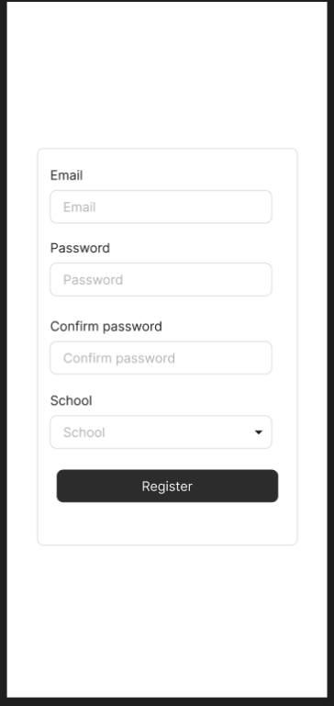
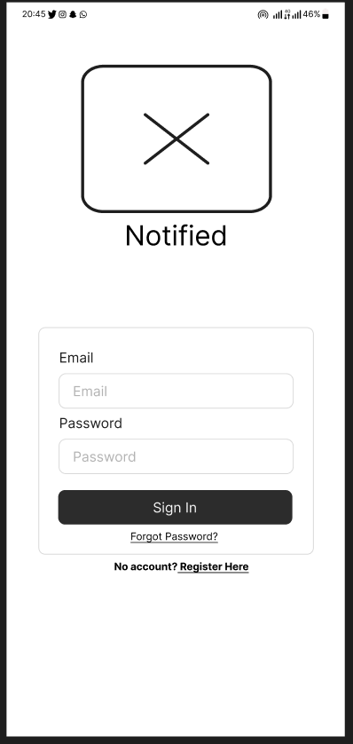

Login: Login Page Registration: Students can register
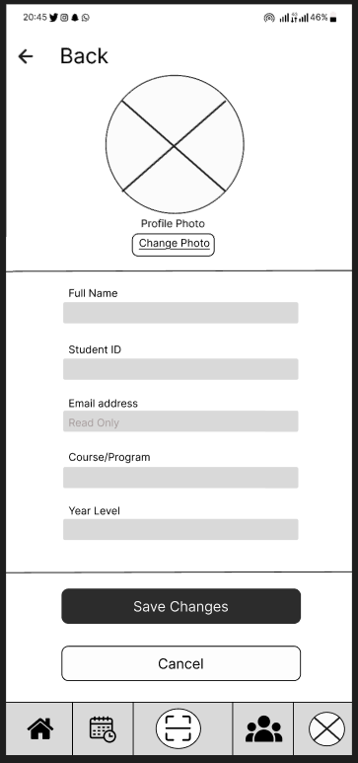
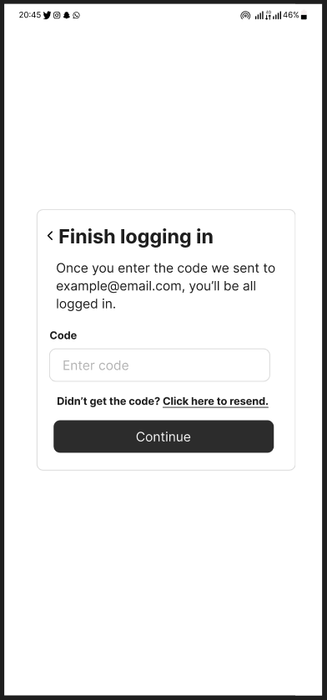

OTP: Students receive OTP to login Student Profile: Students can update their
information

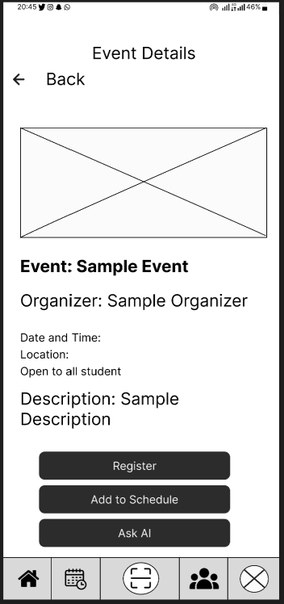
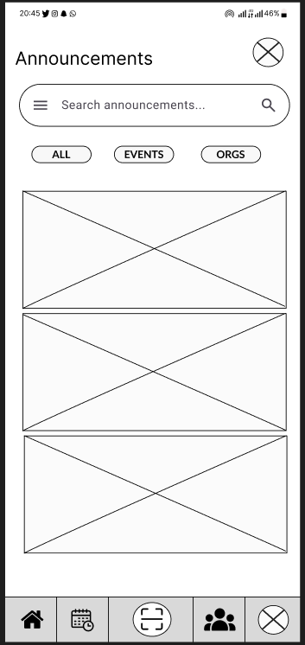

Announcement Page: All announcement Detail Page: Students can see each
and event page, students can also filter announcement or event full details
or search for easier navigation
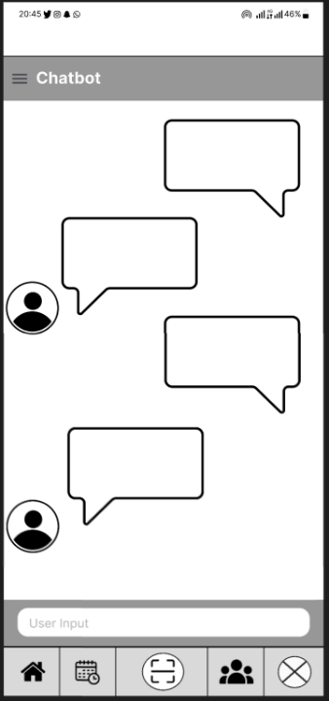
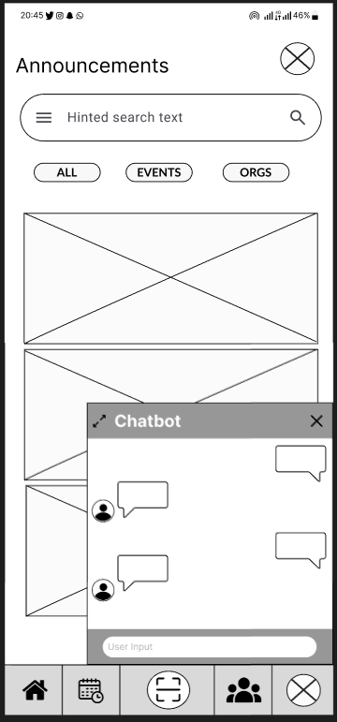

AI Chatbot (Floating): Floating AI chatbot AI Chatbot (Expanded): Expanded AI
chatbot
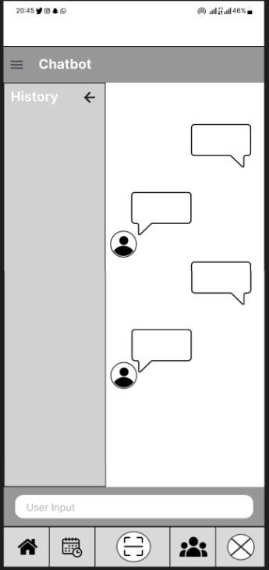
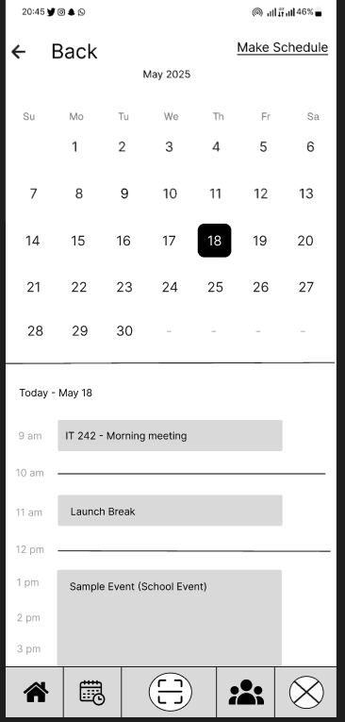

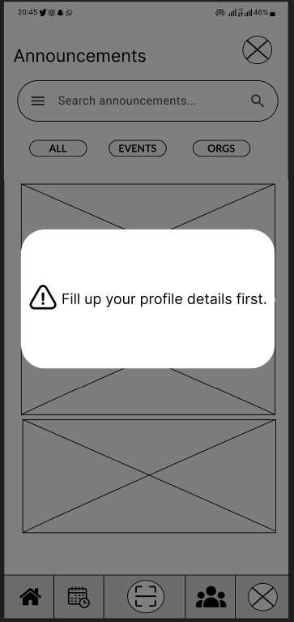
AI Chatbot (History): Chatbot History Schedule Management: Where students can see upcoming events and manage their own schedule
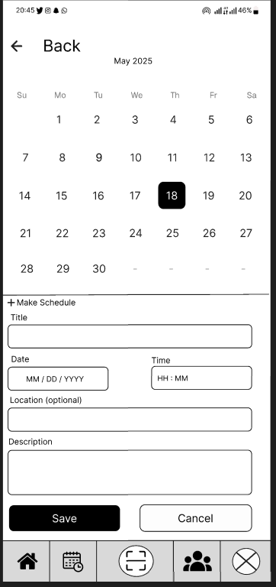

Schedule Management (Schedule Manager): Warning: Warning pop-up when
Where students manage their own schedule students haven’t filled up their profile details

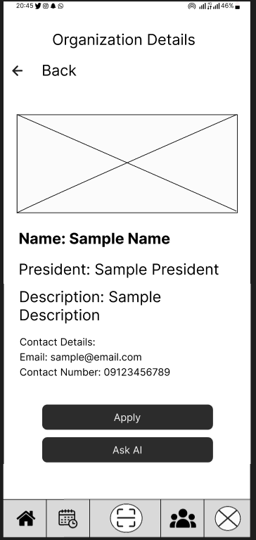
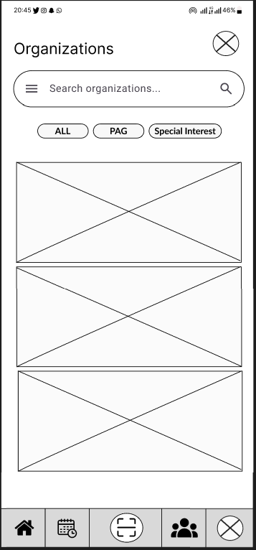

Organization Directory: Students can Organization Details: Details of each
view each organization and filter it organization
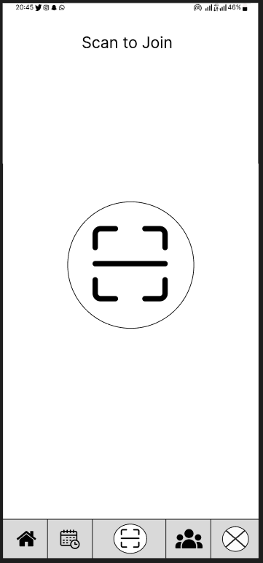

QR Scanner: Students can register using QR scanner

Project Lean Canvas
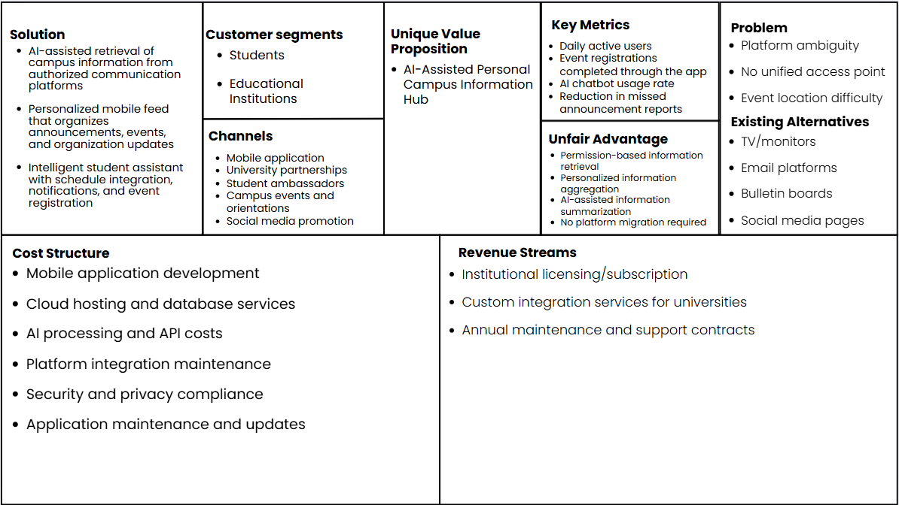

User Classes and Characteristics

Roles | Description
Student | The primary end-user of the platform. This includes regular students who view announcements, browse events, and manage their schedules.
Notified campus system(web) | The centralized administrative interface. This component acts as the backend portal used by administrators and faculty advisers to review, approve, or disapprove event submissions, manage notifications, and monitor system analytics.
AI | The automated processing layer embedded within the system. This component generates summaries for announcements and events, answers student questions through the chatbot interface, and assists in detecting schedule conflicts.

Product Backlog

User Story | Accepted Criteria
As a student, I want to view announcements in a chronological feed, so that I am always up to date with the latest official school news. | • Announcements are displayed in descending order, with the most recent entries shown first.
 | • Each announcement includes a title, date, and a brief content preview.
 | • A “Read More” option is available to display the full announcement details.
As a student, I want to ask the AI chatbot questions in natural language, so that I can get immediate assistance with campus-related inquiries | • The chatbot interface is accessible from the main application interface.
 | • The system processes user input and generates contextually relevant responses.
 | • The chatbot supports session continuity through chat history or provides an option to start a new session.
 | • The system displays an error message if the user attempts to send a message without an active internet connection
As a student, I want to manage my class schedule by manually inputting my subjects, so that I have a digital copy of my daily timetable within the app | • Users can add, edit, and delete schedule entries with specific days and time slots.
 | • The system stores schedule data and identifies potential conflicts with campus events.
 | • The schedule is presented in a clear and structured daily or weekly format.
 | • The system prevents the user from saving an entry if mandatory fields like "Subject Name" or "Time Slot" are left blank.
 | • The system provides an "Undo" or "Confirm Delete" prompt before permanently removing a scheduled item to prevent accidental data loss.
As a student, I want to browse the organization directory so that I can discover different campus groups and find their contact information. | • A complete list of recognized campus organizations is displayed.
 | • Selecting an organization reveals its details, including officers and contact information.
 | • Events associated with each organization are accessible within the organization profile.

Product Roadmap
(Create your product roadmap. Template can be found in the CoursePack)

Release Plan
(
Include here your updated release plan and discuss whether you are on/ahead/behind schedule. Explain also how much of the product backlog has been finished (it is up to you how you will present it, without being repetitive. You can say something like, “The complete product backlog is in Table ___”. Note: template can be found in the CoursePack.
)

Use Case Diagram

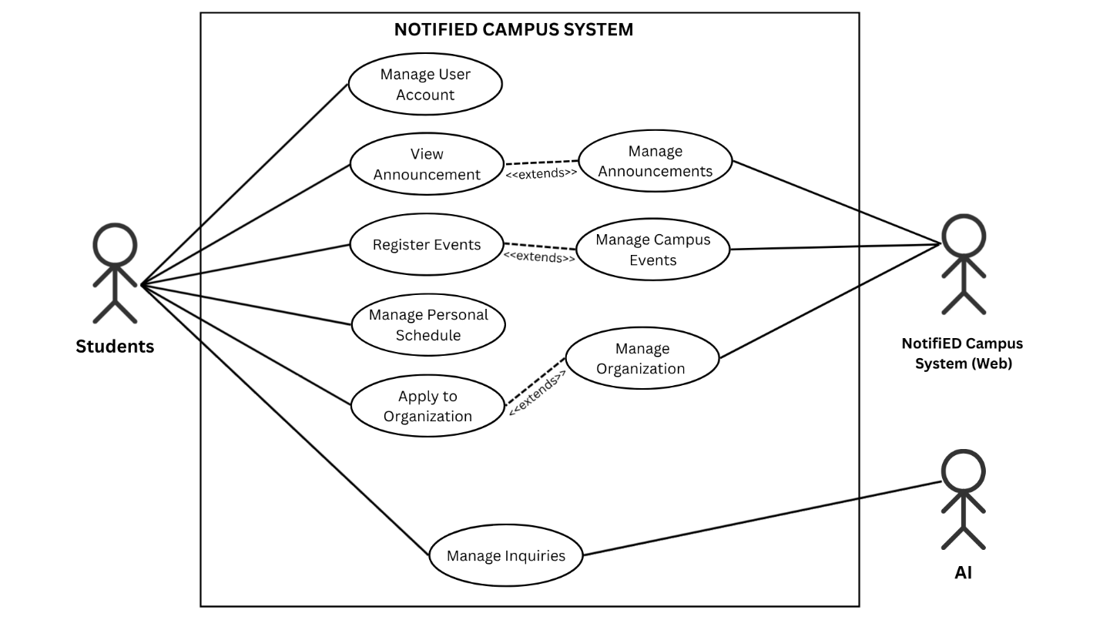

Use Case Full Description

Use Case 1: Manage User Account
Field | Description
Use Case Name | Manage User Account
Actor | Students
Description | The student creates and manages their personal profile within the NotifiED application, providing necessary information such as name, student ID, course, and year level.
Precondition | The student has downloaded and opened the NotifiED application.
Main Flow | 1. Student opens the application. 2. Student is prompted to create or update their account. 3. Student enters required profile information. 4. System saves and confirms the account details.
Postcondition | The student's account is created and they are granted access to the application.

Use Case 2: View Announcement
Field | Description
Use Case Name | View Announcement
Actor | Students
Description | The student optionally opens and reads a specific announcement from the centralized announcement feed. This use case extends Manage Announcements.
Precondition | The student is logged in and the announcement feed is loaded.
Main Flow | 1. Student browses the announcement feed. 2. Student selects a specific announcement. 3. System displays the full details of the selected announcement.
Postcondition | The student has read the full announcement details.
Extension Point | Extends Manage Announcements: triggered only when the student chooses to open a specific announcement.

Use Case 3: Manage Announcements
Field | Description
Use Case Name | Manage Announcements
Actor | Students, NotifiED Campus System (Web)
Description | The system retrieves and displays all campus announcements from the web backend, providing students with a centralized and organized feed of official updates.
Precondition | The student is logged in and has a stable internet connection.
Main Flow | 1. Student navigates to the announcements section. 2. System sends a request to the NotifiED Campus System (Web). 3. Web system returns the list of available announcements. 4. System displays the announcements in the student's feed.
Postcondition | The student can view all available campus announcements in one place.

Use Case 4: Register Events
Field | Description
Use Case Name | Register Events
Actor | Students
Description | The student optionally registers for a specific campus event by scanning a QR code or manually inputting their information. This use case extends Manage Campus Events.
Precondition | The student is logged in and has accessed the campus events section.
Main Flow | 1. Student browses available campus events. 2. Student selects an event they wish to join. 3. Student scans the QR code or input their information associated with the event. 4. System records the student's registration. 5. System confirms successful registration.
Postcondition | The student is successfully registered for the selected event.
Extension Point | Extends Manage Campus Events — triggered only when the student chooses to register for a specific event.

Use Case 5: Manage Campus Events
Field | Description
Use Case Name | Manage Campus Events
Actor | Students, NotifiED Campus System (Web)
Description | The system retrieves and displays all available campus events from the web backend, allowing students to explore upcoming activities and opportunities.
Precondition | The student is logged in and has a stable internet connection.
Main Flow | 1. Student navigates to the campus events section. 2. System sends a request to the NotifiED Campus System (Web). 3. Web system returns the list of available events. 4. System displays the events to the student.
Postcondition | The student can view all available campus events.

Use Case 6: Manage Personal Schedule
Field | Description
Use Case Name | Manage Personal Schedule
Actor | Students
Description | The student manually inputs and manages their personal class schedule within the application, which the AI then uses to identify free time slots and suggest productive windows.
Precondition | The student is logged in and has accessed the schedule section.
Main Flow | 1. Student navigates to the personal schedule section. 2. Student manually inputs their class schedules, including subject, time, and day. 3. System saves and displays the student's weekly schedule. 4. AI analyzes the schedule and identifies available time slots.
Postcondition | The student's personal schedule is saved and visible within the application.

Use Case 7: Apply to Organization
Field | Description
Use Case Name | Apply to Organization
Actor | Students
Description | The student optionally submits an application to join a campus organization after exploring the organization directory. This use case extends Manage Organization.
Precondition | The student is logged in and has accessed the organization directory.
Main Flow | 1. Student browses the organization directory. 2. Student selects an organization they wish to join. 3. Student submits an application through the platform. 4. System records and forwards the application. 5. System confirms that the application has been submitted.
Postcondition | The student's application has been successfully submitted to the selected organization.
Extension Point | Extends Manage Organization — triggered only when the student chooses to apply to a specific organization.

Use Case 8: Manage Organization
Field | Description
Use Case Name | Manage Organization
Actor | Students, NotifiED Campus System (Web)
Description | The system retrieves and displays the organization directory from the web backend, providing students with a centralized listing of all recognized campus organizations and their details.
Precondition | The student is logged in and has a stable internet connection.
Main Flow | 1. Student navigates to the organization directory. 2. System sends a request to the NotifiED Campus System (Web). 3. Web system returns the list of organizations and their profile details. 4. System displays the organizations to the student.
Postcondition | The student can explore all available campus organizations and their information.

Use Case 9: Manage Inquiries
Field | Description
Use Case Name | Manage Inquiries
Actor | Students, AI
Description | The student submits a question or inquiry through the conversational AI interface, and the AI processes the request by scanning the platform database to provide an immediate and accurate response or summary.
Precondition | The student is logged in and has accessed the inquiry or chatbot section.
Main Flow | 1. Student opens the AI chatbot interface. 2. Student types and submits a question or inquiry. 3. AI scans the platform database for relevant information. 4. AI returns a response, summary, or actionable answer to the student. 5. System displays the AI's response in the chat interface.
Postcondition | The student has received a relevant response to their inquiry from the AI.

Conclusion

This project established the foundation for addressing the challenges of fragmented campus communication and platform ambiguity within educational institutions, using Asia Pacific College (APC) as the primary context. Through research, system planning, requirements analysis, and system design, the NotifiED framework was developed as an AI-assisted mobile platform intended to consolidate campus-related information from multiple communication channels into a centralized and personalized student experience.
During this initial design phase, the project successfully achieved the following objectives:
- Design of a Centralized Information Retrieval Framework: To address the issue of platform ambiguity, a system architecture was developed that retrieves and organizes campus-related information from authorized communication platforms. This framework provides students with a unified access point for announcements, events, and organizational updates without requiring institutions or organizations to migrate to a separate posting platform.
- Development of Personalized Information Access Mechanisms: To improve information accessibility and reduce information fragmentation, the project designed a personalized announcement feed, announcement filtering system, automated notification mechanism, and organization directory. These features enable students to efficiently discover and access relevant campus information according to their interests and academic needs.
- Integration of AI-Assisted Student Support Features: To enhance information comprehension and engagement, the proposed solution incorporates an AI-assisted chatbot capable of helping students interact with retrieved campus information through natural language inquiries. This allows users to obtain summarized responses and quickly access important details regarding announcements, events, schedules, and organizational activities.
- Design of Student Engagement and Participation Features: To support student involvement beyond information discovery, the system incorporates organization exploration, schedule integration, and QR code-based event registration features. These components create a more complete student engagement workflow by connecting information access with participation opportunities.
Overall, the project demonstrates the potential of an AI-assisted campus information hub to improve how students discover, organize, and interact with campus-related information. While further development, testing, and institutional collaboration are necessary for full implementation, the proposed framework provides a strong foundation for addressing communication inefficiencies and improving student access to relevant campus information.

References
[1] P. H. Cheong and P. Nyaupane, “Smart campus communication, Internet of Things, and data governance: Understanding student tensions and imaginaries,” Big Data & Society, vol. 9, no. 1, 2022. [Online]. Available: https://doi.org/10.1177/20539517221092656
[2] A. Hidayat and M. Farhan, “Digital learning fatigue and its impact on student engagement in higher education: A structural equation modeling approach,” Preprint, 2025. [Online]. Available: https://www.researchgate.net/publication/401017594_Digital_Learning_Fatigue_and_Academic_Motivation_in_Students_at_Ahmad_Dahlan_University_Yogyakarta
[3] I. Hossain et al., “Managing the activities of a university department through Android application,” Preprint, 2023. [Online]. Available: https://www.researchgate.net/publication/369181153_Managing_the_Activities_of_a_University_Department_through_Android_Application
[4] U. Ibrahim, “Assessing the impact of mobile applications on student engagement in ICT and Computer Science education,” Int. J. Appl. Educ. Res. (IJAER), vol. 2, no. 1, pp. 51–62, 2024.
[5] Inside Higher Ed and College Pulse, “Student Voice survey: Digital tools for in-person college student connections,” Inside Higher Ed, 2023. [Online]. Available: https://www.insidehighered.com/news/student-success/college-experience/2024/12/04/digital-tools-person-college-student-connections
[6] R. M. Oducado, G. P. Soriano, and J. D. Maniago, “A cross-sectional study on Zoom fatigue and satisfaction with online learning among Filipino nursing students,” Innoeduca: Int. J. Technol. Educ. Innov., vol. 10, no. 1, 2024. [Online]. Available: https://revistas.uma.es/index.php/innoeduca/article/view/15402
[7] S. Orhani, E. Saramati, L. Drini, M. H. Kolukaj, and M. Morina, “Benefits of Information and Communication Technology (ICT) in the successful management of schools in the world: Increasing the efficiency and quality of education,” Int. J. Res. Innov. Soc. Sci., vol. 8, no. 3, pp. 5078–5092, 2024. [Online]. Available: https://doi.org/10.47772/IJRISS.2024.803011
[8] J. C. G. Tolentino and J. P. P. Miranda, “Self-reported Zoom exhaustion and fatigue levels among physical education teacher education students in a state university in the Philippines,” J. Efficiency Responsib. Educ. Sci., vol. 17, no. 3, pp. 205–213, 2024. [Online]. Available: https://doi.org/10.7160/eriesj.2024.170303
[9] vmedulife Software, “Enhancing campus connectivity with vmedulife’s centralized communication tools,” vmedulife Blog, 2025. [Online]. Available: https://vmedulife.com/blog/communication-portal/centralized-communication-tools/
[10] S. Wollny et al., “Are we there yet? A systematic literature review on chatbots in education,” Front. Artif. Intell., vol. 4, Art. no. 654942, 2021. [Online]. Available: https://doi.org/10.3389/frai.2021.654942

Appendices

Appendix A: Roles and Responsibilities

Project leader: Charles Capagngan
Responsibilities: Led overall project coordination and documentation. Contributed to wireframes and prototype mock flows. Participated in Design Thinking (UCD and Lean Canvas).

Member: Cristian Saldua
Responsibilities: Assisted in documentation and contributed to wireframes and prototype mock flows. Participated in Design Thinking (UCD and Lean Canvas).

Member: Gabrielle Calibo
Responsibilities: Contributed to project documentation. Participated in Design Thinking (UCD and Lean Canvas).

Member: Patricia Marie Valera
Responsibilities: Contributed to project documentation. Participated in Design Thinking (UCD and Lean Canvas).

Appendix B: Minutes of the Meetings
Link: Minutes of the Meetings

Meeting with Sir Gonzalo Gumogda
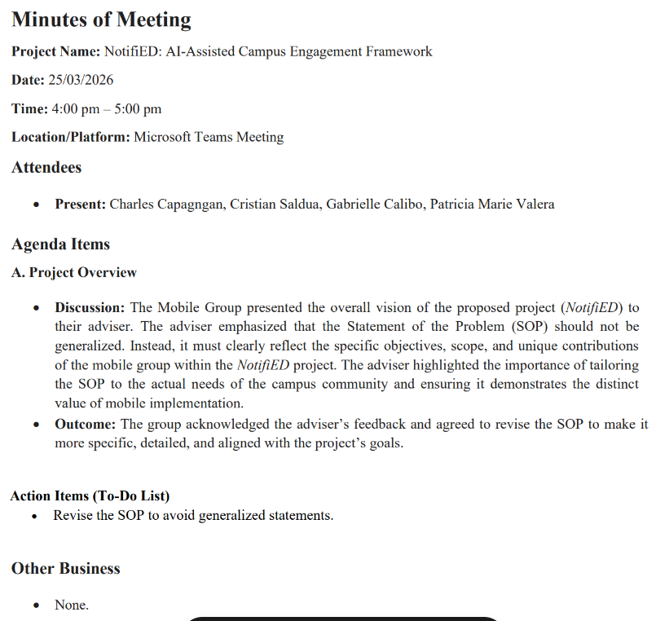
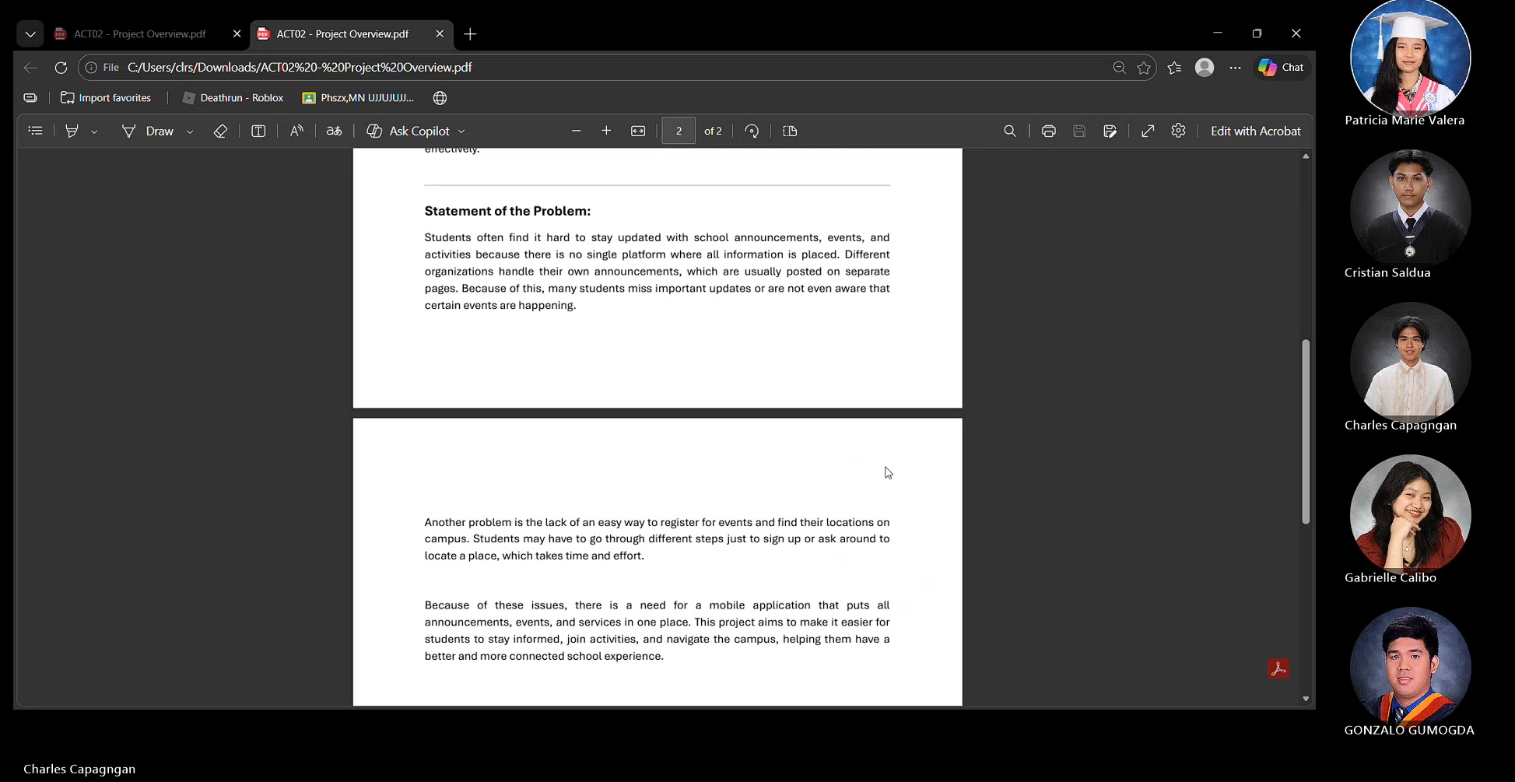

Meeting with Ms Ma Revvie Zoe Congson

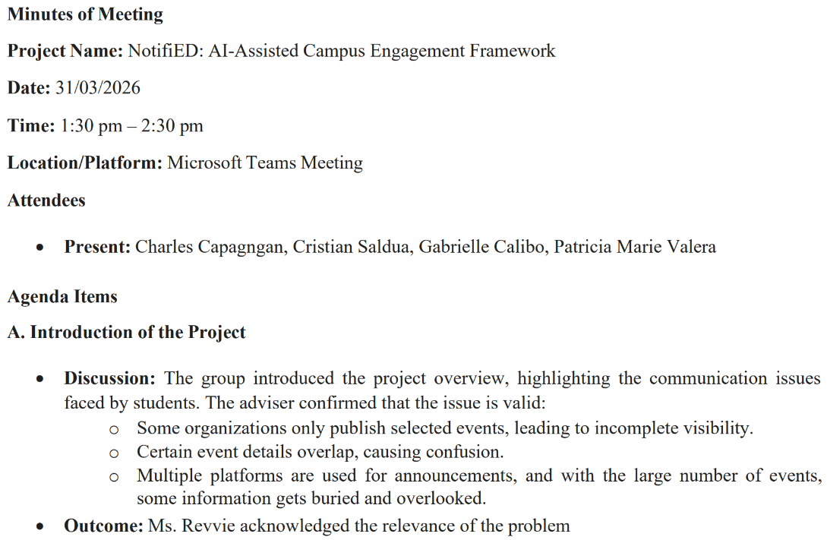
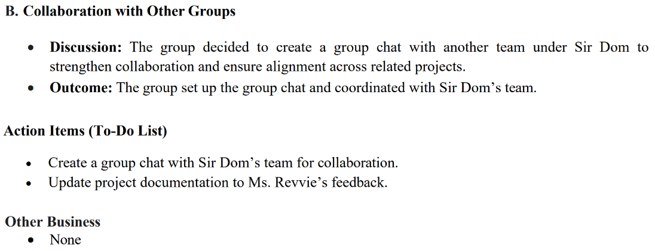

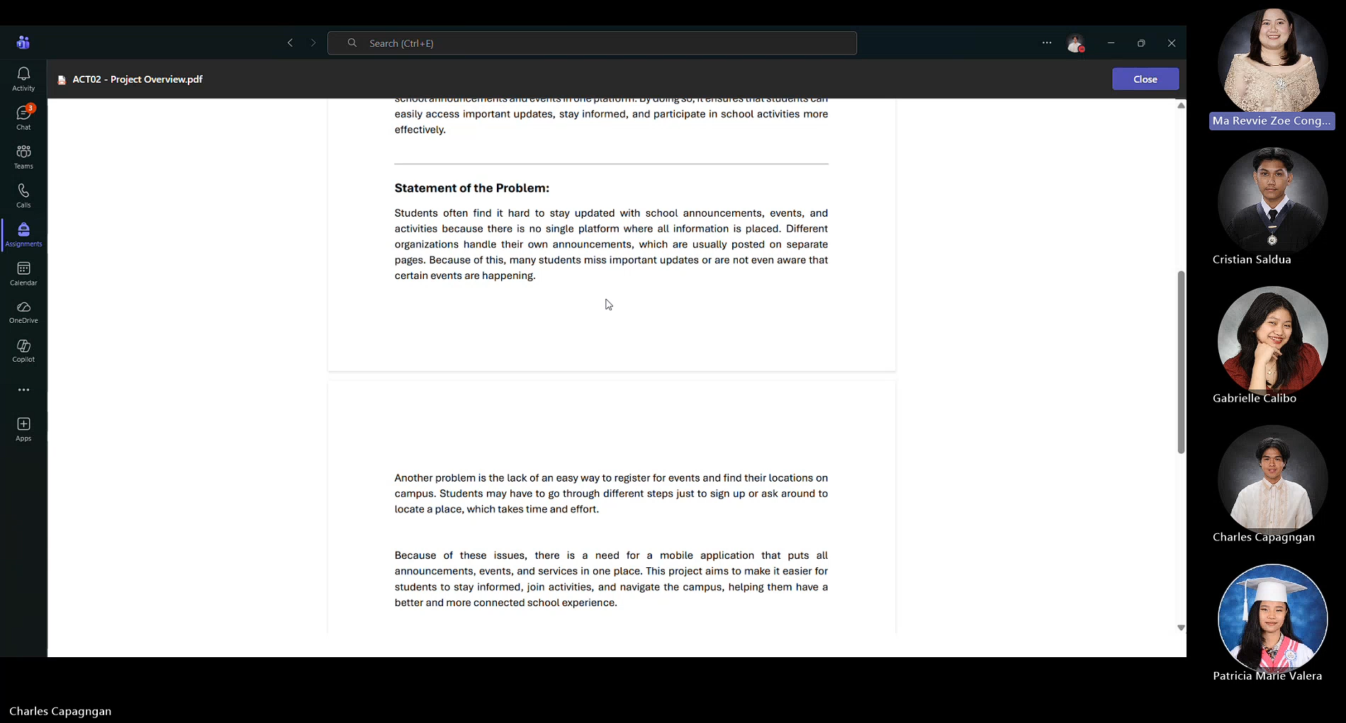

Meeting with Sir Gonzalo Gumogda

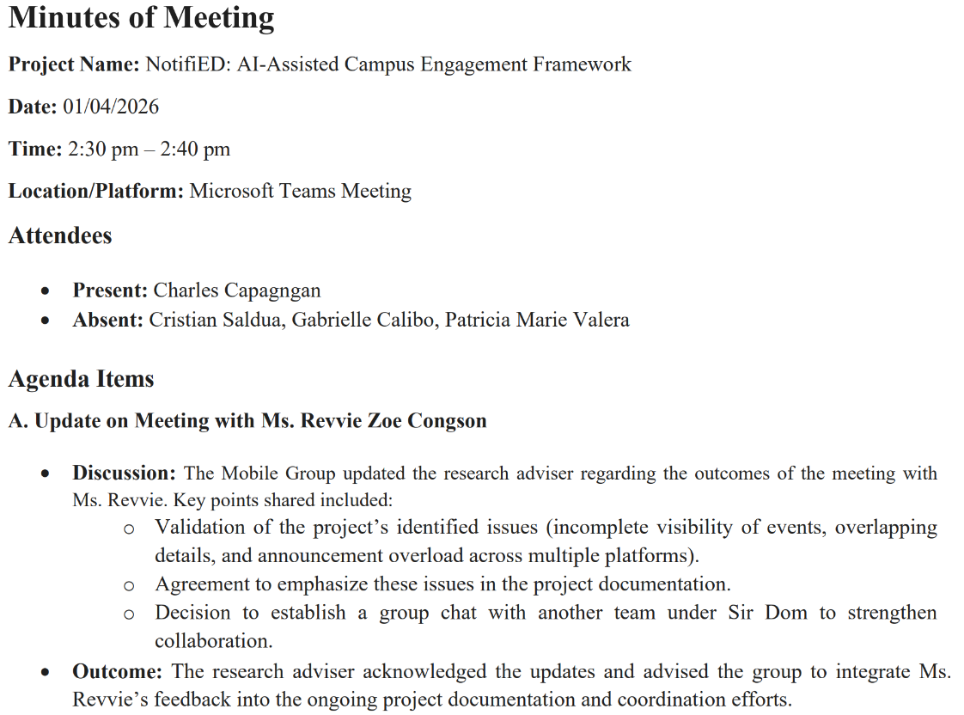

Meeting with Sir Gonzalo Gumogda

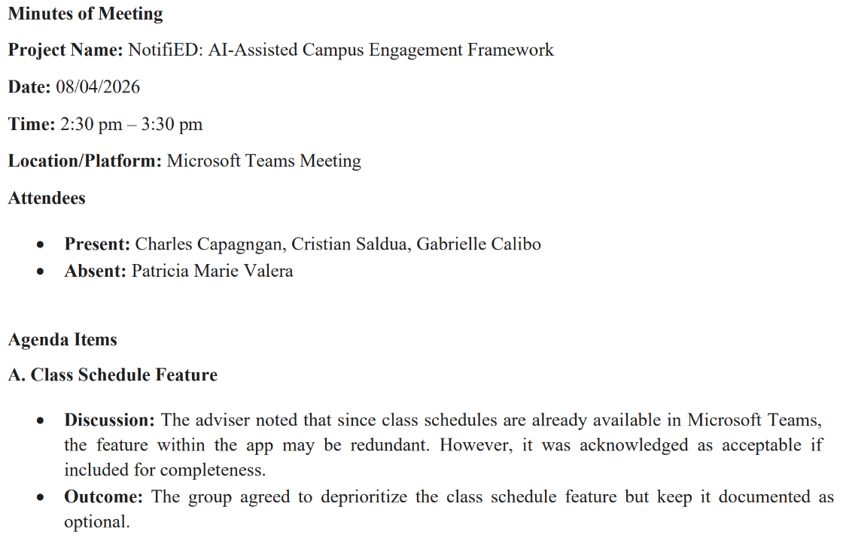

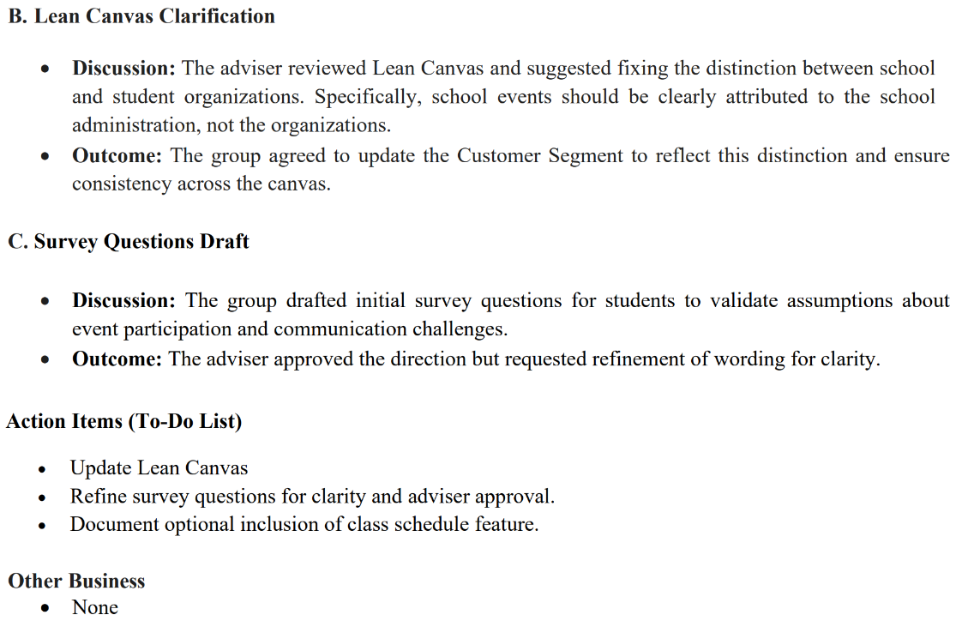

Meeting with Web Group

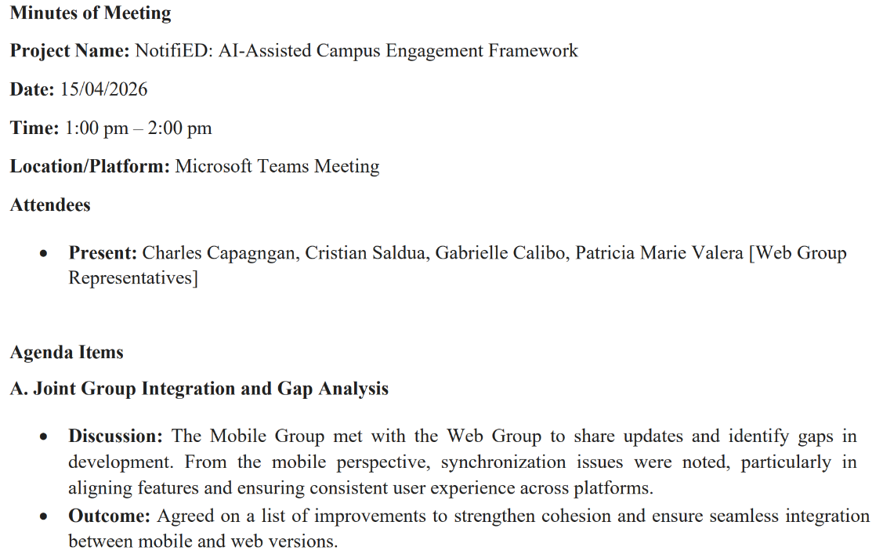

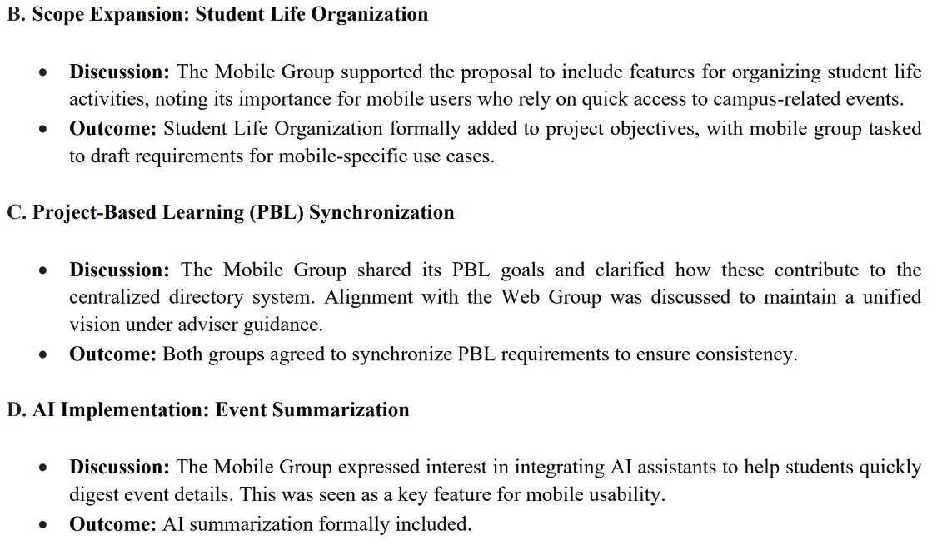

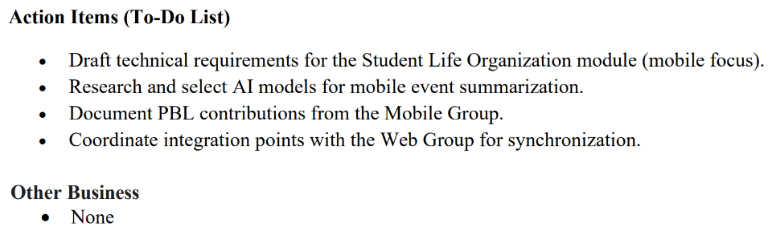
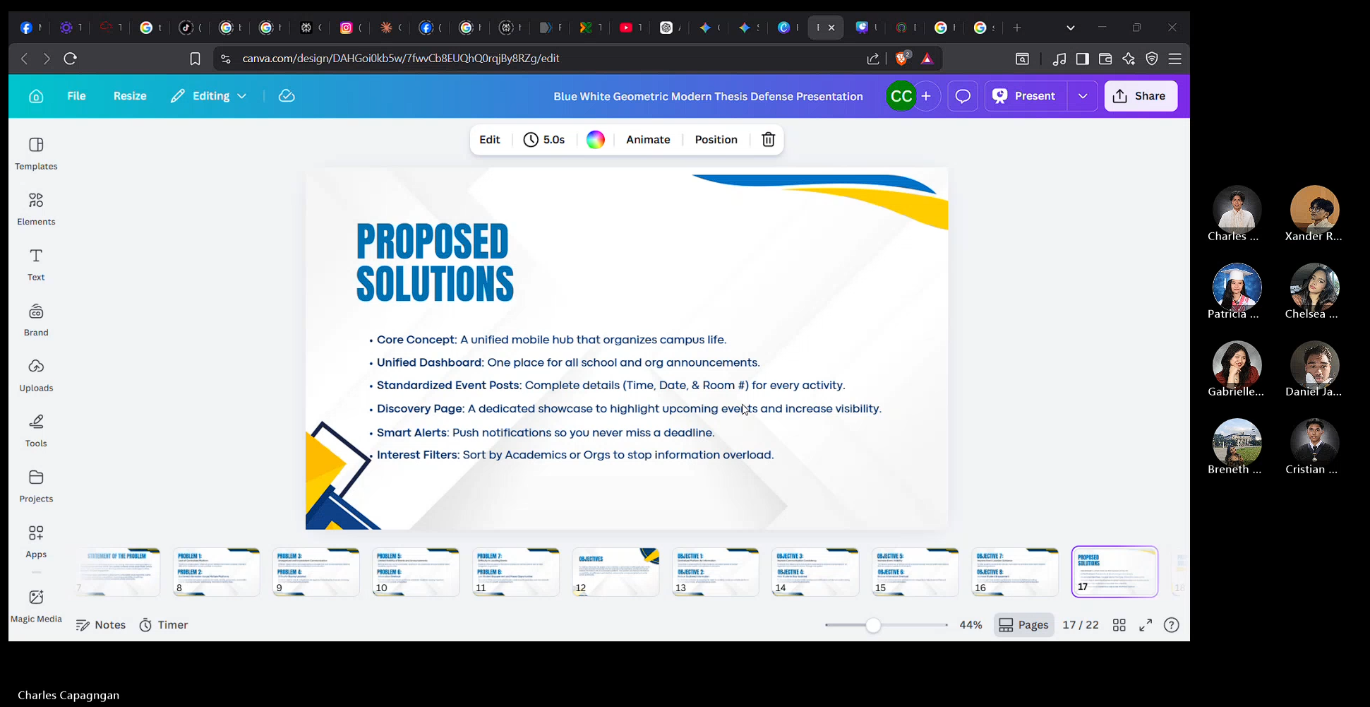

Meeting with Sir Gonzalo Gumogda

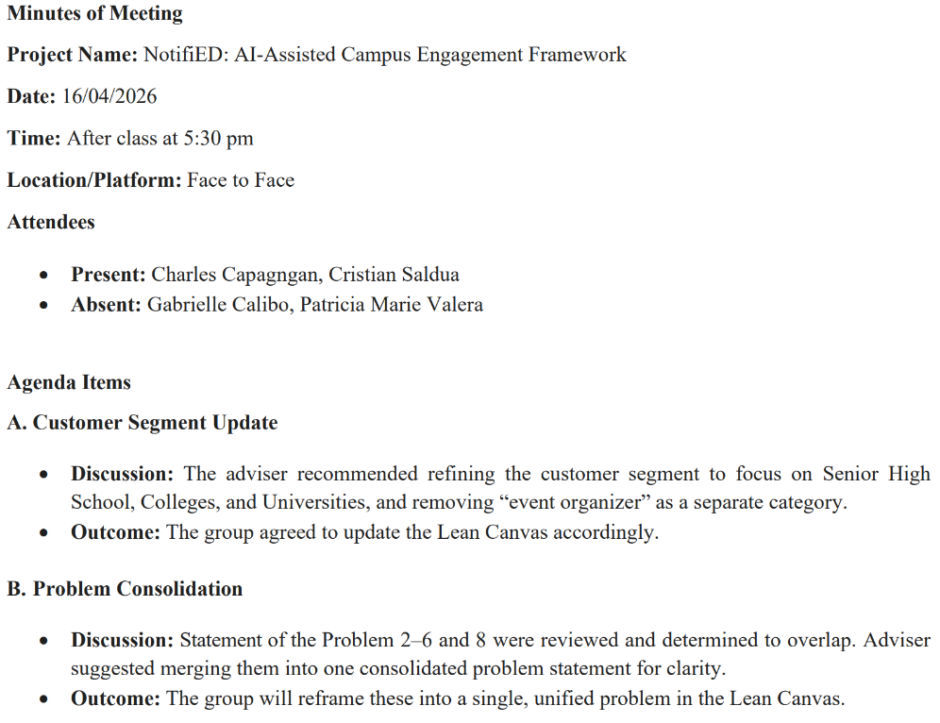
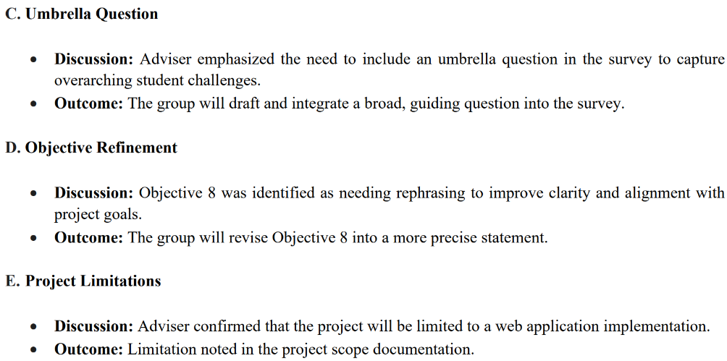
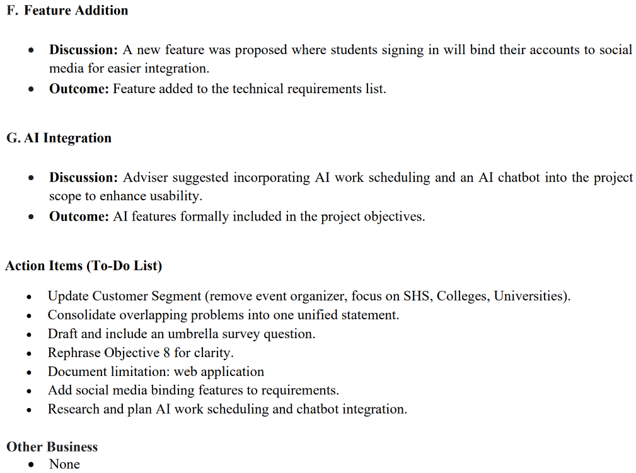

Meeting with Web Group

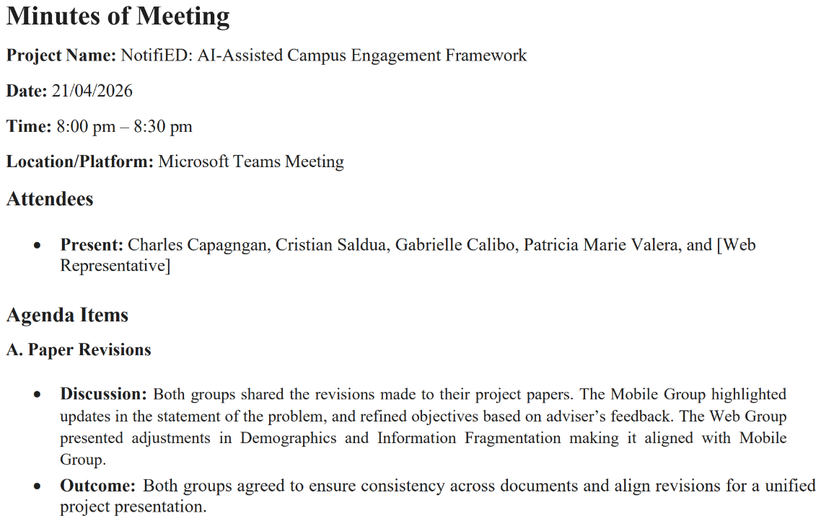
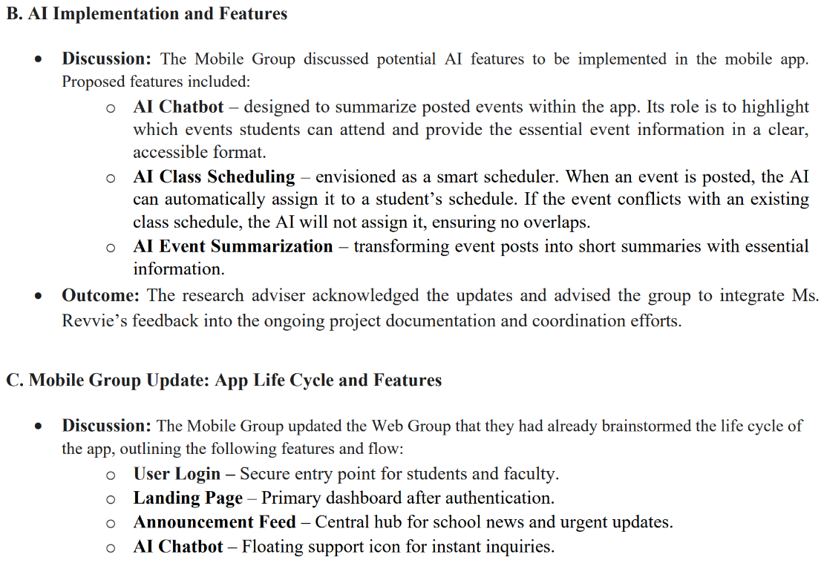
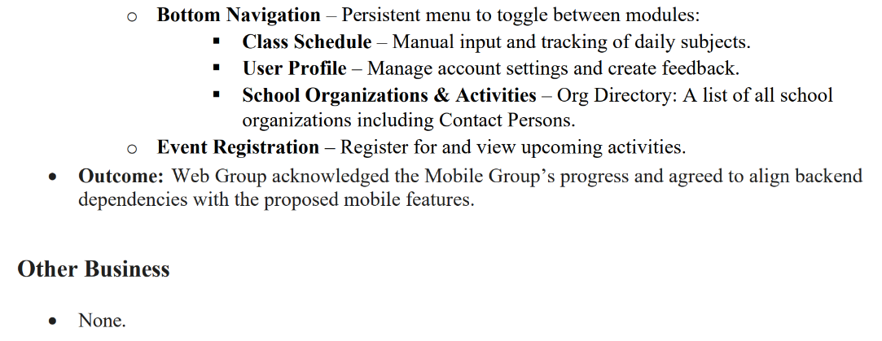

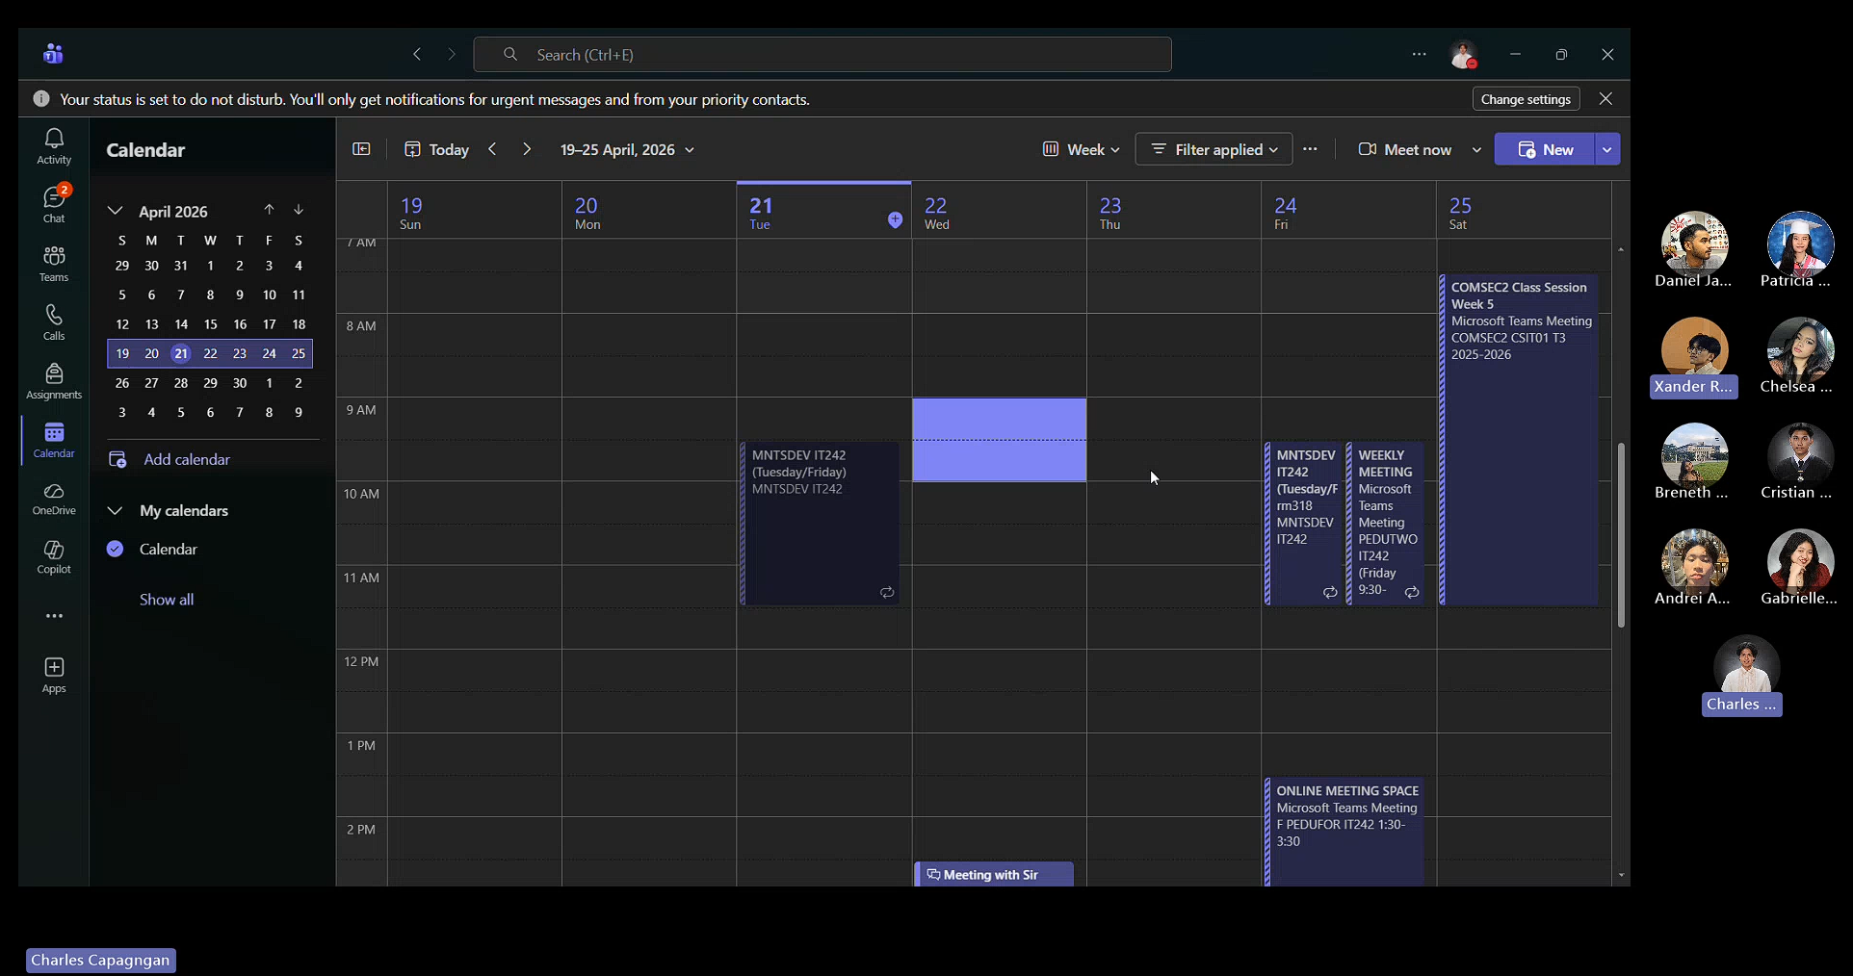

Meeting with Sir Gonzalo Gumogda
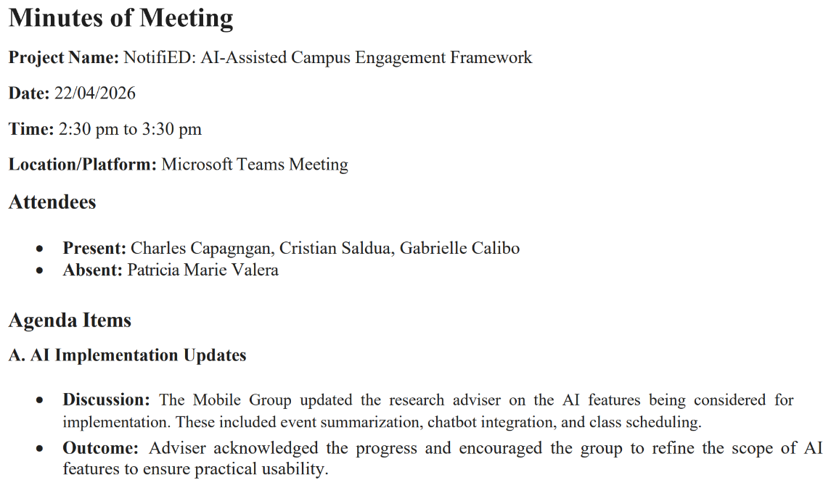
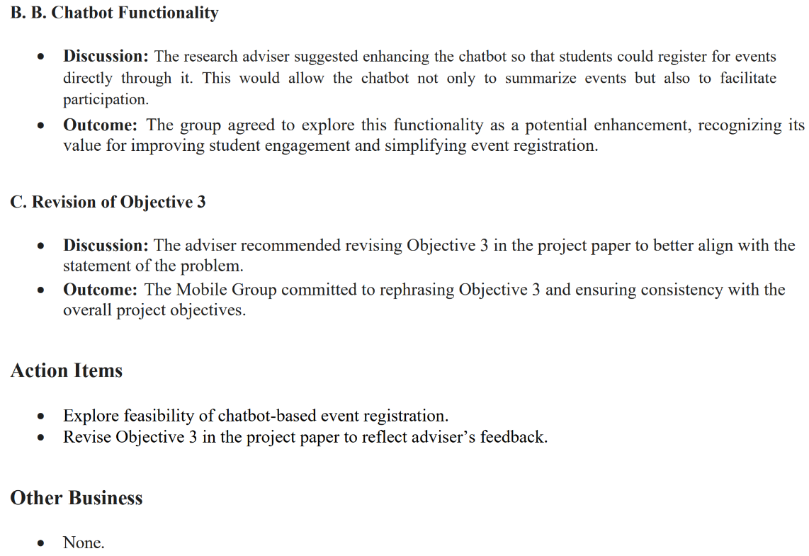


Meeting with Web Group

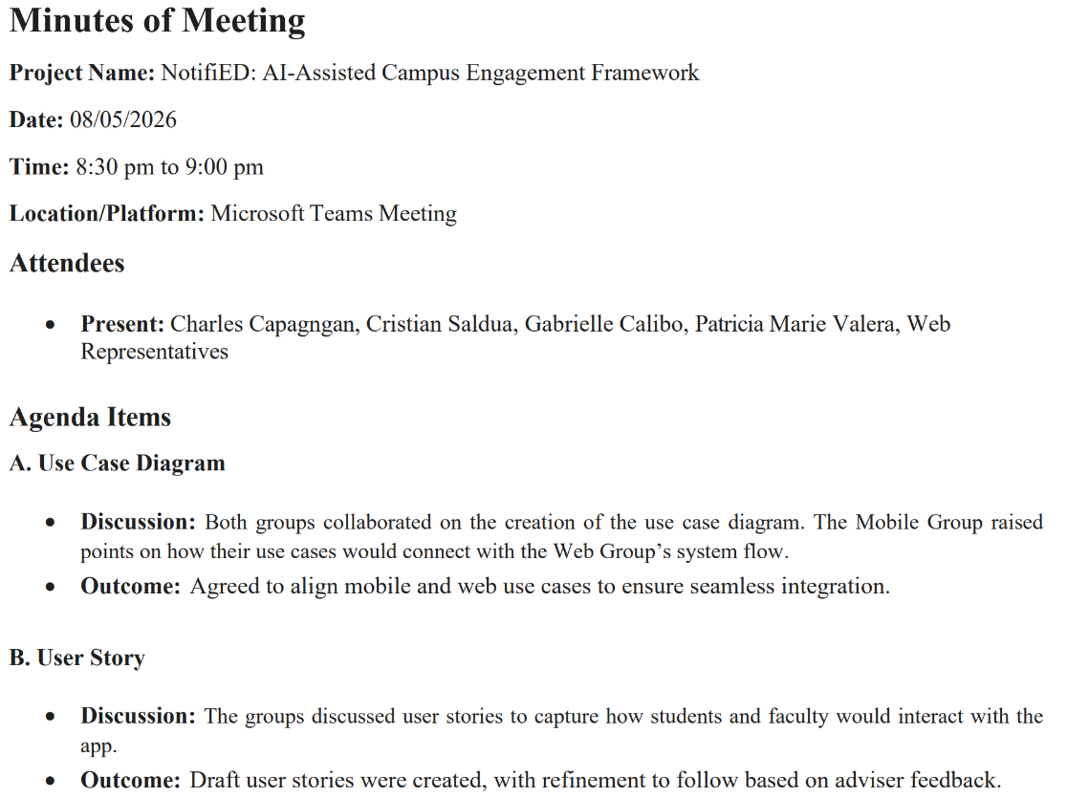
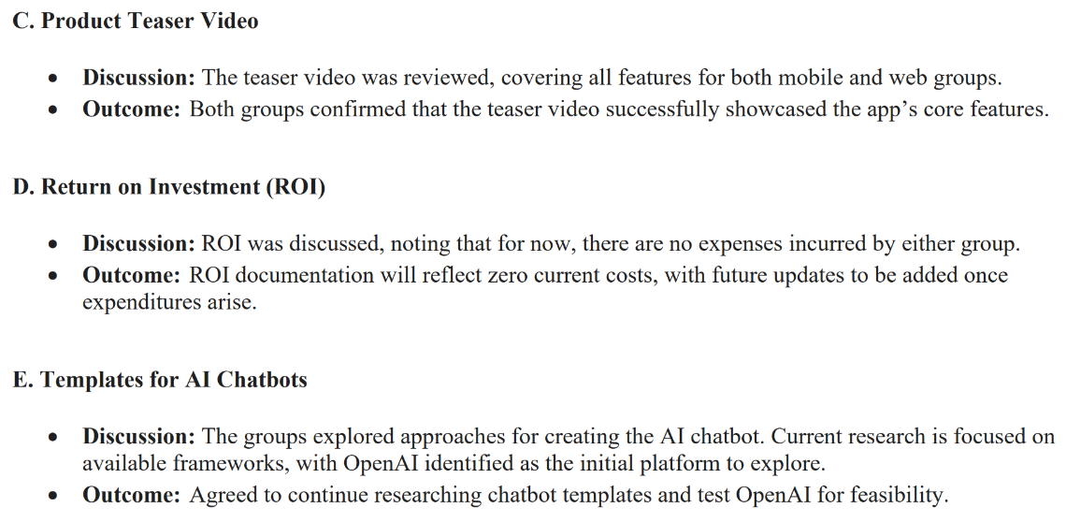
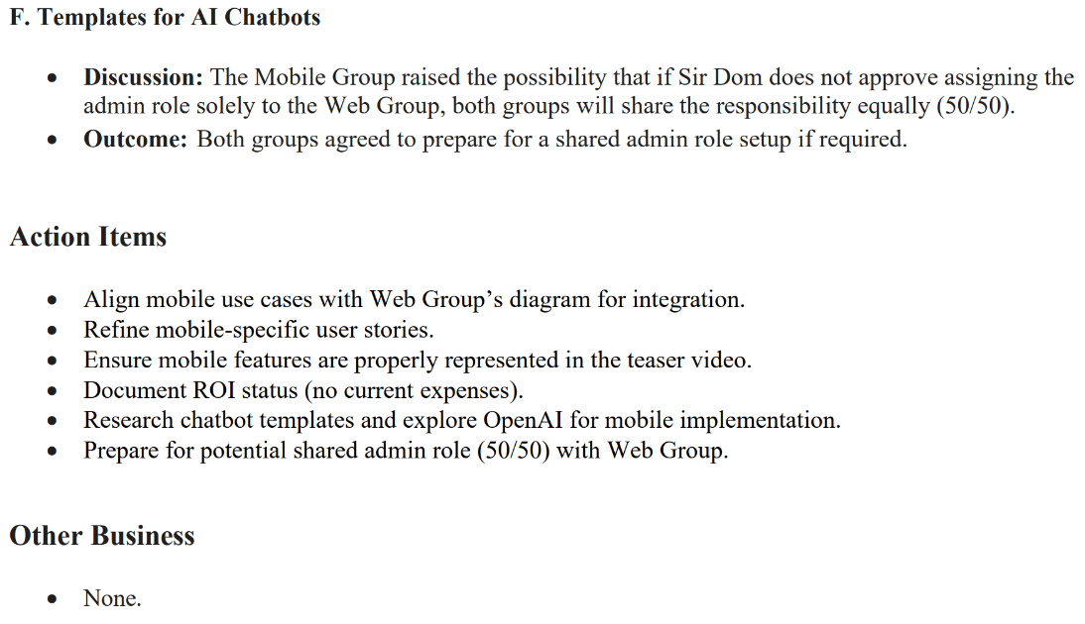
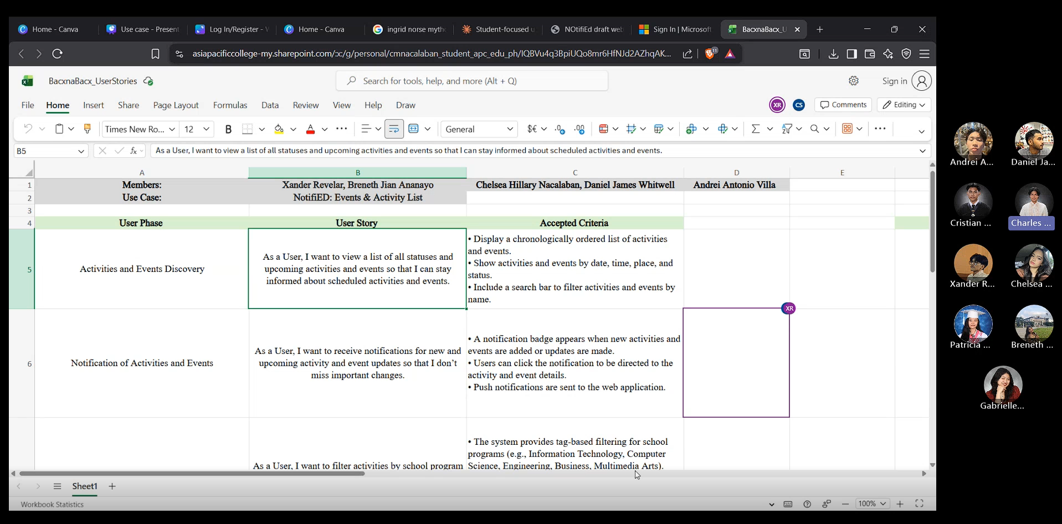

Meeting with Sir Gonzalo Gumogda

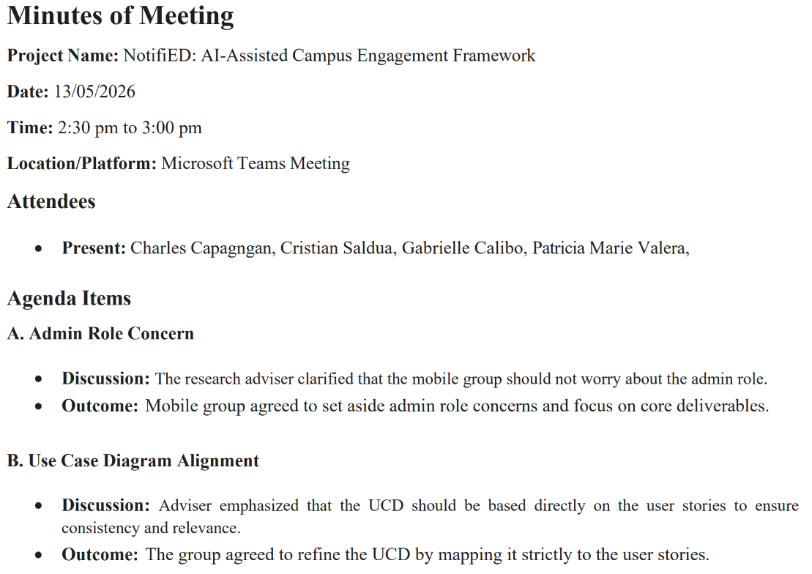
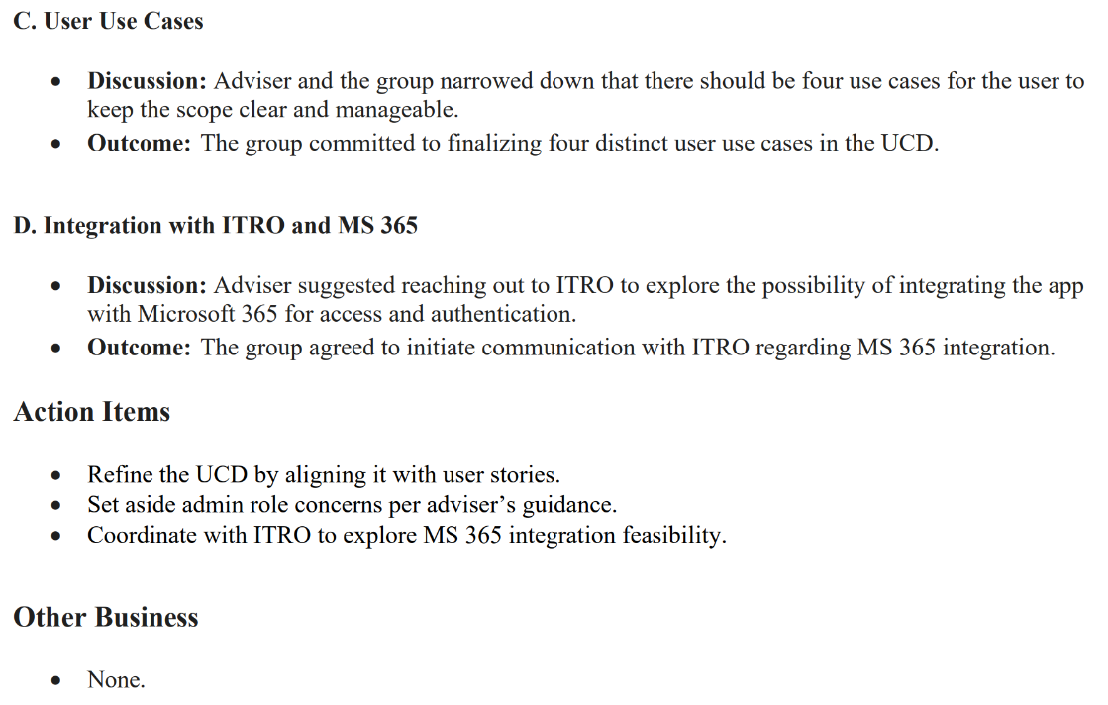
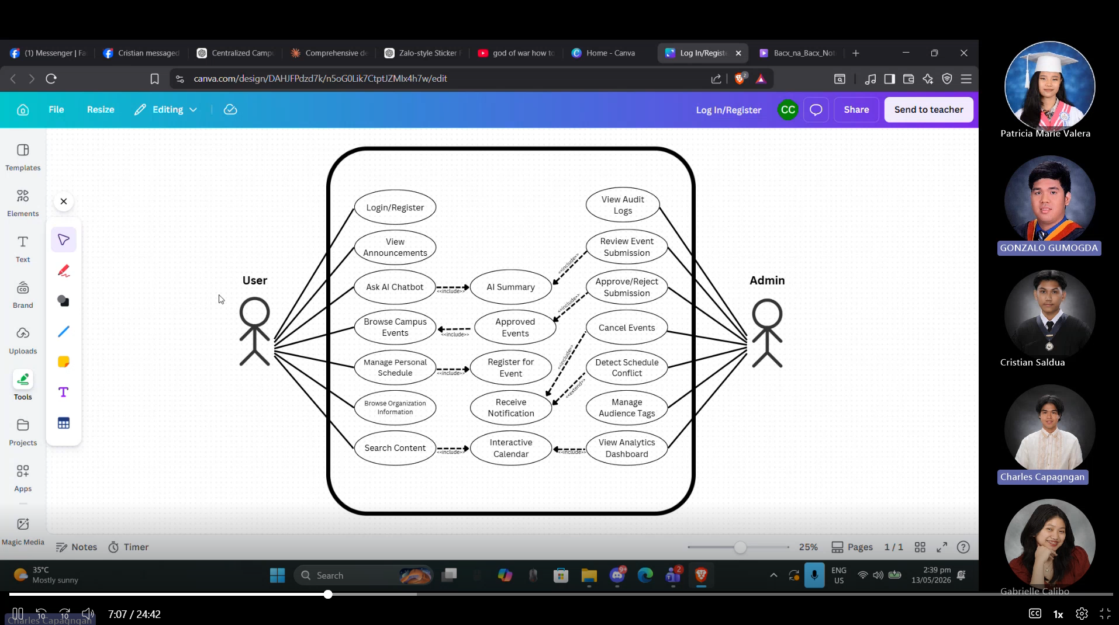

Meeting with Web Group
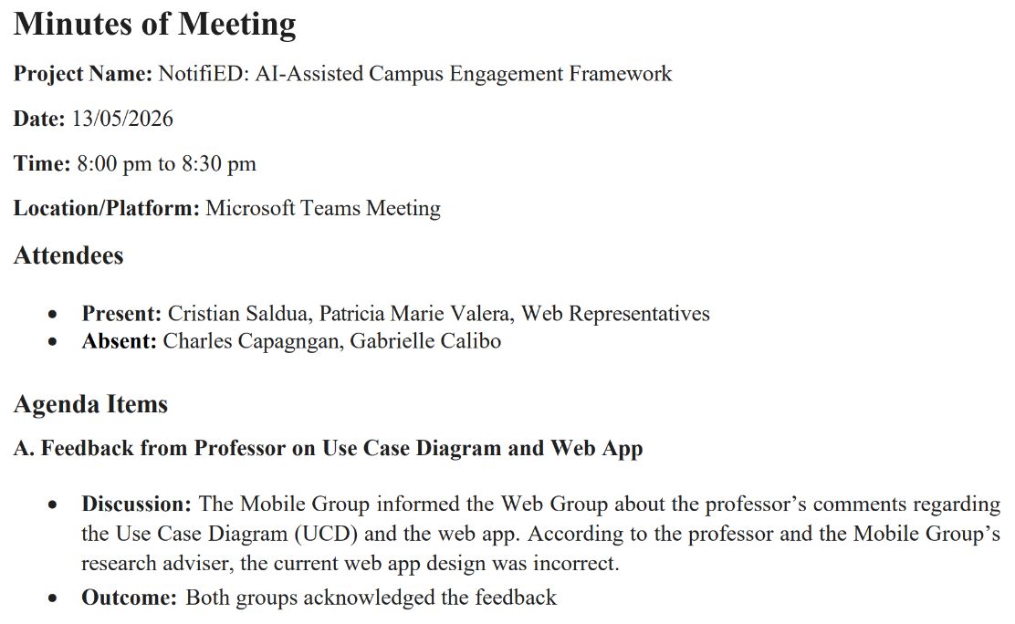
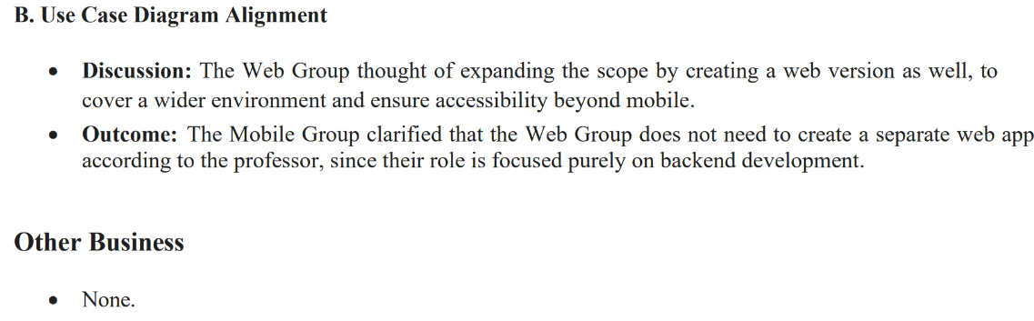


Meeting with Web Group
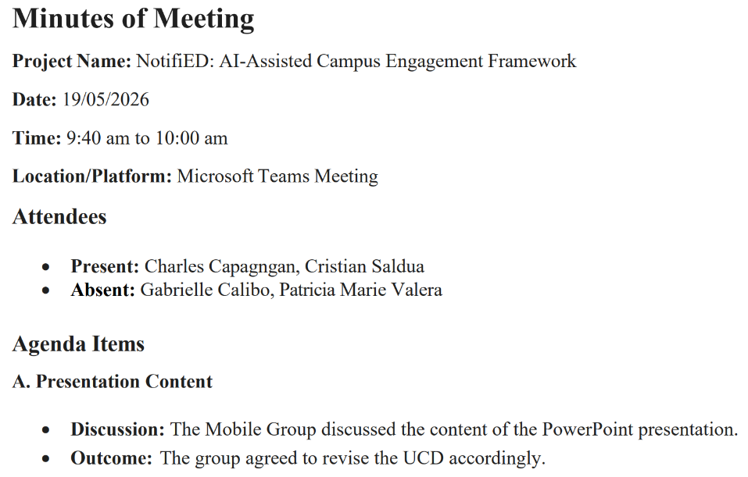
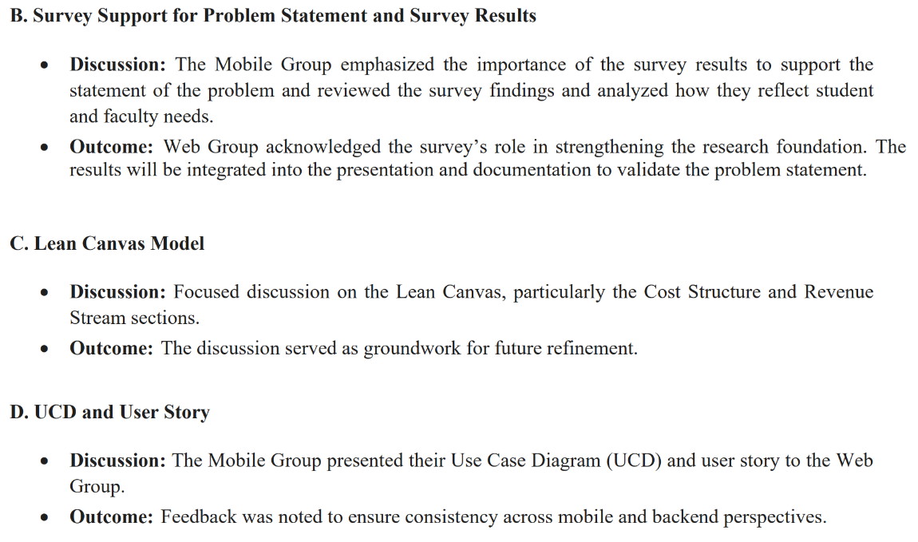
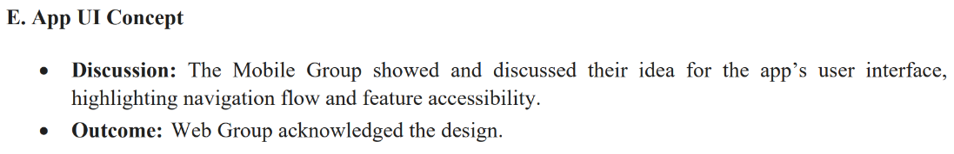
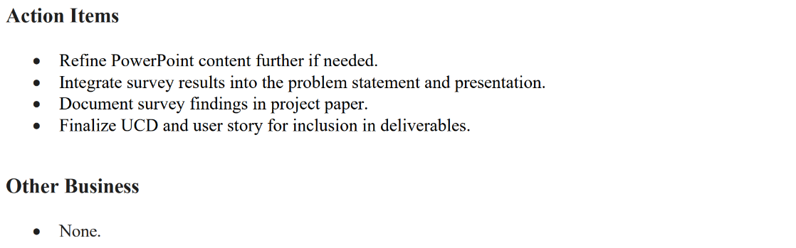

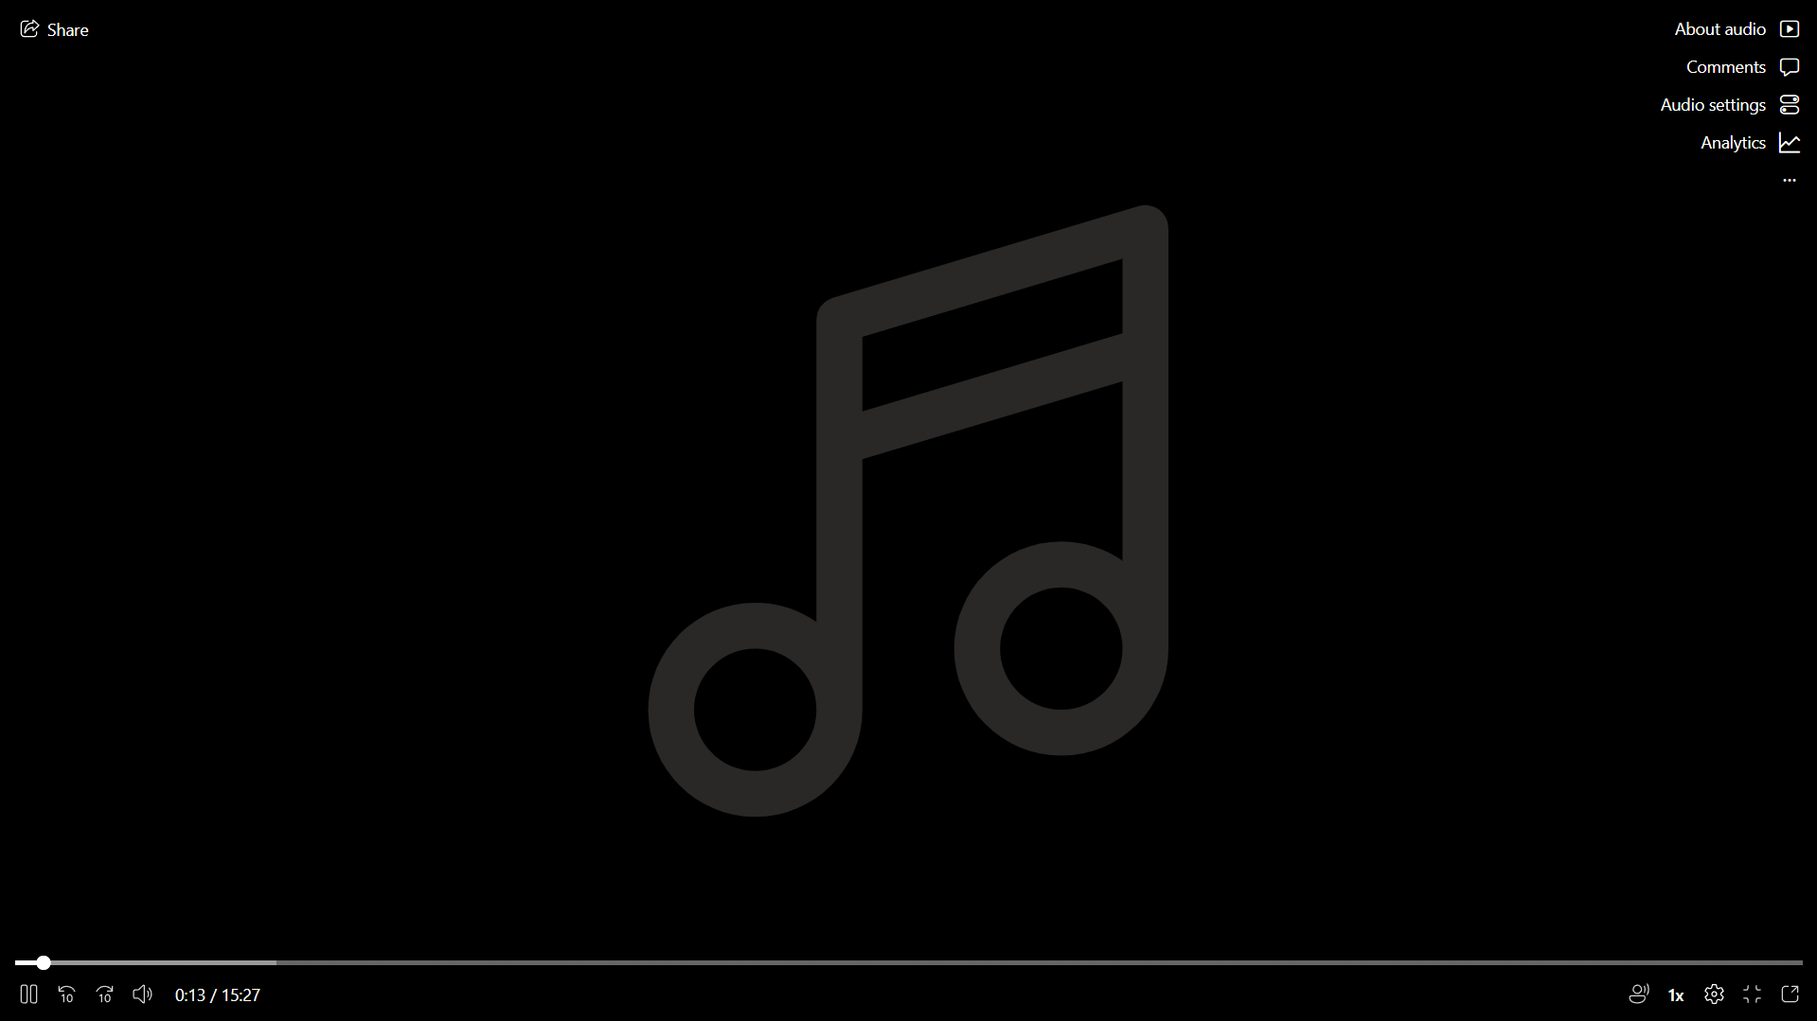

Meeting with Sir Gonzalo Gumogda
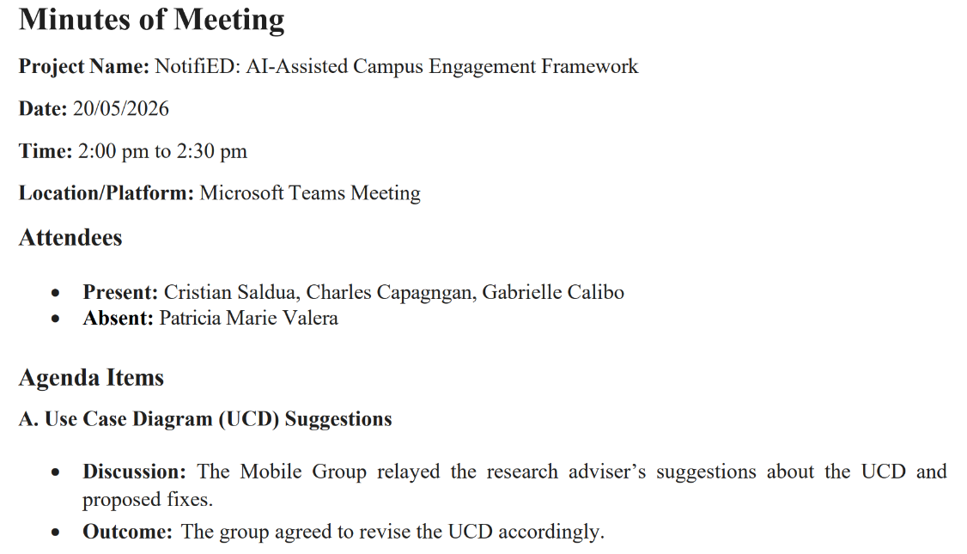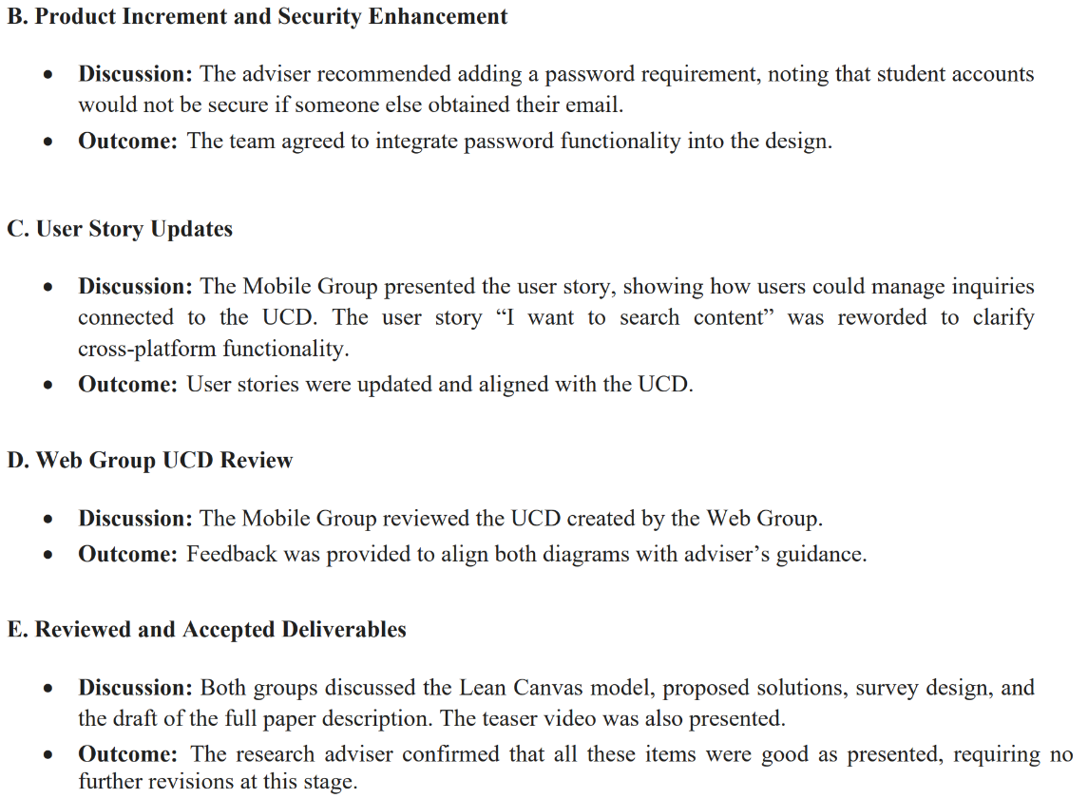
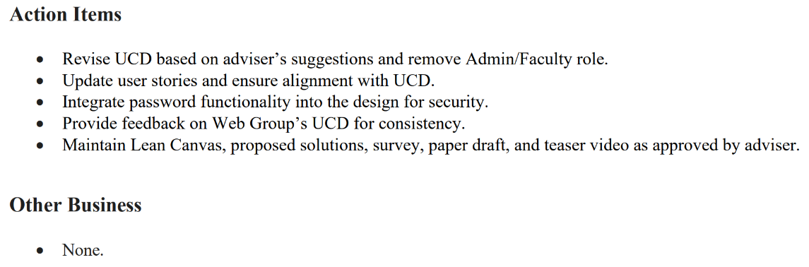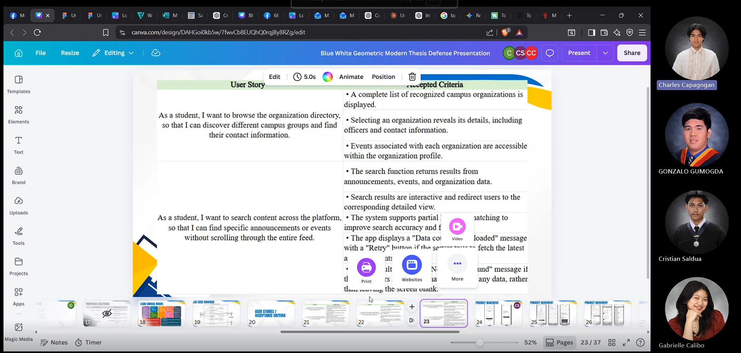

Appendix C: Methodology

Survey
A quantitative survey design was utilized to investigate student experiences, challenges, and preferences regarding campus communication. The primary objective of this survey was to assess the impact of decentralized information across multiple platforms and to gauge student interest in potential solutions that NotifiED can provide.

The primary data collection tool was a structured questionnaire deployed electronically. The section evaluated in this document consists of 10 distinct Likert-scale statements designed to measure student sentiment across three main areas:
- Information Fragmentation: Challenges with keeping track of announcements spread across multiple platforms (e.g., Facebook, Messenger, Email).
- User Experience & Engagement: Feelings of overwhelm due to notification fatigue and difficulty locating specific event details or campus venues.
- Solution Readiness: Assessment of student willingness to adopt a dedicated mobile app or an AI-powered summary tool.

Measurement Scale
Participants rated their level of agreement with each statement using a 5-point Likert Scale, ordered as follows:
- Strongly Agree
- Agree
- Neutral
- Disagree
- Strongly Disagree

Survey Link: https://forms.office.com/Pages/DesignPageV2.aspx?origin=NeoPortalPage&subpage=design&id=5kW3rmaBj0-SMxeegQnEnnrfQ8nAqodAtaEP_349sUdUNU5ZVUdaRzczRTlFUVlMV1czQTJUV1pZWC4u&analysis=true

Appendix D: Project Sharepoint Link
https://asiapacificcollege.sharepoint.com/:u:/r/sites/RamTrack-CharlesAngel%27s/SitePages/ProjectHome.aspx?csf=1&web=1&e=BNWR0U

Appendix E: Requirements Traceability Matrix

Appendix F: RACI Matrix

